Supplementary Information

Host-Guest-Induced Electronic State Triggers Two-Electron Oxygen Reduction Electrocatalysis

Hongni Chen^{1,#}, Chao Wang^{1,#}, Han Wu¹, Lili Li¹, Yali Xing¹, Chuanhui Zhang¹, Xiaojing Long^{1,}*

¹ State Key Laboratory of Bio-fibers and Eco-textiles, Collaborative Innovation Center of Shandong Marine Biobased Fibers and Ecological Textiles, Institute of Marine Biobased Materials, College of Materials Science and Engineering, Qingdao University, Qingdao 266071, P. R. China
# These authors contributed equally to this work.
* Corresponding author: Xiaojing Long (longxj@qdu.edu.cn)

- Statistical analysis
1. Pre-processing of data: XRD, BET, in-situ SERS, LSV, CV, EIS, and other electrochemical data were converted into TXT format by the corresponding instruments, and plotted by Origin software without normalization and evaluation of outliers. Raman data were preprocessed by baseline correction. The data of SEM, TEM, contact angle, and DFT calculations were in the form of pictures or numbers, which were directly drawn by Powerpoint software without conversion, normalization, and evaluation of outliers.
2. Data presentation: The electrochemical measurements were independently tested three times in order to avoid any incidental error. And the related error bars (presented in the form of mean ± SD) were also shown in the manuscript and supporting information.
3. Sample size for each statistical analysis: The sample size of the related electrochemical measurements was three.
4. Statistical methods used to assess significant differences with sufficient details: The statistical test was two-sided testing, the α value was 0.05, and related P values were analyzed by Student’s two-sided t-test and shown in the manuscript and supporting information.
5. Software used for statistical analysis: The related software was Origin, Vmd, Powerpoint, and 3D MAX.

- Structural, morphology, and performance characterization

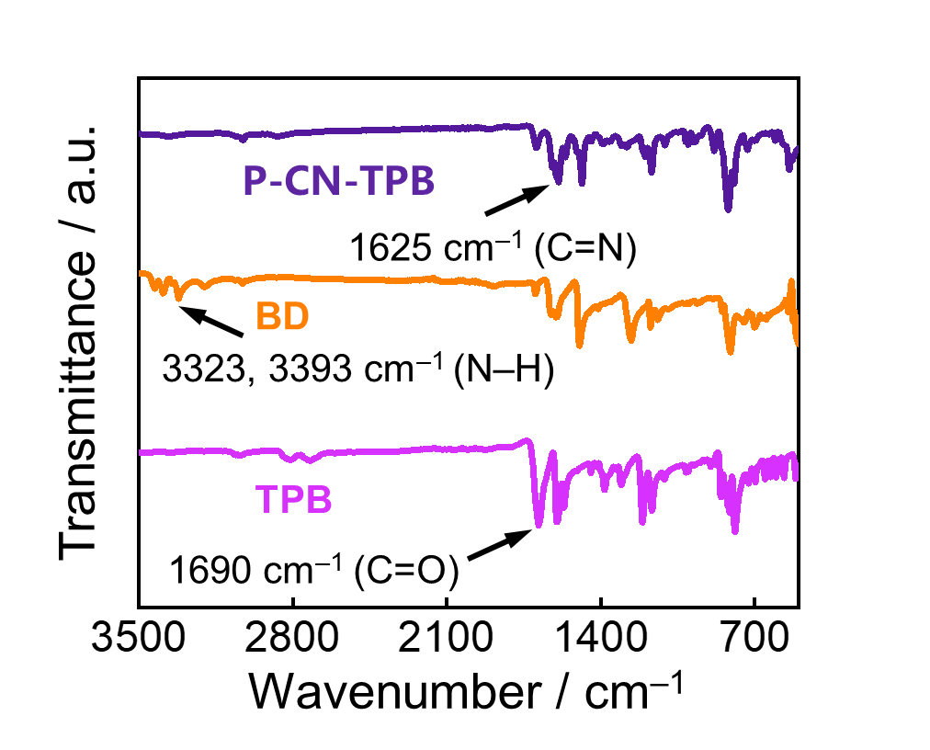
Figure S1. FT-IR spectra of P-CN-TPB.

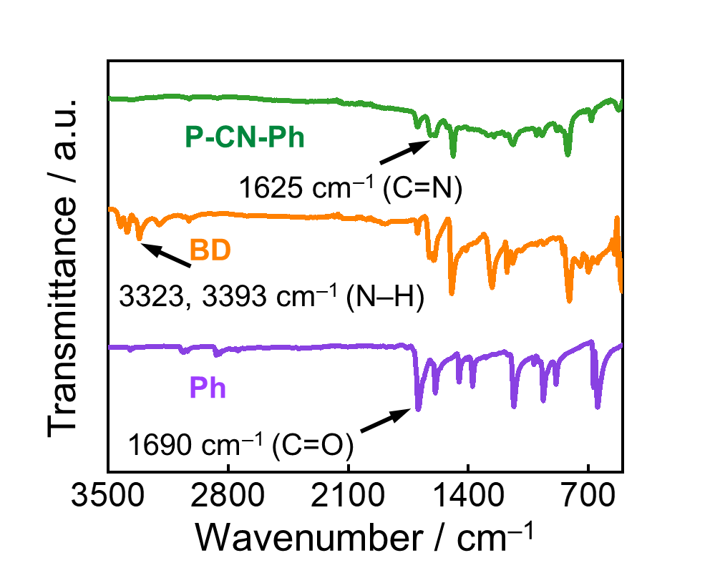
Figure S2. FT-IR spectra of P-CN-Ph.

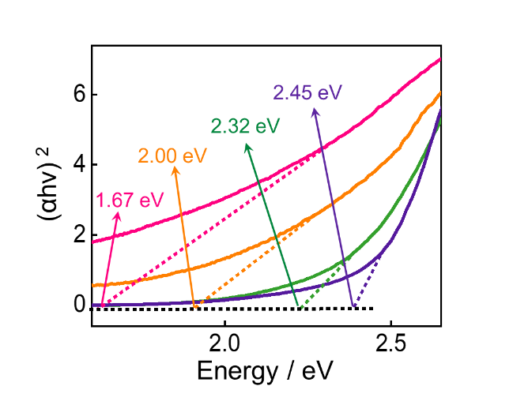
Figure S3. The Kubelka–Munk (K–M)-transformed reflectance spectrum.

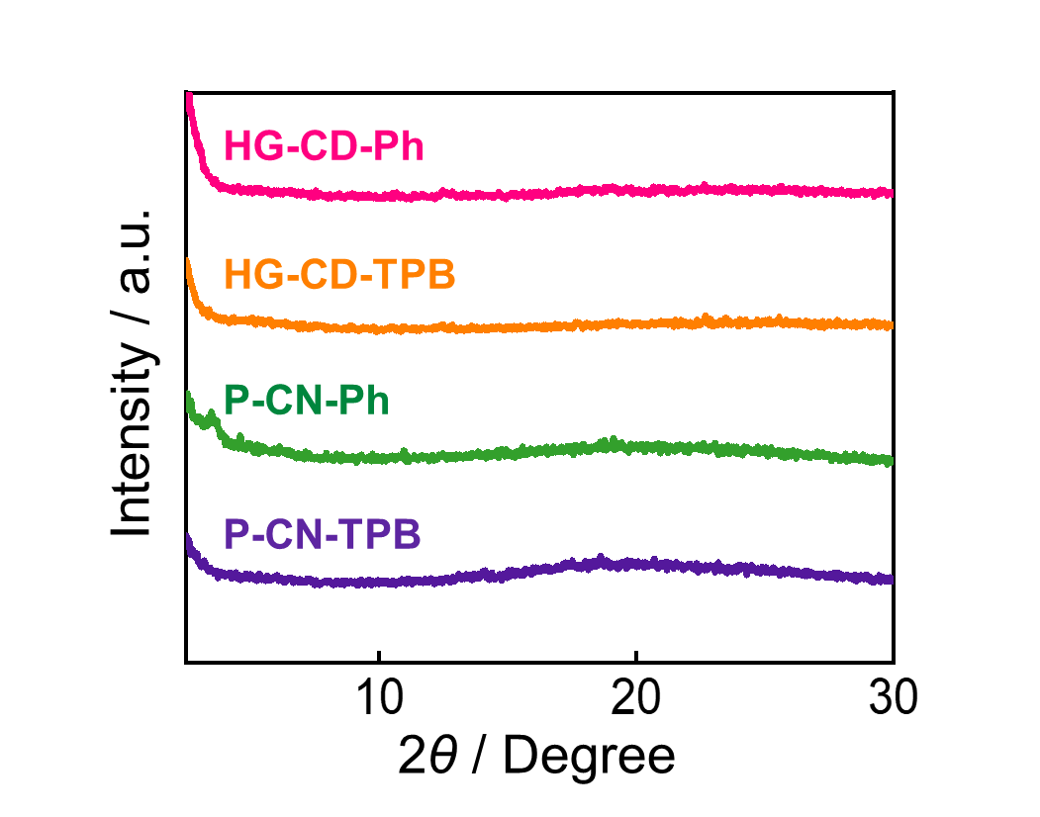
Figure S4. PXRD patterns of HG-CD-Ph, HG-CD-TPB, P-CN-Ph and P-CN-TPB.

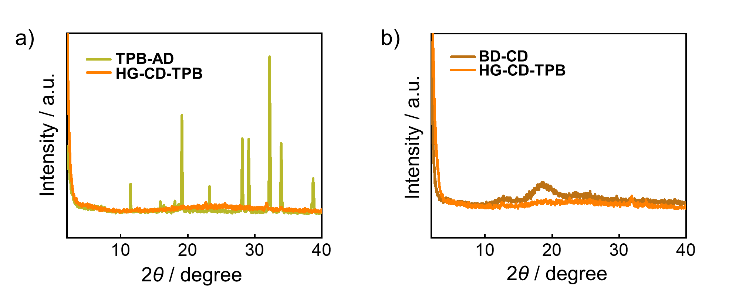
Figure S5. a-b) The PXRD patterns of HG-CD-TPB compared with TPB-AD and BD-CD monomers, respectively.

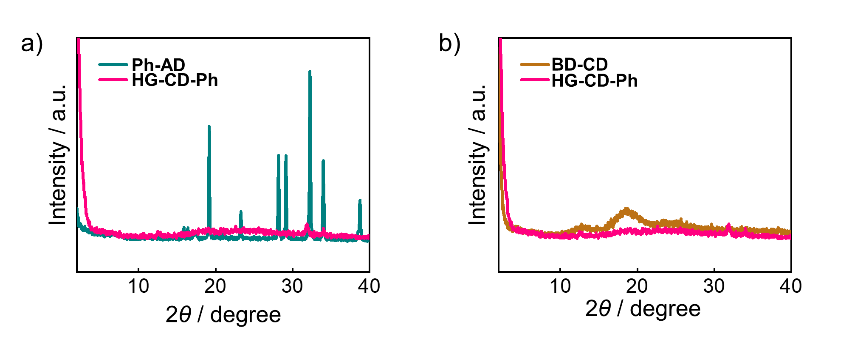
Figure S6. a-b) The PXRD patterns of HG-CD-Ph compared with Ph-AD and BD-CD monomers, respectively.

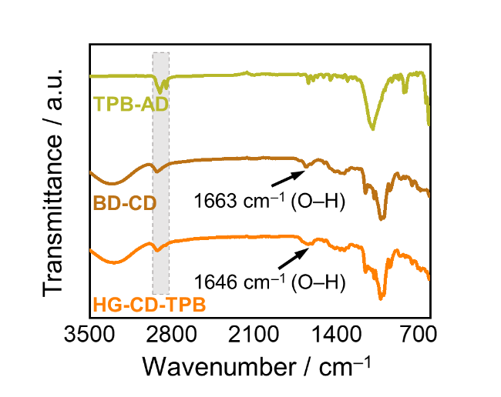
Figure S7. FT-IR spectra of HG-CD-TPB.

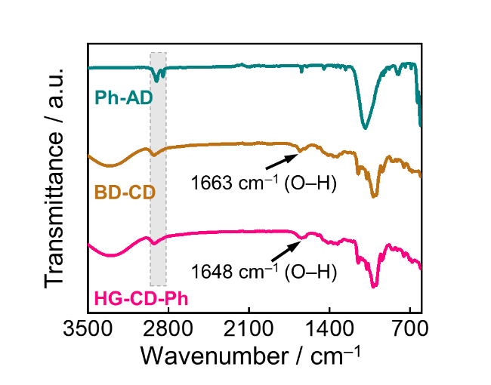
Figure S8. FT-IR spectra of HG-CD-Ph.

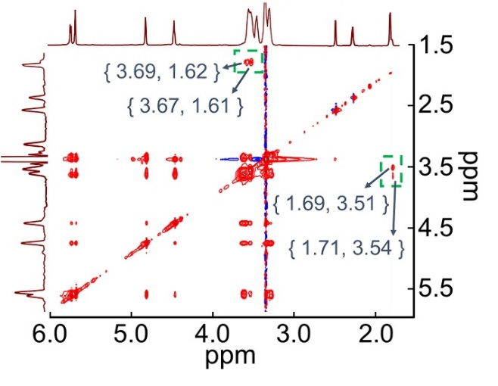
Figure S9. 2D-NOESY spectra (600 MHz, DMSO-d, 298 K) of HG-CD-TPB.

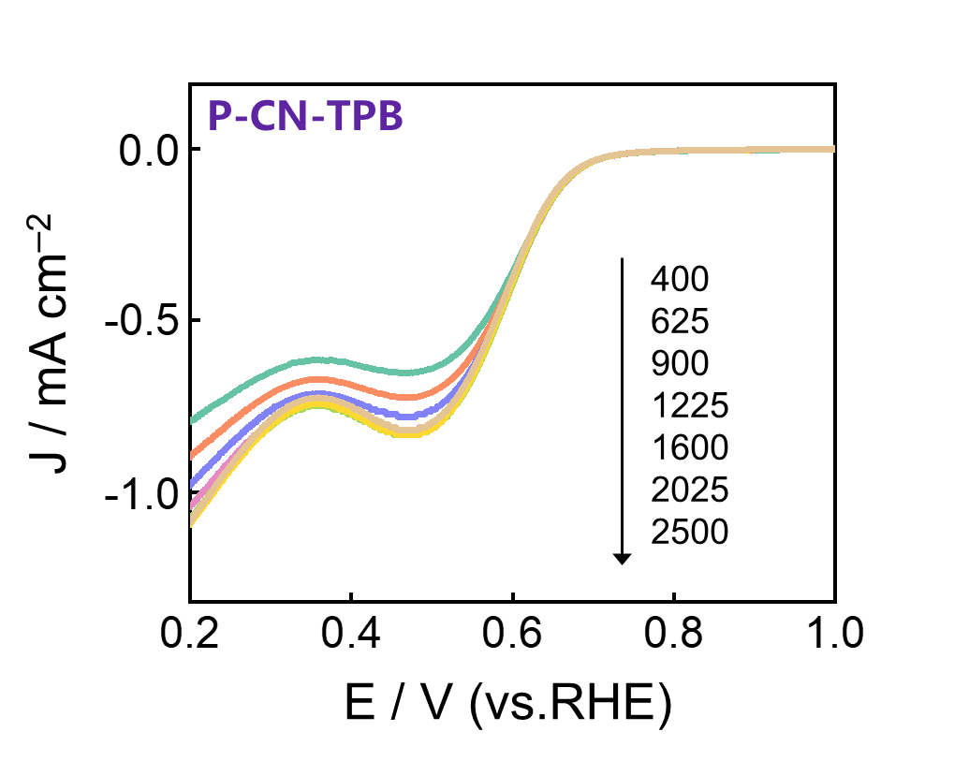
Figure S10. LSV curves of P-CN-TPB in 0.1 M KOH solution from 400 rpm to 2500 rpm.

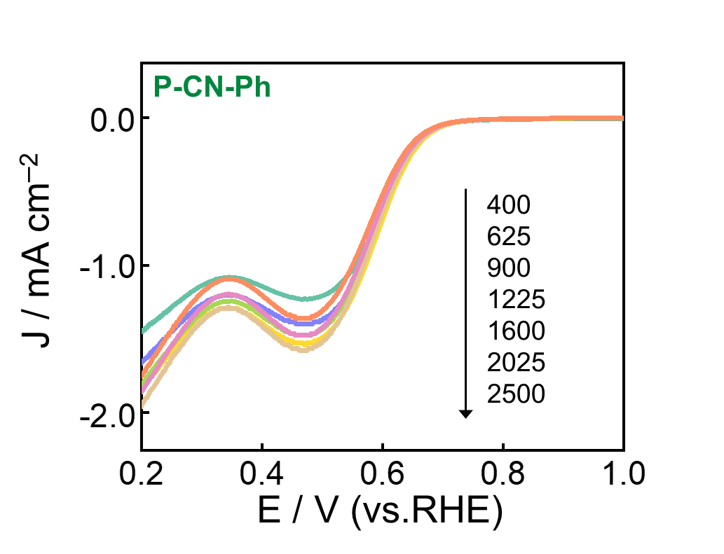
Figure S11. LSV curves of P-CN-Ph in 0.1 M KOH solution from 400 rpm to 2500 rpm.

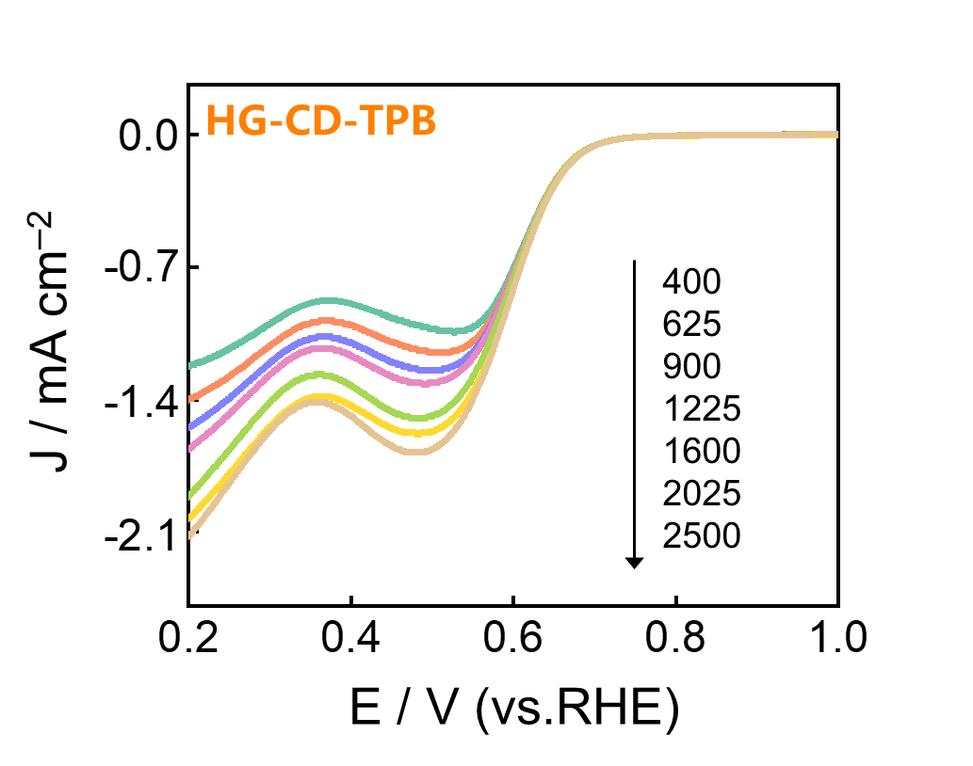
Figure S12. LSV curves of HG-CD-TPB in 0.1 M KOH solution from 400 rpm to 2500 rpm.

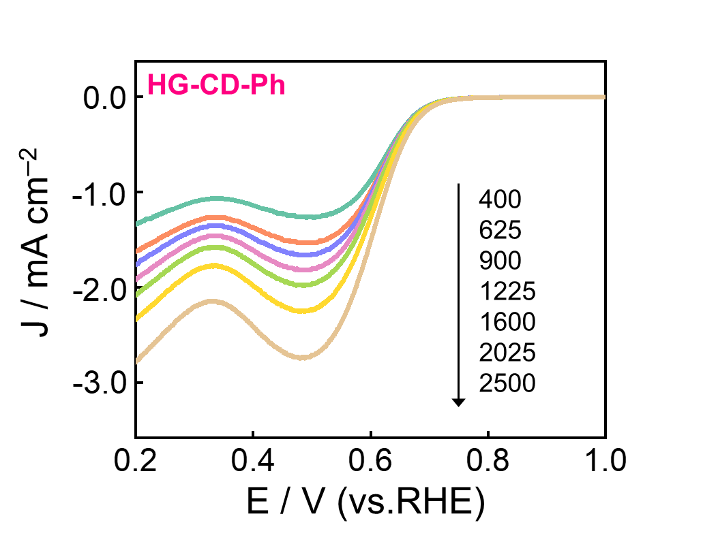
Figure S13. LSV curves of HG-CD-Ph in 0.1 M KOH solution from 400 rpm to 2500 rpm.

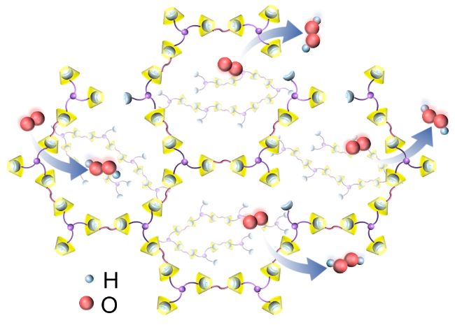
Figure S14. Proposed ORR processes on host-guest-based supramolecular polymers.

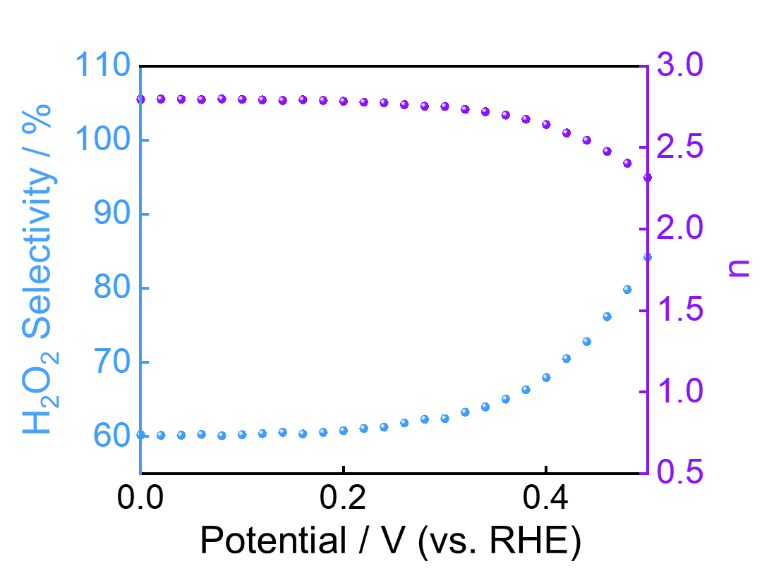
Figure S15. The corresponding H₂O₂ selectivity profiles and the electron-transfer number of HG-CD-Ph in O₂-saturated PH = 7 PBS electrolyte.

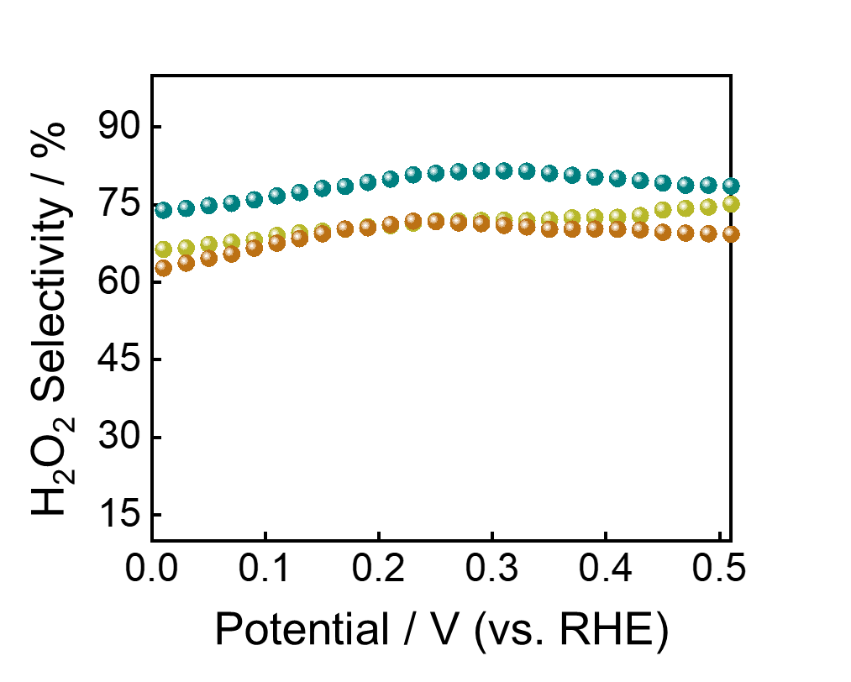
Figure S16. The corresponding H₂O₂ selectivity profiles of supramolecular precursors Ph-AD (green), TPB-AD (yellow), and BD-CD (brown) in O₂-saturated 0.1 M KOH electrolyte.
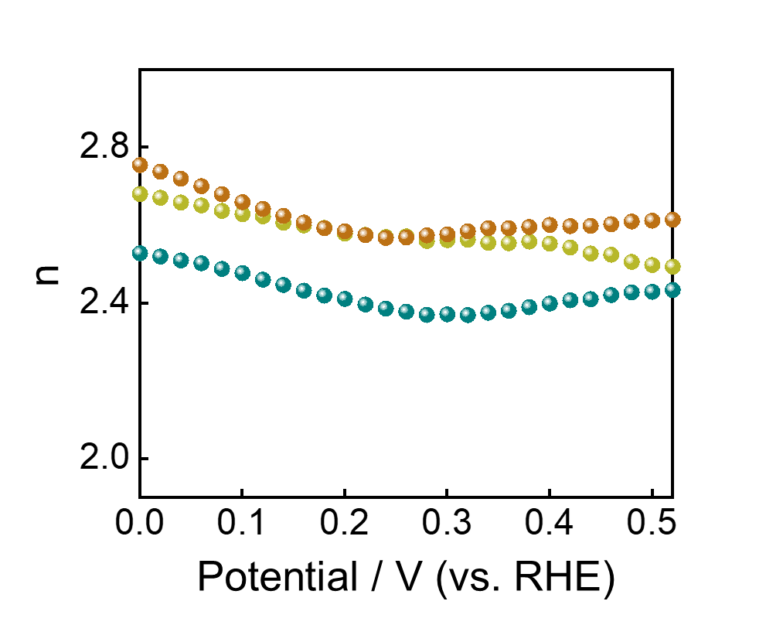
Figure S17. The corresponding electron-transfer number of supramolecular precursors Ph-AD (green), TPB-AD (yellow), and BD-CD (brown) in O₂-saturated 0.1 M KOH electrolyte.

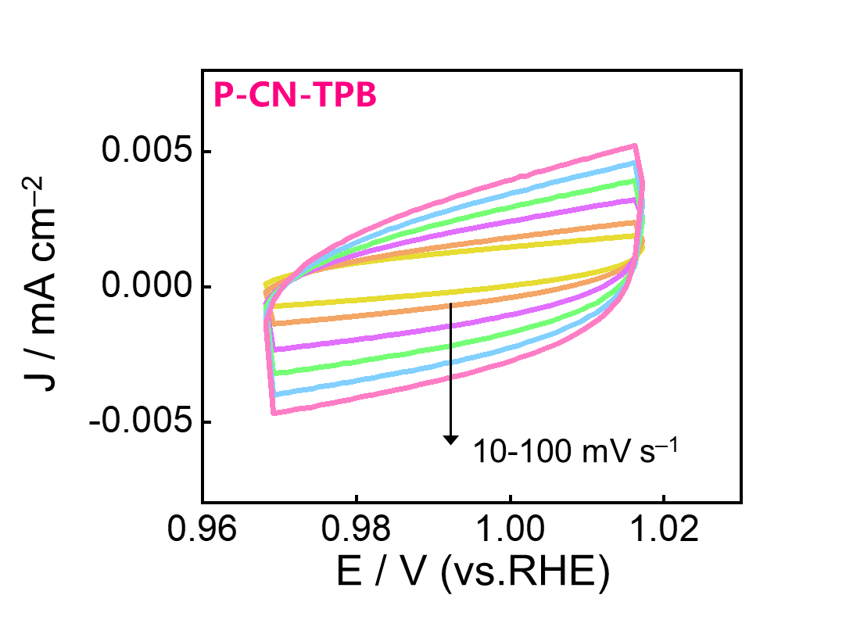
Figure S18. CV curves of P-CN-TPB in 0.1 M KOH solution with the scan rate from 10 mV s^{–1} to 100 mV s^{–1}).

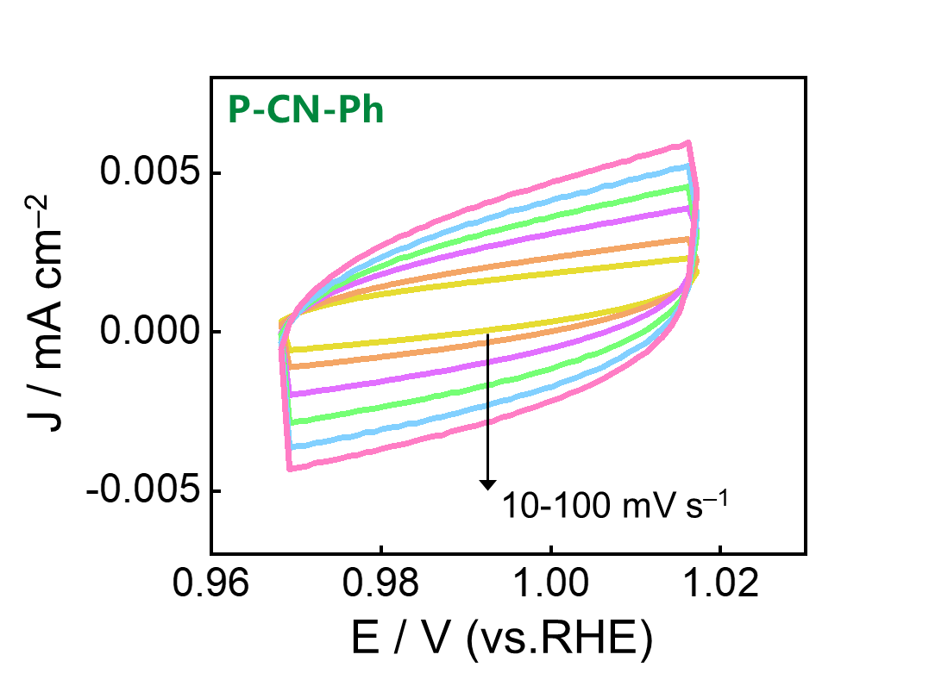
Figure S19. CV curves of P-CN-Ph in 0.1 M KOH solution with the scan rate from 10 mV s^{–1} to 100 mV s^{–1}).
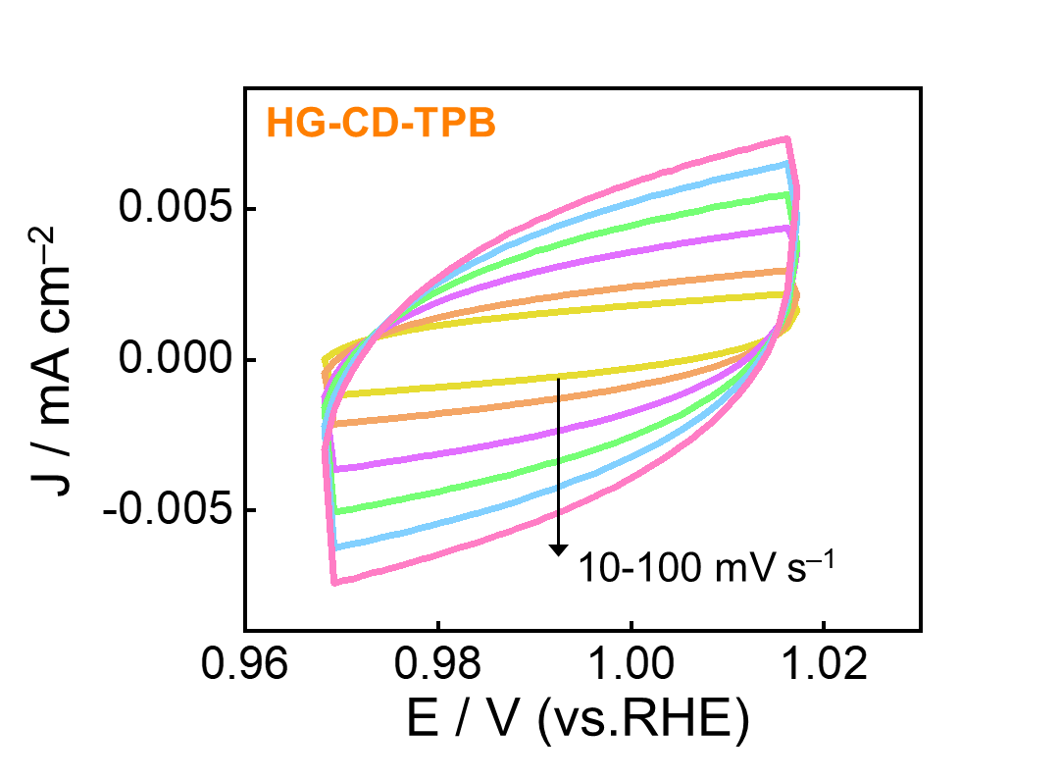
Figure S20. CV curves of HG-CD-TPB in 0.1 M KOH solution with the scan rate from 10 mV s^{–1} to 100 mV s^{–1}).

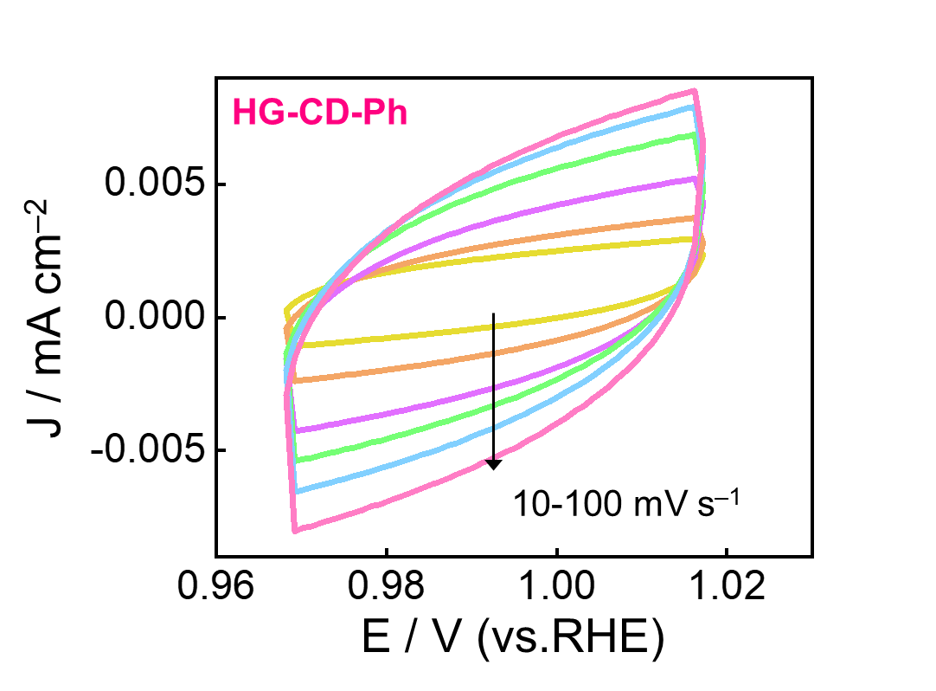
Figure S21. CV curves of HG-CD-Ph in 0.1 M KOH solution with the scan rate from 10 mV s^{–1} to 100 mV s^{–1}).

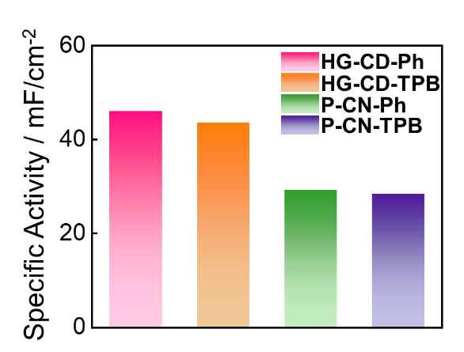
Figure S22. The specific activities of HG-CD-Ph, HG-CD-TPB, P-CN-Ph, and P-CN-TPB.
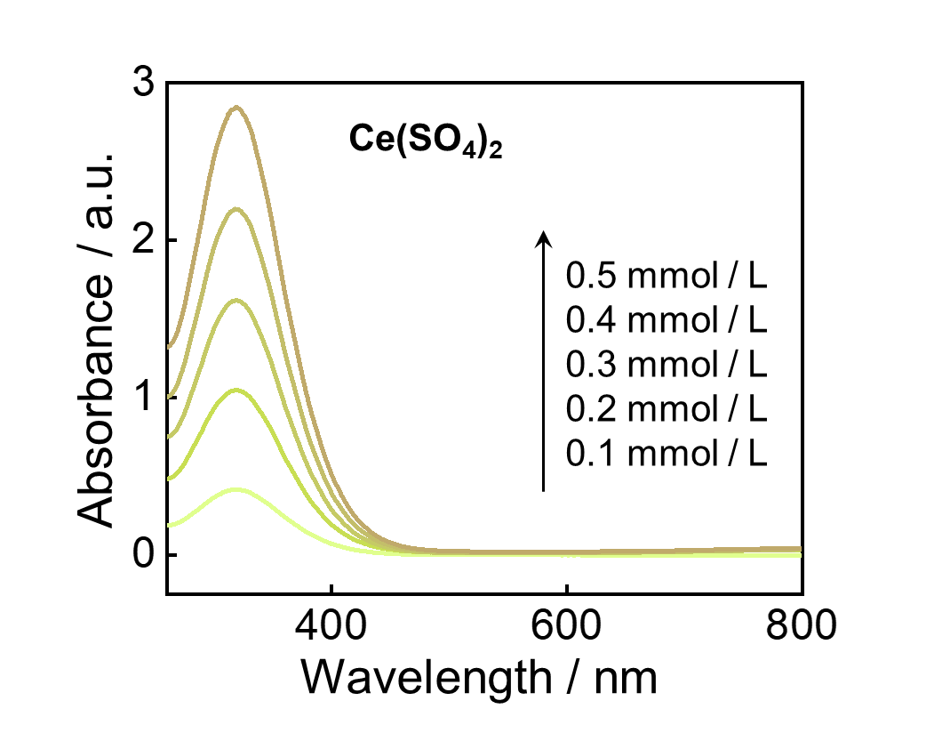
Figure S23. Absorbance spectra of standard Ce(SO₄)₂ solutions (up to 0.5 mM) in 0.5 M H₂SO₄.

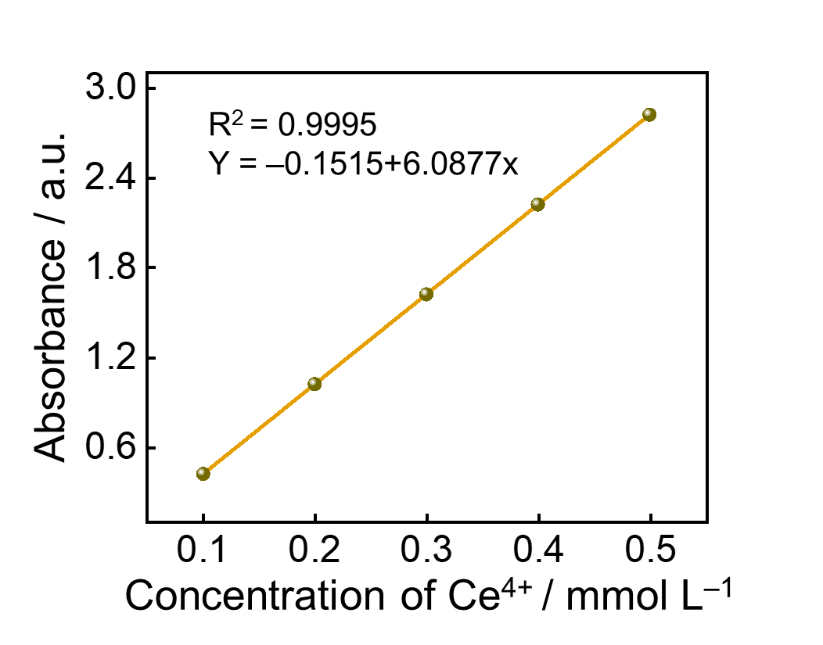
Figure S24. The linear relationship between the concentration of Ce(SO₄)₂ and the absorbance.

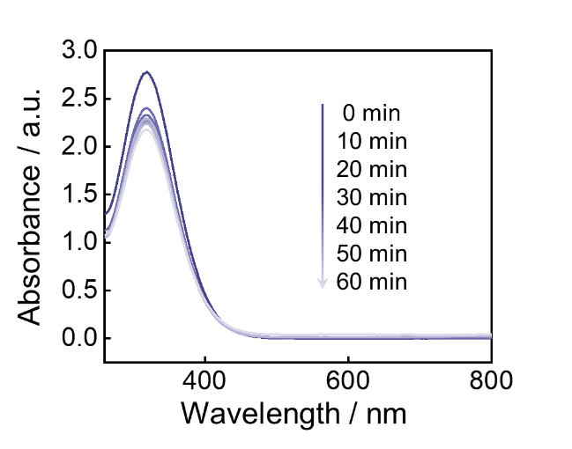
Figure S25. Absorbance spectra of standard 0.5 mM Ce(SO₄)₂ solutions after mixing KOH electrolyte catalyzed by P-CN-TPB to produce H₂O₂.
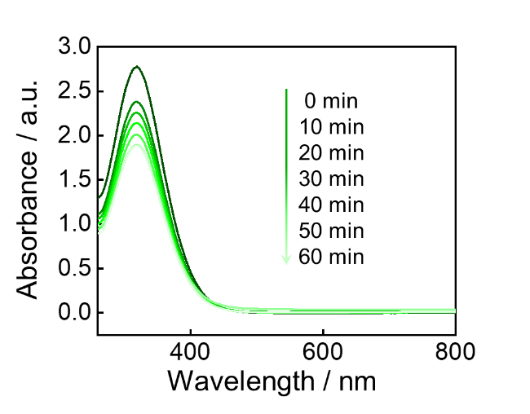
Figure S26. Absorbance spectra of standard 0.5 mM Ce(SO₄)₂ solutions after mixing KOH electrolyte catalyzed by P-CN-Ph to produce H₂O₂.

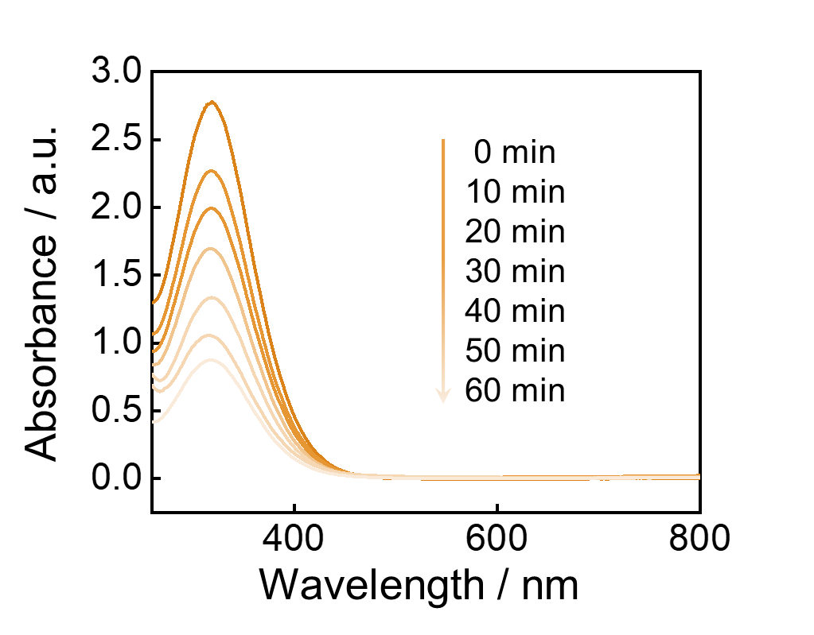
Figure S27. Absorbance spectra of standard 0.5 mM Ce(SO₄)₂ solutions after mixing KOH electrolyte catalyzed by HG-CD-TPB to produce H₂O₂.

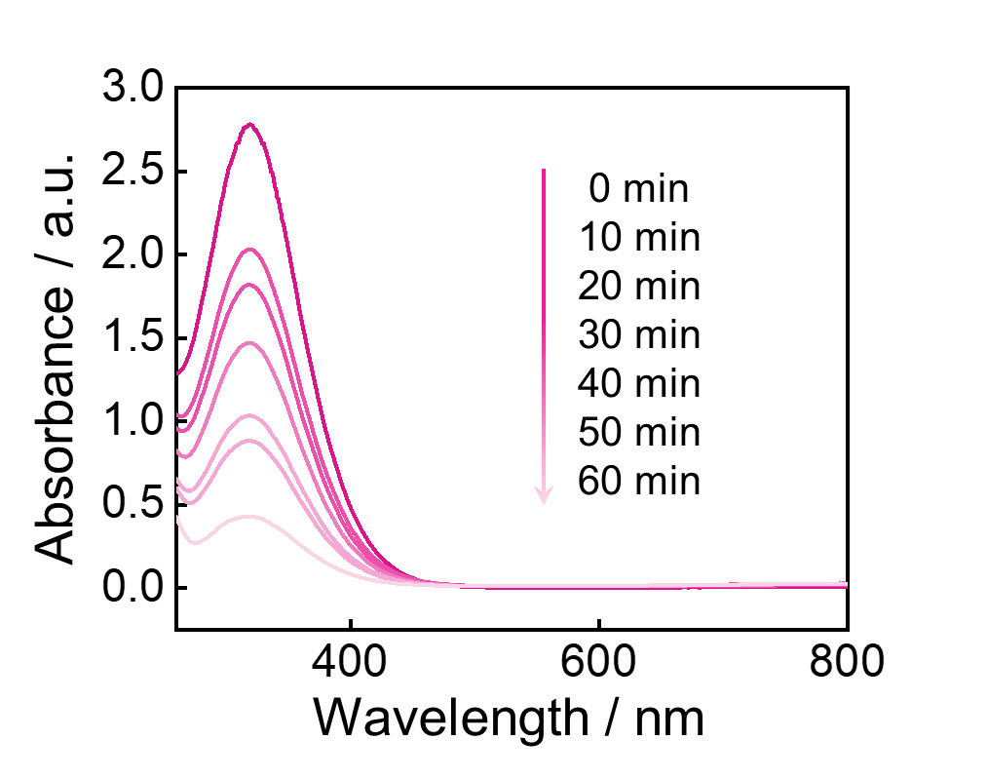
Figure S28. Absorbance spectra of standard 0.5 mM Ce(SO₄)₂ solutions after mixing KOH electrolyte catalyzed by HG-CD-Ph to produce H₂O₂.

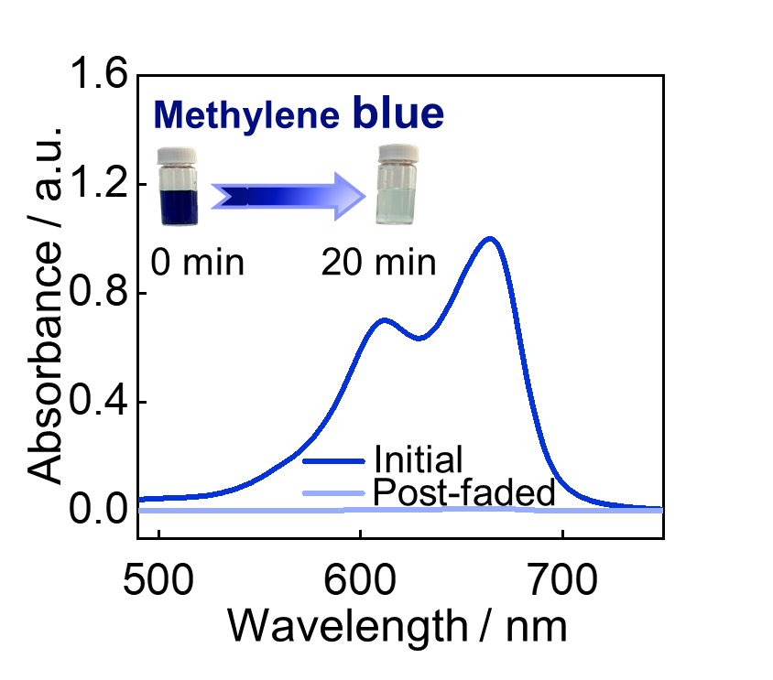
Figure S29. Digital images for the decolorization of Methylene blue.

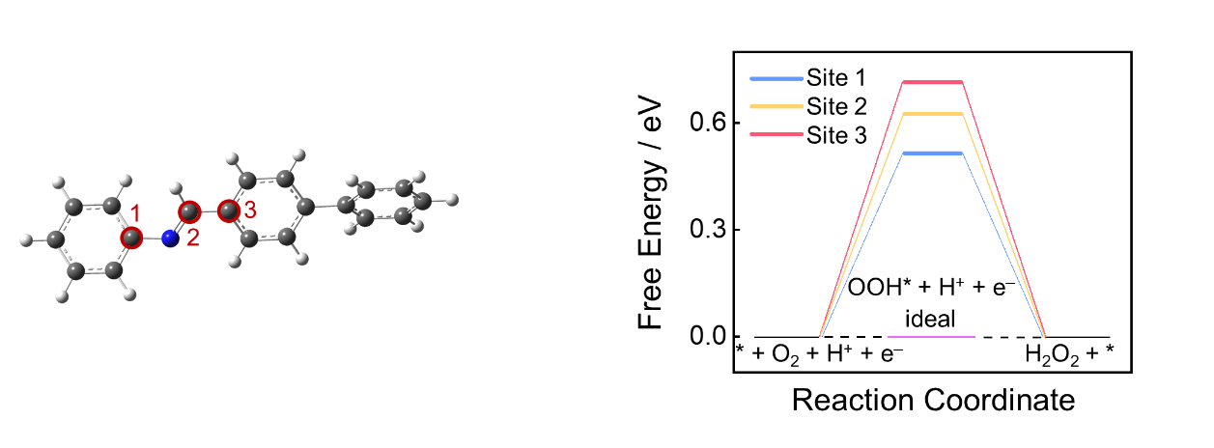
Figure S30. ΔG_{OOH*} for ORHP of P-CN-TPB at the equilibrium potential of UO₂ / H₂O₂ = 0.70 V at different sites.
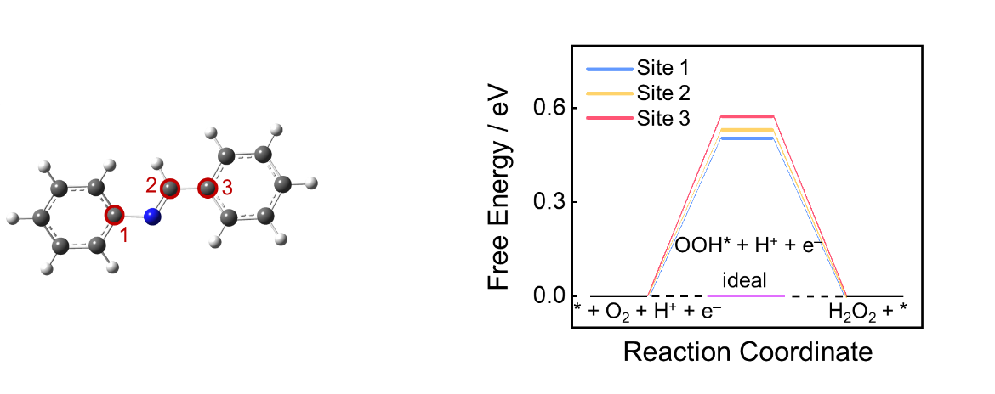
Figure S31. ΔG_{OOH*} for ORHP of P-CN-Ph at the equilibrium potential of UO₂ / H₂O₂ = 0.70 V at different sites.

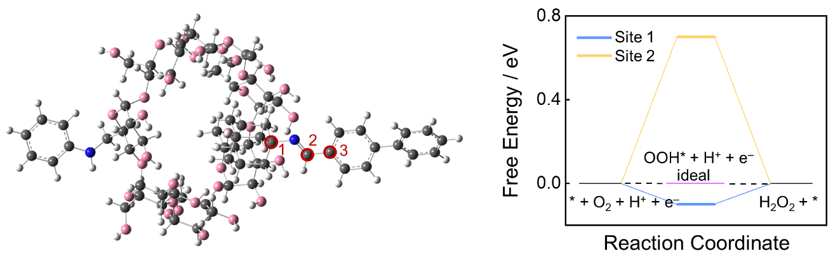
Figure S32. ΔG_{OOH*} for ORHP of HG-CD-TPB at the equilibrium potential of UO₂ / H₂O₂ = 0.70 V at different sites.

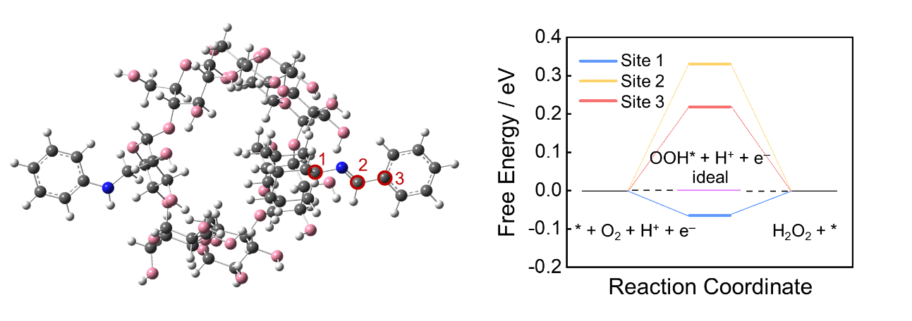
Figure S33. ΔG_{OOH*} for ORHP of HG-CD-Ph at the equilibrium potential of UO₂ / H₂O₂ = 0.70 V at different sites.

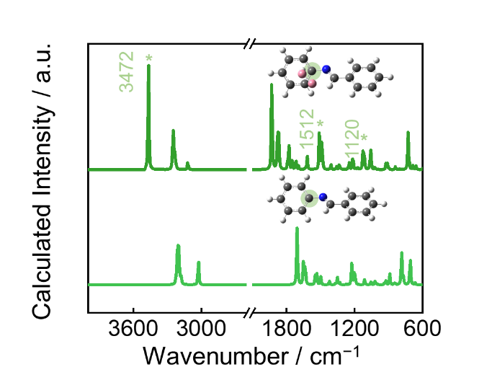
Figure S34. Theoretical FT-IR spectra of P-CN-TPB model before and after the adsorption of OOH* intermediates.

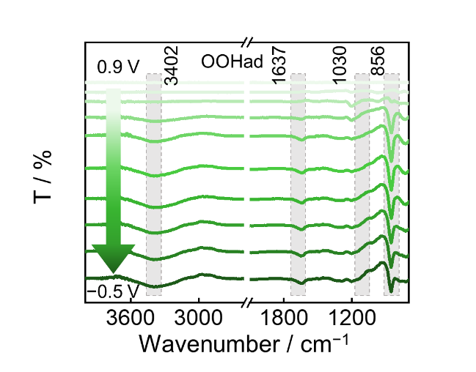
Figure S35. In situ electrochemical FT-IR spectra of P-CN-TPB in O₂-saturated 0.1 M KOH solution (pH = 13) ranging from −0.5 to 0.9 V versus RHE at an interval of 200 mV.

Table S1. Comparative ORR activity table with recently reported covalent bonded catalysts.
Index | Catalysts | H₂O₂ Selectivity(%) | H₂O₂ Yield(mol g⁻¹ _{cat} h⁻¹) | H₂O₂ FE(%) | Ref.
1 | BUCT-COF-7 | 83.40 | 2.25 | 80.00 | 1
2 | CoPc-2SO₃H-COF | 88.30 | 4.20 | 93.00 | 2
3 | NiPyCN/CN | 94.54 | 4.80 | 68.60 | 3
4 | Co-SCD | 98.20 | 5.58 | 98.70 | 4
5 | Ni-N₂O₂ | 96.00 | 3.90 | 90.00 | 5
6 | OCNS₉₀₀ | 94.00 | 0.77 | 89.60 | 6
7 | NBO-GQDs | 90.00 | 0.71 | 81.00 | 7
8 | Co-Nx | 90.00 | 0.10 | 85.00 | 8
9 | M-N-C | 80.00 | 4.33 | 70.00 | 9
10 | Oxo-G/NH₃·H₂O | 83.60 | 0.22 | 43.60 | 10
This work | HG-CD-Ph | 94.94 | 9.14 | 98.01 | This work

Table S2. The free energy values of different sites in P-CN-TPB.
Site | 1 | 2 | 3
Overpotential | 0.52 | 0.63 | 0.72
△G1 | 0.52 | 0.63 | 0.72
△G2 | –0.57 | –0.47 | –0.42
△G3 | 0.82 | –0.12 | 0.57
△G4 | –0.77 | –0.03 | –0.86

Table S3. The free energy values of different sites in P-CN-Ph.
Site | 1 | 2 | 3
Overpotential | 0.50 | 0.53 | 0.57
△G1 | 0.50 | 0.53 | 0.57
△G2 | –0.56 | –0.39 | –0.43
△G3 | 0.87 | –0.12 | 0.83
△G4 | –0.81 | –0.02 | –0.97

Table S4. The free energy values of different sites in HG-CD-TPB.
Site | 1 | 2 | 3
Overpotential | –0.10 | 0.70
△G1 | –0.10 | 0.70
△G2 | 1.46 | –0.80
△G3 | 1.73 | 0.32
△G4 | –0.18 | –0.22

Table S5. The free energy values of different sites in HG-CD-Ph.
Site | 1 | 2 | 3
Overpotential | –0.07 | 0.33 | 0.22
△G1 | –0.07 | 0.33 | 0.22
△G2 | –0.84 | –0.43 | 0.02
△G3 | 1.81 | 0.39 | 0.57
△G4 | –0.91 | –0.29 | –0.81

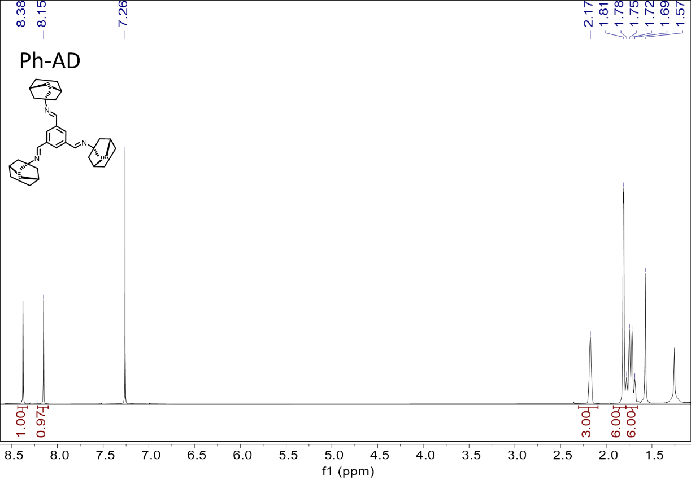
Figure S36. ¹H NMR spectrum of Ph-AD.

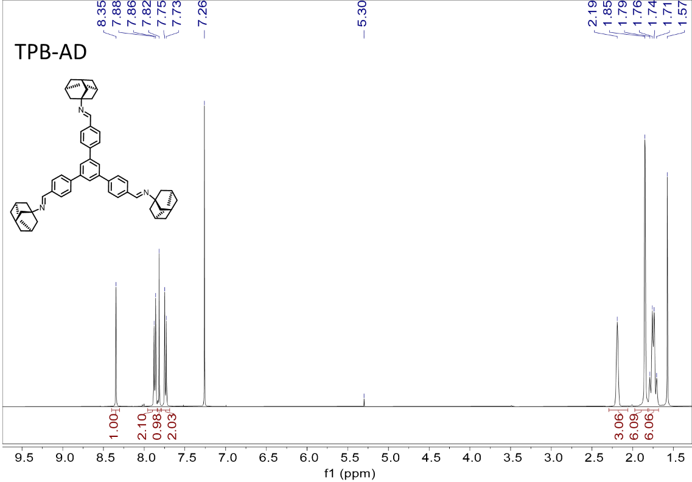
Figure S37. ¹H NMR spectrum of TPB-AD

- Supplementary references
1. Zhang, Y. et al. Multicomponent Synthesis of Imidazole-Linked Fully Conjugated 3D Covalent Organic Framework for Efficient Electrochemical Hydrogen Peroxide Production. Angew. Chem. Int. Ed. 62, e202314539 (2023).
2. Jiang, R. et al. Hydrophilic phthalocyanine covalent organic frameworks for enhanced electrocatalytic H₂O₂ production. Chem. Eng. J. 489, 151232 (2024).
3. Sun, L. et al. Conjugated Nickel Phthalocyanine Derivatives for Heterogeneous Electrocatalytic H₂O₂ Synthesis. Adv. Mater. 35, 2306336 (2023).
4. Qi, D. et al. Cyclodextrin-supported Co(OH)₂ Clusters as Electrocatalysts for Efficient and Selective H₂O₂ Synthesis. Angew. Chem. Int. Ed. 62, e202307355 (2023).
5. Wang, Y. et al. High-Efficiency Oxygen Reduction to Hydrogen Peroxide Catalyzed by Nickel Single-Atom Catalysts with Tetradentate N₂O₂ Coordination in a Three-Phase Flow Cell. Angew. Chem. Int. Ed. 59, 13057–13062 (2020).
6. Chen, S. et al. Chemical Identification of Catalytically Active Sites on Oxygen-doped Carbon Nanosheet to Decipher the High Activity for Electro-synthesis Hydrogen Peroxide. Angew. Chem. Int. Ed. 59, 13057–13062 (2020).
7. Fan, M. et al. N–B–OH Site-Activated Graphene Quantum Dots for Boosting Electrochemical Hydrogen Peroxide Production. Adv. Mater. 35, 2209086 (2023).
8. Rawah, B. S. et al. Electrocatalytic generation of hydrogen peroxide on cobalt nanoparticles embedded in nitrogen‐doped carbon. Chinese J. Catal 42, 2296–2305 (2021).
9. Sun, Y. et al. Activity−Selectivity Trends in the Electrochemical Production of Hydrogen Peroxide over Single-Site Metal−Nitrogen−Carbon Catalysts. J. Am. Chem. Soc. 141, 12372−12381 (2019).
10. Han, L. et al. In-Plane Carbon Lattice-Defect Regulating Electrochemical Oxygen Reduction to Hydrogen Peroxide Production over Nitrogen-Doped Graphene. ACS Catal. 9, 1283−1288 (2019).

