Table 2 Effect of salinity, K and Fe deficiency on chlorophyll and carotenoid content of C. maritima and A. thaliana plants. Plants were grown in presence or absence of Fe (2 days) or K (7 days), and supplied or not with NaCl for 2 days. 200 mM NaCl and 400 mM NaCl were used for A. thaliana and C. maritima, respectively. Data are given as means ± SE (n = 6). Within each treatment, bars with different letters indicate significant differences (P < 0.05)

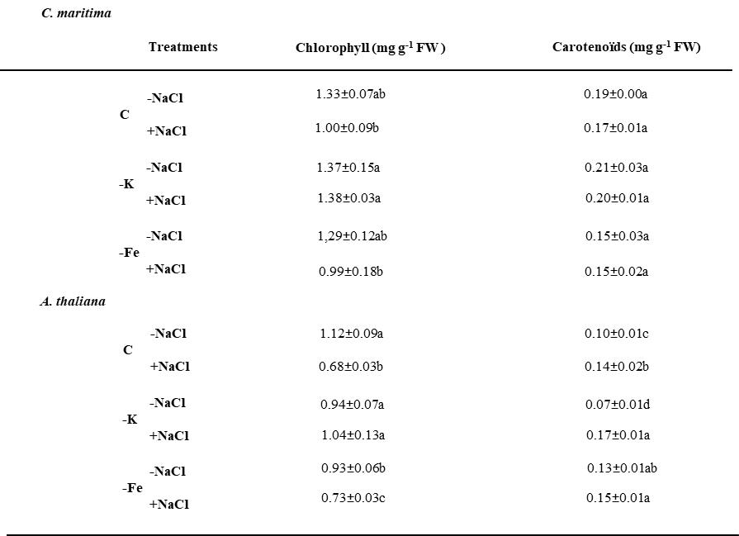

Table 3 Effect of salinity, K and Fe deficiency on shoot and root Na⁺ content and water content of C. maritima and A. thaliana plants. Plants were grown in presence or absence of Fe (2 days) or K (7 days), and supplied or not with NaCl for 2 days. 200 mM NaCl and 400 mM NaCl were used for A. thaliana and C. maritima, respectively. Data are given as means ± SE (n = 6). Within each treatment, bars with different letters indicate significant differences (P < 0.05)

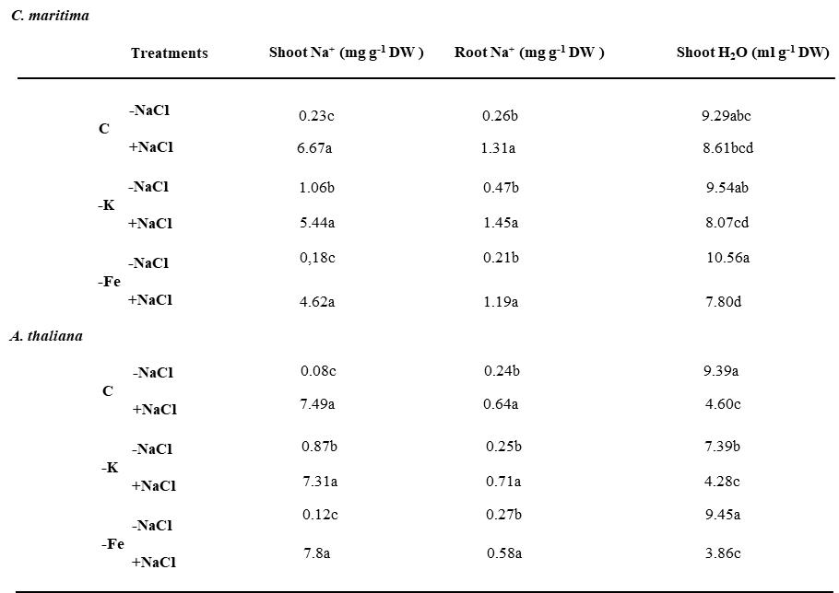

Table 4 Effect of salinity, K and Fe deficiency on root K⁺ and Fe contents of C. maritima and A. thaliana plants. Plants were grown in presence or absence of Fe (2 days) or K (7 days) and supplied or not with NaCl for 2 days. 200 mM NaCl and 400 mM NaCl were used for A. thaliana and C. maritima, respectively. Data are given as means ± SE (n = 6). Within each treatment, bars with different letters indicate significant differences (P < 0.05)

