Deciphering the molecular mechanism of water boiling at heterogeneous interfaces
Konstantinos Karalis¹*, Dirk Zahn², N. Prasianakis³, B. Niceno⁴ and Sergey V. Churakov^{1,3}*
¹Institute of Geological Sciences, University of Bern, CH-3012 Bern, Switzerland
²Lehrstuhl für Theoretische Chemie/Computer Chemie Centrum, Friedrich-Alexander Universität Erlangen-Nürnberg, Erlangen, Germany
³Laboratory for Waste Management (LES), Paul Scherrer Institute, CH-5232 Villigen, Switzerland
⁴Laboratory of Scientific Computing and Modelling (LSM), Paul Scherrer Institute, CH-5232 Villigen, Switzerland
*Corresponding author(s): konstantinos.karalis@geo.unibe.ch, sergey.churakov@psi.ch

Supplementary Informatio n
Figure S1. Radial distribution function of the zirconia interface atoms (Zr, O_{zr}) with the oxygen and hydrogen atoms of the water molecules for the (001) and (-111) interface planes. In both interface planes, the water dipoles are oriented with the hydrogen atom being closer to the interface.

Figure S2. Density profile in fluid phase normal to zirconia interface at hydrophobic (001) and hydrophilic (-111) zirconia surface faces. In the hydrophilic (-111) interface plane, a hydrogen pre-peak close to the solid interface is evident, indicating the formation of hydrogen bonds between the water and solid atoms.

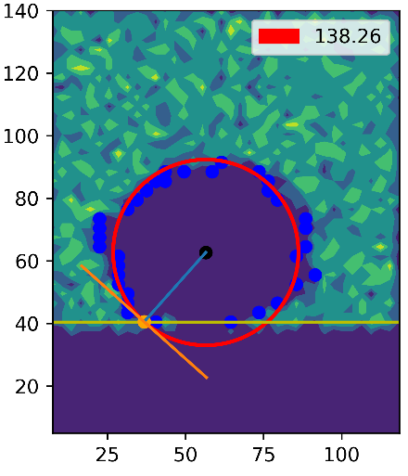 | 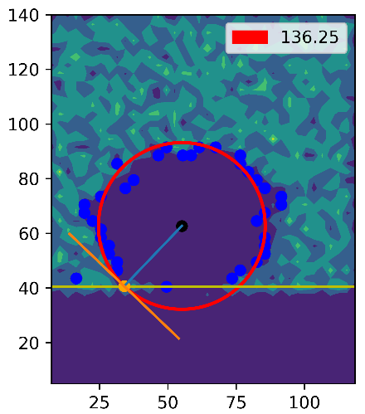 | 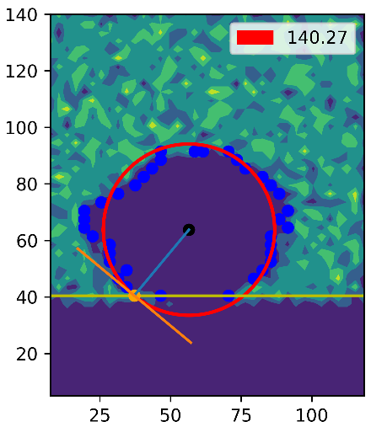
(a) | (b) | (c)
Figure S3. Contact angle estimation on water vapor bubble embedded into condensed phase at (-111) the interface.

(a) | (b)
Figure S4. Average of Hamiltonian derivatives (u_{sl(LJ}) and u_{sl(C)})and work of adhesion (W_{sl}) for a) the zirconia (-111) interface plane at 298.15K and 396.15K and b) the zirconia (001) interface plane at 298.15K and 396.15K respectively. The work of adhesion (W_{sl}) at κ=1 on the LJ coupling parameter case was used as the initial value for the work of adhesion using the Coulomb coupling parameter. The cumulative W_{sl} (at λ equal to 1.0) of the Coulomb coupling parameter was applied in the Young-Dupré equation to calculate the water contact angle.

Figure S5. Water density profile evolution during the initial stage heterogeneous water nucleate boiling in contact with the (-111) interface of mZrO₂. The two independent density profiles indicate a thin adsorbed water layer (6-8Å) on the hydrophilic interface. The almost constant increase of the box size along z-distance (bottom graph) indicates the trajectory decorrelation from the artificially generated pathway (the initial stage of heterogeneous water nucleate boiling, explosive boiling).

Figure S6. Parallel mean square displacement (MSD) divided by the survival probability (SP) for specific water layers from the zirconia interface at (-111) face. The parallel MSD is defined as the average MSD values in x and y directions.

Figure S7. Potential of mean force (PMF) profile of a hydrophobic particle normal to zirconia interface at (001) and (-111) surface faces.

