Supplementary Materials for

Strengthening ENSO amplitude asymmetry: historical trends and future projections in a warming climate

This file includes:
Supplementary Figure 1. Variability of the El Niño-Southern Oscillation (ENSO) amplitude asymmetry.
Supplementary Figure 2. Changes in SST anomalies (SSTAs) during ENSO events.
Supplementary Figure 3. Changes in positive feedbacks of ENSO events.
Supplementary Figure 4. The relationship between the zonal SST gradient and the central-eastern tropical Pacific (180°–90°W) zonal current anomalies.
Supplementary Figure 5. Difference of zonal currents between the period 1901–1960 and the period 1961–2010 over the central-eastern equatorial Pacific.
Supplementary Figure 6. Difference of Ekman pumping velocity (EPV) between the period 1901–1960 and the period 1961–2010 over the central-eastern equatorial Pacific.
Supplementary Figure 7. Spatial patterns of eastern Pacific (EP) ENSO calculated from observation and CESM ensemble members.
Supplementary Figure 8. Spatial patterns of central Pacific (CP) ENSO calculated from observation and CESM ensemble members.

Supplementary Figure 1. Variability of the El Niño-Southern Oscillation (ENSO) amplitude asymmetry. Running skewness of the boreal winter (December–February, DJF) ENSO indices for the period 1900–2020 on different SST datasets (a, b), different lengths of the moving window (c, d), and different ENSO indices (e, f). In (e-f), the indices_1 was calculated using a mathematic rotation of the Niño3 and Niño4 indices⁴⁷. The indices_2 was obtained by EOF analysis⁴⁶.

Supplementary Figure 2. Changes in SST anomalies (SSTAs) during ENSO events. a, b, The sum of the boreal winter (DJF) SSTAs (shading units: °C) for El Niño and La Niña events during the period 1 (P1; 1901–1960) (a) and the period 2 (P2;1961–2020) (b). c, The difference between (a) and (b). The dotted regions indicate the difference significant at the 95% confidence level.

Supplementary Figure 3. Changes in positive feedbacks of ENSO events. a, b, The composite difference of ZAF, EKF, TCF and the sum of these three positive feedbacks (units: °C month⁻¹) between El Niño and La Niña events for EP types over the Niño3 region (a) and CP types over the Niño4 region (b) during their developing phases. These feedbacks were calculated based on the Bjerknes stability index²⁹.
Supplementary Figure 4. The relationship between the zonal SST gradient and the central-eastern tropical Pacific (180°–90°W) zonal current anomalies. The red (blue) stars denote the annual value for the period 1901–1960 (1961–2010). Squares indicate the mean SST gradient and corresponding current anomalies. The data is from Simple Ocean Data Assimilation (SODA) version 2.2.4.

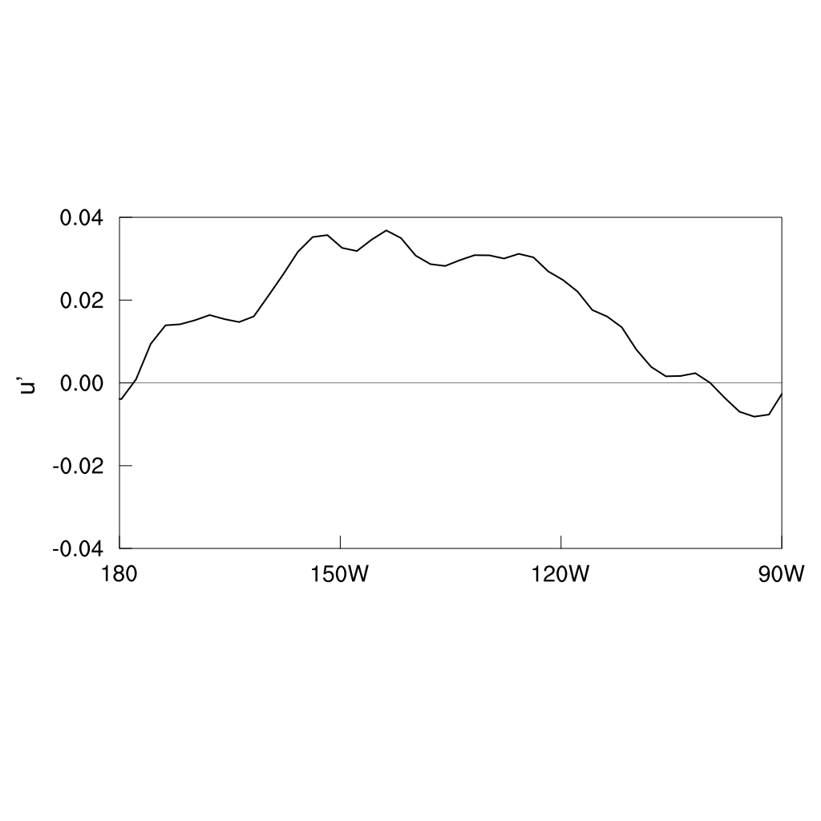
Supplementary Figure 5. Difference of zonal currents between the period 1901–1960 and the period 1961–2010 over the central-eastern equatorial Pacific. The units in the ordinates are $m/s$, and the data is from SODA version 2.2.4.

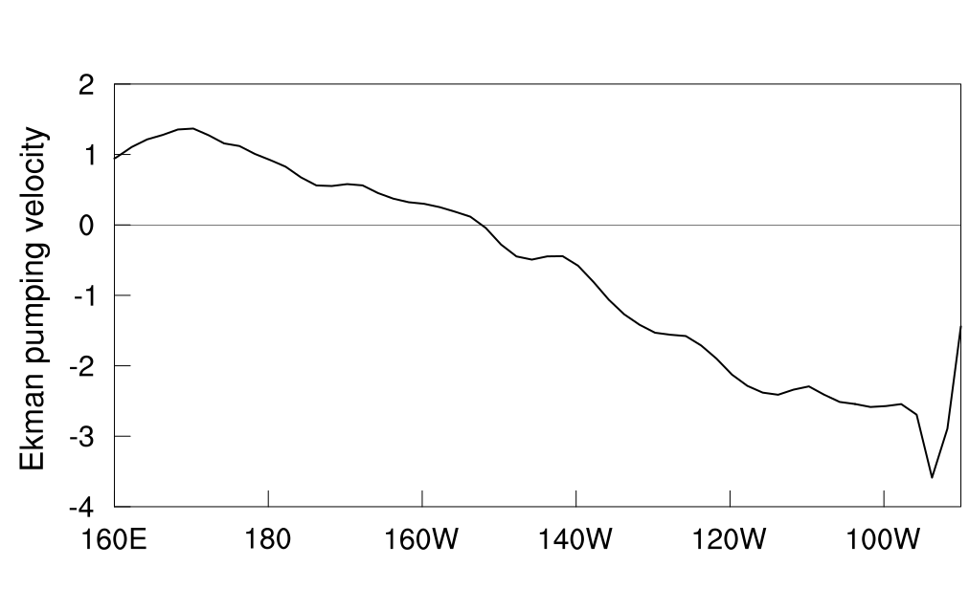
Supplementary Figure 6. Difference of EPV between the period 1901–1960 and the period 1961–2010 over the central-eastern equatorial Pacific. The EPV (units: $1×{10}^{5} m/s$) is calculated from wind stress curl, with data sourced from SODA version 2.2.4.

Supplementary Figure 7. Spatial patterns of EP ENSO calculated from observation(a) and CESM ensemble members (b1-b39). The EP ENSO pattern is the first EOF mode of the SST anomalies over the tropical Pacific (20°S-20°N, 120°E-80W°). The numbers at the upper right of each panel indicate the percentage of variance explained by each model’s first EOF mode.

Supplementary Figure 8. Spatial patterns of CP ENSO from calculated from observation(a) and CESM ensemble members (b1-b39). The calculation of CP ENSO pattern is similar to that of EP ENSO, but it represents the second EOF mode.

