Supplementary Figures
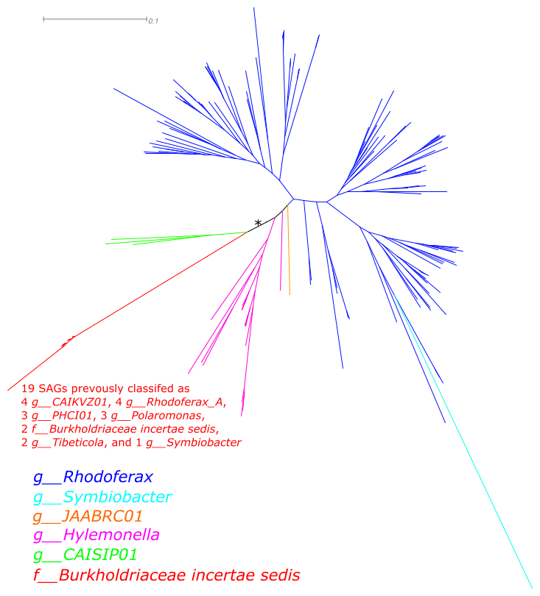
Supplementary Fig. 1. An example of manual taxonomic correction. The figure above is part of a maximum-likelihood tree reconstructed using the GTDB alignment of f__Burkholderiaceae that was cropped out at an asterisk. The 19 SAGs produced in this study were cohesively clustered in this tree but affiliated with different GTDB genera. Based on the tree topology, these SAGs were taxonomically considered f__Burkholderiaceae incertae sedis in this study.

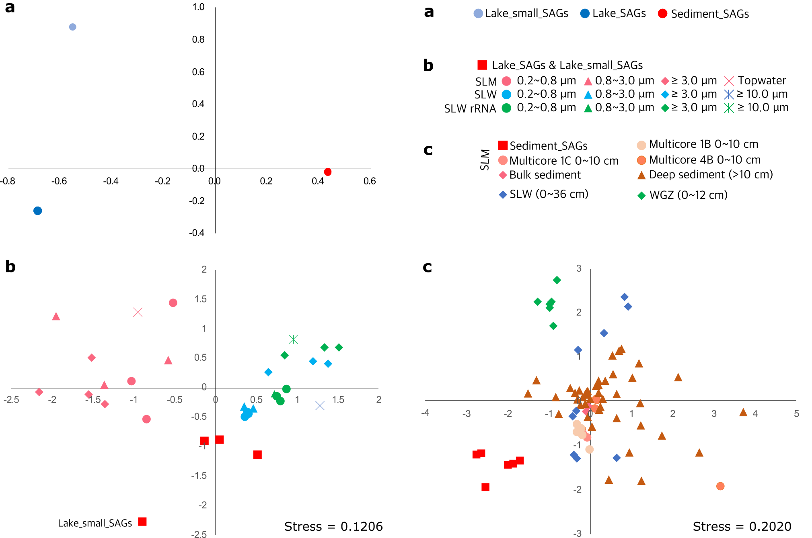
Supplementary Fig. 2. Bray-Curtis dissimilarity-based non-metric multidimensional scaling between samples. (a) NMDS of 10 subsamples of SLM, where three (>0.2 μm pore sizes, called Lake_SAGs on figure) and one (<0.2 μm, Lake_small_SAGs) from the water column and six from sediment (Sediment_SAGs). The relatedness was based on the relative abundance of SAGs at the GTDB genus level. Note that the three water column samples of >0.2 um pore sizes and six sediment samples overlapped, respectively. (b) NMDS of lake water samples from this study (SAGs) and previous study (16S rRNA for SLM and SLW)¹. The relatedness between samples were scaled by relative abundance of OTUs. (c) NMDS of sediment samples from this study (SAGs) and previous study (16S rRNA for SLM, SLW, and WGZ). The detailed methods for drawing NMDS plots can be found in Materials and Methods.

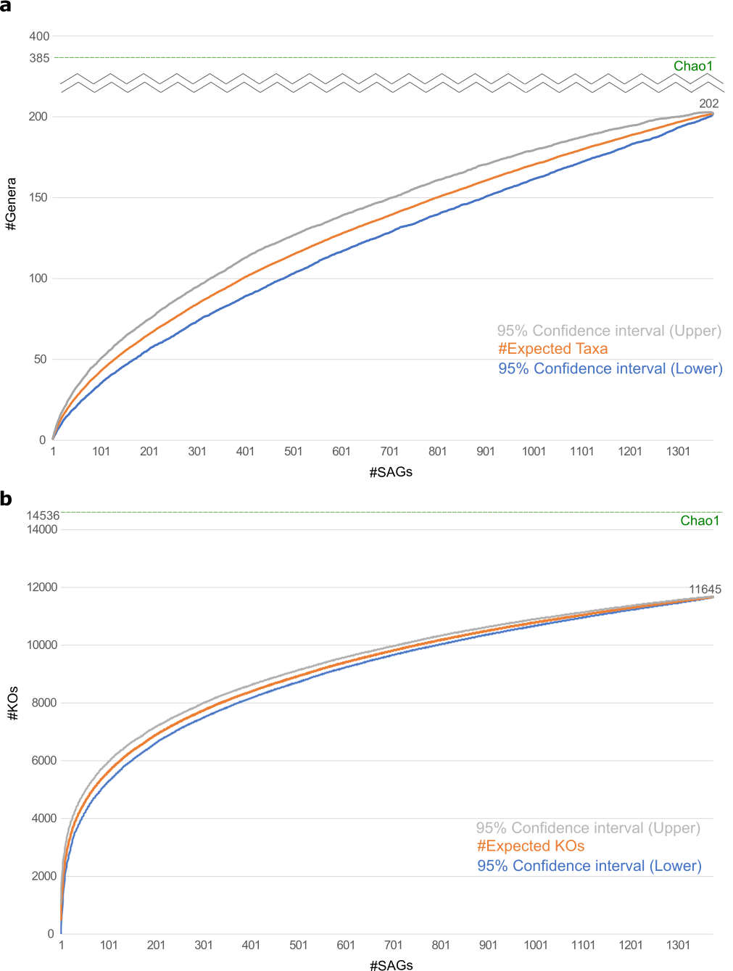
Supplementary Fig. 3. The richness estimation for species diversity and functional diversity. (a) the taxonomic richness at the GTDB genus level was evaluated using Chao1 (a horizontal green dotted line) and rarefaction with 95% confidence interval. (b) the functional richness at the KEGG orthology level evaluated using the same approach of (a).

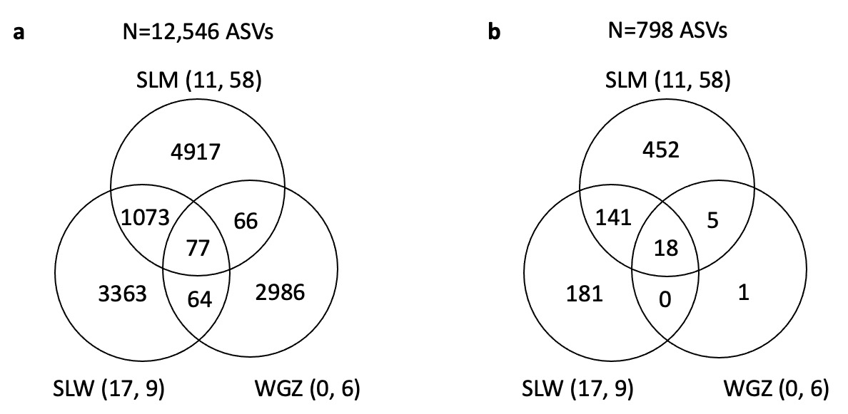

Supplementary Fig. 4. Sharing ASVs between samples. (a) previously sequenced ASVs shared by SLM, SLW, and WGZ¹. The letter on the top of Venn diagram indicates the total number of ASVs. The numbers in parentheses indicate the numbers of samples from lake water and sediment, respectively. The 464 ASVs were only found in technical test samples that include the borehole water. (b) ASVs shared by SLM, SLW, and WGZ only for 803 ASVs that are nearly identical to 16S rRNA sequences extracted from SLM’s SAGs.

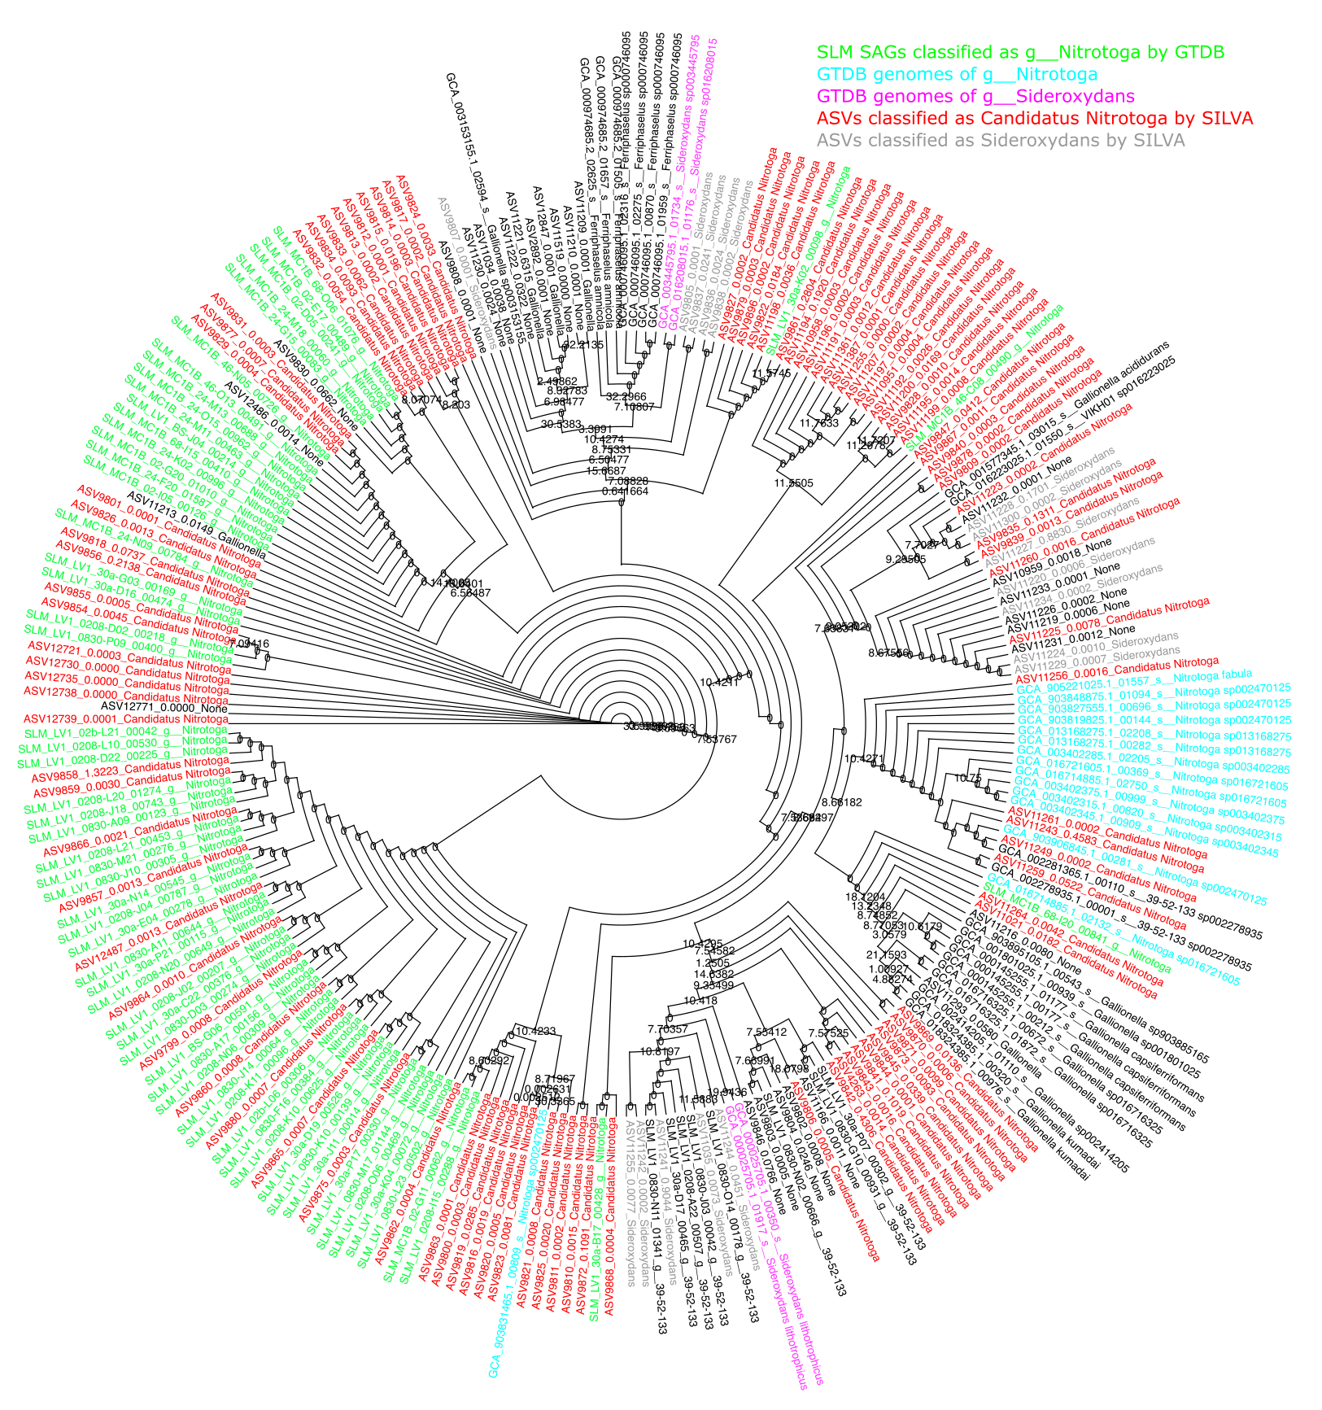
Supplementary Fig. 5. Unstable taxonomic assignments based on short 16S rRNA sequences. A maximum-likelihood tree was reconstructed. 16S rRNA sequences were derived from SAGs belonging to the GTDB g__Nitrotoga (taxa in green), the reference GTDB genomes belonging to the same genus (cyan), and the reference GTDB genomes belonging to g__Sideroxydans (magenta). The ASV sequences belonging to Nitrotoga and belonging to Sideroxydans were highlighted in red and grey, respectively. Taxa in black indicates sequences belonging to other genera in f__Gallionellaceae.

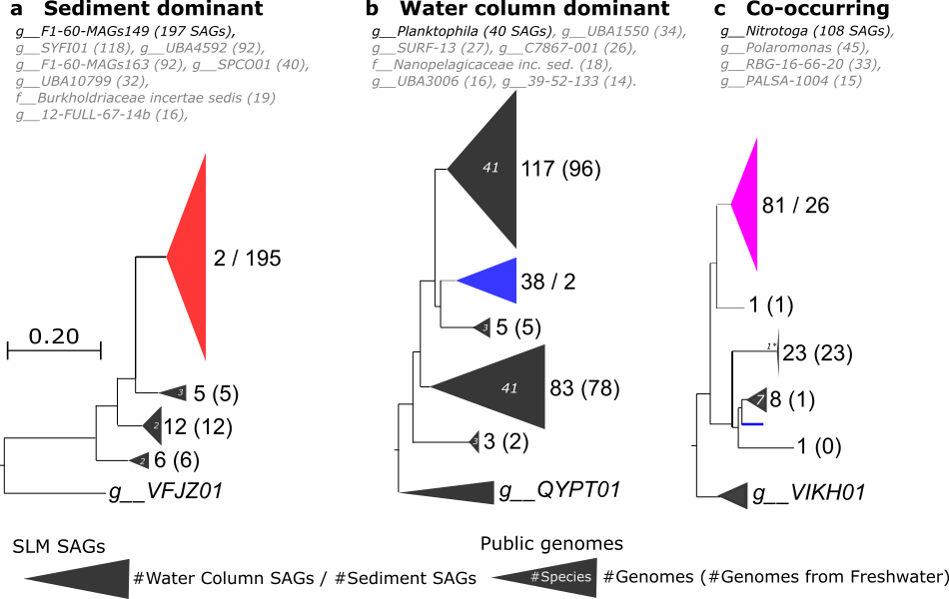
Supplementary Fig. 6. Habitat preferences of the 19 most abundant genera. The phylogenomic trees of SLM’s SAGs belonging to the most abundant genera and their closely related public genomes (see Materials & Methods for detailed tree reconstruction). The trees were rooted by outgroup genomes that were chosen from the closest neighboring genera. The terminal taxa were collapsed into triangles, where height and width correlate with the number of genomes and phylogenetic depth, respectively. (a) Eight genera for which SAGs are dominant in sediments (red). (b) Seven genera for which SAGs are dominant in in the water column (blue), and (c) Four genera of SAGs found in both habitats that cluster together (magenta). The trees were visualized for g__F1-60-MAGs149 (a), g__Planktophila (b), and g__Nitrotoga (c) in bold that represent the largest number of SAGs.

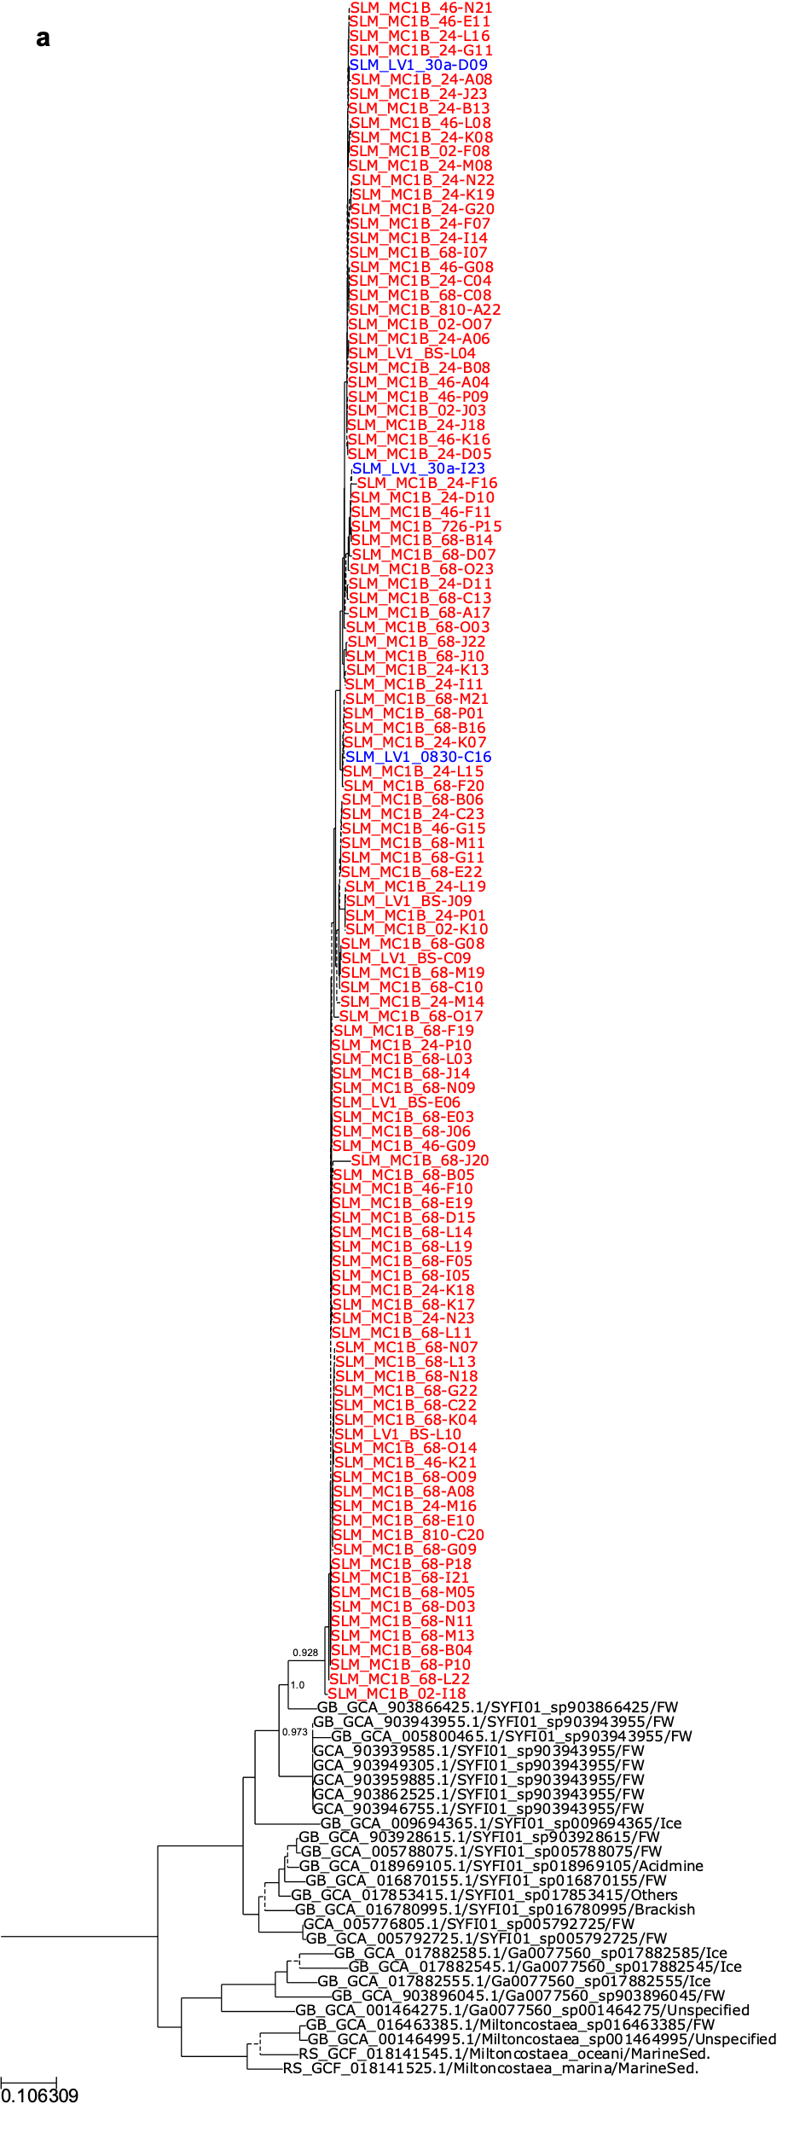
Supplementary Fig. 7. Phylogenomic trees of the 19 most abundant genera. Maximum-likelihood trees were reconstructed using the GTDB marker gene alignments of SAGs (lake water SAGs in blue and sedimentary SAGs in red) and closely related GTDB genomes (taxa in black). Or detailed tree reconstruction, see Materials and Methods. The Shimodaira-Hasegawa support values were given either above branches or beside nodes. Clades with <80% support values were indicates with dotted lines. (a) tree of the genus g__SYFI01. The remaining trees from (b) to (s) can be found below, where (b) g__F1-60-MAGs163; (c) g__F1-60-MAGs149; (d) g__UBA4592; (e) g__UBA10799; (f) g__Planktophila; (g) f__Nanopelagicaceae incertae sedis; (h) g__UBA3006; (i) g__RBG-16-66-20; (j) g__PALSA-1004; (k) g__Polaromonas; (l) f__Burkholderiaceae incertae sedis; (m) g__Nitrotoga; (n) g__39-52-133; (o) g__SURF-13; (p) g__12-FULL-67-14b; (q) g__SPCO01; (r) g__C7867-001; and (s) g__UBA1550.

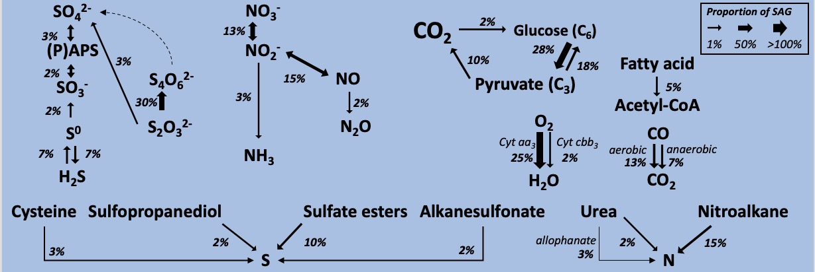
Supplementary Fig. 8. Metabolic potential inferred from SLM’s lake_small_SAGs. The proportion of 189 lake_small_SAGs involved in a metabolic reaction were calculated regarding incomplete genome recovery as described previously² and correlates with the thickness of arrow bodies.

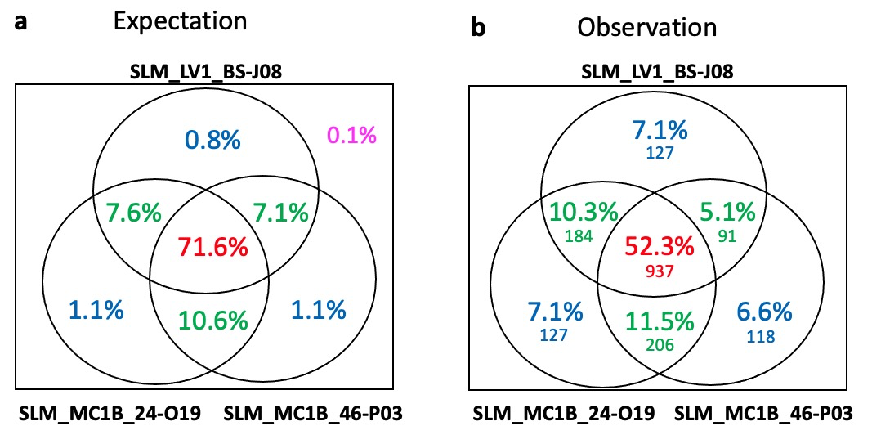
Supplementary Fig. 9. Genetic heterogeneity between SAGs of the same species. The proportion of KEGG orthologs shared by highly similar three SAGs (SLM_MC1B_46-P03, SLM_MC1B_24-O19, and SLM_LV1_BS-J08) belonging to the same species were calculated. (a) The expected proportion of KEGG orthologs shared by the three incomplete genomes under a null hypothesis that these genomes are completely same in gene content when they are complete genomes. (b) The observed proportion of KEGG orthologs shared by the three incomplete genomes.

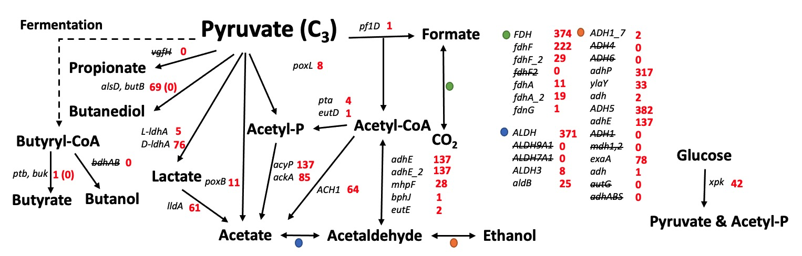
Supplementary Fig. 10. Fermentation potential exhibited by SLM’s SAGs. The word and number beside an arrow indicate a gene name and the number of SAGs possessing it. The alsD, butB and ptb, buk enzyme pairs conducted cascade reaction but it does not co-occur in any SAG.
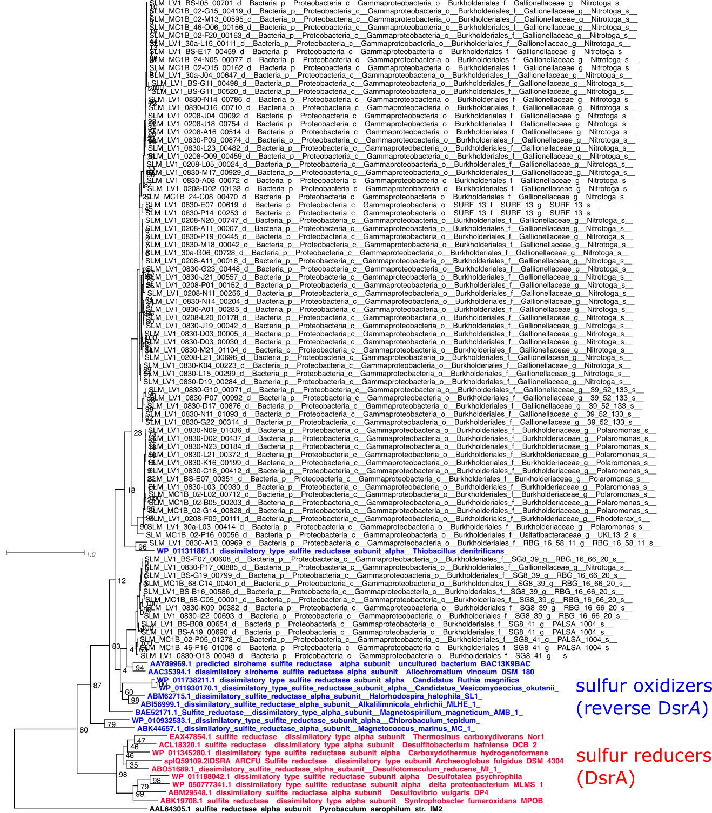
Supplementary Fig. 11. Phylogenetic tree of the DsrA sequences. In order to determine whether DsrA proteins from SAGs are responsible for sulfur oxidation or sulfite reduction, a maximum-likelihood tree was reconstructed using RAxML with sequences of SAGs (taxa in black) and experimentally proved oxidizers (taxa in blue) and reducers (taxa in red)³. Bootstrap confidence values were given at nodes of the tree.
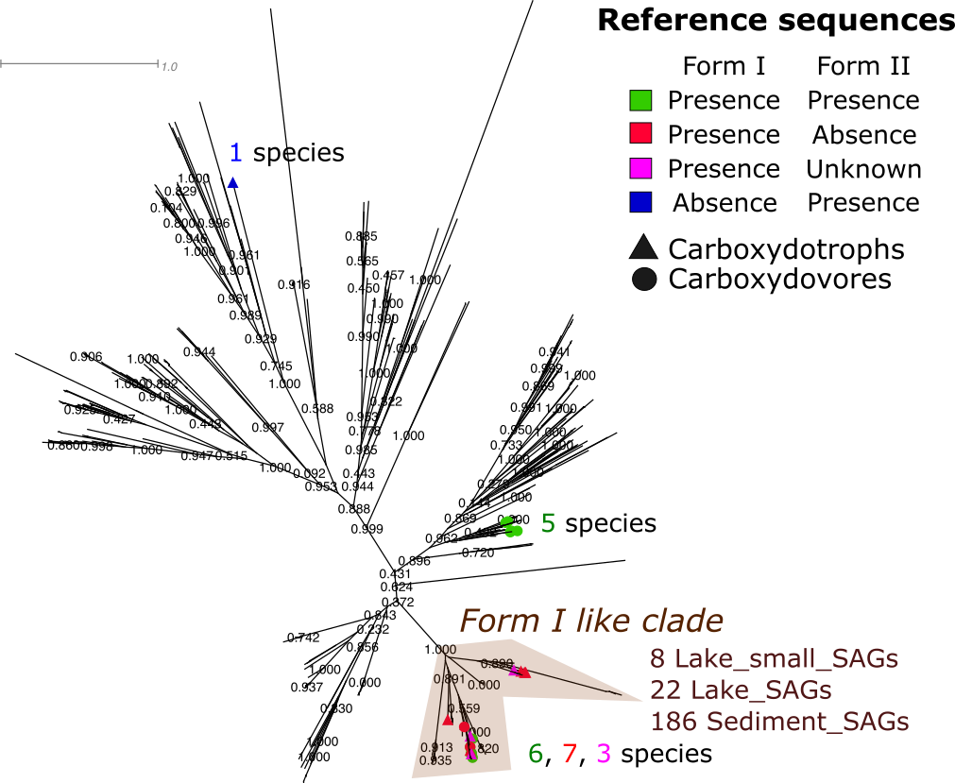
Supplementary Fig. 12. Phylogenetic tree of CoxL. In order to separate the Form I CoxL sequences from the Form II CoxL, a maximum-likelihood trees were reconstructed using FastTree v2.1.11⁴ with sequences of SAGs and a previous study⁵. Bootstrap confidence values were given at nodes of the tree. Experimentally verified carboxydotrohps and carboxydovores were indicated by triangles and circles at the taxon tips, respectively. The reference CoxL sequences were classified into those originating from genomes possessing both Forms I and II (taxa in green), genomes possessing only Form I (taxa in red), genomes possessing only Form II (taxa in blue) and genomes possessing Form I with uncertain existence of Form II (taxa in magenta). From the ancestral node pointing to the most recent common ancestor that encompasses all of the reference form I CoxL sequences, a derived monophyletic group was considered ‘Form I like clade’. A total of 216 SAGs were included in this clade, where form II reference CoxL sequences were not found.

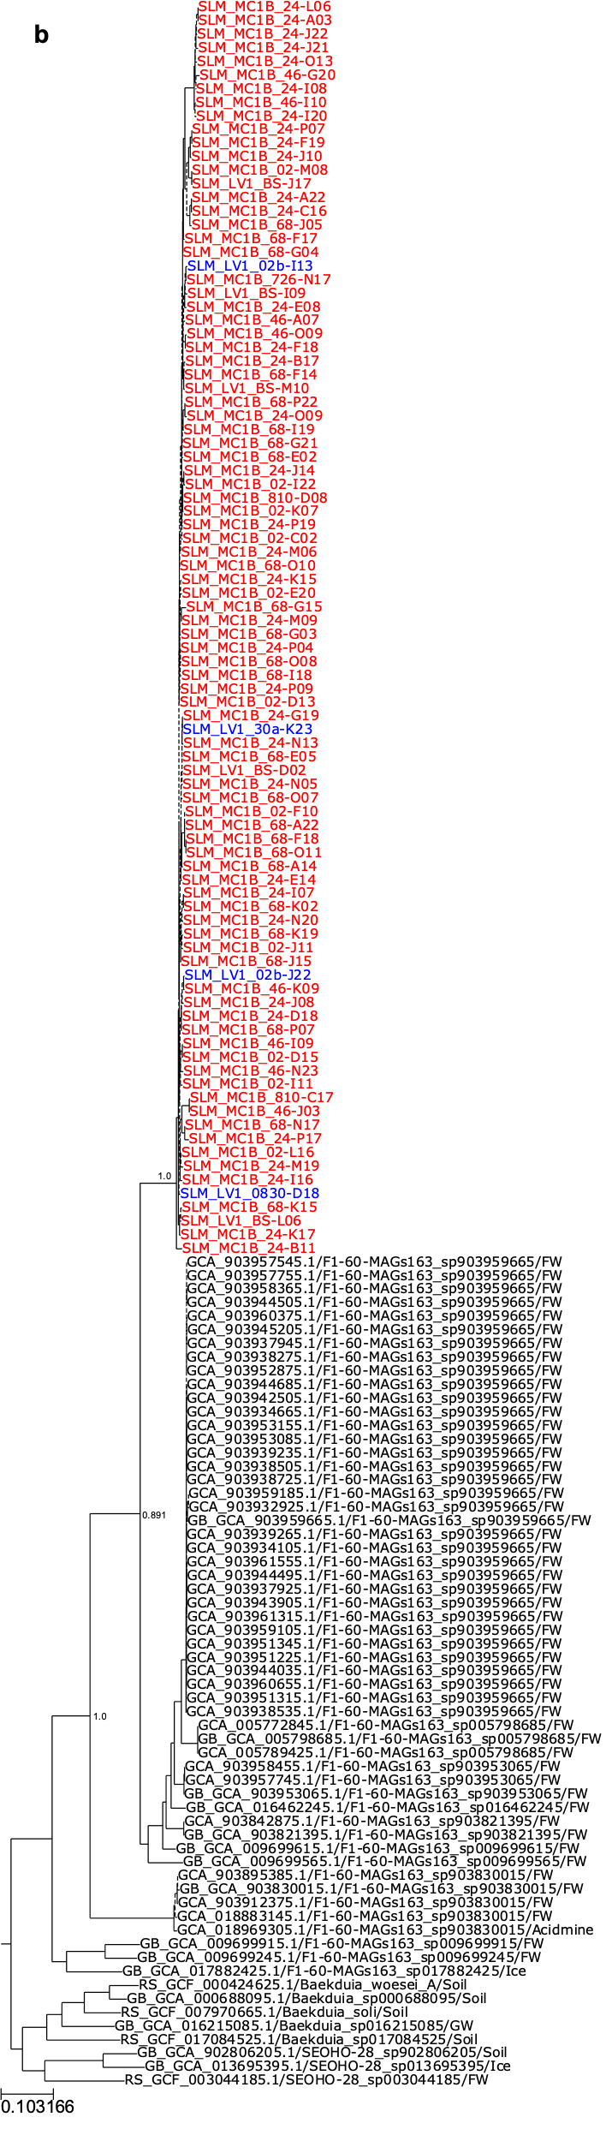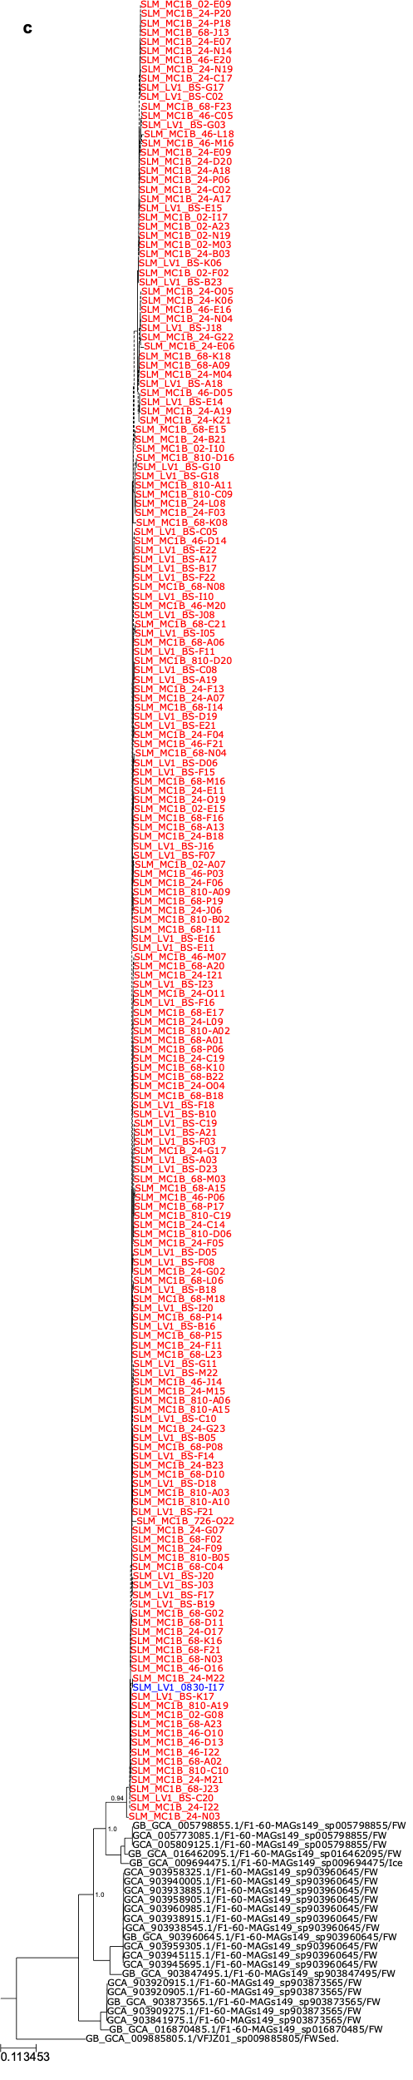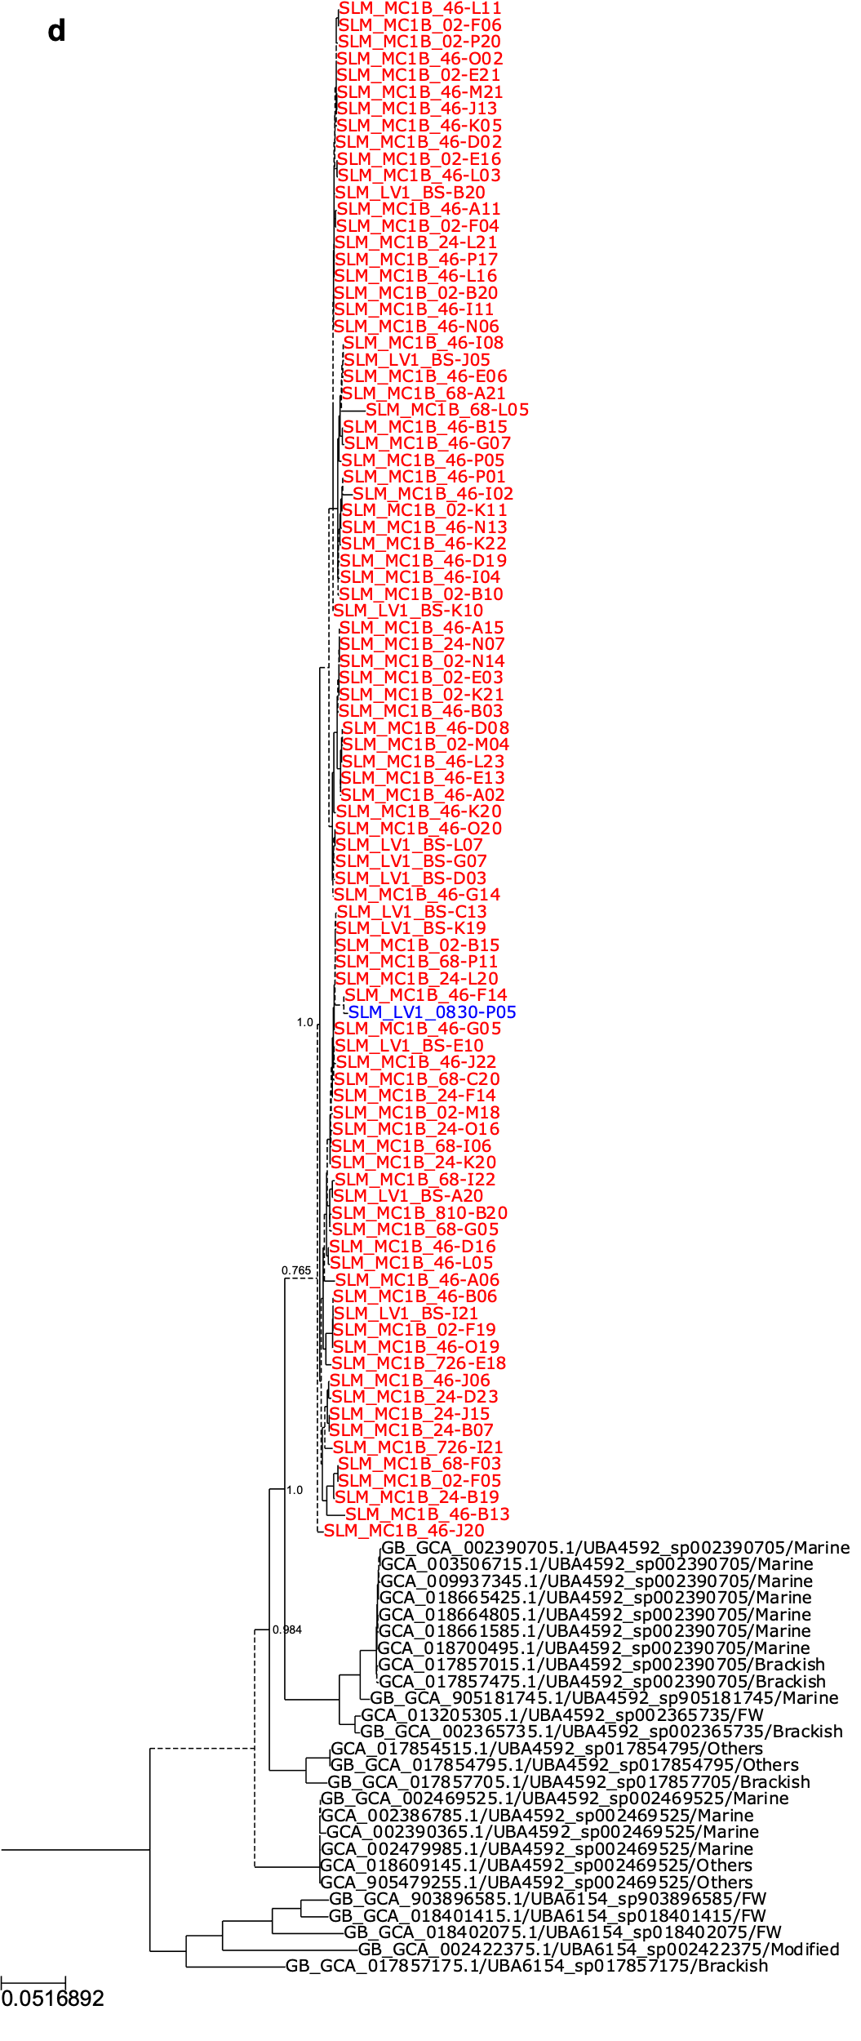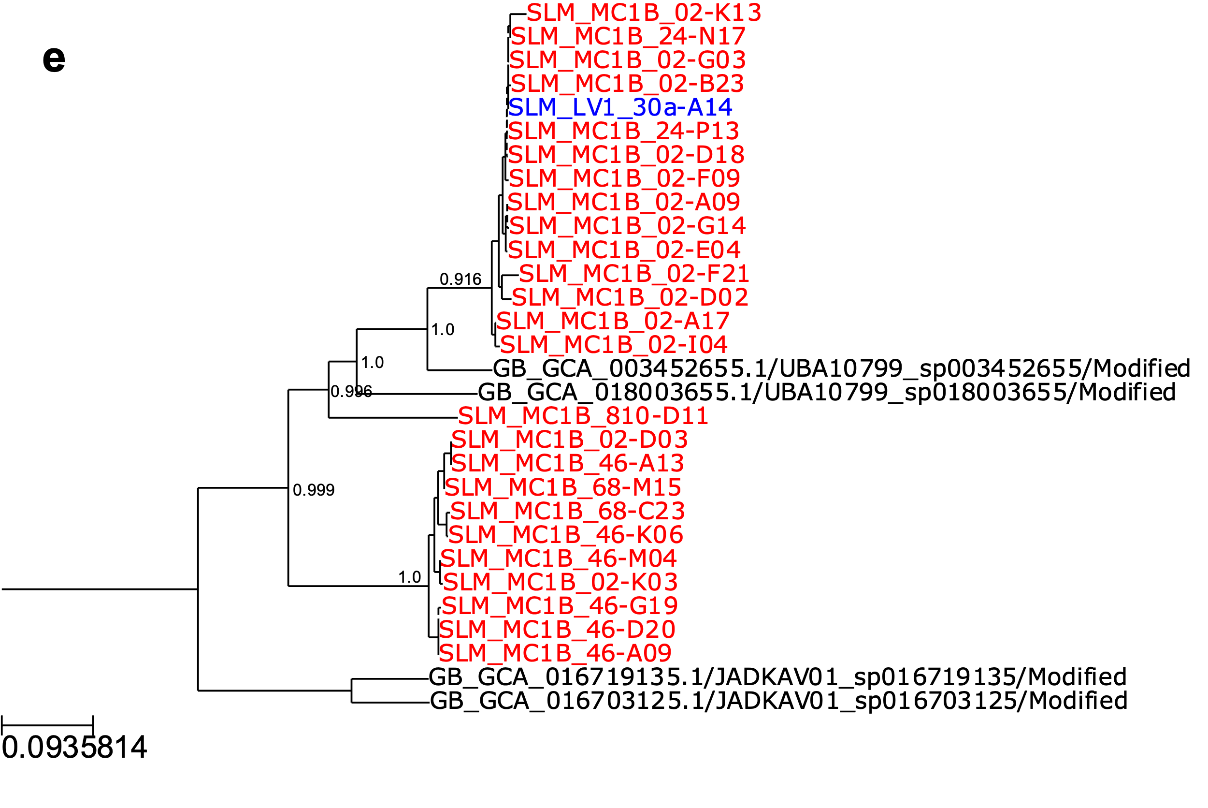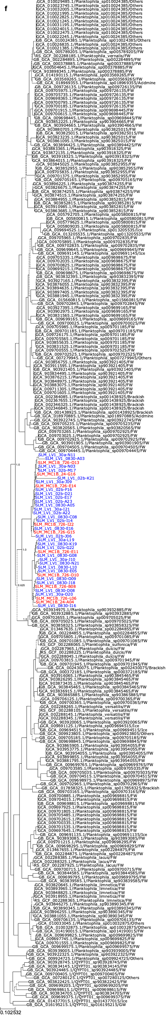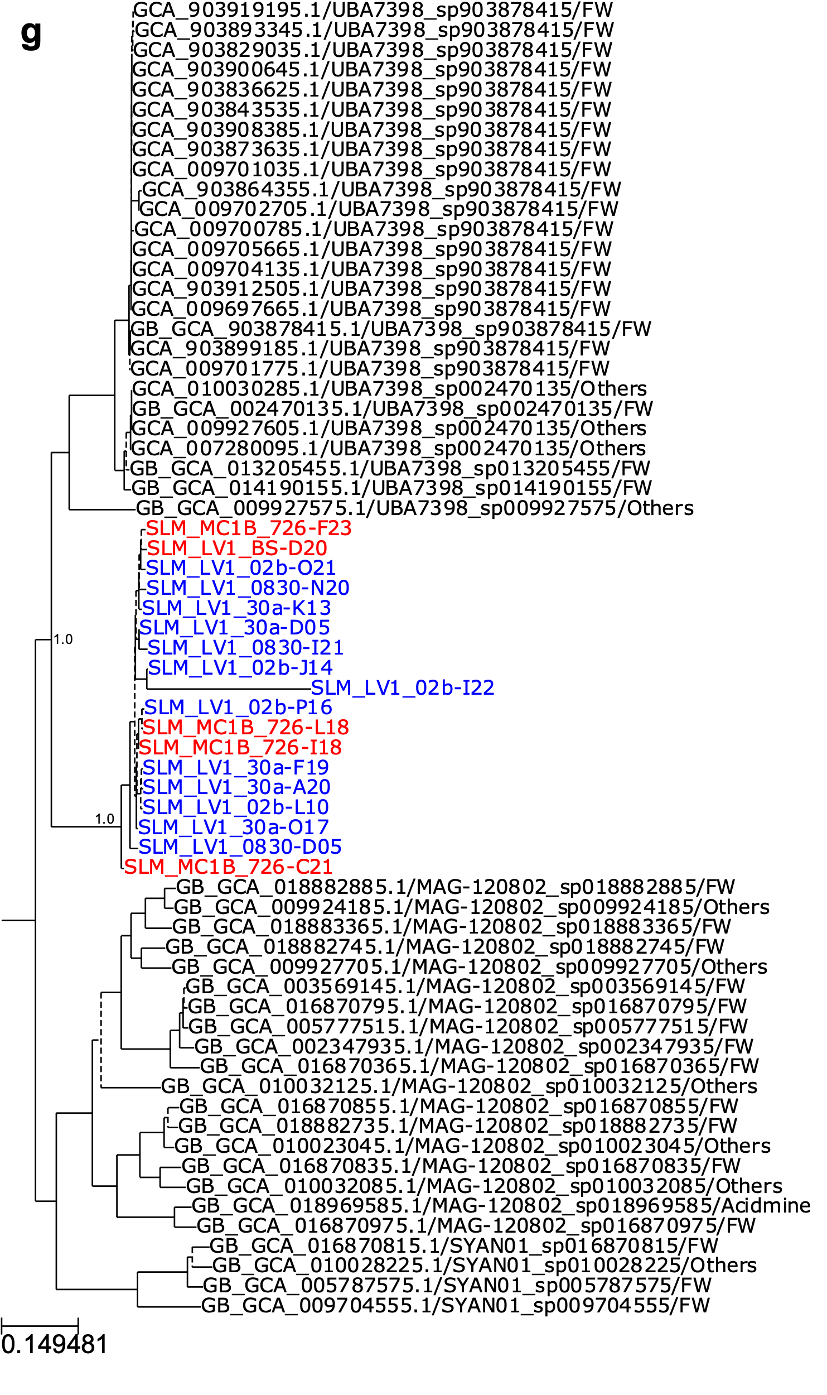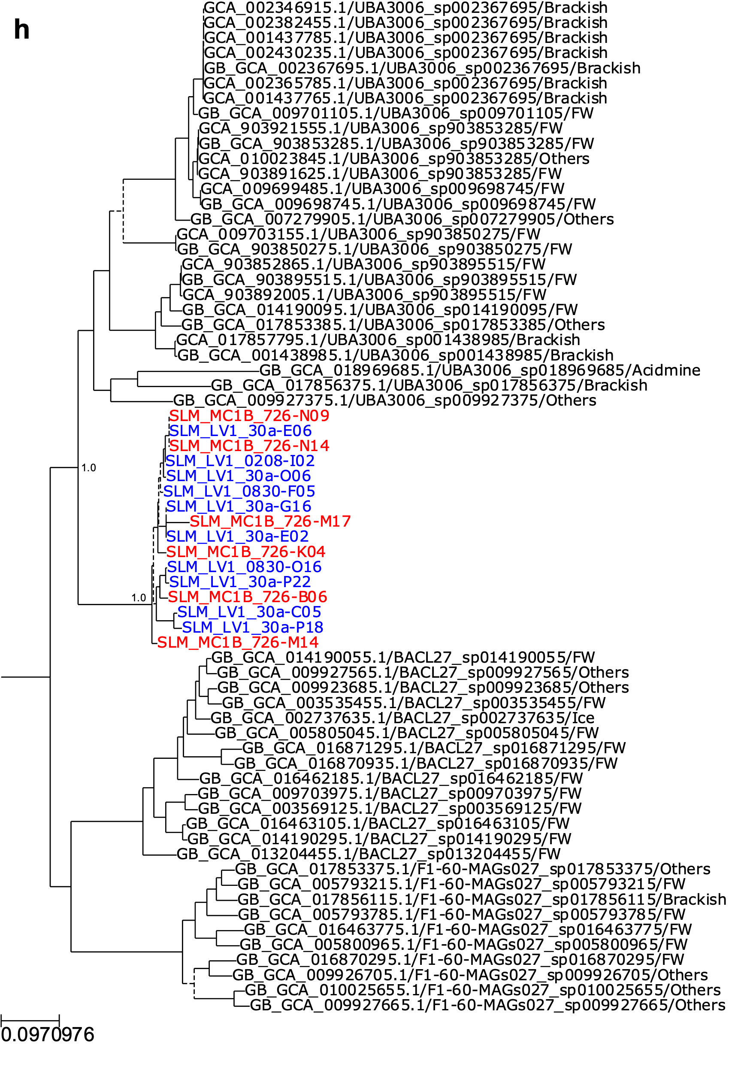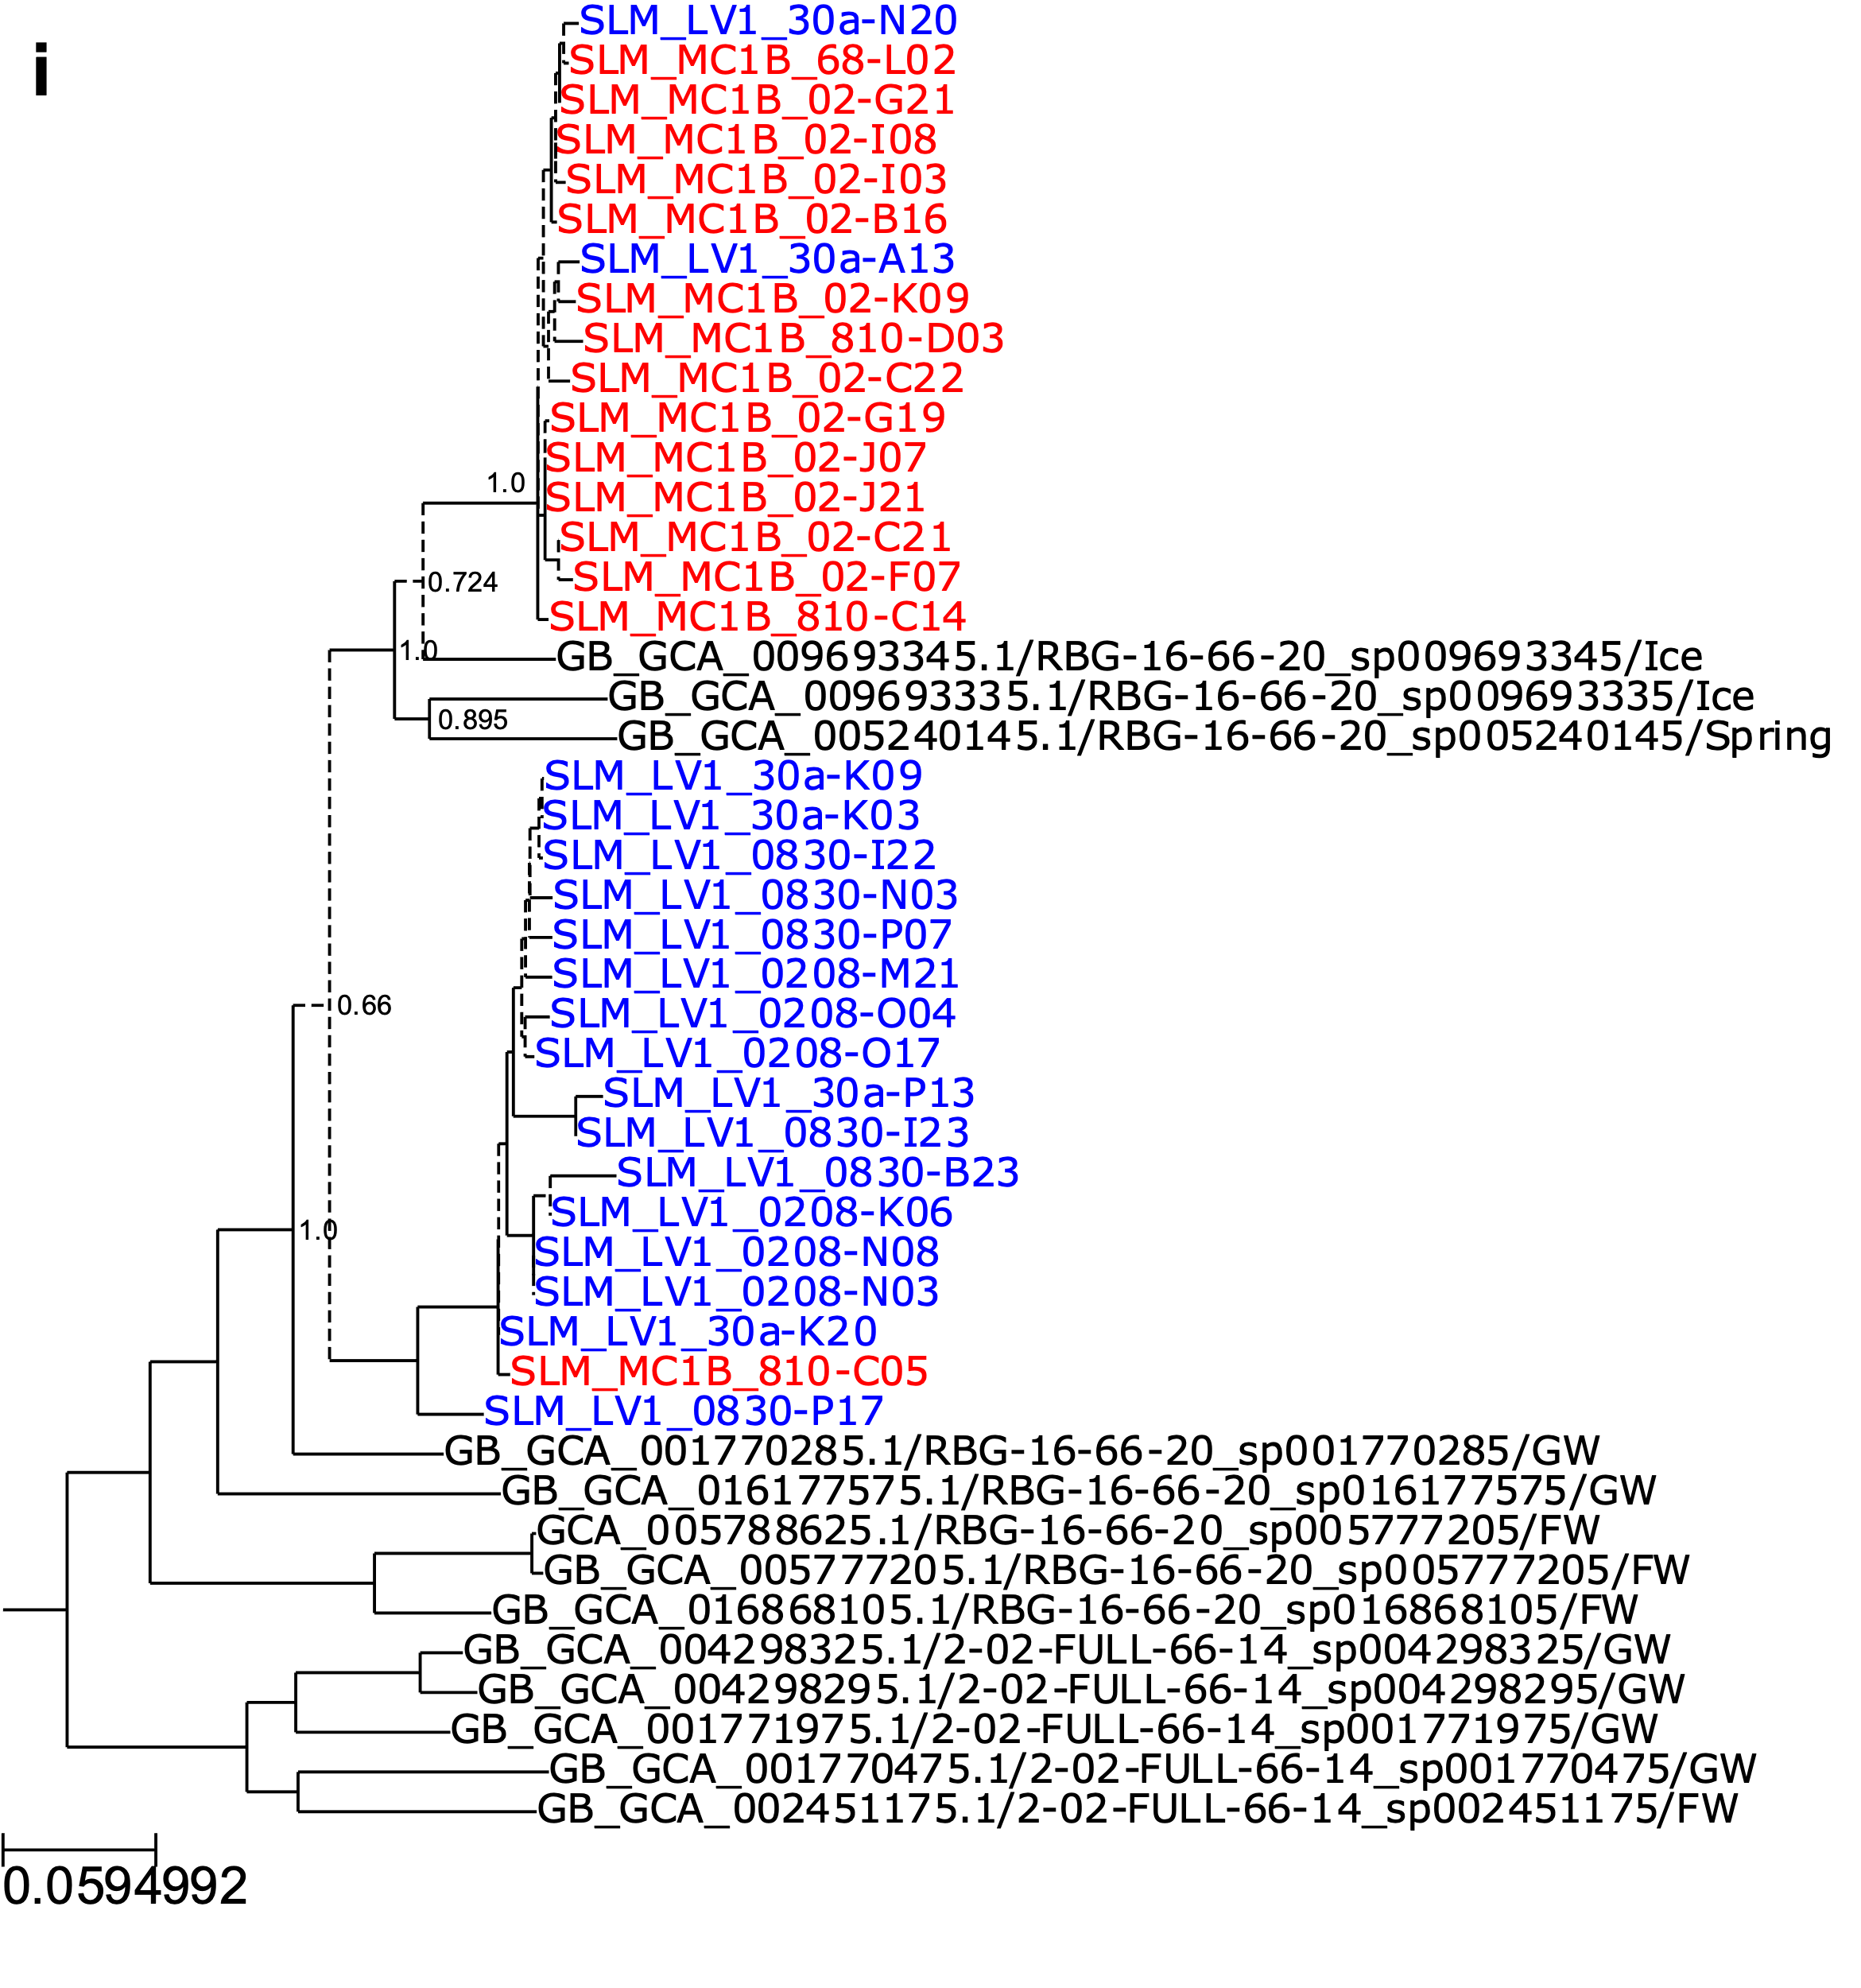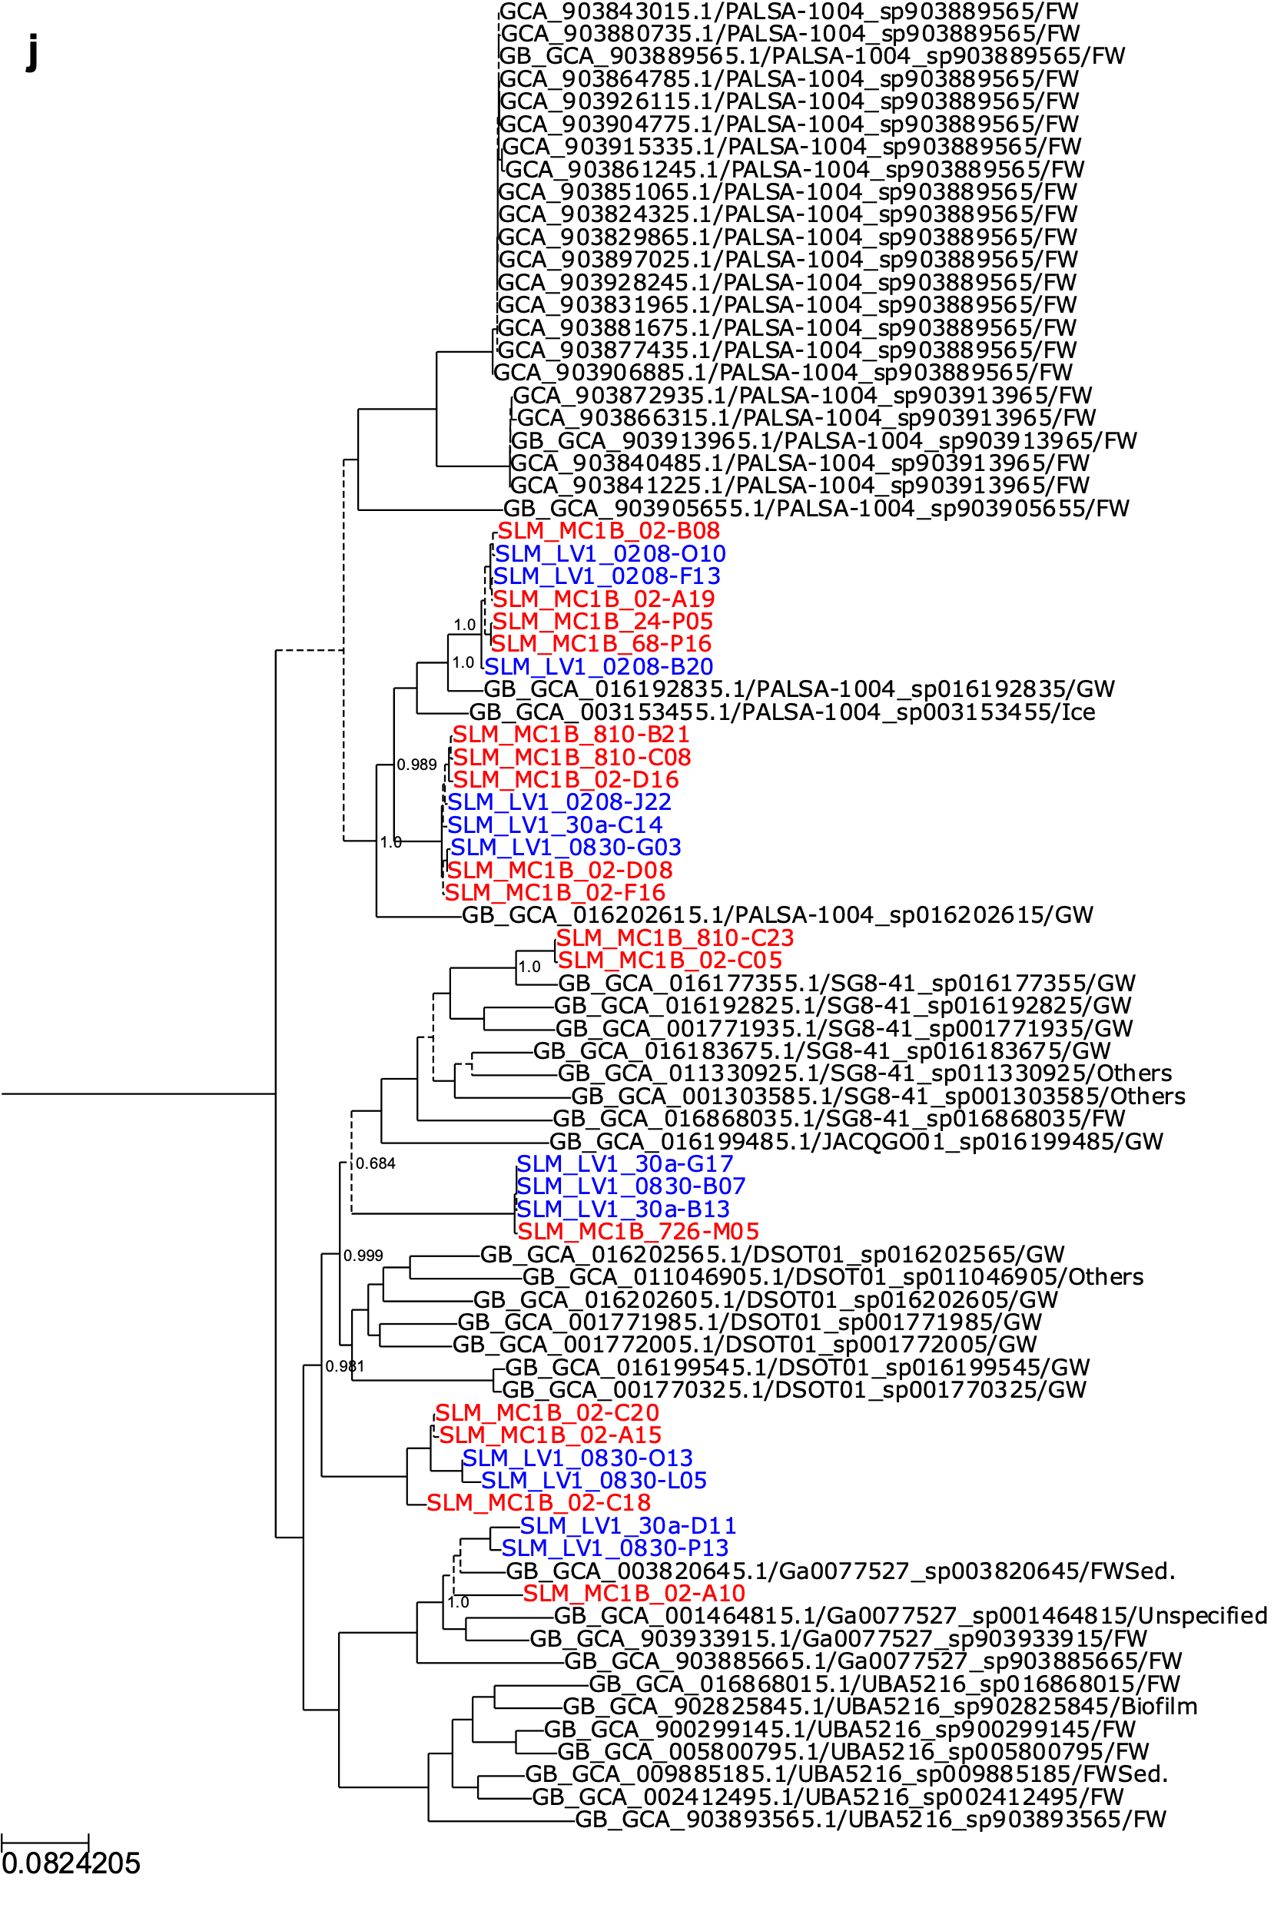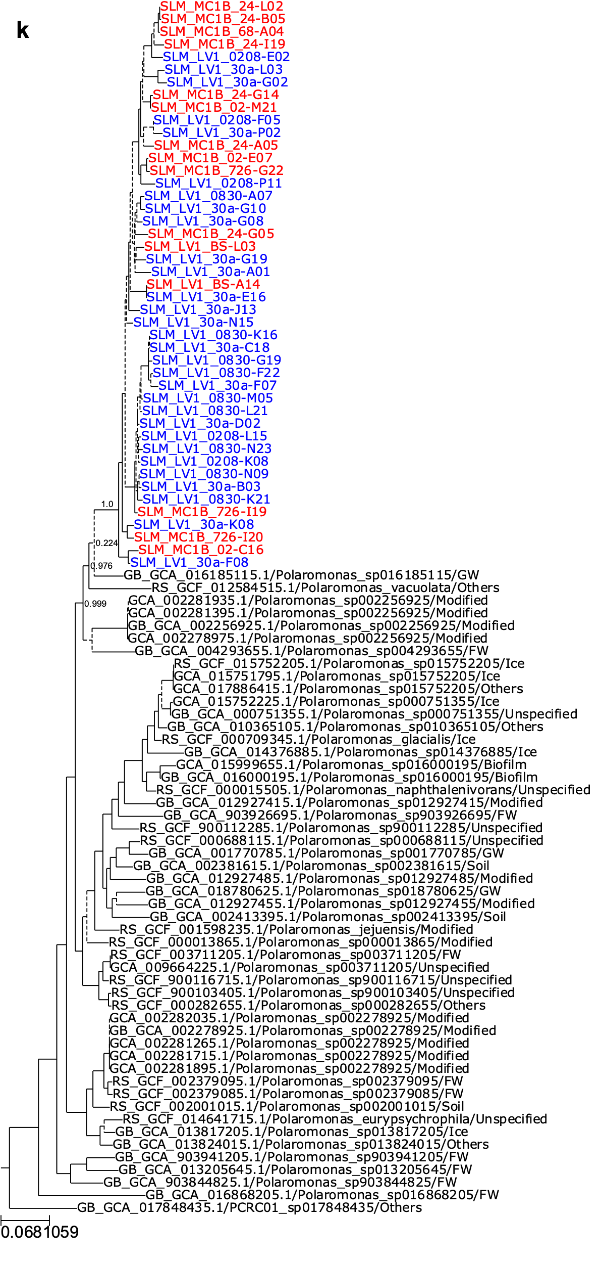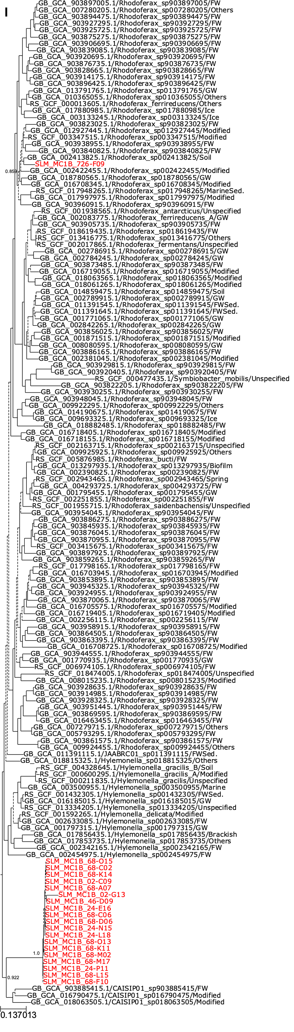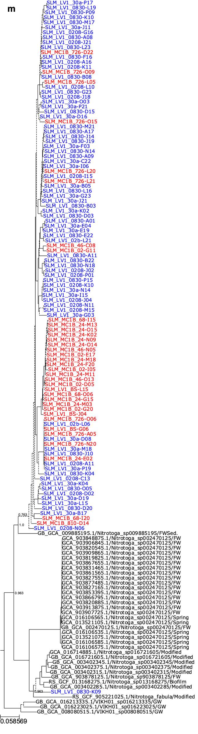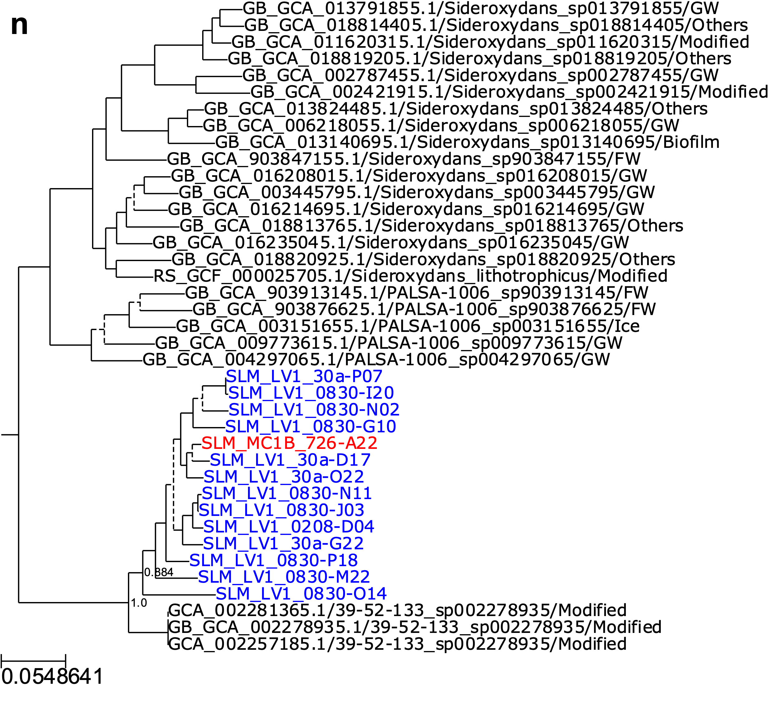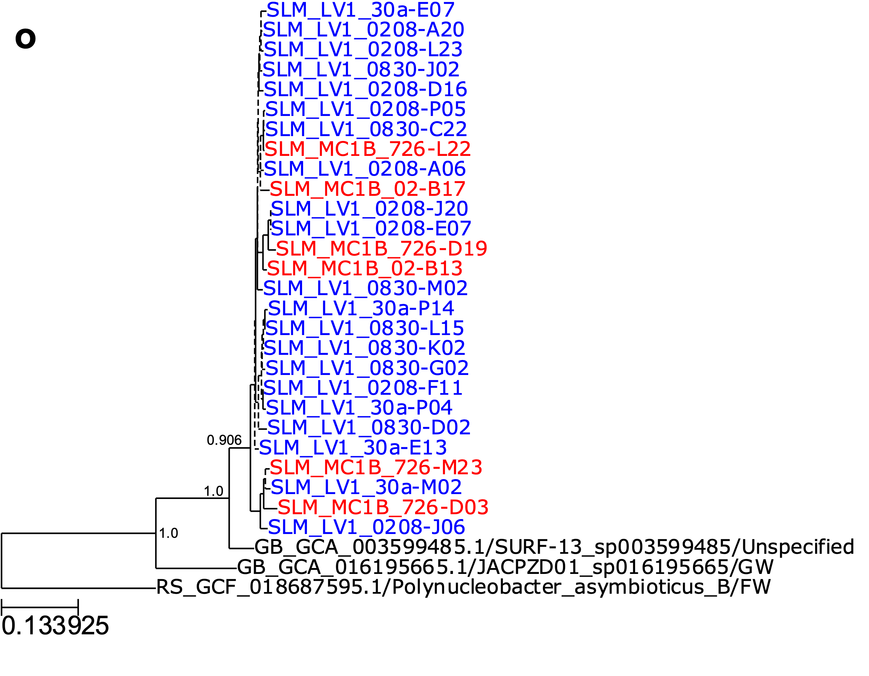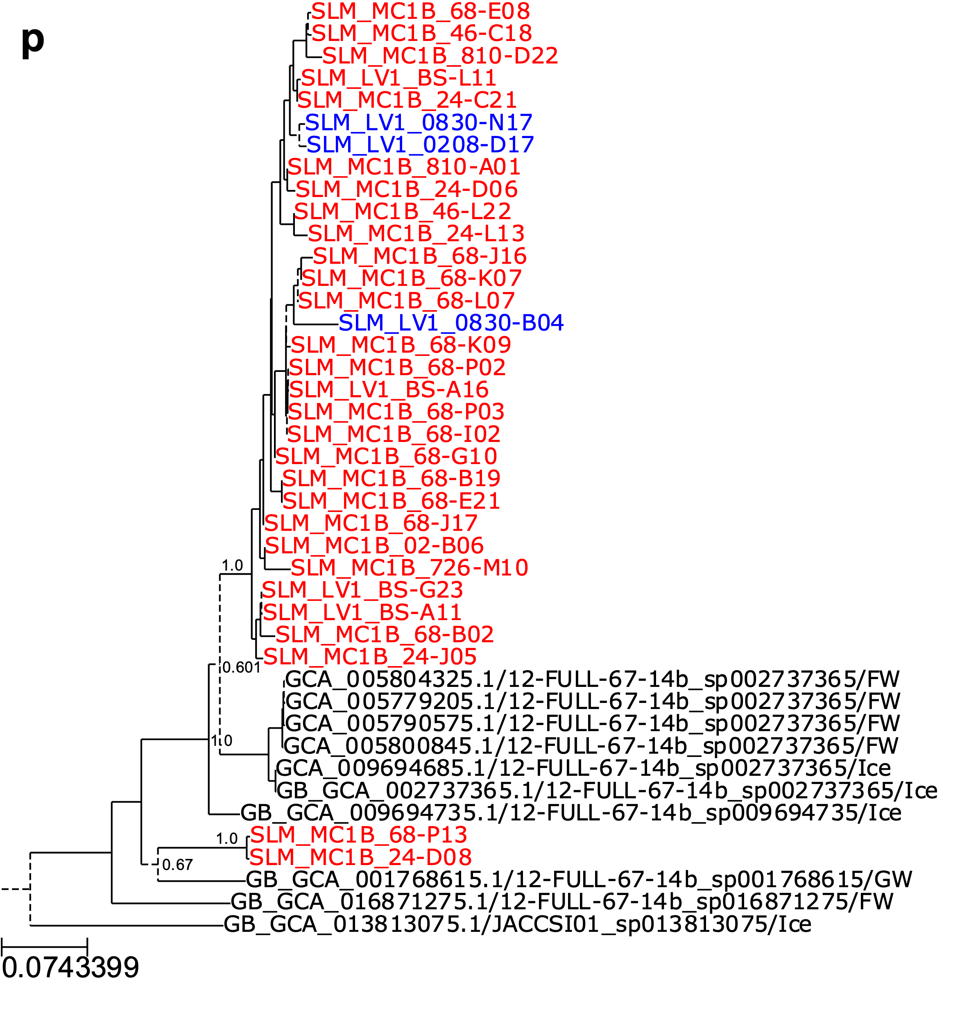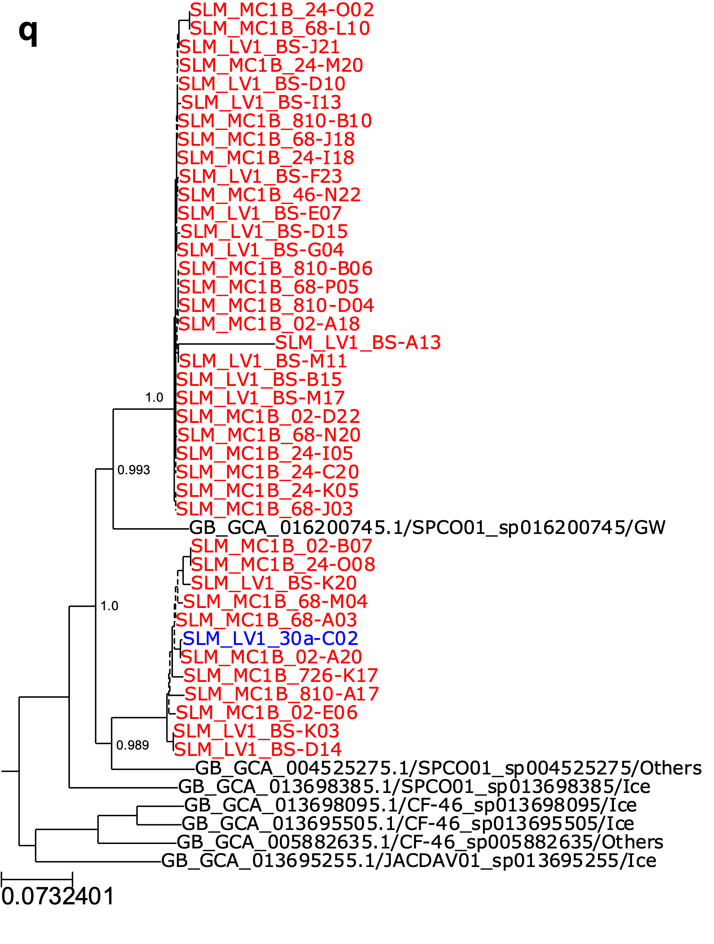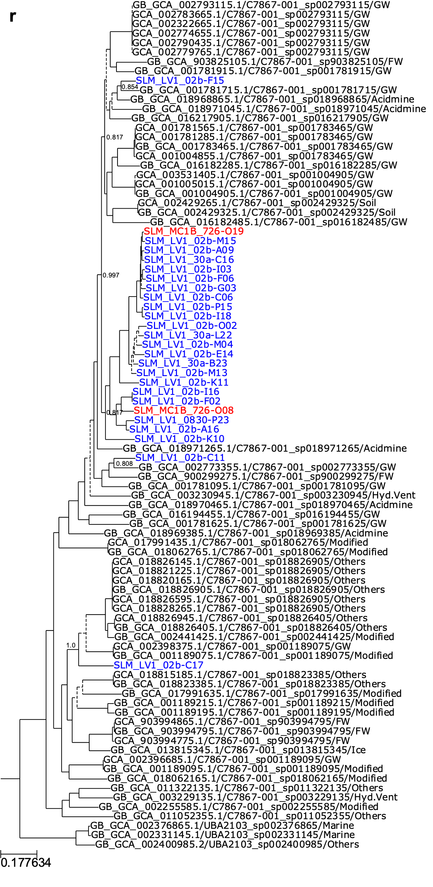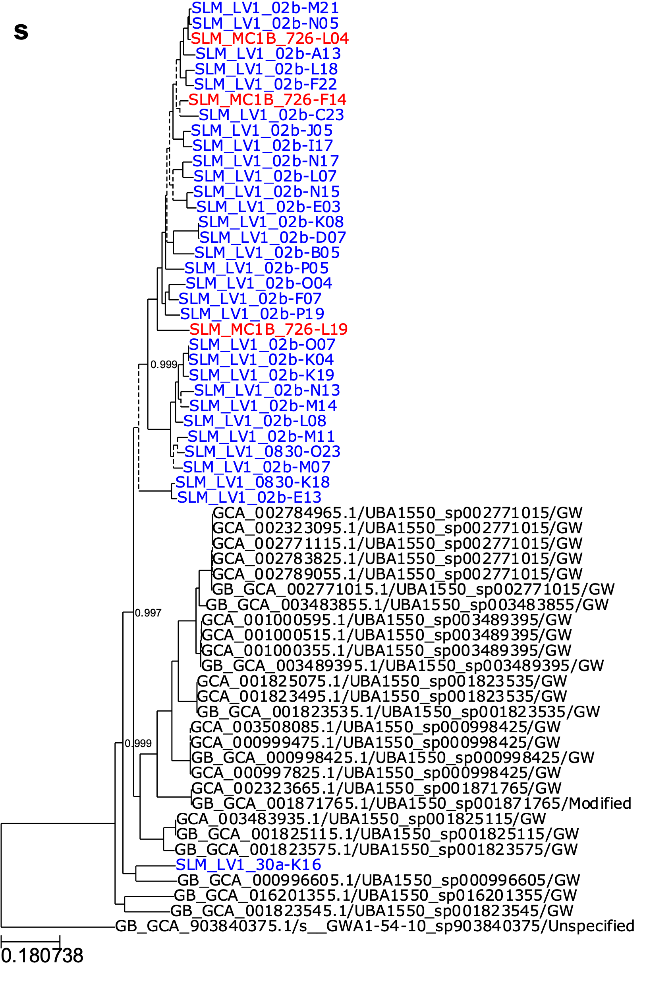
References
1 Davis, C. L. et al. Biogeochemical and historical drivers of microbial community composition and structure in sediments from Mercer Subglacial Lake, West Antarctica. ISME communications 3, 8 (2023).
2 Acker, M. et al. Phosphonate production by marine microbes: exploring new sources and potential function. Proceedings of the National Academy of Sciences 119, e2113386119 (2022).
3 Tully, B. J., Wheat, C. G., Glazer, B. T. & Huber, J. A. A dynamic microbial community with high functional redundancy inhabits the cold, oxic subseafloor aquifer. The ISME journal 12, 1-16 (2018).
4 Price, M. N., Dehal, P. S. & Arkin, A. P. FastTree: computing large minimum evolution trees with profiles instead of a distance matrix. Molecular biology and evolution 26, 1641-1650 (2009).
5 King, G. M. & Weber, C. F. Distribution, diversity and ecology of aerobic CO-oxidizing bacteria. Nature Reviews Microbiology 5, 107-118 (2007).

