Supplementary Data

Synthesis, Characterization and antibacterial study of Ag-loaded TiO₂ Electrospun nanofibers: Mechanistic insights of nanofibers interacting with bacteria
Bisma Khanamª, Shahzad Anwar^{b *}, Muhammad Zakria^{b}, Taj Muhammad Khan^{b}, A. Rahman^{b}, Ahmad Adnanª, Nida Ali Shan^{c}, Rafaqat Ali Khan^{b}, Muhammad Raffi^{b *}
ª Department of Chemistry, Government College University (GCU), Lahore, Pakistan
^{b} National Institute of Lasers and Optronics College, Pakistan Institute of Engineering and Applied Sciences, Islamabad 45650, Pakistan
^{c} Center for Omic Sciences, Islamia College University Peshawar KP Pakistan 25120

*Corresponding Authors
Shahzad Anwar
(Shahzadanwar112@yahoo.com)
Muhammad Raffi
(doctormat@gmail.com)

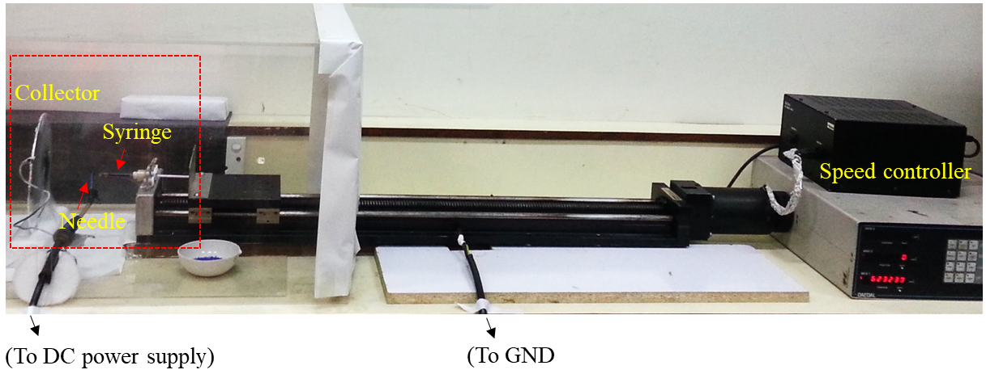
Fig. S1. Photograph of indigenously developed electrospinning setup used in synthesis process
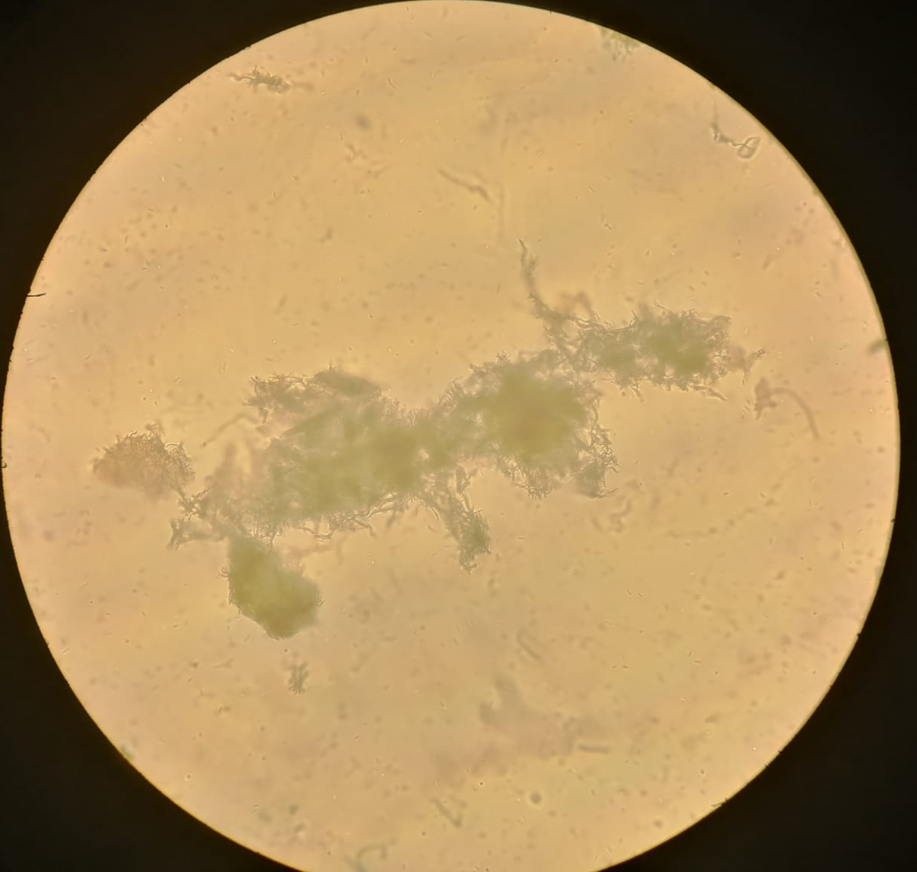
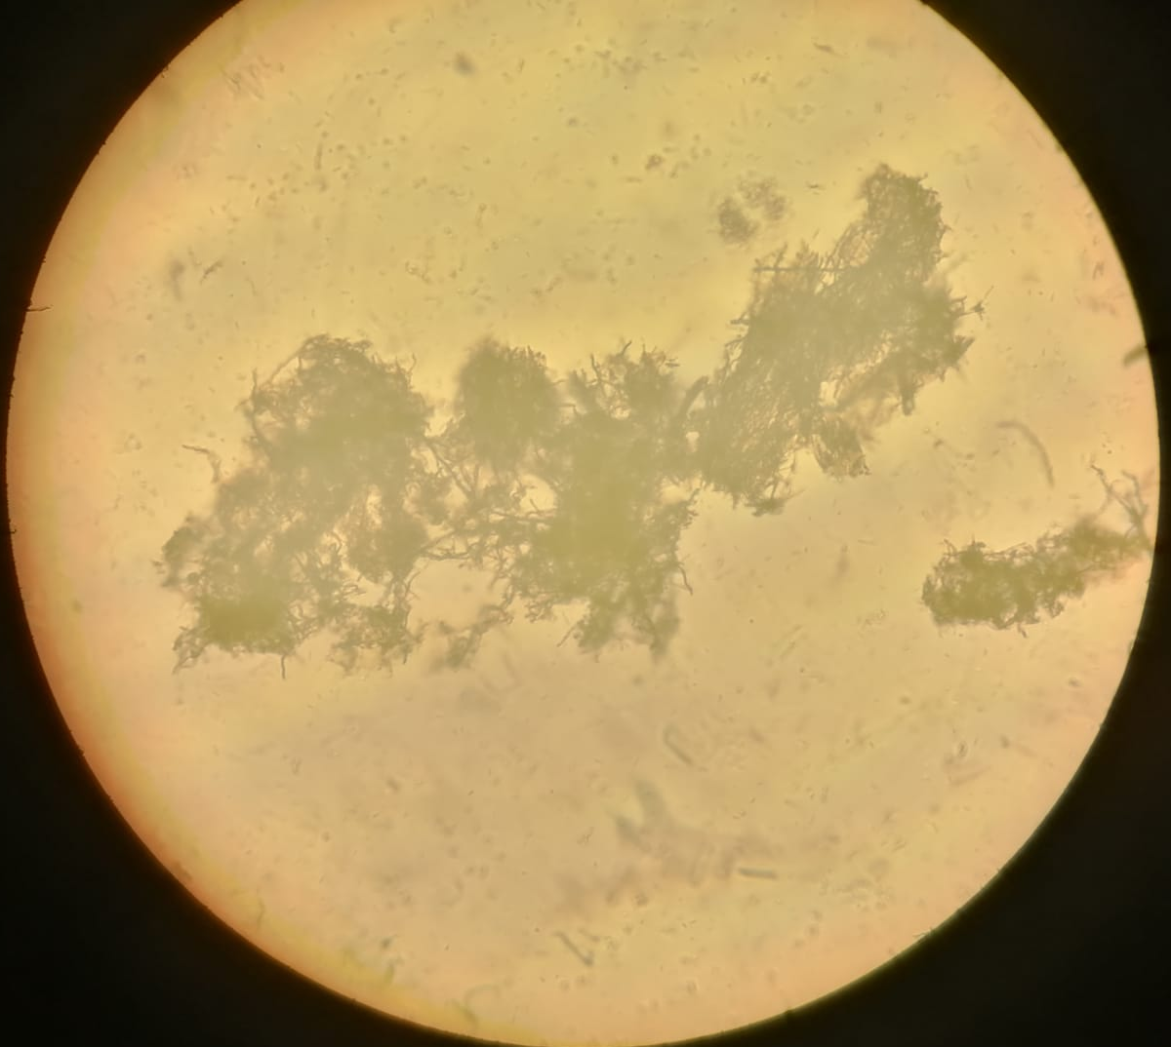
Figure. S2. Brightfield images of bacterial interaction with nanofibers with two different focus point
Table S1. Summary of mean diameter, Ag loading and antibacterial activity (log₁₀ CFU and ZOI) of nanofibers
Samples | Mean dia.  (after calcination) | Composition of Ag in TiO₂ matrix (Wt. %) EDX Analysis | Antibacterial efficacy  CFU ZOI (mm)
A | 83.06 nm | 0 | 4.35 | 3.17 ± 0.40
B | 70.33 nm | 1.5 | 3.87 | 14.31 ± 0.23
C | 31.87 nm | 3.7 | 3.69 | 15.60 ± 0.34
D | 28.90 nm | 5.1 | 3.60 | 16.09 ± 0.23
E | 25.80 nm | 7.2 | 3.00 | - 0.19

