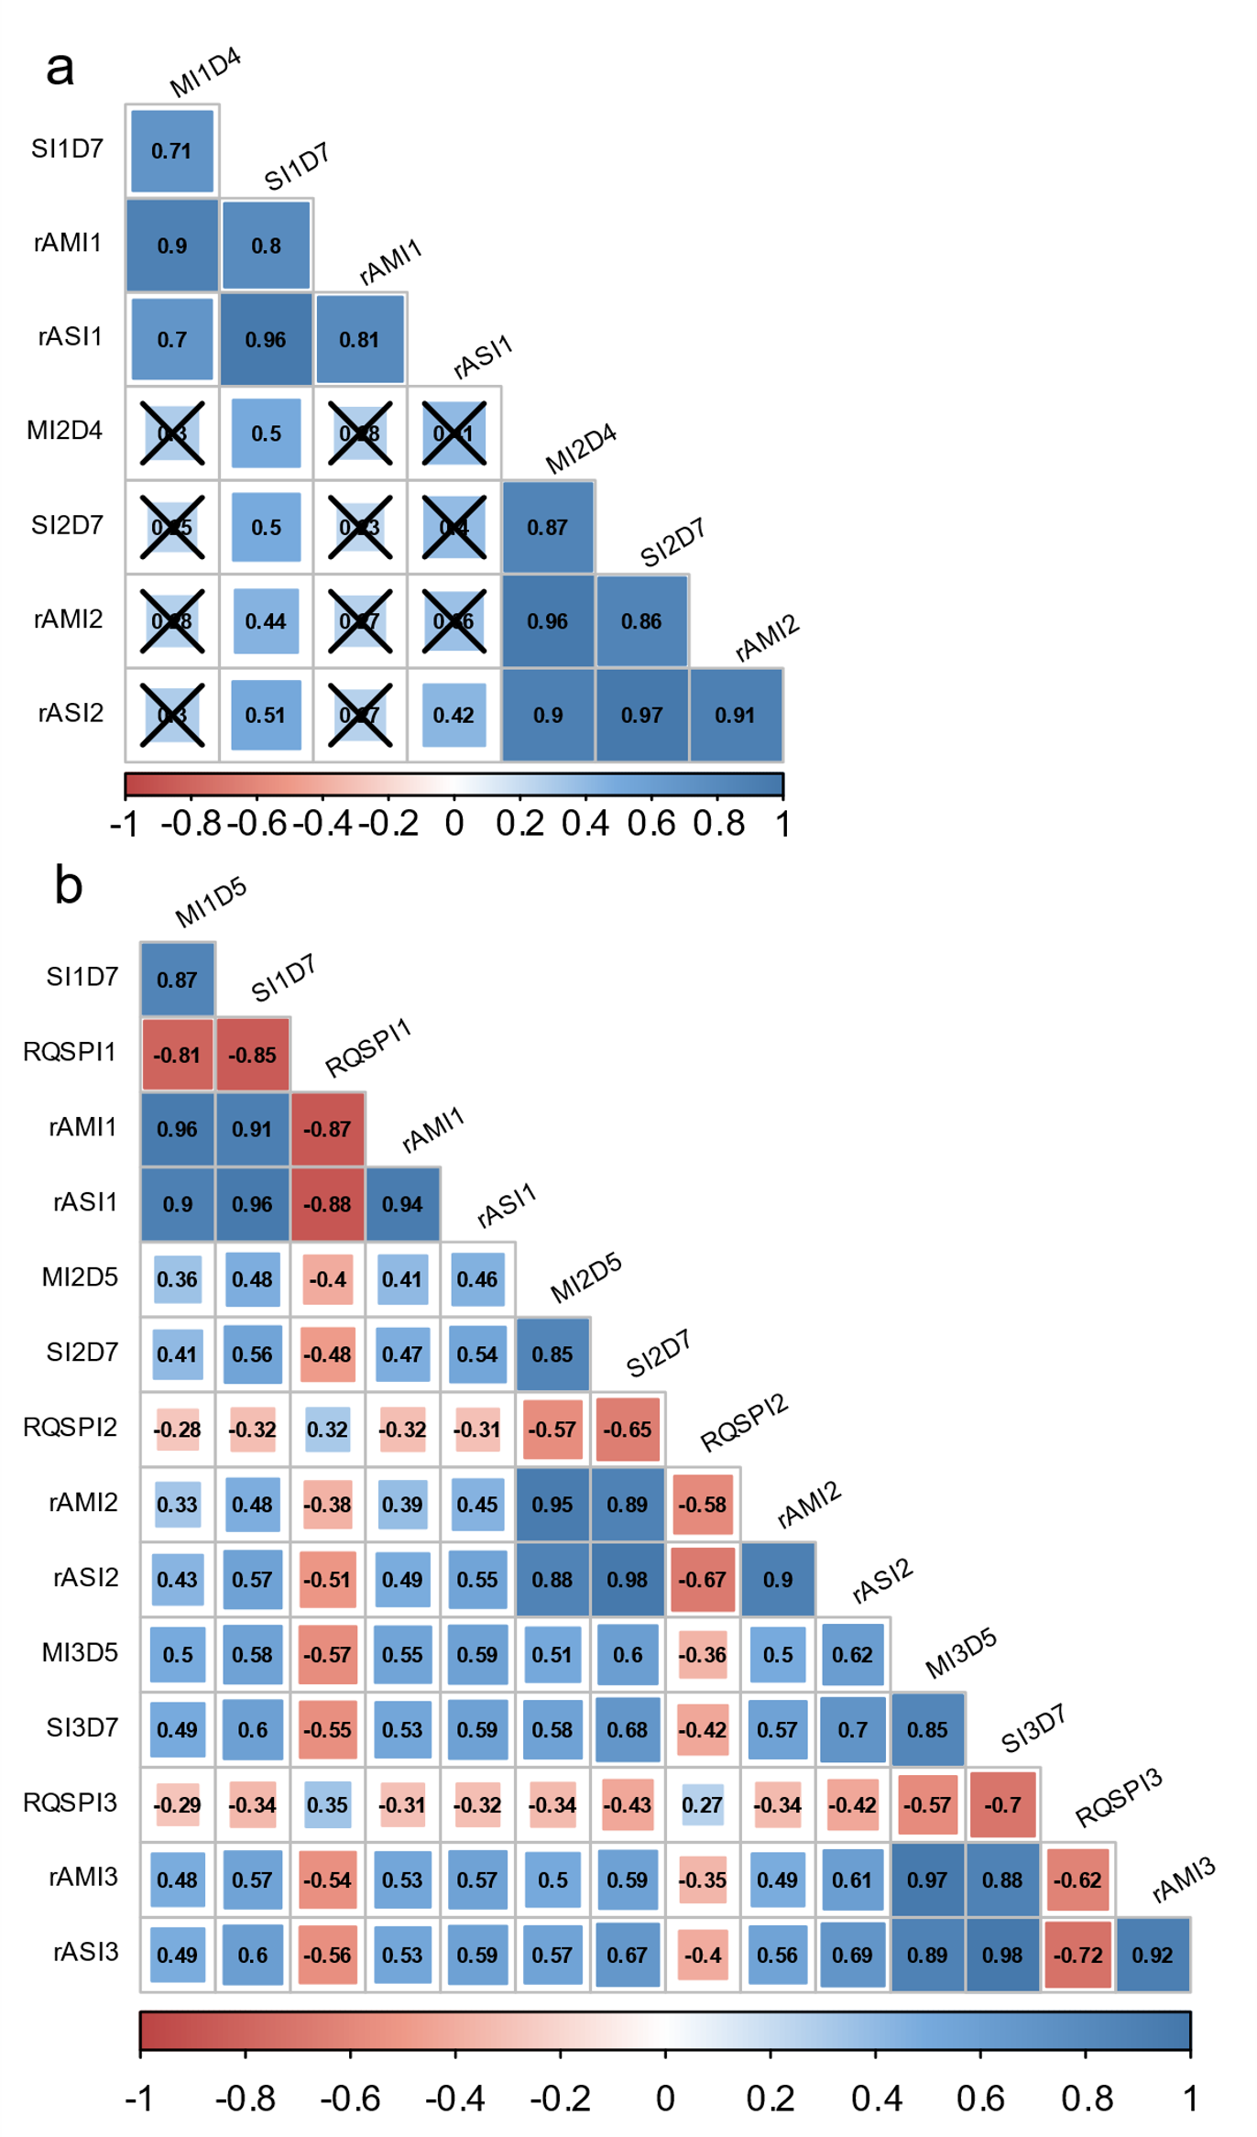
Figure S2. Some pairwise correlation (Spearman’s rank correlation) between phenotypic data recorded on the breeding populations 50041-‘Chardonnay’ x ‘Tskhvedianis tetra’ (plot a) and 50042-‘Shavtsitska’ x ‘Glera’ (plot b) during the E. necator infections on leaf discs. The acronyms identify the phenotypic data series: the first letter specifies the infection features (M-mycelium growth, S-sporulation intensity, RQSP-conidia counts by Malassez counting chamber square-root transformed, rAM-rAUDPC for mycelium growth and rAS-rAUDPC for sporulation intensity), the second letter-number designates the experiments replicate (inoculation-replicate 1-2-3) and the additional letter-number indicates the dpi of observation (dpi 5-7). Spearman’s rank correlation coefficients crossed represent correlation with p-value > 0.001.

