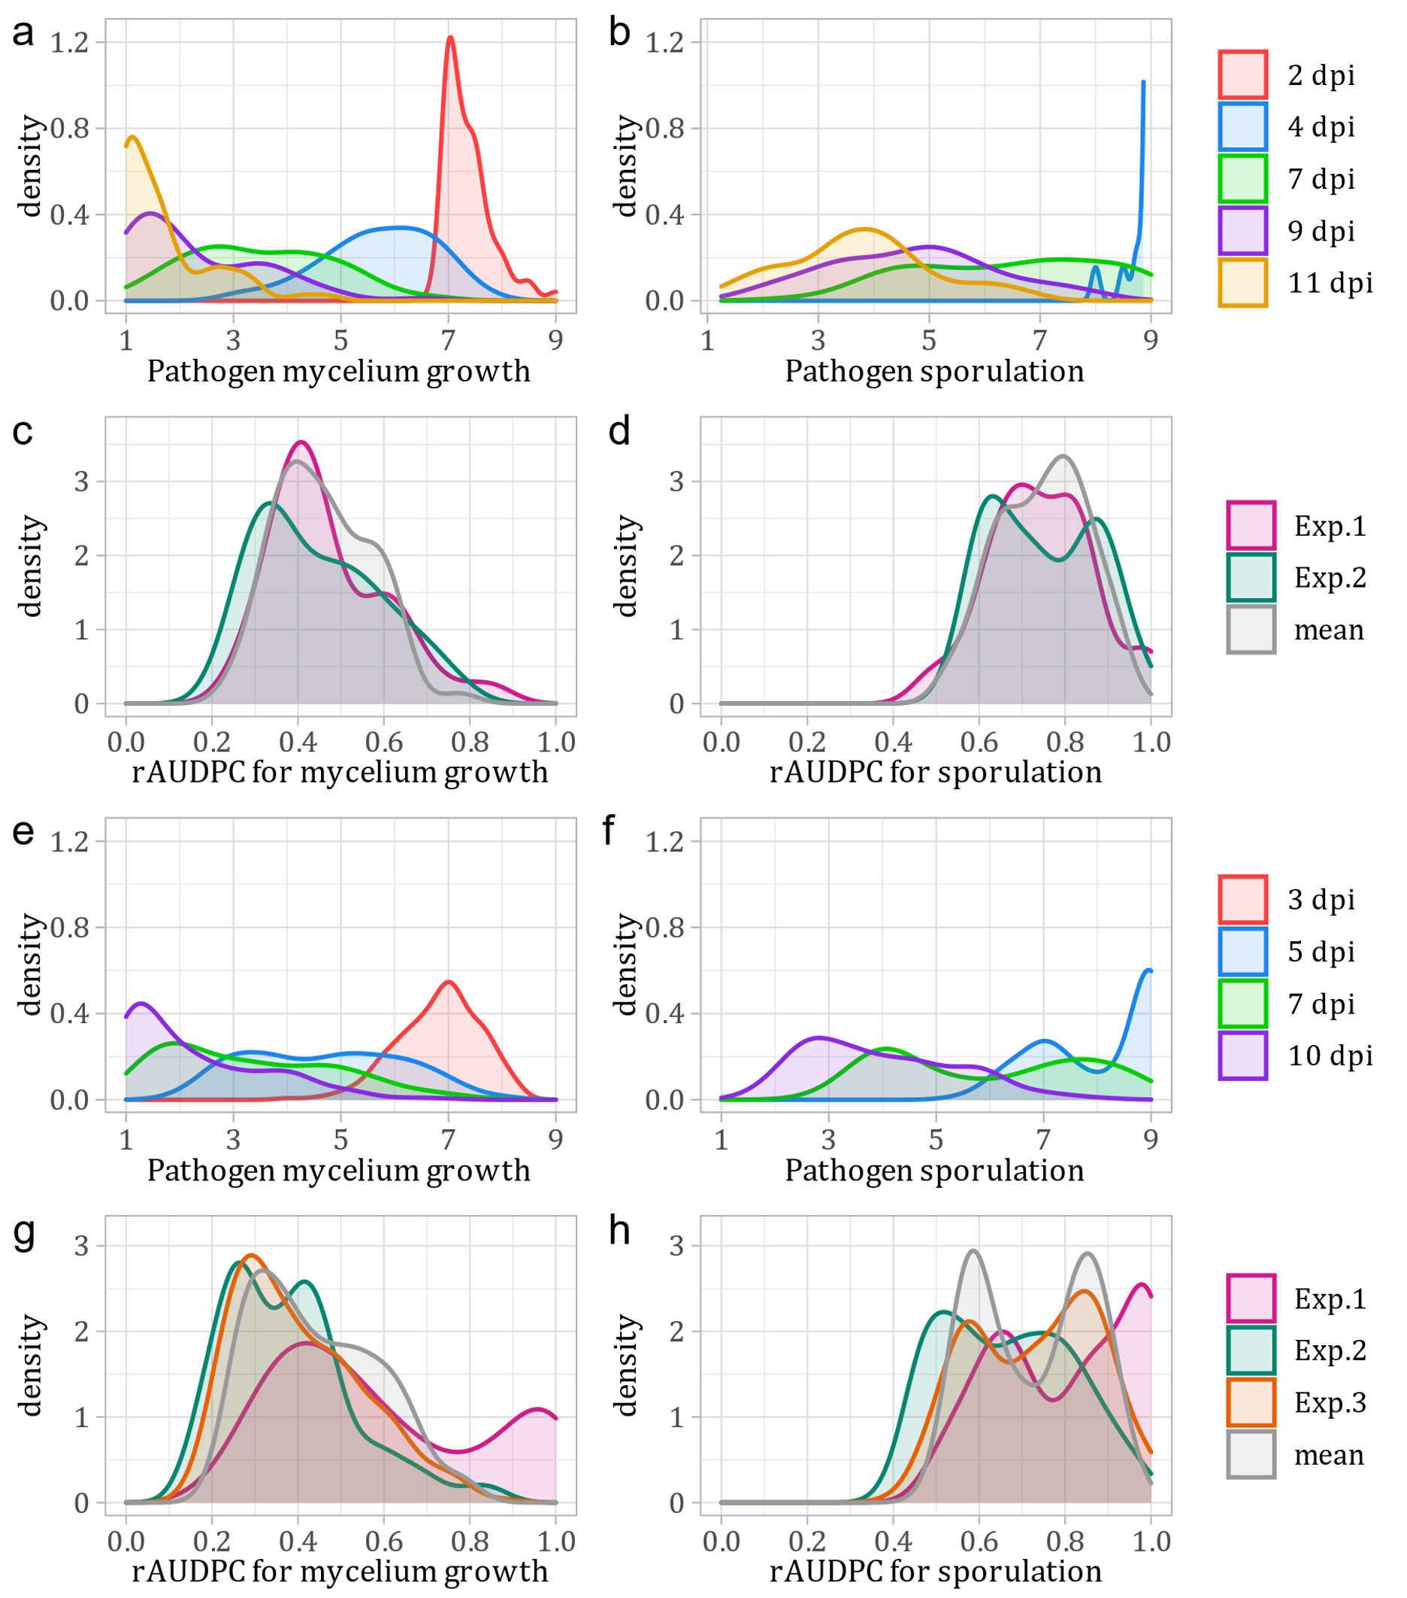
Figure S1. The plots show the distributions of some phenotypic data collected in the evaluation of the resistance to E. necator of the cross populations 50041-‘Chardonnay’ x ‘Tskhvedianis tetra’ (plot a) and (plot a-b-c-d) and 50042-‘Shavtsitska’ x ‘Glera’ (plot e-f-g-h). Plots a-b-e-f display the distributions of the averaged values per offspring (calculated from 2 or 3 experiments replicates) for E. necator mycelium growth and sporulation intensity recorded in different dpi (different colours). Plots c-d-g-h display the distributions of the calculate rAUDPC values per offspring for E. necator mycelium growth and sporulation intensity in the different experiment replicates (different colours).

