Supplementary Materials for

Rationally synthesized framework polymer membranes enable high selectivity and barrierless anion conduction

Junkai Fang^{1,2#}, Guozhen Zhang^{3#}, Marc-Antoni Goulet⁴, Peipei Zuo^{1,2}, Hui Li^{1,2}, Jun Jiang¹, Michael D. Guiver⁵, Zhengjin Yang^{1,2}* and Tongwen Xu^{1,2}*

¹Key Laboratory of Precision and Intelligent Chemistry, University of Science and Technology of China, Hefei, Anhui 230026, P. R. China
²Department of Applied Chemistry, School of Chemistry and Materials Science, University of Science and Technology of China, Hefei, Anhui 230026, P. R. China
³Hefei National Research Center for Physical Sciences at the Microscale, University of Science and Technology of China, Hefei, Anhui 230026, P. R. China
⁴Department of Chemical and Materials Engineering, Concordia University, Montreal, QC, H3G 1M8, CANADA
⁵State Key Laboratory of Engines, School of Mechanical Engineering, Tianjin University, Tianjin 300072, P. R. China

# These authors contribute equally.
E-mail: yangzj09@ustc.edu.cn, twxu@ustc.edu.cn

Materials and Methods………………………………………………………………………….2-7
Supplementary Figures……………………………………………………………...…………8-36
Supplementary Tables……...……………………………………………………...…………37-46
References..………………………………………………………...……………...……………..47

Materials
Materials and Chemicals
Selemion® DSV and AMV membranes were obtained from Asahi Glass CO., LTD (Japan). The positively charged dicyano monomer, namely 3-((4,4'-dicyano-[1,1'-biphenyl]-3-yl)oxy)-N,N,N-trimethylpropan-1-aminium bromide was synthesized according to a reported procedure from our group (1). Bis(3-trimethylammonio)propyl viologen tetrachloride (BTMAP-Vi) and (ferrocenylmethyl)trimethylammonium chloride (FcNCl) were prepared according to previous reports (2, 3). The as-synthesized chemicals were identified by ¹H-NMR (Figs. S1 and S2). Other chemicals were purchased from domestic chemical vendors and used without further purification.

Preparation of covalent triazine framework membranes
Triazine framework membranes were synthesized via a similar organic sol‒gel procedure reported in the literature (1, 4). Briefly, trifluoromethanesulfonic acid (TFSA, 1 mL) was added to a mixture of 4,4'-biphenyldicarbonitrile (0.12 g, 0.59 mmol) and 3-((4,4'-dicyano-[1,1'-biphenyl]-3-yl)oxy)-N,N,N-trimethylpropan-1-aminium bromide (0.08 g, 0.20 mmol) at 0 ºC under stirring. The resultant red solution was continuously stirred until the solution became viscous and then diluted to 3 mL with TFSA. This solution was transferred and cast on a clean glass plate and heated at 70 ºC under nitrogen flow for 4 hours, and finally at 100 ºC until the membrane was completely dry. The membrane was then peeled off by immersion in water. The thickness of membranes could be controlled by the solution concentration and was kept at around 20 μm in this work. Excess TFSA within the membrane was then removed by immersing the membrane samples in KOH solution (0.1 M) for 24 h, affording QCTF membranes. Counter-ions of the QCTF membrane were exchanged to Cl⁻ by immersion in KCl solution (1.0 M) and finally washed with deionized water at least five times during 24 h to remove remaining salts. The theoretical ion exchange capacity (IEC) of the QCTF membrane was designed to be 1.0 mmol g⁻¹.
Protonation and methylation of the QCTF membrane samples were then conducted to alter the membrane framework chemistry. The QCTF membrane sample was immersed in HCl solution (1 M) for 24 h to protonate the triazine rings and then exchanged to the Cl⁻ form according to the above procedure, affording P-QCTF membrane in the Cl⁻ form. The QCTF membrane sample was immersed in a mixture of methyl iodide (2 mL) and methanol (20 mL) for 48 h to methylate the triazine rings and then exchanged to the Cl⁻ form, yielding the M-QCTF membrane, in the Cl⁻ form.

Methods
General
¹H-NMR spectra were recorded in deuterated solvents on a Bruker AscendTM 400 MHz spectrometer. ¹³C NMR spectra of the QCTF membrane samples were recorded with a 400 MHz WB solid-state nuclear magnetic resonance spectrometer (Bruker AVANCE III 400 WB). ¹⁹F NMR spectra of KF aqueous solution (0.1 M) with or without membrane samples were obtained with a 600 MHz WB solid-state NMR spectrometer (Bruker AVANCE NEO 600 WB). Fourier transform infrared spectra (FTIR) of the QCTF membrane samples were acquired on an attenuated total reflectance FTIR (ATR-FTIR, Thermo Nicolet FTIR spectrometer, USA). X-ray photoemission spectra (XPS) of the QCTF membrane samples were obtained on an X-ray photoemission spectroscopy instrument (ESCALAB 250Xi). The zeta potential of the QCTF membranes was measured in KCl (1 mM in water) on a SurPASS 3 (Anton Paar, Austria). Thermal stability of the QCTF membrane samples was measured with a TGA Q5000 thermogravimetric analyzer (TA Instruments, USA) under a nitrogen atmosphere from room temperature to 800 °C at a heating rate of 10 °C min⁻¹. The tensile strength of the QCTF membrane samples was evaluated on a dynamic mechanical analyzer (DMA Q800). Water contact angles of the QCTF membrane samples were determined using static contact angle measurements on an SL200B instrument (Solon Tech Co., Ltd., China). Scanning electron microscopy (SEM) and energy dispersive spectroscopy (EDS) were collected on a GeminiSEM 500 instrument (Carl Zeiss AG). UV‒visible spectra (UV‒Vis) were obtained via a UV‒Vis spectrophotometer (Persee, TU-1901). CO₂ adsorption/desorption isotherms of the powdered QCTF samples were measured at 273 K on ASAP 2020 (Micromeritics, USA). Prior to measurement, the powders were degassed under a high vacuum at 120 °C for 24 h.

Ion exchange capacity (IEC)
IEC (mmol g⁻¹) values of QCTF membrane samples were determined through the titration method (5). The membrane samples in the Cl⁻ form were dried in a vacuum oven at 80 ºC for 24 h to remove residual water, and the dry weight (W_{dry}, g) of the membrane samples was recorded. Then, the membrane samples were immersed in 0.5 M Na₂SO₄ for 6 h. This was repeated 4 times to allow the complete exchange of Cl⁻ with SO₄²⁻. The exchanged Cl⁻ in the solution was titrated with AgNO₃ solution (0.01 M) utilizing 5 wt% K₂CrO₄ as the indicator, and the volume of consumed AgNO₃ solution (V_{AgNO3}, mL) was recorded. Titrated IEC values of QCTF membrane samples were calculated according to equation (1):
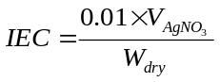 (1)

Water uptake (WU), swelling ratio (SR), and hydration number (λ) measurements
Membrane samples (4×4 cm², in the Cl⁻ form) in a square shape were dried at 80 ºC under vacuum for 24 h, whilst dry weight (W_{dry}) and dry length (L_{dry}) were recorded. These samples were then immersed in deionized water for 24 h at temperatures ranging from 30 ºC to 80 ºC. The weight (W_{wet}) and length (L_{wet}) of wet membrane samples were recorded after quickly wiping dry the membrane surface. The hydration number (λ) refers to the number of water molecules per mole of charged functional groups. The WU, SR, and λ were calculated according to equations (2-4):
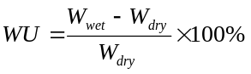 (2)
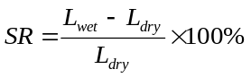 (3)
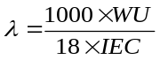 (4)

Transference number measurement
The transference number of Cl⁻ (t₋) across the membrane was measured by a laboratory-made two-compartment diffusion cell. One compartment was filled with 10 mL of 10 mM KCl solution (C_{high}), and the other was filled with 10 mL of 1 mM KCl solution (C_{low}). Transmembrane current–voltage (I–V) curves were measured using a pair of Ag/AgCl reference electrodes at a voltage range from -0.1 V to 0.1 V with a voltage sweeping rate of 0.01 mV s⁻¹ on a Keithley 6487 picoammeter. Prior to measurements, the membrane specimen was immersed in a 5.5 mM KCl solution for 24 h. The transference number of Cl⁻ (t₋) was calculated according to equation (5):
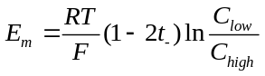 (5)
where E_{m}, t₋, R, T, and F represent the transmembrane potential, transference number of Cl⁻, molar gas constant, absolute temperature, and Faraday constant, respectively, while C_{low} and C_{high} are the low and high electrolyte concentrations (KCl in this case), respectively.

Diffusion and crossover measurements
Ion diffusion and redox active species crossover measurements were conducted on a laboratory-made two-compartment diffusion cell. During measurements, both the donating and receiving solutions were vigorously agitated to eliminate concentration polarization. For ion diffusion measurements, 20 mL of 0.1 M KCl solution was added to the donating side, while the receiving compartment was filled with 20 mL of deionized water. The solution conductivity of the receiving compartment was measured constantly with a conductivity meter (DDS-307A from Shanghai INESA Scientific Instrument Co., Ltd.). The KCl concentration of the receiving solution was determined according to a pre-established relationship between solution conductivity and KCl concentration.
For redox active electrolyte crossover measurements, 20 mL of 0.1 M BTMAP-Vi (or FcNCl) in 1 M KCl aqueous solution was added to the donating compartment, and 20 mL of 1 M KCl aqueous solution was added to the receiving compartment. Changes in the concentration of BTMAP-Vi or FcNCl on the receiving side were quantitatively determined via the UV–Vis spectrophotometry and the concentration was obtained from a standard line according to the measured absorbance at the characteristic peak. All measurements were conducted at room temperature. Aliquots were taken from the receiving compartment at constant intervals.
The diffusion coefficient (D, cm² s⁻¹) of Cl⁻, BTMAP-Vi or FcNCl through the membrane was calculated from equation (6):
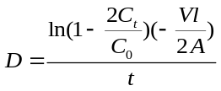 (6)
Where C_{t} (mol L⁻¹) is the concentration of electrolyte in the receiving compartment at time t, C₀ (mol L⁻¹) is the initial concentration of electrolyte in the donating compartment, V (mL) is the volume of solution, l (cm) is the thickness of the membrane, A is the effective membrane area (2 cm²), and t is time (s).
The membrane selectivity S (i.e., the ratio of diffusion coefficient of charge-carrying ions to that of redox-active electrolyte) can be obtained using equation (7):
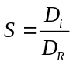 (7)
where D_{i} and D_{R} are the diffusion coefficients of the charge-carrying ion and redox-active electrolyte, respectively.

Cl⁻ conductivity measurement
Cl⁻ conductivity of the membrane sample was obtained from a four-electrode electrochemical impedance spectroscopy (EIS) method on Autolab® PGSTAT 302 over the temperature range from 30 ºC to 80 ºC. The Cl⁻ conductivity was calculated according to equation (8):
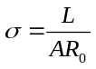 (8)
where σ (mS cm⁻¹) is the Cl⁻ conductivity, L (cm) is the width of the membrane specimen, A (cm²) is the effective membrane area determined by the membrane thickness and the effective distance between two Pt electrodes (herein 1 cm), and R₀ (Ω) is the measured membrane resistance.
The activation energy for Cl⁻ conduction can be derived from conductivity measurements at various temperatures according to Arrhenius equation (9):
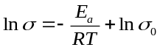 (9)
where E_{a} (kJ mol⁻¹) is the activation energy for Cl⁻ conduction, σ (mS cm⁻¹) is the Cl⁻ conductivity, σ₀ (mS cm⁻¹) is Arrhenius constant, T (K) is absolute temperature, and R (J mol⁻¹ K⁻¹) is molar gas constant.

Model Construction
A method based on the Polymatic algorithm was employed to initiate the trimeric polymerization of the positively charged covalent triazine framework (QCTF). The QCTF chains contained 63 monomers. The molar ratio of charged monomer to neutral monomer depended on the pre-designed ion exchange capacity (IEC) value. Polymerization steps were then performed sequentially. Triazine rings were added among three reactive atoms with lengths less than 8 Å. Energy minimization and dynamic steps to maintain a relaxed structure were conducted throughout the simulated polymerization. The polymerization cycles were repeated until no pairs meeting the bonding criteria were identified. Any unreacted end groups after polymerization were terminated appropriately.
We used Materials Studio to pack polymer chains in an amorphous cell of approximately 50 × 50 × 50 Å³. Subsequently, a probe with radius of 1.7 Å was chosen according to the size of CO₂ for the accessible surface. The Sorption module was used to investigate the CO₂ distributions of the internal pores of the framework polymer at 298 K and 1 bar.

Ion transport mechanism
We used a polymer fragment containing a triazine center and two quaternary ammonium side chains to investigate the free energy surface associated with anion transport between the two nearest cationic quaternary ammonium sites. The fragment was first optimized using the semi-empirical GFN2-xTB method (6) and the generalized born surface approximation (GBSA) implicit solvation model (7) implemented in xTB version 6.5.1 (8). Based on the relaxed structures of these fragments, their GROMACS-style topology files were generated with an online tool developed by Li (https://jerkwin.github.io/prog/gmxtop.html). The parameters of bonded and non-bonded interactions linked with the fragments were described by OPLS-AA forcefield (9). The atomic point charges of every atom in the fragments were reparametrized using Kollman’s restrained electrostatic potential (RESP) method (10). To do so, we first ran single-point calculations of the optimized fragments using B3LYP/6-311G* (11) level of theory and Grimme’s D3 empirical dispersion correction scheme with the Beck‒Johnson damping function (12) and the integral equation formalism for polarizable continuum model (IEFPCM) (13) of water in the Gaussian 16 program, then processed the formed checkpoint files of the Gaussian 16 jobs to generate the RESP parameters using the Multiwfn version 3.8 package (14, 15).
The exploration of two-dimensional free energy surfaces was conducted with classical molecular dynamics simulation in GROMACS version 2020 (16) in conjunction with metadynamics for enhanced sampling using the interfacing PLUMED version 2.7.3 (17) plugin. Guided by the GROMACS tutorial written by Lemkul (18), we placed the fragment in the center of the simulation box and at least 1.0 nm from the box edge, filled the box with thousands of TIP3P water as the solvent and an appropriate number of Cl⁻ ions to maintain the charge neutrality of the system, and prepared the GROMACS input files for metadynamics simulation in three consecutive steps: energy minimization, pre-equilibrium in the NVT ensemble with a velocity rescaling thermostat (19), and pre-equilibrium in NPT ensemble with velocity rescaling thermostat and Berendsen barostat. In the production runs, set up a 30-ns NPT simulation with a timestep of 1.0 fs for each system. To facilitate the simulation of a simplified short-range movement of Cl⁻ ions, we applied position restraints (using the “-DPOSRES” option) on all fragment atoms and all Cl⁻ ions except for the one migrating in water.
Like the previous study on the migration of potassium ions within negatively charged triazine framework membranes (1), we define two collective variables of metadynamics through the linear combination of r₁ and r₂ (a = r₁ – r₂, b = r₁ – r₂), where r₁ and r₂ are the distances between the moving Cl⁻ ion and the two N atoms in the quaternary ammonium of two side chains, respectively. With the same spirit as previous work, proper distance ranges were applied to a and b, respectively, to ensure efficient sampling of the configuration space involving potential paths of Cl⁻ ion migration from one quaternary ammonium site to another. For the Gaussian hills in metadynamics, we set HEIGHT = 0.3 kJ mol⁻¹, SIGMA = 0.2, and PACE = 500 as the height, width, and frequency of bias addition, respectively. The system temperature is set to be 600 K (TEMP = 600).

PFG NMR measurement
To measure the diffusion coefficient of ions in the bulk aqueous solution and under confined ion channels within these membrane samples, pulsed-field gradient NMR (PFG‒NMR) measurements were conducted. The self-diffusion coefficients of F⁻ in 0.1 M KF solution were obtained using ¹⁹F PFG‒NMR with a gamma radiation of 25172 rad (s*Gauss)⁻¹. To measure the diffusion coefficient of F⁻ within membranes, the membrane sample was placed in NMR tubes and immersed in 0.1 M KF solutions. All measurements were carried out on a 600 MHz NMR spectrometer (Bruker AVANCE NEO) equipped with a 5-mm BBO static probe, which can generate the maximum gradient strength of ~23 T m⁻¹. PFG echo profiles with 16 equal steps as a function of gradient strength (g) were obtained using the bipolar gradient PFG sequence. The maximum gradient strengths were carefully chosen to observe a sufficient decay of the echo profiles. The self-diffusion coefficient of F⁻ was derived from the echo profiles according to the Stejskal‒Tanner equation (10):
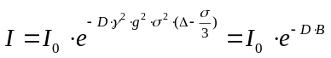 (10)
where, I and I₀ are the echo height at the gradient strength (g, Gauss m⁻¹) of g and 0, respectively, D (m² s⁻¹) is the diffusion coefficient, γ is the gyromagnetic ratio of fluoride nucleus (25172 rad (s×Gauss)⁻¹), σ (s) is the gradient time, Δ (s) is the diffusion delay time, and B values (s m⁻²) is the total contribution of these variables (γ, g, σ, and Δ).

Redox flow battery experiments
Cell hardware was purchased from Fuel Cell Tech (Albuquerque, USA) with two pieces of POCO single serpentine pattern graphite plates, which were used to assemble the flow batteries. A piece of membrane was sandwiched between the positive and negative electrodes (the effective geometric area is 5 cm²) composing a stack of three sheets of carbon paper (SGL 39AA). The electrolytes were fed to the cell at a pumping rate of 60 rpm utilizing a Masterflex L/S peristaltic pump (Cole-Parmer, Vernon Hills, IL). To acquire the electrochemical polarization curve, the cell was charged to a certain state of charge (SOC) and then polarized by linear sweep voltammetry. The corresponding power density at the desired SOC (e.g., 10, 50, and ~ 100 %) was derived from the current-voltage curve. Potentio-controlled electrochemical impedance spectroscopy (PEIS) was collected at specific SOC (10, 50, and ~ 100 %) at frequencies ranging from 1 Hz to 10 kHz. Other details regarding the assembly of pH-neutral organic flow batteries can be found in previous reports from our group and the Liu group. (20, 21)
A pH-neutral AORFB was configured with either the QCTF, P-QCTF, or M-QCTF membrane (or commercial anion exchange membranes, such as Selemion® DSV membrane and Selemion® AMV membrane) as separator and BTMAP-Vi/FcNCl as the electrolytes. Typically, the anolyte consisted of 5 mL of 0.1 M BTMAP-Vi in 2.0 M KCl, and the catholyte consisted of 10 mL of 0.1 M FcNCl in 2.0 M KCl. For high-concentration cells, the concentration of FcNCl and BTMAP-Vi was raised to 0.5 M, while the supporting electrolyte was 2.0 M KCl and the electrolyte volume remained the same. The cells were charged and discharged with cutoff voltages of 1.2 V and 0.3 V, respectively. All the experiments were performed in a glovebox filled with argon at room temperature.

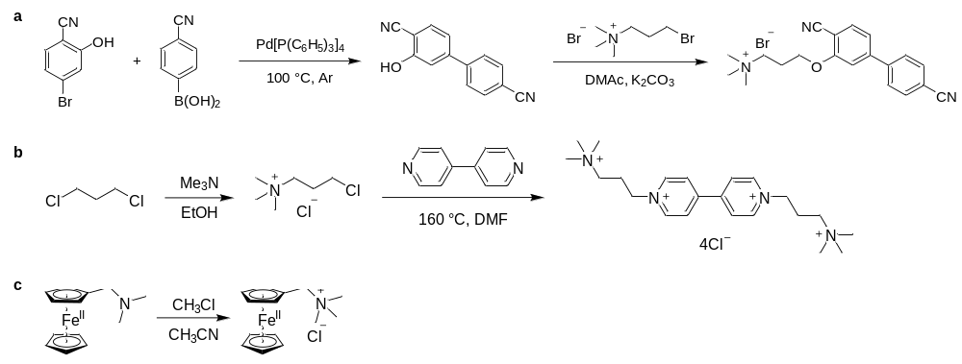
Fig. S1. Synthetic route for a) quaternized dicyano monomer (3-((4,4'-dicyano-[1,1'-biphenyl]-3-yl)oxy)-N,N,N-trimethylpropan-1-aminium bromide), b) bis(3-trimethylammonio)propyl viologen tetrachloride (BTMAP-Vi), and c) (ferrocenylmethyl)trimethylammonium chloride (FcNCl).

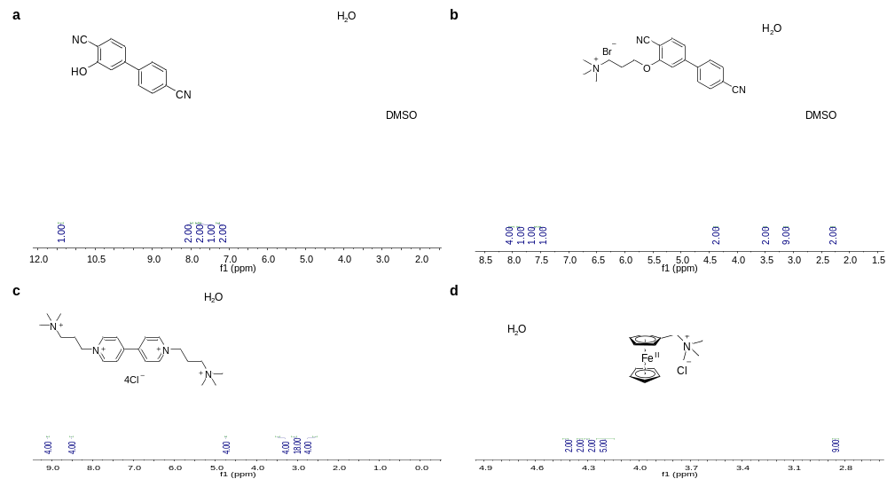
Fig. S2. ¹H-NMR spectra of aromatic nitrile monomers (a, b) and redox-active organic electrolytes (c, d).

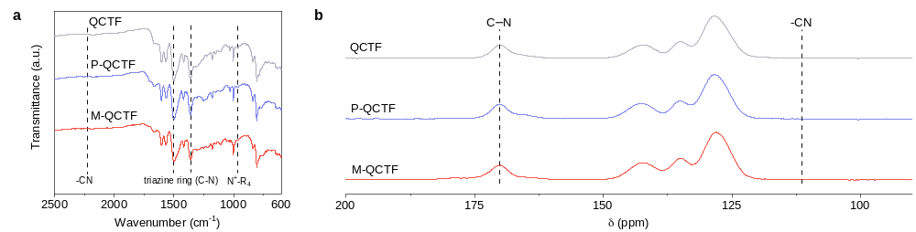
Fig. S3. FTIR spectra (a) and solid-state ¹³C-NMR spectra (b) of positively charged covalent triazine framework membranes.
Notes: The characteristic signals of quaternary ammonium groups and triazine rings (C–N) are highlighted with dotted lines. Characteristic peaks of –CN moieties were not found in the FTIR or the ¹³C-NMR spectra, implying nearly complete conversion of nitrile groups during the modified organic sol‒gel process.

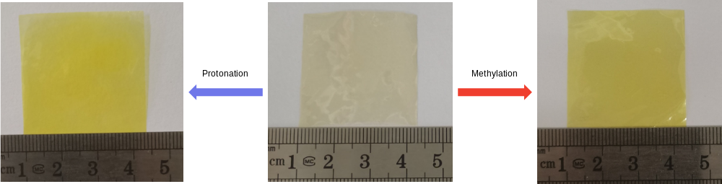
Fig. S4. Photographs of positively charged covalent triazine framework (QCTF) membranes: protonated QCTF (P-QCTF, left), QCTF (middle), and methylated QCTF (M-QCTF, right).

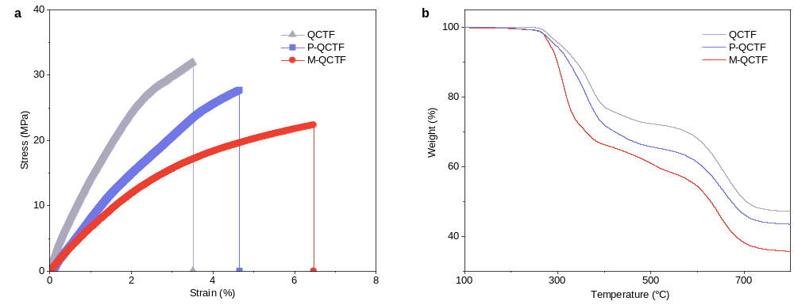
Fig. S5. (a) The stress-strain curve measured for QCTF, P-QCTF, and M-QCTF membrane samples. (b) TGA curves recorded for QCTF, P-QCTF, and M-QCTF membrane samples under N₂ at a heating rate of 10 ºC min⁻¹.
Notes: The tensile strengths of QCTF, P-QCTF, and M-QCTF reached 32.0 MPa, 27.7 MPa, and 22.4 MPa, respectively, and their elongations at break were 3.5%, 4.7%, and 6.5%, respectively. The Young’s modulus of these membrane samples was calculated to be 0.91 GPa, 0.59 GPa, and 0.34 GPa, respectively. The high Young’s modulus and small elongation at break imply the exceptional rigidity of QCTF membrane framework compared with other anion exchange membranes. These membrane samples were thermally stable up to >200 °C.

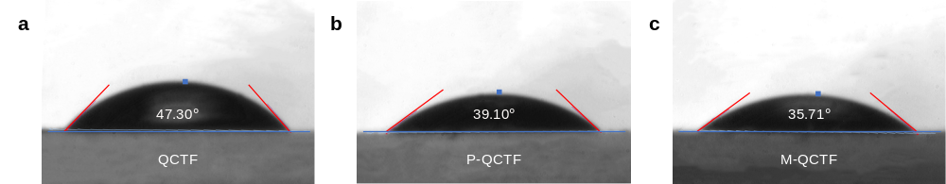
Fig. S6. Static water contact angles of QCTF (a), P-QCTF (b), and M-QCTF (c).

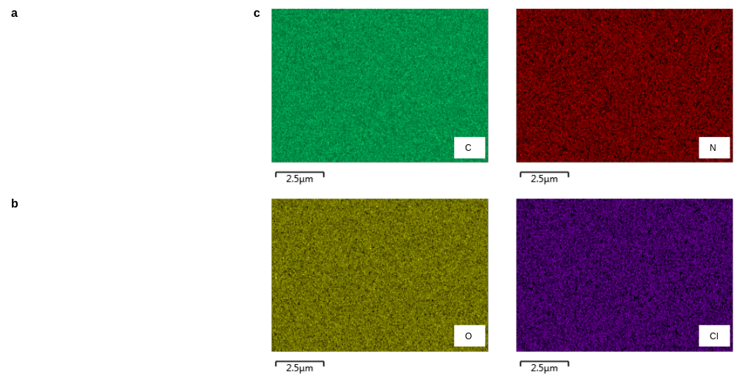
Fig. S7. Surface morphology (a, b) and EDS elemental mapping (c) for M-QCTF membrane samples.
Notes: The surface SEM images of the M-QCTF membrane sample revealed a uniform and flat morphology, free of defects. The EDS mapping images further demonstrate uniform elemental distributions.

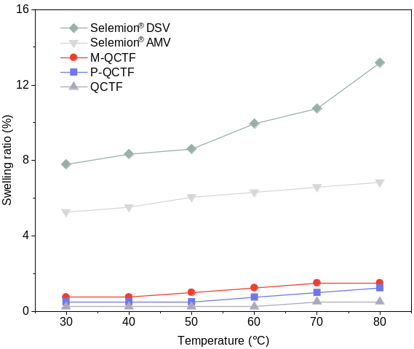
Fig. S8. Swelling ratio of the Selemion® DSV, Selemion® AMV, M-QCTF, P-QCTF, and QCTF membranes at various temperatures.

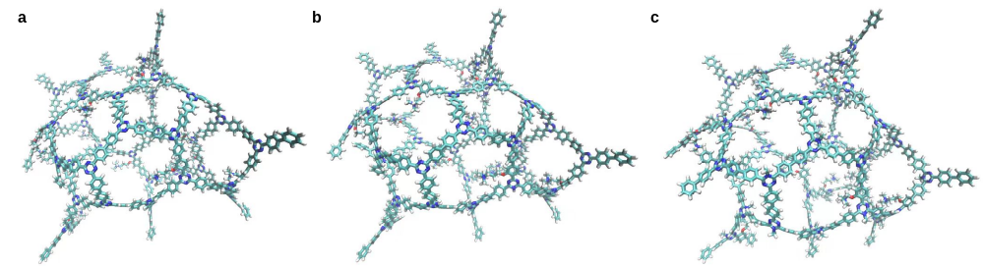
Fig. S9. Stick-filling models of polymer chains for QCTF (a), P-QCTF (b), and M-QCTF (c). A total of 63 repeating units were used to generate these chains. Color code: carbon in cyan, nitrogen in blue, oxygen in red, hydrogen in white.

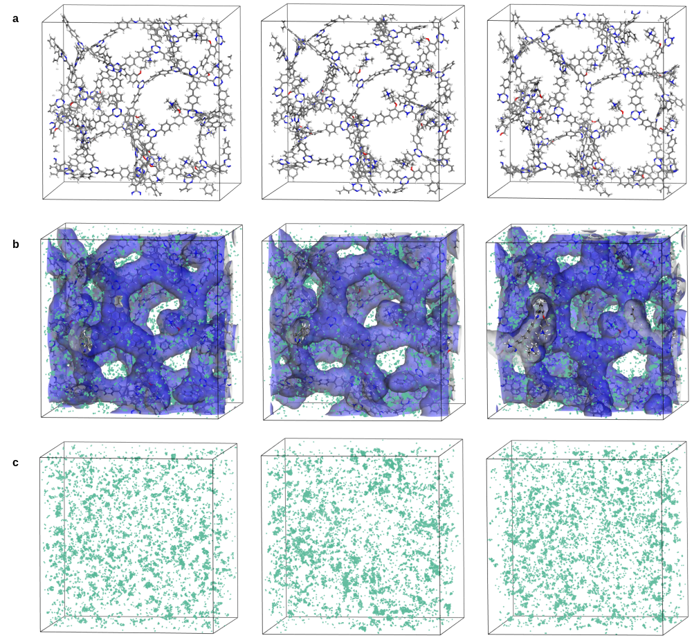
Fig. S10. (a) Molecular models of QCTF (left), P-QCTF (middle), and M-QCTF (right). (b) Three-dimensional view of the amorphous cells of QCTF (left), P-QCTF (middle), and M-QCTF (right), with adsorbed CO₂ at 1 bar. Cell size: 50 × 50 × 50 Å³. Blue color: Accessible surface at a probe radius of 1.7 Å (i.e., CO₂-sized probe). (c) CO₂ distributions when adsorbed in QCTF (left), P-QCTF (middle) and M-QCTF (right) at 1 bar. Green dot: CO₂.

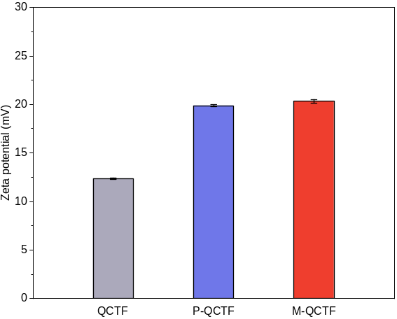
Fig. S11. Zeta potential of positively charged covalent triazine framework (QCTF) membranes.
Notes: The zeta potential was determined to investigate the surface charge of these membranes. To note, the zeta potentials of P-QCTF and M-QCTF were similar, indicating that P-QCTF and M-QCTF had nearly the same degree of protonation or methylation. The ion exchange capacity of the QCTF membranes was titrated to be 1.11±0.19 mmol g⁻¹ for QCTF, 2.34±0.45 mmol g⁻¹ for P-QCTF and 2.21±0.31 mmol g⁻¹.

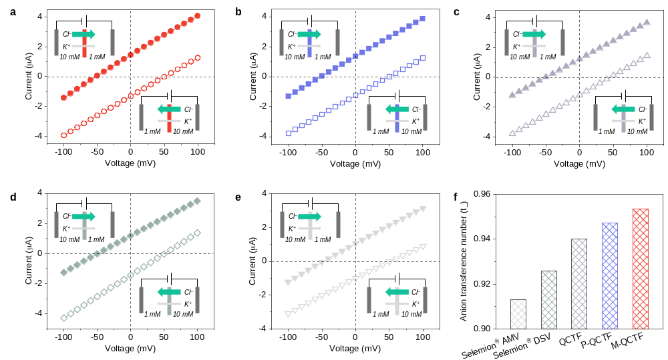
Fig. S12. Current–voltage (I‒V) curves recorded for (a) M-QCTF, (b) P-QCTF, (c) QCTF, (d) Selemion® DSV, and (e) Selemion® AMV membranes under a 10-fold KCl concentration gradient across a two-compartment diffusion cell. The curve reflects a net anion flow from the high-concentration compartment to the low-concentration compartment, suggesting anion selectivity. (f) The anion transference number (t₋) of these membranes as derived from I–V curves.

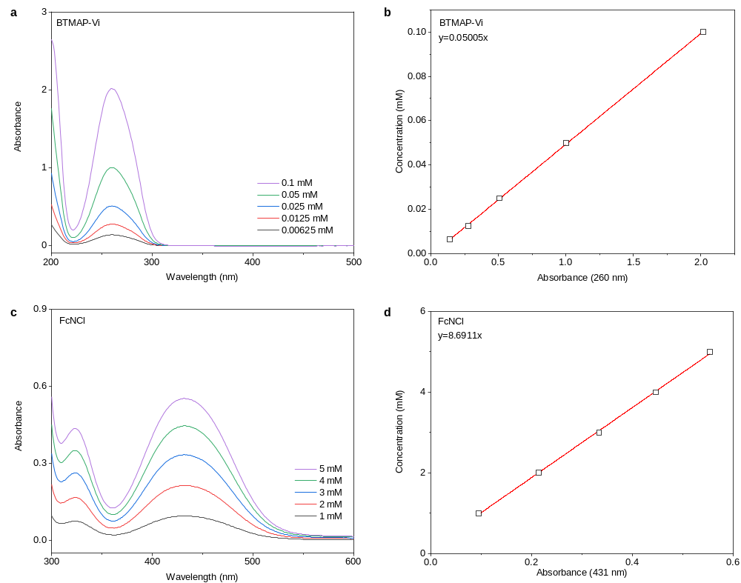
Fig. S13. UV-Vis spectra and the corresponding calibration curves established according to the absorbance at maximum absorption for (a, b) BTMAP-Vi and (c, d) FcNCl.

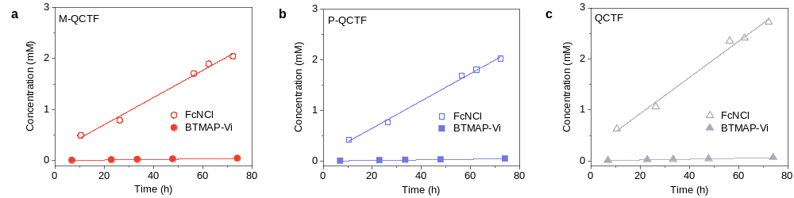
Fig. S14. The concentration of BTMAP-Vi or FcNCl in the receiving compartment of the two-compartment diffusion cell as a function of time, recorded during electrolyte crossover measurements for the M-QCTF (a), P-QCTF (b) and QCTF (c) membranes.

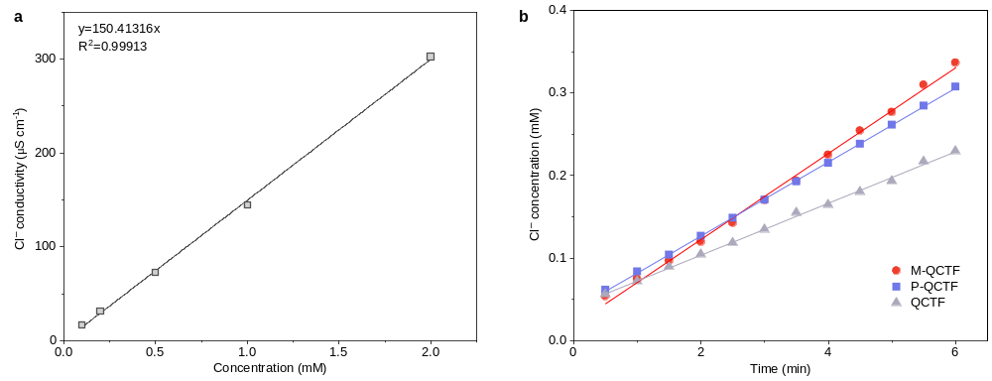
Fig. S15. (a) Calibration line of Cl⁻ conductivity versus concentration for KCl solution. (b) The cross-membrane diffusion of Cl⁻ measured in a lab-made two-compartment diffusion cell. The figure shows the concentration of the receiving side as a function of time.

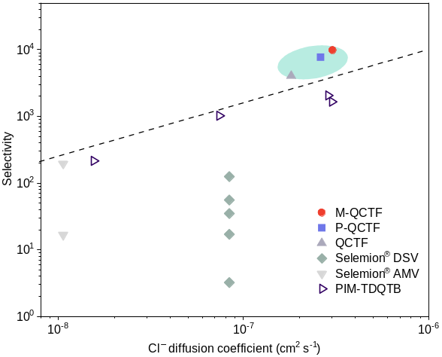
Fig. S16. Comparison of the membrane selectivity and ion diffusion coefficient for QCTF membranes, Selemion® DSV, AMV, and previously reported PIM-TDQTB. The detailed values can be found in Table S6. The line and the shadow are guides for the eye.

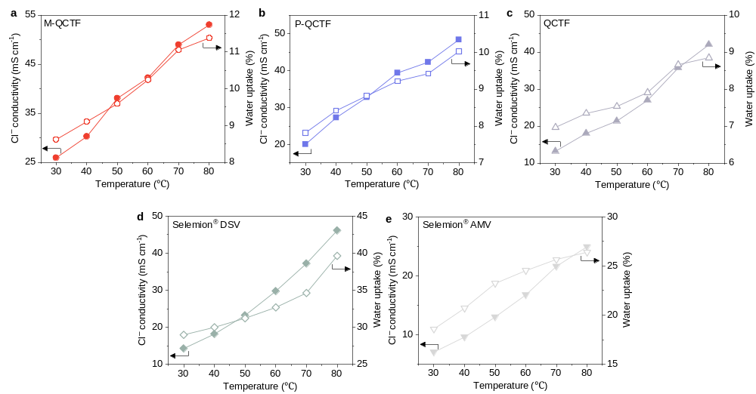
Fig. S17. Cl⁻ conductivity and membrane water uptake (WU) measured at varied temperatures for (a) M-QCTF, (b) P-QCTF, (c) QCTF, (d) Selemion® DSV, and (e) Selemion® AMV membranes.

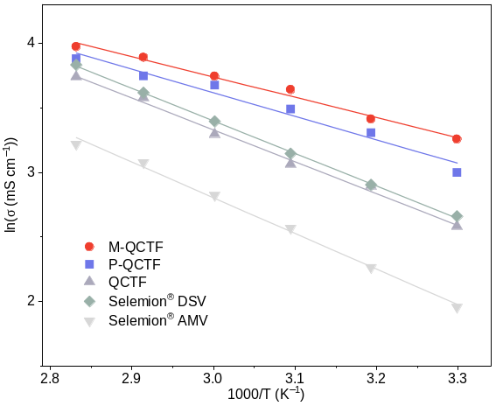
Fig. S18. Temperature dependence of Cl⁻ conductivities for QCTF membranes, Selemion® DSV membrane, and Selemion® AMV membrane. The figure is drawn according to the Arrhenius equation and E_{a} is derived from the slope of the curve.

Fig. S19. Atomic numbers of QCTF (a), P-QCTF (b), and M-QCTF (c). Color code: carbon in gray, nitrogen in blue, oxygen in red, hydrogen in white.
Notes: The charge distribution values of different atoms can be found in Table S9.

Fig. S20. Snapshots taken during simulation, demonstrating the interactions between Cl⁻ and the pore walls of QCTF (a), P-QCTF (b), and M-QCTF (c). Insets on the right denote the specific interactions at positions 1 and 2. Color code: carbon in cyan, nitrogen in blue, oxygen in red, hydrogen in white, and chlorine in green.
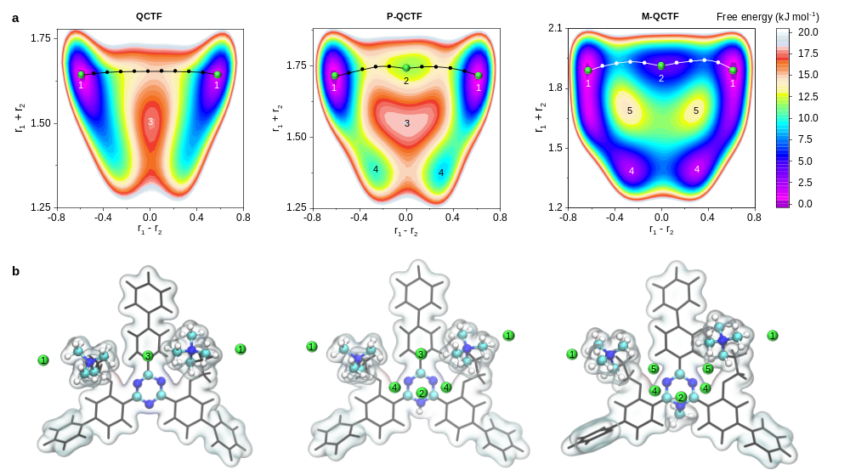
Fig. S21. (a) Computed free energy map for the transport of Cl⁻ ions within the QCTF (left), P-QCTF (middle), and M-QCTF (right) membrane matrices. The black or white lines denote the Cl⁻ ion transport pathways (1-1 or 1-2-1) with the lowest free energy barrier. (b) Snapshots taken during simulation, showing the interactions between Cl⁻ and the membrane pore walls of QCTF (left), P-QCTF (middle), and M-QCTF (right) at the numbered sites.

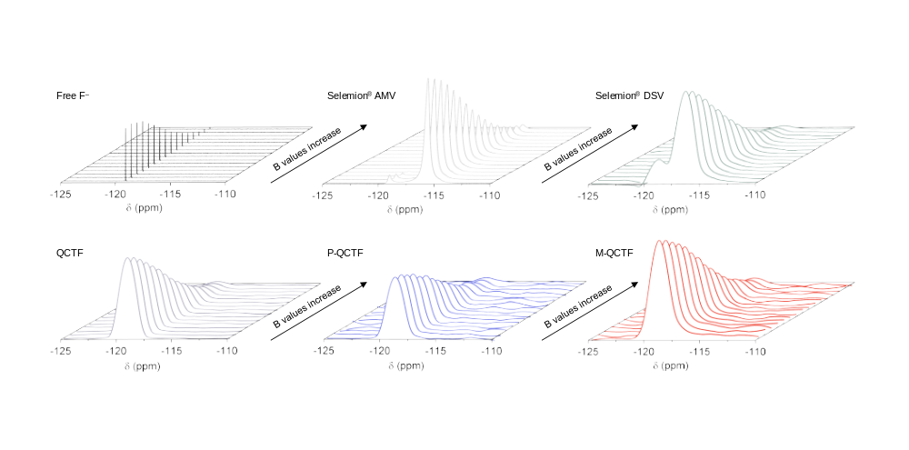
Fig. S22. ¹⁹F PFG–NMR spectra recorded for 0.1 M KF solution without membranes (left in the first row) and membrane samples of Selemion® AMV (middle in the first row), Selemion® DSV (right in the first row), QCTF (left in the second row), P-QCTF (middle in the second row) and M-QCTF (right in the second row) immersed in 0.1 M KF solutions, respectively. The membrane samples were placed in NMR tubes during measurements.

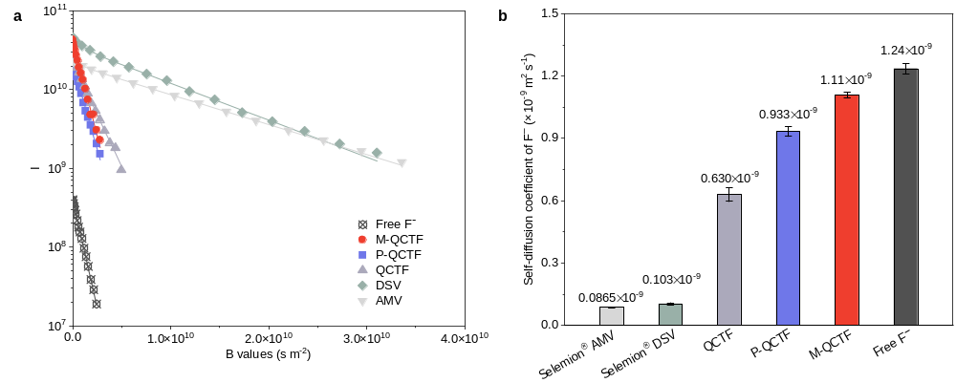
Fig. S23. (a) Plot of PFG–NMR signal intensity versus magnetic gradient strength (B values) and (b) diffusion coefficients derived from PFG–NMR for F⁻ in water, M-QCTF, P-QCTF, QCTF, Selemion® DSV, and Selemion® AMV membrane samples. Echo profiles are fitted to the Stejskal–Tanner equation. I denotes the echo height at a given gradient strength; B denotes the product of all parameters before the diffusion coefficient (D) of the Stejskal–Tanner equation (that is, equation 13). Error bars (s.d.) are derived from three measurements based on three parallel experiments.

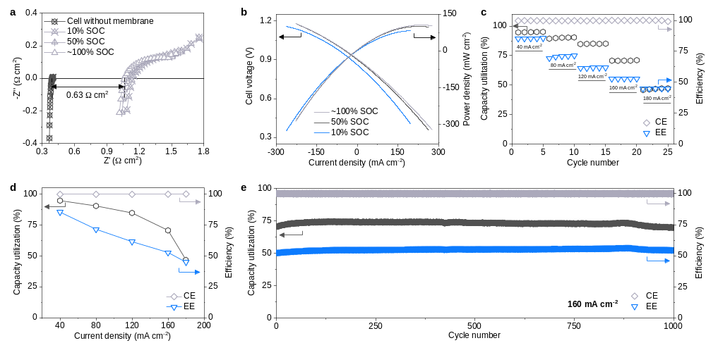
Fig. S24. Performance of a 0.1 M BTMAP-Vi/FcNCl cell assembled with the QCTF membrane. (a) EIS spectra and (b) polarization curves at various SOCs. (c, d) The capacity utilization, Coulombic efficiency (CE), and energy efficiency (EE) at various current densities. (e) Long-term galvanostatic cycling of the cell at 160 mA cm⁻². The capacity utilization, Coulombic efficiency, and energy efficiency are plotted against the cycle number.

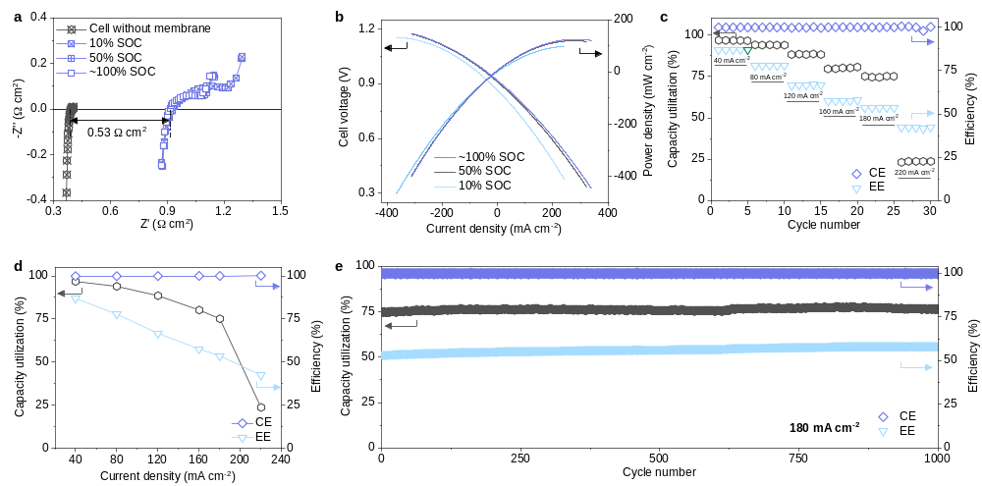
Fig. S25. Performance of a 0.1 M BTMAP-Vi/FcNCl cell assembled with the P-QCTF membrane. (a) EIS spectra and (b) polarization curves at various SOCs. (c, d) The capacity utilization, Coulombic efficiency (CE), and energy efficiency (EE) at various current densities. (e) Long-term galvanostatic cycling of the cell at 180 mA cm⁻². The capacity utilization, Coulombic efficiency, and energy efficiency are plotted against the cycle number.

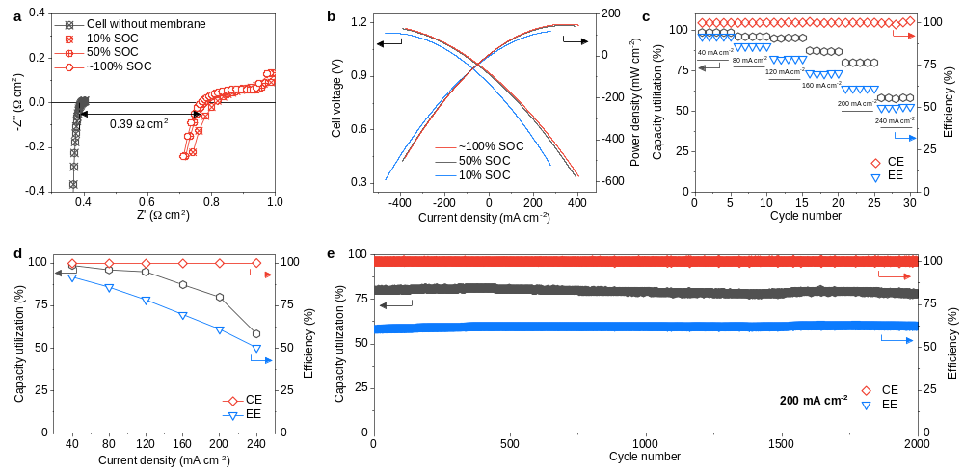
Fig. S26. Performance of a 0.1 M BTMAP-Vi/FcNCl cell assembled with the M-QCTF membrane. (a) EIS spectra and (b) polarization curves at various SOCs. (c, d) The capacity utilization, Coulombic efficiency (CE), and energy efficiency (EE) at various current densities. (e) Long-term galvanostatic cycling of the cell at 200 mA cm⁻². The capacity utilization, Coulombic efficiency, and energy efficiency are plotted against the cycle number.

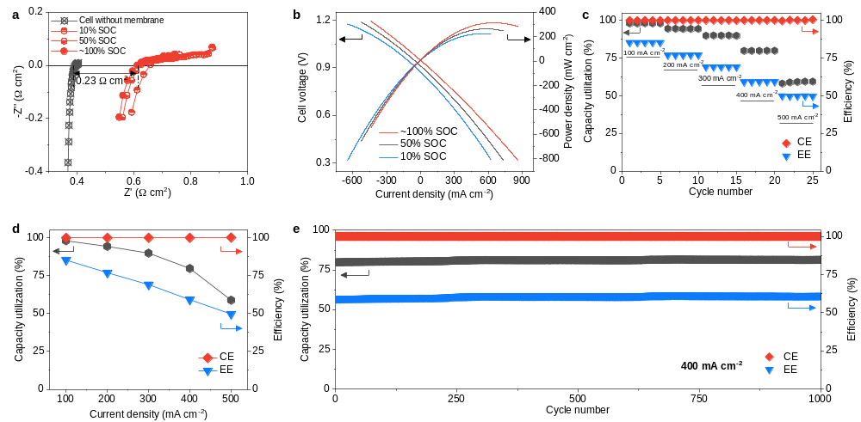
Fig. S27. Performance of a 0.5 M BTMAP-Vi/FcNCl cell assembled with the M-QCTF membrane. (a) EIS spectra and (b) polarization curves at various SOCs. (c, d) The capacity utilization, Coulombic efficiency (CE), and energy efficiency (EE) at various current densities. (e) Long-term galvanostatic cycling of the cell at 400 mA cm⁻². The capacity utilization, Coulombic efficiency, and energy efficiency are plotted against the cycle number.

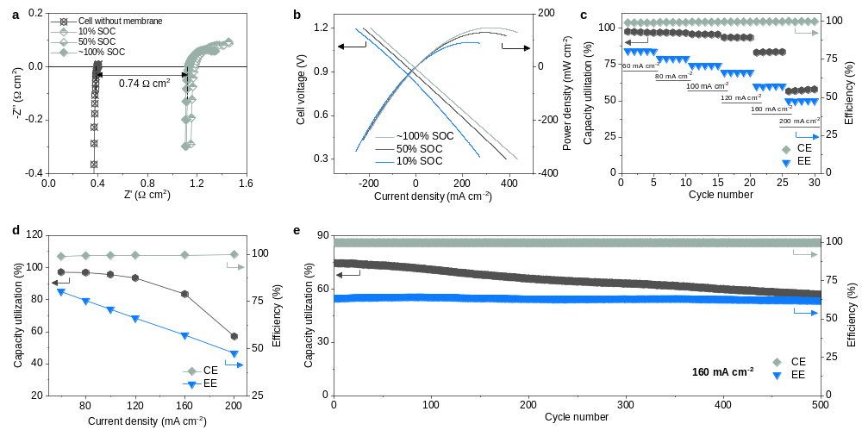
Fig. S28. Performance of a 0.5 M BTMAP-Vi/FcNCl cell assembled with selemion® DSV membrane. (a) EIS spectra and (b) polarization curves at various SOCs. (c, d) The capacity utilization, Coulombic efficiency (CE), and energy efficiency (EE) at various current densities. (e) Long-term galvanostatic cycling of the cell at 160 mA cm⁻². The capacity utilization, Coulombic efficiency, and energy efficiency are plotted against the cycle number.

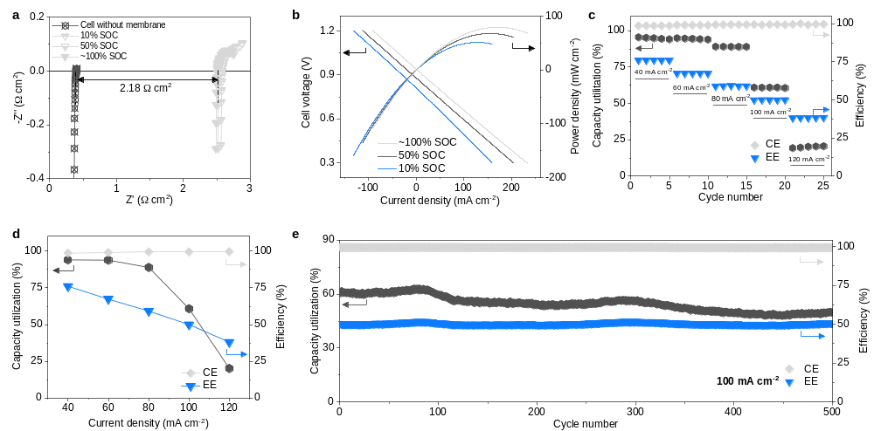
Fig. S29. Performance of a 0.5 M BTMAP-Vi/FcNCl cell assembled with selemion® AMV membrane. (a) EIS spectra and (b) polarization curves at various SOCs. (c, d) The capacity utilization, Coulombic efficiency (CE), and energy efficiency (EE) at various current densities. (e) Long-term galvanostatic cycling of the cell at 100 mA cm⁻². The capacity utilization, Coulombic efficiency, and energy efficiency are plotted against the cycle number.

Table S1. The activation energy (E_{a}) for Cl⁻ conduction across various membranes
Membrane | Activation energy (E_{a}, kJ mol⁻¹) | Reference
M-QCTF | 13.1 | this work
P-QCTF | 15.2 | this work
QCTF | 20.6 | this work
Selemion® DSV | 21.0 | this work
Selemion® AMV | 23.0 | this work
MTCP-30 | 23.7 | (5)
MTCP-50 | 21.2 | (5)
MTCP-70 | 23.1 | (5)
FumionTM | 18 | (22)
PFTP-0 | 16.6 | (22)
PFTP-13 | 14.9 | (22)
PFBP-0 | 13.9 | (22)
PFBP-14 | 14.5 | (22)
DMBP-QTB | 30.6 | (23)
DMDPM-QTB | 17.9 | (23)
Trip-QTB | 14.5 | (23)
PIM-TDQTB-20 | 18.1 | (20)
PIM-TDQTB-50 | 17.9 | (20)
PIM-TDQTB-80 | 17.3 | (20)
PIM-TDQTB-100 | 16.9 | (20)

Table S2. Comparison of energy efficiency (EE, %) and capacity utilization (CU, %) at various current densities between pH-neutral and alkaline AORFBs. The redox chemistry, charge carrier ion and membrane for cell assembly are listed.
Membrane | 200 mA cm⁻² |  | 300 mA cm⁻² |  | 400 mA cm⁻² |  | 500 mA cm⁻² |  | Transport ion | Concentration | Anolyte/catholyte | Reference
Membrane | EE | CU | EE | CU | EE | CU | EE | CU
M-QCTF | 76.94 | 94.33 | 69.08 | 89.91 | 59.10 | 79.78 | 49.65 | 58.78 | Cl⁻ | 0.5 M/0.5 M | BTMAP-Vi/FcNCl | this work
SCTF-BP | 77.3 | 98 | 67.7 | 92.8 | 58.9 | 82.5 | 50.4 | 62 | K⁺ | 0.4 M/0.4 M | DHAQ/K₄Fe(CN)₆ | (1)
QCTF-BP | 66.1 | 76.1 | 57.5 | 62.8 | 46.2 | 43.4 | - | - | Cl⁻ | 0.5 M/1.0 M | BTMAP-Vi/TEMPTMA | (1)
MTCP-50 | 60.06 | 63.74 | - | - | - | - | - | - | Cl⁻ | 0.5 M/0.5 M | MV/TEMPTMA | (5)

Table S3. Performance comparison between BTMAP-Vi/FcNCl cells assembled with M-QCTF, Selemion® DSV, and Selemion® AMV membranes.
Membrane | R_{cell}  (Ω cm²) | R_{m}  (Ω cm²) | Membrane resistance contribution  (%) | Electrolyte concentration | Anolyte/catholyte
M-QCTF | 0.904 | 0.23 | 25.4 | 0.5 M/0.5 M | BTMAP-Vi/FcNCl
Selemion® DSV | 1.412 | 0.74 | 52.4 | 0.5 M/0.5 M | BTMAP-Vi/FcNCl
Selemion® AMV | 2.799 | 2.18 | 77.88 | 0.5 M/0.5 M | BTMAP-Vi/FcNCl
Notes: R_{cell} referred to area-specific resistance (ASR) of the whole cell derived from the polarization curves at 0 mA cm⁻². The membrane resistance (R_{m}) was obtained by subtracting the resistance (R_{other}) contributed by the electrode, the electrolytes, and the contact resistance from the high-frequency ASR (R_{t}). R_{other} was measured from cells without a membrane. The membrane resistance contribution was calculated according to R_{m}/R_{cell} × 100%.

Table S4. The membrane swelling ratio (SR) at various temperatures.
Membrane | Swelling ratio (SR, %)
Membrane | 30 ºC | 40 ºC | 50 ºC | 60 ºC | 70 ºC | 80 ºC
M-QCTF | 0.75 | 0.75 | 1 | 1.25 | 1.5 | 1.5
P-QCTF | 0.5 | 0.5 | 0.5 | 0.75 | 1 | 1.25
QCTF | 0.25 | 0.25 | 0.25 | 0.25 | 0.5 | 0.5
Selemion® DSV | 7.8 | 8.3 | 8.6 | 9.9 | 10.8 | 13.2
Selemion® AMV | 5.3 | 5.5 | 6.1 | 6.3 | 6.6 | 6.8

Table S5. Membrane thickness and redox-active organic electrolyte permeability across different membranes.
Membranes | Permeability (cm² s⁻¹) |  | Reference
Membranes | BTMAP-Vi | FcNCl | Reference
M-QCTF | 3.1×10⁻¹¹ | 1.48×10⁻⁹ | This work
P-QCTF | 3.4×10⁻¹¹ | 1.5×10⁻⁹ | This work
QCTF | 4.5×10⁻¹¹ | 1.97×10⁻⁹ | This work
Selemion® DSV | 6.7×10⁻¹⁰ | not given | (2)
Selemion® AMV | 5.4×10⁻¹¹ | not given | (2)

Table S6. Cl⁻ diffusion coefficient and selectivity for membrane implemented in aqueous organic redox flow batteries.
Membranes | D_{Cl}- (cm² s⁻¹) | Selectivity | Reference
M-QCTF | 3.03×10⁻⁷ | 9.79×10³ | This work
P-QCTF | 2.61×10⁻⁷ | 7.68×10³ | This work
QCTF | 1.82×10⁻⁷ | 4.04×10³ | This work
Selemion® AMV | 1.06×10⁻⁸ | 1.66×10¹ | (20)
Selemion® AMV | 1.06×10⁻⁸ | 1.96×10² | The value for D_{Cl}- is from (20), and selectivity is from (2)
Selemion® DSV | 8.37×10⁻⁸ | 1.25×10² | The value for D_{Cl}- is from (20), and selectivity is from (2)
Selemion® DSV | 8.37×10⁻⁸ | 1.71×10¹ | The value for D_{Cl}- is from (20), and selectivity is from (24)
Selemion® DSV | 8.37×10⁻⁸ | 3.22×10⁰
Selemion® DSV | 8.37×10⁻⁸ | 5.58×10¹
Selemion® DSV | 8.37×10⁻⁸ | 3.49×10¹
PIM-TDQTB-100 | 3.0×10⁻⁷ | 1.65×10³ | (20)
PIM-TDQTB-80 | 2.86×10⁻⁷ | 2.05×10³ | (20)
PIM-TDQTB-50 | 7.4×10⁻⁸ | 1.02×10³ | (20)
PIM-TDQTB-20 | 1.22×10⁻⁸ | 2.14×10² | (20)
Notes: Selectivity refers to the ratio of the cross-membrane diffusion coefficient between the ion (Cl⁻) and redox-active organic electrolyte.

Table S7. Membrane water uptake (WU) at various temperatures.
Membrane | Water uptake (WU, %)
Membrane | 30 ºC | 40 ºC | 50 ºC | 60 ºC | 70 ºC | 80 ºC
M-QCTF | 8.6 | 9.1 | 9.6 | 10.2 | 11.1 | 11.4
P-QCTF | 7.8 | 8.4 | 8.8 | 9.2 | 9.4 | 10.0
QCTF | 7.0 | 7.3 | 7.5 | 7.9 | 8.7 | 8.9
Selemion® DSV | 29.0 | 30.0 | 31.2 | 32.7 | 34.6 | 39.6
Selemion® AMV | 18.6 | 20.7 | 23.2 | 24.5 | 25.7 | 26.4

Table S8. Cl⁻ conductivity and hydration number for different membranes at various temperatures.
Temperature  (ºC) | M-QCTF |  | P-QCTF |  | QCTF |  | Selemion® DSV |  | Selemion® AMV
Temperature  (ºC) | λ | σ  (mS/cm) | λ | σ  (mS/cm) | λ | σ  (mS/cm) | λ | σ  (mS/cm) | λ | σ  (mS/cm)
30 | 2.2 | 25.9 | 1.9 | 20.0 | 3.5 | 13.2 | 8.1 | 14.3 | 5.4 | 7.0
40 | 2.3 | 30.3 | 2.0 | 27.3 | 3.7 | 18.0 | 8.3 | 18.2 | 6.1 | 9.6
50 | 2.4 | 38.1 | 2.1 | 32.8 | 3.8 | 21.4 | 8.7 | 23.2 | 6.8 | 13.0
60 | 2.6 | 42.2 | 2.2 | 39.4 | 4.0 | 27.0 | 9.1 | 29.8 | 7.2 | 16.8
70 | 2.8 | 48.9 | 2.2 | 42.3 | 4.3 | 35.7 | 9.6 | 37.2 | 7.5 | 21.6
80 | 2.9 | 53.0 | 2.4 | 48.4 | 4.4 | 42.0 | 11.0 | 46.1 | 7.7 | 25.0

Table S9. Charge distributions of the QCTF, P-QCTF, and M-QCTF fragments from the restrained electrostatic potential (RESP).
 | QCTF |  | P-QCTF |  | M-QCTF
Atomic number | Atom | Charge | Atom | Charge | Atom | Charge
1 | C | -0.12413 | C | -0.11527 | C | -0.11303
2 | C | -0.14014 | C | -0.13704 | C | -0.14198
3 | C | -0.15218 | C | -0.14333 | C | -0.14222
4 | C | 0.116018 | C | 0.102538 | C | 0.11559
5 | C | -0.1995 | C | -0.19911 | C | -0.20369
6 | C | -0.11405 | C | -0.1053 | C | -0.10851
7 | C | -0.00334 | C | 0.030684 | C | 0.002456
8 | C | -0.1175 | C | -0.11614 | C | -0.0804
9 | C | -0.12654 | C | -0.06044 | C | -0.12051
10 | C | -0.16566 | C | -0.25098 | C | -0.12215
11 | C | 0.066279 | C | 0.086811 | C | 0.075747
12 | C | -0.18241 | C | -0.16632 | C | -0.17538
13 | H | 0.138554 | H | 0.138817 | H | 0.140253
14 | H | 0.131282 | H | 0.133427 | H | 0.132634
15 | H | 0.151784 | H | 0.158381 | H | 0.160021
16 | H | 0.131077 | H | 0.1299 | H | 0.131317
17 | H | 0.123236 | H | 0.125482 | H | 0.117847
18 | H | 0.144651 | H | 0.128074 | H | 0.125143
19 | H | 0.131591 | H | 0.129961 | H | 0.134964
20 | N | -0.73481 | N | -0.63071 | N | -0.38605
21 | C | 0.857941 | C | 0.696411 | C | 0.364508
22 | C | 0.748991 | C | 0.795121 | C | 0.579496
23 | C | 0.761485 | C | 0.656738 | C | 0.438155
24 | C | -0.31894 | C | -0.33385 | C | -0.26325
25 | C | -0.05935 | C | -0.04263 | C | -0.06599
26 | C | -0.19848 | C | -0.21678 | C | -0.19889
27 | C | 0.062697 | C | 0.136795 | C | 0.083977
28 | C | -0.37316 | C | -0.38751 | C | -0.37385
29 | C | 0.461317 | C | 0.478973 | C | 0.481097
30 | C | 0.079439 | C | 0.058559 | C | 0.079001
31 | C | -0.14775 | C | -0.13984 | C | -0.1473
32 | C | -0.1439 | C | -0.13912 | C | -0.14072
33 | C | -0.11268 | C | -0.10347 | C | -0.10699
34 | C | -0.14388 | C | -0.13764 | C | -0.13637
35 | C | -0.14247 | C | -0.14157 | C | -0.14986
36 | C | -0.38346 | C | -0.30607 | C | -0.14189
37 | C | 0.016227 | C | -0.07924 | C | -0.1612
38 | C | -0.23257 | C | -0.17573 | C | -0.1383
39 | C | 0.045663 | C | 0.071694 | C | 0.0365
40 | C | -0.27951 | C | -0.25483 | C | -0.22244
41 | C | 0.381993 | C | 0.366093 | C | 0.322616
42 | C | 0.11164 | C | 0.085193 | C | 0.09343
43 | C | -0.1666 | C | -0.15036 | C | -0.15895
44 | C | -0.13732 | C | -0.1392 | C | -0.13466
45 | C | -0.12084 | C | -0.10475 | C | -0.10583
46 | C | -0.139 | C | -0.14584 | C | -0.14823
47 | C | -0.1554 | C | -0.13816 | C | -0.12862
48 | H | 0.133205 | H | 0.148984 | H | 0.151558
49 | H | 0.137114 | H | 0.151577 | H | 0.148924
50 | H | 0.18031 | H | 0.183065 | H | 0.186779
51 | H | 0.134329 | H | 0.136822 | H | 0.137347
52 | H | 0.135627 | H | 0.137275 | H | 0.137441
53 | H | 0.136734 | H | 0.137398 | H | 0.13712
54 | H | 0.127559 | H | 0.134469 | H | 0.134945
55 | H | 0.099649 | H | 0.157169 | H | 0.173164
56 | H | 0.143117 | H | 0.143702 | H | 0.139265
57 | H | 0.126532 | H | 0.130383 | H | 0.125794
58 | H | 0.137787 | H | 0.137168 | H | 0.141841
59 | H | 0.136319 | H | 0.138965 | H | 0.138543
60 | H | 0.135994 | H | 0.14031 | H | 0.141883
61 | H | 0.133241 | H | 0.134788 | H | 0.129251
62 | N | -0.71935 | N | -0.50768 | N | 0.002131
63 | N | -0.66708 | N | -0.58306 | N | -0.46656
64 | H | 0.129805 | H | 0.130228 | H | 0.13105
65 | H | 0.13038 | H | 0.130741 | H | 0.130381
66 | H | 0.127403 | H | 0.129025 | C | -0.33341
67 | O | -0.27465 | O | -0.24986 | H | 0.162346
68 | C | 0.057394 | C | 0.05167 | H | 0.162346
69 | C | -0.07234 | C | -0.06011 | H | 0.162346
70 | C | -0.2124 | C | -0.23657 | H | 0.128235
71 | H | 0.084998 | H | 0.093483 | O | -0.29927
72 | H | 0.084998 | H | 0.093483 | C | 0.200858
73 | H | 0.081328 | H | 0.081987 | C | -0.119
74 | H | 0.081328 | H | 0.081987 | C | -0.17028
75 | H | 0.152601 | H | 0.155435 | H | 0.057973
76 | H | 0.152601 | H | 0.155435 | H | 0.057973
77 | N | 0.167509 | N | 0.196224 | H | 0.082476
78 | C | -0.41109 | C | -0.44762 | H | 0.082476
79 | C | -0.42084 | C | -0.41333 | H | 0.120686
80 | C | -0.2353 | C | -0.23925 | H | 0.120686
81 | H | 0.192162 | H | 0.199681 | N | 0.285149
82 | H | 0.192162 | H | 0.199681 | C | -0.57591
83 | H | 0.192162 | H | 0.199681 | C | -0.41892
84 | H | 0.19041 | H | 0.191464 | C | -0.2865
85 | H | 0.19041 | H | 0.191464 | H | 0.230479
86 | H | 0.19041 | H | 0.191464 | H | 0.230479
87 | H | 0.160444 | H | 0.161483 | H | 0.230479
88 | H | 0.160444 | H | 0.161483 | H | 0.189674
89 | H | 0.160444 | H | 0.161483 | H | 0.189674
90 | H | 0.049706 | H | 0.044465 | H | 0.189674
91 | O | -0.36279 | O | -0.29265 | H | 0.168209
92 | C | 0.021534 | C | -0.08171 | H | 0.168209
93 | C | 0.134008 | C | 0.145818 | H | 0.168209
94 | C | -0.28524 | C | -0.27508 | H | 0.028531
95 | H | 0.091607 | H | 0.123084 | O | -0.34764
96 | H | 0.091607 | H | 0.123084 | C | -0.01015
97 | H | 0.0165 | H | 0.023731 | C | 0.080524
98 | H | 0.0165 | H | 0.023731 | C | -0.2304
99 | H | 0.159098 | H | 0.157317 | H | 0.108376
100 | H | 0.159098 | H | 0.157317 | H | 0.108376
101 | N | 0.252713 | N | 0.308175 | H | 0.036542
102 | C | -0.39932 | C | -0.34952 | H | 0.036542
103 | C | -0.47596 | C | -0.48553 | H | 0.145914
104 | C | -0.37052 | C | -0.45296 | H | 0.145914
105 | H | 0.19828 | H | 0.181017 | N | 0.227898
106 | H | 0.19828 | H | 0.181017 | C | -0.39279
107 | H | 0.19828 | H | 0.181017 | C | -0.46973
108 | H | 0.212787 | H | 0.212295 | C | -0.3868
109 | H | 0.212787 | H | 0.212295 | H | 0.197914
110 | H | 0.212787 | H | 0.212295 | H | 0.197914
111 | H | 0.186027 | H | 0.20291 | H | 0.197914
112 | H | 0.186027 | H | 0.20291 | H | 0.212628
113 | H | 0.186027 | H | 0.20291 | H | 0.212628
114 |  |  | H | 0.361456 | H | 0.212628
115 |  |  |  |  | H | 0.194524
116 |  |  |  |  | H | 0.194524
117 |  |  |  |  | H | 0.194524

Table S10. Energy efficiency (EE, %) and capacity utilization (CU, %) of pH-neutral AORFBs assembled with different membranes and operated at various current densities and various electrolyte concentrations.
Membranes | Anolyte/catholyte | 0.1 M anolyte |  |  |  | 0.5 M anolyte |  |  |  | Reference
M-QCTF | 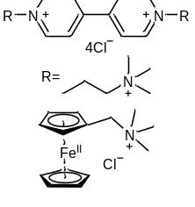 | CD |  | EE | CU | CD |  | EE | CU | This work
M-QCTF |  | 40 |  | 91.86 | 98.70 | 100 |  | 85.30 | 98.05 | This work
M-QCTF |  | 80 |  | 85.90 | 96.11 | 200 |  | 76.94 | 94.33 | This work
M-QCTF |  | 120 |  | 78.49 | 94.98 | 300 |  | 69.08 | 89.91 | This work
M-QCTF |  | 160 |  | 69.78 | 87.40 | 400 |  | 59.10 | 79.78 | This work
M-QCTF |  | 200 |  | 61.17 | 80.10 | 500 |  | 49.65 | 58.78 | This work
M-QCTF |  | 240 |  | 50.30 | 58.41 | - |  | - | - | This work
P-QCTF |  | 0.1 M anolyte |  |  |  |  |  |  |  | This work
P-QCTF |  | CD |  |  | EE |  |  | CU |  | This work
P-QCTF |  | 40 |  |  | 86.95 |  |  | 96.72 |  | This work
P-QCTF |  | 80 |  |  | 77.81 |  |  | 93.91 |  | This work
P-QCTF |  | 120 |  |  | 66.64 |  |  | 88.49 |  | This work
P-QCTF |  | 160 |  |  | 57.58 |  |  | 80.14 |  | This work
P-QCTF |  | 180 |  |  | 53.63 |  |  | 75.13 |  | This work
P-QCTF |  | 220 |  |  | 42.41 |  |  | 23.73 |  | This work
QCTF |  | 0.1 M anolyte |  |  |  |  |  |  |  | This work
QCTF |  | CD |  |  | EE |  |  | CU |  | This work
QCTF |  | 40 |  |  | 85.43 |  |  | 94.71 |  | This work
QCTF |  | 80 |  |  | 71.61 |  |  | 90.41 |  | This work
QCTF |  | 120 |  |  | 61.53 |  |  | 84.78 |  | This work
QCTF |  | 160 |  |  | 52.86 |  |  | 70.68 |  | This work
QCTF |  | 180 |  |  | 44.94 |  |  | 46.79 |  | This work
Selemion® DSV |  | 0.5 M anolyte |  |  |  |  |  |  |  | This work
Selemion® DSV |  | CD |  |  | EE |  | CU |  |  | This work
Selemion® DSV |  | 60 |  |  | 80.29 |  | 97.15 |  |  | This work
Selemion® DSV |  | 80 |  |  | 75.5 |  | 96.88 |  |  | This work
Selemion® DSV |  | 100 |  |  | 70.89 |  | 95.68 |  |  | This work
Selemion® DSV |  | 120 |  |  | 66.2 |  | 93.48 |  |  | This work
Selemion® DSV |  | 160 |  |  | 57.25 |  | 83.45 |  |  | This work
Selemion® DSV |  | 200 |  |  | 47.6 |  | 57.06 |  |  | This work
Selemion® AMV |  | 0.5 M anolyte |  |  |  |  |  |  |  | This work
Selemion® AMV |  | CD |  |  | EE |  | CU |  |  | This work
Selemion® AMV |  | 40 |  |  | 75.97 |  | 93.98 |  |  | This work
Selemion® AMV |  | 60 |  |  | 67.3 |  | 93.81 |  |  | This work
Selemion® AMV |  | 80 |  |  | 69.13 |  | 88.8 |  |  | This work
Selemion® AMV |  | 100 |  |  | 50 |  | 60.74 |  |  | This work
Selemion® AMV |  | 120 |  |  | 38.09 |  | 20.15 |  |  | This work
Selemion® DSV | 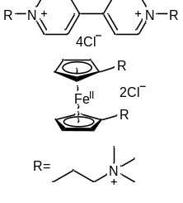 | 1.3 M anolyte |  |  |  |  |  |  |  | (25)
Selemion® DSV |  | CD |  |  | EE |  | CU |  |  | (25)
Selemion® DSV |  | 25 |  |  | 81.84 |  | 96.3 |  |  | (25)
Selemion® DSV |  | 50 |  |  | 66.78 |  | 91.97 |  |  | (25)
Selemion® DSV |  | 75 |  |  | 54.03 |  | 84.97 |  |  | (25)
Selemion® DSV |  | 100 |  |  | 43.83 |  | 71.24 |  |  | (25)
Selemion® DSV |  | 125 |  |  | 36.01 |  | 46.54 |  |  | (25)
Selemion® DSV |  | 150 |  |  | 29 |  | 6.51 |  |  | (25)
Selemion® DSV | 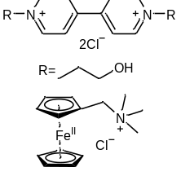 | 0.1 M anolyte |  |  |  | 2.0 M anolyte |  |  |  | (26)
Selemion® DSV |  | CD | EE |  | CU | CD | EE |  | CU | (26)
Selemion® DSV |  | 20 | 89.78 |  | not given | 80 | 63.08 |  | not given | (26)
Selemion® DSV |  | 40 | 81.16 |  | not given | 100 | 55.26 |  | not given | (26)
Selemion® DSV |  | 60 | 72.66 |  | not given | 120 | 47.45 |  | not given | (26)
Selemion® DSV |  | 80 | 64.18 |  | not given | 140 | 29.82 |  | not given | (26)
Selemion® DSV |  | 100 | 54.32 |  | not given | - | - |  | - | (26)
Selemion® DSV |  | 0.1 M anolyte |  |  |  |  |  |  |  | (26)
Selemion® DSV |  | CD |  |  | EE |  | CU |  |  | (26)
Selemion® DSV |  | 20 |  |  | 90.6 |  | not given |  |  | (26)
Selemion® DSV |  | 40 |  |  | 81.7 |  | not given |  |  | (26)
Selemion® DSV |  | 60 |  |  | 73.2 |  | not given |  |  | (26)
Selemion® DSV |  | 80 |  |  | 64.73 |  | not given |  |  | (26)
Selemion® DSV |  | 100 |  |  | 57.31 |  | not given |  |  | (26)
Selemion® DSV | 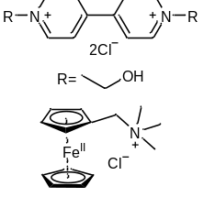 | 0.1 M anolyte |  |  |  |  |  |  |  | (26)
Selemion® DSV |  | CD |  |  | EE |  | CU |  |  | (26)
Selemion® DSV |  | 20 |  |  | 92.11 |  | not given |  |  | (26)
Selemion® DSV |  | 40 |  |  | 83.76 |  | not given |  |  | (26)
Selemion® DSV |  | 60 |  |  | 76.62 |  | not given |  |  | (26)
Selemion® DSV |  | 80 |  |  | 68.82 |  | not given |  |  | (26)
Selemion® DSV |  | 100 |  |  | 61.97 |  | not given |  |  | (26)
Selemion® DSV | 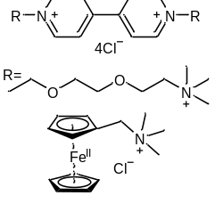 | 0.5 M anolyte |  |  |  | 1 M anolyte |  |  |  | (27)
Selemion® DSV |  | CD | EE |  | CU | CD | EE |  | CU | (27)
Selemion® DSV |  | 60 | 80.23 |  | 84.93 | 40 | 82.94 |  | 93.02 | (27)
Selemion® DSV |  | 80 | 74.63 |  | 77.76 | 60 | 76.61 |  | 82.92 | (27)
Selemion® DSV |  | 100 | 69.36 |  | 67.02 | 80 | 70.73 |  | 72.01 | (27)
Selemion® DSV |  | 120 | 62.92 |  | 53.21 | 100 | 54.19 |  | 54.09 | (27)
Selemion® DSV |  | 2 M anolyte |  |  |  |  |  |  |  | (27)
Selemion® DSV |  | CD |  |  | EE |  | CU |  |  | (27)
Selemion® DSV |  | 60 |  |  | 73.02 |  | 79.48 |  |  | (27)
Selemion® DSV |  | 80 |  |  | 67.05 |  | 50.01 |  |  | (27)
Selemion® DSV |  | 100 |  |  | 60.76 |  | 27.6 |  |  | (27)
Selemion® DSV |  | 120 |  |  | 50.89 |  | 10.1 |  |  | (27)
Selemion® DSV |  | 0.1 M anolyte |  |  |  |  |  |  |  | (20)
Selemion® DSV |  | CD |  |  | EE |  | CU |  |  | (20)
Selemion® DSV |  | 20 |  |  | 89.35 |  | not given |  |  | (20)
Selemion® DSV |  | 40 |  |  | 81.84 |  | not given |  |  | (20)
Selemion® DSV |  | 60 |  |  | 73.58 |  | not given |  |  | (20)
Selemion® DSV |  | 80 |  |  | 65.88 |  | not given |  |  | (20)
Selemion® AMV | 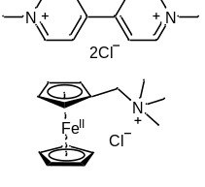 | 0.5 M catholyte |  |  |  |  |  |  |  | (21)
Selemion® AMV |  | CD |  |  | EE |  | CU |  |  | (21)
Selemion® AMV |  | 40 |  |  | 72.06 |  | 82.46 |  |  | (21)
Selemion® AMV |  | 60 |  |  | 60.11 |  | 81.34 |  |  | (21)
Selemion® AMV |  | 80 |  |  | 51.53 |  | 79.7 |  |  | (21)
Selemion® AMV |  | 100 |  |  | 42.05 |  | 76.57 |  |  | (21)
Selemion® AMV | 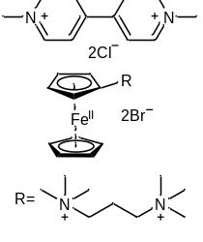 | 0.5 M catholyte |  |  |  |  |  |  |  | (21)
Selemion® AMV |  | CD |  |  | EE |  | CU |  |  | (21)
Selemion® AMV |  | 40 |  |  | 70.47 |  | 98.66 |  |  | (21)
Selemion® AMV |  | 60 |  |  | 57.57 |  | 97.01 |  |  | (21)
Selemion® AMV |  | 80 |  |  | 46.33 |  | 92.69 |  |  | (21)
Selemion® AMV |  | 100 |  |  | 36.22 |  | 81.64 |  |  | (21)
Selemion® AMV | 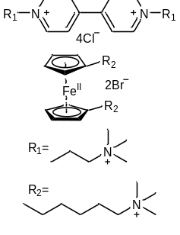 | 1.5 M catholyte |  |  |  |  |  |  |  | (3)
Selemion® AMV |  | CD |  |  | EE |  | CU |  |  | (3)
Selemion® AMV |  | 20 |  |  | 64.04 |  | 79.02 |  |  | (3)
Selemion® AMV |  | 30 |  |  | 53.53 |  | 74.88 |  |  | (3)
Selemion® AMV |  | 40 |  |  | 42.65 |  | 70.24 |  |  | (3)
Selemion® AMV | 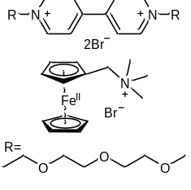 | 0.5 M anolyte |  |  |  |  |  |  |  | (28)
Selemion® AMV |  | CD |  |  | EE |  | CU |  |  | (28)
Selemion® AMV |  | 20 |  |  | not given |  | 91.42 |  |  | (28)
Selemion® AMV |  | 30 |  |  | not given |  | 86.64 |  |  | (28)
Selemion® AMV |  | 40 |  |  | not given |  | 75.67 |  |  | (28)
Selemion® AMV |  | 50 |  |  | not given |  | 52.54 |  |  | (28)
Selemion® AMV |  | 0.1 M anolyte |  |  |  |  |  |  |  | (20)
Selemion® AMV |  | CD |  |  | EE |  | CU |  |  | (20)
Selemion® AMV |  | 20 |  |  | 80.03 |  | not given |  |  | (20)
Selemion® AMV |  | 40 |  |  | 64.64 |  | not given |  |  | (20)
Selemion® AMV |  | 60 |  |  | 46.68 |  | not given |  |  | (20)
AME115 | 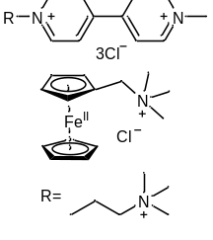 | 0.25 M anolyte |  |  |  |  |  |  |  | (29)
AME115 |  | CD |  |  | EE |  | CU |  |  | (29)
AME115 |  | 40 |  |  | 76.89 |  | 90.22 |  |  | (29)
AME115 |  | 60 |  |  | 66.15 |  | 89.33 |  |  | (29)
AME115 |  | 80 |  |  | 56.31 |  | 86.27 |  |  | (29)
AME115 |  | 100 |  |  | 46.66 |  | 75.82 |  |  | (29)
PIM-TDQTB-100 |  | 0.1 M anolyte |  |  |  |  |  |  |  | (20)
PIM-TDQTB-100 |  | CD |  |  | EE |  | CU |  |  | (20)
PIM-TDQTB-100 |  | 20 |  |  | 91 |  | not given |  |  | (20)
PIM-TDQTB-100 |  | 40 |  |  | 84.3 |  | not given |  |  | (20)
PIM-TDQTB-100 |  | 60 |  |  | 76.95 |  | not given |  |  | (20)
PIM-TDQTB-100 |  | 80 |  |  | 70.08 |  | not given |  |  | (20)
PIM-TDQTB-80 |  | 0.1 M anolyte |  |  |  |  |  |  |  | (20)
PIM-TDQTB-80 |  | CD |  |  | EE |  | CU |  |  | (20)
PIM-TDQTB-80 |  | 20 |  |  | 88.87 |  | not given |  |  | (20)
PIM-TDQTB-80 |  | 40 |  |  | 79.9 |  | not given |  |  | (20)
PIM-TDQTB-80 |  | 60 |  |  | 71.39 |  | not given |  |  | (20)
PIM-TDQTB-80 |  | 80 |  |  | 63.24 |  | not given |  |  | (20)
PIM-TDQTB-50 |  | 0.1 M anolyte |  |  |  |  |  |  |  | (20)
PIM-TDQTB-50 |  | CD |  |  | EE |  | CU |  |  | (20)
PIM-TDQTB-50 |  | 20 |  |  | 86.57 |  | not given |  |  | (20)
PIM-TDQTB-50 |  | 40 |  |  | 75.3 |  | not given |  |  | (20)
PIM-TDQTB-50 |  | 60 |  |  | 64.55 |  | not given |  |  | (20)
PIM-TDQTB-50 |  | 80 |  |  | 54.59 |  | not given |  |  | (20)
PIM-TDQTB-20 |  | 0.1 M anolyte |  |  |  |  |  |  |  | (20)
PIM-TDQTB-20 |  | CD |  |  | EE |  | CU |  |  | (20)
PIM-TDQTB-20 |  | 20 |  |  | 75.81 |  | not given |  |  | (20)
PIM-TDQTB-20 |  | 40 |  |  | 56.71 |  | not given |  |  | (20)
PIM-TDQTB-20 |  | 60 |  |  | 30.26 |  | not given |  |  | (20)

References
1. P. Zuo et al., Near-frictionless ion transport within triazine framework membranes. Nature 617, 299-305 (2023).
2. Y. Liu et al., A long-lifetime all-organic aqueous flow battery utilizing TMAP-TEMPO radical. Chem 5, 1861-1870 (2019).
3. Y. Liu et al., Designer ferrocene catholyte for aqueous organic flow batteries. ChemSusChem 14, 1295-1301 (2021).
4. X. Zhu et al., A superacid-catalyzed synthesis of porous membranes based on triazine frameworks for CO₂ separation. J. Am. Chem. Soc. 134, 10478-10484 (2012).
5. W. Song et al., Upscaled production of an ultramicroporous anion-exchange membrane enables long-term operation in electrochemical energy devices. Nat. Commun. 14, 2732 (2023).
6. C. Bannwarth et al., GFN2-xTB—an accurate and broadly parametrized self-consistent tight-binding quantum chemical method with multipole electrostatics and density-dependent dispersion contributions. J. Chem.Theory Comput. 15, 1652-1671 (2019).
7. S. Ehlert et al., Robust and efficient implicit solvation model for fast semiempirical methods. J. Chem.Theory Comput. 17, 4250-4261 (2021).
8. C. Bannwarth et al., Extended tight‐binding quantum chemistry methods. WIREs Comput. Mol. Sci. 11, e01493 (2020).
9. W. L. Jorgensen et al., Development and testing of the OPLS all-atom force field on conformational energetics and properties of organic liquids. J. Am. Chem. Soc. 118, 11225-11236 (1996).
10. J. Wang et al., How well does a restrained electrostatic potential (RESP) model perform in calculating conformational energies of organic and biological molecules? J. Comput. Chem. 1, 1049-1074 (2000).
11. A. D. Becke et al., Density-functional thermochemistry. III. The role of exact exchange. J. Chem. Phys. 98, 5648-5652 (1993).
12. S. Grimme et al., Effect of the damping function in dispersion corrected density functional theory. J. Comput. Chem. 32, 1456-1465 (2011).
13. J. Tomasi et al., Quantum mechanical continuum solvation models. Chem. Rev. 105, 2999-3093 (2005).
14. T. Lu et al., Multiwfn: A multifunctional wavefunction analyzer. J. Comput. Chem. 33, 580-592 (2011).
15. J. Zhang et al., Efficient evaluation of electrostatic potential with computerized optimized code. Phys. Chem. Chem. Phys. 23, 20323-20328 (2021).
16. M. J. Abraham et al., GROMACS: High performance molecular simulations through multi-level parallelism from laptops to supercomputers. SoftwareX 1-2, 19-25 (2015).
17. G. A. Tribello et al., PLUMED 2: New feathers for an old bird. Comput. Phys. Commun. 185, 604-613 (2014).
18. J. Lemkul et al., From proteins to perturbed hamiltonians: a suite of tutorials for the GROMACS-2018 molecular simulation package [Article v1.0]. Living J. Comput. Mol. Sci. 1, 5068 (2019).
19. G. Bussi et al., Canonical sampling through velocity rescaling. J. Chem. Phys. 126, 014101 (2007).
20. H. Li et al., Ultra-microporous anion conductive membranes for crossover-free pH-neutral aqueous organic flow batteries. J. Membr. Sci. 668, 121195 (2023).
21. B. Hu et al., Long-cycling aqueous organic redox flow battery (AORFB) toward sustainable and safe energy storage. J. Am. Chem. Soc. 139, 1207-1214 (2017).
22. N. Chen et al., Poly(fluorenyl aryl piperidinium) membranes and ionomers for anion exchange membrane fuel cells. Nat. Commun. 12, 2367 (2021).
23. Z. Yang et al., Highly conductive anion‐exchange membranes from microporous Tröger's base polymers. Angew. Chem. Int. Ed. 55, 11499-11502 (2016).
24. L. Wang et al., Highly soluble TEMPO‐viologen bipolar molecule for ultra‐stable aqueous redox flow batteries. Adv. Funct. Mater., 2310620 (2023).
25. E. S. Beh et al., A neutral pH aqueous organic–organometallic redox flow battery with extremely high capacity retention. ACS Energy Lett. 2, 639-644 (2017).
26. Y. Liu et al., Screening viologen derivatives for neutral aqueous organic redox flow batteries. ChemSusChem 13, 2245-2249 (2020).
27. K. Peng et al., A PEGylated viologen for crossover-free and high-capacity pH-neutral aqueous organic redox flow batteries. Batteries Supercaps 6, e202200426 (2023).
28. Y. Yao et al., Nonionic oligo(ethylene glycol)-substituted viologen negolytes for aqueous organic redox flow batteries. J. Mater. Chem. A 11, 12984-12991 (2023).
29. C. DeBruler et al., Designer two-electron storage viologen anolyte materials for neutral aqueous organic redox flow batteries. Chem 3, 961-978 (2017).

