Supplement Materials
Factors Influencing the Improvement of Environmental Health Literacy in Shanghai Residents: Three Rounds of Cross-sectional Studies from 2020 to 2022.
Fengchan Han ^{a,b1}, Ling Tong ^{a,b1}, Hailei Qian ^{a,b}, Yewen Shi ^{a,b}, Jianghua Zhang ^{a,b}, Chunyang Dong ^{a,b}, Duo Wang ^{a,b}, Feier Chen ^{a,b}, Chen Wu ^{a,b}, Mingjing Xu ^{a,b}, Yongping Liu ^{c}, Jin Su ^{a,b}, Huihui Xu ^{a,b}, Yi He ^{a,b*}, Tian Chen ^{a,b*}, Shaofeng Sui ^{a,b*}

ª: State Environmental Protection Key Laboratory of the Assessment of Effects of Emerging Pollutants on Environmental and Human Health, Shanghai Municipal Center for Disease Control and Prevention, Shanghai 200336, China
^{b}: Department of Environmental Health, Shanghai Municipal Center for Disease Control and Prevention, Shanghai 200336, China
^{c}: Putuo District Center for Disease Control and Prevention, Shanghai 200333, China

*Corresponding authors. He Yi, Shanghai Municipal Center for Disease Control and Prevention. E-mail address: heyi@scdc.sh.cn; Chen Tian, Department of Environmental Health, Shanghai Municipal Center for Disease Control and Prevention. E-mail address: chentian@scdc.sh.cn; Sui Shaofeng, Department of Environmental Health, Shanghai Municipal Center for Disease Control and Prevention. E-mail address: suishaofeng@scdc.sh.cn

¹ These authors contribute equally to this article.
Table and figure legends:

Table S1 The proportional distribution of the investigation population information.
Table S2 The proportion ratio and number of investigation population in each investigation unit
Table S3 The number of investigation population in each investigation unit for new plan
Table S4 The knowledge content covering in three dimensions of categorical EHL.
Table S5 The linear regression relationship between the total score of EHL and its three dimensions
Table S6 Associations between individual scores and related factors by univariate generalized linear regression analysis.
Table S7 The Second categorical EHL in different subgroups.

Fig. S1. The detail sampling steps of instigation.
Fig. S2. The workflow chart of investigation
Fig. S3 The total scores of EHL in subgroup layering by various factors.
Fig. S4 Adjusted OR with 95% CI for EHL among subgroup in population Shanghai layered by investigation years.

Table S1 showed the details of the proportion distribution of the surveyed population, and the number of community residents committee or administrative village in each district.
Table S1 The proportional distribution of the investigation population information.
Study districts | Permanent  population  (person) | Population density (person/square kilometer) | Proportion of total investigation population (%) | Number of investigation population(person) | Number of investigation unit *
Huangpu | 653,800 | 31955 | 6.14 | 215 | 5
Xuhui | 1,084,400 | 19803 | 10.18 | 356 | 8
Changning | 694,000 | 18120 | 6.51 | 228 | 5
Putuo | 1,281,900 | 23380 | 12.03 | 421 | 9
Yangpu | 1,312,700 | 21615 | 12.32 | 431 | 9
Jinshan | 805,000 | 1374 | 7.56 | 264 | 6
Songjiang | 1,762,200 | 2910 | 16.54 | 579 | 12
Qingpu | 1,219,000 | 1819 | 11.44 | 400 | 8
Fengxian | 1,152,000 | 1676 | 10.81 | 378 | 8
Chongming | 688,100 | 580 | 6.46 | 226 | 5
Sum | 10,653,100 | - | 100 | 3500 | 75
Investigation unit *: each neighborhood committee or village committee was an investigation unit.
Number of investigation unit = Number of investigation population /50 (the decimals round up as integer), which 50 denoted as number of survey people for per survey unit.

Table S2 showed the proportion and number of surveyed population stratified by age for each investigation unit in 2020.
Table S2 The proportion ratio and number of investigation population in each investigation unit
Study districts | Age proportion（%） |  |  |  | Number of investigation population (person) ª
Study districts | 15-34 | 35-49 | 50-69 |  | 15-34 | 35-49 | 50-69
Huangpu | 23.69 | 24.92 | 51.39 |  | 12 | 13 | 26
Xuhui | 26.58 | 28.71 | 44.71 |  | 14 | 15 | 23
Changning | 24.41 | 27.59 | 48.00 |  | 13 | 14 | 24
Putuo | 22.20 | 26.56 | 51.23 |  | 12 | 14 | 26
Yangpu | 26.76 | 24.72 | 48.51 |  | 14 | 13 | 25
Jinshan | 22.36 | 28.91 | 48.73 |  | 12 | 15 | 25
Songjiang | 26.66 | 30.74 | 42.60 |  | 14 | 16 | 22
Qingpu | 23.47 | 29.46 | 47.06 |  | 12 | 15 | 24
Fengxian | 22.50 | 30.00 | 47.49 |  | 12 | 15 | 24
Chongming | 21.12 | 27.32 | 51.55 |  | 11 | 14 | 26
ª: The number of investigation population in each age group is the total number of male and female with the proportion of 50% (the decimals round up as integer), respectively.

Shanghai selected three urban districts (Huangpu, Yangpu, and Jing’an) and three suburban districts (Jinshan, Fengxian, and Baoshan) as representatives to participate in the national survey. Table S3 showed the requirements about the age of the population surveyed in each investigation.
Table S3 The number of investigation population in each investigation unit for new plan
Age | Gender |  | Sum (person)
Age | Male (person) | Female (person) | Sum (person)
15-17 | 2 | 2 | 4
18-34 | 9 | 9 | 18
35-49 | 9 | 9 | 18
55-69 | 10 | 10 | 20
Sum (person) | 30 | 30 | 60

Table S4 shown the key elements covered by the EHL questionnaire at each level.
Table S4 The knowledge content covering in three dimensions of categorical EHL.
First-level EHL | Second-level EHL | Third -level EHL
Basic concepts | Basic cognition | Basic knowledge and understanding of the relationship between the environment and health, basic concepts
 | Basic attitude | Prevention concept; Conscientiousness
Basic knowledge | Scientific knowledge | Scientific knowledge between health and air, soil, water, radiation, noise, ocean, biodiversity, climate change, domestic garbage, toxic harmful substances, etc..
 | Behavioral knowledge | Green and healthy lifestyles and behaviors about reducing pollution generation, practicing green consumption, classifying and disposing of household waste, protecting natural ecology; obtaining information proactively.
Basic skills | Cognitive skills | Ability to acquire, identify, understand, and utilize environmental and health information
 | Operating skills | Emergency skills, The monitoring and safeguarding skills in the event of environmental and health incidents

Linear regression was aimed to describe the relationship between the level of EHL and the basic concepts, basic knowledge, and basic skills. Table S5 showed the standardized coefficients.
Table S5 The linear regression relationship between the total score of EHL and its three dimensions
Years | Dimensions | Unstandardized  Coefficients | Standardized  Coefficients | t | P
2020 | Constant | 2.87E-13 |  | < 0.001 | 1.000
 | Basic concepts | 1.000 | 0.407 | 2.09E8 | < 0.001*
 | Basic knowledge | 1.000 | 0.395 | 2.05E8 | < 0.001*
 | Basic skills | 1.000 | 0.366 | 1.99E8 | < 0.001*
2021 | Constant | 2.35E-13 |  | < 0.001 | 1.000
 | Basic concepts | 1.000 | 0.384 | 2.47E8 | < 0.001*
 | Basic knowledge | 1.000 | 0.423 | 2.68E8 | < 0.001*
 | Basic skills | 1.000 | 0.336 | 2.26E8 | < 0.001*
2022 | Constant | -0.092 |  | -2.713 | 0.007
 | Basic concepts | 1.015 | 0.285 | 398.527 | < 0.001*
 | Basic knowledge | 1.001 | 0.499 | 652.500 | < 0.001*
 | Basic skills | 0.997 | 0.338 | 450.124 | < 0.001*
2020-2022 | Constant | -0.023 |  | -3.880 | < 0.001*
 | Basic concepts | 0.999 | 0.396 | 3646.333 | < 0.001*
 | Basic knowledge | 1.003 | 0.461 | 3785.182 | < 0.001*
 | Basic skills | 1.000 | 0.354 | 2770.579 | < 0.001*
*: P<0.05, have statistical differences.

Univariate generalized linear regression analyses were conducted to analyze the factors affecting the scores. The results were shown in Table S6.
Table S 6 Associations between individual scores and related factors by univariate generalized linear regression analysis.
 | Variable | Factors | β | S _{β} | 95% CI |  | Wald χ² value | P value
 | Years | 2020 | Ref.
 |  | 2021 | 6.488 | 0.387 | 5.730 ~ 7.245 |  | 281.600 | <0.001*
 |  | 2022 | 6.850 | 0.497 | 5.879 ~7.824 |  | 189.886 | <0.001*
 | Areas | Urban | Ref.
 |  | Suburban | -0.407 | 0.358 | -0.295 ~ 1.109 |  | 1.290 | 0.256
 | Sex | Male | Ref.
 |  | Female | -0.423 | 0.358 | -1.124~ 0.297 |  | 1.395 | 0.238
 | Age | 15-17 | Ref.
 |  | 18-34 | -0.433 | 0.824 | -2.047 ~ 1.182 |  | 0.276 | 0.600
 |  | 35-49 | -3.244 | 0.820 | -4.851~ -1.638 |  | 15.670 | <0.001*
 |  | 50-65 | -9.503 | 0.807 | -11.084 ~ -7.922 |  | 138.789 | <0.001*
 | Ethnic | Han nationality | Ref.
 |  | Others | 2.715 | 2.036 | -1.275 ~ 6.705 |  | 1.779 | 0.182
 | Education | Primary school and below | Ref.
 | level | Junior high school | 4.262 | 0.746 | 2.800 ~ 5.724 |  | 32.642 | <0.001*
 |  | Senior high school | 8.831 | 0.729 | 7.402 ~ 10.259 |  | 146.834 | <0.001*
 |  | Junior college /Undergraduate | 13.734 | 0.711 | 12.341 ~ 15.128 |  | 373.248 | <0.001*
 |  | Postgraduate and above | 14.345 | 1.491 | 11.424 ~ 17.267 |  | 92.629 | <0.001*
 | Occupation | Farmer | Ref.
 |  | Labors in city | 8.647 | 0.767 |  | 7.145 ~ 10.149 | 127.277 | <0.001*
 |  | Civil servants and leaders | 11.605 | 1.056 | 9.535 ~ 13.676 |  | 120.738 | <0.001*
 |  | Students | 12.443 | 0.948 | 10.585 ~ 14.301 |  | 172.287 | <0.001*
 |  | Retirees | 1.757 | 0.811 | 0.169 ~ 3.346 |  | 4.700 | 0.037*
 |  | Others | 8.744 | 0.969 | 6.846 ~ 10.643 |  | 81.474 | 0.004*
 | Per capita | < 5500 | Ref.
 | monthly income | 5500 ~ 12999 | 4.063 | 0.440 | 3.201 ~ 4.926 |  | 85.261 | <0.001*
 | (Yuan) *# | 13000 ~ 20999 | 5.232 | 0.647 | 3.963 ~ 6.501 |  | 65.319 | 0.176
 |  | ＞ 21000 | 7.132 | 0.848 | 5.469~ 8.795 |  | 70.669 | 0.001*
#: Results from 2020-2021.
*: P<0.05, have statistical differences.

Table S7 showed the levels of the secondary categorical EHL for the other subgroups.
Table S7 The second categorical EHL in different subgroups.
 | Variable | Factors | Second categorical EHL
 | Variable | Factors | Basic cognition | Basic Attitude | Scientific knowledge | Behavioral knowledge | Cognition skills | Operating skills
 | Areas | Suburban | 39.33% | 53.30% | 17.54% | 34.38% | 64.44% | 22.38%
 |  | Urban | 40.11% | 51.13% | 19.80% | 35.55% | 68.52% | 24.36%
 |  | χ² | 0.531 | 3.942 | 7.032 | 1.263 | 15.526 | 4.589
 |  | P | 0.466 | 0.047 | 0.008* | 0.261 | <0.001* | 0.032*
 | Sex | Male | 39.71% | 51.97% | 19.16% | 34.62% | 66.49% | 23.62%
 |  | Female | 39.71% | 52.53% | 18.11% | 35.26% | 66.33% | 23.05%
 |  | χ² | <0.001 | 0.270 | 1.516 | 0.377 | 0.023 | 0.371
 |  | P | 0.999 | 0.604 | 0.218 | 0.539 | 0.880 | 0.543
 | Age | 15-17 | 41.40% | 61.99% | 27.38% | 54.30% | 74.43% | 26.92%
 |  | 18-34 | 48.94% | 60.61% | 23.09% | 41.20% | 74.97% | 28.71%
 |  | 35-49 | 41.13% | 53.94% | 19.72% | 36.81% | 68.57% | 24.81%
 |  | 50-65 | 31.49% | 43.33% | 13.21% | 26.07% | 57.22% | 17.67%
 |  | χ² | 172.838 | 183.953 | 114.894 | 224.367 | 211.999 | 99.401
 |  | P | <0.001* | <0.001* | <0.001* | <0.001* | <0.001* | <0.001*
 | Ethnic | Han nationality | 39.62% | 52.22% | 18.64% | 34.91% | 66.33% | 23.25%
 |  | Others | 100.00% | 56.92% | 16.92% | 38.46% | 76.92% | 33.85%
 |  | χ² | 3.347 | 0.573 | 0.126 | 0.357 | 3.245 | 4.046
 |  | P | 0.067 | 0.449 | 0.723 | 0.550 | 0.072 | 0.44
 | Occupation | Farmer | 26.88% | 44.17% | 12.08% | 22.29% | 47.08% | 12.08%
 |  | Larbors in city | 42.65% | 55.75% | 19.13% | 37.17% | 69.27% | 25.24%
 |  | Civil servants and leaders | 53.49% | 62.09% | 18.14% | 40.70% | 78.37% | 27.91%
 |  | Students | 44.93% | 60.94% | 29.66% | 51.10% | 75.33% | 28.34%
 |  | Retiree | 31.28% | 40.72% | 12.62% | 26.36% | 58.26% | 17.85%
 |  | Others | 40.98% | 54.80% | 27.48% | 34.96% | 69.59% | 27.80%
 |  | χ² | 148.315 | 175.992 | 147.335 | 190.595 | 208.584 | 96.729
 |  | P | <0.001* | <0.001* | <0.001* | <0.001* | <0.001* | <0.001*
 | Education | Primary school and below | 25.87% | 38.02% | 10.24% | 23.61% | 41.84% | 14.06%
 | level | Junior high school | 29.69% | 44.07% | 13.61% | 28.25% | 57.32% | 16.64%
 |  | Senior high school | 33.96% | 49.14% | 22.25% | 32.15% | 65.42% | 24.63%
 |  | Junior college /Undergraduate | 51.74% | 61.14% | 20.00% | 42.92% | 76.50% | 27.50%
 |  | Postgraduate and above | 56.52% | 72.46% | 28.26% | 37.68% | 76.81% | 35.51%
 |  | χ² | 374.255 | 234.072 | 92.535 | 170.773 | 384.269 | 121.664
 |  | P | <0.001* | <0.001* | <0.001* | <0.001* | <0.001* | <0.001*
 | Per capita | < 5500 | 36.73% | 45.81% | 8.11% | 33.44% | 60.58% | 15.70%
 | monthly | 5500 ~ 12999 | 45.14% | 52.47% | 10.31% | 37.25% | 69.69% | 21.55%
 | income | 13000 ~ 20999 | 45.55% | 57.18% | 12.93% | 41.28% | 72.24% | 24.56%
(Yuan) |  | ＞ 21000 | 51.16% | 55.26% | 14.44% | 37.97% | 73.98% | 28.88%
 |  | χ² | 63.157 | 49.297 | 48.544 | 31.323 | 80.901 | 65.436
 |  | P | <0.001* | <0.001* | <0.001* | <0.001* | <0.001* | <0.001*
*: P<0.05, have statistical differences.
Detailed sampling steps were shown as Figure S1.

Figure S1
Shanghai of China
First round: 2020
Second and third round: 2022-2022
Multistage cluster random sampling method
Dividing urban districts (A) and rural districts (B)
Shanghai work plan
National work plan
Random
Total sample size: at least 3500
A: Xuhui, Changning, Huangpu, Putuo, and Yangpu
B: Songjiang, Qingpu, Fengxian, Jinshan, Chongming

Total sample size: at least 2880 ^{b}/1440 ^{c}
A: Huangpu, Yangpu, and Jing’an
B: Jinshan, Fengxian, and Baoshan
Investigation units ª：(5-12)
neighborhood / villages committees
Investigation units:（8^{b}/4^{c}）
neighborhood / villages committees
Households：(60)
Each investigation units
Households：(75)
Each investigation units
One respondent in each households：
(at least 50 persons in each unit)
One respondent in each households：
(at least 60 persons in each unit)
Valid questionnaires:
3722
Valid questionnaires:
3186 ^{b}/ 1440 ^{c}
First stage:
Second stage:
Third stage:
Fourth stage:
Cluster random
Cluster random
Random
Environmental health literacy

Fig. S1. The detail sampling steps of instigation.
A: Representing central urban areas (Xuhui, Changning, Huangpu, Putuo, Yangpu and Jin’an).
B: Representing rural areas (Songjiang, Qingpu, Fengxian, Jinshan, Baoshan and Chongming).
a: Considering local population proportion, various number of investigation units in different districts; b: number in 2021; c: number in 2022.
A flowchart of the investigation is shown as Fig. S2

Fig. S2
Selected survey subjects
Obtained participation intention by phoning or visiting households.
Have an approving communication response?
Questionnaire investigation
Yes
Informed consent
Agree
Recorded the results and ended survey
Review, date analysis and summary
Finished
Households
Community Health Service Center
Dial or visit again, fail three times treated as losing to follow-up, end the communication and record results.
No
Disagree

Fig. S2. The workflow chart of investigation

The scores were firstly stratified by year of survey, and then by different age groups, educational groups, occupational groups and income groups, respectively. The results showed that there were significant differences in all subgroups (as shown in Fig.S3, a1, b1, c1 and d1). The figure of a2, b2, c2, d2 ( Fig.S3) showed the stratified scores for each age group, education group, occupational group , income group, and the survey year, respectively.
Fig. S3
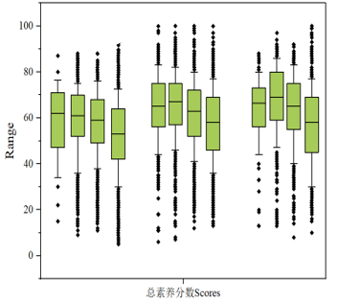
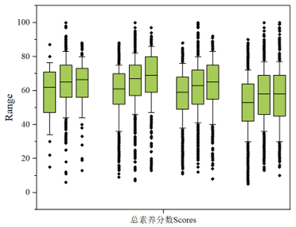
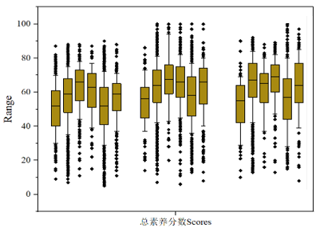
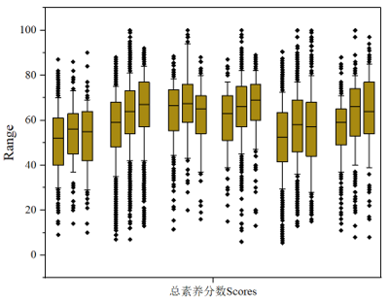
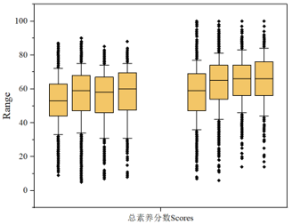
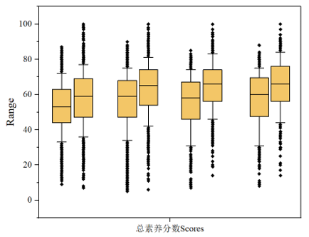
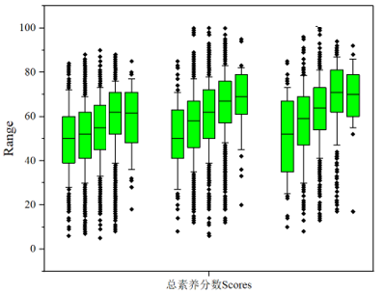
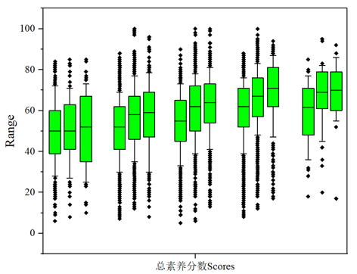
b1
c1
d1
a1
b2
c2
d2
a2
: P25-P75
: P50
: P10-90
2020
2021
2021
2020
2022
2021
2022
2021
2020
2022
2021

S

S
S
S
S
S
S
S
Scores
Scores
Scores
Scores
Scores
Scores
*
*
*
*
*
*
*
*
*
*
*

Age (A, B, C, D)
Income (P, Q, R, S)
)
Occupation (J, K, L, M, N, O)
)
o
s
r
q
p
Education (E, F, G, H, I)
)
n
m
l
k
j
i
h
g
f
e
d
c
b
a

Scores
Scores

*
*
*
*
*
*
*
*
*
*
*
*
#
*
*
*
*
*
#
Years (2020, 2021, 2022)
Years (2020, 2021)
Years (2020, 2021, 2022)
Years (2020, 2021, 2022)
Fig. S3 The total scores of EHL in subgroup layering by various factors.
Note: a1, b1, c1 and d1: denoted the score of firstly layering by investigation year, then by various age groups, education groups, occupation groups and income groups, respectively.
a2, b2, c2 and d2: denoted the score of firstly layering by various age groups, education groups, occupation groups and income groups, then by investigation year, respectively.
A, B, C, D: denoted age groups of 15-17, 18-34, 35-49, 50-69, respectively.
E, F, G, H, I: denoted education groups of the Primary school and below, Junior high school, Senior high school, Junior college /Undergraduate, Postgraduate and above, respectively.
J, K, L, M, N, O: denoted occupation groups of the Farmer, Labors in city, Civil servants and leaders, Students, Retirees, Other, respectively.
P, Q, R, S: denoted income groups of < 5500, 5500 ~ 12999, 13000 ~ 20999, ＞ 21000 Yuan, respectively.
*: P<0.05, have statistical differences. #: P≥0.05, have no statistical differences.
The having EHL rate were shown as following for all participants total three rounds survey: age groups (15-17: 37.78%, 18-34:37.14%, 35-49:28.32%, 50-69:17.70%), education groups (the primary school and below:13.19%, junior high school:15.56%, senior high school:25.99%, junior college /undergraduate:37.17%, postgraduate and above:42.02%), occupation groups (farmer:11.04%, labors in city:29.89%, civil servants and leaders:39.07%, students:41.26%, retiree:17.18%, other:30.73%), income groups ( < 5500:18.48%, 5500 ~ 12999:27.59%, 13000 ~ 20999:30.01%, ＞21000:32.62%)].
The results showed that there were significant differences in all subgroups for the scores, which firstly layering by investigation year, then by various age groups, education groups, occupation groups and income groups, respectively (as shown a1, b1, c1, d1 in Fig.S3)
For the scores of three rounds investigation in figure of a2, b2, c2 and d2 , there were significant differences at age group of 18-34 (H = 128.460, P < 0.001), 35-49 (H = 54.497, P < 0.001), and 50-69 (H = 71.530, P < 0.001) ; at education group of Junior high school (H = 64.644, P < 0.001), Senior high school (H = 133.287, P < 0.001), Junior college /Undergraduate (H = 174.481, P < 0.001), and Postgraduate and above (H = 12.028, P = 0.002); at occupation group of the Farmer (H = 6.188, P = 0.045), Labors in city (H = 198.630, P < 0.001), Civil servants and leaders (H = 6.002, P = 0.050), Students (H = 10.747, P = 0.050) ; Retirees (H = 44.428, P < 0.001); and Other occupations (H = 31.338, P < 0.001) at income group of < 5500 Yuan (H = 61.085, P < 0.001 ), 5500 ~ 12999 Yuan (H = 138.095, P < 0.001), 13000 ~ 20999 Yuan (H = 72.541, P < 0.001), ＞ 21000 Yuan (H = 14.167, P < 0.001).
The results of multiple stratified logistic analyses by survey year almost identical in Fig.S4.
Fig. S4
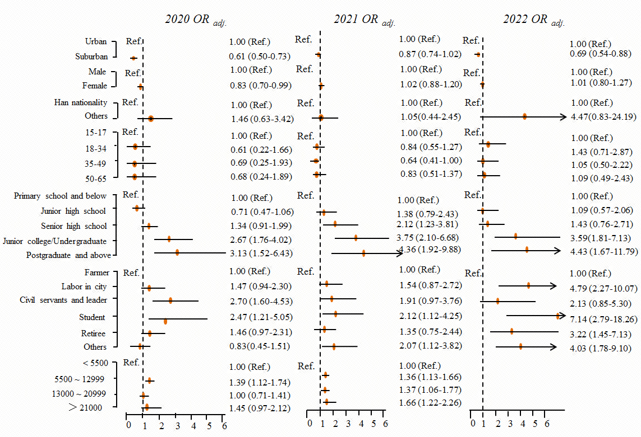Fig. S4 Adjusted OR with 95% CI for EHL among subgroup in population Shanghai layered by investigation years.

References
1. Zhao Y, Sheng Y, Zhou J, Wang H, Chilufya MM, Liu X, Mohamed AO, Han J, Qu C: Influencing factors of residents' environmental health literacy in Shaanxi province, China: a cross-sectional study. BMC Public Health 2022, 22(1):114.
2. Raufman J, Blansky D, Lounsbury DW, Mwangi EW, Lan Q, Olloquequi J, Hosgood HD, 3rd: Environmental health literacy and household air pollution-associated symptoms in Kenya: a cross-sectional study. Environ Health 2020, 19(1):89.
3. Announcement on the Release of Environment and Health Literacy of Chinese Citizens (Trial Implementation) . [EB / OL]. [http://www.mee.gov.cn/ gkml/hbb/bgg/ 201310/ t20131009 _26133 6.htm]
4. Technical Guidelines for the Assessment of Citizen Environmental and Health Literacy (Trial) (Draft for Comments) . [EB / OL]. [http://www.mee.gov.cn/ gkml/hbb/bgg/201706/ t20170608 _41 5684.htm]
5. Action of Healthy China (2019–2030). [EB / OL]. [https://www.gov.cn/xinwen/2019-07/15/ content_5409694.htm.]
6. Results of the First Survey of Chinese Residents’ Environmental HealthLiteracy[EB/OL]. [http://www.mee.gov.cn/ ywgz/ fgbz/hjyjk/gzdt/202008/ t20200810_793281.shtml]
7. Results of the Survey of Chinese Residents’ Environmental Health Literacy in 2022[EB/OL]. [https://www.mee.gov.cn /ywgz/fgbz/hjyjk/gzdt/202311/t20231120_1056812. shtml.]

