Extended Data (Online Supplement)

Optimizing Dementia Risk Reduction: Balancing Sleep and Physical Activity Trade-offs

Contents
eFigure 1. Sample selection

eFigure 2. Causal directed acyclic graph

eFigure 3. Time-use substitutions and total brain volume for normal and short sleepers.

eFigure 4. Time-use substitutions for grey matter volume for normal and short sleepers.

eFigure 5. Time-use substitutions for white matter volume, for normal and short sleepers.

eFigure 6. Time-use substitutions for log white matter hyperintensities for normal and short sleepers.

eFigure 7. All-cause dementia risk ratio for time-use substitutions, with adjustment for the covariates outlined in the main text plus wake after sleep onset.

eFigure 8. All-cause dementia risk ratio for time-use substitutions, with adjustments for the covariates outlined in the main text plus disease history and disease risk factors, including sick/disabled (self-reported employment category), history of diabetes, history of cancer, history of a mental disorder, history of a nervous system disease (excluding severe neurological diseases which are excluded from the sample), history of cardiovascular disease, systolic blood pressure, blood pressure medication, and body mass index.
eFigure 9. All-cause dementia risk ratio for time-use substitutions, truncating the first three years of follow-up.
eFigure 10. All-cause dementia risk ratio for time-use substitutions, correcting for selective participation in the UK Biobank by standardising to a set of representative UK population characteristics.

Full UKB sample (accessed March 2024): n = 502,180

Did not participate in accelerometry sub-study: n = 398,553
Incident dementia analysis
GGIR quality control: n= 4,793
MRI data unavailable: n = 72,130
MRI analysis
Final MRI analysis sample: n = 15,338
MRI study prior to accelerometry study: n = 1,162
Accelerometry data unreliable using UKB criteria (inadequate wear time, poor calibration): n = 9,313
Prevalent dementia or other serious neurodegenerative disease (n = 885)
Valid accelerometry data available: n = 89,521
Final incident dementia analysis sample: n = 88,630

eFigure 1. Sample selection. MRI = magnetic resonance imaging.
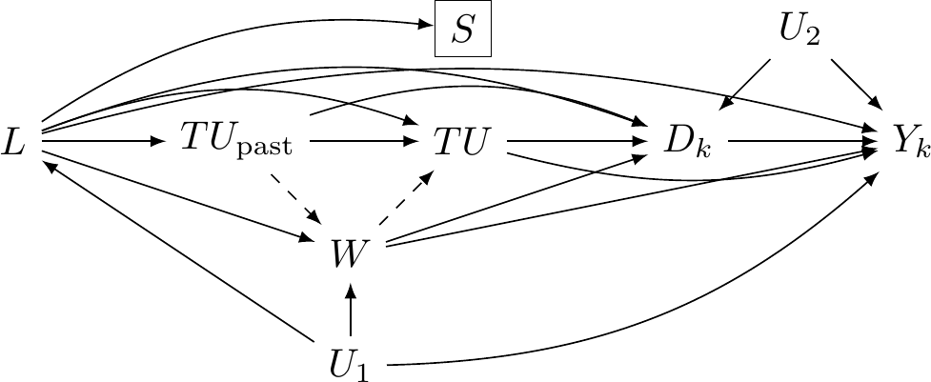
eFigure 2. Causal directed acyclic graph. $TU$ represents time use at baseline and $TU_{past}$ represents time use before the study baseline (unmeasured). $L$ represents the set of confounders, measured at baseline, which are presumed to cause, but not be caused by, 24-hour behaviors. These are: age, sex, education, ethnicity, APOE-e4 genotype, household income, antidepressant, antipsychotic, and sedative medication use, retirement status, and shift work. $W$ is the set of variables that may lie on the causal path between 24-hour behaviors and dementia incidence. These are: history of cardiovascular disease, BMI, blood pressure medication, systolic blood pressure, and sickness or disability (employment category). $S$ represents selection into the accelerometry sample, caused by the variables in $L$. $Y_{k}$ is dementia occurrence at time $k$ of follow-up. $D_{k}$ represents death at time $k$. $U_{1}$ is the set of unmeasured shared causes of $L$, $W$ and $Y_{k}$ and $U_{2}$ is the set of unmeasured shared causes of $D_{k}$ and $Y_{k}$ (e.g., genetics, physiological dysregulation). Paths represent the direction of causal effects between nodes. Dashed lines into and out of W indicate paths that we are uncertain about.

Given this DAG, we are presented with two options for confounder adjustment: adjusting for the variables in $W$ or not adjusting for the variables in $W$ (in addition to adjusting for the variables in $L$). If the path from $TU_{past}$ to $W$ is present, then $W$ is on the causal path between time use and the outcome. In this case, we ought not to adjust for $W$. If the path from $W$ to $TU_{past}$ is present, then $W$ is a confounder. In this case, adjusting for $W$ will eliminate confounding at the expense of introducing bias due to adjusting for possible mediators, if the $TU_{past}$ to $W$ path exists.

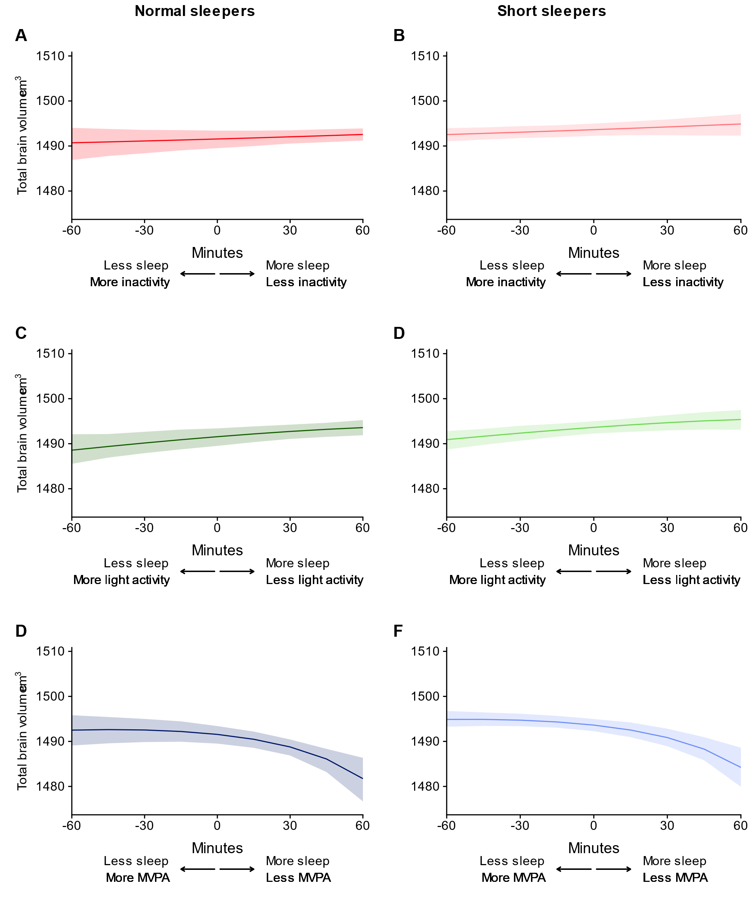eFigure 3. Time-use substitutions and total brain volume for normal and short sleepers. MVPA = moderate to vigorous physical activity. Normal sleepers are defined as persons with ≥6 hours of sleep (0.1% of samples had > 9 hours of sleep). Short sleepers are defined as persons with <6 hours of sleep.

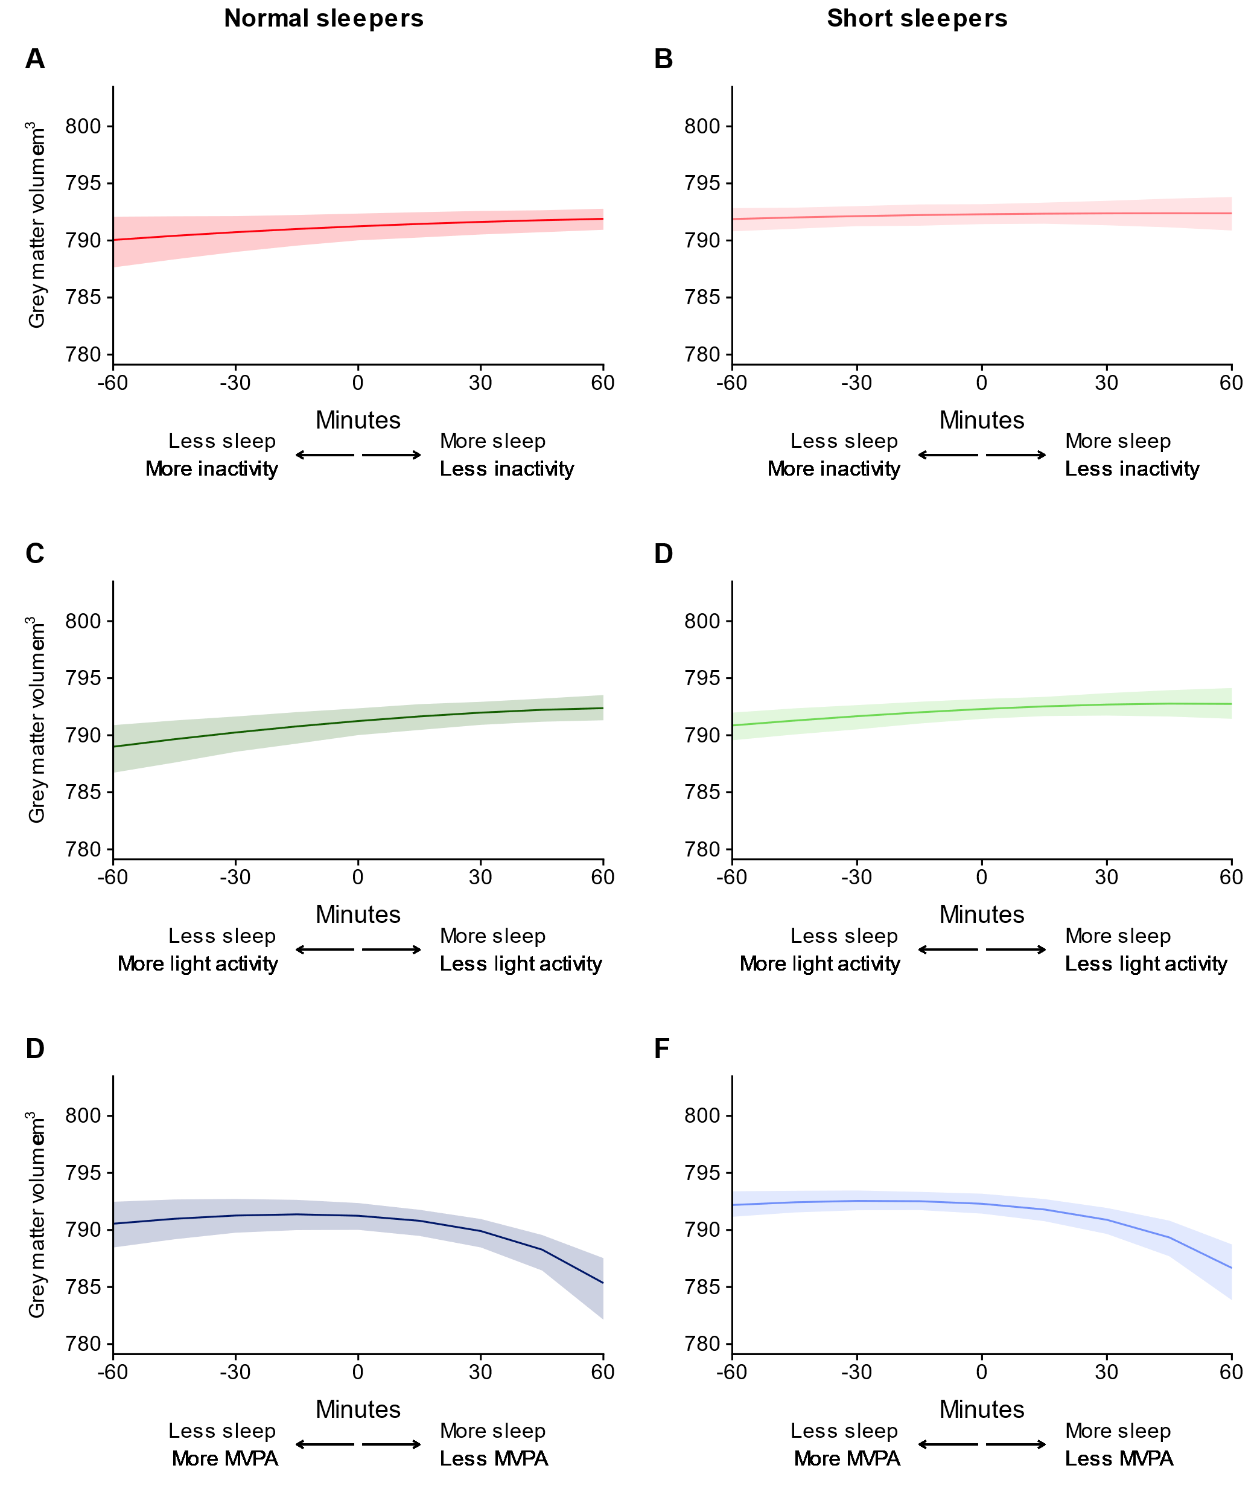eFigure 4. Time-use substitutions for grey matter volume for normal and short sleepers. MVPA = moderate to vigorous physical activity. Normal sleepers are defined as persons with ≥6 hours of sleep (0.1% of samples had > 9 hours of sleep). Short sleepers are defined as persons with <6 hours of sleep.
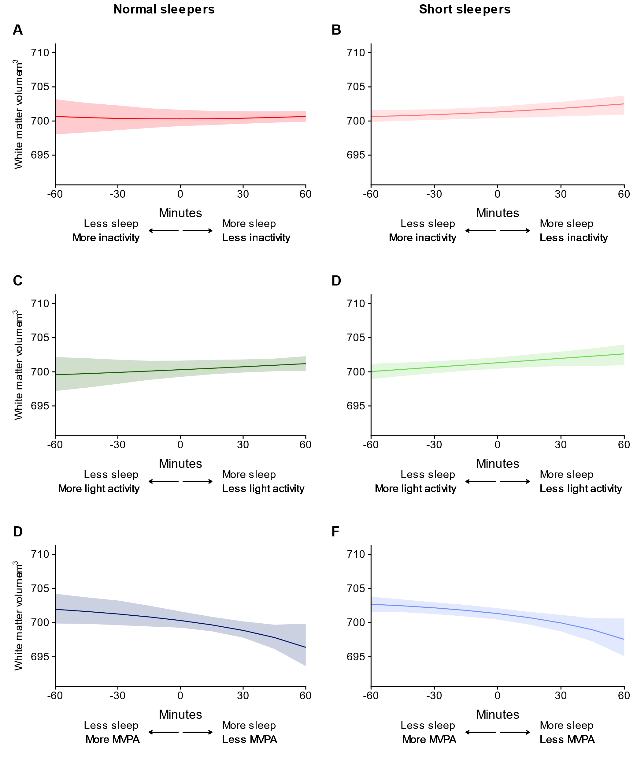eFigure 5. Time-use substitutions for white matter volume, for normal and short sleepers. MVPA = moderate to vigorous physical activity. Normal sleepers are defined as persons with ≥6 hours of sleep (0.1% of samples had > 9 hours of sleep). Short sleepers are defined as persons with <6 hours of sleep.
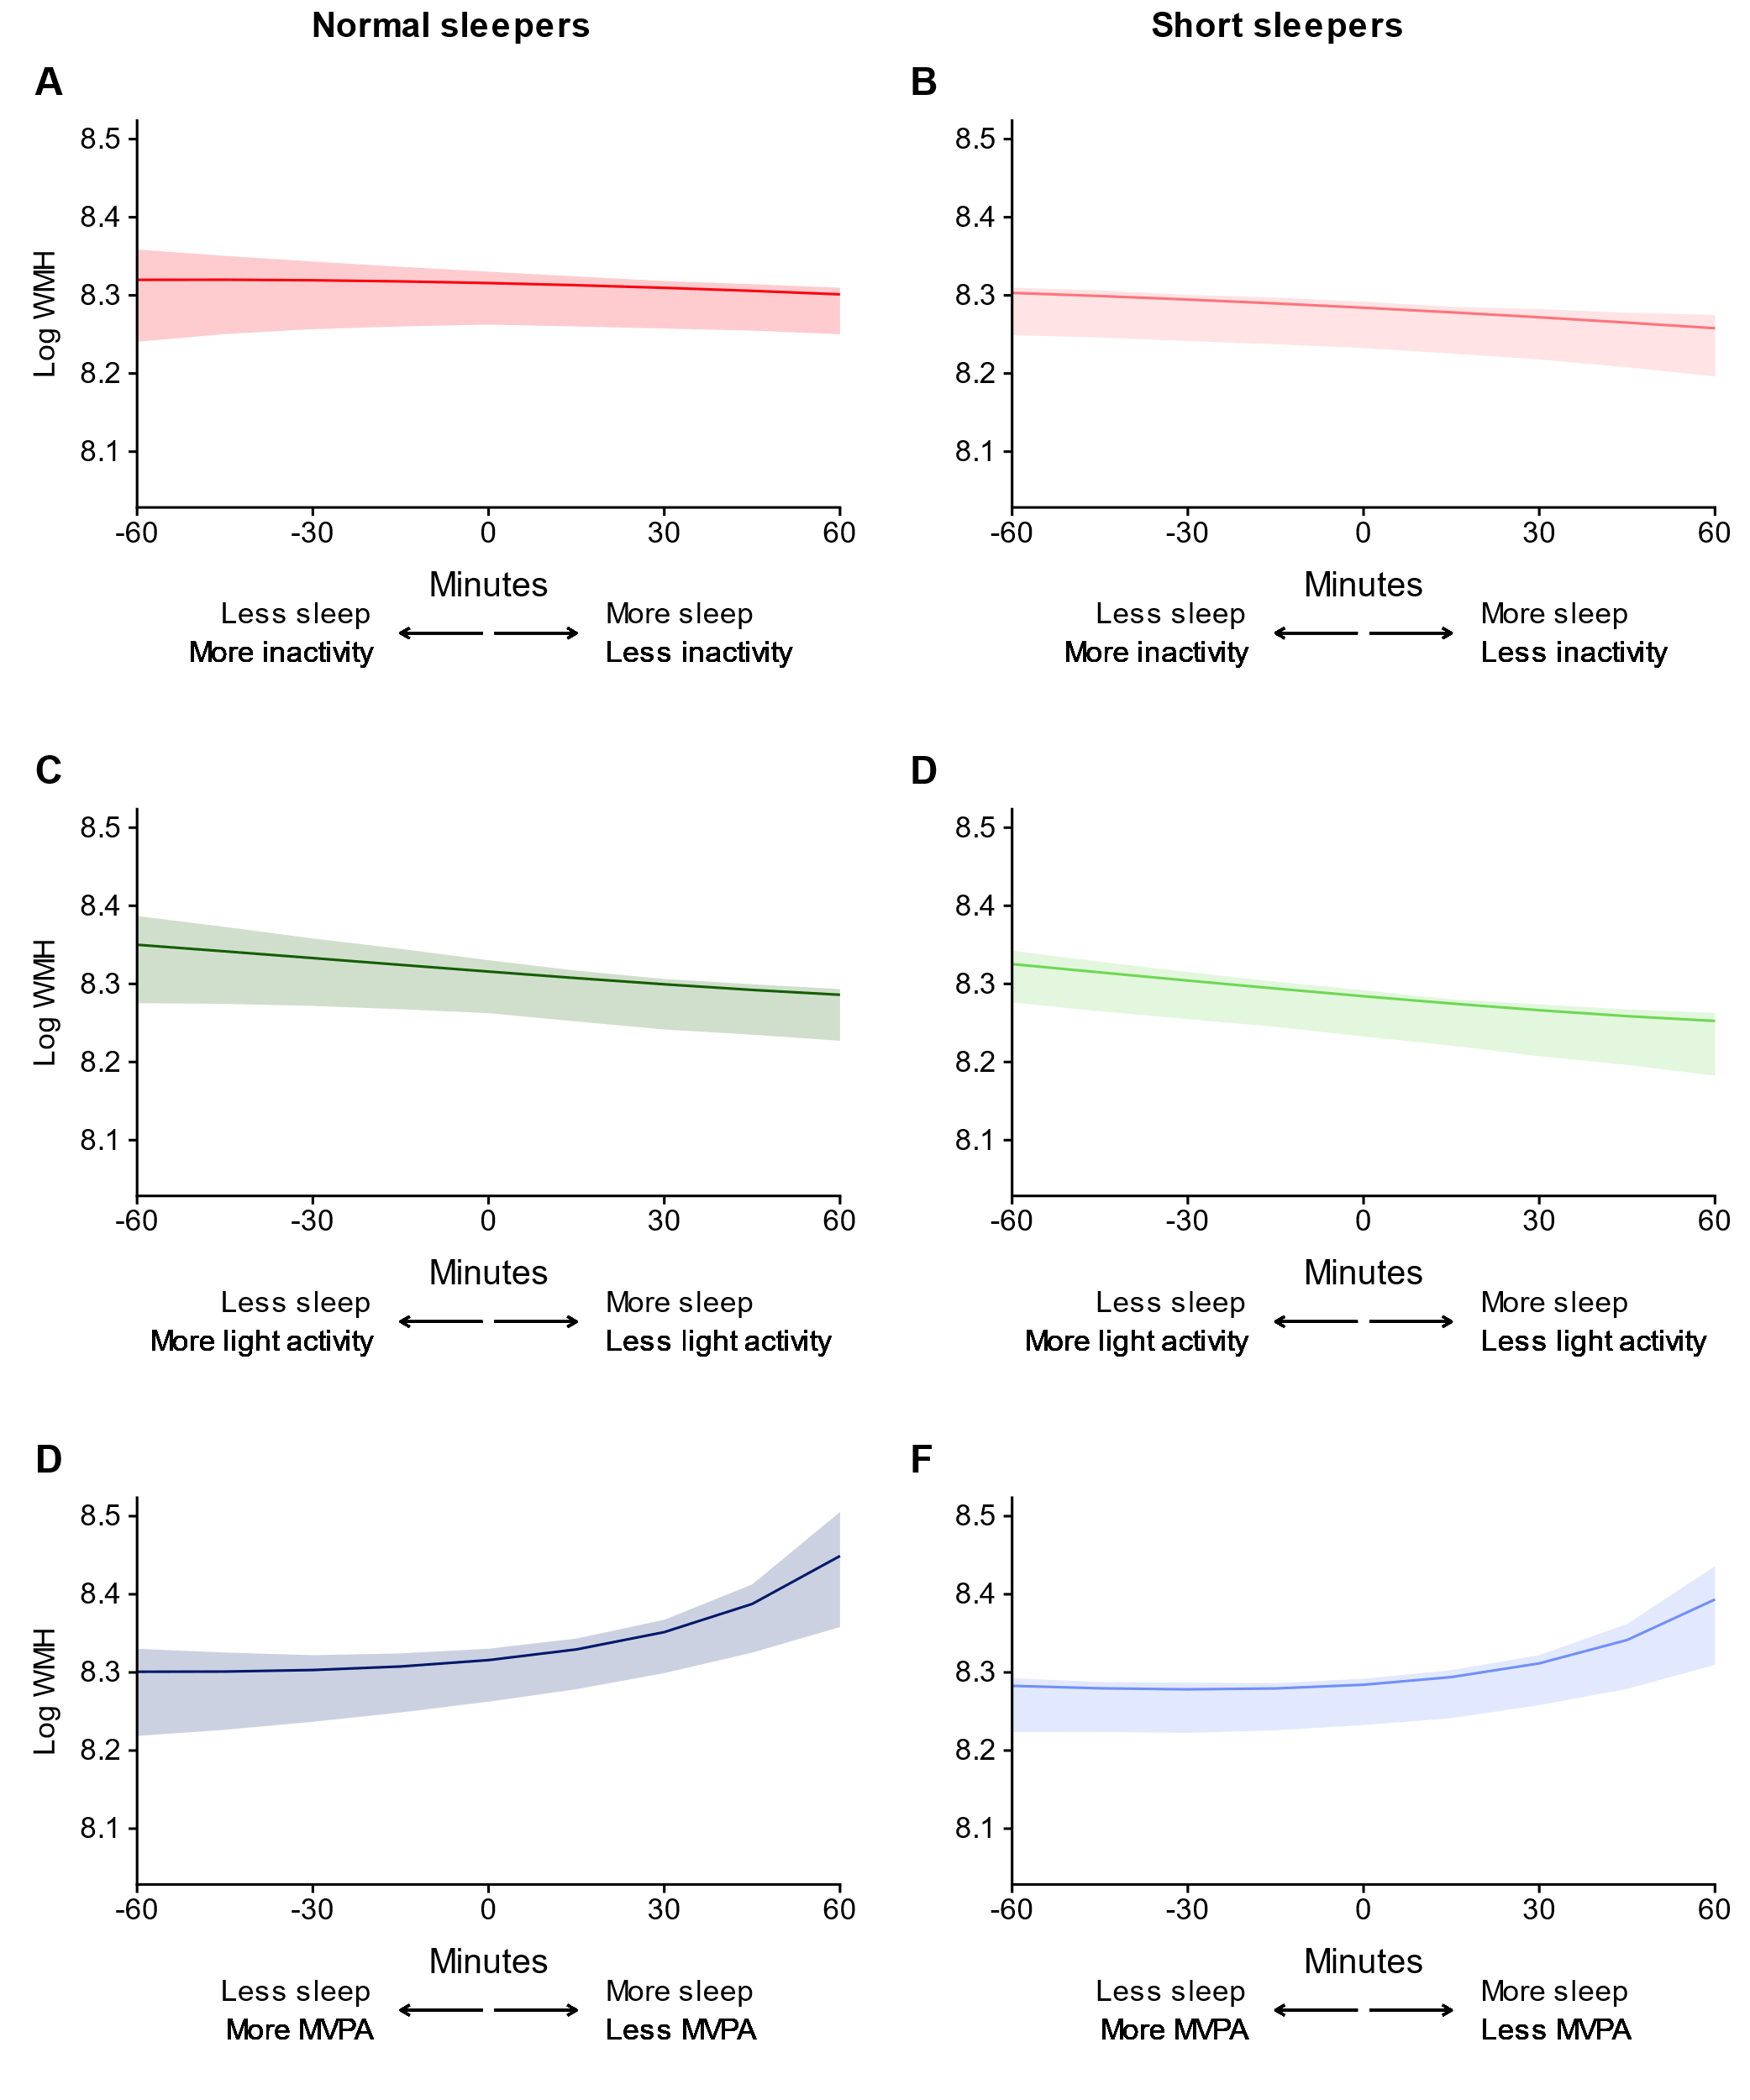eFigure 6. Time-use substitutions for (log) white matter hyperintensities for normal and short sleepers. MVPA = moderate to vigorous physical activity. Normal sleepers are defined as persons with ≥6 hours of sleep (0.1% of samples had > 9 hours of sleep). Short sleepers are defined as persons with <6 hours of sleep.

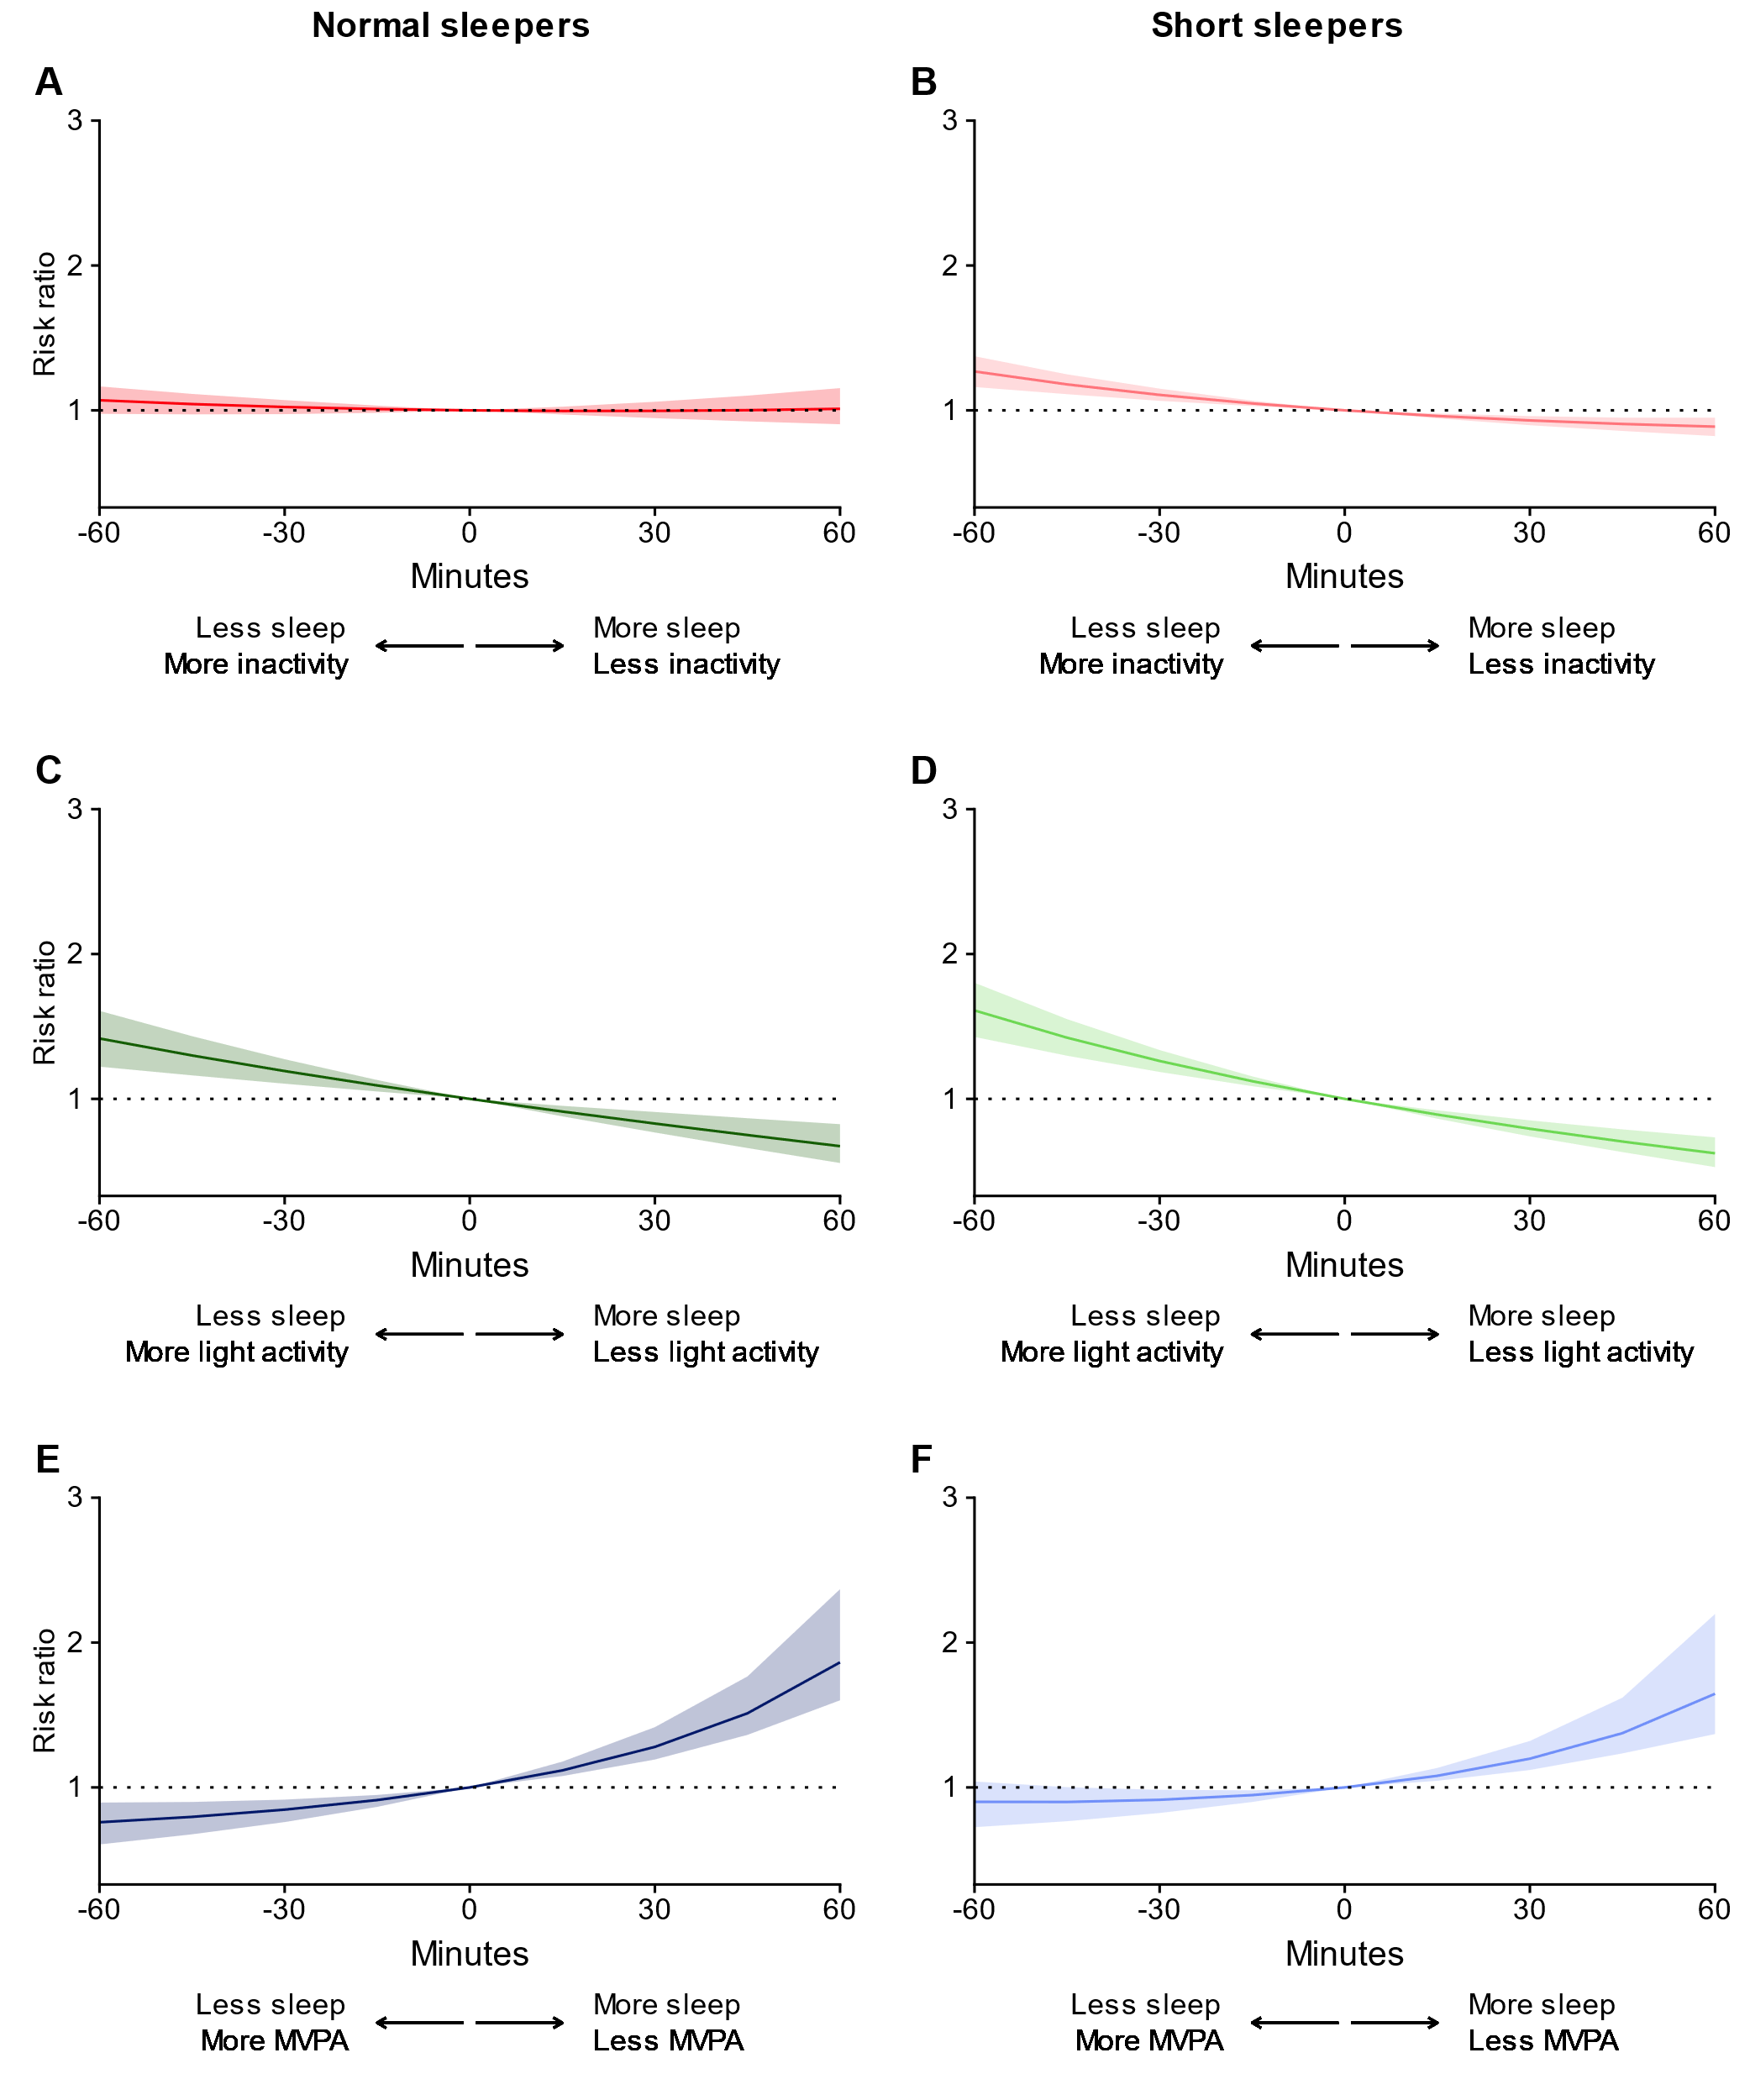eFigure 7. All-cause dementia risk ratio for time-use substitutions, with adjustment for the covariates outlined in the main text plus wake after sleep onset. MVPA = moderate to vigorous physical activity. Normal sleepers are defined as persons with ≥6 hours of sleep (0.1% of samples had > 9 hours of sleep). Short sleepers are defined as persons with <6 hours of sleep.

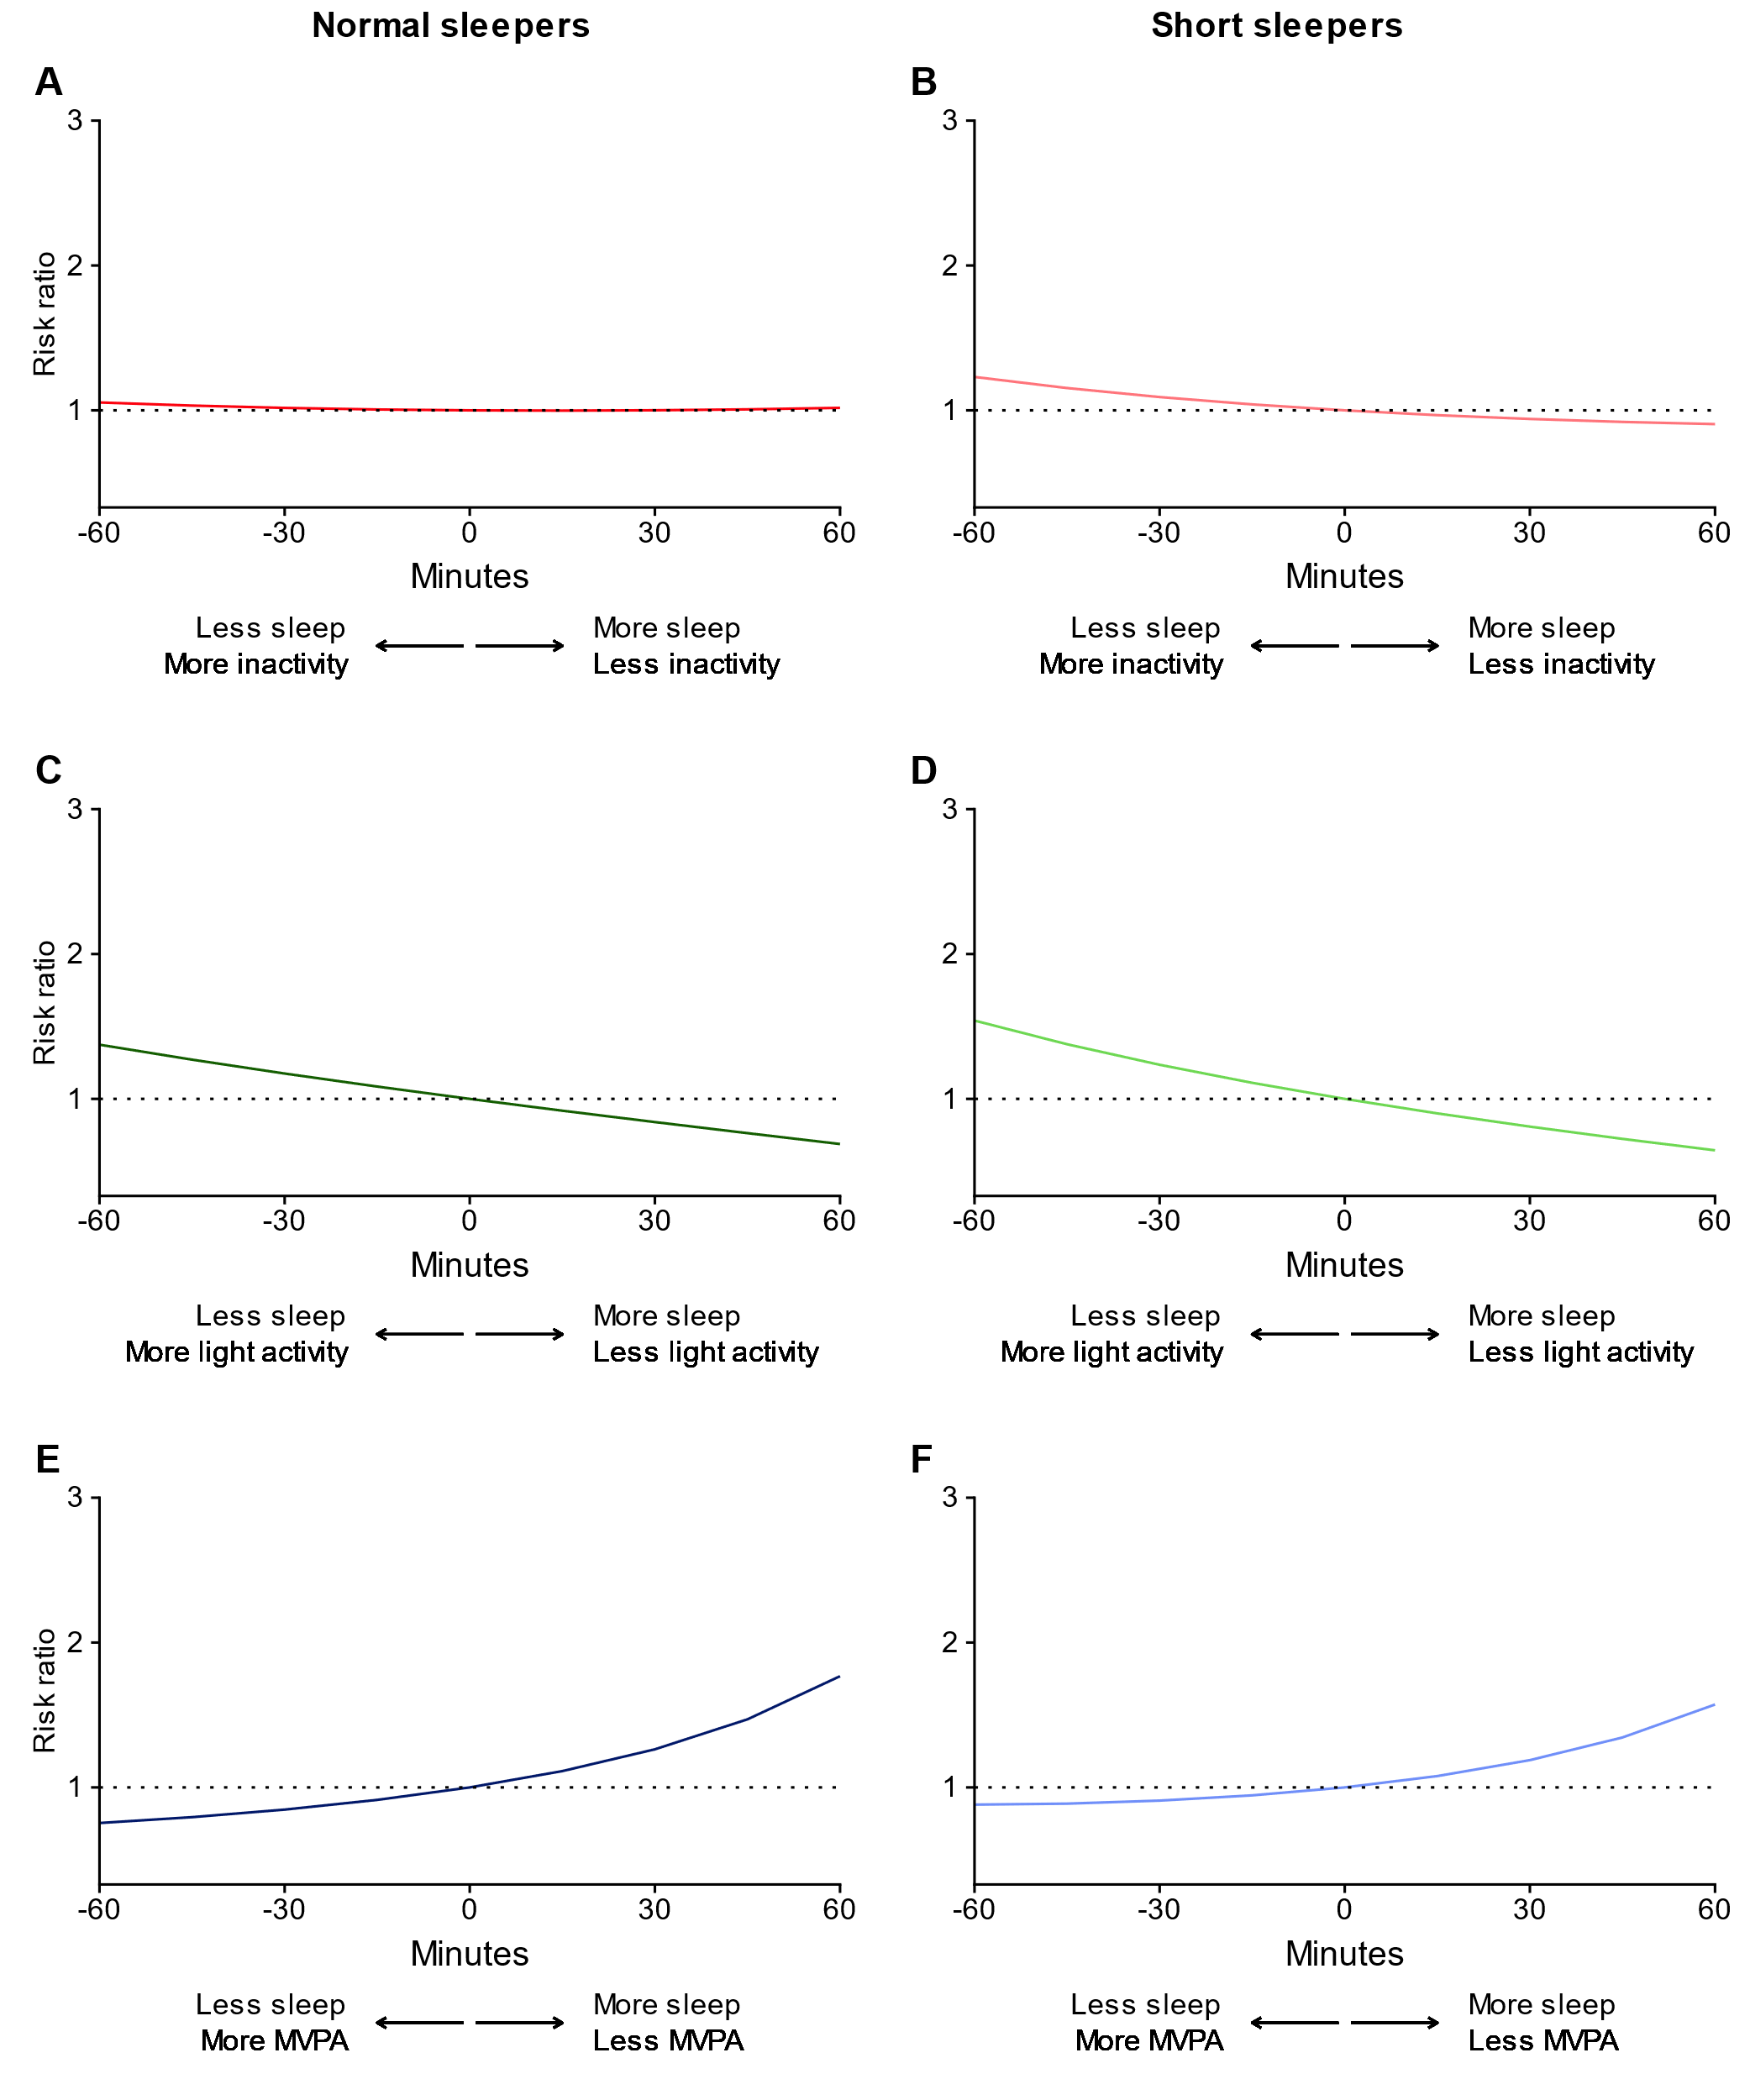
eFigure 8. All-cause dementia risk ratio for time-use substitutions, with adjustments for the covariates outlined in the main text plus disease history and disease risk factors, including sick/disabled (self-reported employment category), history of diabetes, history of cancer, history of a mental disorder, history of a nervous system disease (excluding severe neurological diseases which are excluded from the sample), history of cardiovascular disease, systolic blood pressure, blood pressure medication, and body mass index. MVPA = moderate to vigorous physical activity. Normal sleepers are defined as persons with ≥6 hours of sleep (0.1% of samples had > 9 hours of sleep). Short sleepers are defined as persons with <6 hours of sleep.

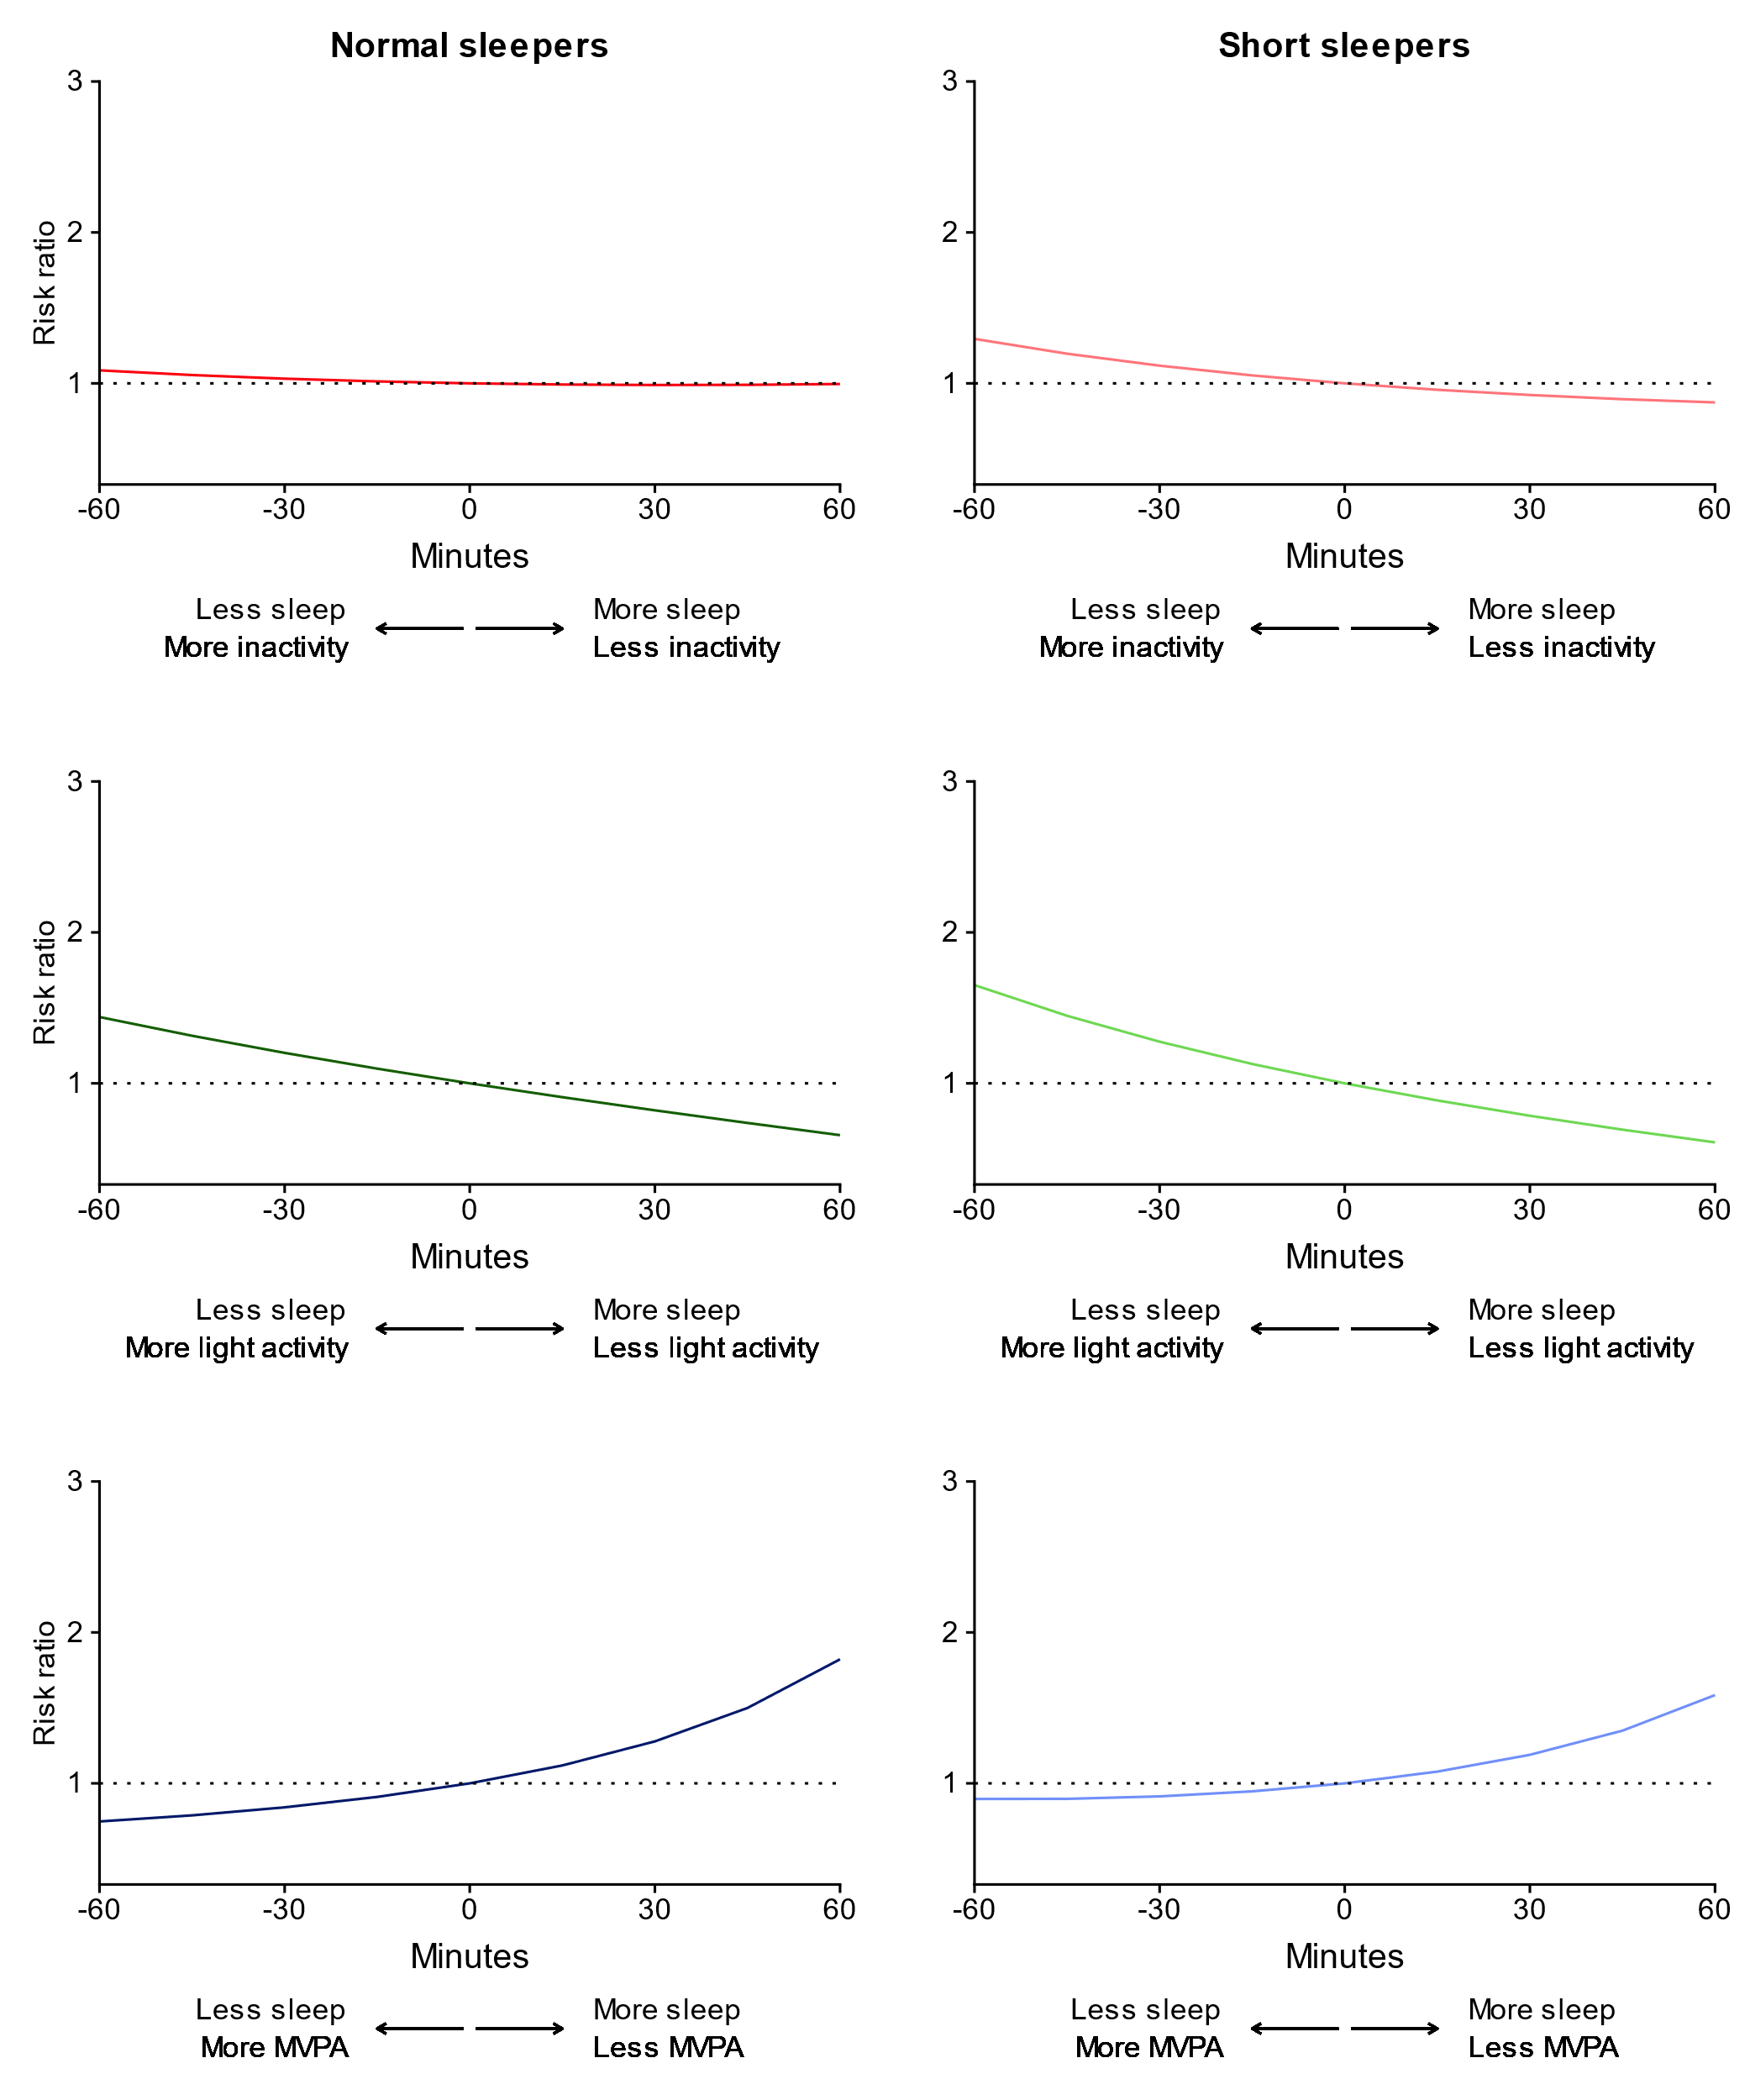eFigure 9. All-cause dementia risk ratio for time-use substitutions, truncating the first three years of follow-up. MVPA = moderate to vigorous physical activity. Normal sleepers are defined as persons with ≥6 hours of sleep (0.1% of samples had > 9 hours of sleep). Short sleepers are defined as persons with <6 hours of sleep. Note that confidence intervals are not provided i) to limit computational burden and ii) as the focus of this sensitivity analysis was on the sample risk ratio estimates.

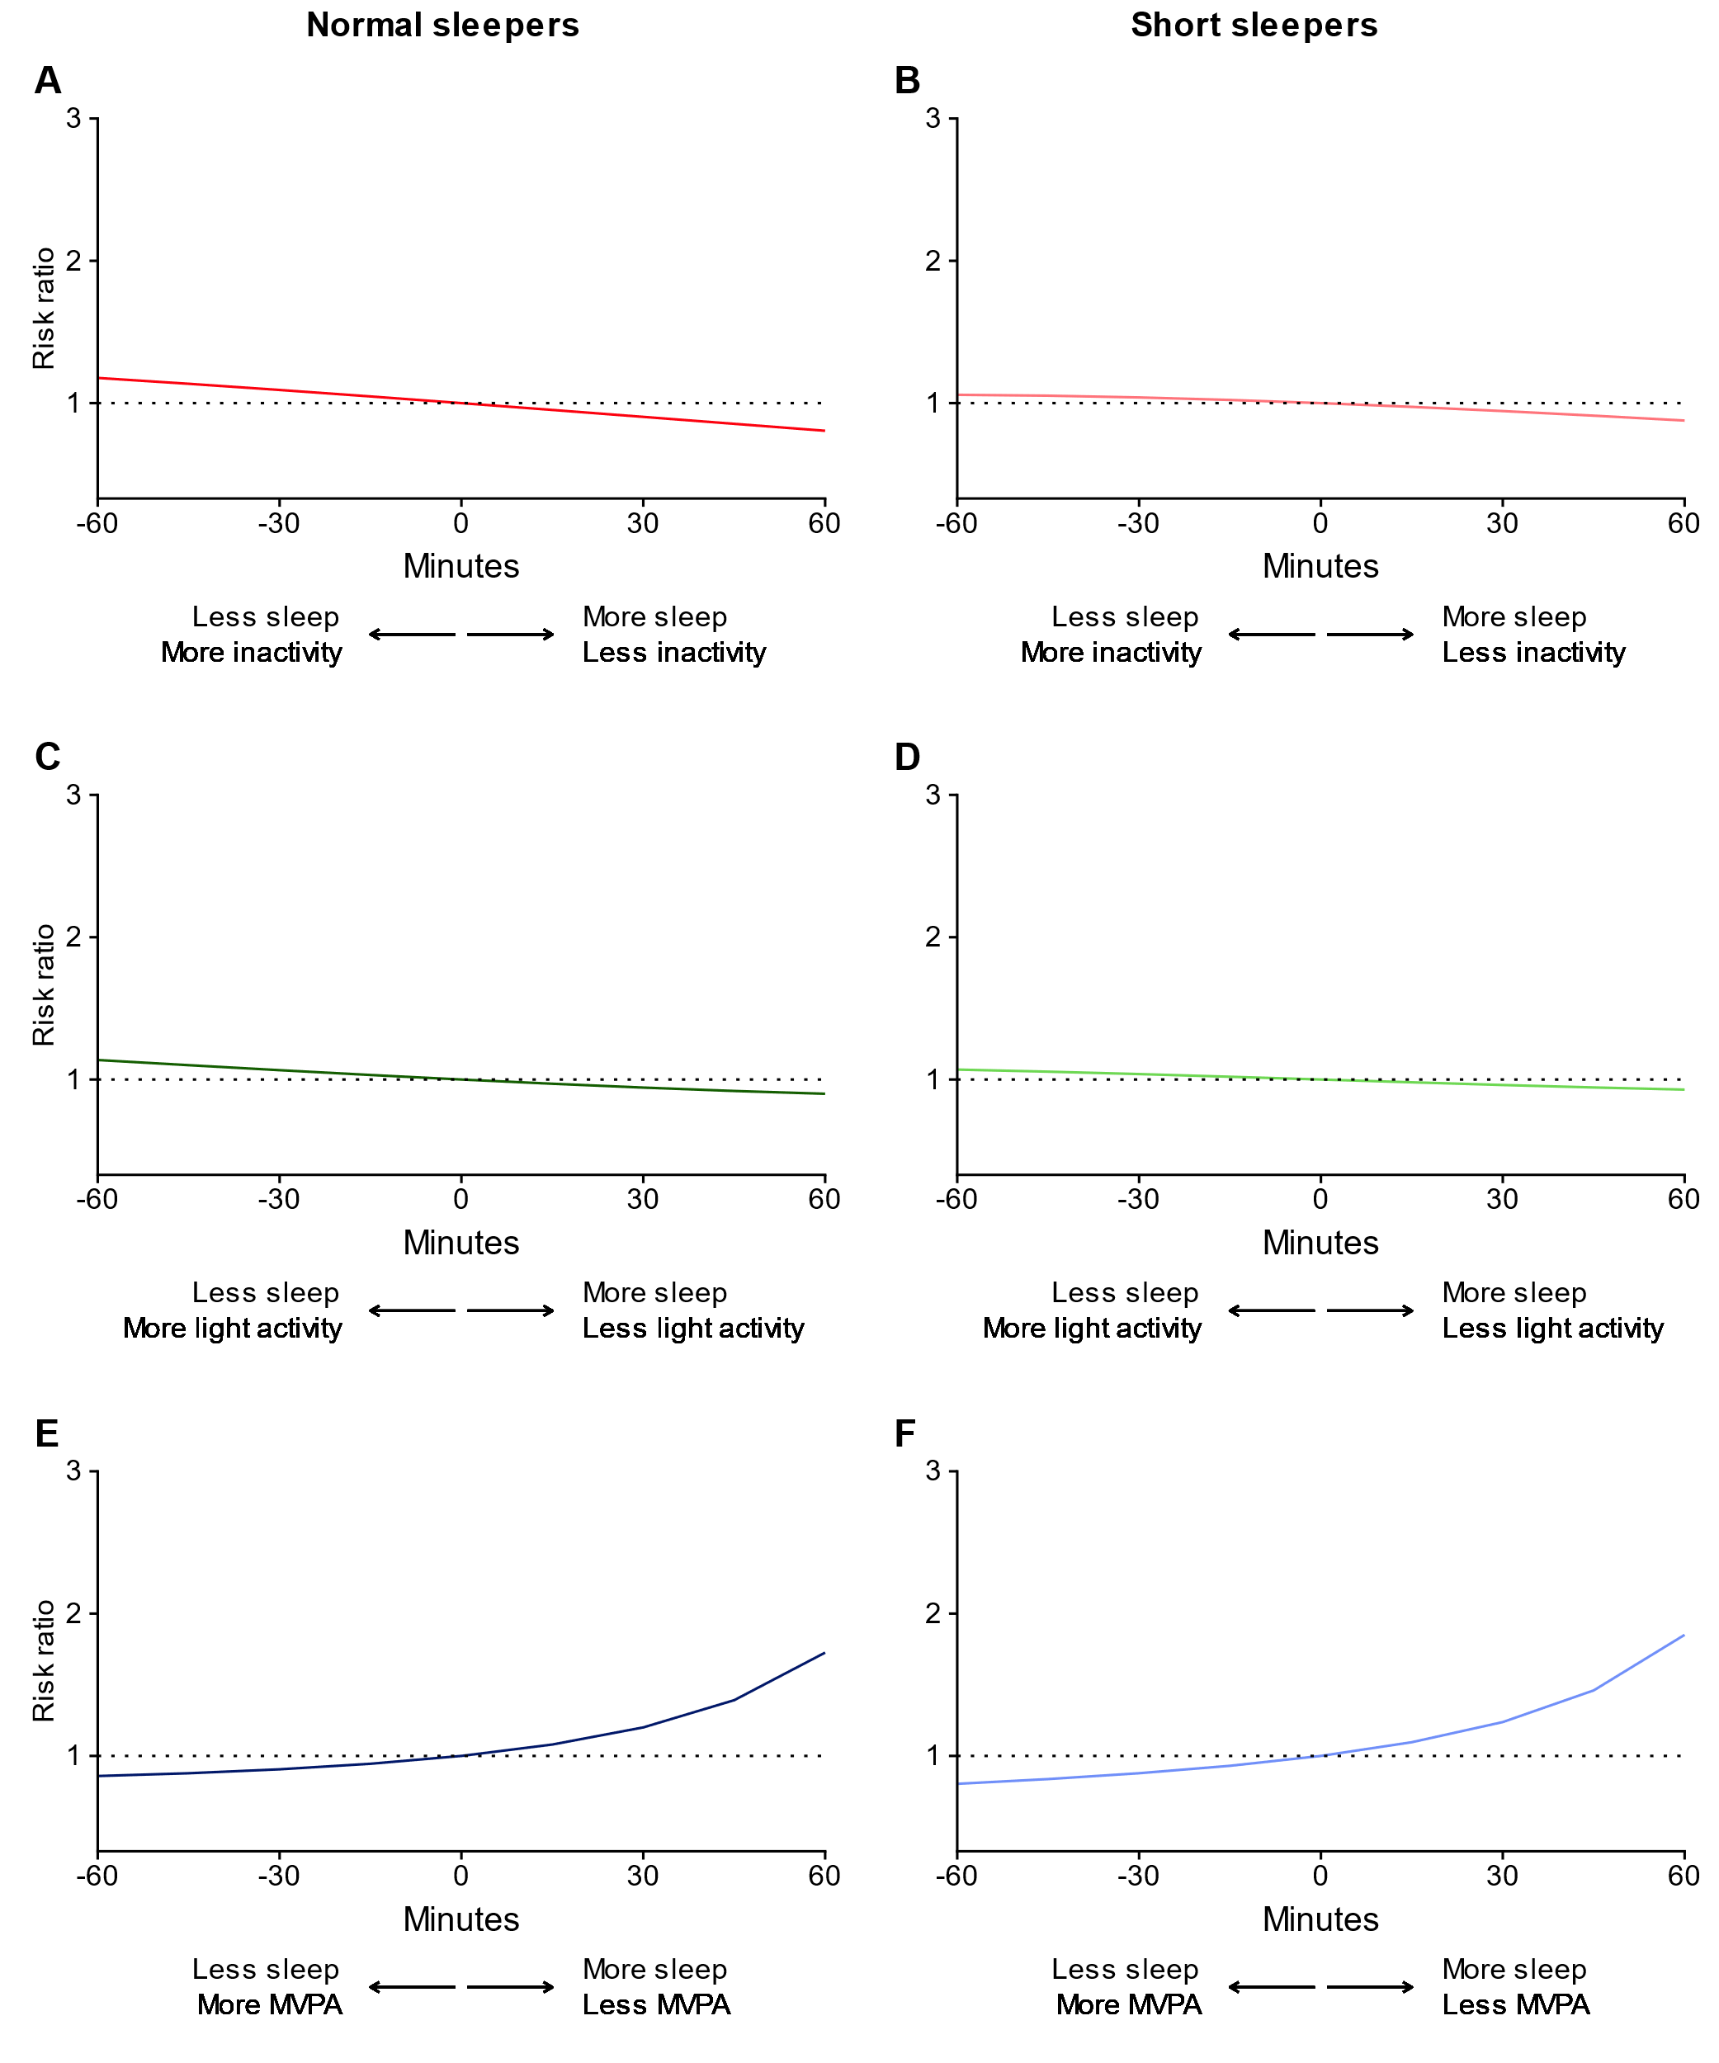eFigure 10. All-cause dementia risk ratio for time-use substitutions, correcting for selective participation in the UK Biobank by standardizing to a set of representative UK population characteristics. MVPA = moderate to vigorous physical activity. Normal sleepers are defined as persons with ≥6 hours of sleep (0.1% of samples had > 9 hours of sleep). Short sleepers are defined as persons with <6 hours of sleep. Note that confidence intervals are not provided i) to limit computational burden and ii) as the focus of this sensitivity analysis was on the sample risk ratio estimates.

