Supplement
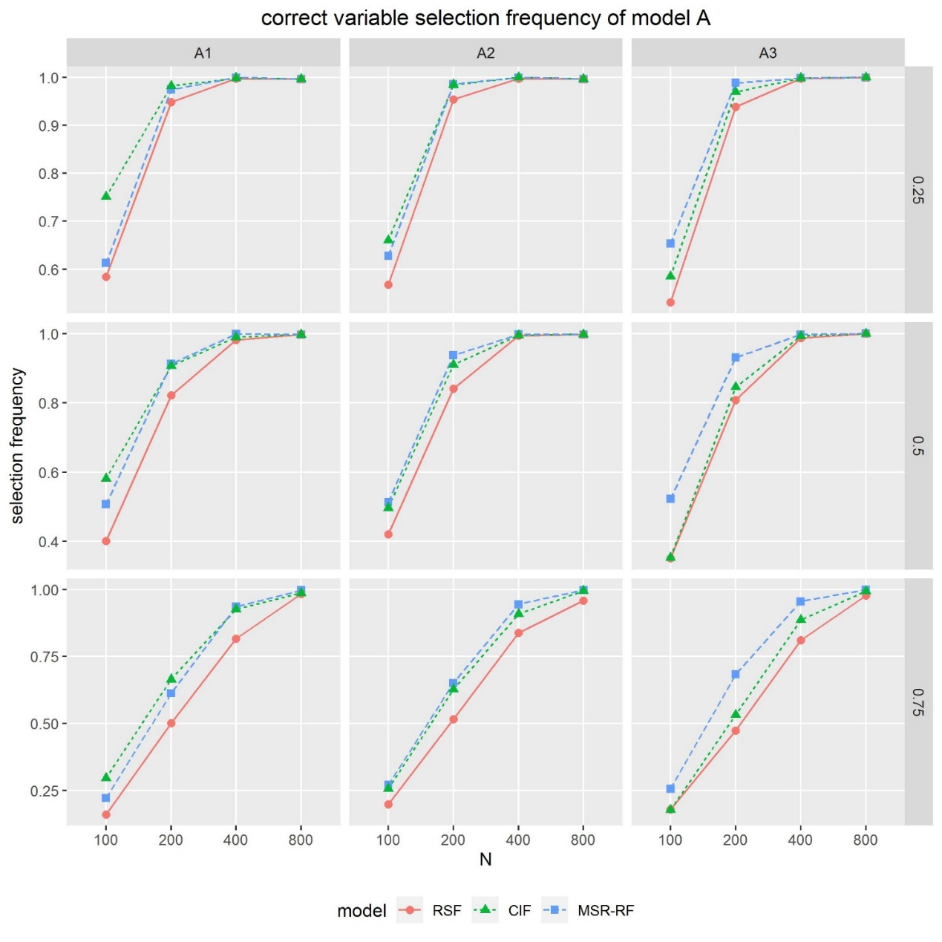
Fig S1 Correct variable selection frequency for datasets A with RSF,CIF and MSR-RF.
Dataset A was set in a linear form, with a continuous variable and a categorical variable associated with the outcome with coefficient 1. The categorical covariate associated with the outcome was (A1) covariate with 2 categories; (A2) covariate with 4 categories; (A3) covariate with 8 categories. The sample size was set to 100,200,400,800; the censoring rate was set to 25%, 50%, 75%.

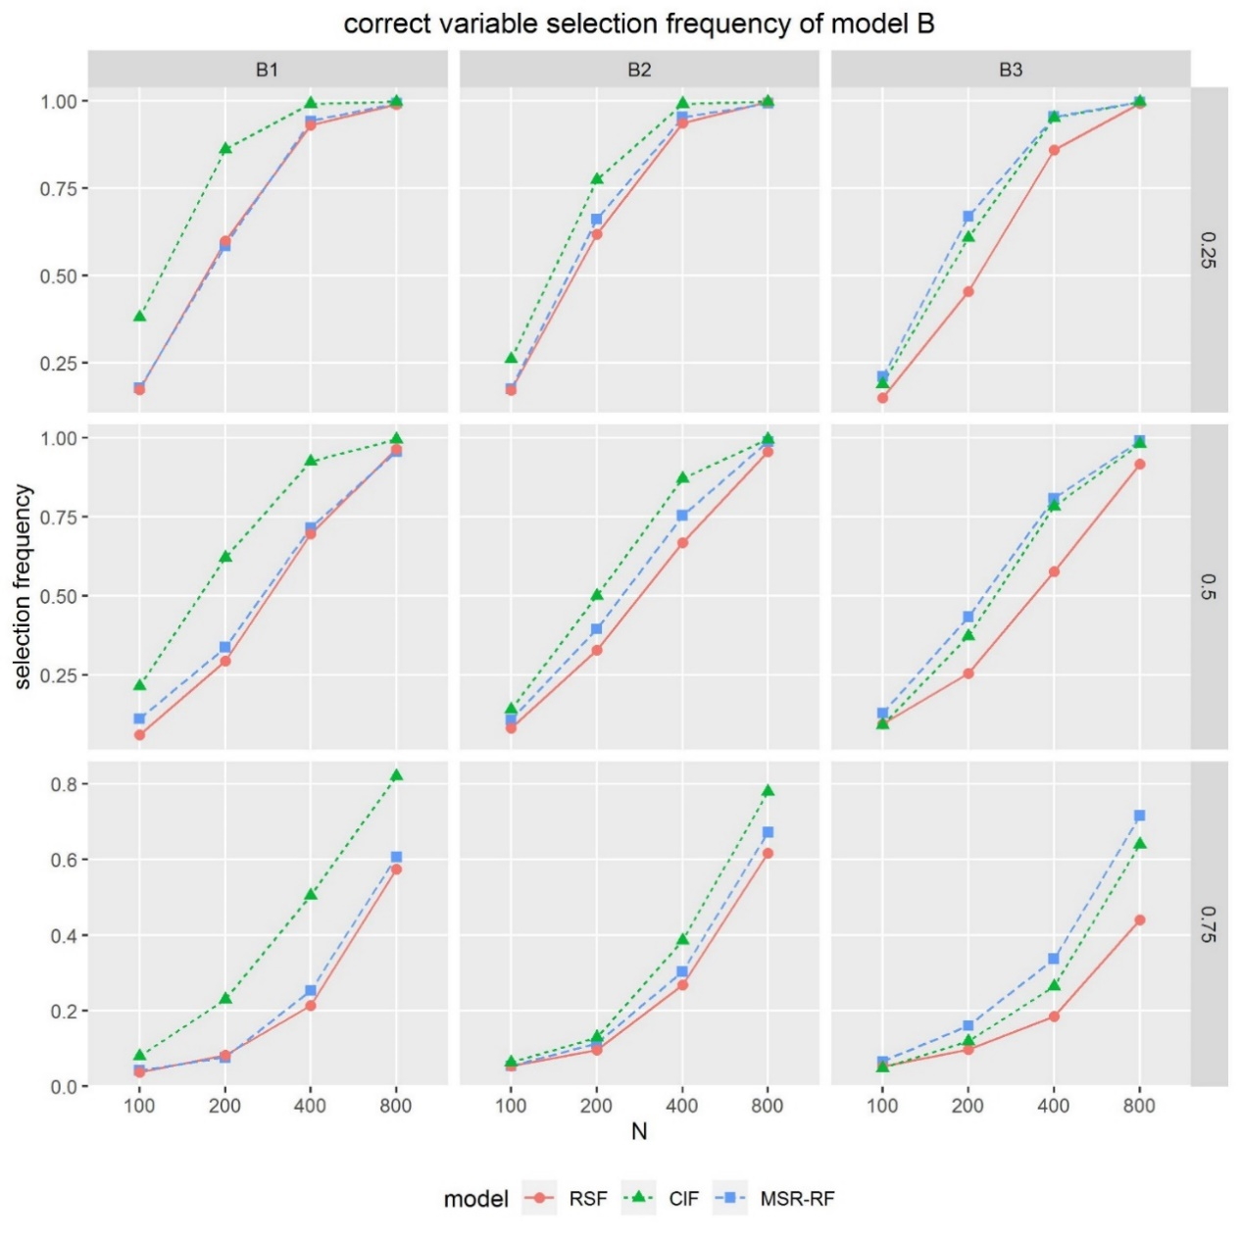
Fig S2 Correct variable selection frequency for datasets B with RSF,CIF and MSR-RF. Dataset B was set in an interaction form, with a continuous variable and a categorical variable associated with the outcome with coefficient 1. The categorical covariate associated with the outcome was (B1) covariate with 2 categories; (B2) covariate with 4 categories; (B3) covariate with 8 categories. The sample size was set to 100,200,400,800; the censoring rate was set to 25%, 50%, 75%.

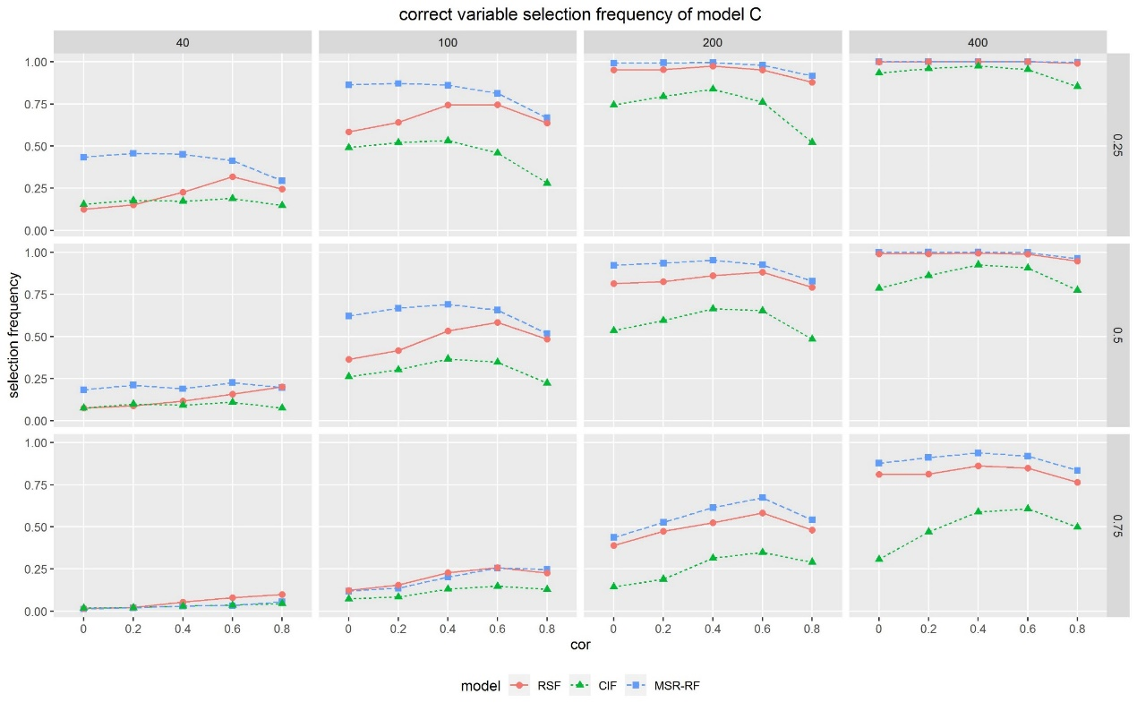
Fig S3 Correct variable selection frequency for datasets C with RSF,CIF and MSR-RF. Dataset C was set in a linear form with 10 variables generated from the multiple normal distribution. Selection frequency means the rates of the two correct variables $x_{1}$ and $x_{2}$ ranking top, whereas $x_{1}$ with coefficient 1 and $x_{2}$ with coefficient 1.5. The sample size was set to 40, 100,200,400; the censoring rate was set to 25%, 50%, 75%. The censoring parameter $ρ$ was set to 0, 0.2, 0.4, 0.6, 0.8.

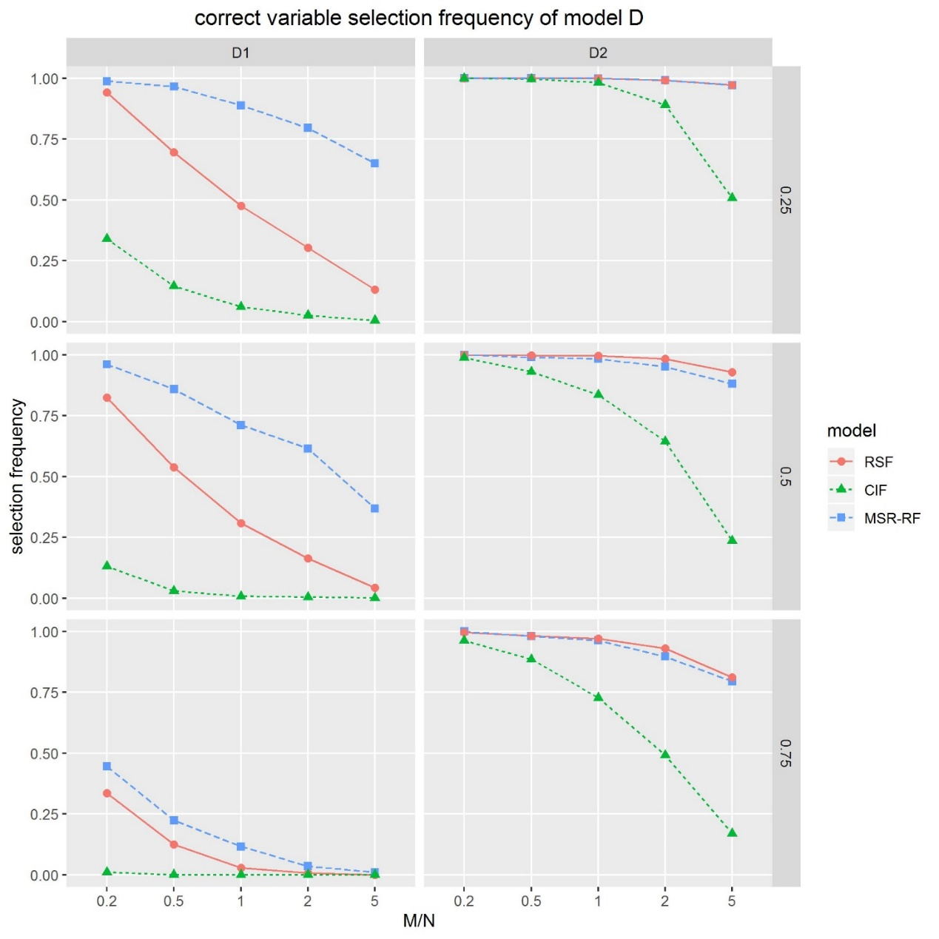
Fig S4 Correct variable selection frequency for datasets D with RSF,CIF and MSR-RF. Dataset D was set in a linear form with all variables generated from the standard normal distribution for D1 and the binomial distribution with 0.5 probability for D2. Selection frequency means the rates of the two correct variables $x_{1}$ and $x_{2}$ranking top, whereas $x_{1}$ with coefficient 2 and $x_{2}$ with coefficient 3. The sample size was set to 100; the censoring rate was set to 25%, 50%, 75%.

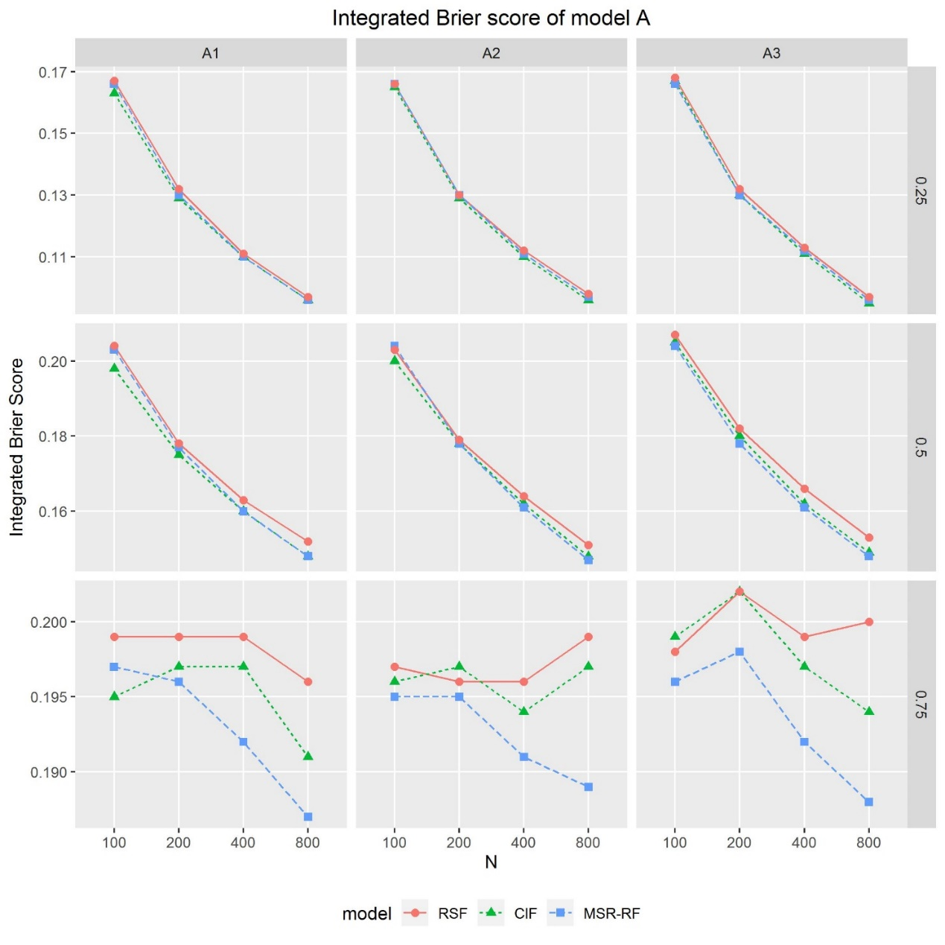
Fig S5 Integrated Brier scores of A datasets.
Dataset A was set in a linear form, with a continuous variable and a categorical variable associated with the outcome with coefficient 1. The categorical covariate associated with the outcome was (A1) covariate with 2 categories; (A2) covariate with 4 categories; (A3) covariate with 8 categories. The sample size was set to 100,200,400,800; the censoring rate was set to 25%, 50%, 75%.
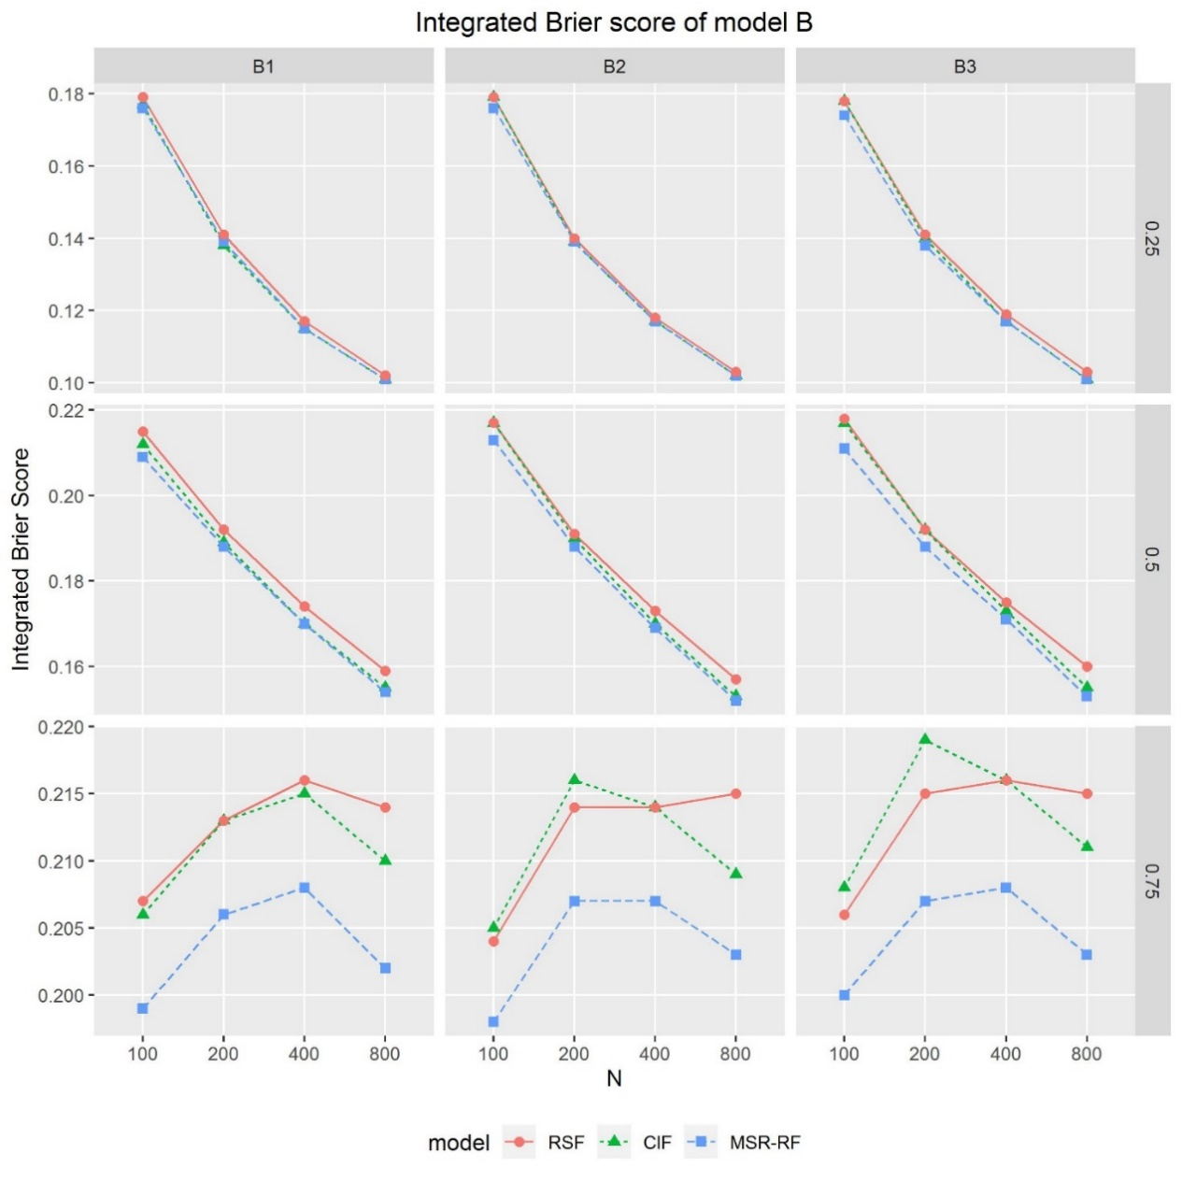
Fig S6 Integrated Brier scores of B datasets.
Dataset B was set in an interaction form, with a continuous variable and a categorical variable associated with the outcome with coefficient 1. The categorical covariate associated with the outcome was (B1) covariate with 2 categories; (B2) covariate with 4 categories; (B3) covariate with 8 categories. The sample size was set to 100,200,400,800; the censoring rate was set to 25%, 50%, 75%.

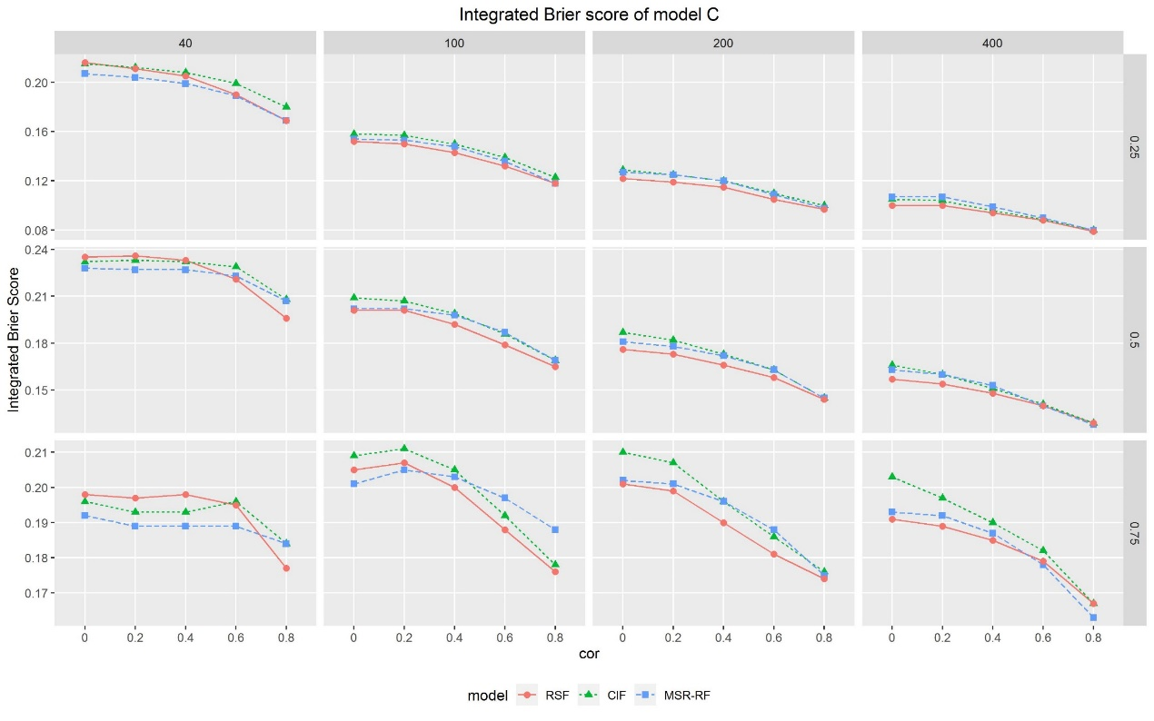
Fig S7 Integrated Brier scores of C datasets.
Dataset C was set in a linear form with 10 variables generated from the multiple normal distribution. Selection frequency means the rates of the two correct variables $x_{1}$ and $x_{2}$ ranking top, whereas $x_{1}$ with coefficient 1 and $x_{2}$ with coefficient 1.5. The sample size was set to 40, 100,200,400; the censoring rate was set to 25%, 50%, 75%. The censoring parameter $ρ$ was set to 0, 0.2, 0.4, 0.6, 0.8.

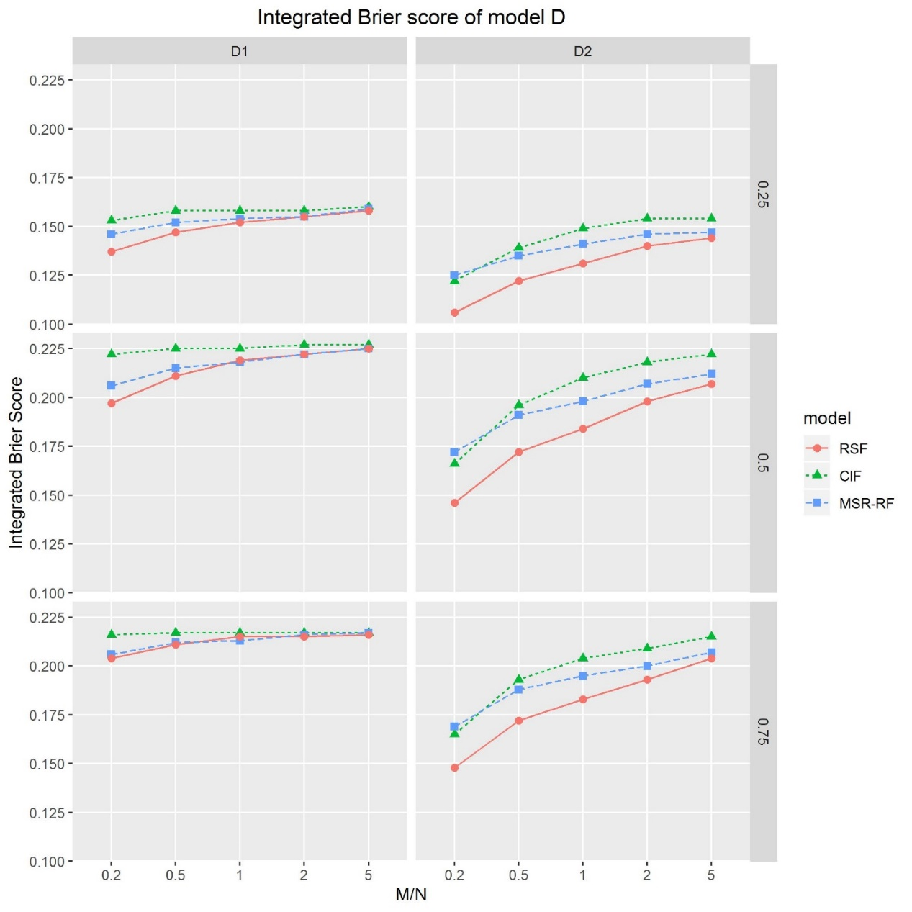
Fig S8 Integrated Brier scores of D datasets with RSF, CIF and MSR-RF.
Dataset D was set in a linear form with all variables generated from the standard normal distribution for D1 and the binomial distribution with 0.5 probability for D2. Selection frequency means the rates of the two correct variables $x_{1}$ and $x_{2}$ranking top, whereas $x_{1}$ with coefficient 2 and $x_{2}$ with coefficient 3. The sample size was set to 100; the censoring rate was set to 25%, 50%, 75%.

