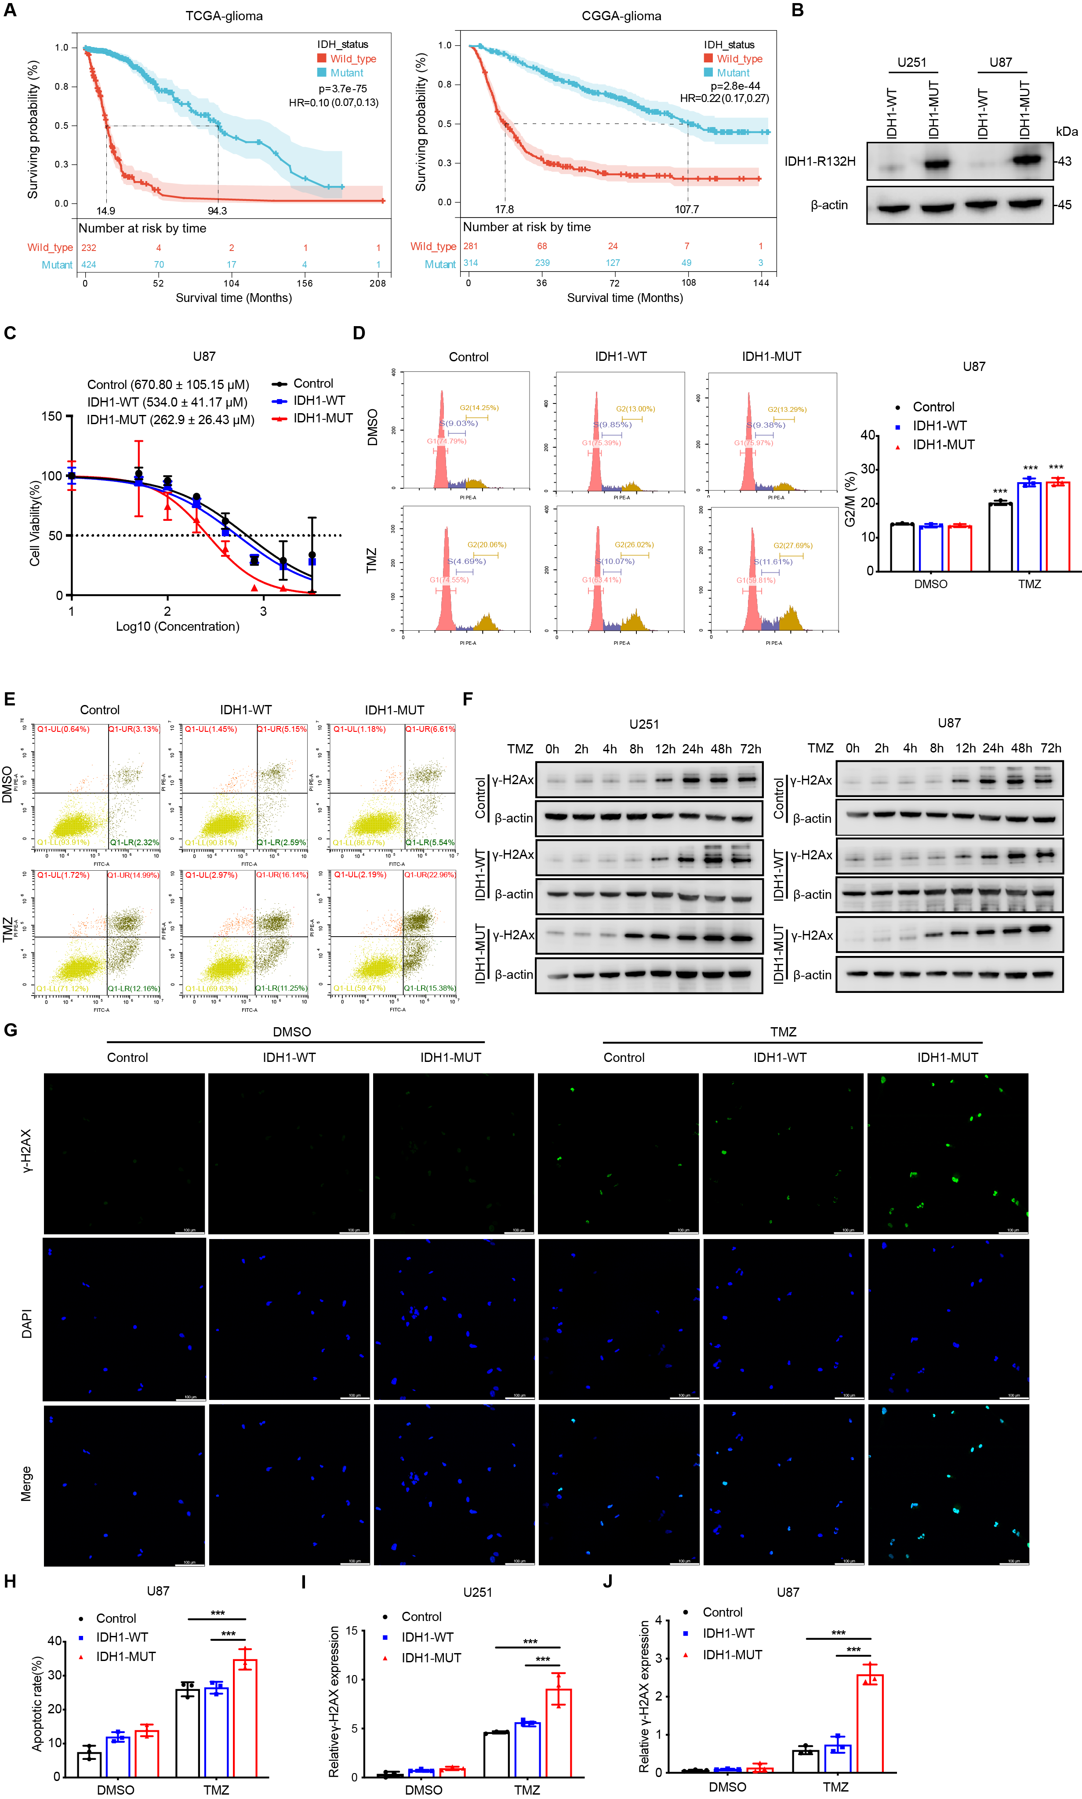
Supplementary Figures S1-S6

Supplementary Figure S1. IDH1 mutation increases TMZ sensitivity and TMZ-induced DNA damage in glioma cells
A The survival analysis of IDH1 mutant and wild-type glioma patients based on TCGA and CGGA databases, with the hazard ratio (HR) and p values displayed. B IDH1 mutant cells expressing IDH1-R132H mutants in U251 and U87 cell lines. IDH1-R132H expression was confirmed by western blot. C IC50 value of 48 h TMZ treatment on empty vector control, IDH1-WT and IDH1-mutant U87 cells (n=3). D Flow cytometry analysis of the cell cycle in U87 cells treated with indicated concentrations of TMZ for 48 h (n=3). E Annexin-V apoptosis assay of control, IDH1-WT and IDH1-mutant U87 cells with TMZ or DMSO treatment (n=3). F The protein levels of γ-H2AX in U251 and U87 glioma cells with expressing IDH1-WT, IDH1-MUT and control at different time points. G Immunofluorescence staining of γ-H2AX in U87 cells after TMZ treatment for 48 h (n=3). Scale bar, 100 μm. H Statistical analysis of apoptotic U87 cells with expressing control, IDH1-WT and IDH1-mutant cells with TMZ or DMSO treatment for 48 h (n=3). I-J Statistical analysis of IF assay in U251 and U87 cells with expressing control, IDH1-WT and IDH1-mutant cells with TMZ or DMSO treatment for 48 h (n=3). *p < 0.05, **p < 0.01, ***p < 0.001.

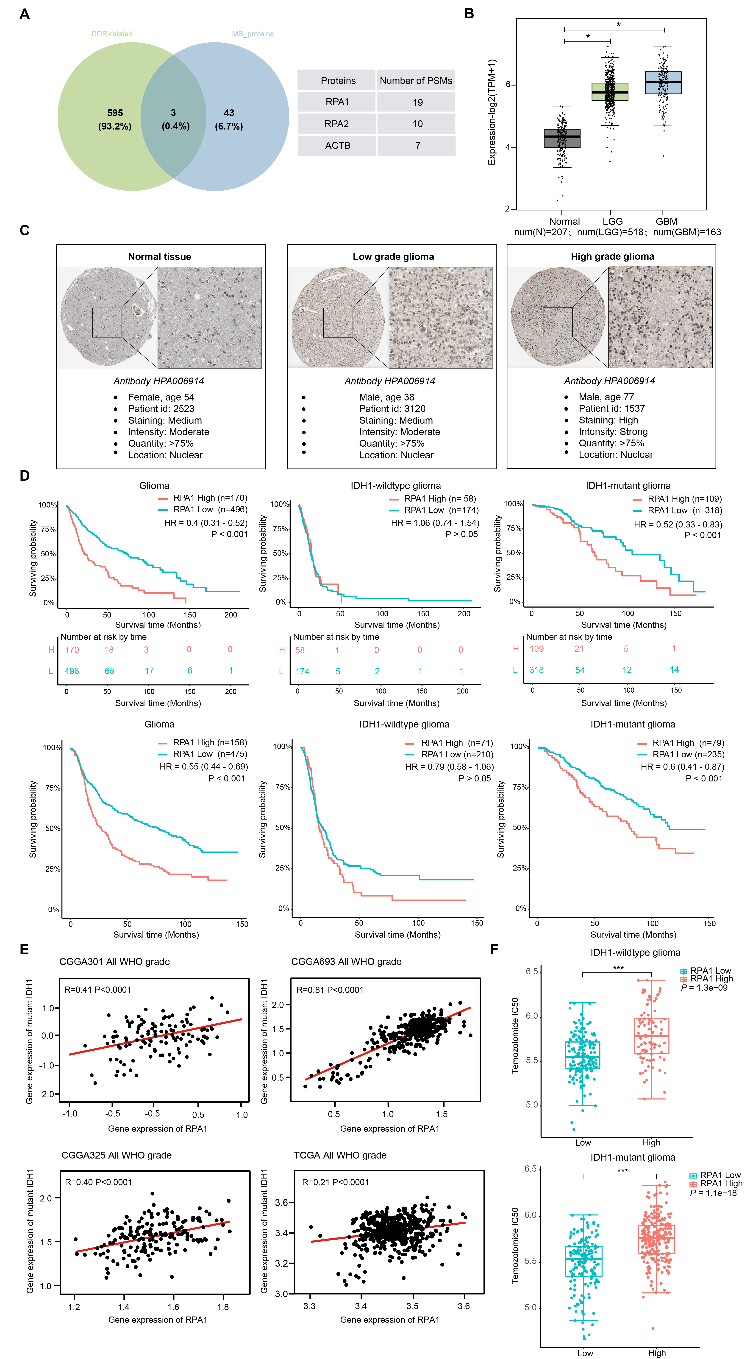

Supplementary Figure S2. The expression and survival analysis of RPA1 in normal brain tissue and glioma tissue
A Three DNA damage repair-related proteins screened from IP-MS-identified proteins. B The mRNA expression levels of RPA1 in normal brain tissue, LGG, and GBM. C The protein levels of RPA1 in normal brain tissue, LGG, and GBM from HPA database. D The survival analysis of RPA1 high-expression and low-expression groups in IDH1 wild-type and mutant glioma patients based on the TCGA and CGGA databases. E The Pearson correlation analysis of mutant IDH1 and RPA1 in TCGA and CGGA (CGGA301, CGGA325, and CGGA693) datasets. F The GDSC database analyzed the relationship between RPA1 expression and TMZ sensitivity in IDH1 wild-type and mutant gliomas, with p values displayed.

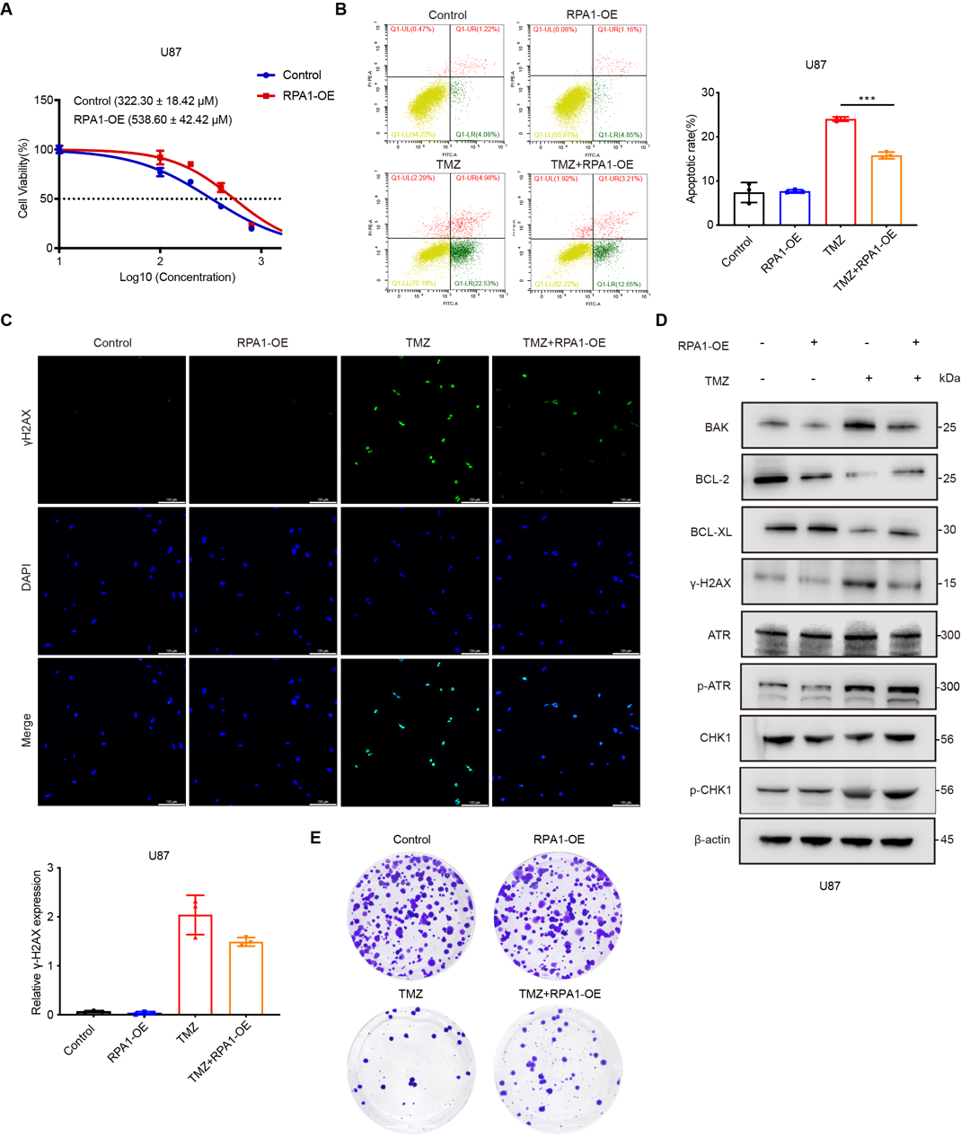

Supplementary Figure S3. RPA1 overexpression reverses TMZ induces cell toxicity and DNA damage
A MTT assay shows that overexpression of RPA1 could reserve the inhibitory effect of TMZ treatment for 48 h in U87 cells (n=3). B Cell apoptosis analysis of U87 cells transfected with overexpressed RPA1 or NC for 48 h, followed by treatment with or without TMZ for 48 h (n=3). C IF images of γ-H2AX in DMSO or TMZ-treated U87 cells with RPA1 overexpressing (n=3). Scale bar, 100 µm. D Apoptosis-related, γ-H2AX and the downstream pathway ATR/CHK1 were evaluated by western blot in U87 glioma cells. E Colony formation assay of TMZ treated U87 cells transfected with overexpressed RPA1 or NC for 48 h (n=3). *p < 0.05, **p < 0.01, ***p < 0.001.

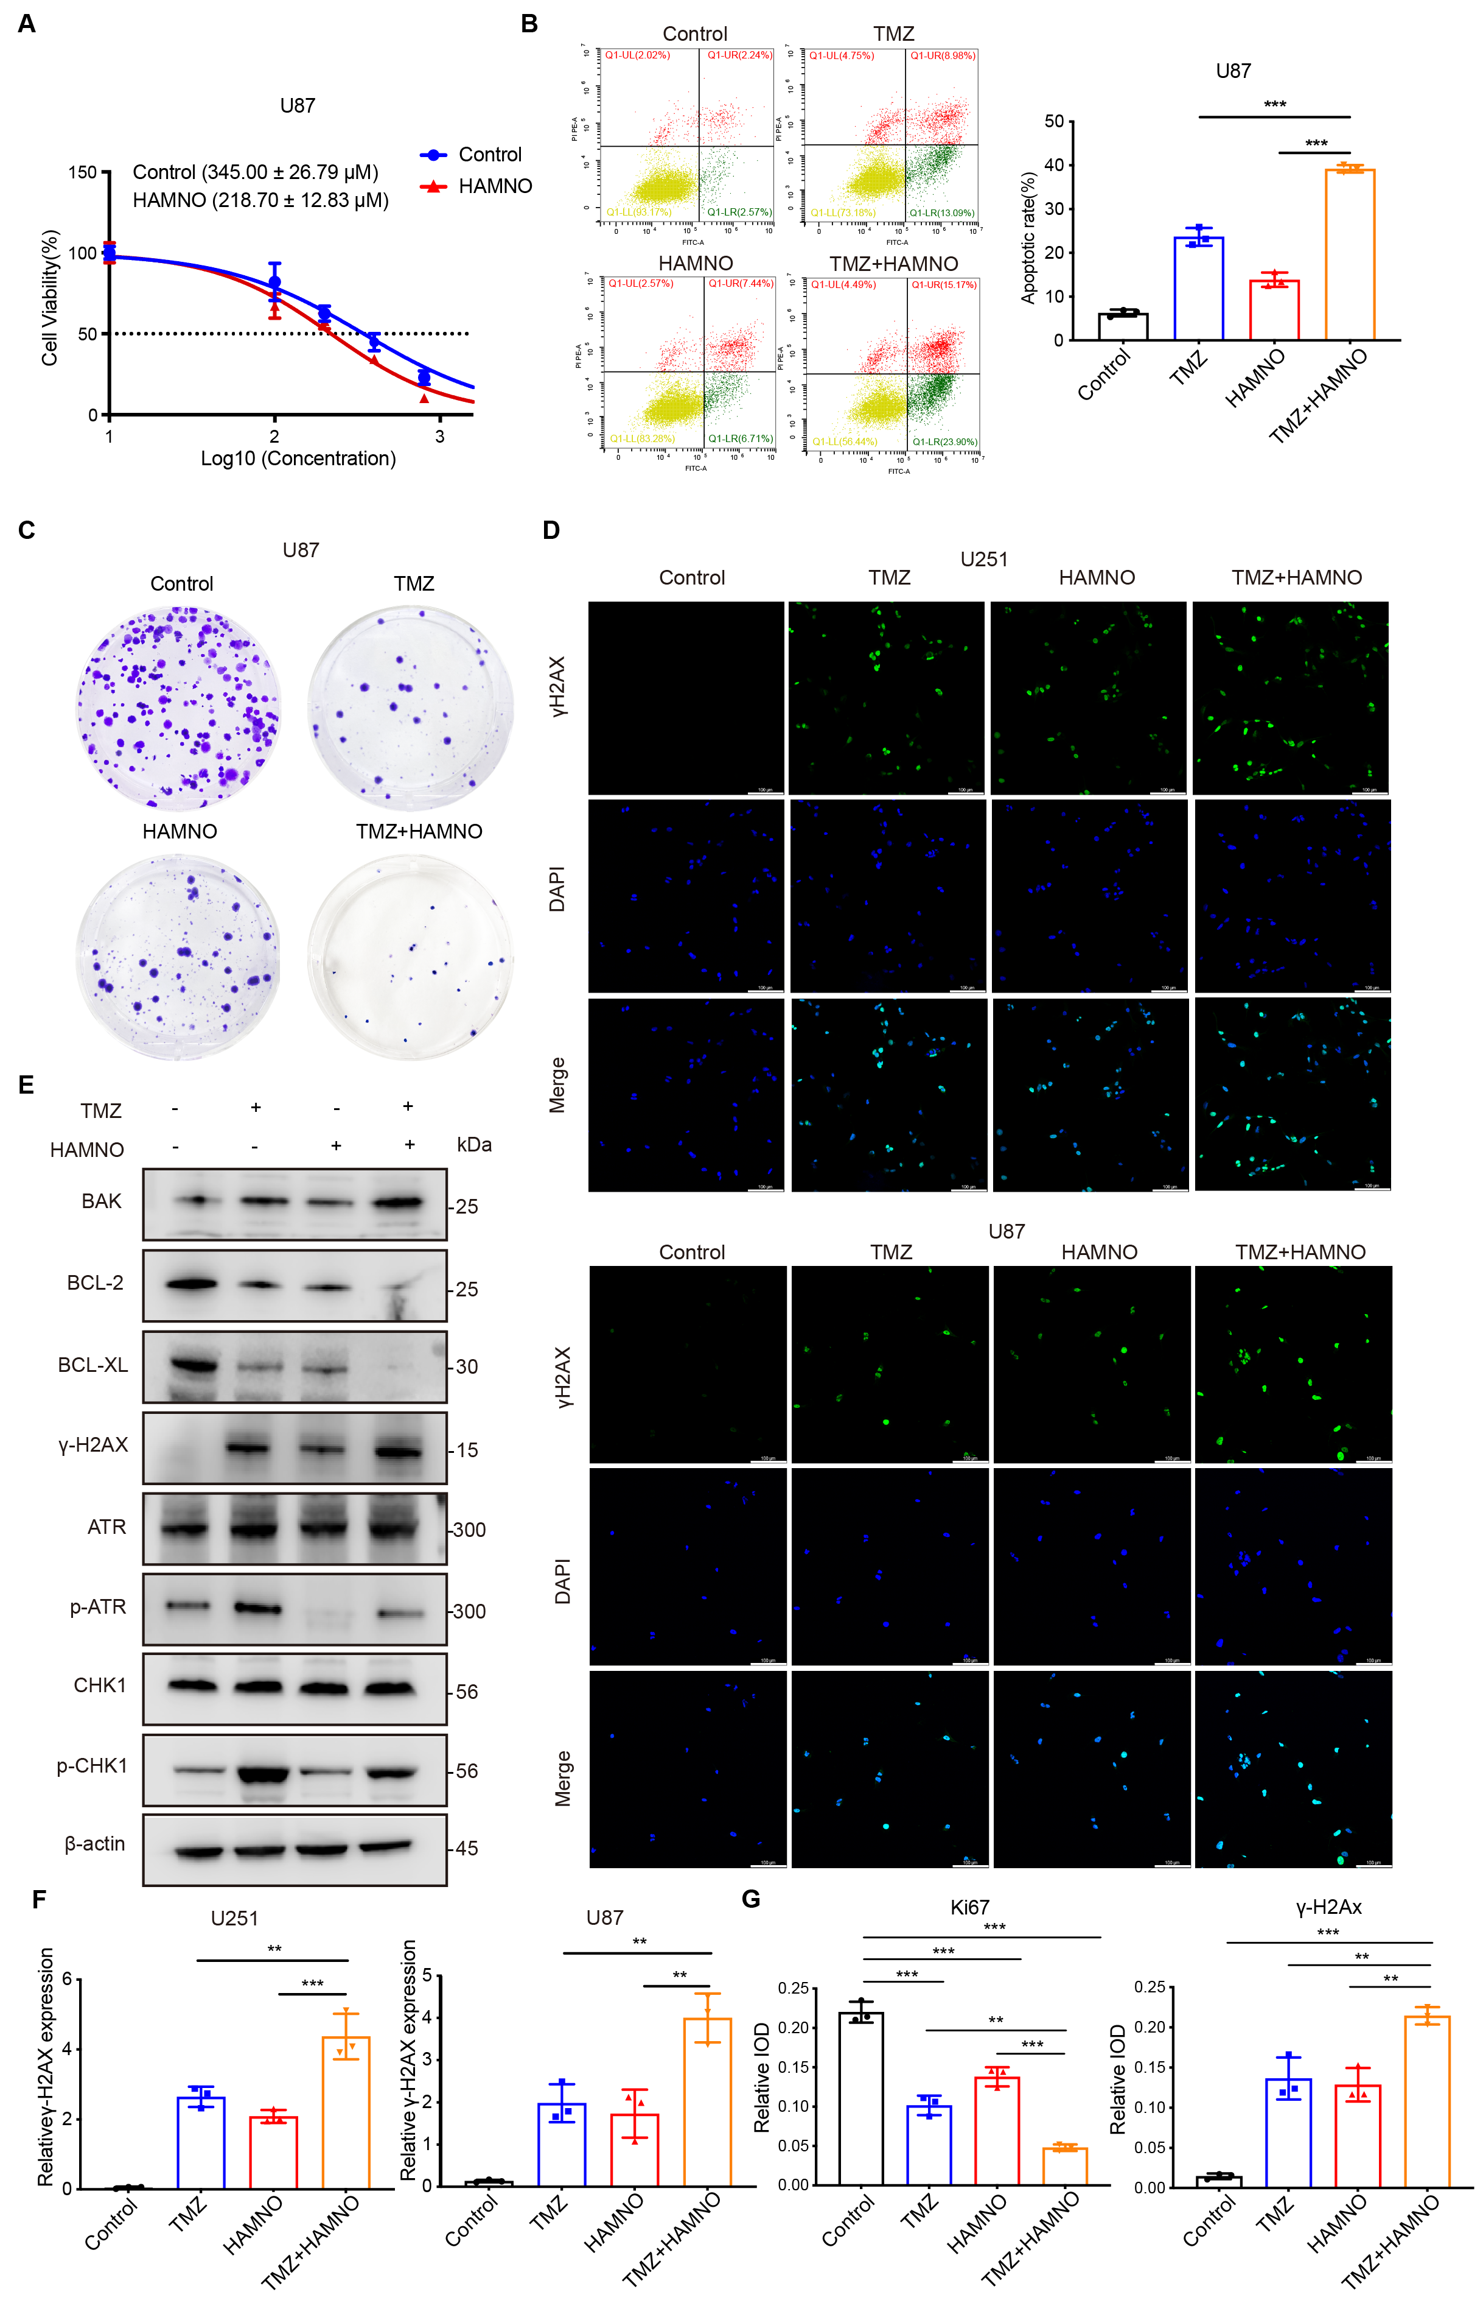

Supplementary Figure S4. RPA1 inhibitor HAMNO synergistically enhances TMZ cytotoxic effects in vitro
A IC50 value of 48 h TMZ treatment on U87 cells with pre-treatment with HAMNO (n=3). B Apoptosis assay of U87 cells after 48 h TMZ treatment with combination of HAMNO (n=3). C Colony formation assay of U87 cells with TMZ and HAMNO treated for 48h. D IF images of γ-H2AX in U87 cells after 48 h TMZ treatment with combination of HAMNO (n=3). Scale bar, 100 µm. E Western blot assay of apoptosis-related proteins, γ-H2AX and ATR/CHK1 in U87 cells with TMZ and HAMNO treated for 48h. F Statistical analysis of γ-H2AX foci of U251 cells after 48 h TMZ treatment with combination of HAMNO (n=3). G Statistical analysis of Ki67 and γ-H2AX staining degree in the excised tumors from indicated groups (Control/TMZ/HAMNO/TMZ + HAMNO). **p < 0.01, ***p < 0.001.

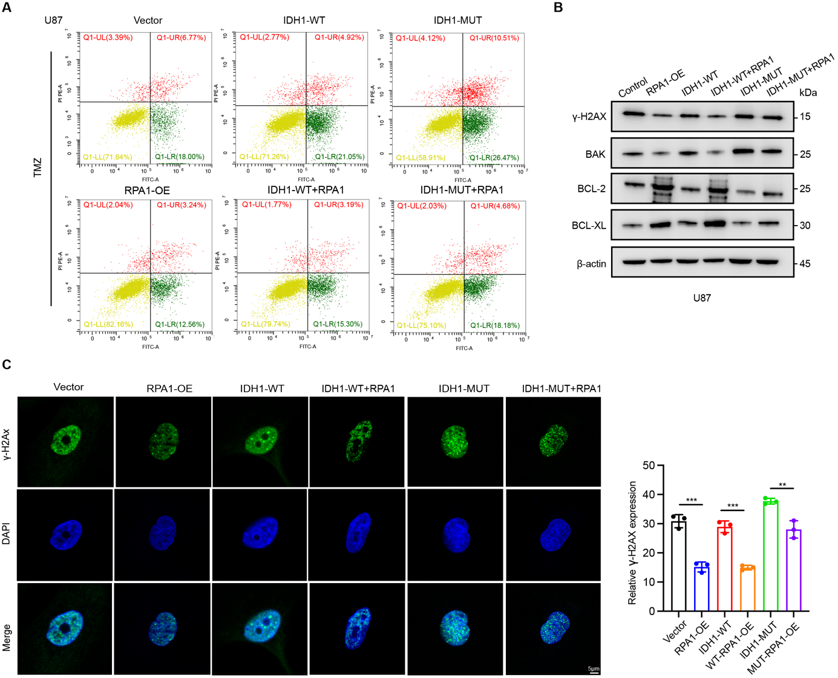

Supplementary Figure S5. mIDH1 impairs RPA1-mediated DNA damage repair effect in TMZ treated glioma cells
A Apoptosis assay in control, IDH1-WT, IDH1-MUT U87 cells with RPA1 expression after 48 h TMZ treatment (n=3). B Western blot assay of apoptosis-related proteins and γ-H2AX in control, IDH1-WT, IDH1-MUT U87 cells with RPA1 overexpressing after TMZ-treated for 48h. C IF images of γ-H2AX in control, IDH1-WT, IDH1-MUT U87 cells with RPA1 overexpressing after TMZ-treated for 48h (n=3). Scale bar, 5 µm. **p < 0.01, ***p < 0.001.

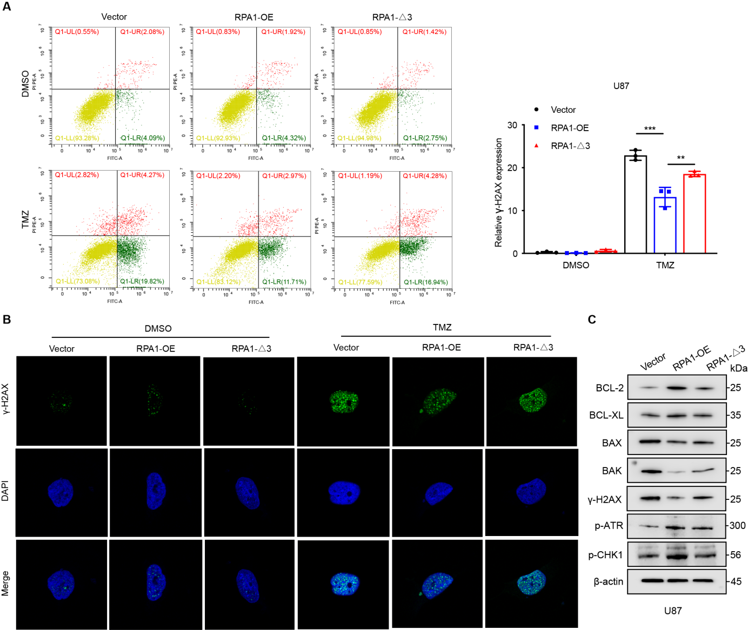

Supplementary Figure S6. RPA1 DBD-A domain is required for RPA1-mediated DNA damage repair
A Apoptosis assay of U87 cells with expressing RPA1 DBD-A domain depletion and RPA1 full length after 48 h TMZ or DMSO treatment (n=3). B IF images of U87 cells with expressing RPA1 DBD-A domain depletion and RPA1 full length after 48 h TMZ or DMSO treatment (n=3). C Western blot assay of apoptosis-related proteins, γ-H2AX and ATR/CHK1 phosphorylationin level in U87 cells with expressing RPA1 DBD-A domain depletion and RPA1 full length after 48 h TMZ treatment. **p < 0.01, ***p < 0.001.

