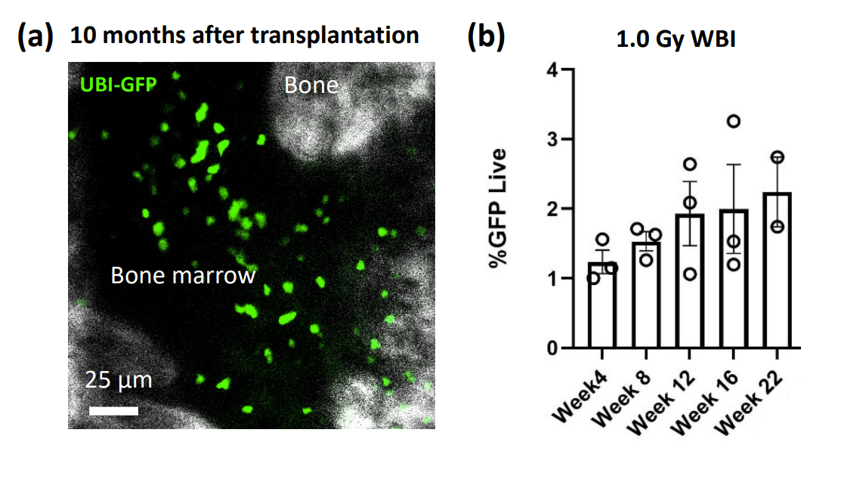
Supplementary Figure 1: Low dose irradiation allowed long term and titratable engraftment. (a) Cellular engraftment 10-months after low-dose 0.5 Gy whole body irradiation. An intravital z-section image of the mouse calvaria bone marrow (black) and bone (white) 10 months after transplantation containing transplanted normal UBI-GFP (green) cells. (b) Engraftment analysis of the transplanted UBI-GFP⁺ cells in peripheral blood. The recipient mice received 1 Gy whole body irradiation. N=3 Mice for weeks 4-16, N=2 mice for week 22.

Supplementary Movie 1: Intravital timelapse video demonstrates UBIGFP cells remain in circulation 10-months after transplantation. (Uploaded MOV MovieS1.mov)

Supplementary Movie 2: Real-time tracking of Rhodamine dextran (70 kDa) perfused into interstitial space. (Uploaded MOV MovieS2.mov)

Supplementary Movie 3: Subsets of Tet2^{+/-} and WT cells form discrete, stable association with the microenvironment whereas a substantial fraction of cells are highly motile over the course of a 1-hour timelapse period. (Uploaded MOV MovieS3.mov)

