Supplemental Materials:

Supplemental Figure 1: Plot of malaria test positivity (number of positive tests divided by total number of tests) and mean elevation. Higher elevation woredas tended to have lower malaria test positivity.

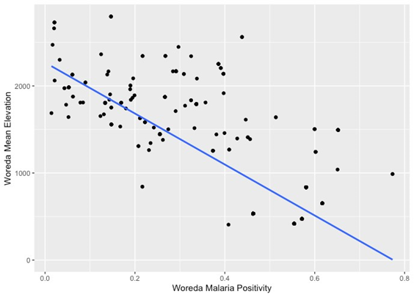
Variable 1 | Variable 2 | Spearman’s rho | p-value
Mean Elevation | Malaria Positivity | -0.6034064 | <0.001

Supplemental Figure 2: Map of malaria test positivity in places of origin (Woredas) of settlers in the study site (Lunga, indicated by a star in the map) ~ Average 2021/22

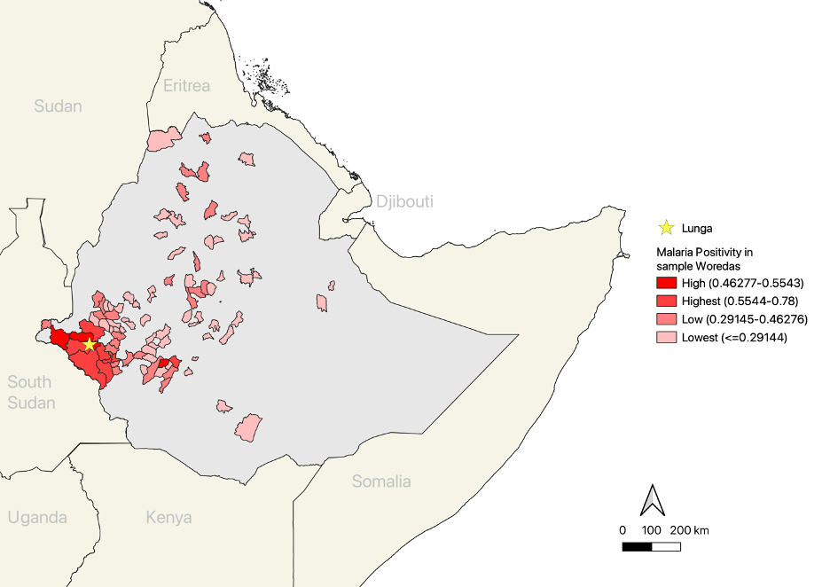

Supplemental Figure 3(a)(b): Model 1A Spline Variable Plots

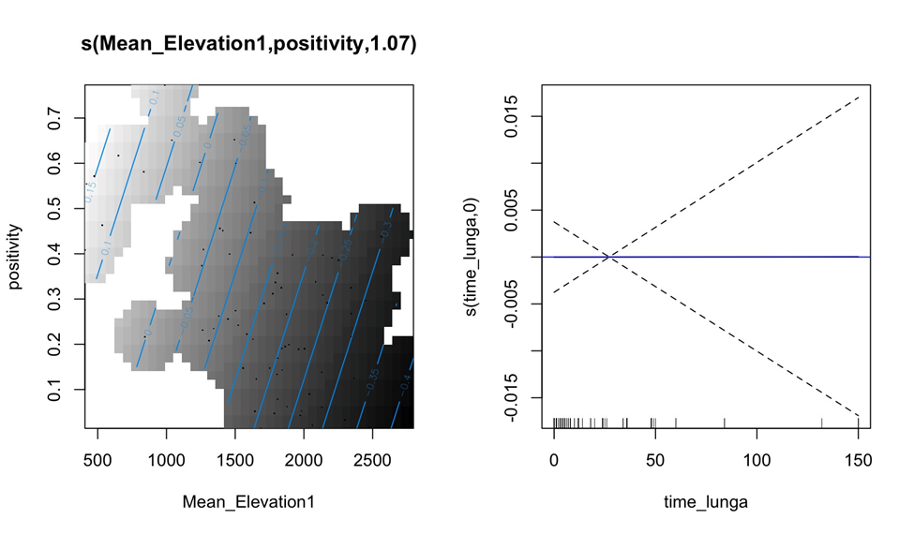

Supplemental Figure 4(a)(b)(c): Model 1B Spline Variable Plots
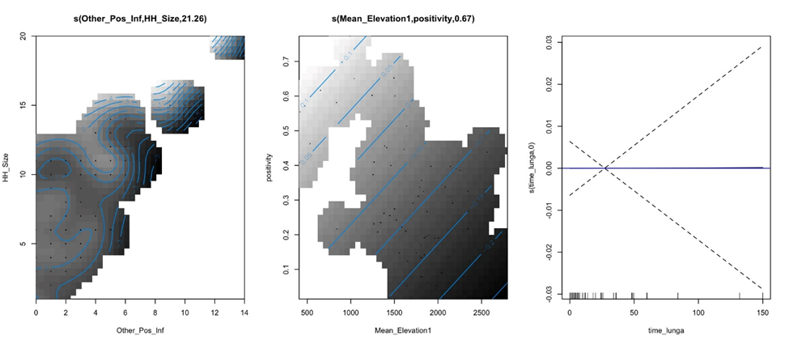

Supplemental Figure 5(a)(b): Model 2A Spline Variable Plots
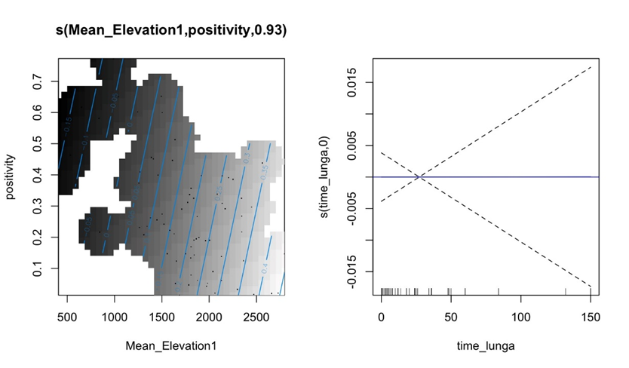
Supplemental Figure 6(a)(b)(c): Model 2B Spline Variable Plots
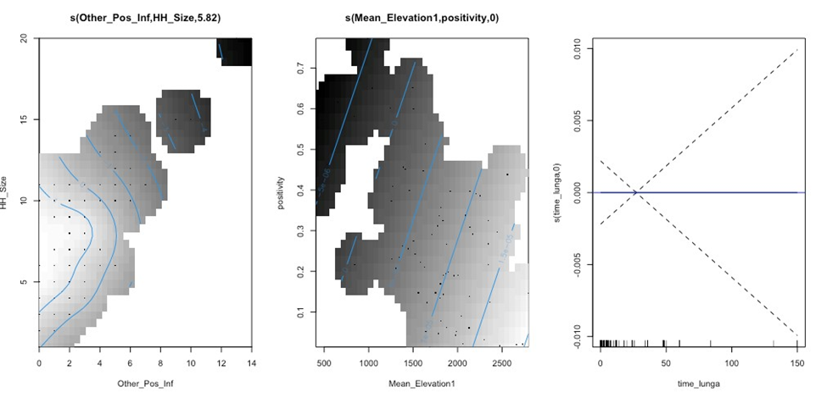

Supplemental Table 1: Demographics of sample

 | n | Mean | Range
Age (years) |  | 23 | 1-62 years
Age Groups
0-4 | 48 | - | -
5-14 | 43 | -
15-24 | 248 | - | -
25+ | 250 | - | -
Gender
Male | 335 | - | -
Female | 255 | - | -
Pregnancy
Yes | 10 | - | -
No | 396 | - | -
Religion
Catholic | 5 | - | -
Muslim | 53 | - | -
Orthodox | 179 | - | -
Protestant | 339 | - | -
Waqefeta | 1 |  | -
Education (among adults 18 years+) |  | -
None | 32 | - | -
Some primary education only | 239 | - | -
At least some secondary education | 204 | - | -
Occupation
Dependent | 69 | - | -
Farming | 14 | - | -
Gold mining | 270 | - | -
Hospitality | 26 | - | -
Housework | 22 | - | -
Merchant | 49 | - | -
Private Business | 83 | -
Student | 32 | - | -
Unemployed | 1 | - | -
Other | 14 | - | -
Time in Lunga
Months spent in Lunga | - | 27 months | 0-300 months
Household size
Number of people in a household | - | 6 people | 1-20 people

Supplemental Table 2: Model output of spline functions from generalized additive logistic regressions for falciparum (PF) malaria infections and bed net access. Interpretation of coefficients is best by visualizing the plots of smoothed effects (Supplemental Figure 3(a)(b) and Figure 4(a)(b)(c)). Variable names correspond to Table 1. Model A only included individual level variables. Model B included those same variables as well as the household level interaction term for other house members having a falciparum infection and for the number of other occupants in the house.

 | Model 1A |  |  |  | Model 1B
 | edf | Ref.df | Chi sq | p-value | edf | Ref.df | Chi sq | p-value
s(Other Household PF Infections, Household Size) | - | - | - | - | 21.26 | 29 | 59.45 | <0.0001
s(Mean woreda Elevation, Mean woreda positivity) | 1.07 | 29 | 3.40 | 0.0491 | 0.67 | 29 | 1.25 | 0.1520
s(Time in Lunga) | 0.0002 | 9 | 0 | 0.7312 | 0.0005 | 9 | 0 | 0.6021

Supplemental Table 3: Model output of spline functions from generalized additive logistic regressions for falciparum malaria (PF) infections and bed net access. Interpretation of coefficients is best by visualizing the plots of smoothed effects (Supplemental Figure 5(a)(b) and Supplemental Figure 6(a)(b)(c)). Variable names correspond to Table 1. Model A only included individual level variables. Model B included those same variables as well as the household level interaction term for other house members having a falciparum infection and for the number of other occupants in the house.

 | Model 2A |  |  |  | Model 2B
 | edf | Ref.df | Chi sq | p-value | edf | Ref.df | Chi sq | p-value
s(Other Household PF Infections, Household Size) | - | - | - | - | 5.82 | 29 | 21.51 | <0.0001
s(Mean woreda Elevation, Mean woreda positivity) | 0.93 | 29 | 2.34 | 0.0869 | 0.0001 | 29 | 0 | 0.6122
s(Time in Lunga) | 0.0001 | 9 | 0 | 0.7497 | 0.00001 | 9 | 0 | 0.9429

Supplemental Table 4: KAP Model Results I

 | Knowledge of mosquito bites causing malaria | Knowledge of sleeping under a bed net | Knowledge of mosquito repellent | Knowledge of household insecticide spraying | Pregnant people can get serious case of malaria | Children under 5 can get serious case of malaria
Age | 0.95  (0.91-0.99) | 0.96  (0.92-1.00) | 0.97  (0.90-1.06) | 0.97  (0.93-1.02) | 0.99  (0.96-1.02) | 1.04  (1.00-1.07)
Gender
Female (reference) | - | - | - | - | - | -
Male | 3.11  (1.23-7.86) | 1.70  (0.78-3.73) | 0.26  (0.07-0.98) | 1.83  (0.74-4.54) | 0.90  (0.50-1.64) | 0.73  (0.41-1.30)
Occupation
No Goldmining | - | - | - |  | - | -
Yes Goldmining | 0.32  (0.12-0.85) | 0.60  (0.27-1.33) | 1.27  (0.39-4.09) | 0.92  (0.36-2.38) | 0.74  (0.41-1.31) | 1.11  (0.63-1.94)
Education
None (reference) | - | - | - | - | - | -
Primary | 1.14  (0.31-4.15) | 1.98  (0.70-5.60) | 0.42  (0.09-2.02) | 1.62  (0.36-7.39) | 0.84  (0.28-2.50) | 1.51  (0.57-4.03)
Secondary | 1.60  (0.41-6.27) | 2.44  (0.82-7.23) | 0.91  (0.20-4.17) | 1.73  (0.37-8.20) | 1.05  (0.35-3.18) | 1.45  (0.54-3.90)
AIC | 234.5062 | 310.9768 | 155.824 | 236.9733 | 441.4158 | 482.5724
n | 421 | 421 | 421 | 412 | 421 | 421

Supplemental Table 5: KAP Model Results II

 | Fever | Feeling cold | Headache | Nausea and vomiting | Dizziness | Loss of appetite | Body ache/joint pain | Body weakness
Age | 0.99 (0.95-1.03) | 0.96 (0.93-0.99) | 0.99 (0.96-1.03) | 1.02  (0.99-1.05) | 1.02  (0.98-1.05) | 1.02  (0.98-1.07) | 0.99  (0.94-1.04) | 0.98  (0.94-1.02)
Gender
Female (reference) | - | - | - | - | - | - | - | -
Male | 1.37 (0.65-2.87) | 1.18 (0.66-2.14) | 1.37 (0.76-2.47) | 0.59  (0.33-1.03) | 0.39  (0.21-0.74) | 0.35  (0.16-0.77) | 0.98 (0.47-2.05) | 1.20 (0.62-2.33)
Occupation
No Goldmining | - | - | - | - | - | - | - | -
Yes Goldmining | 0.66 (0.32-1.34) | 0.75 (0.41-1.35) | 1.37 (0.75-2.31) | 2.00  (1.15-3.51) | 2.64  (1.38-5.08) | 2.74  (1.25-6.03) | 1.00  (0.49-2.07) | 0.74 (0.39-1.39)
Education
None (reference) | - | - | - | - | - | - | - | -
Primary | 0.85 (0.26-2.81) | 1.51 (0.59-3.88) | 1.43 (0.61-3.33) | 2.06  (0.71-5.98) | 2.03  (0.53-7.76) | 2.71  (0.33-22.11) | 0.62 (0.18-2.13) | 1.24 (0.38-4.04)
Secondary | 1.26 (0.37-4.30) | 1.30 (0.49-4.45) | 2.40 (0.99-5.85) | 2.70  (0.93-7.88) | 4.16  (1.09-15.85) | 3.09  (0.38-25.22) | 0.68  (0.20-2.34) | 0.97 (0.29-3.23)
AIC | 325.3193 | 483.3765 | 474.1287 | 500.9739 | 422.5835 | 277.3923 | 306.1645 | 372.2643
n | 421 | 421 | 421 | 421 | 421 | 421 | 421 | 421

