Reproductive biology of the threatened Kaempfer's Tody-Tyrant (Hemitriccus kaempferi)
Journal: Ornithology Research
Guilherme Willrich^{1*}, Fernando Bittencourt de Farias¹, Luiz dos Anjos², Marcos Robalinho Lima²
1 Programa de Pós-graduação em Ciências Biológicas, Departamento de Biologia Animal e Vegetal, Universidade Estadual de Londrina, CEP 86051-970, Londrina, PR, Brazil
2 Departamento de Biologia Animal e Vegetal, Centro de Ciências Biológicas, Universidade Estadual de Londrina, 86051-970, Londrina Brazil.
*Corresponding author: guigawillrich@hotmail.com

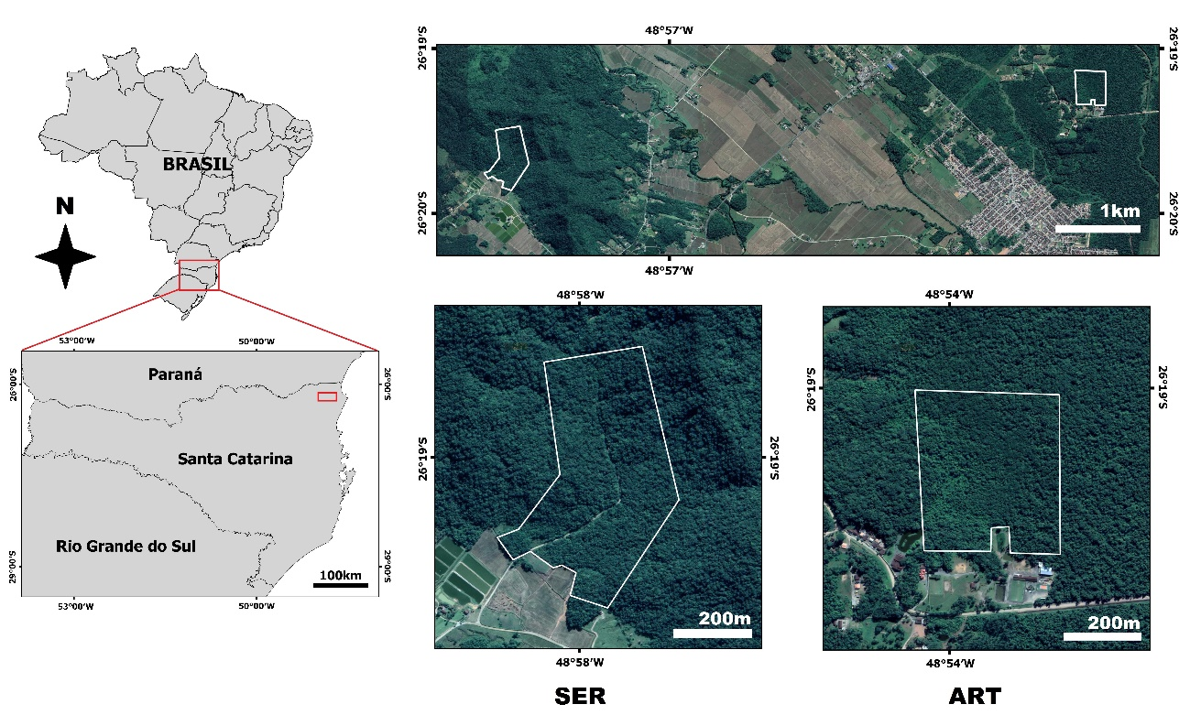
Supplementary Fig. 1 The study areas in the municipally of Joinville, north coast of Santa Catarina state, southern Brazil. SER (26⁰19'31,1''S, 48⁰58'14,0''W) has an area of 25 ha, while ART (26⁰18'57,4''S, 48⁰53'58,1''W) has an area of 15 ha. Both areas are separated by 8km of an urban and agricultural matrix

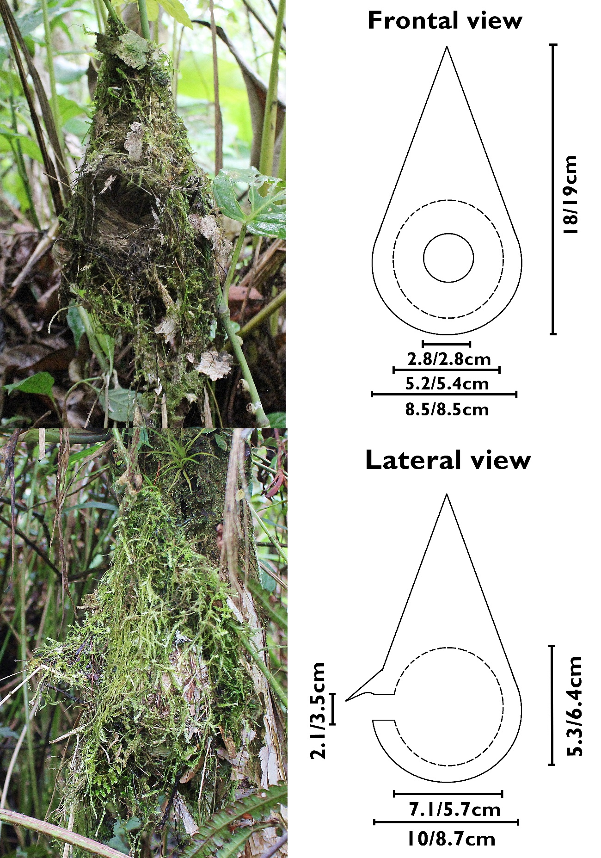
Supplementary Fig. 2 Frontal (N2) and lateral (N1) view of the nests of the Kaempfer's Tody-Tyrant (Hemitriccus kaempferi), with the representation and measurements of each nest (N1/N2). Dashed lines indicate the limits of the incubatory chamber. Measurements are in centimetres. Photographs: Guilherme Willrich

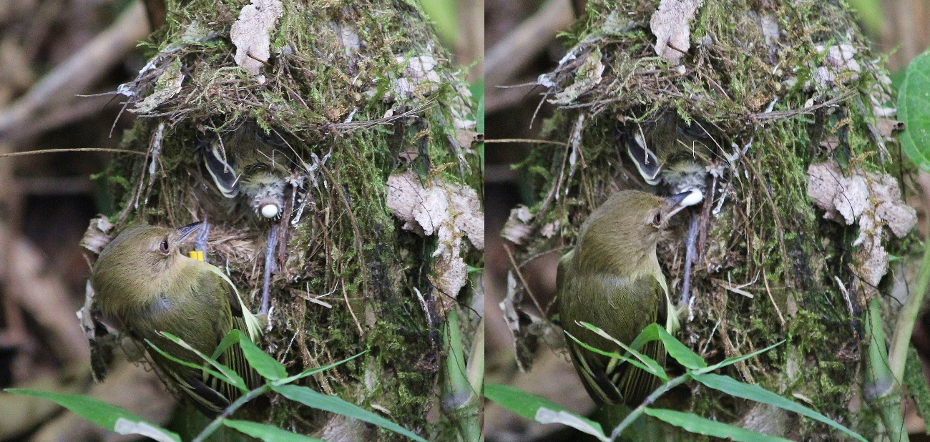
Supplementary Fig. 3 Female of Hemitriccus kaempferi removing fecal sacs directly from nestling’s cloaca (nestling 15 days of age). Photographs: Guilherme Willrich

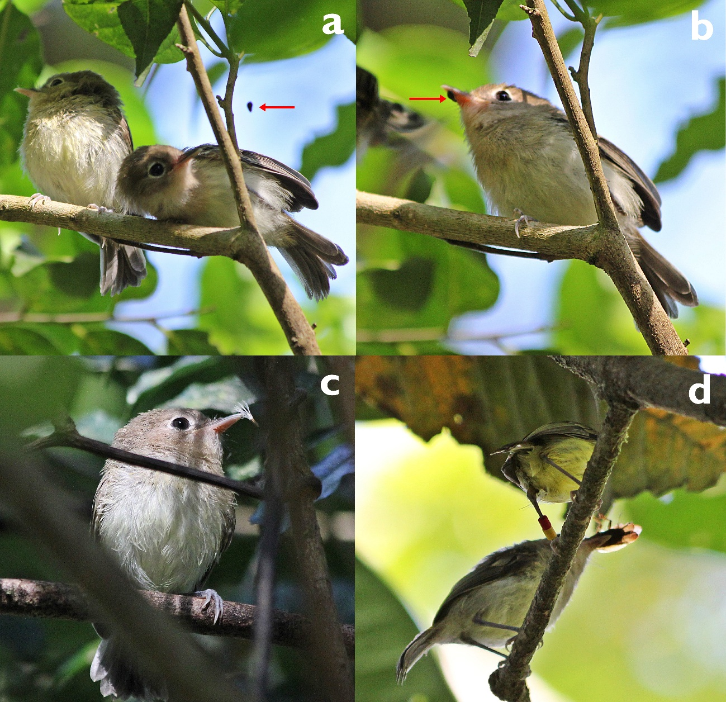
Supplementary Fig. 4 Juveniles of Hemitriccus kaempferi capturing and handling food items. a and b) show a juvenile capturing a food item (red arrow) in a spider web. c) juvenile “handling” a wind dispersal seed (not consumed). d) female delivering an insect (probably Blattodea) to be handled by the juvenile. Photographs: Guilherme Willrich

