Supplementary Information for

V activated Ag-O catalytic sites for direct electro-epoxidation to successive producing propylene oxide

Yan Lin^{2,§}, Xiaodong Miao^{1,§}, Yunayuan Sun¹, Hui Li¹, Hao Ren¹, Wangyang Cui¹, Mingbo Wu¹ and Zhongtao Li^{1,*}

¹State Key Laboratory of Heavy Oil Processing, College of Chemical Engineering, China University of Petroleum (East China), Qingdao 266580, P. R. China.
² Department of Chemistry, Tsinghua University, Beijing 100084, P. R. China

§ These authors contributed equally to this work.
* Corresponding Author, E-mail: liztao@upc.edu.cn.

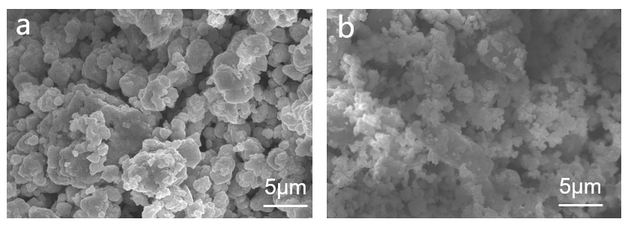
Figure S1 SEM images of a) Ag-O/GDL; b) Ag-V-O/GDL

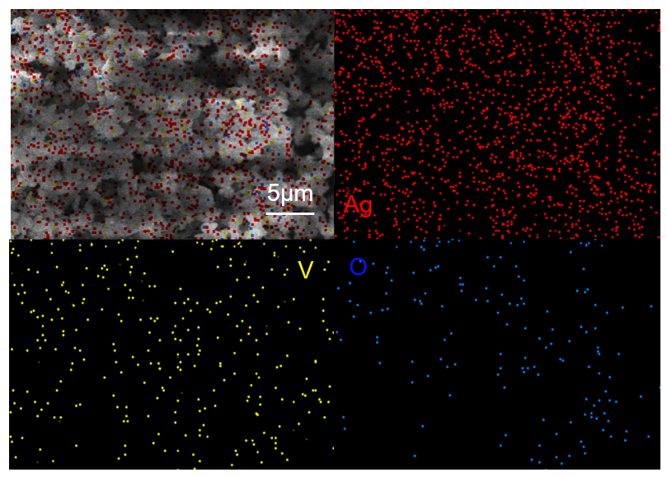
Figure S2 SEM-mapping image of Ag-V-O/GDL

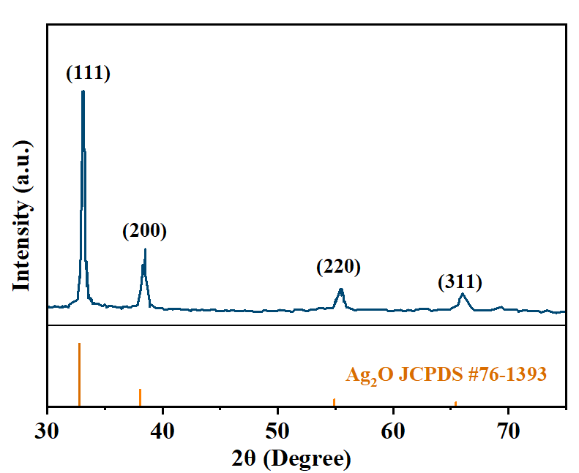
Figure S3 X-ray diffraction images of Ag-O/GDL

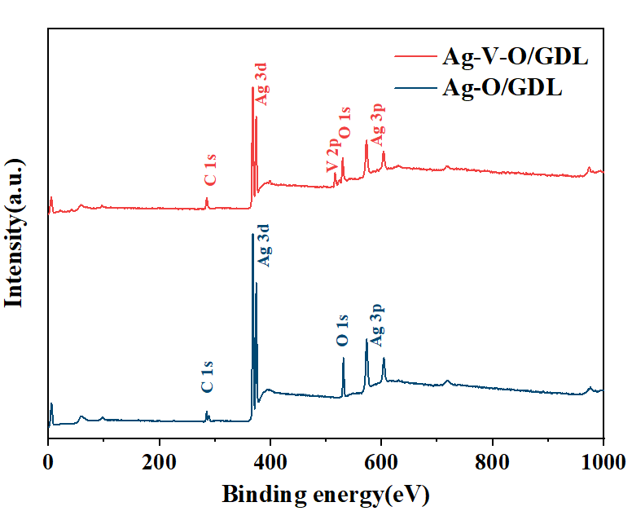
Figure S4 X-ray photoelectron spectroscopy of Ag-O/GDL and Ag-V-O/GDL catalysts

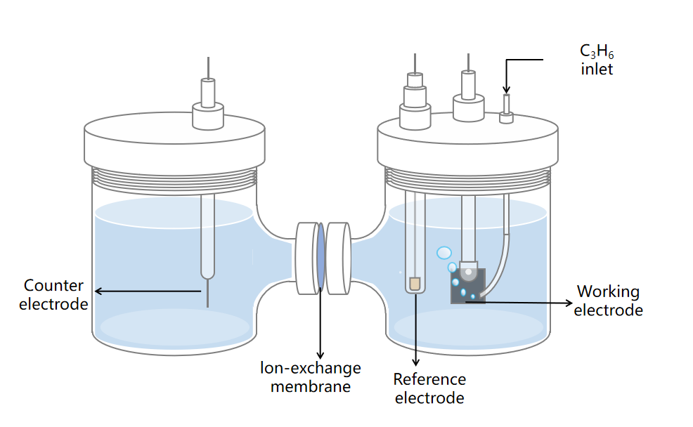
Figure S5 Schematic diagram of an H-cell used for propene epoxidation

Figure S6 Constant current polarization curve and Faradaic efficiency variation diagram of the H-cell (electrode area 1*1 cm², polarization current 3 mA)

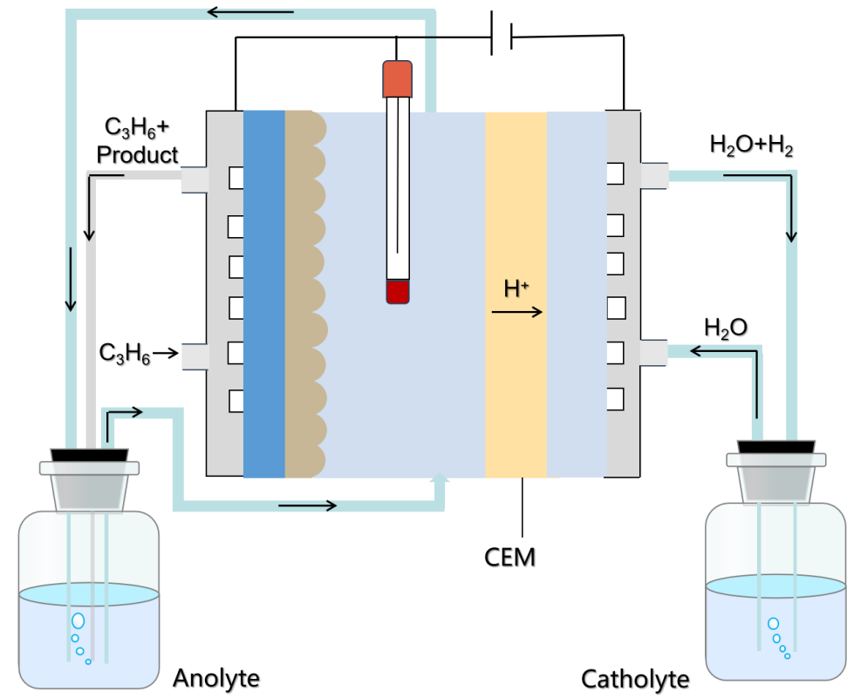
Figure S7 Schematic diagram of a flow-cell used for propene epoxidation

Figure S8 Constant current polarization curve and Faradaic efficiency variation diagram of the flow cell (electrode area 1.5*1.5 cm², polarization current 6.75 mA).

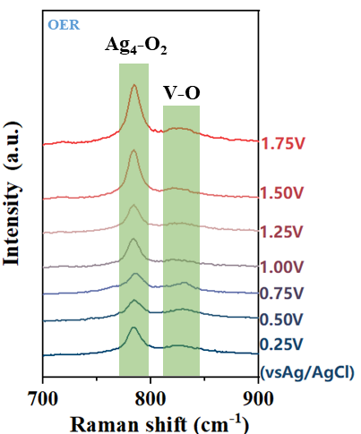
Figure S9 In-situ Raman spectrum of the OER process of Ag-V-O/GDL (700cm⁻¹-900cm⁻¹)^{1,2}

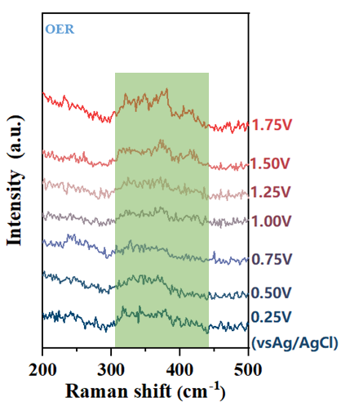
Figure S10 In-situ Raman spectrum of the OER process of Ag-V-O/GDL (200cm⁻¹-500cm⁻¹)³

Figure S11 Membrane electrode condition optimization - different humidities

Figure S12 Membrane electrode condition optimization - different temperatures

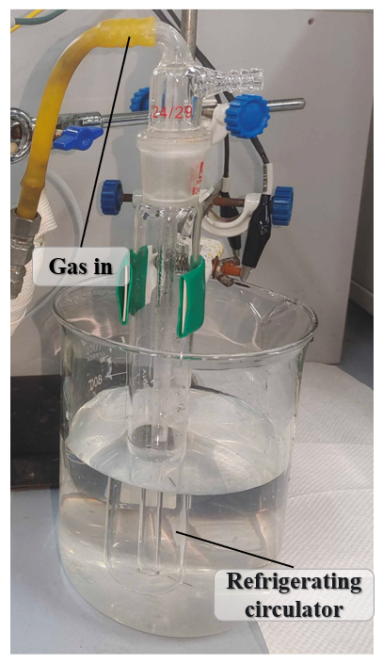
Figure S13 Physical diagram of the product (PO) collection device after the electrochemical reaction

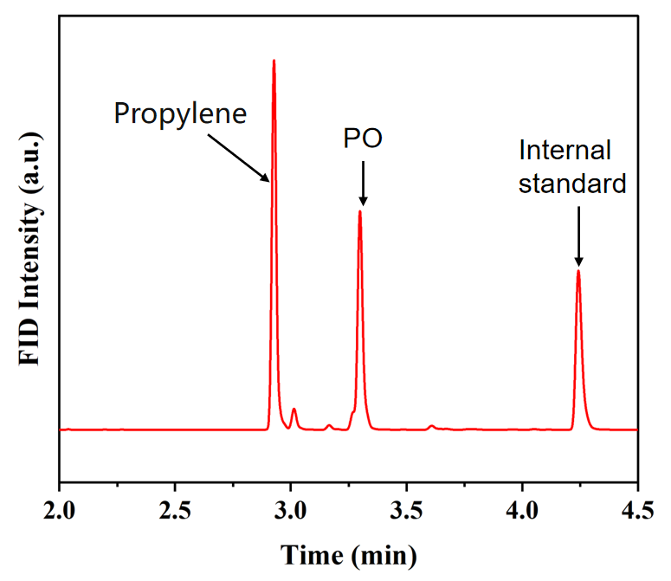
Figure S14 Gas chromatography detection after 4 hours of reaction under optimal membrane electrode conditions (using FKB-PK-130 cation exchange membrane as the separator, reaction temperature at 35°C, relative humidity at 100%, anode electrode area of 2*2 cm², reaction current of 12mA).

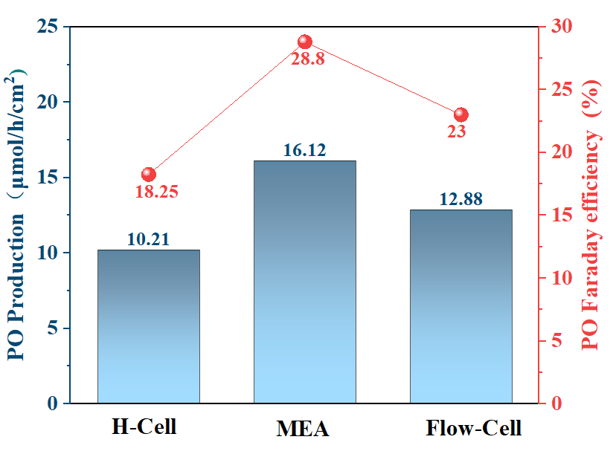
Figure S15 Comparison of the Faradaic efficiency and area yield of the three types of electrolysis cells

Figure S16 XRD diagram of Ag-V-O/GDL catalyst before and after the reaction

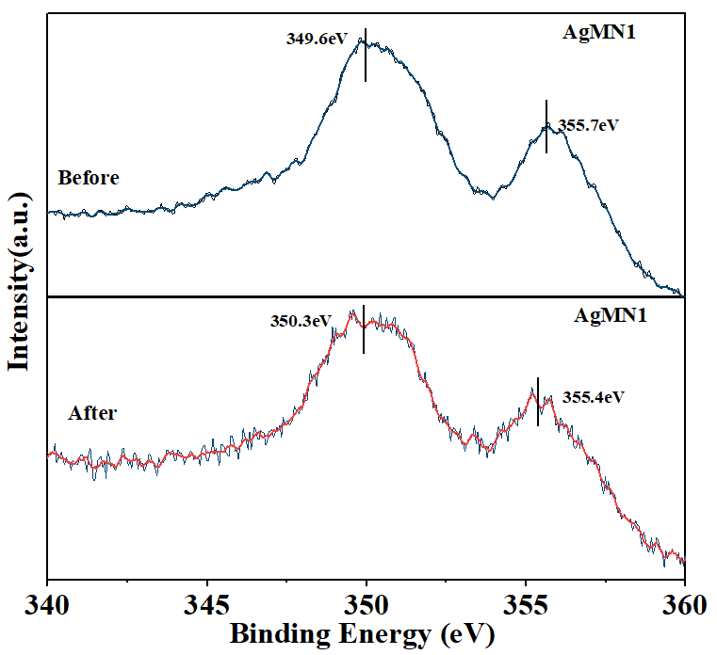
Figure S17 XPS spectrum of Ag-V-O/GDL catalyst before and after the reaction

Table S1 Impedance fitting results for Ag-O/GDL and Ag-V-O/GDL
Catalyst | R_{s} (Ω cm²) | R_{ct}(Ω cm²) | CPE-T(F/cm²)
Ag-O/GDL | 13.88 | 34.53 | 0.00115
Ag-V-O/GDL | 13.87 | 20.91 | 0.00334

Table S2 Comparison of the epoxidation performance of electrocatalytic propylene in this work with other reported reports
Catalyst | Conditions | Highest epoxide production rate (μmol cm-²/h⁻¹) | Epoxidation FE at the highest rate | Reference
Ag₃PO₄ cube | 2.4 V vs. RHE | 9.2 | 18.7 % | 4
PtOx | 1.6 V vs. SHE | 37 | 7.4% | 5
PtOx(N2H4) | 1.6 V vs. SHE | 4.7 | 40% | 5
Ag | - | <0.02 | > 0 | 6
PdPtOx/C | 1.1V vs. Fc/Fc+ | 473 | 66% | 7
Ag-V-O/GDL | 3mA/cm² | 16.12 | 28.8% | This work

References
1 Pu, T. et al. Revealing the Nature of Active Oxygen Species and Reaction Mechanism of Ethylene Epoxidation by Supported Ag/α-Al₂O₃ Catalysts. ACS Catal. 14, 406-417(2023).
2 Cao, X. et al. Strong p-d Orbital Hybridization on Bismuth Nanosheets for High Performing CO₂ Electroreduction. Adv. Mater. 36, 2309648(2024).
3 Chen, D., Kang, P. L. & Liu, Z. P. Active site of catalytic ethene epoxidation: machine-learning global pathway sampling rules out the metal sites. ACS Catal. 11, 8317-8326(2021).
4 Ke, J. et al. Facet-dependent electrooxidation of propylene into propylene oxide over Ag₃PO₄ crystals. Nat. Commun. 13, 932(2022).
5 Iguchi, S. et al. Direct epoxidation of propylene with water at a PtOx anode using a solid-polymer-electrolyte electrolysis cel. Catal. Sci. Tech. 12, 469-473(2022).
6 Holbrook, L. L. & Wise, H. Electrooxidation of olefins at a silver electrode. J. Catal. 38, 294-298(1975).
7 Chung, M. et al. Direct propylene epoxidation via water activation over Pd-Pt electrocatalysts. Science 383, 49-55(2024).

