Supplementary materials
Table S1 Effects of Cd treatment on chlorophyll content of different rice cultivars
Treatment | Chlorophyll contents  (mg/g) |  |  | Carotenoid contents  (mg/g)
Treatment | a | b | a+b | Carotenoid contents  (mg/g)
W4-CK | 34.62±0.38a | 15.65±1.39a | 50.26±1.01a | 8.23±0.35a
9311-CK | 34.67±0.36a | 9.14±0.3b | 43.84±2.23b | 8.88±0.29a
W4-Cd10 | 23.88±0.33b | 8.98±0.35b | 32.86±0.66c | 4.53±0.16b
9311-Cd10 | 31.69±3.68a | 9.97±1.07b | 41.66±2.61b | 8.40±0.80a
The rice seedlings were hydroponically treated with or without 10 μM Cd for 14 days. Data were means ± S.D., n = 3. Different lower cases indicate significant differences at P < 0.05 by Tukey’s test.

Table S2 Effect of Cd treatment on root morphological parameters
Treatment | Root length (cm) | Root surface area (cm²) | Root diameter (mm) | Root volume (cm³) | Root tip number
W4-CK | 354.90±28.49a | 46.34±5.56b | 0.40±0.02bc | 354.90±28.49b | 1912±104.89a
9311-CK | 362.50±12.70a | 56.85±4.60a | 0.47±0.02a | 469.93±65.49a | 2001.24±125.80a
W4-Cd10 | 238.54±30.87b | 26.26±3.96c | 0.35±0.03c | 238.54±30.87c | 1374.78±126.20b
9311-Cd10 | 361.24±6.28a | 49.76±3.93ab | 0.44±0.03ab | 361.24±6.28b | 2031.70±100.75a
The rice seedlings were hydroponically treated with or without 10 μM Cd for 14 days. Data were means ± S.D., n = 3. Different lower cases indicate significant differences at P < 0.05 by Tukey’s test.

Table S3 Effects of Cd treatment on photosynthetic characteristics of different rice cultivars.
Treatment | P_{n}/(μmol·m⁻²·s⁻¹) | G_{s}/(mol·m⁻²·s⁻¹) | C_{i}/(μmol·mol⁻¹) | T_{r}/(mmol·m⁻²·s⁻¹)
W4-CK | 25.34±1.45b | 0.09±0.01a | 449.73±16.41a | 1.68±0.2a
9311-CK | 35.00±2.69a | 0.12±0.02a | 470.08±1.78a | 1.97±0.24a
W4-Cd10 | 23.55±0.49b | 0.03±0.002b | 343.11±66.76b | 0.47±0.08c
9311-Cd10 | 32.48±3.50a | 0.05±0.003ab | 467.54±32.93a | 0.91±0.05b
The rice seedlings were hydroponically treated with or without 10 μM Cd for 14 days. Data were means ± S.D., n = 3. Different lower cases indicate significant differences at P < 0.05 by Tukey’s test.

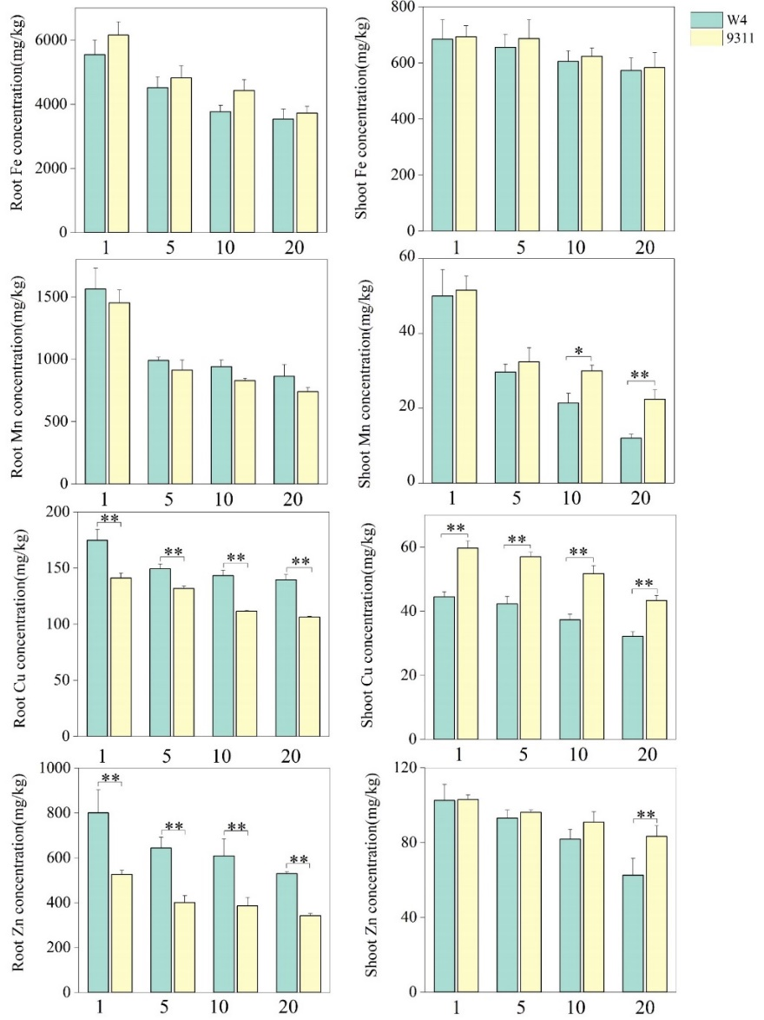
Fig. S1 Fe, Mn, Cu, and Zn contents in rice seedling roots and shoots of W4 and 9311 in the presence of 10 μM Cd for 14 days. Data were shown as means ± S.D., n = 3. Different lower cases indicate significant differences at P < 0.05 by Tukey’s test.

