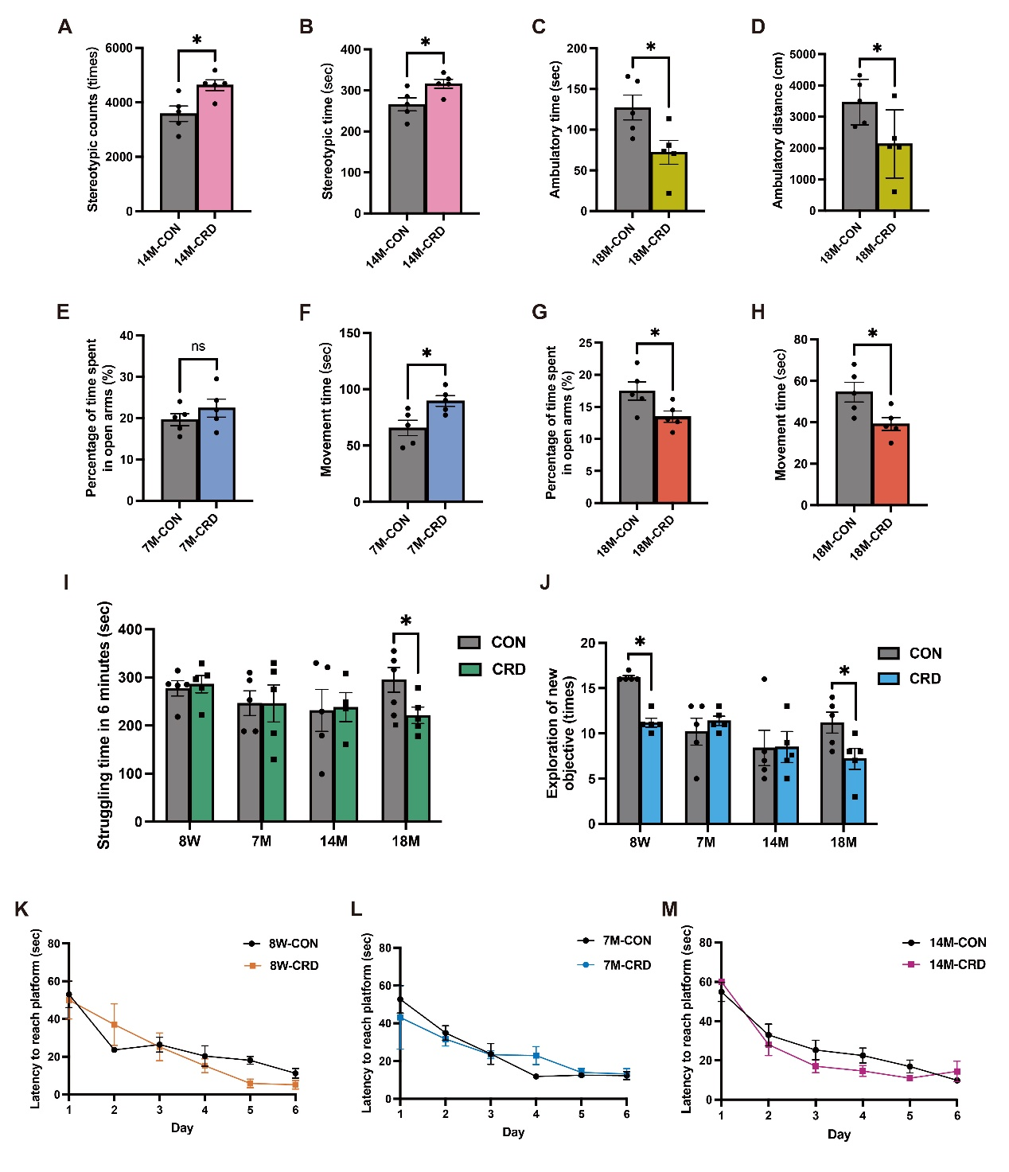
Figure S1. Effects of CRD on the behavioral characteristics of mice of different ages. Related to Figure 1.
(A) Number of stereotypic behaviors during the OFT in 14-month-old mice (n=5 mice per group). (B) Duration of stereotypic behaviors during the OFT in 14-month-old mice (n=5 mice per group). (C) Duration of ambulatory activity during the OFT in 18-month-old mice (n=5 mice per group). (D) Distance moved by 18-month-old mice during the OFT (n=5 mice per group). (E) Percentage of time spent in the open arm during the EPM by 7-month-old mice (n=5 mice per group). (F) Time spent moving during the EPM by 7-month-old mice (n=5 mice per group). (G) Percentage of time spent in the open arm during the EPM by 18-month-old mice (n=5 mice per group). (H) Time spent moving during the EPM by 18-month-old mice (n=5 mice per group). (I) Time spent struggling by mice within the 6 min of the TST (n=5 mice per group). (J) Number of times mice were exposed to new objects during the NOR test (n=5 mice per group). (K–M) Time taken to find the platform during the MWM training phase by 8-week-old, 7-month-old, and 14-month-old mice (n=5 mice per group). All data are mean±SEM, *p<0.05.

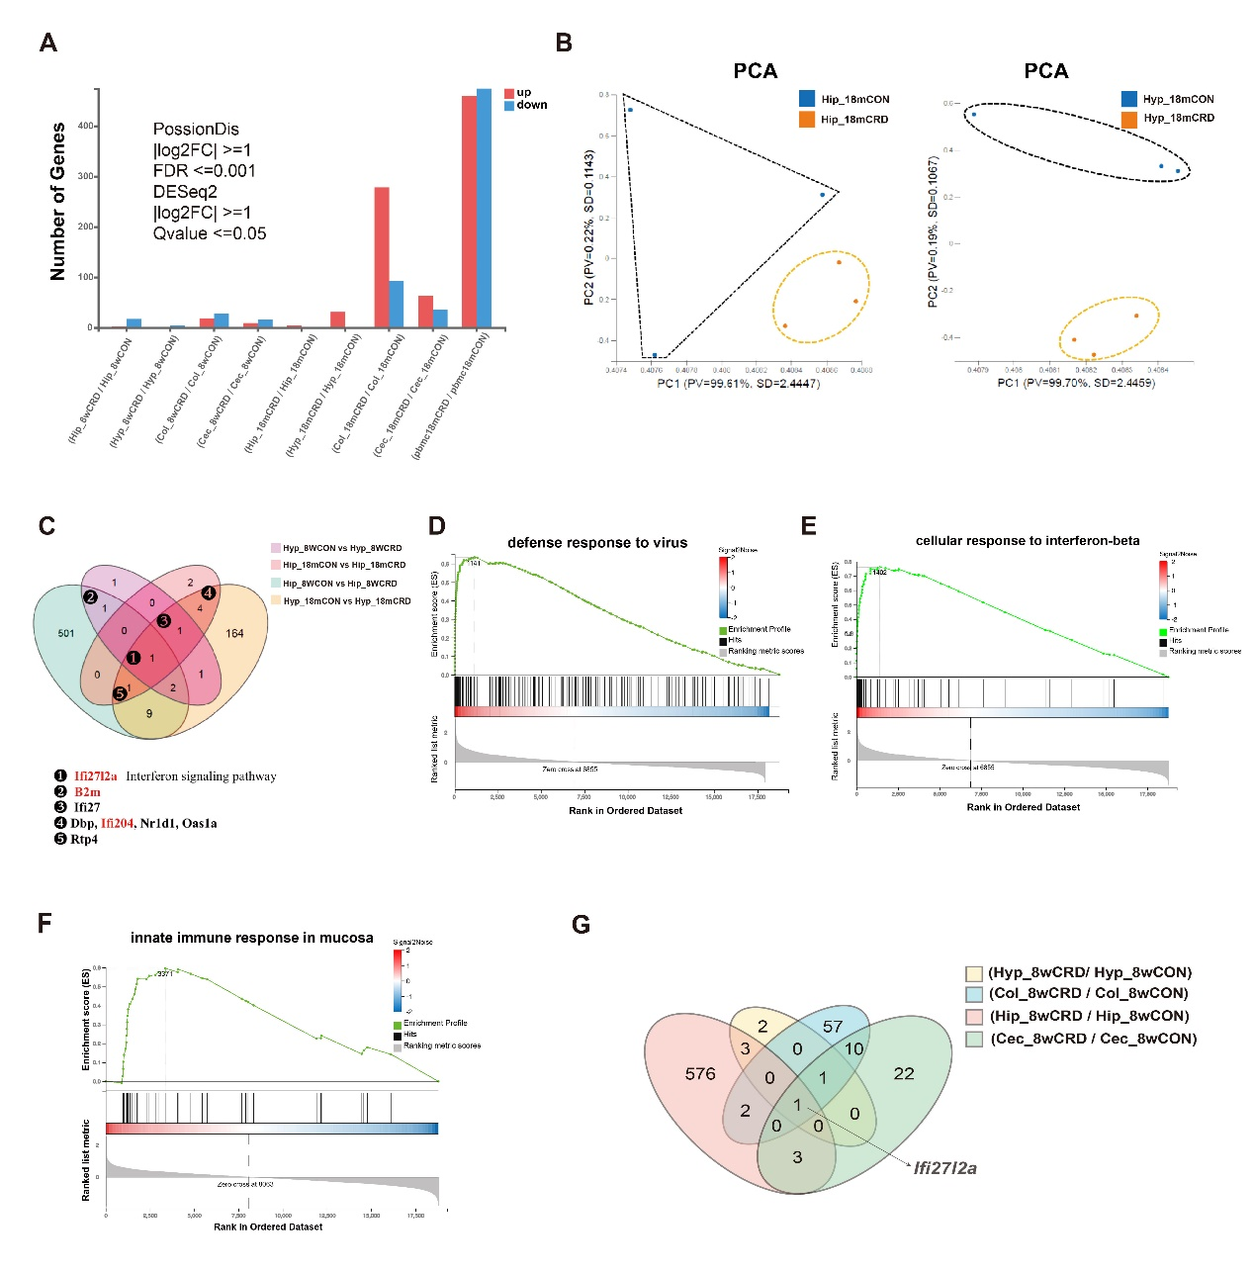
Figure S2. Results of RNA-seq, suggesting the activation of systemic innate immunity in 18-month-old CRD mice. Related to Figure 2.
(A) Effect of CRD on the number of DEGs in young and old mice. (B) Results of PCA, revealing the existence of different expression profiles in the hippocampus and hypothalamus of 18-month-old CRD and CON mice. (C) Venn diagram demonstrating the expression of DEGs common to the hippocampus and hypothalamus in 8-week-old and 18-month-old mice subjected to CRD. (D) Results of GSEA, revealing enrichment of the defense response to virus pathway in 18-month-old CRD mice. (E) Results of GSEA, revealing enrichment of the cellular response to interferon-beta pathway in 18-month-old CRD mice. (F) Results of GSEA, revealing enrichment of the innate immune response in the mucosa pathway in the colons of 18-month-old CRD mice. (G) Venn diagram showing significant enrichment of Ifi27l2a in all the tissues of 8-week-old mice subjected to CRD.

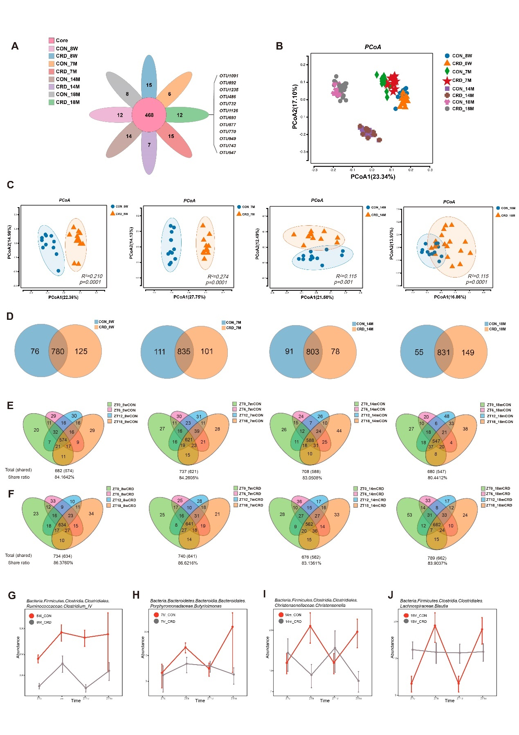
Figure S3. Results of 16S rRNA sequencing, revealing negative effects of CRD on the composition of the gut microbiota of mice of various ages.
(A) Venn diagram showing the OTUs specific to CON and CRD mice of various ages. (B) Results of PCoA, demonstrating the characteristics of CON and CRD mice of various ages. (C) Results of PCoA, demonstrating the characteristics of CON and CRD mice of the same age. (D) Venn diagram demonstrating the common and differing OTUs of CON and CRD mice of the same age. (E) Venn diagram demonstrating the common and differing OTUs of CON mice of the same age group at four sampling time points, used to calculate the shared OTU ratio. (F) Venn diagram demonstrating the common and differing OTUs of CRD mice of the same age group at four sampling time points, used to calculate the shared OTU ratio. (G–J) OTUs with significantly different oscillations in CON and CRD mice of each age, analyzed using JTK_Cycle.

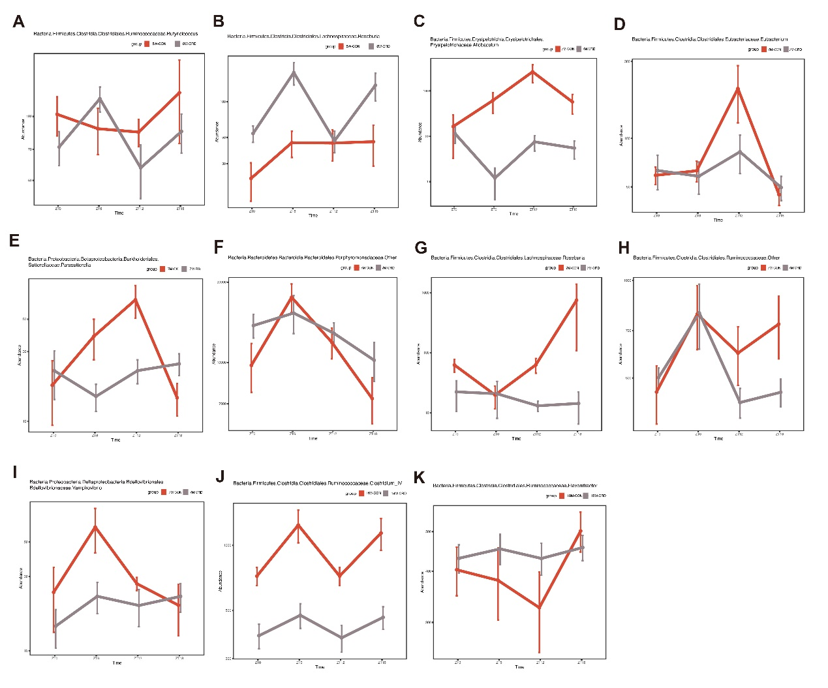
Figure S4. Diurnal oscillatory differences of specific gut microbes in CRD and CON mice, according to the results of JTK_Cycle analysis. Related to Figure S3.
(A–B) Gut microbes showing differences in diurnal oscillations in 8-week-old CRD and CON mice. (C–I) Gut microbes showing differences in diurnal oscillations in 7-month-old CRD and CON mice. (J) Gut microbes showing differences in diurnal oscillations in 14-month-old CRD and CON mice. (K) Gut microbes showing differences in diurnal oscillations in 18-month-old CRD and CON mice.

