Supplementary Information
Nambu-Goldstone mode in K₃Na(SeO₄)₂ crystal.
M. Kaczmarski, J. Jenczyk, B. Mróz

Fig. S1 shows structures of monoclinic and trigonal phases of K₃Na(SeO₄)₂. Fig. S1(a) displays 8 monoclinic unit cells and 12 trigonal unit cells in order to illustrate the subtle structural changes taking place during phase transition. It is worth noticing that the sodium and potassium positions within the lattice do not change substantially upon transition. The lattice parameter c characteristic for monoclinic structure equals 15.021 Å whereas the doubled value of c=7.5552 Å, which is characteristic for trigonal phase, equals 15.1104 Å. Similarly, there is only small increase in the case of b lattice parameter from 5.867 Å to 5.906 Å during phase transition from monoclinic to trigonal phase. Accordingly, the specific volume of the crystal increases. An apparent structural differences are discernable when the SeO₄ tetrahedra spatial orientations are analyzed. Clearly, the Se – O1 bond changes its orientation with respect to the c axis upon phase transition.
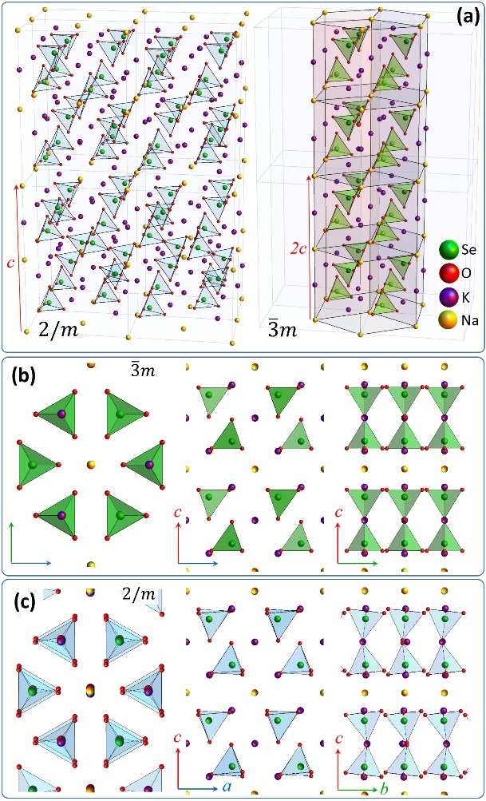
Fig. S1. a) the low-symmetry monoclinic phase C2/c (2/m) and the trigonal $P\overline{3}m1 (\overline{3}m)$ phase of K3Na(SeO4)₂, b) and c) display structural differences between these two phases taking into account three orthogonal projections.
Animation SA1. Tetrahedron modulations
https://drive.google.com/file/d/1QCVJlhLQA2g6CJduDx8jghqZlb2CThqi/view?usp=sharing
Link provides an access to animation, which schematically illustrates possible modulation involving SeO₄ tetrahedra. The modulation can be described as propagating disturbance forming traveling wave. Its wavelength can be temperature dependent and may significantly excess the size of the unit cell. The presence of such modulation could introduce structural distortion, which is incommensurable with the crystal lattice parameters and accordingly brake the translational symmetry.
Table S1. Raman mode assignment for amplitudon and phason

amplitudon (zz)
A_{g} (zz, yx) A_{g} A_{1g} (xx, yy, zz)
A_{2g} (silent mode)
B_{g} (yz) phason (yx) E_{g}
2/m (C_{2h}) │ IC + 2/m │ │ m
240 K 334 K 346 K

