Characterization of wastewater quality and denitrification potential of domestic wastewater
Nguyen Quoc Khanh, Shun-Hsing Chuang*
Graduate Institute of Environmental Engineering, National Central University, 300 Zhong-da Road, Zhongli, Taoyuan 32001, Taiwan
Corresponding author: Shun-Hsing Chuang
Graduate Institute of Environmental Engineering, National Central University,
Zhongli 320, Taiwan
Email: shchuang@ncu.edu.tw
Tel.: +886-3-4227151, ext. 34682
Table S1 OUR test parameters
No. | COD (mg/L) | VSS (mg/L) | Initial loading  (kg COD/kg VSS)
1 | 250 | 2500 | 0.1
2 | 250 | 1250 | 0.2
3 | 250 | 833 | 0.3
4 | 250 | 625 | 0.4
5 | 250 | 500 | 0.5
Table S2-A Wastewater characteristics data for raw wastewater
Sample | D1 |  | D2 |  | D3
Sample | Influent | Effluent | Influent | Effluent | Influent | Effluent
S_{S} | 41.1 ± 0.4 | 2.5 ± 0.4 | 34.5 ± 0.8 | 2.0 ± 0.8 | 60.5 ± 0.4 | 1.2 ± 0.4
S_{I} | 11.8 ± 0.4 | 12.1 ± 1.1 | 15.5 ± 1.2 | 16.8 ± 0.7 | 12.4 ± 0.2 | 14.6 ± 2.5
X_{S} | 197.0 ± 2.8 | 2.2 ± 0.3 | 175.0 ± 3.5 | 3.9 ± 0.5 | 118.9 ± 4.2 | 13.9 ± 1.0
X_{I} | 128.2 ± 4.6 | 1.0 ± 2.2 | 166.7 ± 2.1 | 2.1 ± 0.8 | 115.4 ± 16.5 | 3.6 ± 0.0
SCOD | 52.9 ± 0.8 | 14.6 ± 1.5 | 50.0 ± 2.0 | 18.8 ± 1.5 | 72.9 ± 0.6 | 15.8 ± 2.9
TCOD | 378.1 ± 8.2 | 17.8 ± 4.0 | 391.7 ± 7.7 | 24.9 ± 2.8 | 307.2 ± 21.3 | 33.3 ± 3.9
Table S2-B Wastewater characteristics data for raw wastewater
Sample | D4 |  | D5 |  |  | D6 |  | D7 | D8 | D9
Sample | Influent | Effluent |  | Influent | Effluent | Influent | Effluent | Influent | Influent | Influent
S_{S} | 46.9 ± 1.2 | 10.8 ± 1.2 | 46.5 ± 0.4 |  | 16.3 ± 1.2 | 46.8 ± 0.8 | 0.0 ± 0.4 | 34.6 ± 0.4 | 40.1 ± 0.8 | 32.3 ± 0.4
S_{I} | 11.1 ± 0.2 | 12.0 ± 1.5 | 11.9 ± 0.7 |  | 13.0 ± 1.3 | 13.4 ± 0.6 | 13.3 ± 0.9 | 16.8 ± 0.5 | 18.4 ± 1.6 | 16.7 ± 1.2
X_{S} | 94.3 ± 6.2 | 1.9 ± 0.5 | 95.3 ± 5.3 |  | 6.3 ± 1.3 | 123.1 ± 0.8 | 6.4 ± 0.8 | 159.8 ± 5.0 | 153.5 ± 1.8 | 143.4 ± 3.0
X_{I} | 22.1 ± 2.6 | 4.7 ± 0.8 | 27.9 ± 10.8 |  | 5.0 ± 1.3 | 65.5 ± 9.0 | 9.3 ± 2.5 | 33.1 ± 5.2 | 76.4 ± 11.8 | 14.6 ± 2.5
SCOD | 58.0 ± 1.3 | 22.8 ± 2.7 | 58.4 ± 1.1 |  | 29.3 ± 2.5 | 60.2 ± 1.4 | 13.3 ± 1.3 | 51.4 ± 0.9 | 58.5 ± 2.4 | 49.0 ± 1.6
TCOD | 174.4 ± 10.1 | 29.4 ± 3.9 | 181.6 ± 17.2 |  | 40.6 ± 5.1 | 248.8 ± 11.2 | 29.0 ± 4.6 | 244.3 ± 11.1 | 288.4 ± 16.0 | 207.0 ± 7.1

Table S3 TKN fractions value for domestic wastewater
 | Raw wastewater |  |  | Settled wastewater
 | D1 | D2 | D3 | D4 | D5 | D6 | D7 | D8
S_{ND} | 0.4 ± 0.1 | 1.2 ± 0.1 | 3.6 ± 0.0 | 1.8 ± 0.1 | 4.5 ± 0.2 | 5.6 ± 0.2 | 0.3 ± 0.0 | 0.8 ± 0.1
X_{ND} | 18.2 ± 0.1 | 7.6 ± 0.0 | 7.1 ± 0.1 | 6.2 ± 0.1 | 6.3 ± 0.0 | 6.1 ± 0.2 | 8.8 ± 0.2 | 7.7 ± 0.3
S_{NI} | 0.1 ± 0.0 | 0.3 ± 0.1 | 1.4 ± 0.0 | 0.5 ± 0.0 | 1.9 ± 0.1 | 1.1 ± 0.2 | 0.9 ± 0.1 | 2.6 ± 0.2
X_{NI} | 12.8 ± 0.5 | 6.7 ± 0.2 | 6.9 ± 0.3 | 1.6 ± 0.0 | 1.7 ± 0.1 | 2.6 ± 0.2 | 4.5 ± 0.1 | 0.7 ± 0.0
NH₄⁺-N | 36.7 ± 0.1 | 27.9 ± 0.1 | 45.9 ± 2.4 | 46 ± 0.8 | 28.1 ± 0.2 | 33.8 ± 0.6 | 30.9 ± 2.1 | 45.8 ± 0.1
TKN_{tot} | 68.2 ± 0.9 | 43.7 ± 0.7 | 64.9 ± 2.5 | 56.1 ± 1.9 | 42.5 ± 1.0 | 49.2 ± 2.0 | 45.4 ± 5.1 | 57.6 ± 1.0
TKN_{in,0.45} | 37.2 ± 0.1 | 29.4 ± 0.2 | 50.9 ± 5.3 | 48.3 ± 0.9 | 34.5 ± 0.3 | 40.5 ± 0.7 | 32.1 ± 2.2 | 49.2 ± 0.2
TKN_{eff,0.45} | 0.9 ± 0.1 | 2.4 ± 0.0 | 1.7 ± 1.7 | 14.3 ± 0.3 | 2.5 ± 0.7 | 1.5 ± 0.2 | 1.5 ± 0.0 | 2.9 ± 0.8
NO₃⁻-N | 1.1 ± 0.1 | 0.3 ± 0.0 | - | 0.2 ± 0.1 | 0.2 ± 0.1 | - | 0.6 ± 0.1 | 0.7 ± 0.1
NO₂⁻-N | 0.8 ± 0.0 | 0.2 ± 0.0 | - | 0.1 ± 0.0 | 0.1 ± 0.0 | - | 0.5 ± 0.0 | 0.7 ± 0.0
- below detection limit
Table S4 Denitrification parameters for two types of carbon sources
Substrate | C/N ratio | SDNR  (mg NO₃⁻-N /g VSS.hr) | SSUR  (mg COD/g VSS.hr) | NO₃⁻-N removal rate (%)
Acetate | 3 | 2.05 ± 0.13 | 6.229 ± 0.07 | 97.2 ± 4.6
Acetate | 4 | 2.382 ± 0.12 | 7.197 ± 0.26 | 97.2 ± 4.6
Acetate | 5 | 2.42 ± 0.03 | 9.451 ± 0.25 | 97.2 ± 4.6
Acetate | 6 | 2.423 ± 0.05 | 13.709 ± 0.55 | 97.2 ± 4.6
Raw wastewater | 3 | 1.22 ± 0.04 | 1.45 ± 0.23 | 47.6 ± 3.1
Raw wastewater | 4 | 1.35 ± 0.17 | 1.52 ± 0.15 | 47.6 ± 3.1
Raw wastewater | 5 | 1.47 ± 0.11 | 1.59 ± 0.17 | 47.6 ± 3.1
Raw wastewater | 6 | 1.67 ± 0.04 | 1.96 ± 0.12 | 47.6 ± 3.1

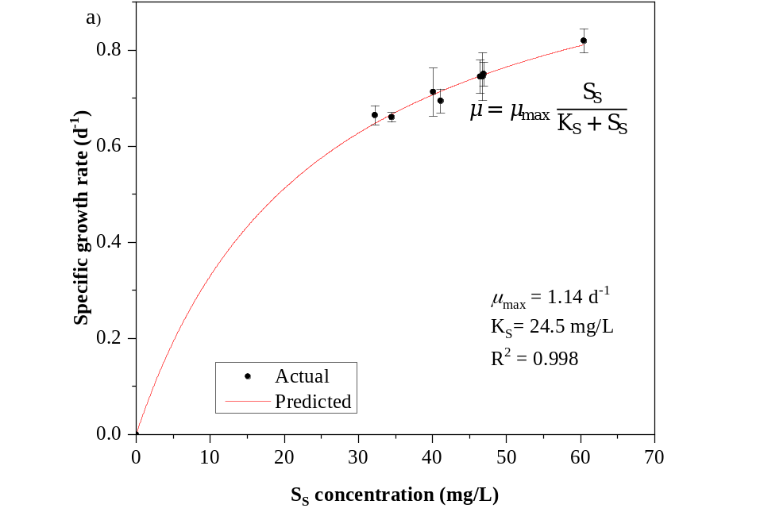
Fig. S1 Response of microorganisms to different S_{S} concentrations for domestic WWT
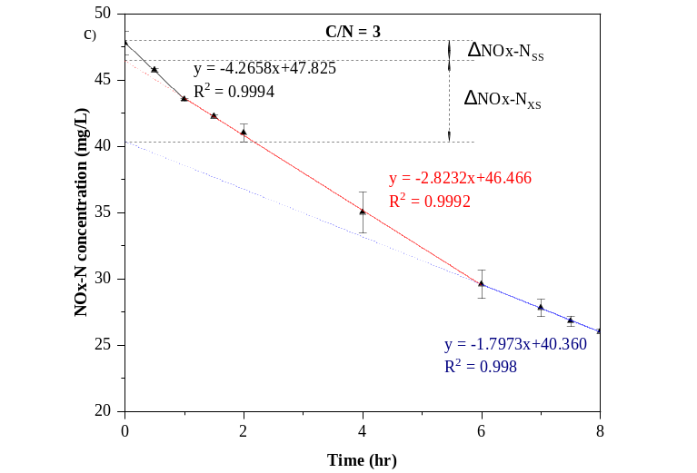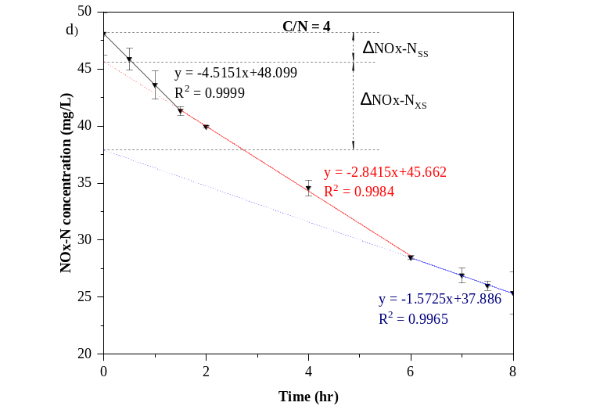
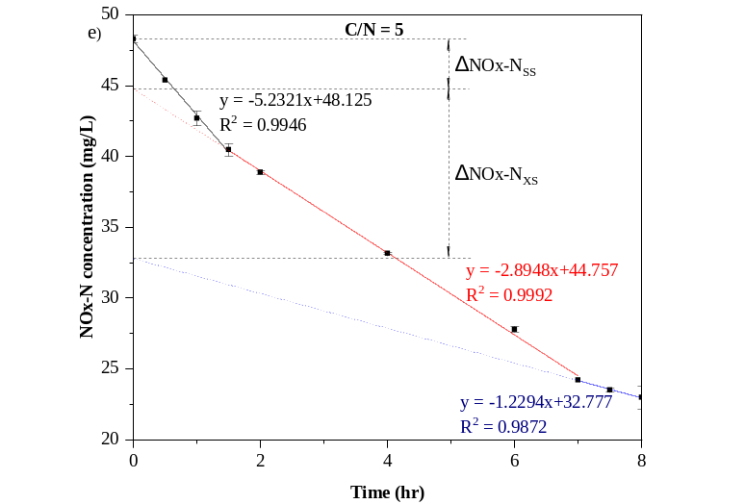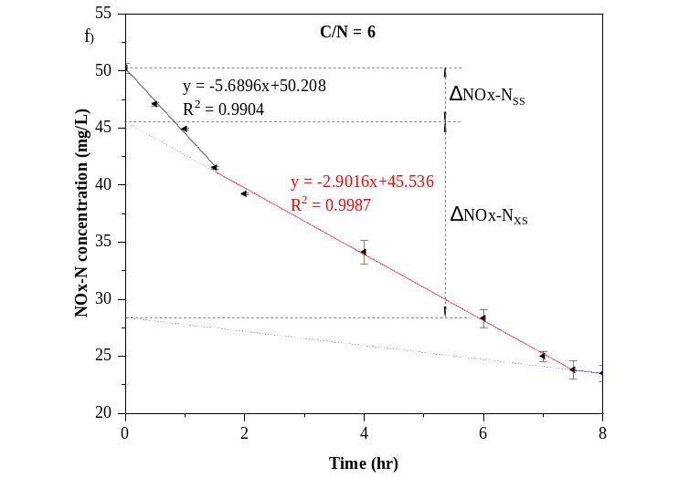
Fig. S2 Linear regression analysis of the denitrification mechanism by different C/N ratios for domestic WWT (Figure c, d, e, f)

