- Appendix A. Methods
  - Crops and crop categories considered
We considered 26 crops in GAEZ which aggregate the FAOSTAT crop list (160 unique crops in the 2020 download) to calculate the food production losses due to solar photovoltaic (PV) encroachment on cropland. We analyzed the integrated food losses by converting the production losses into calories based on the nutritive factors provided by FAO. The calories per 100 grammes of each crop could be found in https://www.fao.org/economic/the-statistics-division-ess/publications-studies/publications/nutritive-factors/en/.
Table S1 Crops and crop categories
Crops and crop categories | kilocalories per 100 grammes | FAOSTAT crop (production domain crop code)
Banana | 60 | Bananas (486), Plantains (489)
Barley | 332 | Barley (44)
Cassava | 109 | Cassava (125)
Cotton | 253 | Seed Cotton (328)
Crop SNES | 340 | Brazil nuts with shell (216), Cashew nuts with shell (217), chestnut (220), Almonds with shell (221), Walnuts with shell (222), Pistachios (223), Kola nuts (224), Hazelnuts with shell (225), Areca nuts (226), Nuts nes (234), Coconuts (249), Karite nuts (sheanuts) (263), Tung nuts (275), Melonseed (299), Kapok Fruit (310), Oranges (490), Tangerines (495), Lemons and limes (497), Grapefruit (507), Fruit citrus nes (512), Apples (515), Pears (521), Quinces (523), Apricots (526), Cherries sour (530), Cherries (531), Peaches and nectarines (534), Plums and sloes (536), Fruit stone nes (541), Fruit pome nes (542), Strawberries (544), Raspberries (547), Gooseberries (549), Currants (550), Blueberries (552), Cranberries (554), Berries nes (558), Grapes (560), Watermelons (567), Melons other (568), Figs (569), Mangoes guavas (571), Avocados (572), Pineapples (574), Dates (577), Persimmons (587), Cashewapple (591), Kiwi fruit (592), Papayas (600), Fruit tropical fresh nes (603), Fruit fresh nes (619), Sugar crops nes (161), Vetches (205), Lupins (210), Castor oil seed (265), jojoba Seeds (277), Safflower seed (280), sesame seed (289), Mustard seed (292), Poppy seed (296), Tallowtree Seeds (305), Linseed (333), Hempseed (336), Oilseeds nes (339). Hops (677), Pepper (687), Vanilla (692), Cinnamon (693), Cloves (698), Nutmeg mace cardamoms (702), Anise badian fennel (711), Ginger (720), Spices nes (723), Peppermint (748), Pyrethrum dried (754), Flax fibre and tow (773), Hemp tow waste (777), Jute (780), Bastfibres other (782), Ramie (788), Sisal (789), Agave fibres nes (800), Manila fibre (abaca) (809), Fibre crops nes (821)
Fodder crops | 343 | Cabbages for fodder (644), Pumpkins for fodder (645), Turnips for fodder (646), Beets for fodder 647), Carrots for fodder (648), Swedes for fodder (649), Vegetables & roots fodder (655), Forage & silage crops (n.a.), Forage products (651), Forage & silage, maize (636), Forage & silage, sorghum (637), Forage & silage, rye grass (638), Forage & silage, grasses nes (639), Forage & silage, clover (640), Forage &silage, alfalfa (641), Forage & silage, green oilsd (642), Forage & silage, legumes (643)
Groundnut | 414 | Groundnuts with shell (242)
Maize | 356 | Maize (56)
Millet | 340 | Millet (79)
Oil palm fruit | 158 | Oil Palm Fruit (254)
Olives | 175 | Olives (260)
Other cereals | 340 | Rye (71), Oats (75), Buckwheat (89), Quinoa (92), Fonio (94), Triticale (97), Canary seed (101), Grain mixed (103), Cereals nes (108)
Potato And Sweet potato | 92 | Potatoes (116), Sweet potatoes (122)
Pulses | 340 | Beans dry (176), Broad beans dry (181), Peas dry (187), chick peas (191), Cow peas dry (195), Pigeon peas (197), Lentils (201), Bambara beans (203), Pulses nes (211)
Rapeseed | 494 | Rapeseed (270)
Rice | 280 | Rice paddy (27)
Sorghum | 343 | Sorghum (83)
Soybean | 335 | Soybeans (236)
Stimulants | 94 | Coffee green (656), Cocoa beans (661), Tea (667), Maté (671)
Sugar beet | 70 | Sugar beet (157)
Sugarcane | 30 | Sugar cane (156)
Sunflower | 308 | Sunflower seed (267)
Tobacco |  | Tobacco unmanufactured (826)
Vegetables | 176 | Cabbages (358), Artichokes (366), Asparagus (367), Lettuce and chicory (372), Spinach (373), Cassave Leaves (378), Tomatoes (388), Cauliflowers and broccoli (393), Pumpkins squash gourds (394), Cucumbers and gherkins (397), Eggplants (aubergines) (399), Chillies peppers green (401), Onions shallots green (402), Onions dry (403), Garlic (406), Leeks (407), Beans green (414), Peas green (417), Vegetables legum nes (420), String beans (423), Carrots and turnips (426), Okra(430), Maize green (446), Mushrooms and truffles (449), Chicory roots (459), Carobs (461), Vegetables fresh nes (463), Chillies and peppers dry (689)
Wheat | 334 | Wheat (15)
Yams and other roots | 101 | Yautia (cocoyam) (135), Taro (cocoyam) (136), Yams (137), Roots and tubers nes (149)

  - Description of forecast scenarios
To predict the future demand and impacts of PV Solar Power, we employed seven distinct projection scenarios, each incorporating varied input assumptions drawn from the International Energy Outlook 2023 (IEO2023). These scenarios prioritize well-understood variables capable of yielding substantial shifts in global supply and demand dynamics, including macroeconomic growth, costs associated with zero-carbon generation technologies, and crude oil prices. Parameters of the different scenarios as well as technical details can be found at https://www.eia.gov/outlooks/ieo/narrative/index.php.
(1) Reference scenario
The Reference scenario employs projections based on current energy trends, regulatory frameworks, and pertinent economic and technological shifts. It encompasses existing laws and regulations as of spring 2023, incorporating legislated energy sector policies within the World Energy Projection System (WEPS). U.S. projections in IEO2023 mirror those in the Annual Energy Outlook 2023 (AEO2023), assuming no alterations to U.S. laws and regulations as of November 2022. Within the Reference case, a world oil price of $102 per barrel (2022 USD) is projected for 2050. Regional macroeconomic growth rate assumptions can be found in https://www.eia.gov/outlooks/ieo/data.php.
(2) High and Low Economic Growth scenarios
The High Economic Growth and Low Economic Growth scenarios capture the variability in global economic growth projections. These scenarios illustrate the consequences of different assumptions regarding economic growth rates, leading to either higher or lower growth compared to the Reference scenario across various regions.
Within the economic growth scenarios, adjustments are made to the GDP growth rates of each region based on its GDP per capita, measured in real 2015 purchasing power parity (PPP) adjusted USD per person. Countries are categorized into two groups: countries with Low GDP per capita ($≤$ $30,000 per person) and countries with High GDP per capita ($>$ $30,000 per person). Generally, nations with lower GDP per capita experience more volatile business cycles and exhibit greater variability in long-term trend growth rates. There is thus greater uncertainty surrounding economic projections for low-income economies compared to high-income ones. To reflect this uncertainty, the growth rates of countries classified as low GDP per capita vary between approximately -1.0% in the Low Economic Growth scenario and +1.0% in the High Economic Growth scenario, relative to the Reference scenario. For countries classified as high GDP per capita, the annual GDP growth rates vary less, ranging between approximately -0.5% in the Low Economic Growth scenario and +0.5% in the High Economic Growth scenario.
(3) High and Low Oil Price scenarios
Differing expectations regarding future oil prices can exert a substantial impact on energy system forecasts. Oil Price scenarios are thus explored to evaluate the ramifications of varying future oil price paths. Initial assumptions regarding the global crude oil price are derived from AEO2023, which provides projections for spot prices of North Sea Brent crude oil, a widely recognized benchmark for light, sweet crude oil prices. A wide spectrum of potential price trajectories is considered in both the Low Oil Price and High Oil Price scenarios, illustrating the uncertain and potentially divergent global demand and supply of petroleum and other liquid fuels. The Low Oil Price scenario posits that all crude oil resources are extracted using more cost-effective methods driven by technological advancements or policy incentives, thereby leading to a decrease in prices. Conversely, the High Oil Price scenario assumes the opposite scenario, where higher extraction costs and policy factors contribute to elevated prices for all crude oil resources.
(4) High and Low Zero‐Carbon Technology Cost scenarios
The proportion of electricity generation sourced from renewable outlets has witnessed a notable surge across many regions globally, owing partly to swift declines in costs. Over the past two decades, the capital expenditures associated with renewables indicate considerable uncertainty and fluctuation in the pace of reduction. Although the decrease in solar technology expenses has displayed more consistent directionality, the rate of decline has demonstrated significant variation during this timeframe.
Within WEPS, the International Electricity Market Module (IEMM) assumes that capital costs for each technology within the Reference scenario diminish annually throughout the projection period. This reduction stems from cost-saving measures such as learning-by-doing, economies of scale in manufacturing, government-funded research and development, and fluctuations in commodity costs. In the High Zero-Carbon Technology Cost scenario, we presume no reduction in costs from learning-by-doing and maintain capital expenses at the 2022 level for zero-carbon electricity-generating technologies—encompassing solar, wind, battery storage, and nuclear—throughout the projection period. Conversely, the Low Zero-Carbon Technology Cost scenario anticipates a swifter decline in capital costs compared to the Reference scenario, achieving a 40% reduction in capital costs for these zero-carbon technologies by 2050.

- Appendix B. Figures
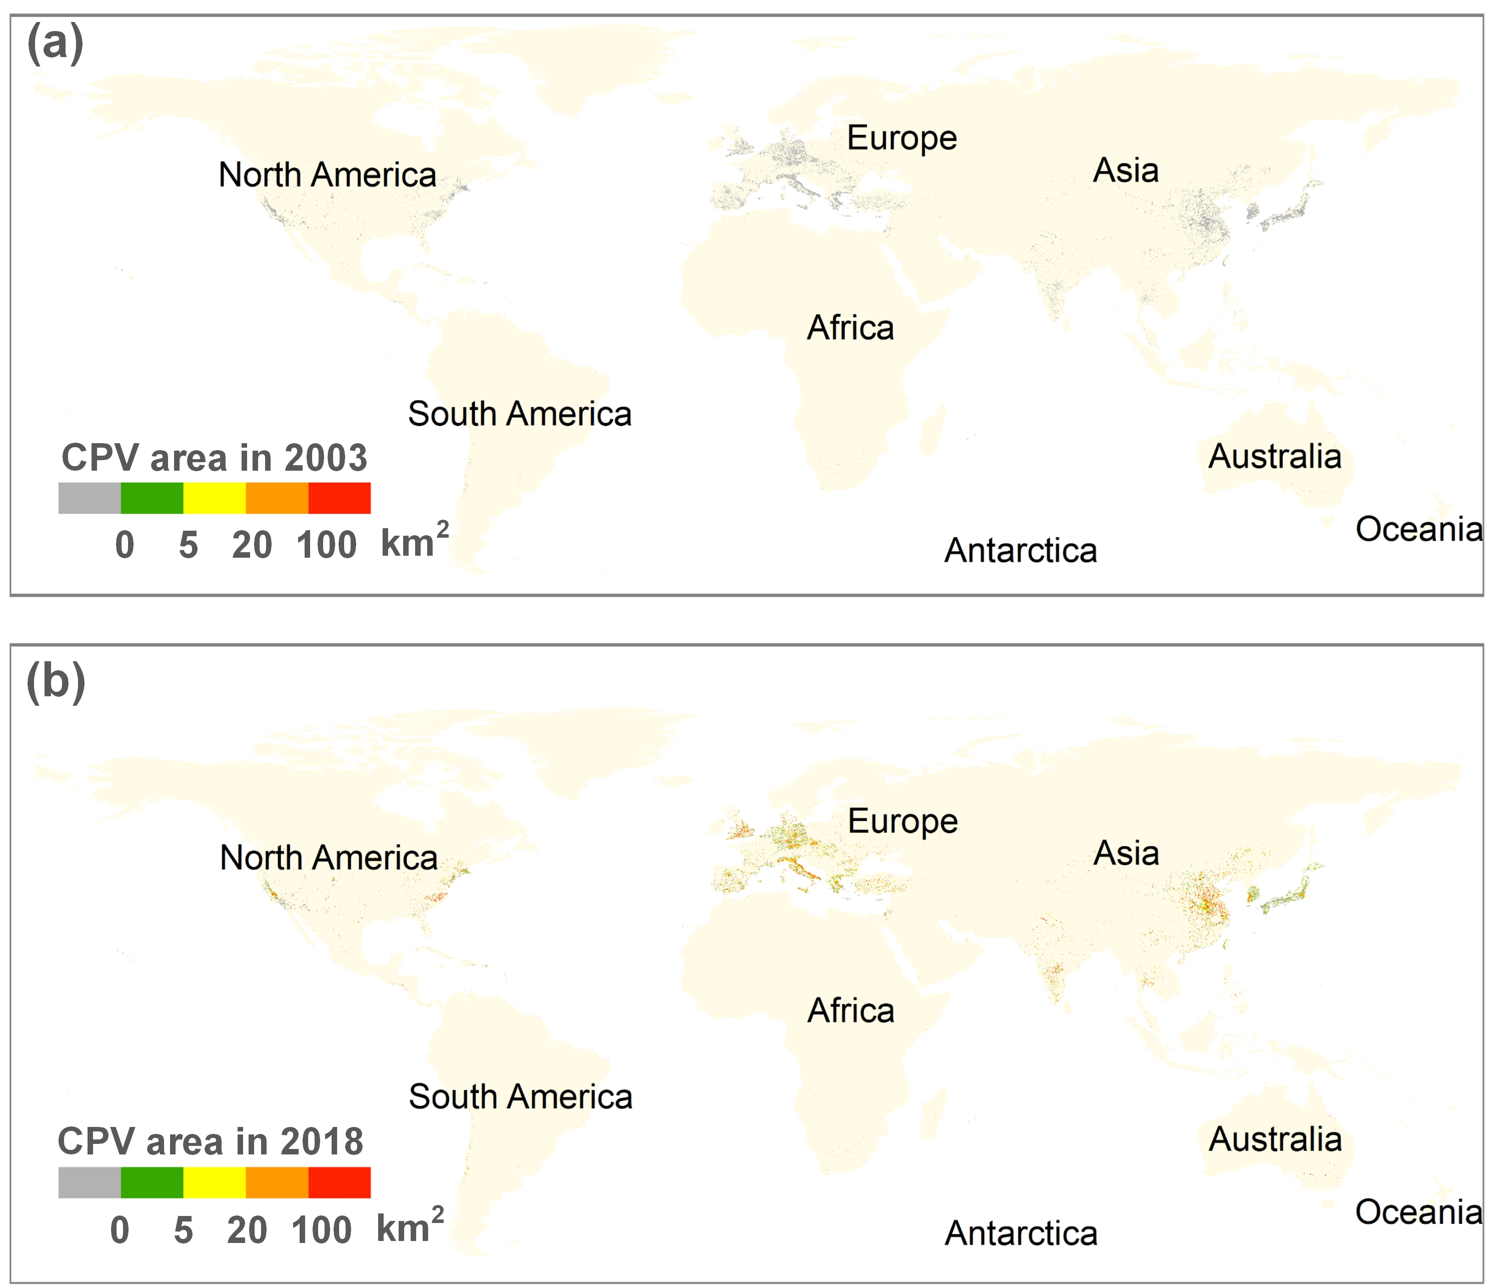

Fig. S1 Area of cropland occupied by PV installations at 0.1-degree grids
A grey grid means that there are currently PV installations on the grid but no cropland.
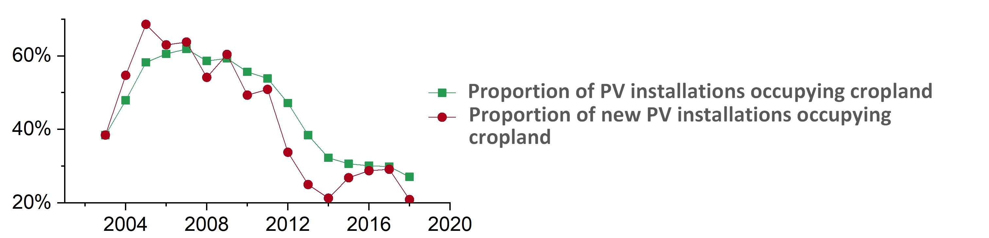

Fig. S2 Percentage of PV installations occupying cropland annually from 2003 to 2018
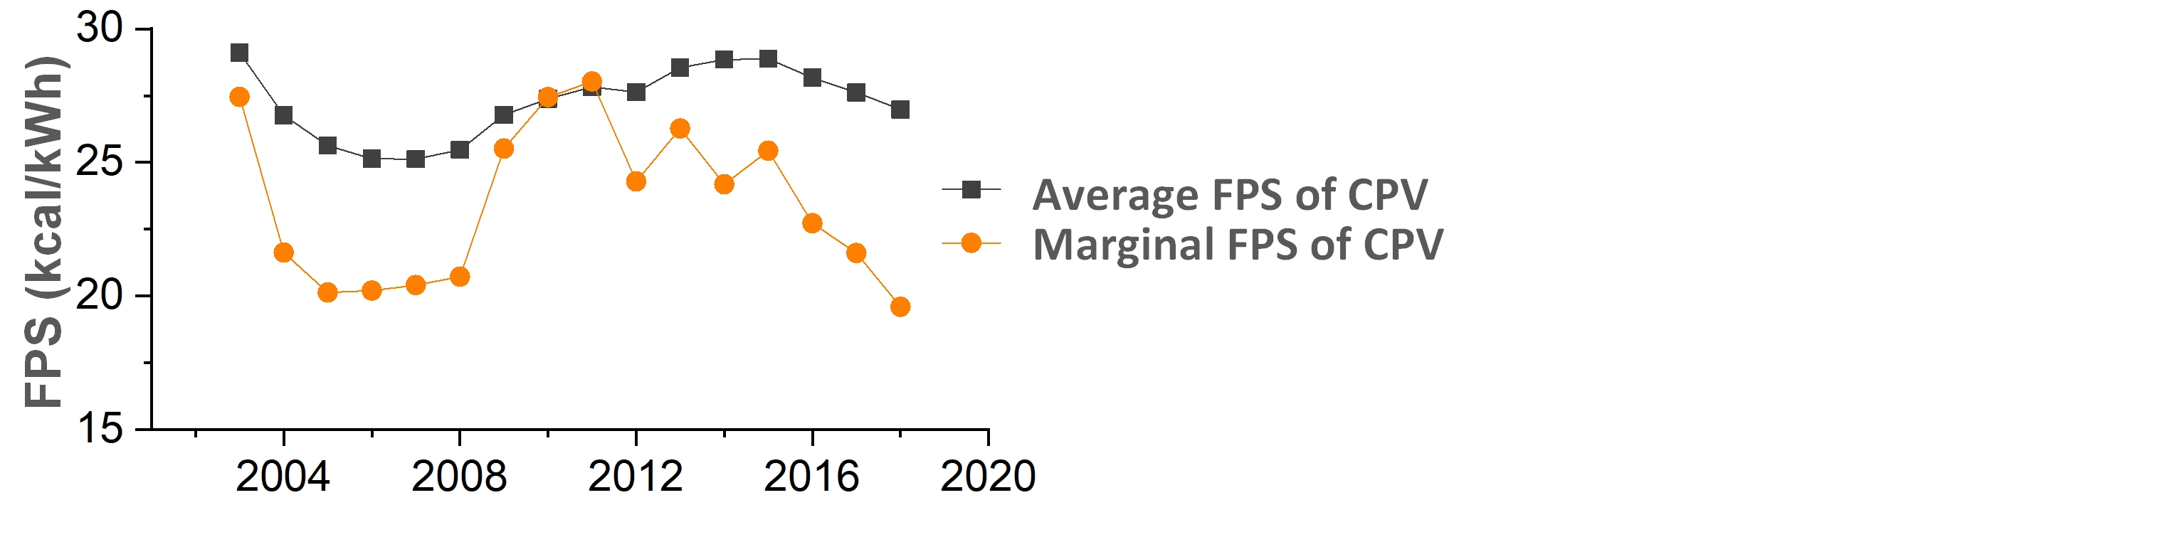

Fig. S3 Average and marginal food production loss per solar energy gain (FPS) annually from 2003 to 2018

Fig. S4 Evaluation of precision of identifying the timing of construction of PV installations
PA means Producer Accuracy. UA means user accuracy. The harmonic average value F is the reconciled average of user and producer accuracy.

Fig. S5 Validation of PV power generation estimation results
The green bars represent the PV power generation calculated in this study, obtained by the sum of the PV power generation calculated at the pixel level. The purple bars represent statistics published by the USA Energy Information Administration.

