Table.1 Distribution characteristics of anti-SSA and anti-SSB.
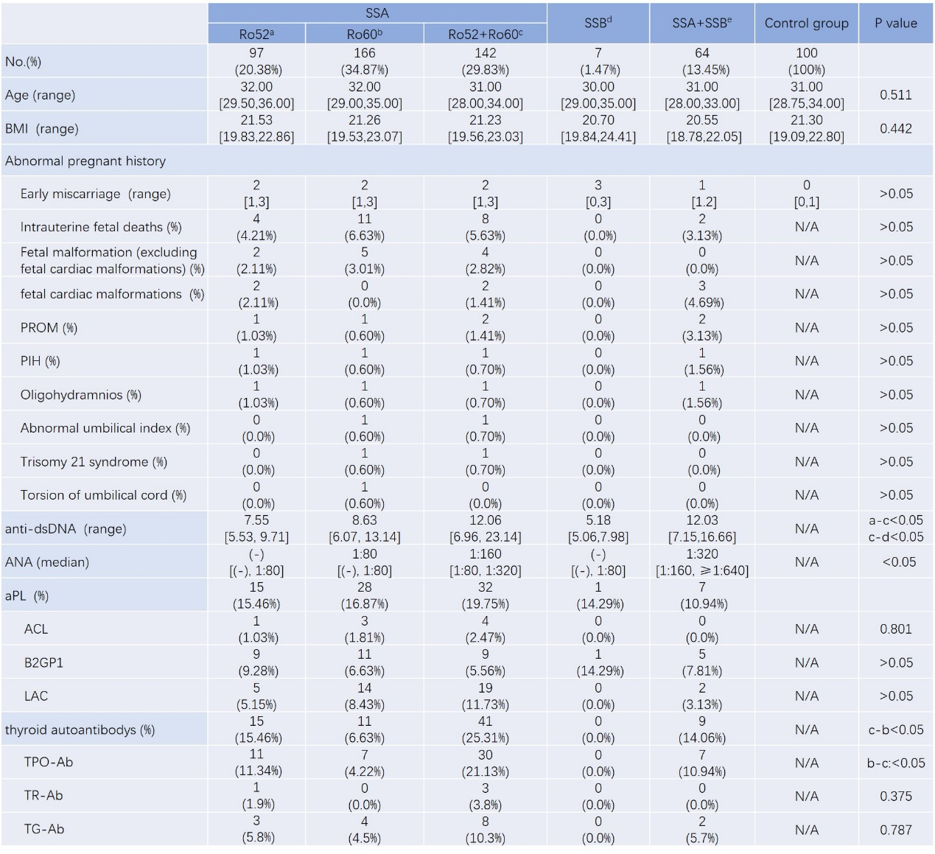

Table 2. The correlation between the distribution characteristics of anti-SSA and anti-SSB and
the diagnosis of autoimmune diseases.
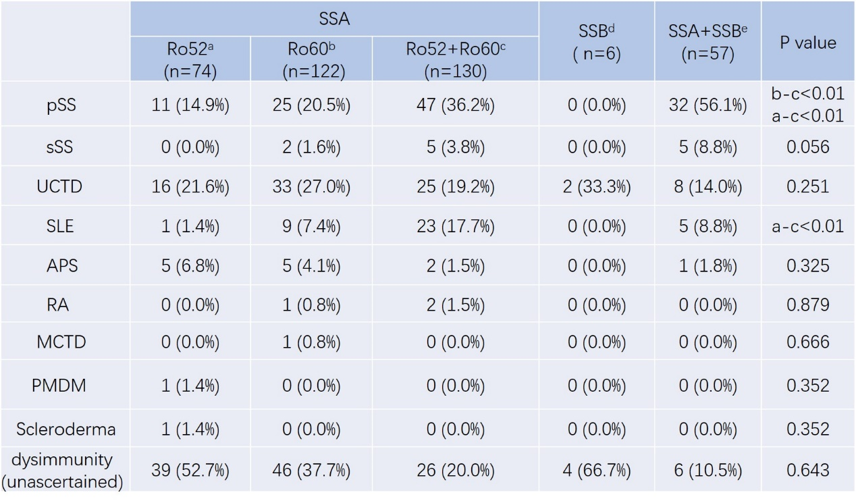

Table. 3 The impact of anti-SSA and anti-SSB on pregnancy outcomes.
