Supplementary Material
Optomechanical Motions of Gold Dimer’s Spin, Rotation and Revolution Manipulated by Bessel Beam

Chao-Kang Liu¹, Yun-Cheng Ku^{1,2}, Mao-Kuen Kuo¹, Jiunn-Woei Liaw^{2,3,4*}

¹Institute of Applied Mechanics, National Taiwan University, Taiwan
²Department of Mechanical Engineering, Chang Gung University, Taiwan
³Department of Mechanical Engineering, Ming Chi University of Technology, Taiwan
⁴Proton and Radiation Therapy Center, Linkou Chang Gung Memorial Hospital, Taiwan
Corresponding: markliaw@mail.cgu.edu.tw

The motions of a pair of identical gold nanoparticles (GNPs) manipulated by left-handed (LH) or right-handed (RH) Bessel beams of different orders are studied. The surrounding medium is water (refractive index n= 1.33). Figure S1 shows the normalized intensity distributions of different-order Bessel beams of l= 0, 1 or 2, where the wavelength λ is 800 nm and the cone angle α is 10°. The radii of the first peak of Bessel beams of l= 0, 1 or 2 are 2115 nm, 1020 nm and 1690 nm, respectively.
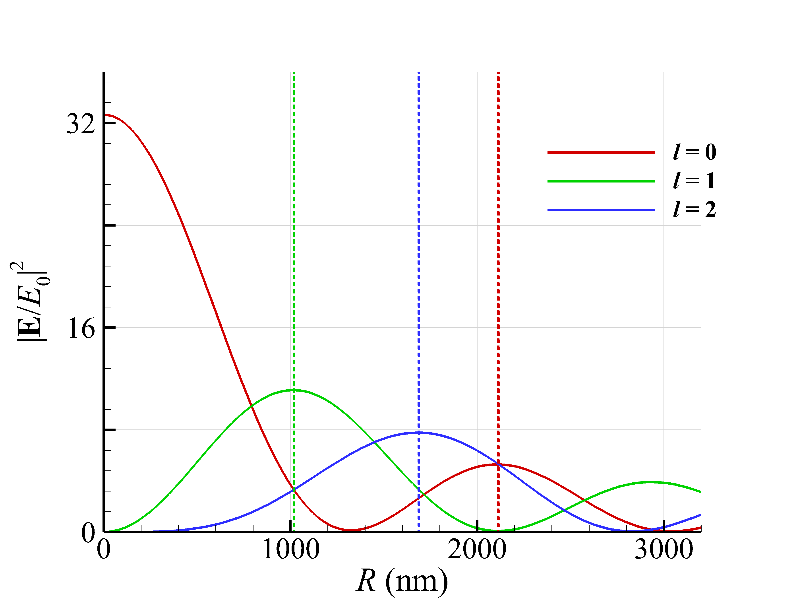
(b)
Fig. S1. The intensity distributions of 800-nm Bessel beams of l= 0, 1 and 2 with a cone angle of α = 10°.

The motions of the two individual GNPs in water are analyzed. Figure S2a shows the trajectories of two GNPs of a= 50 nm and their center of mass (COM) under the irradiation of a RH Bessel beam of l= 0, propagating along z direction. The amplitude of Bessel beam is . No matter the initial positions of the two GNPs are, they will be optically bound together to form a dimer eventually with a distance of about 600 nm between them, close to the effective wavelength of light in water. Afterward, the two GNPs are trapped within the intensity peak of a Bessel beam ring, where they remain nearly stationary. Nevertheless, both GNPs undergo spinning. The angular speeds of spin, rotation and revolution of the two GNPs versus time are plotted in Fig. S2b. This phenomenon is because Bessel beam of l= 0 only has spin angular momentum (SAM), but does not have orbital angular momentum (OAM) intrinsically. Additionally, for smaller GNPs of a= 50 nm, the effect of spin-orbit interaction (SOI) via the light scattering is very weak, so there is almost no rigid-body rotation and orbital revolution. In contrast, the SOI effect becomes severe for larger GNPs of a= 150 nm, so that a part of SAM of Bessel beam of l= 0 is converted into OAM to induce the dimer’s rotation and the COM’s orbital revolution via the light scattering. The average terminal angular speeds of spin, rotation and revolution of a GNP dimer of a= 50 nm induced by LH or RH 800-nm Bessel beams of l= 0, 1, and 2 are listed in Table SI. The results of a GNP dimer of a= 50 nm irradiated by a LH or RH Bessel beam of l= 1 are shown in Fig. S3. There is no precession in the COM’s orbital revolution, as shown in Figs. S3a and S3c.

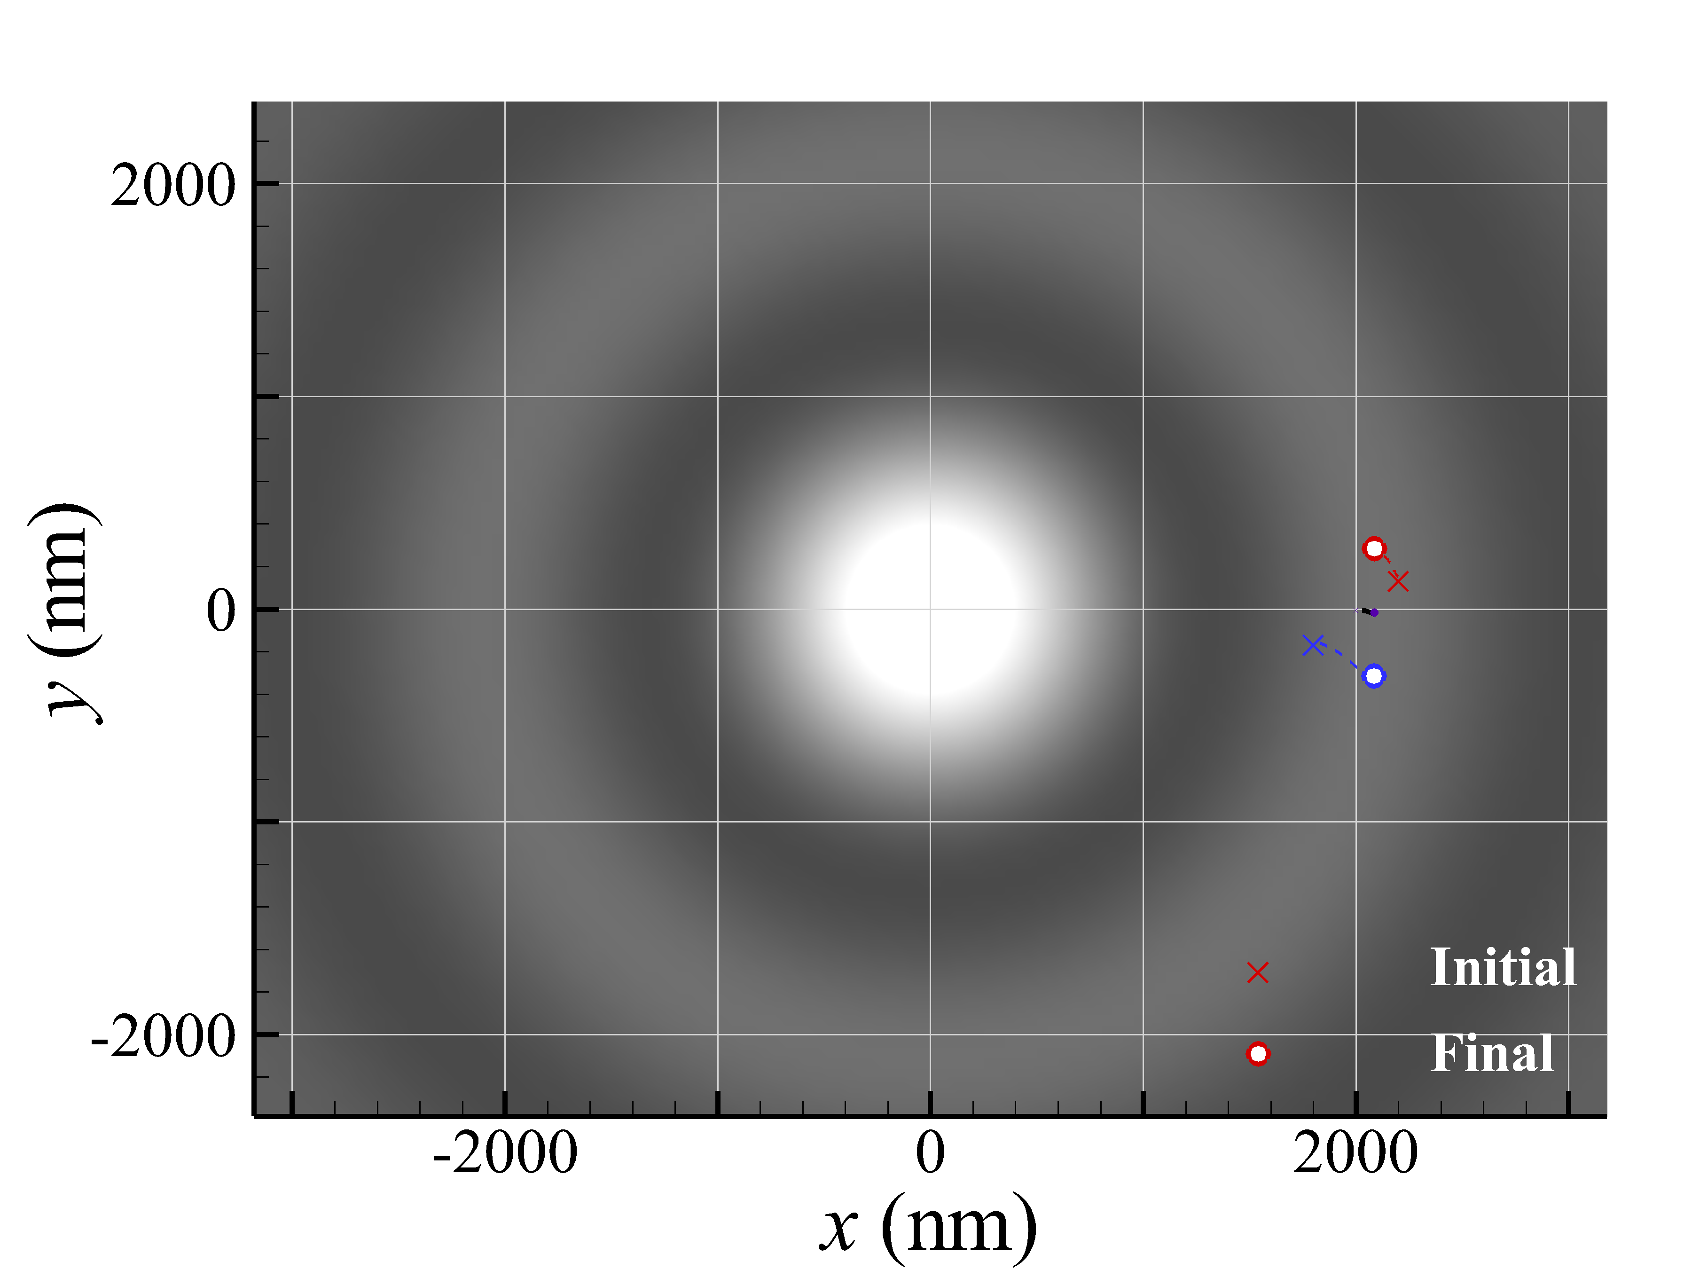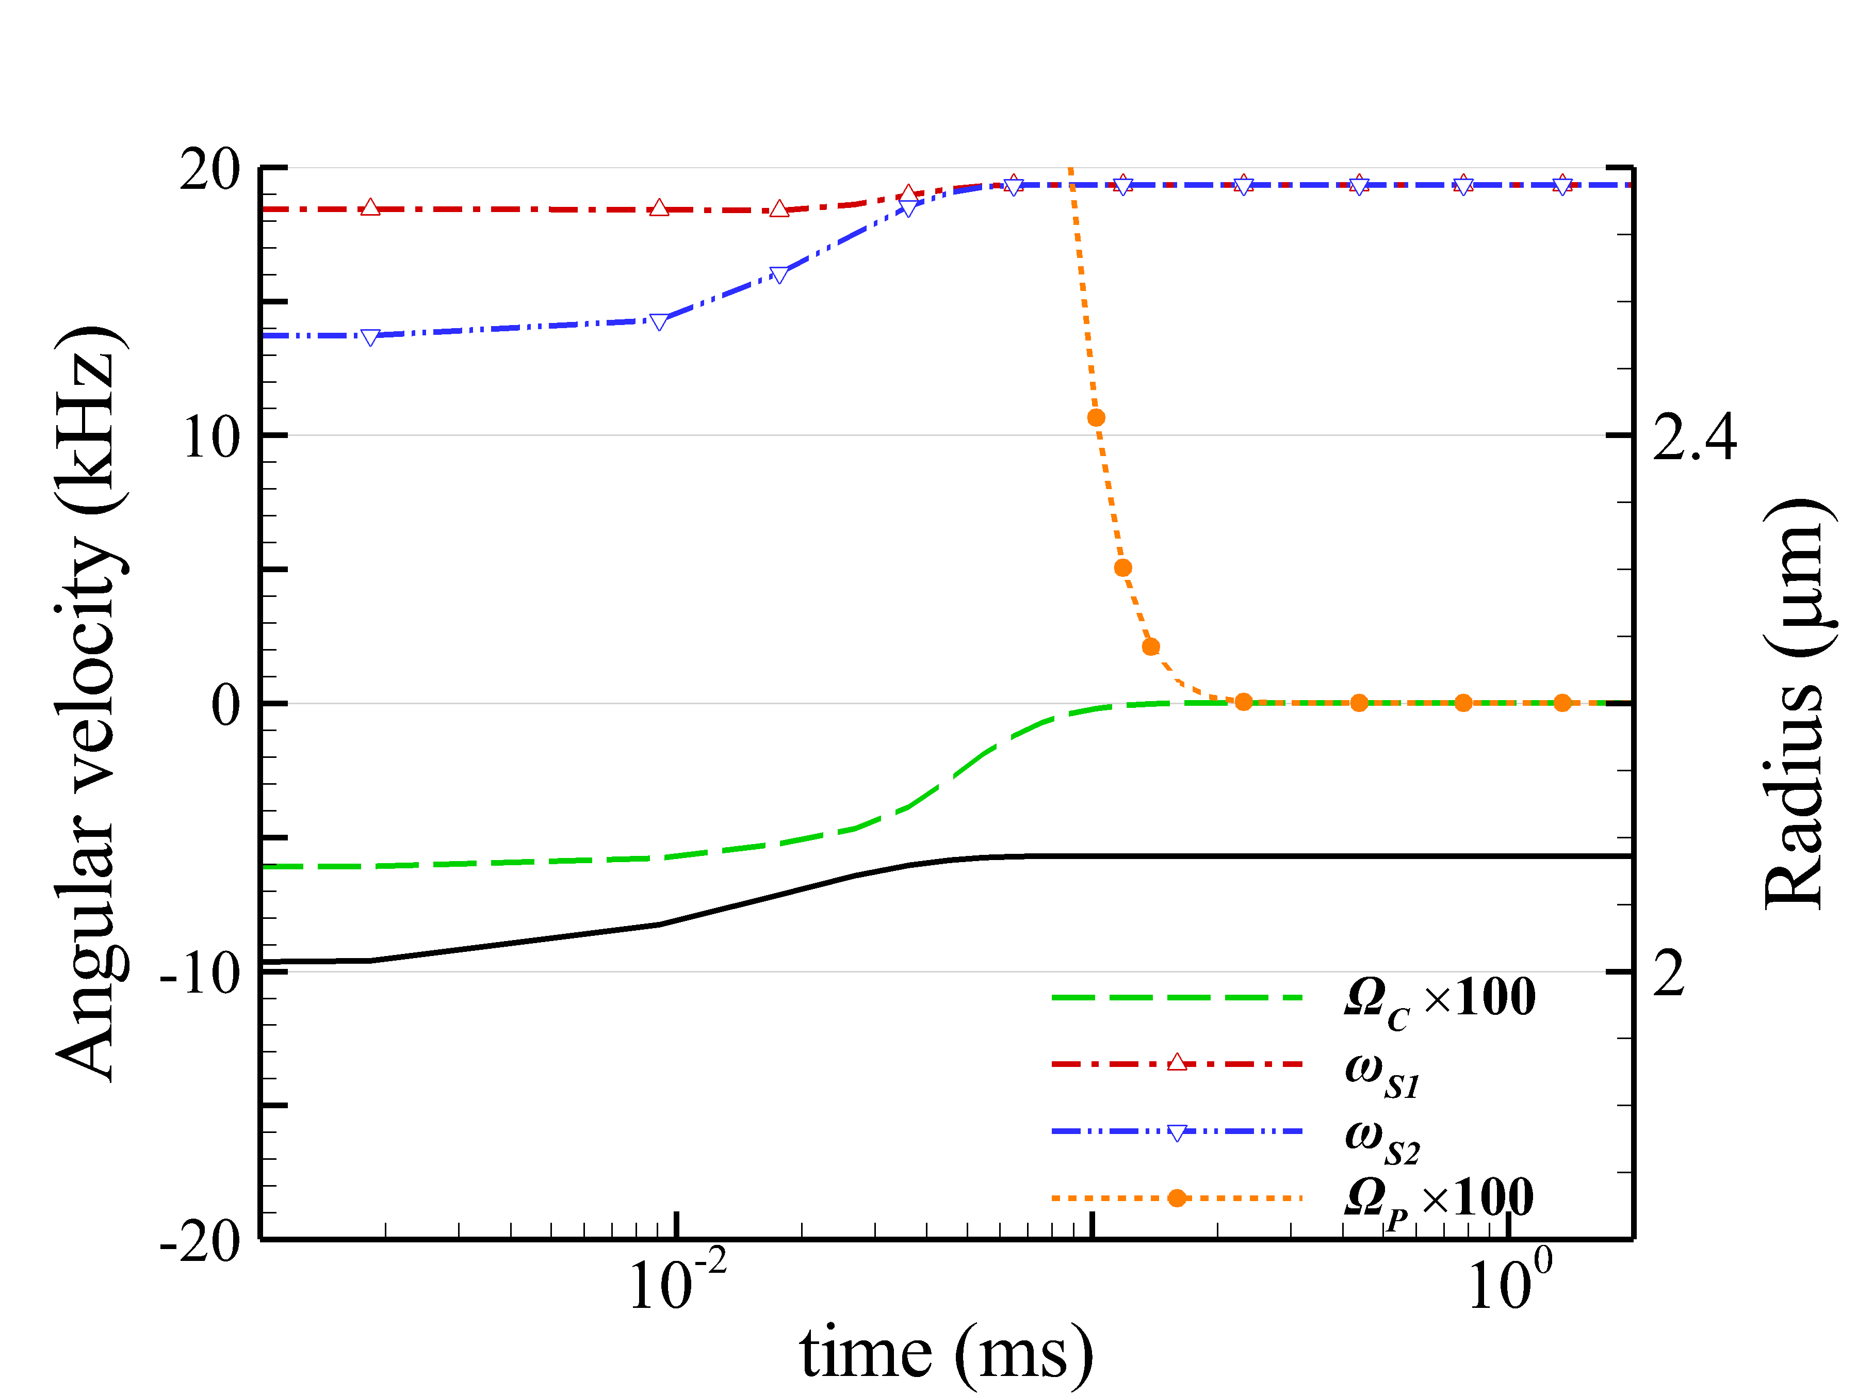
(a)
(b)
Fig. S2. (a) Trajectories of two GNPs of a= 50 nm irradiated by 800-nm RH Bessel beam of l= 0 and α = 10°. (b) The orbital radius of COM and the angular speeds of spin, rotation and revolution of GNP dimer versus time.

Table SI. The average terminal angular speeds of spin, rotation and revolution of GNP dimer of a= 50 nm induced by LH/RH 800-nm Bessel beams of l= 0, 1, and 2 with a cone angle of α = 10°.
(kHz) | LH |  |  | RH
Order | Ω_{C} | Ω_{P} | ω_{S} | Ω_{C} | Ω_{P} | ω_{S}
l= 0 | -2.55x10⁻⁴ | -2.55x10⁻⁴ | -19.35, -19.34 | 2.55x10⁻⁴ | 2.55x10⁻⁴ | 19.35, 19.34
l= 1 | 1.59 | 1.59 | -40.09, -40.25 | 1.58 | 1.58 | 40.06, 40.29
l= 2 | 0.81 | 0.81 | -27.96, -28.11 | 0.81 | 0.81 | 27.94, 28.13

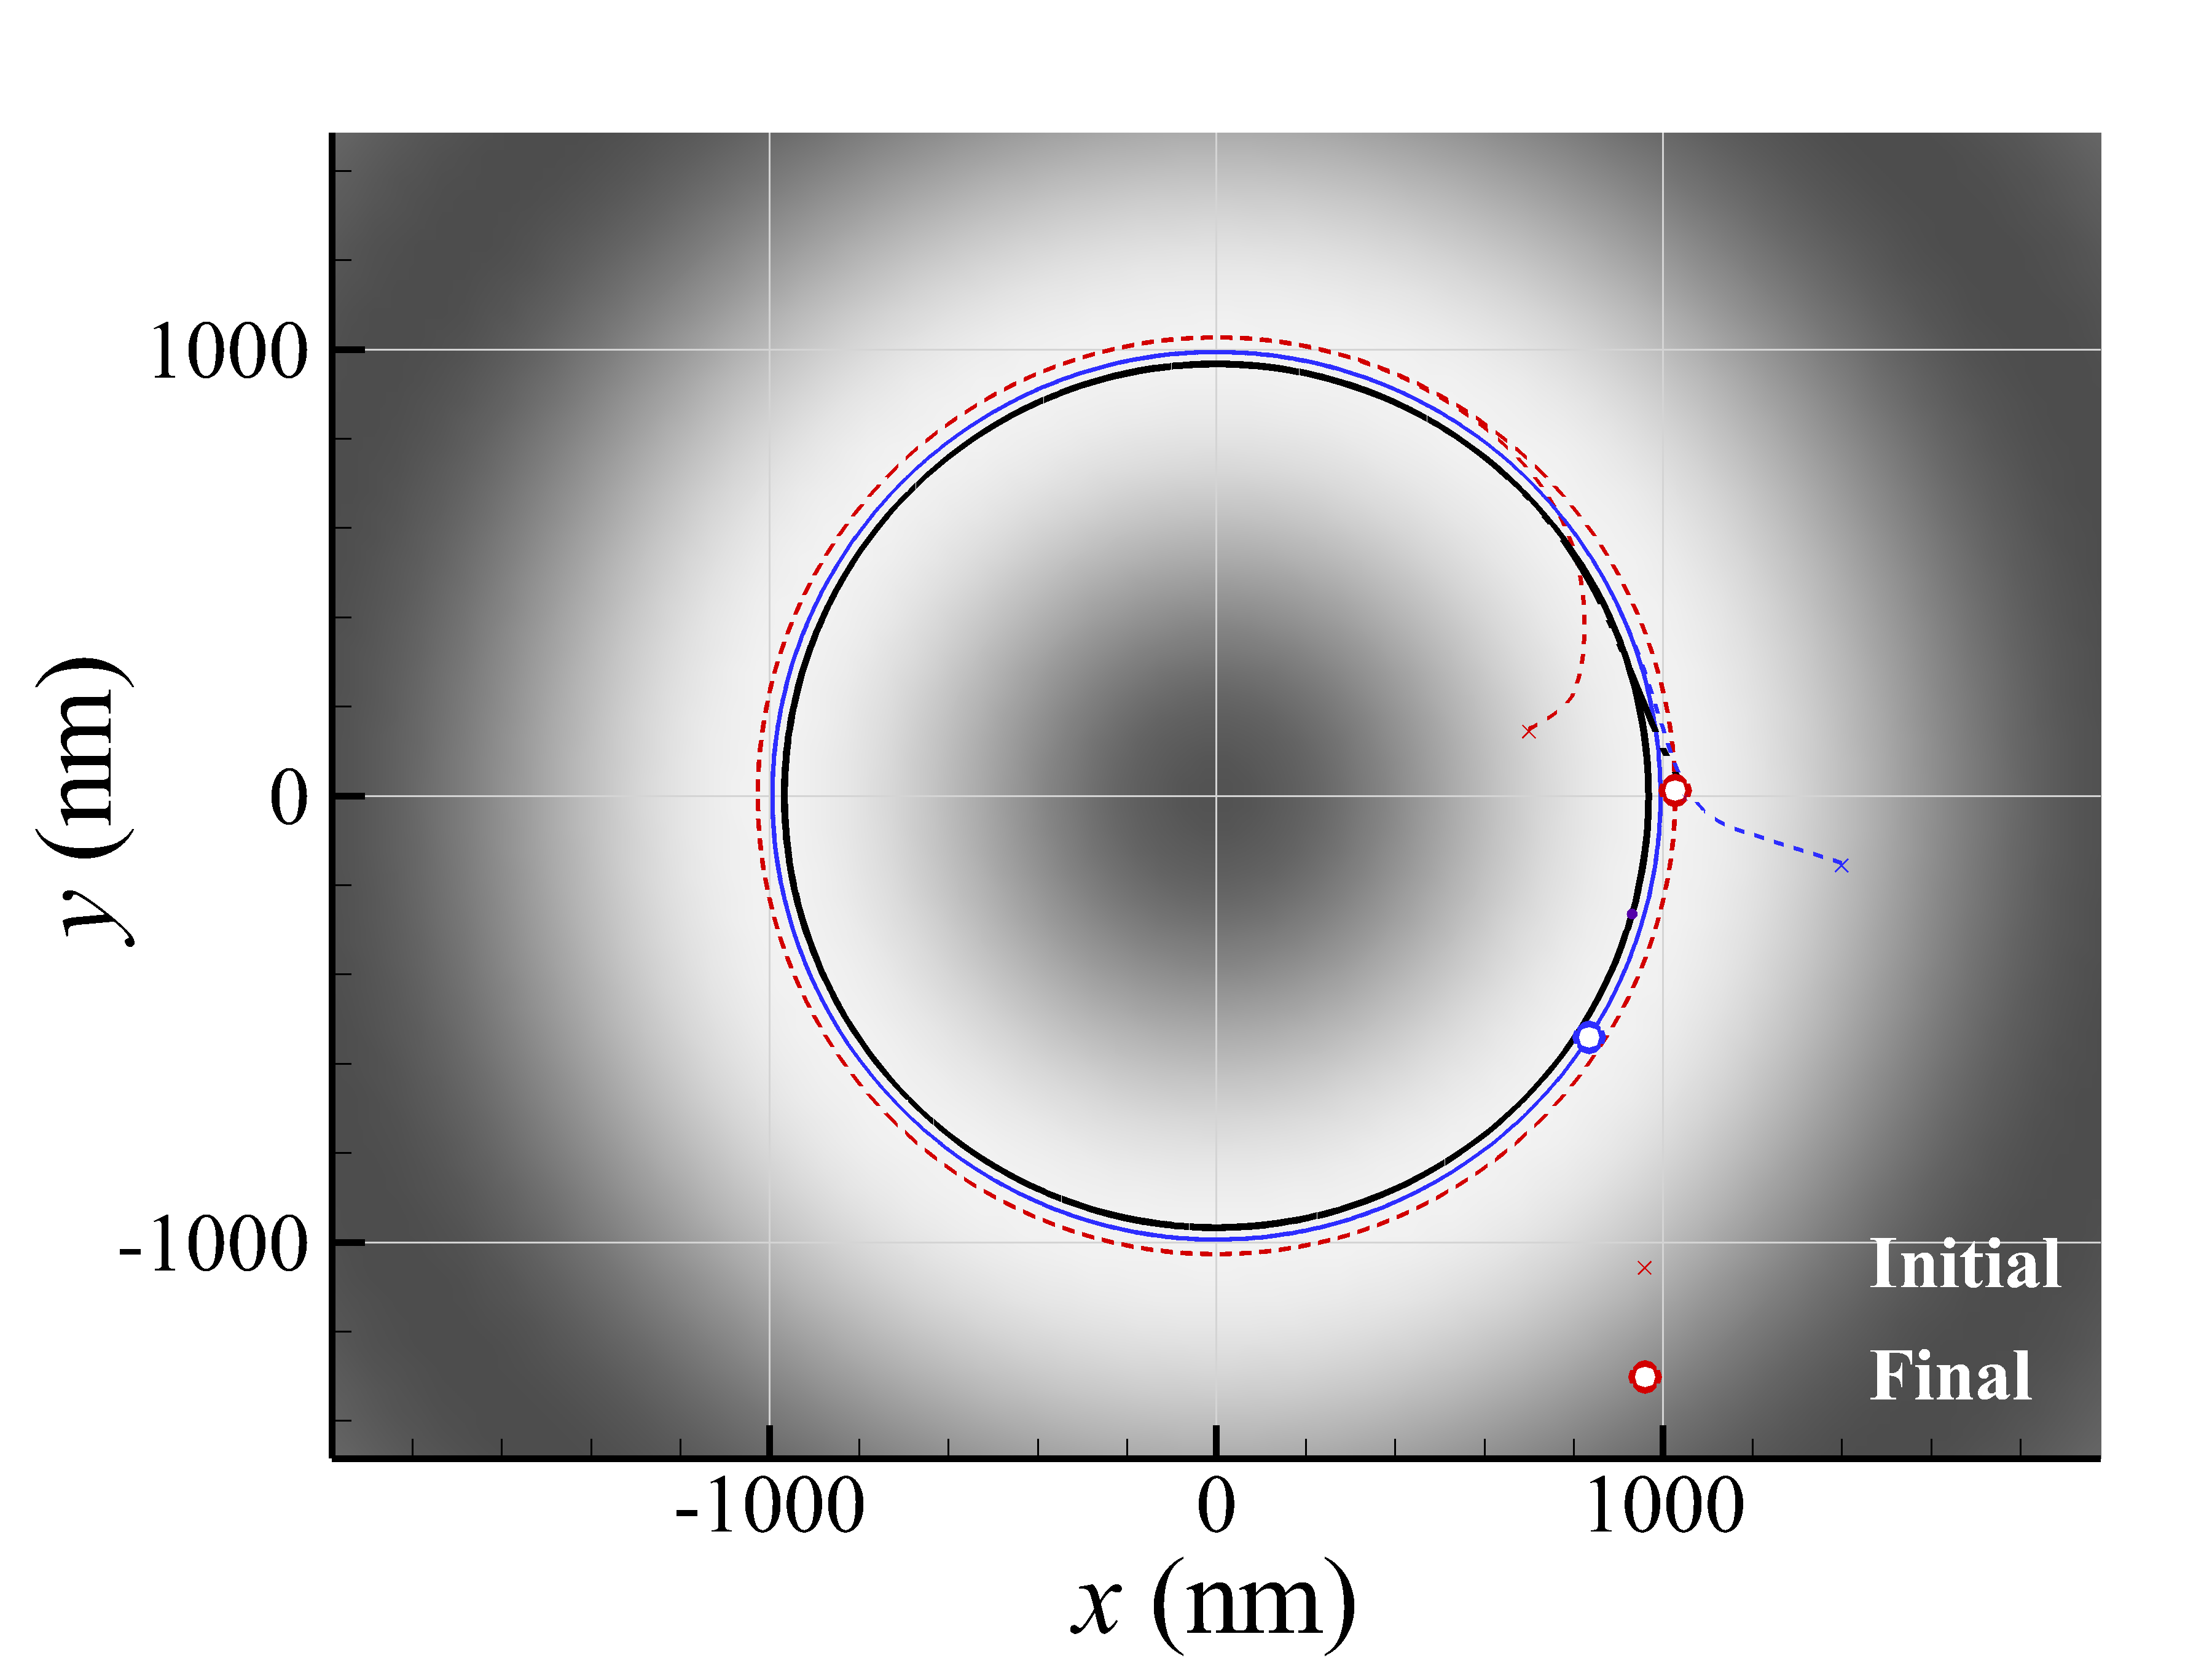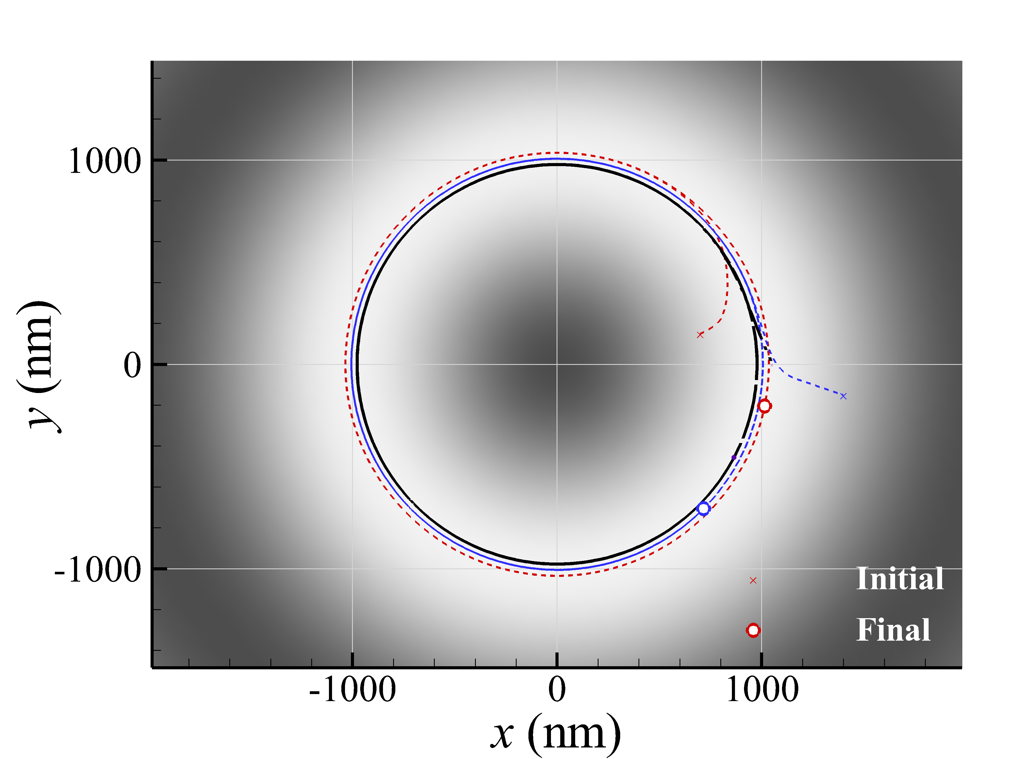
(a)
(b)
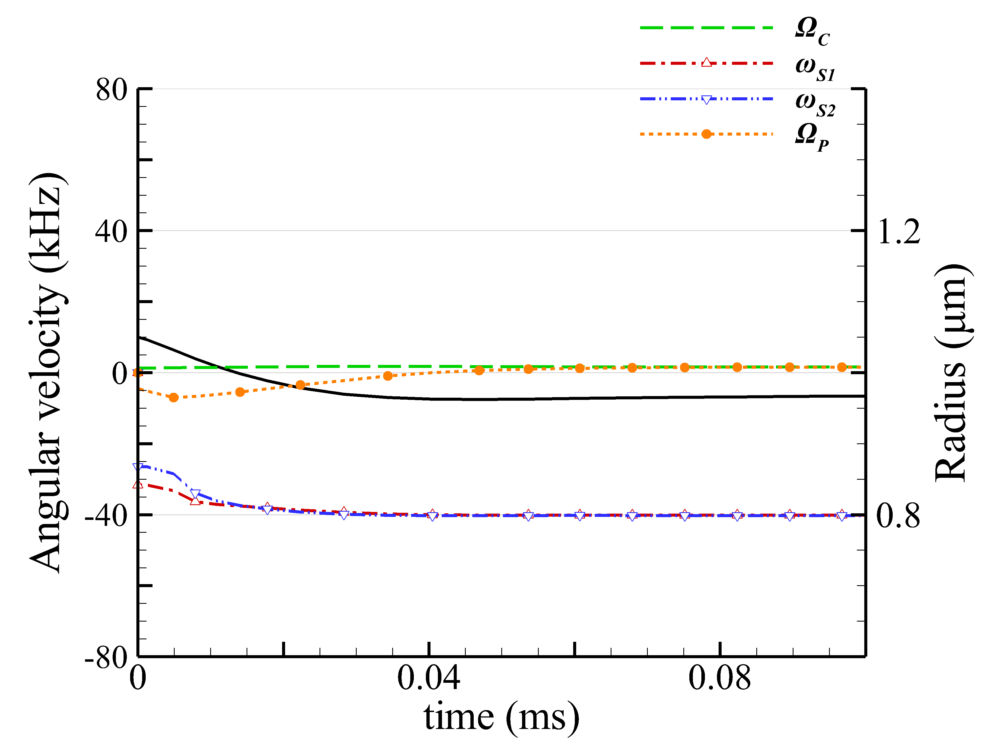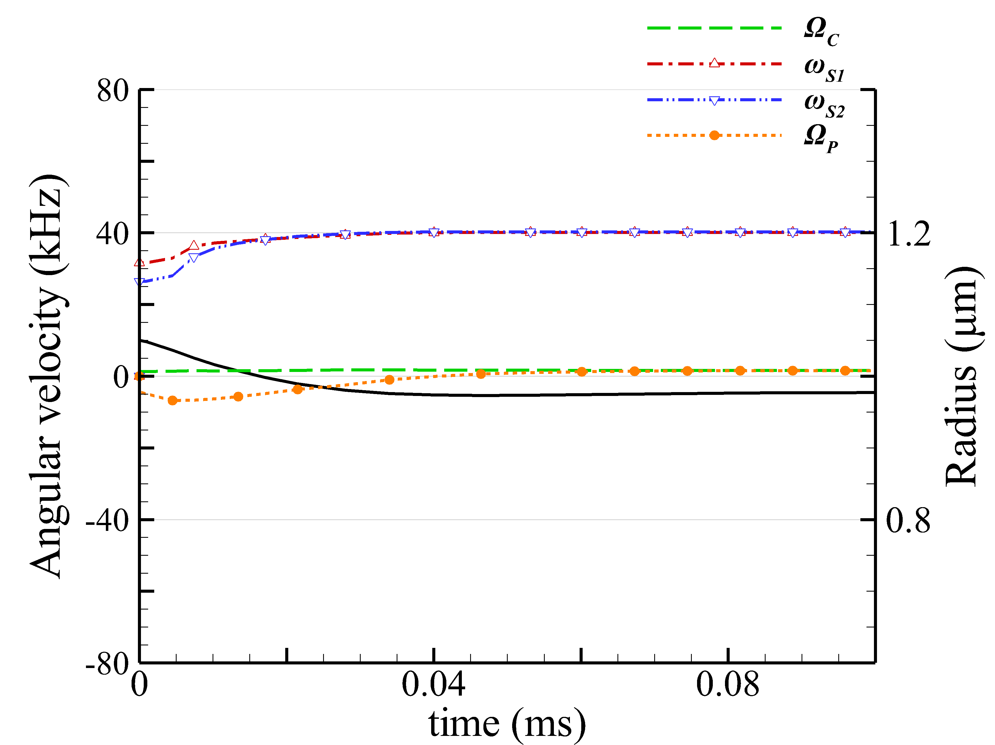
(c)
(d)
Fig. S3. The trajectories of a smaller GNP dimer of a= 50 nm, irradiated by a (a) LH and (b) RH 800-nm Bessel beam of l= 1 with a cone angle α = 10°. (c) and (d) are the orbital radius of COM and the angular speeds of spin, rotation and revolution of GNP dimer versus time, corresponding to (a) and (b), respectively.

The motions of the two individual GNPs of a= 100 nm or 150 nm in water under the irradiation of a Bessel beam of l= 2 are analyzed. Figure S4 shows the orbital radius of COM and the angular speeds of spin, rotation and revolution of two GNPs of and their COM versus time. The variations in the orbital radius of COM and the angular speeds of the dimer’s rigid-body rotation and COM’s orbital revolution are observed in Figs. S4a and S4d, implying a precession in the orbital motion. For the smaller GNP dimer (a= 100 nm), the direction of the rotation is CW due to LH Bessel beam, and the direction of the revolution is CCW due to the positive order (l= 2), as shown in Fig. S4a; they are opposite. For the larger GNP dimer (a= 150 nm), the reverse rotation is observed due to the negative optical torque, resulting in the opposite directions of the rotation (CW) and the revolution (CCW), as shown in Fig. S4d. For the other cases of Figs. S4b and S4c, the angular speeds of rotation and revolution converge towards the same, and the COM’s orbit is a circle eventually. For both cases, there is no precession.

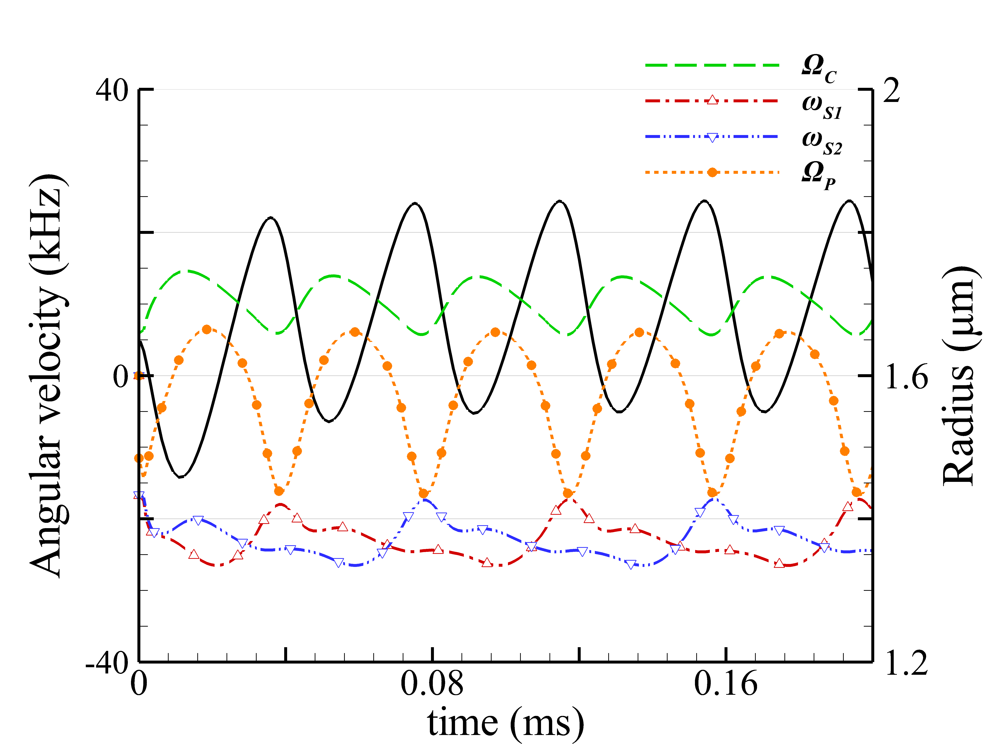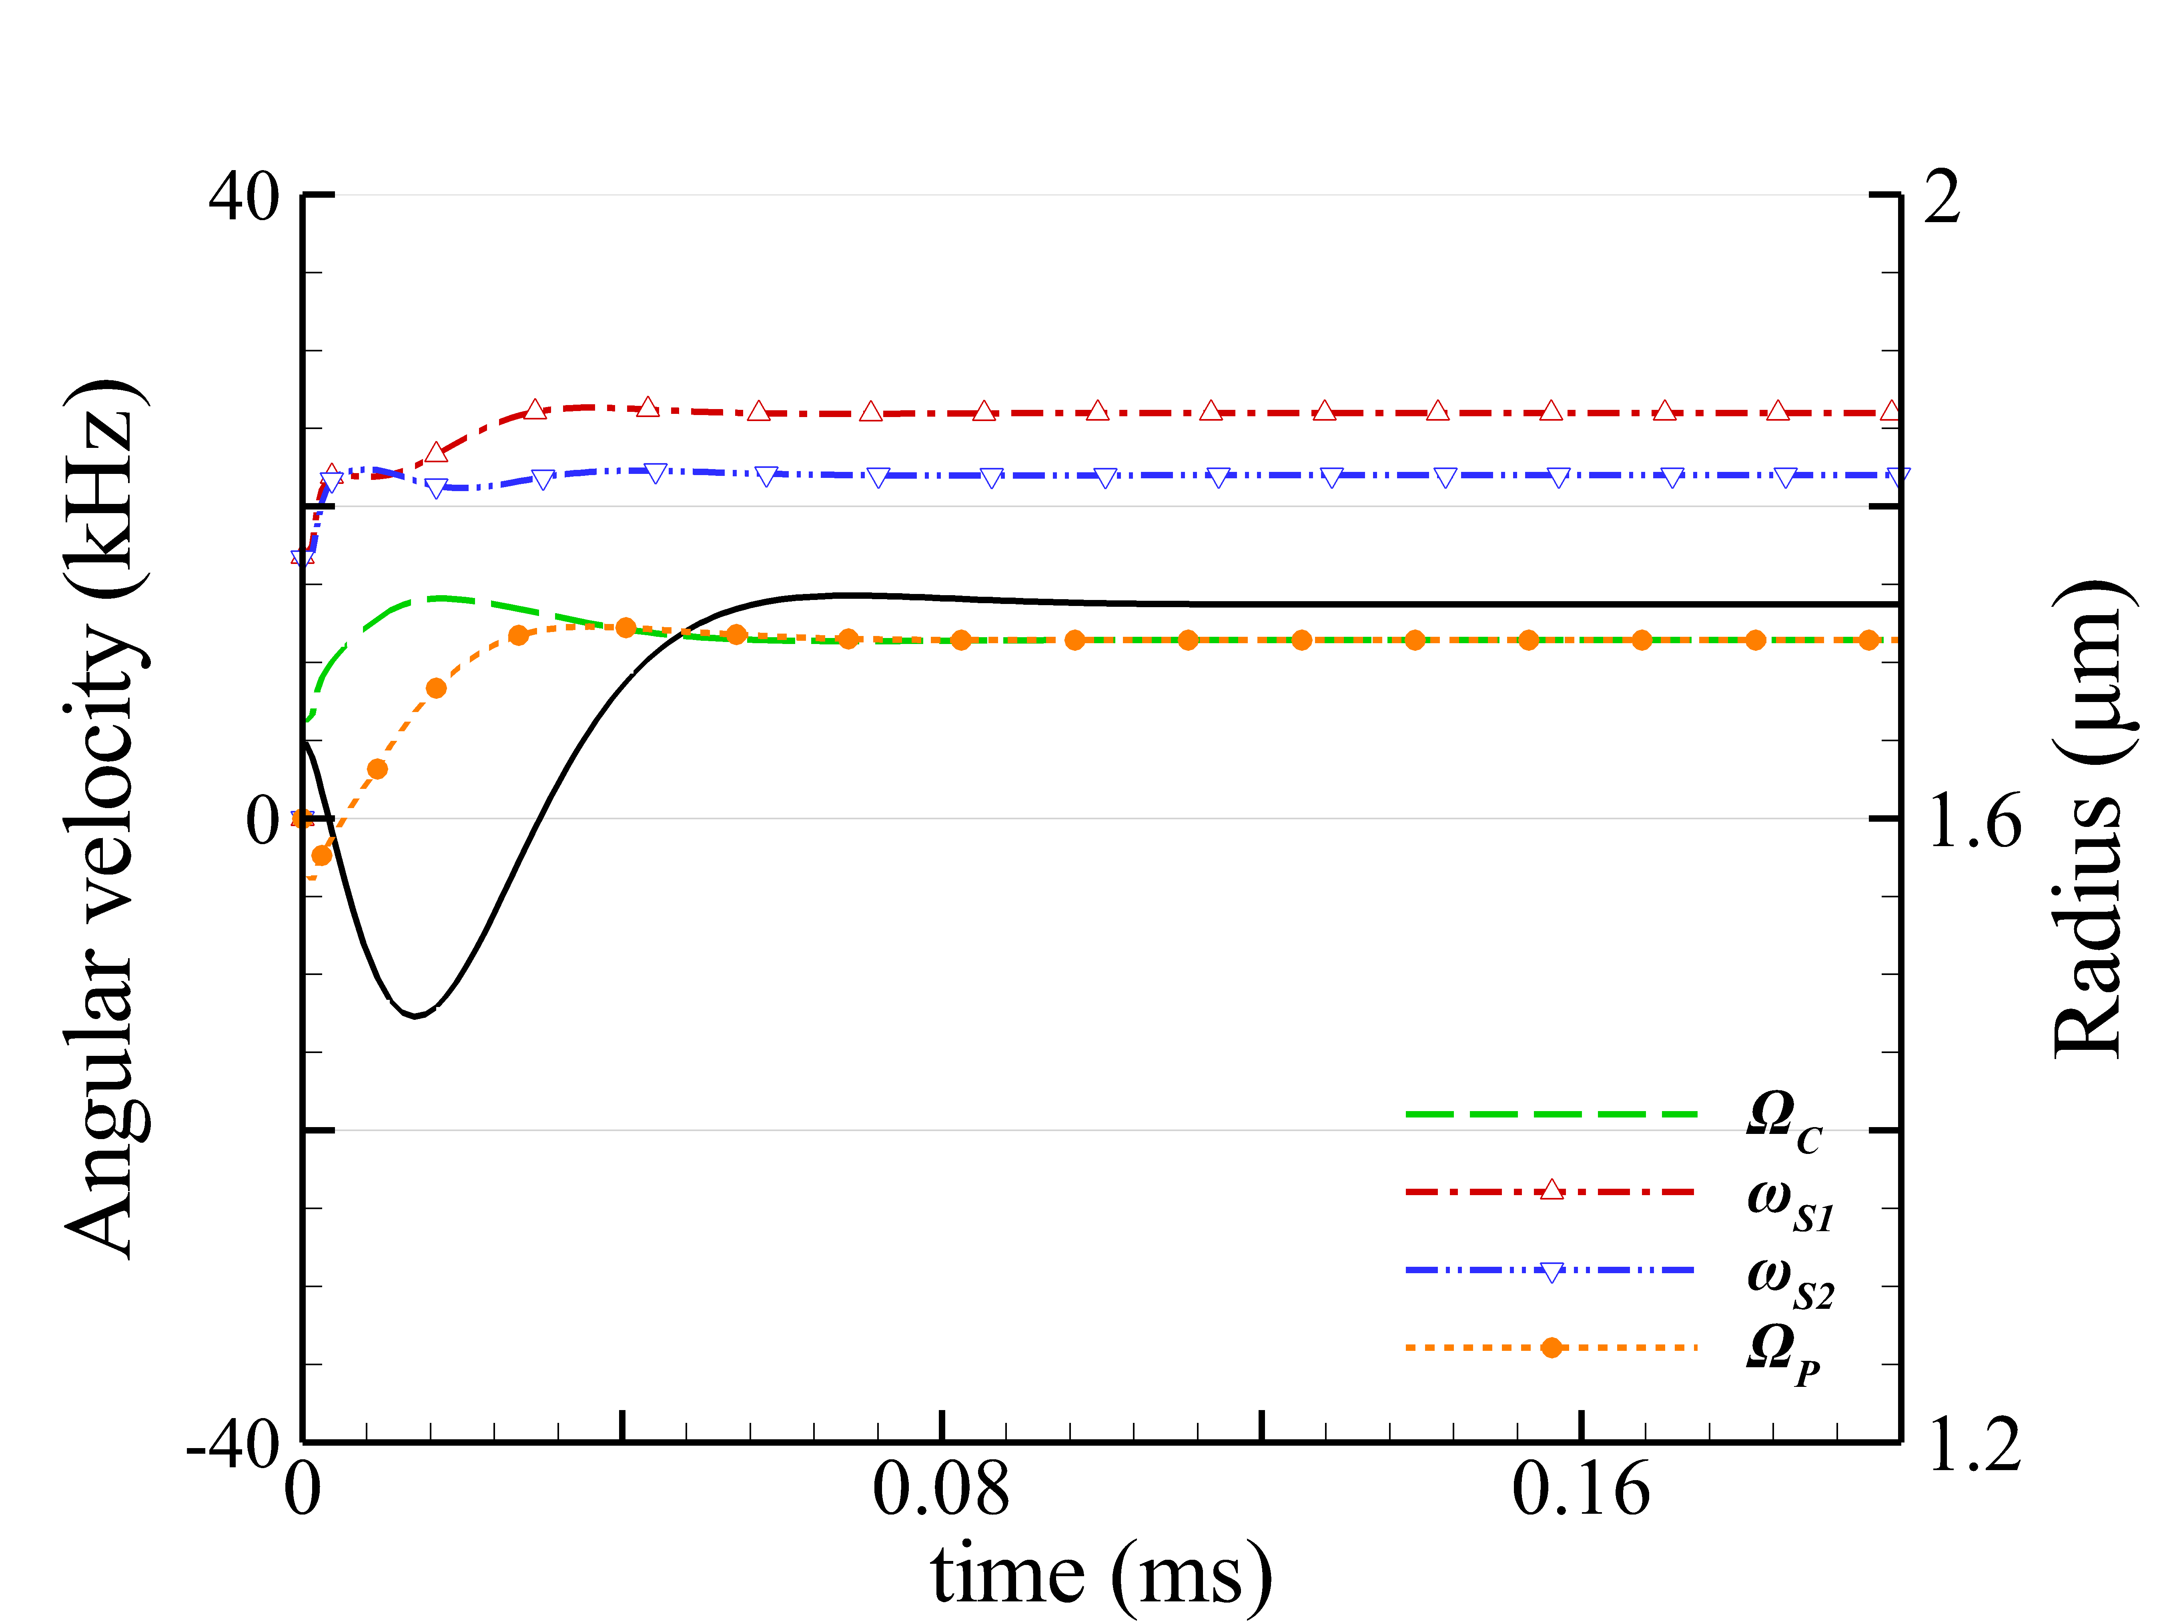
(a)
(b)
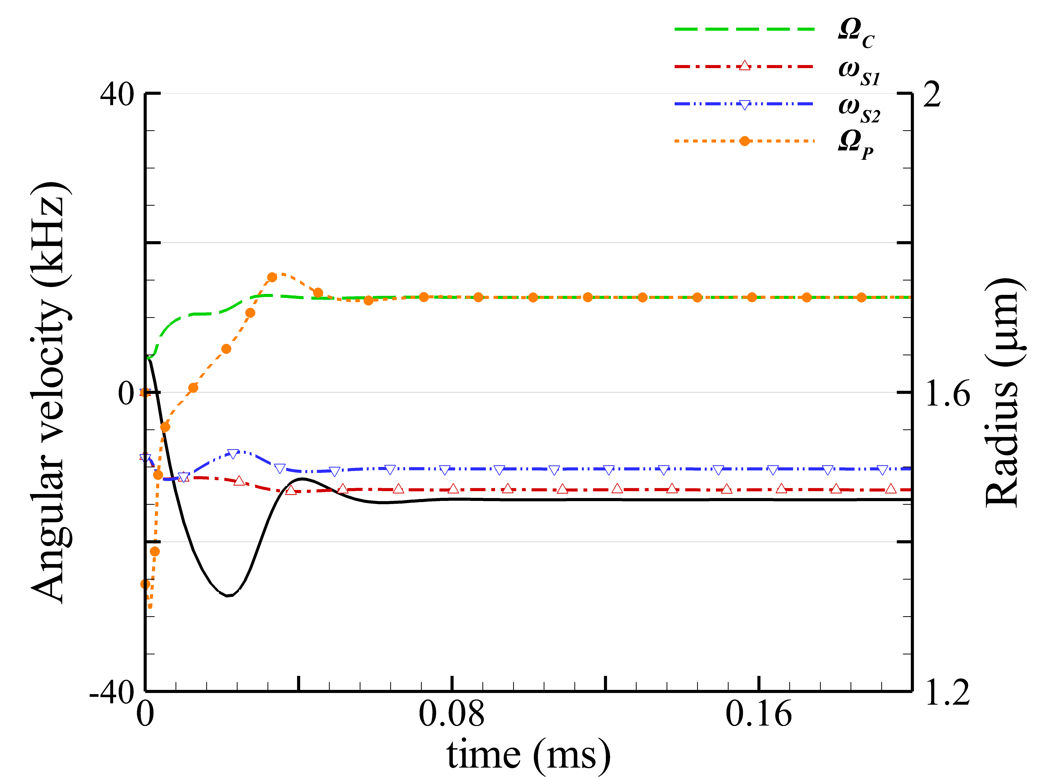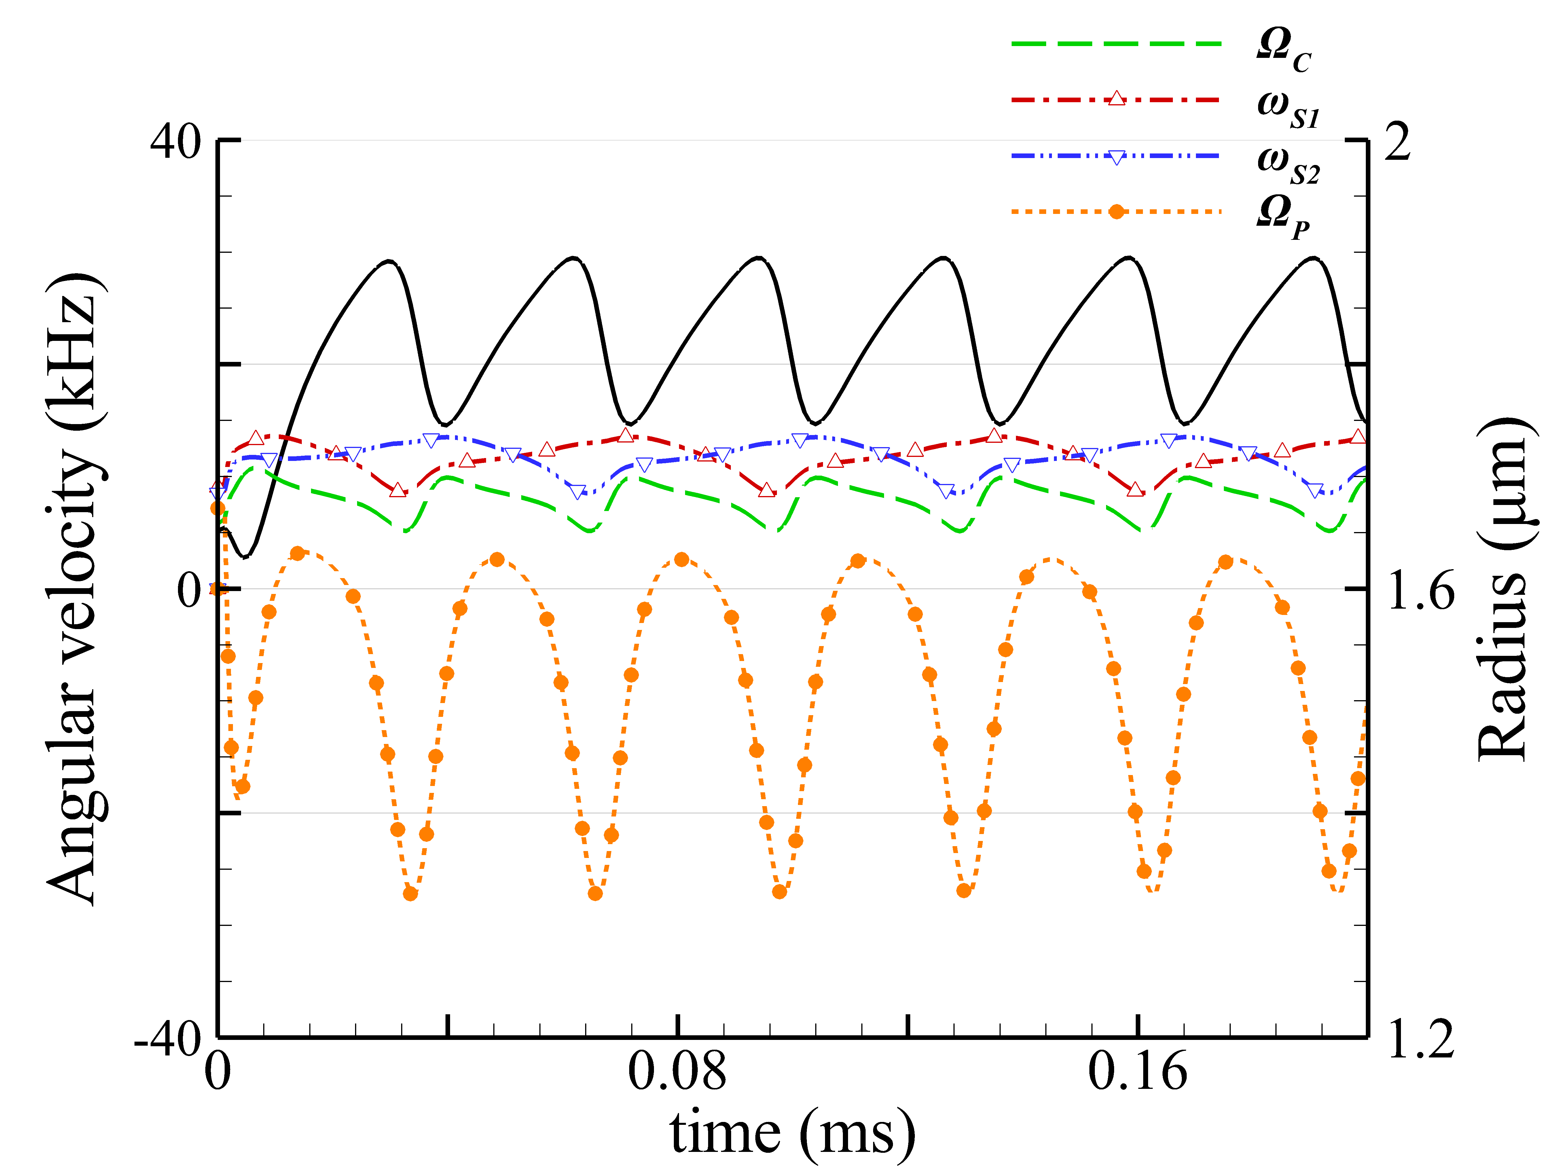
(c)
(d)
Fig. S4. The orbital radius of COM and the angular speeds of spin, rotation and revolution of GNP dimer of a= 100 nm, induced by (a) LH and (b) RH Bessel beam of l= 2 and α = 10°. The results of GNP dimer of a= 150 nm induced by (c) LH and (d) RH Bessel beam. Black solid line: orbital radius of COM.

