Plant peptide hormone phytosulfokine promotes embryogenic development of calli in Pinus massoniana
Author names and affiliations
Qunfeng Luo ¹&Shan Hu ², Zhaolei Deng ², Zhenjun Gu ², Qian Liu ², Guang Zhou ², Qiang Du ²,and Chunxia Yang ^{2,}*
- Guangxi Key Laboratory of Superior Timber Trees Resource Cultivation, Guangxi Forestry Research Institute ，Nanning 530002, China;
2. Jiangxi Provincial Key Laboratory of Improved Variety Breeding and Efficient Utilization of Native Tree Species, Jiangxi Academy of Forestry, Nanchang 330032, China

Note:
- &: These authors contributed equally to this work and should be considered co-first authors.
- *: The author is corresponding author.

Corresponding author
No.1629 Fenglin West Street, Nanchang Economic and Technological Development Zone, Jiangxi Province, P. R. China, 330032. Email: yangcx0812@126.com.

Appendix
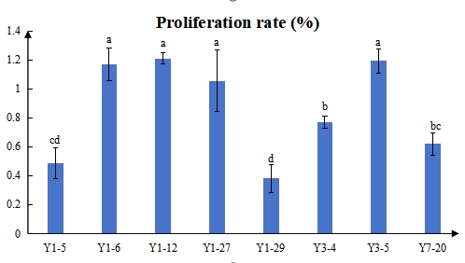
Fig. S1 Differences in proliferation rates of 8 P. massoniana cell lines

