Supporting Information

Acid-Induced In Situ Phase Separation and Percolation for Constructing Bi-Continuous Phase Hydrogel Electrodes with High Conductivity and Robust Mechanical Properties
Qingquan Han^{1,2,§}, Xigang Gao^{3,§}, Chao Zhang^{3,§}, Yajie Tian¹, Sen Liang¹, Xin Li^{1,2}, Yafeng Jing^{1,2}, Milin Zhang^{3,}*, Anhe Wang^{1,2,}*, Shuo Bai^{1,2,}*
¹ State Key Laboratory of Biochemical Engineering, Institute of Process Engineering；Key Laboratory of Biopharmaceutical Preparation and Delivery, Chinese Academy of Sciences, Beijing, 10090, China.
² University of Chinese Academy of Sciences, 100049 Beijing, China.
³ Department of Electronic Engineering, Tsinghua University, 100084 Beijing, China.
§ These authors contributed equally: Qingquan Han, Xigang Gao, and Chao Zhang.

* Corresponding author:
Prof. Milin Zhang, Email: zhangmilin@tsinghua.edu.cn
Prof. Anhe Wang, Email: ahwang@ipe.ac.cn
Prof. Shuo Bai, Email: baishuo@ipe.ac.cn

The Supporting Information file includes:
Supporting Notes 1 to 2
Figures S1 to S20
Tables S1 to S3
Legends for movies S1 to S4

Other Supporting Materials for this manuscript include the following:
Movies S1 to S4
Supporting Note 1: The theoretical fracture strain calculation of PPP hydrogel.
The extensibility of PPP hydrogels arises from the entropy elasticity of the polymer chains. Here, we utilize the state equation of the cross-linked gel network to compute the average molecular weight ${\overline{M}}_{c}$ of polymer chains between adjacent cross-linking points in the hydrogel, as depicted in equation (1).
$$σ_{nom}=\frac{ρ_{0}RT}{{\overline{M}}_{c}}\left(λ-\frac{1}{λ^{2}}\right)$$ | （1）
where, $σ_{nom}$ represents the engineering stress (nominal stress), $ρ_{0}$ is the density of polymer chains, R is the gas constant, T denotes the test temperature, and λ is the sample elongation. The calculation of E for the hydrogel, in accordance with its definition, is outlined in equation (2).
$$E=\frac{σ_{nom}}{ε}$$ | （2）
where, $ε$ represents strain. By integrating equation (1) and (2), we arrive at equation (3).
$${\overline{M}}_{c}=\frac{ρ_{0}RT}{εE}\left(λ-\frac{1}{λ^{2}}\right)$$ | （3）
Based on $λ=ε+1$, and with E defined as the stress-strain ratio under small strain (elastic region) conditions, simplifying the expression within the parentheses of equation (3) yields equation (4).
$$λ-\frac{1}{λ^{2}}=\frac{ε^{3}+{3ε}^{2}+3ε}{{\left(1+ε\right)}^{2}}≈3ε$$ | （4）
Therefore, further rewriting of equation (3) results in equation (5).
$${\overline{M}}_{c}\text{=}\frac{\text{3}ρ_{0}\text{RT}}{E}$$ | （5）
where, $ρ_{0}$ is approximately 10⁵ g·m⁻³, R is 8.314 J·mol⁻¹·K⁻¹, and T is 300 K. Upon substituting these values into the above expression, we obtain an approximate average molecular weight ${\overline{M}}_{c}$ of polymer chains between adjacent cross-linking points of about 1.4×10⁵ g·mol⁻¹.
For hydrogel networks composed of polymers, their tensile performance arises from the entropy elasticity of polymer chains. Therefore, its ultimate fracture strain ratio $λ_{lim}$ is the ratio of the stretched chain length between adjacent cross-linking points to the unperturbed chain length, as expressed in equation (6). Here, the unperturbed chain length is denoted by the root-mean-square end-to-end distance of the unperturbed chain.
$$λ_{lim}=\frac{h_{max}}{{〈h^{2}〉}_{0}^{\frac{1}{2}}}=\frac{\text{Nb}}{\sqrt{N}b}=N^{\frac{1}{2}}$$ | （6）
where, $h_{max}$ and ${〈h^{2}〉}_{0}^{\frac{1}{2}}$ respectively denote the stretched chain length and the root-mean-square end-to-end distance of the unperturbed chain. N and b represent the number of Kuhn segments within the chain and their length.
PPP hydrogels consist of polymer chains of PVA and PVP, approximated as polyethylene chains. The stretched chain can be considered to have a planar sawtooth-like conformation, and its length calculation can be based on equation (7).
$$h_{max}=Nb=nl\sin\left(\frac{θ}{2}\right)$$ | （7）
where n, l, and θ represent the number of C-C bonds, bond length, and bond angle within each chain segment, respectively. Furthermore, the length of the unperturbed chain can be calculated by means of the mean-square end-to-end distance equation (8).
$${〈h^{2}〉}_{0}\text{=}=C_{∞}nl^{2}$$ | （8）
where, $C_{∞}$ represents the ultimate characteristic ratio. By combining equation (6), (7), and (8) and simplifying, we arrive at equation (9).
$$λ_{lim}=\frac{\sqrt{n}\sin\left(\frac{θ}{2}\right)}{\sqrt{C_{∞}}}$$ | （9）
Considering that PPP hydrogels are approximately obtained from equimolar reactions of PVA and PVP, the segments between adjacent cross-linking points can be assumed to consist of repeating units [M]. The average molecular weight $\overline{M}$ of [M] can be considered as the average of the molecular weights of repeating units in PVA and PVP polymer chains. Given that PVA's degree of alcoholysis is approximately 88%, a simple calculation yields $\overline{M}$ at approximately 80 g·mol⁻¹. Combining this with ${\overline{M}}_{c}$, we find that the average degree of polymerization (DP) of segments between adjacent cross-linking points is 1750. In the case of long chains, the relationship between DP and the number of bonds n is as shown in equation (10).
$$\text{n}\text{=2DP}-\text{1}≈2DP$$ | （10）
Hence, it can be determined that the number of C-C bonds, n, in the segments between adjacent cross-linking points in PPP hydrogels is approximately 3500. Considering the approximation as polyethylene chains, with a bond angle θ of 109.5° and an ultimate characteristic ratio $C_{∞}$ of 7.4, substituting these values into equation (9) yields $λ_{lim}$ at approximately 1780%.

Supporting Note 2: The theoretical variation of the resistance of hydrogels with strain.
The theoretical change in resistance of PPP hydrogels with strain is calculated according to Pouillet's law, as shown in equation (11).
$$R=\frac{ρL}{S}$$ | （11）
where R represents resistance, ρ represents resistivity, L and S respectively denote the length along the conduction direction and the cross-sectional area perpendicular to this direction. For hydrogel materials, it is assumed to have a Poisson's ratio (μ) of 0.5, meaning it behaves as an incompressible elastic material. Thus, in the axial (one-dimensional) stretching process, its volume remains constant, as given in equation (12).
$$V_{0}=L_{0}S_{0}≡V=LS$$ | （12）
where $V_{0}$ represents the volume of the hydrogel before axial stretching, and V represents the volume after axial stretching. For the case of axial stretching, the rate of change in resistance can be derived from equation (11), as shown in equation (13).
$$\frac{R}{R_{0}}=\frac{LS_{0}}{L_{0}S}$$ | （13）
where $R_{0}$ represents the resistance of the hydrogel before axial stretching, and R represents the resistance after axial stretching. By combining the two equations and assuming that the elongation after axial stretching is λ, we finally arrive at the formula for the resistance change induced by axial tensile deformation, as described in equation (14).
$$\frac{R}{R_{0}}=λ^{2}$$ | （14）

Supporting Figures
Figure S1. FT-IR spectrum and schematic diagram of the reaction between PVA and PVP. A new peak around 1100 cm⁻¹ appeared in PVA-PVP hydeogel, indicating the formation of ketal, i.e., covalent cross-linking between the PVA and PVP chains is formed via ketalization reaction.

Figure S2. Quantitative analysis results of EDS mapping. (a) EDS spectra of the freeze-dried PPP hydrogels with different PEDOT:PSS content. (b) The relative mass of elements in PPP hydrogels with different PEDOT:PSS content.

Figure S3. Quantitative analysis results of EDS mapping. Photographs of PPP hydrogels with different PEDOT:PSS contents.

Figure S4. Chemical structure of PEDOT changes from benzoid structure to quinoid structure under acid induction.

Figure S5. FT-IR spectra of PPP hydrogels with different PEDOT:PSS contents. The formation of hydrogen bonds between precipitated PEDOT:PSS and PVA resulted in a shift of the hydroxyl stretching vibration peak to lower wavenumbers.

Figure S6. Illustration of the protonation of PSS⁻ under acid-induced conditions.

Figure S7. C_{1s} peak in XPS spectra of PEDOT:PSS. The peak at 292.4 eV indicates the presence of π-π stacking interactions in PEDOT:PSS.

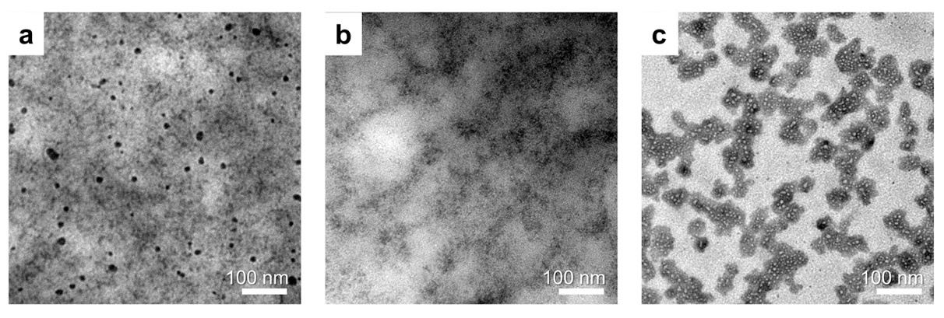
Figure S8. TEM images of PEDOT:PSS phase separation with different morphologies under various pH conditions. (a) The morphology of PEDOT:PSS after phase separation at pH 2.8, where it formed colloidal coils. (b) The morphology of PEDOT:PSS after phase separation at pH 1.8, where it exhibited a bi-continuous phase. (c) The morphology of PEDOT:PSS after phase separation at pH 0.8, where it appeared as isolated particles.

Figure S9. (a) Open-circuit voltage of the Electrochemical impedance spectroscopy testing setup. (b) Internal impedance of the testing electrode.

Figure S10. Different degrees of PEDOT:PSS phase separation. (a) Photographs and (b) CLSM images of hydrogels with varying degrees of phase separation under different pH conditions.

Figure S11. Conductive self-healing demonstration. (a) Photographs and corresponding circuit diagrams of conductive self-healing process, the PPP hydrogel was connected in series with a yellow LED in state of initial, cutting and healing from left to right, respectively, voltage= 3 V. Time evolution of the self-healing process for the PPP hydrogel by the real-time resistance measurements: (b) the cutting-healing cycles at the same location and (c) the magnified self-healing process.

Figure S12. Photographs of the gelation results of different concentrations of PVA and PVP solutions.

Figure S13. The viscoelasticity of PPP hydrogels. (a) Amplitude sweep curves of the PPP hydrogels with different PEDOT:PSS content. (b) Storage moduli (G') of the PPP hydrogels with different PEDOT:PSS content were obtained from the average value (0.1% to 10% strain) via oscillation tests.

Figure S14. Dissipation energy and resilience properties of the PPP hydrogels at various strain. The dissipation energy was defined as the area of hysteresis loop encompassed by the loading-unloading curve and calculated as $\int{\text{loading} σdε}$ - $\int{\text{unloading} σdε}$, where $σ$ is tensile stress, and $ε$ is strain (%). $ε≡Δλ$. In addition, resilience was defined as $\frac{\int{\text{un}\text{loading} σdε}}{\int{\text{loading} σdε}}$ × 100%.

Figure S15. Schematic of strain insensitivity in PPP hydrogels. (a) In PPP hydrogels, PEDOT:PSS formed a percolated conductive network. Due to the entropy elasticity of PEDOT:PSS, deformation (stretching) only changed the conduction pathway's shape but not its actual length. Therefore, PPP hydrogels exhibited resistance stability, i.e., strain insensitivity. (b) In non-percolating systems, deformation resulted in a significant increase in resistance.

Figure S16. Schematic diagram of adhesive mechanism of the PPP hydrogel. Residual hydroxyl groups in the PVA contributed to the tissue adhesiveness, which could rapidly form physical crosslinks (e.g., hydrogen bonds) with carboxyl and primary amine on the tissue surface.

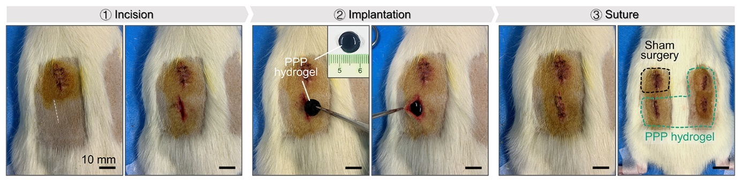
Figure S17. Photographs of the process of subcutaneous implantation in SD rats for the biocompatibility evaluation.

Figure S18. Noise power spectra of PPP hydrogel electrode, commercia gel electrode, Ag/AgCl electrode without conductive paste, and Ag/AgCl electrode with conductive paste under frequency range from 1 to 100 Hz.

Figure S19. Photographs of wearable electrode based on the PPP hydrogel. (a) PPP hydrogel electrode for EEG signal monitoring. (b) PPP hydrogel electrode for sEMG signal monitoring.

Figure S20. Comparison of the long-term usage stability of electrodes. (a) Real-time joint motion signals obtained from commercial gel electrode after 2 h of continuous use, and (b) real-time joint motion signals obtained from PPP hydrogel electrode, along with (c, d) the respective signal intensity compared to the initial values.

Supporting Tables
Table S1. The peak species, binding energy, and area ratio of PSS to PEDOT of the S_{2p} spectra.
Sample | Peak species | Binding energy  [eV] | Area ratio of  PSS to PEDOT
PEDOT:PSS solution | S of PEDOT | 164~165 | 2.8
PEDOT:PSS solution | S of PSS | 168.7 | 2.8
AT-PEDOT:PSS | S of PEDOT | 164~165 | 1.5
AT-PEDOT:PSS | S of PSS | 168.8 | 1.5
PPP hydrogel | S of PEDOT | 164~165 | 2.0
PPP hydrogel | S of PSS | 168.7 | 2.0

Table S2. Scoring results of skin irritation tests on SD rats.
Groups | Oedema/erythema/eschar scores (n=3)
Groups | 1 h | 24 h | 48 h | 72 h
PBS | 0 | 0 | 0 | 0
SDS | 2 | 4 | 4 | 4
PPP hydrogel | 0 | 1 | 0 | 0

Table S3. The compositions of PPP hydrogels with different PEDOT:PSS content.
Code | PVA  [mg/mL] | PVP  [mg/mL] | PEDOT:PSS  [mg/mL]
PPP-0 | 80.0 | 88.0 | 0
PPP-1.6 | 80.0 | 88.0 | 1.6
PPP-3.2 | 80.0 | 88.0 | 3.2
PPP-4.8 | 80.0 | 88.0 | 4.8
PPP-8.0 | 80.0 | 88.0 | 8.0

Movie S1. Axial tensile fracture of the PPP hydrogel.

Movie S2. Demonstration of strain insensitivity of PPP hydrogel.

Movie S3. Demonstration of wireless recording of sEMG signals with PPP hydrogel electrode.

Movie S4. Demonstration of anti-motion artifact of PPP hydrogel under walking condition.

