Supplementary materialS
Fig. S1 Mitochondrial Genome Circle Map of Several cotton materials.

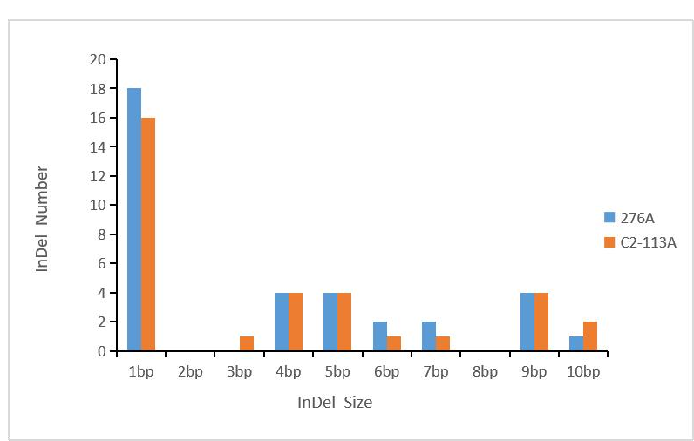
Fig. S2 Distribution of InDels with different lengths in the CMS lines

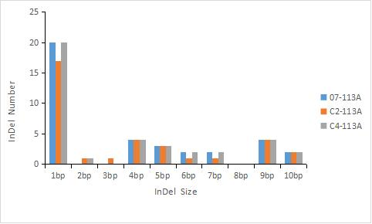
Fig. S3 Distribution of mtDNA in homonuclear heterogeneous CMS lines with different lengths of InDel

table S1 Types of mutations in the CDS region of Sea Island cotton
 | position | codon_mutate | mutate_type | synonymous | Nonsynony-mous | gene_id
 | 41750 | TCT<->TCG | Synonymous | 1 | 0 | nad2
 | 76473 | CTC<->ATC | Nonsynonymous | 0 | 1 | cox3
 | 78211 | ATC<->ATA | Synonymous | 1 | 0 | cox1
276A | 78679 | ATC<->ATA | Synonymous | 1 | 0 | cox1
 | 166017 | TAA<->TCA | Nonsynonymous | 0 | 1 | nad7
 | 205779 | CAA<->AAA | Nonsynonymous | 0 | 1 | matR
 | 246979 | ATC<->CTC | Nonsynonymous | 0 | 1 | rpl2
 | 247226 | TTT<->TTG | Nonsynonymous | 0 | 1 | rpl2
 | 248211 | AAA<->CAA | Nonsynonymous | 0 | 1 | rpl5
 | 279651 | AAA<->CAA | Nonsynonymous | 0 | 1 | rps4
 | 307165 | GTA<->GTC | Synonymous | 1 | 0 | rpl16
 | 404127 | AGC<->AGA | Nonsynonymous | 0 | 1 | atp8
 | 438339 | GAA<->AAA | Nonsynonymous | 0 | 1 | rpl10
 | 635055 | TTA<->TTC | Nonsynonymous | 0 | 1 | sdh3
 | 644471 | TTC<->TTT | Synonymous | 1 | 0 | atp4
 | 41750 | TCT<->TCG | Synonymous | 1 | 0 | nad2
 | 76473 | CTC<->ATC | Nonsynonymous | 0 | 1 | cox3
C2-113A | 78211 | ATC<->ATA | Synonymous | 1 | 0 | cox1
 | 78679 | ATC<->ATA | Synonymous | 1 | 0 | cox1
 | 166017 | TAA<->TCA | Nonsynonymous | 0 | 1 | nad7
 | 205779 | CAA<->AAA | Nonsynonymous | 0 | 1 | matR
 | 246979 | ATC<->CTC | Nonsynonymous | 0 | 1 | rpl2
 | 247226 | TTT<->TTG | Nonsynonymous | 0 | 1 | rpl2
 | 248211 | AAA<->CAA | Nonsynonymous | 0 | 1 | rpl5
 | 279651 | AAA<->CAA | Nonsynonymous | 0 | 1 | rps4
 | 307165 | GTA<->GTC | Synonymous | 1 | 0 | rpl16
 |  |  | 续上表
 | 404127 | AGC<->AGA | Nonsynonymous | 0 | 1 | atp8
 | 438339 | GAA<->AAA | Nonsynonymous | 0 | 1 | rpl10
 | 635055 | TTA<->TTC | Nonsynonymous | 0 | 1 | sdh3
 | 644471 | TTC<->TTT | Synonymous | 1 | 0 | atp4

table S2 Types of mutations in the CDS region of Sea Island cotton
 | position | codon_mutate | mutate_type | synonymous | nonsynonymous | gene_id
07-113A | 41750 | ATA<->ATC | Synonymous | 1 | 0 | nad2
 | 76473 | CTC<->ATC | Nonsynonymous | 0 | 1 | cox3
 | 78211 | ATC<->ATA | Synonymous | 1 | 0 | cox1
 | 78679 | ATC<->ATA | Synonymous | 1 | 0 | cox1
 | 166016 | ATA<->ATC | Synonymous | 1 | 0 | nad7
 | 205778 | CAA<->AAA | Nonsynonymous | 0 | 1 | matR
 | 246978 | ATC<->CTC | Nonsynonymous | 0 | 1 | rpl2
 | 247225 | TTT<->TTG | Nonsynonymous | 0 | 1 | rpl2
 | 248210 | AAA<->CAA | Nonsynonymous | 0 | 1 | rpl5
 | 279650 | AAA<->CAA | Nonsynonymous | 0 | 1 | rps4
 | 307164 | GTA<->GTC | Synonymous | 1 | 0 | rpl16
 | 309073 | AAT<->AAC | Synonymous | 1 | 0 | rps3
 | 404121 | AGC<->AGA | Nonsynonymous | 0 | 1 | atp8
 | 438333 | GAA<->AAA | Nonsynonymous | 0 | 1 | rpl10
 | 635050 | TTA<->TTC | Nonsynonymous | 0 | 1 | sdh3
 | 644466 | TTC<->TTT | Synonymous | 1 | 0 | atp4
C2-113A | 41750 | ATA<->ATC | Synonymous | 1 | 0 | nad2
 | 76473 | CTC<->ATC | Nonsynonymous | 0 | 1 | cox3
 | 78211 | ATC<->ATA | Synonymous | 1 | 0 | cox1
 | 78679 | ATC<->ATA | Synonymous | 1 | 0 | cox1
 | 166016 | ATA<->ATC | Synonymous | 1 | 0 | nad7
 |  |  | 续上表
 | 205778 | CAA<->AAA | Nonsynonymous | 0 | 1 | matR
 | 246978 | ATC<->CTC | Nonsynonymous | 0 | 1 | rpl2
 | 247225 | TTT<->TTG | Nonsynonymous | 0 | 1 | rpl2
 | 248210 | AAA<->CAA | Nonsynonymous | 0 | 1 | rpl5
 | 279650 | AAA<->CAA | Nonsynonymous | 0 | 1 | rps4
 | 307164 | GTA<->GTC | Synonymous | 1 | 0 | rpl16
 | 309073 | AAT<->AAC | Synonymous | 1 | 0 | rps3
 | 404121 | AGC<->AGA | Nonsynonymous | 0 | 1 | atp8
 | 438333 | GAA<->AAA | Nonsynonymous | 0 | 1 | rpl10
 | 635050 | TTA<->TTC | Nonsynonymous | 0 | 1 | sdh3
 | 644466 | TTC<->TTT | Synonymous | 1 | 0 | atp4
C4-113A | 41750 | ATA<->ATC | Synonymous | 1 | 0 | nad2
 | 76473 | CTC<->ATC | Nonsynonymous | 0 | 1 | cox3
 | 78211 | ATC<->ATA | Synonymous | 1 | 0 | cox1
 | 78679 | ATC<->ATA | Synonymous | 1 | 0 | cox1
 | 166016 | ATA<->ATC | Synonymous | 1 | 0 | nad7
 | 205778 | CAA<->AAA | Nonsynonymous | 0 | 1 | matR
 | 246978 | ATC<->CTC | Nonsynonymous | 0 | 1 | rpl2
 | 247225 | TTT<->TTG | Nonsynonymous | 0 | 1 | rpl2
 | 248210 | AAA<->CAA | Nonsynonymous | 0 | 1 | rpl5
 | 279650 | AAA<->CAA | Nonsynonymous | 0 | 1 | rps4
 | 307164 | GTA<->GTC | Synonymous | 1 | 0 | rpl16
 | 309073 | AAT<->AAC | Synonymous | 1 | 0 | rps3
 | 404121 | AGC<->AGA | Nonsynonymous | 0 | 1 | atp8
 | 438333 | GAA<->AAA | Nonsynonymous | 0 | 1 | rpl10
 | 635050 | TTA<->TTC | Nonsynonymous | 0 | 1 | sdh3
 | 644466 | TTC<->TTT | Synonymous | 1 | 0 | atp4

