Electronic Supplementary Material Figure S1
Article title: Systematic review and meta-analysis of eccentric-only versus concentric-only strength training effects on maximal voluntary eccentric, concentric and isometric contraction strength

Author names: Darjan Spudić, Kazunori Nosaka

Affiliation and e-mail of the corresponding author: Dr. Darjan Spudić, Faculty of Sport, University of Ljubljana, Slovenia; darjan.spudic@fsp.uni-lj.si; ORCID-ID: 0000-0001-8353-2958

Fig. S1 Meta-analysis results with forest plot for changes in maximal voluntary eccentric contraction (MVC_{ECC}) strength following eccentric-only training versus concentric-only training
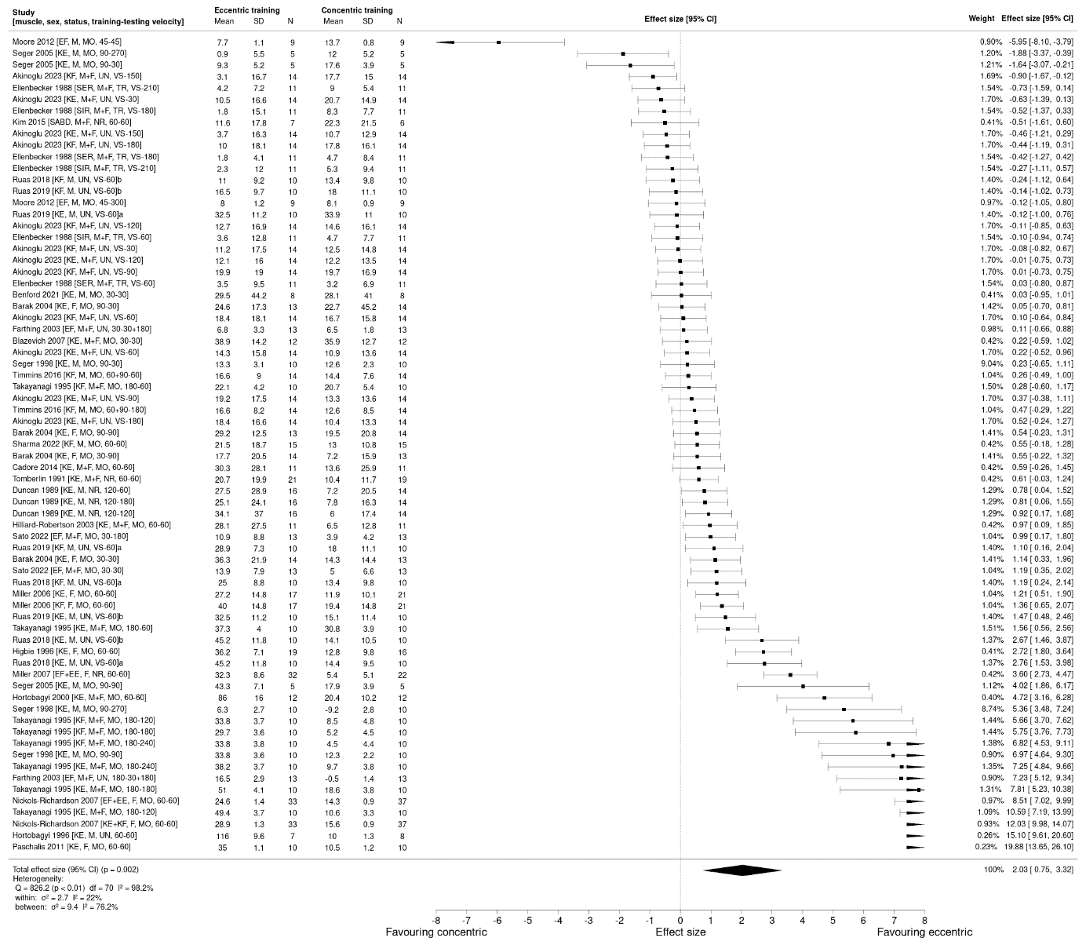
Study characteristics in brackets: muscle trained and tested [KE knee extensors, KF knee flexors, EF elbow flexors, EE elbow extensors, SER shoulder external rotarors, SIR shoulder internal rotators, SABD shoulder abductors], sex [M male, F female, M+F mixed sample], participants training status [UN untrained, MO moderately trained, TR highly strength trained, NR not reported], velocity [training velocity – testing velocity, VS velocity spectrum pyramidal ordering concept training]
a and b present outcomes from two eccentric isokinetic training groups from the same study

Electronic Supplementary Material Figure S2
Article title: Systematic review and meta-analysis of eccentric-only versus concentric-only strength training effects on maximal voluntary eccentric, concentric and isometric contraction strength

Author names: Darjan Spudić, Kazunori Nosaka

Affiliation and e-mail of the corresponding author: Dr. Darjan Spudić, Faculty of Sport, University of Ljubljana, Slovenia; darjan.spudic@fsp.uni-lj.si; ORCID-ID: 0000-0001-8353-2958

Fig. S2 Meta-analysis results with forest plot for changes in maximal voluntary concentric contraction (MVC_{CON}) strength following eccentric-only training versus concentric-only training
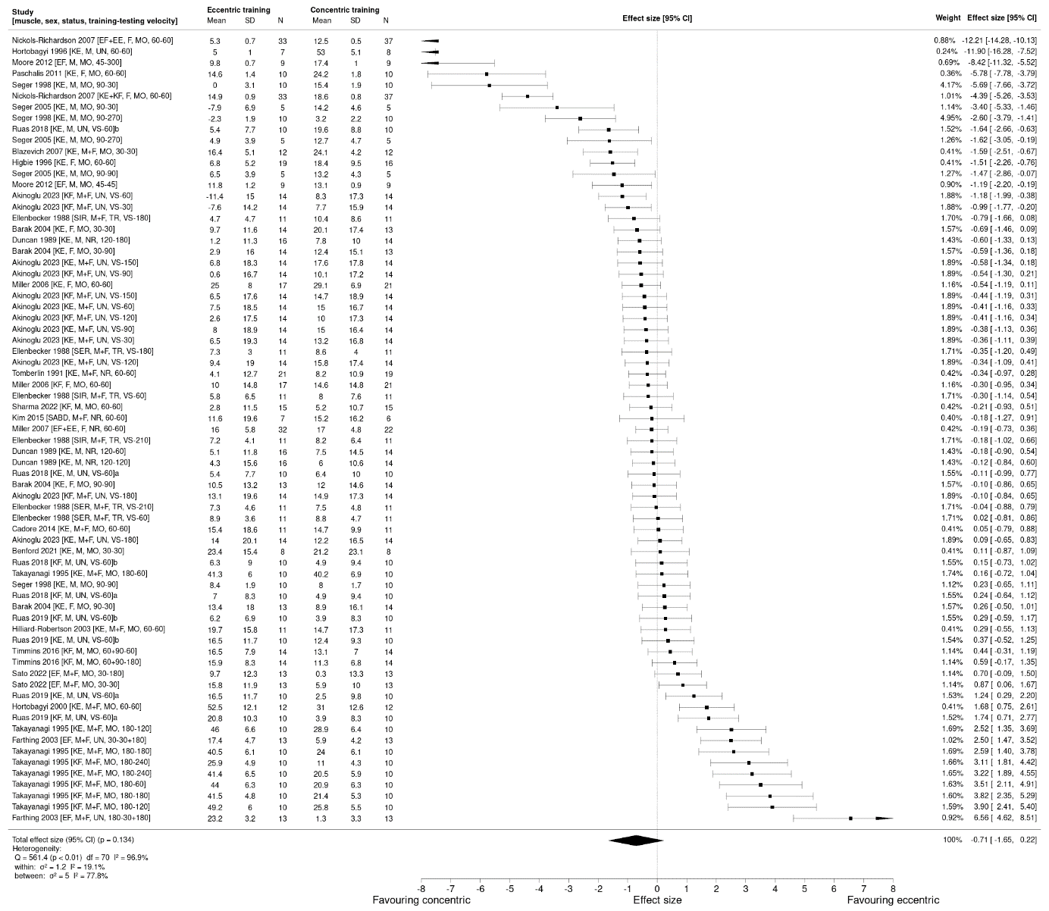
Study characteristics in brackets: muscle trained and tested [KE knee extensors, KF knee flexors, EF elbow flexors, EE elbow extensors, SER shoulder external rotarors, SIR shoulder internal rotators, SABD shoulder abductors], sex [M male, F female, M+F mixed sample], participants training status [UN untrained, MO moderately trained, TR highly strength trained, NR not reported], velocity [training velocity – testing velocity, VS velocity spectrum pyramidal ordering concept training]
a and b present outcomes from two eccentric isokinetic training groups from the same study

Electronic Supplementary Material Figure S3
Article title: Systematic review and meta-analysis of eccentric-only versus concentric-only strength training effects on maximal voluntary eccentric, concentric and isometric contraction strength

Author names: Darjan Spudić, Kazunori Nosaka

Affiliation and e-mail of the corresponding author: Dr. Darjan Spudić, Faculty of Sport, University of Ljubljana, Slovenia; darjan.spudic@fsp.uni-lj.si; ORCID-ID: 0000-0001-8353-2958

Fig. S3 Meta-analysis results with forest plot for changes in maximal voluntary isometric contraction (MVC_{ISO}) strength following eccentric-only training versus concentric-only training
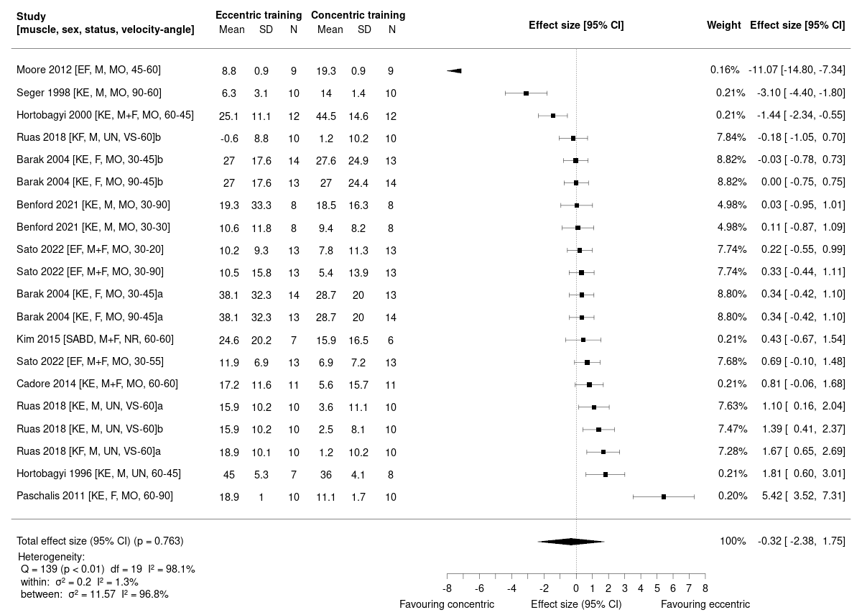
Study characteristics in brackets: muscle trained and tested [KE knee extensors, KF knee flexors, EF elbow flexors, EE elbow extensors, SER shoulder external rotarors, SIR shoulder internal rotators, SABD shoulder abductors], sex [M male, F female, M+F mixed sample], participants training status [UN untrained, MO moderately trained, NR not reported], velocity-angle [training velocity – joint angle of strengh assessement, VS velocity spectrum pyramidal ordering concept training]
a and b present outcomes from two eccentric isokinetic training groups from the same study

Electronic Supplementary Material Table S1
Article title: Systematic review and meta-analysis of eccentric-only versus concentric-only strength training effects on maximal voluntary eccentric, concentric and isometric contraction strength

Author names: Darjan Spudić, Kazunori Nosaka

Affiliation and e-mail of the corresponding author: Dr. Darjan Spudić, Faculty of Sport, University of Ljubljana, Slovenia; darjan.spudic@fsp.uni-lj.si; ORCID-ID: 0000-0001-8353-2958
Table S1 Physiotherapy Evidence Database (PEDro) scores of the included studies
Authors | Eligibility  criteria | Random allocation | Concealed allocation | Baseline comparability | Blind subjects | Blind therapists | Blind assessor | Adequate follow-up dropout <15% | Intention-to- treat | Between-group comparisons | Point estimates and variability | Score | Risk of biasª
Akinoglu 2023 [110] | yes | yes | no | yes | no | no | no | no | yes | yes | yes | 6 | low
Barak 2004 [107] | yes | yes | no | yes | no | no | no | no | yes | yes | yes | 6 | low
Benford 2021 [81] | yes | yes | no | yes | no | no | no | no | yes | yes | yes | 6 | low
Blazevich 2007 [97] | yes | yes | no | yes | no | no | no | no | yes | yes | yes | 6 | low
Cadore 2014 [98] | yes | yes | no | yes | no | yes | yes | yes | yes | yes | yes | 9 | low
Duncan 1989 [95] | yes | yes | no | no | no | no | no | no | yes | yes | yes | 5 | moderate
Ellenbecker 1988 [99] | yes | yes | no | no | no | no | no | no | yes | yes | yes | 5 | moderate
Farthing 2003 [104] | yes | yes | no | no | no | no | no | yes | yes | yes | yes | 6 | low
Higbie 1996 [16] | yes | yes | no | yes | no | no | no | yes | yes | yes | yes | 7 | low
Hilliard-Robertson 2003 [106] | yes | yes | no | yes | no | no | no | no | yes | yes | yes | 6 | low
Hortobagyi 1996 [41] | yes | yes | no | yes | no | no | no | yes | yes | yes | yes | 7 | low
Hortobagyi 2000 [68] | yes | yes | no | no | no | no | no | no | yes | yes | yes | 5 | moderate
Kim 2015 [103] | yes | yes | no | yes | no | no | no | no | yes | yes | yes | 6 | low
Paschalis 2011 [105] | yes | yes | no | yes | no | no | no | yes | yes | yes | yes | 7 | low
Ruas 2018 [108] | yes | yes | no | yes | no | no | no | no | yes | yes | yes | 6 | low
Ruas 2019 [109] | yes | yes | no | yes | no | no | no | no | yes | yes | yes | 6 | low
Miller 2006 [93] | yes | yes | no | yes | no | no | no | yes | yes | yes | yes | 7 | low
Miller 2007 [71] | yes | yes | no | yes | no | no | no | no | yes | yes | yes | 6 | low
Moore 2012 [102] | yes | yes | no | yes | no | no | no | yes | yes | yes | yes | 7 | low
Nickols-Richardson 2007 [72] | yes | yes | no | yes | no | no | no | no | yes | yes | yes | 6 | low
Sato 2022 [96] | yes | yes | no | yes | no | no | no | no | yes | yes | yes | 6 | low
Seger 1998 [70] | yes | yes | no | yes | no | no | no | no | yes | yes | yes | 6 | low
Seger 2005 [69] | yes | yes | no | yes | no | no | no | no | yes | yes | yes | 6 | low
Sharma 2022 [92] | yes | yes | yes | yes | no | no | yes | yes | yes | yes | yes | 9 | low
Takayanagi 1995 [100] | yes | yes | no | yes | no | no | no | no | yes | yes | yes | 6 | low
Timmins 2016 [101] | yes | yes | no | yes | no | no | no | yes | yes | yes | yes | 7 | low
Tomberlin 1991 [94] | yes | yes | no | yes | no | no | no | no | yes | yes | yes | 6 | low
ª low risk score ≥ 6 points, moderate risk score 4 to 5 points, high risk score ≤ 3 points
Electronic Supplementary Material Table S2
Article title: Systematic review and meta-analysis of eccentric-only versus concentric-only strength training effects on maximal voluntary eccentric, concentric and isometric contraction strength

Author names: Darjan Spudić, Kazunori Nosaka

Affiliation and e-mail of the corresponding author: Dr. Darjan Spudić, Faculty of Sport, University of Ljubljana, Slovenia; darjan.spudic@fsp.uni-lj.si; ORCID-ID: 0000-0001-8353-2958
Table S2 Template for Intervention Description and Replication scores of the included studies
Authors | Name | Why | What (materials) | What  (procedures) | Who | How | Where | When and how much | Tailoring | Modifications | How well (planned) | How well (actual) | Score
Akinoglu 2023 [110] | yes | yes | yes | yes | no | yes | no | yes | no | no | no | no | 6
Barak 2004 [107] | yes | yes | yes | yes | no | yes | no | yes | no | no | no | no | 6
Benford 2021 [81] | yes | yes | yes | yes | yes | yes | no | yes | no | no | yes | yes | 9
Blazevich 2007 [97] | yes | yes | yes | yes | no | yes | no | yes | no | no | no | no | 6
Cadore 2014 [98] | yes | yes | yes | yes | yes | yes | no | yes | no | no | yes | yes | 9
Duncan 1989 [95] | yes | yes | yes | yes | no | yes | no | yes | no | no | no | no | 6
Ellenbecker 1988 [99] | yes | yes | yes | yes | no | yes | no | yes | no | no | no | no | 6
Farthing 2003 [104] | yes | yes | yes | yes | no | yes | yes | yes | no | no | no | yes | 8
Higbie 1996 [16] | yes | yes | yes | yes | no | yes | no | yes | no | no | no | yes | 7
Hilliard-Robertson 2003 [106] | yes | yes | yes | yes | no | yes | no | yes | no | no | no | no | 6
Hortobagyi 1996 [41] | yes | yes | yes | yes | no | yes | yes | yes | no | no | no | no | 7
Hortobagyi 2000 [68] | yes | yes | yes | yes | no | yes | no | yes | no | no | no | no | 6
Kim 2015 [103] | yes | yes | yes | yes | yes | yes | no | yes | no | no | no | no | 7
Paschalis 2011 [105] | yes | yes | yes | yes | no | yes | yes | yes | no | no | no | no | 7
Ruas 2018 [108] | yes | yes | yes | yes | no | yes | yes | yes | no | no | no | no | 7
Ruas 2019 [109] | yes | yes | yes | yes | no | yes | no | yes | no | no | no | no | 6
Miller 2006 [93] | yes | yes | yes | yes | no | yes | yes | yes | no | no | no | yes | 8
Miller 2007 [71] | yes | yes | yes | yes | no | yes | no | yes | no | no | no | yes | 7
Moore 2012 [102] | yes | yes | yes | yes | no | yes | yes | yes | no | no | no | yes | 8
Nickols-Richardson 2007 [72] | yes | yes | yes | yes | no | yes | yes | yes | no | no | no | yes | 8
Sato 2022 [96] | yes | yes | yes | yes | yes | yes | yes | yes | no | no | no | no | 8
Seger 1998 [70] | yes | yes | yes | yes | no | yes | no | yes | no | no | no | no | 6
Seger 2005 [69] | yes | yes | yes | yes | no | yes | no | yes | no | no | no | no | 6
Sharma 2022 [92] | yes | yes | yes | yes | yes | yes | yes | yes | no | no | yes | yes | 10
Takayanagi 1995 [100] | yes | yes | yes | yes | no | yes | no | yes | no | no | no | no | 6
Timmins 2016 [101] | yes | yes | yes | yes | no | yes | yes | yes | no | no | yes | yes | 9
Tomberlin 1991 [94] | yes | yes | yes | yes | no | yes | yes | yes | no | no | no | no | 7
The checklist key components were described in the article

Electronic Supplementary Material Table S3
Article title: Systematic review and meta-analysis of eccentric-only versus concentric-only strength training effects on maximal voluntary eccentric, concentric and isometric contraction strength

Author names: Darjan Spudić, Kazunori Nosaka

Affiliation and e-mail of the corresponding author: Dr. Darjan Spudić, Faculty of Sport, University of Ljubljana, Slovenia; darjan.spudic@fsp.uni-lj.si; ORCID-ID: 0000-0001-8353-2958
Table S3 Summarized results of the Grading of Recommendation, Assessment, Development and Evaluations (GRADE) certainty of evidence assessment
Group comparisons | Outcome(s) | Studies (n) | k | Eccentric  training  group (n) | Concentric  training  group (n) | Risk of bias | Inconsistency |  | Imprecision | Indirectness | Tidier score (median) | Publication bias | Quality of evidence  (GRADE)
 |  |  |  |  |  | Pedro scale  score (median) | Q-test  (p-value) | Relative total variability I² | ES (95% CI) | Indirectness | Tidier score (median) | Egger’s test  (p-value) | Quality of evidence  (GRADE)
Eccentric-only  vs  concentric-only | MVC_{ECC} | 25 | 66 | 831 | 821 | 6 (low) | <0.01ª | 96.5ª | 1.51 (0.6, 2.43) | Low | 7 | <0.10ª | low
Eccentric-only  vs  concentric-only | MVC_{CON} | 24 | 66 | 812 | 798 | 6 (low) | <0.01ª | 91.7ª | –0.1 (–0.69, 0.48)ª | Low | 7 | <0.10ª | very low
Eccentric-only  vs  concentric-only | MVC_{ISO} | 9 | 18 | 196 | 196 | 6 (low) | <0.01ª | 88.4ª | 0.04 (–0.82, 0.9)ª | Low | 7 | <0.10ª | very low
Eccentric-only | MVC_{ECC} | 27 | 71 | 904 | 899 | 6 (low) | <0.01ª | 99.8ª | 27.3 (19.4, 35.2) | Low | 7 | 0.377 | moderate
Eccentric-only | MVC_{CON} | 27 | 71 | 904 | 899 | 6 (low) | <0.01ª | 99.5ª | 12.6 (8.6, 16.7) | Low | 7 | 0.763 | moderate
Eccentric-only | MVC_{ISO} | 11 | 20 | 215 | 215 | 6 (low) | <0.01ª | 98.9ª | 18.2 (11.7, 24.7) | Low | 7 | 0.797 | moderate
Concentric-only | MVC_{ECC} | 27 | 71 | 904 | 899 | 6 (low) | <0.01ª | 98.7ª | 10.2 (8.2, 12.3) | Low | 7 | 0.267 | moderate
Concentric-only | MVC_{CON} | 27 | 71 | 904 | 899 | 6 (low) | <0.01ª | 99.6ª | 13.8 (10, 17.5) | Low | 7 | 0.077 | moderate
Concentric-only | MVC_{ISO} | 11 | 20 | 215 | 215 | 6 (low) | <0.01ª | 99.1ª | 16.9 (9.5, 24.2) | Low | 7 | 0.343 | moderate
Eccentric-only | MVC_{ECC} vs MVC_{CON} | 27 | 142 | 904 | 899 | 6 (low) | <0.01ª | 99.9ª | 11.4 (11.2, 11.7) | Low | 7 | <0.10ª | low
Eccentric-only | MVC_{ECC} vs MVC_{ISO} | 27 | 91 | 904 | 899 | 6 (low) | <0.01ª | 99.5ª | 8.6 (9.3, 8.0) | Low | 7 | <0.10ª | low
Eccentric-only | MVC_{CON} vs MVC_{ISO} | 27 | 91 | 904 | 899 | 6 (low) | <0.01ª | 99.6ª | –3.8 (–3.3, –4.3)ª | Low | 7 | <0.10ª | very low
Concentric-only | MVC_{ECC} vs MVC_{CON} | 27 | 142 | 904 | 899 | 6 (low) | <0.01ª | 99.4ª | –1.7 (–1.9, –1.5)ª | Low | 7 | <0.10ª | very low
Concentric-only | MVC_{ECC} vs MVC_{ISO} | 27 | 91 | 904 | 899 | 6 (low) | <0.01ª | 98.8ª | –6.2 (–5.7, –6.7) | Low | 7 | 0.443 | moderate
Concentric-only | MVC_{CON} vs MVC_{ISO} | 27 | 91 | 904 | 899 | 6 (low) | <0.01ª | 99.6ª | –2.1 (–1.7, –2.6)ª | Low | 7 | <0.10ª | very low
In the analyses comparing eccentric-only versus concentric-only training, effect sizes (ES) are presented using Hedge’s g. For all other analyses, ES are presented as percentage values (%)
k number of effect sizes included into the analysis
ª GRADE score downgraded by one level due to this criterion

Electronic Supplementary Material Table S4
Article title: Systematic review and meta-analysis of eccentric-only versus concentric-only strength training effects on maximal voluntary eccentric, concentric and isometric contraction strength

Author names: Darjan Spudić, Kazunori Nosaka

Affiliation and e-mail of the corresponding author: Dr. Darjan Spudić, Faculty of Sport, University of Ljubljana, Slovenia; darjan.spudic@fsp.uni-lj.si; ORCID-ID: 0000-0001-8353-2958
Table S4. Results of subgroup analyses and meta-regressions in search of possible moderators explaining the variability of maximal voluntary eccentric contraction strength (MVC_{ECC}) increase difference following eccentric-only versus concentric-only training
Moderators | Number of studies | Number of effect sizes | Hedge’s g (95% CI) | SE | Z | p | Residual heterogeneity  Q-test (p-value) | Moderator effect  Chi² statistics  (p-value) | pseudo R² (%)
Sex
Reference (Women) | 5 | 9 | 3.06 (1.02, 5.09) | 1.04 | 2.94 | <0.05 | 579.1  (<0.001) | 3.182  (0.204) | 2.7
Man | 9 | 22 | –2.29 (–4.8, 0.23) | 1.28 | –1.78 | 0.075 | 579.1  (<0.001) | 3.182  (0.204) | 2.7
Mixed sample | 11 | 35 | –1.62 (–1.07, 0.84) | 1.25 | –1.29 | 0.197 | 579.1  (<0.001) | 3.182  (0.204) | 2.7
Muscles
Reference (Lower body) | 18 | 52 | 1.3 (0.21, 2.34) | 0.56 | 2.33 | <0.05 | 625.9  (<0.001) | 0.59  (0.443) | 6
Upper body | 7 | 12 | 0.83 (–1.28, 2.93) | 1.07 | 0.77 | 0.440 | 625.9  (<0.001) | 0.59  (0.443) | 6
Training status
Reference (Moderately trained) | 16 | 33 | 1.68 (0.44, 2.91) | 0.63 | 2.67 | <0.05 | 632.3  (<0.001) | 0.894  (0.827) | 18
Trained | 1 | 6 | –2.01 (–6.67, 2.65) | 2.38 | –0.84 | 0.400 | 632.3  (<0.001) | 0.894  (0.827) | 18
Untrained | 4 | 21 | 0.19 (–2.5, 2.85) | 1.36 | 0.14 | 0.890 | 632.3  (<0.001) | 0.894  (0.827) | 18
Not reported | 4 | 6 | –0.55 (–3.32, 2.22) | 1.41 | –0.39 | 0.690 | 632.3  (<0.001) | 0.894  (0.827) | 18
Training to testing velocity
Reference (The same) ª | 19 | 22 | 1.97 (0.91, 3.04) | 0.54 | 3.63 | <0.05 | 564.2  (<0.001) | 7.24  (0.070) | 1.3
High to low ^{b} | 5 | 8 | –1.53 (–2.85, –0.2) | 0.68 | –2.26 | <0.05 | 564.2  (<0.001) | 7.24  (0.070) | 1.3
Low to high ^{c} | 9 | 10 | –0.12 (–1.3, 1.06) | 0.61 | –0.19 | 0.850 | 564.2  (<0.001) | 7.24  (0.070) | 1.3
Velocity spectrum training ^{d} | 4 | 26 | –1.59 (–3.94, 0.76) | 1.20 | –1.32 | 0.190 | 564.2  (<0.001) | 7.24  (0.070) | 1.3
Age
Intercept |  |  | 6.03 (0.96, 11.1) | 2.59 | 2.33 | <0.05 | 629.6  (<0.001) | 3.04  (0.081) | 12.7
Age | 26 | 60 | –0.18 (–0.38, 0.02) | 0.10 | –1.74 | 0.080 | 629.6  (<0.001) | 3.04  (0.081) | 12.7
Initial MVC_{CON}
Intercept |  |  | 0.75 (–1.05, 2.54) | 0.91 | 0.81 | 0.416 | 441.6  (<0.001) | 0.552  (0.458) | 12.2
MVC_{CON} | 18 | 44 | 0.01 (–0.01, 0.02) | 0.01 | 0.74 | 0.458 | 441.6  (<0.001) | 0.552  (0.458) | 12.2
Initial MVC_{ECC}
Intercept |  |  | 0.95 (–1.02, 2.91) | 1.00 | 0.94 | 0.350 | 440.3  (<0.001) | 0.158  (0.691) | 10
MVC_{ECC} | 18 | 44 | 0.01 (–0.01, 0.01) | 0.01 | 0.39 | 0.690 | 440.3  (<0.001) | 0.158  (0.691) | 10
Initial ECC/CON ratio
Intercept |  |  | 6.3 (–0.5, 13.09) | 3.47 | 1.82 | 0.070 | 539.9  (<0.001) | 2.05  (0.152) | 19.5
ECC/CON ratio | 19 | 52 | –4.69 (–11.1, 1.73) | 3.27 | –1.43 | 0.152 | 539.9  (<0.001) | 2.05  (0.152) | 19.5
Training related variables
Intercept |  |  | –2.76 (–11.06, 5.54) | 4.24 | –0.65 | 0.515 | 481.6  (<0.001) | 8.208  (0.084) | 19.5
Repetitions (per set) | 24 | 64 | 0.06 (–0.42, 0.54) | 0.25 | 0.24 | 0.812 | 481.6  (<0.001) | 8.208  (0.084) | 19.5
Sets (per session) | 24 | 64 | 0.02 (–0.61, 0.64) | 0.32 | 0.05 | 0.960 | 481.6  (<0.001) | 8.208  (0.084) | 19.5
Duration (in weeks) | 25 | 66 | 0.25 (0.05, 0.46) | 0.10 | 2.45 | <0.05 | 481.6  (<0.001) | 8.208  (0.084) | 19.5
Frequency (per week) | 25 | 66 | 0.59 (–1.05, 2.22) | 0.84 | 0.70 | 0.482 | 481.6  (<0.001) | 8.208  (0.084) | 19.5
In the subgroup analysis (categorical variables), the first variable of the category was considered as the reference
CI confidence interval, CON concentric, SE standard error, ECC eccentric, ISO isometric, MVC maximal voluntary contraction
ª training and testing at same isokinetic velocity
^{b} training at lower velocity than testing
^{c} training at higher velocity than testing
^{d} velocity spectrum pyramidal ordering concept training

Electronic Supplementary Material Table S5
Article title: Systematic review and meta-analysis of eccentric-only versus concentric-only strength training effects on maximal voluntary eccentric, concentric and isometric contraction strength

Author names: Darjan Spudić, Kazunori Nosaka

Affiliation and e-mail of the corresponding author: Dr. Darjan Spudić, Faculty of Sport, University of Ljubljana, Slovenia; darjan.spudic@fsp.uni-lj.si; ORCID-ID: 0000-0001-8353-2958
Table S5. Results of subgroup analyses and meta-regressions in search of possible moderators explaining the variability of maximal voluntary concentric contraction strength (MVC_{CON}) increase difference following eccentric-only versus concentric-only training
Moderators | Number of studies | Number of effect sizes | Hedge’s g (95% CI) | SE | Z | p | Residual heterogeneity  Q-test (p-value) | Moderator effect  Chi² statistics  (p-value) | pseudo R² (%)
Sex
Reference (Women) | 3 | 8 | –0.57 (–1.95, 0.81) | 0.70 | –0.81 | 0.42 | 348.5  (<0.001) | 3.908  (0.142) | 4.4
Man | 9 | 22 | –0.09 (–1.77, 1.59) | 0.86 | –0.11 | 0.91 | 348.5  (<0.001) | 3.908  (0.142) | 4.4
Mixed sample | 11 | 36 | 1.1 (–0.52, 2.72) | 0.83 | 1.33 | 0.18 | 348.5  (<0.001) | 3.908  (0.142) | 4.4
Muscles
Reference (Lower body) | 18 | 53 | –0.11 (–0.8, 0.59) | 0.35 | –0.30 | 0.76 | 356.1  (<0.001) | 0.0008  (0.977) | 10
Upper body | 6 | 13 | –0.02 (–1.46, 1.42) | 0.74 | –0.03 | 0.98 | 356.1  (<0.001) | 0.0008  (0.977) | 10
Training status
Reference (Moderately trained) | 11 | 32 | –0.35 (–1.16, 0.46) | 0.41 | –0.84 | 0.40 | 352.9  (<0.001) | 1.890  (0.596) | 21.3
Trained | 1 | 6 | 0.08 (–2.93, 3.09) | 1.53 | 0.05 | 0.96 | 352.9  (<0.001) | 1.890  (0.596) | 21.3
Untrained | 4 | 22 | 1.17 (–0.52, 2.86) | 0.86 | 1.36 | 0.18 | 352.9  (<0.001) | 1.890  (0.596) | 21.3
Not reported | 4 | 6 | 0.10 (–1.66, 1.85) | 0.90 | 0.11 | 0.91 | 352.9  (<0.001) | 1.890  (0.596) | 21.3
Training to testing velocity
Reference (The same) | 15 | 20 | 0.00 (–0.79, 0.79) | 0.40 | 0.00 | 1.00 | 356.5  (<0.001) | 8.356  (0.039) | 48.8
High to low | 7 | 10 | –0.99 (–1.74, –0.23) | 0.39 | –2.55 | <0.05 | 356.5  (<0.001) | 8.356  (0.039) | 48.8
Low to high | 9 | 10 | –0.12 (–0.85, 0.61) | 0.37 | –0.33 | 0.74 | 356.5  (<0.001) | 8.356  (0.039) | 48.8
Velocity spectrum training | 4 | 26 | –0.04 (–1.82, 1.73) | 0.91 | –0.05 | 0.96 | 356.5  (<0.001) | 8.356  (0.039) | 48.8
Age
Intercept |  |  | 1.37 (–2.18, 4.91) | 1.81 | 0.75 | 0.45 | 349.5  (<0.001) | 0.677  (0.411) | 12.9
Age | 23 | 60 | –0.06 (–0.2, 0.08) | 0.07 | –0.82 | 0.41 | 349.5  (<0.001) | 0.677  (0.411) | 12.9
Initial MVC_{CON}
Intercept |  |  | –0.21 (–1.05, 0.62) | 0.42 | –0.51 | 0.61 | 200.78  (<0.001) | 0.191  (0.662) | 19.7
MVC_{CON} | 17 | 43 | 0 (–0.01, 0) | 0.00 | –0.44 | 0.66 | 200.78  (<0.001) | 0.191  (0.662) | 19.7
Initial MVC_{ECC}
Intercept |  |  | –0.48 (–1.35, 0.4) | 0.45 | –1.06 | 0.29 | 196.8  (<0.001) | 0.083  (0.774) | 14.5
MVC_{ECC} | 17 | 43 | 0.00 (0.00, 0.01) | 0.00 | 0.29 | 0.77 | 196.8  (<0.001) | 0.083  (0.774) | 14.5
Initial ECC/CON ratio
Intercept |  |  | 2.14 (–1.52, 5.81) | 1.87 | 1.15 | 0.25 | 271.6  (<0.001) | 1.844  (0.174) | 5.2
ECC/CON ratio | 18 | 51 | –2.42 (–5.91, 1.07) | 1.78 | –1.36 | 0.17 | 271.6  (<0.001) | 1.844  (0.174) | 5.2
Training related variables
Intercept |  |  | 1.87 (–2.33, 6.07) | 2.14 | 0.87 | 0.38 | 307.4  (<0.001) | 5.731  (0.220) | 40.7
Repetitions (per set) | 23 | 65 | –0.21 (–0.45, 0.04) | 0.12 | –1.67 | 0.10 | 307.4  (<0.001) | 5.731  (0.220) | 40.7
Sets (per session) | 23 | 65 | 0.27 (–0.03, 0.57) | 0.15 | 1.74 | 0.08 | 307.4  (<0.001) | 5.731  (0.220) | 40.7
Duration (in weeks) | 24 | 66 | –0.1 (–0.21, 0.01) | 0.06 | –1.73 | 0.08 | 307.4  (<0.001) | 5.731  (0.220) | 40.7
Frequency (per week) | 24 | 66 | –0.1 (–0.92, 0.73) | 0.42 | –0.23 | 0.82 | 307.4  (<0.001) | 5.731  (0.220) | 40.7
In the subgroup analysis (categorical variables), the first variable of the category was considered as the reference
CI confidence interval, CON concentric, SE standard error, ECC eccentric, ISO isometric, MVC maximal voluntary contraction
ª training and testing at same isokinetic velocity
^{b} training at lower velocity than testing
^{c} training at higher velocity than testing
^{d} velocity spectrum pyramidal ordering concept training

Electronic Supplementary Material Table S6
Article title: Systematic review and meta-analysis of eccentric-only versus concentric-only strength training effects on maximal voluntary eccentric, concentric and isometric contraction strength

Author names: Darjan Spudić, Kazunori Nosaka

Affiliation and e-mail of the corresponding author: Dr. Darjan Spudić, Faculty of Sport, University of Ljubljana, Slovenia; darjan.spudic@fsp.uni-lj.si; ORCID-ID: 0000-0001-8353-2958
Table S6. Results of subgroup analyses and meta-regressions in search of possible moderators explaining the variability of maximal voluntary isometric contraction strength (MVC_{ISO}) increase difference following eccentric-only versus concentric-only training
Moderators | Number of studies | Number of effect sizes | Hedge’s g (95% CI) | SE | Z | p | Residual heterogeneity  Q-test (p-value) | Moderator effect  Chi² statistics  (p-value) | pseudo R² (%)
Sex
Reference (Women) | 1 | 4 | 0.16 (–2.79, 3.11) | 1.51 | 0.11 | 0.91 | 74.6  (<0.001) | 0.015  (0.993) | 47.0
Man | 4 | 8 | –0.19 (–3.53, 3.14) | 1.70 | –0.11 | 0.91 | 74.6  (<0.001) | 0.015  (0.993) | 47.0
Mixed sample | 4 | 6 | –0.1 (–3.43, 3.22) | 1.70 | –0.06 | 0.95 | 74.6  (<0.001) | 0.015  (0.993) | 47.0
Muscles
Reference (Lower body) | 7 | 14 | –0.07 (–1.12, 0.97) | 0.53 | –0.14 | 0.89 | 73.3  (<0.001) | 0.195  (0.659) | 18.3
Upper body | 2 | 4 | 0.5 (–1.7, 2.69) | 1.12 | 0.44 | 0.66 | 73.3  (<0.001) | 0.195  (0.659) | 18.3
Training status
Reference (Moderately trained) | 6 | 12 | –0.42 (–1.42, 0.58) | 0.51 | –0.82 | 0.41 | 64.8  (<0.001) | 2.850  (0.240) | 8.7
Not reported | 1 | 1 | 1.72 (–0.31, 3.75) | 1.04 | 1.66 | 0.10 | 64.8  (<0.001) | 2.850  (0.240) | 8.7
Untrained | 2 | 5 | 0.85 (–1.92, 3.63) | 1.42 | 0.60 | 0.55 | 64.8  (<0.001) | 2.850  (0.240) | 8.7
Age
Intercept |  |  | 3.40 (–8.59, 15.39) | 6.12 | 0.56 | 0.58 | 73.9  (<0.001) | 0.300  (0.581) | 14.7
Age | 9 | 18 | –0.14 (–0.65, 0.37) | 0.26 | –0.55 | 0.58 | 73.9  (<0.001) | 0.300  (0.581) | 14.7
Initial MVC_{CON}
Intercept |  |  | –0.67 (–2.73, 1.39) | 1.05 | –0.64 | 0.52 | 51.9  (<0.001) | 0.510  (0.476) | 28.7
MVC_{CON} | 6 | 13 | 0.00 (–0.01, 0.02) | 0.01 | 0.71 | 0.48 | 51.9  (<0.001) | 0.510  (0.476) | 28.7
Initial MVC_{ECC}
Intercept |  |  | 0.39 (–2.42, 3.19) | 1.43 | 0.27 | 0.79 | 52.4  (<0.001) | 0.098  (0.754) | 3.6
MVC_{ECC} | 6 | 13 | 0 (–0.02, 0.01) | 0.01 | –0.31 | 0.75 | 52.4  (<0.001) | 0.098  (0.754) | 3.6
Initial ECC/CON ratio
Intercept |  |  | 1.24 (–3.89, 6.37) | 2.62 | 0.47 | 0.64 | 59.3  (<0.001) | 0.168  (0.682) | 30.6
ECC/CON ratio | 7 | 14 | –1.0 (–5.77, 3.78) | 2.44 | –0.41 | 0.68 | 59.3  (<0.001) | 0.168  (0.682) | 30.6
Training related variables
Intercept |  |  | 4.23 (–10.31, 18.77) | 7.42 | 0.57 | 0.57 | 65.1  (<0.001) | 0.660  (0.960) | 14.0
Repetitions (per set) | 9 | 18 | –0.21 (–1.25, 0.83) | 0.53 | –0.40 | 0.69 | 65.1  (<0.001) | 0.660  (0.960) | 14.0
Sets (per session) | 9 | 18 | –0.05 (–1.88, 1.78) | 0.93 | –0.05 | 0.96 | 65.1  (<0.001) | 0.660  (0.960) | 14.0
Duration (in weeks) | 9 | 18 | –0.03 (–0.98, 0.92) | 0.49 | –0.06 | 0.95 | 65.1  (<0.001) | 0.660  (0.960) | 14.0
Frequency (per week) | 9 | 18 | –0.7 (–3.79, 2.39) | 1.58 | –0.44 | 0.66 | 65.1  (<0.001) | 0.660  (0.960) | 14.0
In the subgroup analysis (categorical variables), the first variable of the category was considered as the reference
CI confidence interval, CON concentric, SE standard error, ECC eccentric, ISO isometric, MVC maximal voluntary contraction

Electronic Supplementary Material Table S7
Article title: Systematic review and meta-analysis of eccentric-only versus concentric-only strength training effects on maximal voluntary eccentric, concentric and isometric contraction strength

Author names: Darjan Spudić, Kazunori Nosaka

Affiliation and e-mail of the corresponding author: Dr. Darjan Spudić, Faculty of Sport, University of Ljubljana, Slovenia; darjan.spudic@fsp.uni-lj.si; ORCID-ID: 0000-0001-8353-2958
Table S7. Results of meta-analyses synthesizing the results of individual studies for improvement of maximal voluntary eccentric, concentric and isometric strength after eccentric-only and concentric-only training
Training mode | Meta-analysis | Estimate  % (95% CI) | adjusted  95% CI (%) | SE  (%) | Z | p | Level 2  σ² | Level 3  σ² | Level 2 I² (%) | Level 3 I² (%) | Residual  heterogeneity  Q-test  (p-value) | Total I² (%) | Egger’s test  (p-value)
Eccentric  training | MVC_{ECC} | 27.3 (19.4, 35.2) | 18.2 to 36.4 | 4.0 | 6.75 | <0.001 | 67.0 | 371.2 | 15.3 | 84.5 | 10098.8  (<0.001) | 99.8 | 0.377
Eccentric  training | MVC_{CON} | 12.6 (8.6, 16.7) | 8.0 to 17.3 | 2.1 | 6.11 | <0.001 | 24.7 | 90.6 | 21.3 | 78.2 | 5332.3  (<0.001) | 99.5 | 0.763
Eccentric  training | MVC_{ISO} | 18.2 (11.7, 24.7) | 10.2 to 26.2 | 3.3 | 5.50 | <0.001 | 27.7 | 85.8 | 24.1 | 74.7 | 1160.8  (<0.001) | 98.9 | 0.797
Concentric  training | MVC_{ECC} | 10.2 (8.2, 12.3) | 7.2 to 13.2 | 1.1 | 9.72 | <0.001 | 4.4 | 39.6 | 9.8 | 88.9 | 3671.7  (<0.001) | 98.7 | 0.267
Concentric  training | MVC_{CON} | 13.8 (9.7, 17.9) | 9.7 to 17.9 | 2.0 | 25.2 | <0.001 | 27.5 | 72.5 | 27.4 | 72.1 | 5332.3  (<0.001) | 99.6 | 0.077
Concentric  training | MVC_{ISO} | 16.9 (9.6, 24.2) | 7.8 to 25.9 | 3.7 | 4.50 | <0.001 | 0.00 | 142.4 | 0.00 | 99.1 | 642.7  (<0.001) | 99.1 | 0.343
adjusted CI small sample adjustment to the robust meta-analysis confidence intervals, CI confidence Interval, CON concentric, ECC eccentric, ISO isometric, MVC maximal voluntary contraction, SE standard error

Electronic Supplementary Material Table S8
Article title: Systematic review and meta-analysis of eccentric-only versus concentric-only strength training effects on maximal voluntary eccentric, concentric and isometric contraction strength

Author names: Darjan Spudić, Kazunori Nosaka

Affiliation and e-mail of the corresponding author: Dr. Darjan Spudić, Faculty of Sport, University of Ljubljana, Slovenia; darjan.spudic@fsp.uni-lj.si; ORCID-ID: 0000-0001-8353-2958
Table S8. Meta-analyses results comparing differences in improvement of maximal voluntary eccentric, concentric and isometric strength following eccentric-only and concentric-only training
Training mode | Meta-analysis | Variable | Estimate  % (95% CI) | adjusted  95% CI (%) | SE  (%) | Z | p | Level 2  σ² | Level 3  σ² | Level 2 I² (%) | Level 3 I² (%) | Residual heterogeneity  Q-test (p-value) | Total I² (%) | Egger’s test  (p-value) | Difference  Chi² statistics (p-value)
Eccentric  training | MVC_{ECC vs} MVC_{CON} | Intercept | –1.07 (–9.13, 6.99) | –7.94 to 5.8 | 4.12 | –0.26 | 0.79 | 333.5 | 200.8 | 37.5 | 62.3 | 31048.8  (<0.001) | 99.9 | <0.001 | 10305.8  (<0.001)
Eccentric  training | MVC_{ECC vs} MVC_{CON} | MVC_{ECC} | 11.45 (11.22, 11.67) | –1.92 to 24.8 | 0.11 | 101.5 | <0.001
Eccentric  training | MVC_{ECC vs} MVC_{ISO} | Intercept | 22.80 (17.86, 27.73) | 10.80 to 34.8 | 2.52 | 9.05 | <0.001 | 92.73 | 125.6 | 57.3 | 42.3 | 18193.5  (<0.001) | 99.5 | <0.001 | 693.8  (<0.001)
Eccentric  training | MVC_{ECC vs} MVC_{ISO} | MVC_{ISO} | –8.62 (–9.26, –7.97) | –61.70 to 44.4 | 0.32 | –26.34 | <0.001
Eccentric  training | MVC_{CON vs} MVC_{ISO} | Intercept | 8.70 (4.70, 12.64) | 3.80 to 13.50 | 2.03 | 4.30 | <0.001 | 61.8 | 76.6 | 55.1 | 44.5 | 8796.8  (<0.001) | 99.6 | <0.001 | 212.4  (<0.001)
Eccentric  training | MVC_{CON vs} MVC_{ISO} | MVC_{ISO} | 3.78 (3.27, 4.28) | –5.70 to 13.20 | 0.26 | 14.57 | <0.001
Concentric training | MVC_{ECC vs} MVC_{CON} | Intercept | 7.62 (4.72, 10.53) | 4.48 to 10.77 | 1.48 | 5.13 | <.0001 | 31.7 | 42.1 | 56.7 | 42.7 | 14329.4  (<0.001) | 99.4 | <0.001 | 445.24  (<0.001)
Concentric training | MVC_{ECC vs} MVC_{CON} | ECC | –1.70 (–1.86, –1.54) | –7.54 to 4.14 | 0.08 | –21.10 | <.0001
Concentric training | MVC_{ECC vs} MVC_{ISO} | Intercept | 9.49 (7.13, 11.84) | 6.50 to 12.50 | 1.2 | 7.88 | <0.001 | 15.8 | 32.5 | 66.4 | 32.3 | 5959.5  (<0.001) | 98.8 | 0.440 | 641.1  (<0.001)
Concentric training | MVC_{ECC vs} MVC_{ISO} | ISO | 6.21 (5.73, 6.70) | 1.41 to 11.00 | 0.25 | 25.32 | <0.001
Concentric training | MVC_{CON vs} MVC_{ISO} | Intercept | 10.80 (6.89, 14.74) | 7.00 to 14.60 | 2.0 | 5.40 | <0.001 | 74.5 | 47.1 | 38.6 | 61.0 | 7648.4  (<0.001) | 99.6 | <0.001 | 85.0  (<0.001)
Concentric training | MVC_{CON vs} MVC_{ISO} | ISO | 2.11 (1.66, 2.56) | –6.98 to 11.20 | 0.23 | 9.22 | <0.001
adjusted CI small sample adjustment to the robust meta-analysis confidence intervals, CI confidence interval, CON concentric, ECC eccentric, ISO isometric, MVC maximal voluntary contraction, SE standard error

