Scientific Reports
Supplementary Materials for

Insights on Earthquake Nucleation Revealed by Numerical Simulation and Unsupervised Machine Learning of Laboratory-Scale Earthquake Nucleation
Sheng Hua Ye^{1,2}, Semechah K. Y. Lui^{2,3}, R. Paul Young^{1,3}
¹Civil and Mineral Engineering, University of Toronto, 35 St. George St., Toronto, M5S 1A4, Ontario, Canada
²Chemical and Physical Sciences, University of Toronto Mississauga, 3359 Mississauga Road, Mississauga, L5L 1C6, Ontario, Canada
³Earth Sciences, University of Toronto, 22 Ursula Franklin Street, Toronto, Ontario, M5S 3B1, Ontario, Canada
Supplemental Background
Spherical particles have been widely used since their shape allows for easier contact resolution¹. Several solutions, e.g., flat-joint (FJ) contacts, have been proposed to address the lack of rolling resistance². The FJ contact itself is finite in size and can be partially damaged, effectively mimicking a polygon-like surface. Compared to other contact models, FJ contacts have the advantage of providing rolling resistance with geometry, which is closer to the behaviors observed in natural grains in rocks^{2–5}.
Discontinuities in rock matrices, such as faults, have been traditionally simulated by removing the contacts between particles^{6–8}. In such a configuration, a pair of shearing particles need to roll past each other (Figure S. 1). The resulting faults in these simulations have been shown to exhibit unrealistically high strengths due to the fault geometries described by the circular/spherical particles. To account for this issue, smooth-joint (SJ) contacts were introduced. In simulations using SJ contacts, a pair of shearing particles are allowed to pass through each other in the direction of the fault plane, thus reducing the fault strength^{3,9–12}.
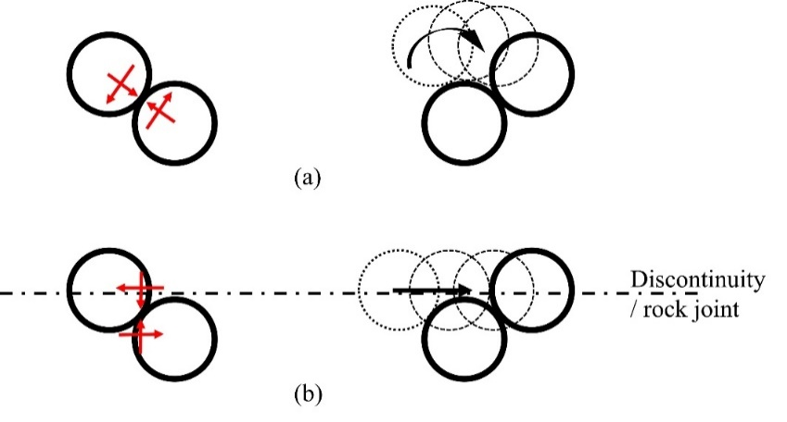
Figure S. 1 (a) The normal and shear forces applied to a pair of spherical particles bonded by the standard contact model and their resultant displacements. The orientation of the particles results in excessive resistance during the displacement. (b) The normal and shear forces applied to a pair of spherical particles bonded by the SJ contact model and their resultant displacements. The normal and shear forces are always perpendicular and parallel to the plane of the rock joint regardless of particle orientations with respect to the plane. After Mas Ivars et al. ⁹.
Supplemental Methods
In addition to the Hausdorff distance, we also used the Chamfer distance and earth mover distance to measure the similarities between two point clouds. The Chamfer distance between two finite sets (point clouds) is calculated as the summation of the squared Euclidean distances between all nearest neighbor pairs:
$CD\left(A,B\right)=\sum_{a∈A}{\min_{b∈B}{{\left\|a-b\right\|}^{2}}}+\sum_{b∈B}{\min_{a∈A}{{\left\|a-b\right\|}^{2}}}$ (1)
The earth mover distance is usually described in terms of minimizing the total work required to map data from one signature to another, where a signature is a variable-size description of distributions proposed by Rubner et al. ¹³. For two point clouds where every point is of equal weight, the earth mover distance can be simplified as the minimum of the sum of pairwise Euclidean distances between set B and an optimal A’⊆A. Here, A’ is mapped to B via a bijection.
$EMD\left(A,B\right)=\min_{ϕ:A^{'}→B}{\sum_{a∈A^{'}}{\left\|a-ϕ(a)\right\|} , where }ϕ:A^{'}→B is a bijection$ (2)
Although all three distance metrics have been employed widely in various studies, they each have limitations: the Hausdorff distance is prone to outliers, the Chamfer distance is insensitive to mismatched local density, and the earth mover’s distance can overlook the fidelity of detailed structures ¹⁴. We repeated the clustering with single, average, centroid, and complete linkage methods to validate the results.
After clustering, we compare the two trees, T_{f} and T_{m}, by calculating the Fowlkes–Mallows index. With 27 simulations to be clustered (i.e., 27 nodes in the first level), there are $\left({27 \atop 2}\right)$ different possible configurations of the 26 nodes at the second level. Thus, there are a total of $\left({27 \atop 2}\right)\left({26 \atop 2}\right)\left({25 \atop 2}\right)$…$\left({3 \atop 2}\right)\left({2 \atop 2}\right)$ different configurations that can be constructed, and each configuration is equally likely. To construct all of these possible configurations would incur massive computational costs. To reduce computational costs, we used the strategy proposed by Nemec and Brinkhurst ¹⁵; namely, the problem can be simplified for practical purposes by running a sequence test on every level of the hierarchy tree while limiting the calculations to the next level down from the current level. For instance, on the k-th level of a tree with N levels in total, we only consider the (k+1)-th level, focusing on the $\left({k+1 \atop 2}\right)$ different configurations in which the nodes on the k-th level can be constructed. Thus, for each level k $∈$ [2, 27], all $\left({k+1 \atop 2}\right)$ configurations of nodes on the k-th level were constructed to represent null T_{f} at that level. For each configuration, the Fowlkes–Mallows index between the null T_{f} at the k-th level and T_{m} at the same level was calculated, from which the null distribution of the Fowlkes–Mallows index and, subsequently, its empirical cumulative distribution on the k-th level were obtained. We then computed the Fowlkes–Mallows index between T_{f} and T_{m} on that level, $B_{k}(k)$, and calculated the p value from the empirical cumulative distribution function of the null distribution to determine if the null hypothesis could be rejected.
The sequence of the testing was independent, as clustering on the k-th level depends only on the nodes on the (k+1)-th level, which are fixed in each test. The overall significance level of m statistically independent tests can be determined using a familywise error rate¹⁵:
$α=1-{(1-α_{m})}^{m}$ (3)
where $α_{m}$ is the significance level applied to each level and m is the total number of independent tests. Therefore, we apply the significance level $α_{N-2}$ to each test (or on each level k $∈$ [2,26]) to achieve the overall desired significance level. Specifically, m = N–2 = 25 in Equation (3). By setting the desired overall alpha to 5%, $α_{N-2}$ for each level between [2,27] was calculated to be approximately 0.2%.
Supplemental Results
Figure S. 2 shows an example of how the KDF can isolate the foreshock or mainshock episodes in each simulation. We compared our results to an additional KDF segmentation in which the bandwidth was set to 3,600 steps. The KDF curve generated using the larger bandwidth is slightly smoother, but the identified extrema are similar to the curve generated by the smaller bandwidth.
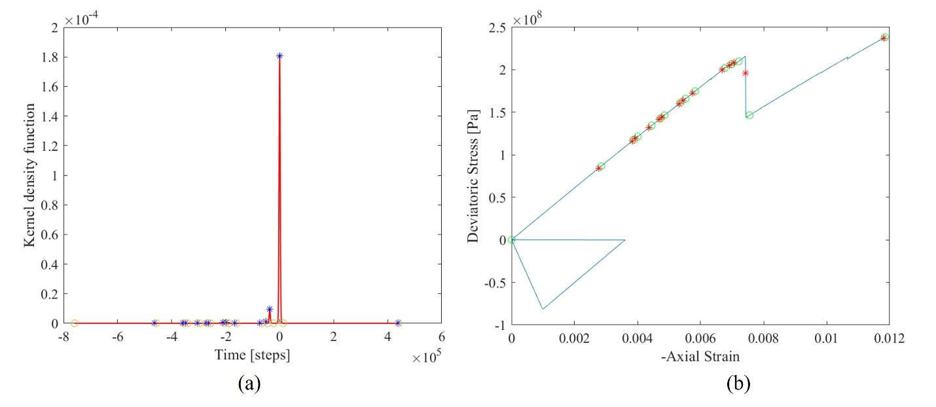
Figure S. 2 An example of the use of a KDF to isolate foreshock and mainshock episodes. (a) KDF as a solid curve plotted against PFC cycles. The asterisks mark the KDF peaks, indicating the highest likelihood of finding an episode. The circles mark the KDF minima, indicating the lowest likelihood of finding an episode, and thus serve as an indication of where to cut the PFC cycle (time) such that each time segment contains only a single episode. (b) The stress‒strain relationship presented as a solid curve. The asterisks mark the stress drops, while the circles mark the points at which the sequence was cut.
Figure S. 3 to Figure S. 24 show the hierarchy trees constructed using various distances and linkages, based on either foreshock or mainshock parameters.
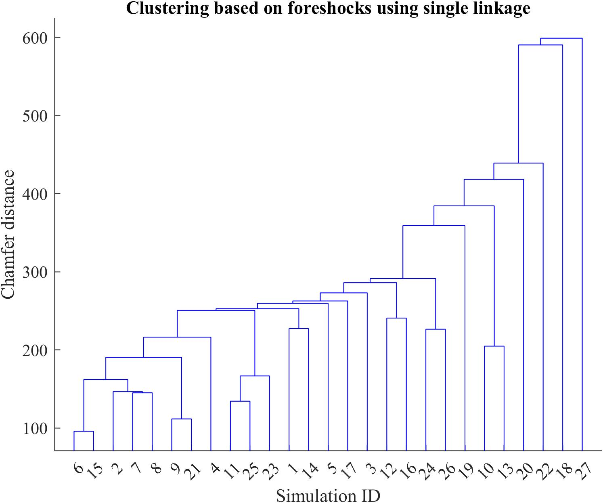Figure S. 3 Hierarchy tree constructed using Chamfer distance and single linkage that describes the clustering of the 27 simulations based on foreshock variables.

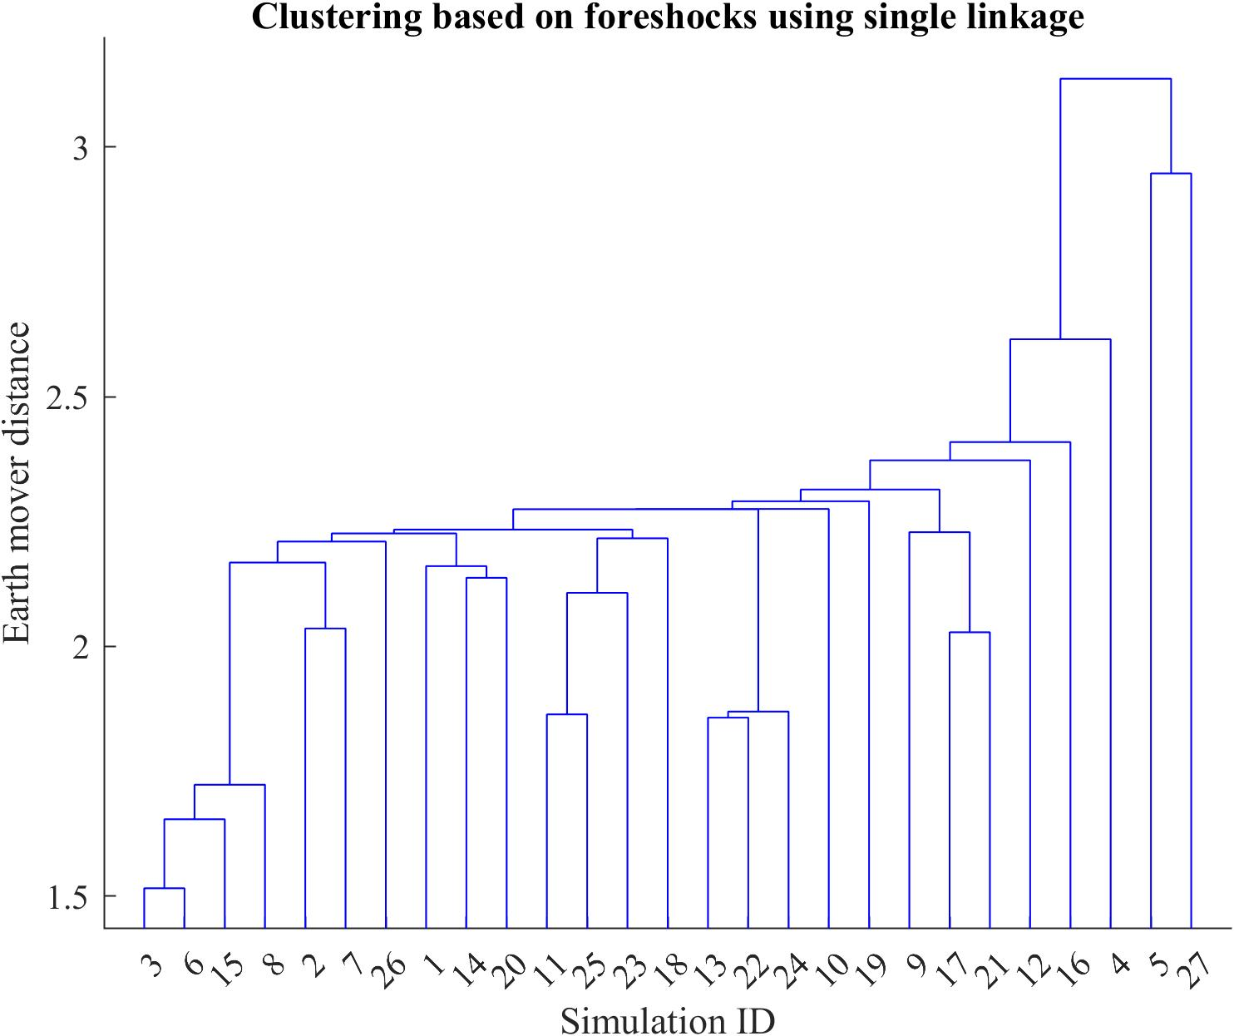
Figure S. 4 Hierarchy tree constructed using the Earth mover distance and single linkage that describes the clustering of the 27 simulations based on foreshock variables.
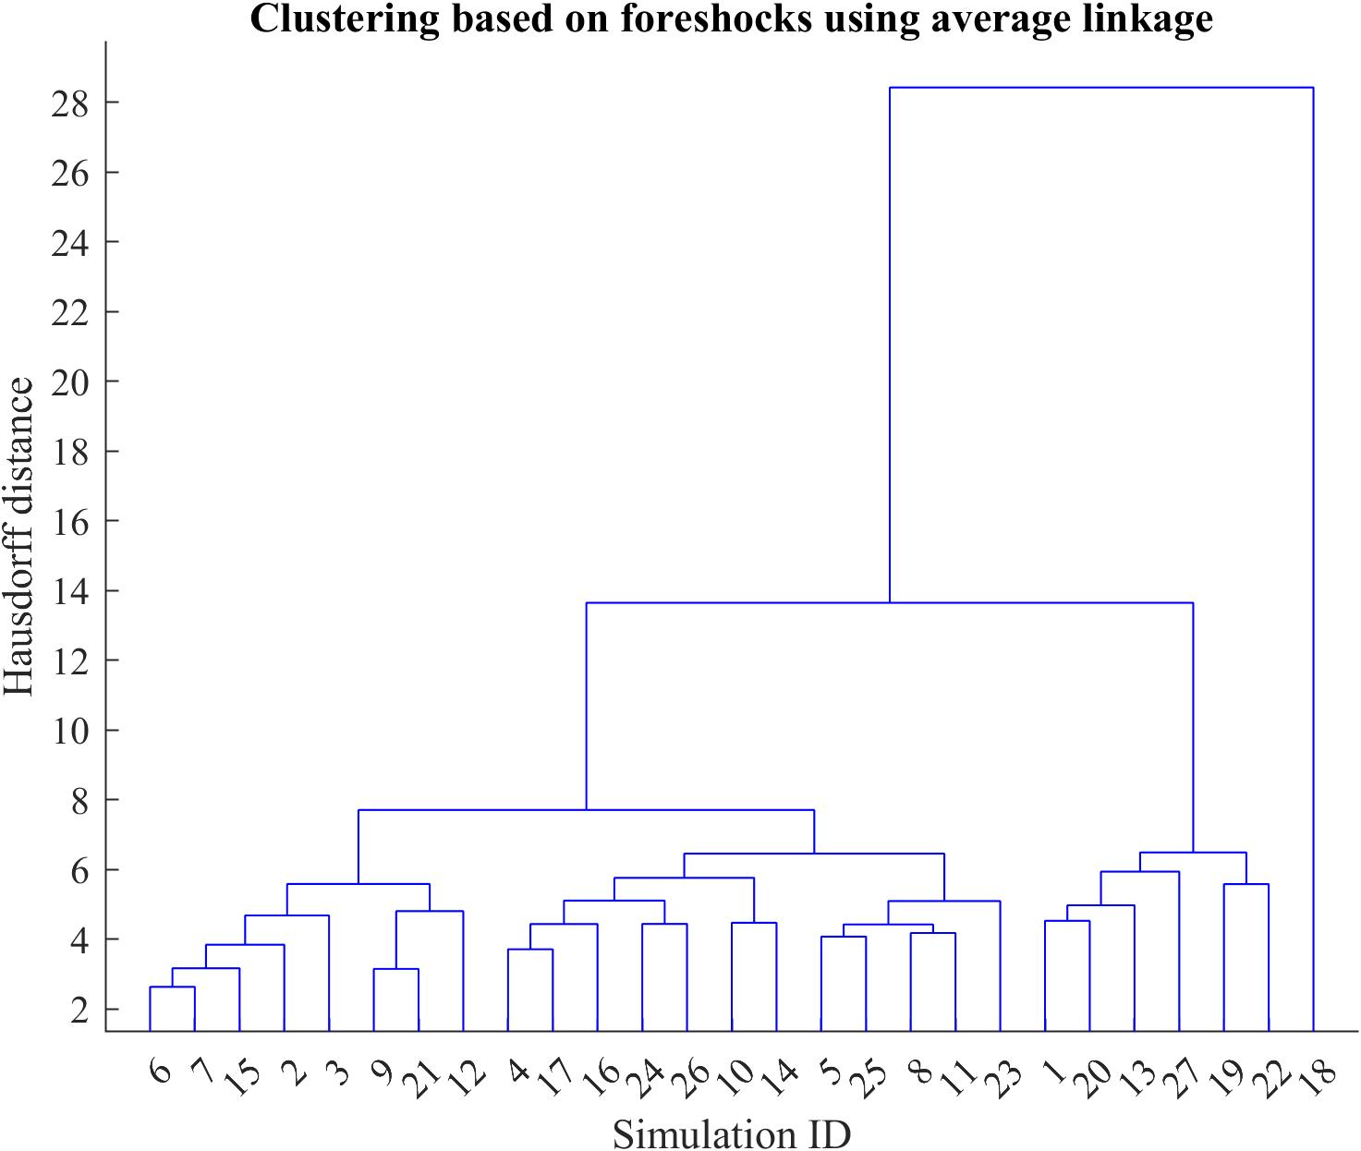
Figure S. 5 Hierarchy tree constructed using the Hausdorff distance and average linkage that describes the clustering of the 27 simulations based on foreshock variables.
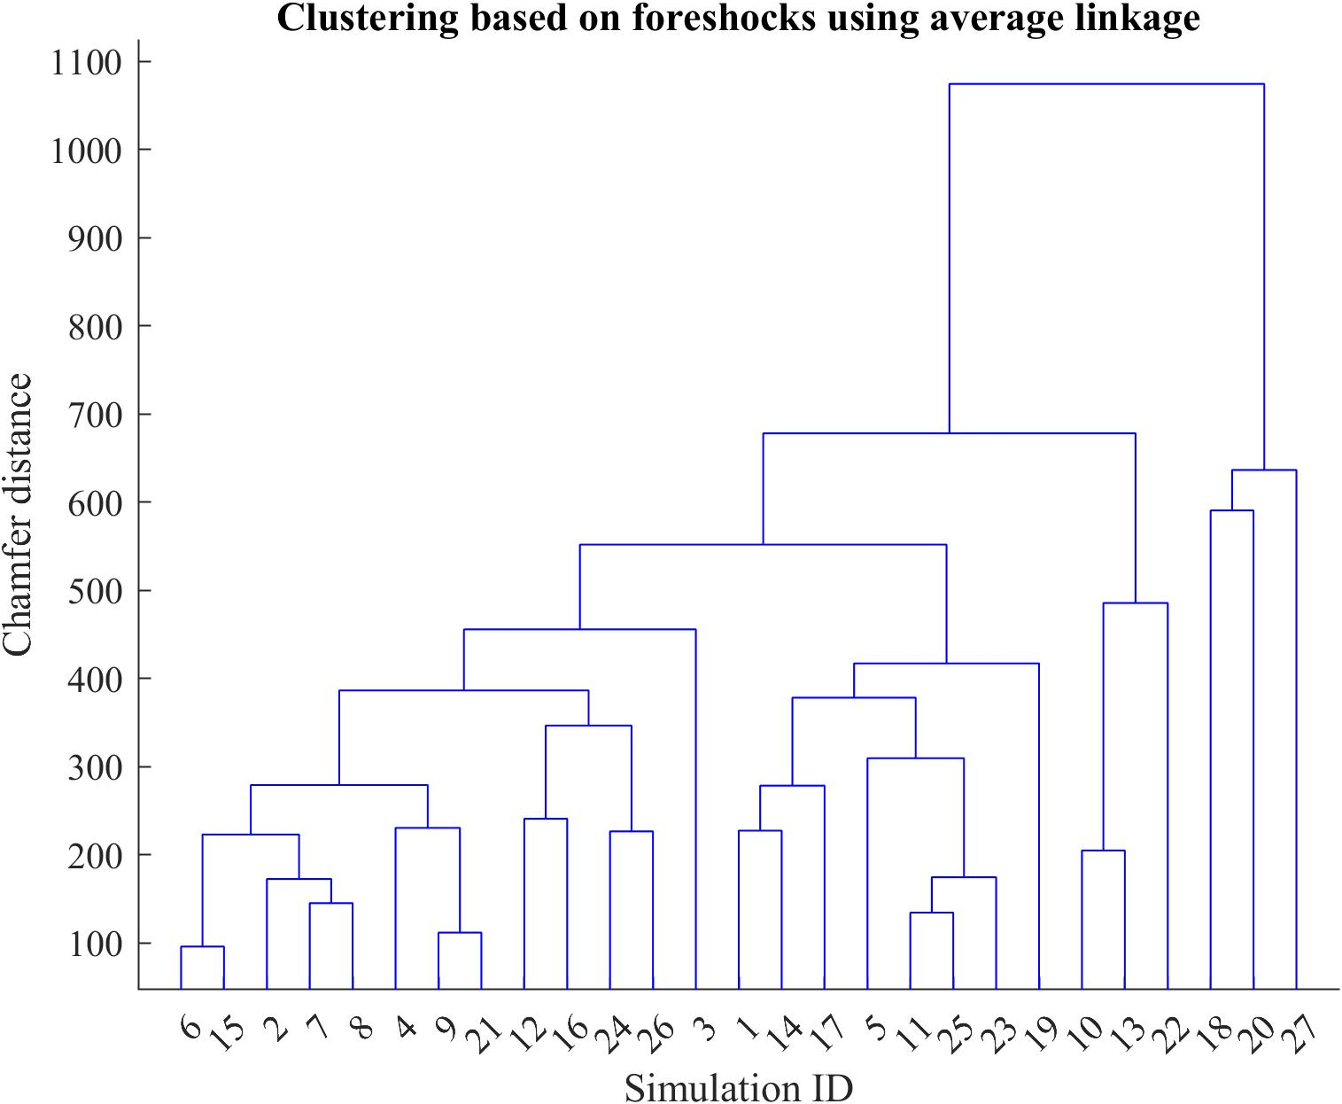
Figure S. 6 Hierarchy tree constructed using the Chamfer distance and average linkage that describes the clustering of the 27 simulations based on foreshock variables.

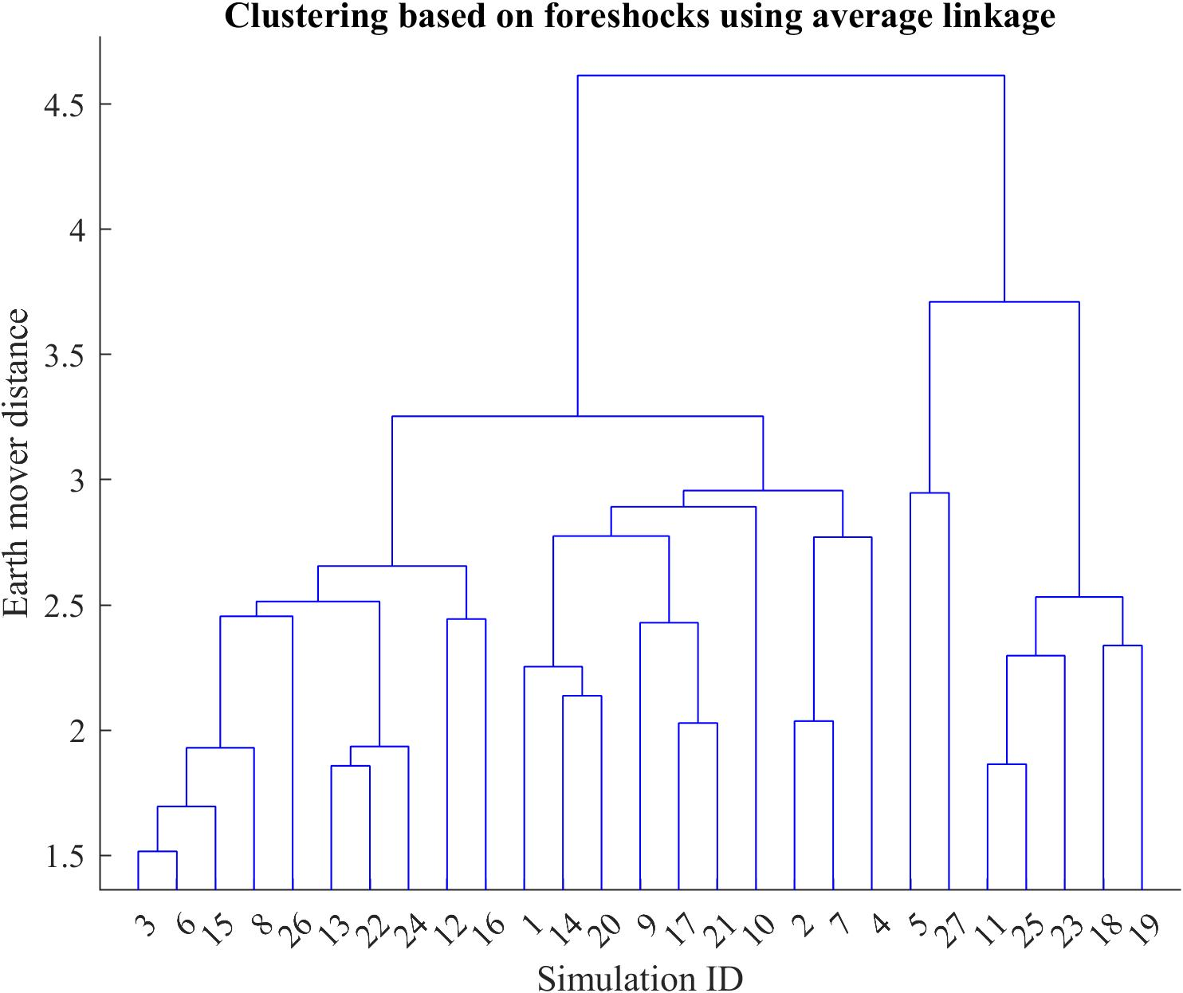
Figure S. 7 Hierarchy tree constructed using the Earth mover distance and average linkage that describes the clustering of the 27 simulations based on foreshock variables.
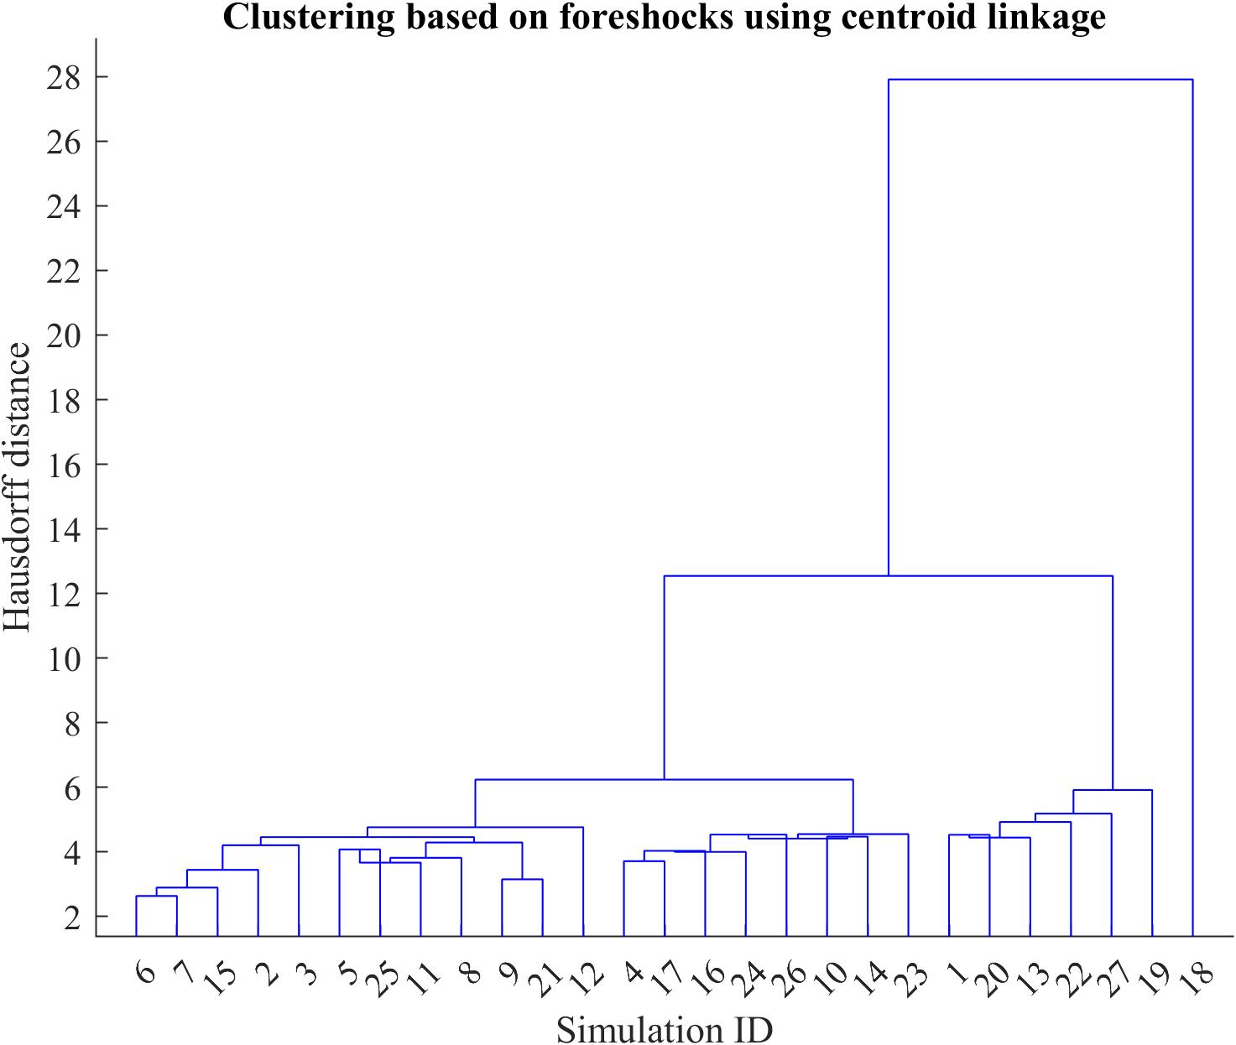
Figure S. 8 Hierarchy tree constructed using the Hausdorff distance and centroid linkage that describes the clustering of the 27 simulations based on foreshock variables.
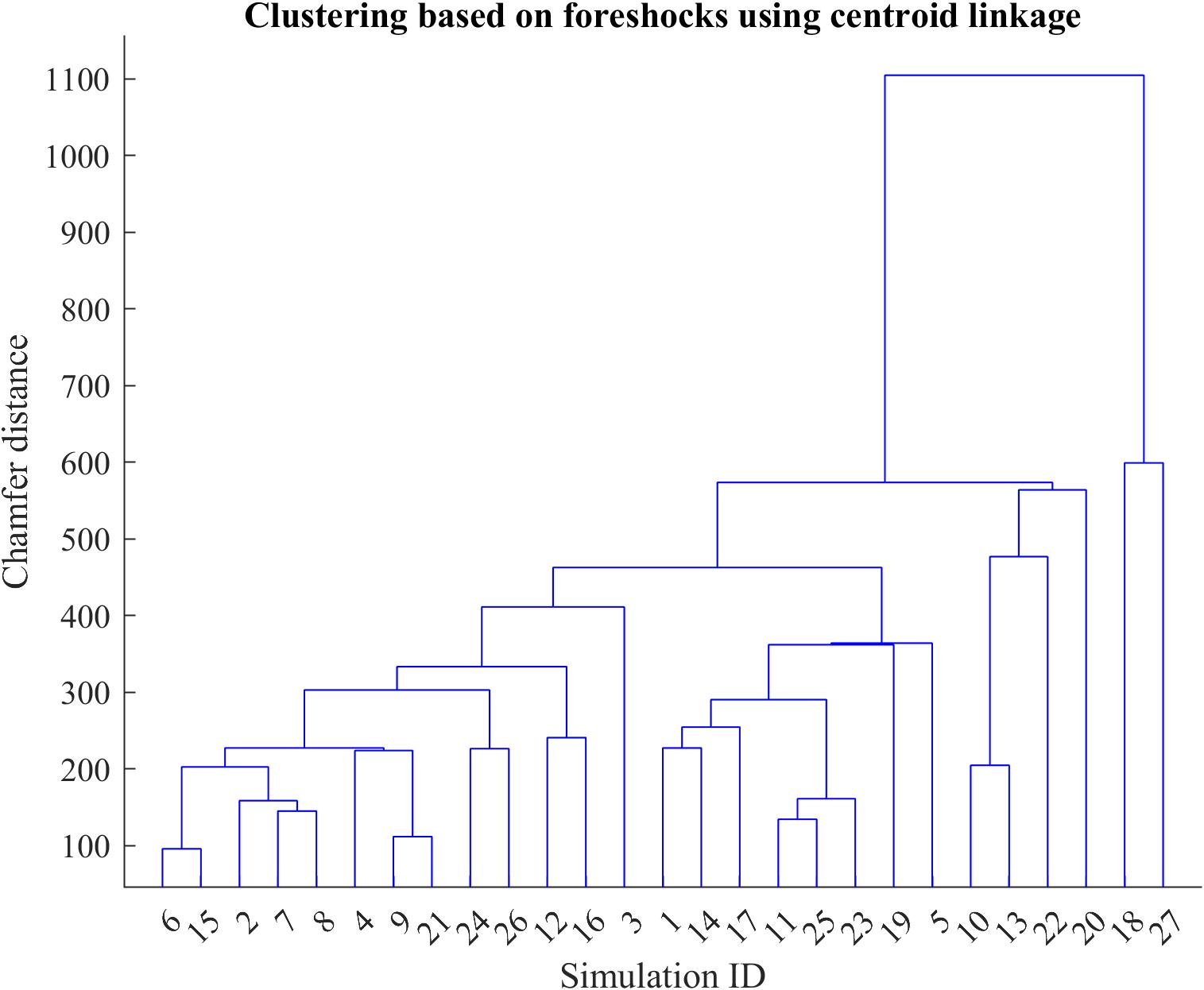
Figure S. 9 Hierarchy tree constructed using the Chamfer distance and centroid linkage that describes the clustering of the 27 simulations based on foreshock variables.

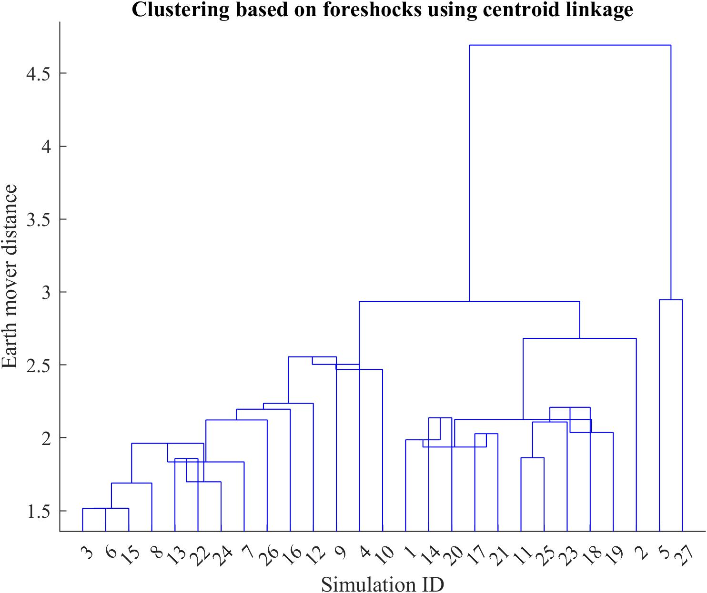
Figure S. 10 Hierarchy tree constructed using the earth mover distance and centroid linkage that describes the clustering of the 27 simulations based on foreshock variables.
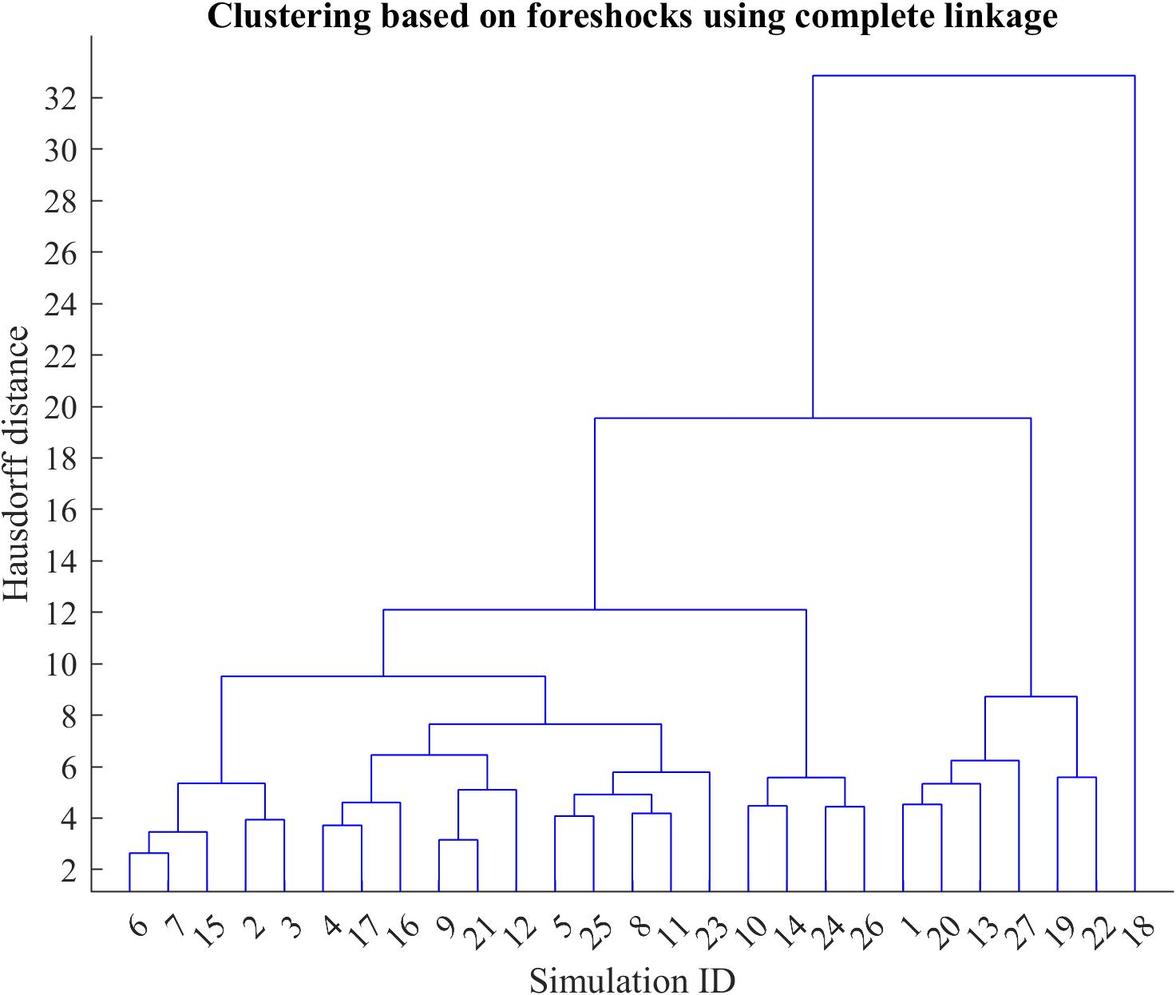
Figure S. 11 Hierarchy tree constructed using the Hausdorff distance and complete linkage that describes the clustering of the 27 simulations based on foreshock variables.

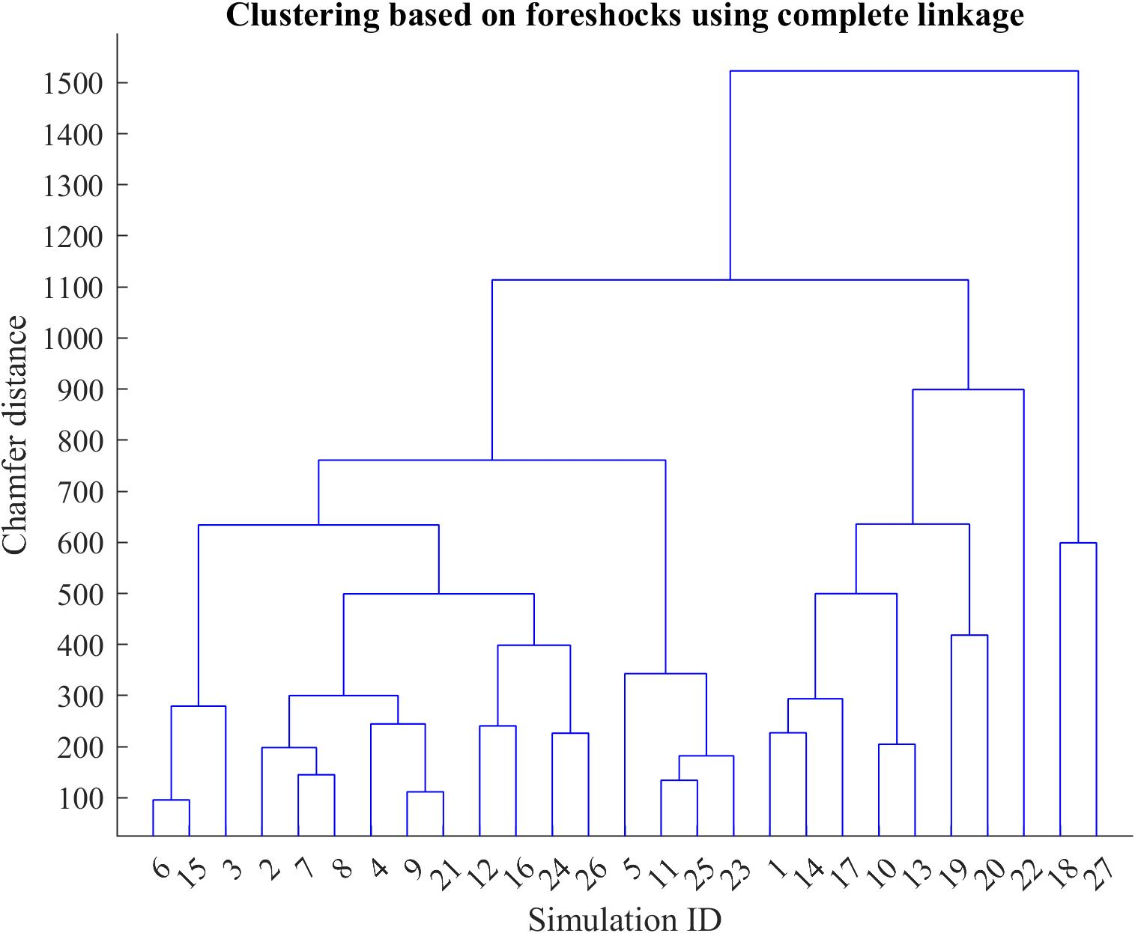
Figure S. 12 Hierarchy tree constructed using the Chamfer distance and complete linkage that describes the clustering of the 27 simulations based on foreshock variables.

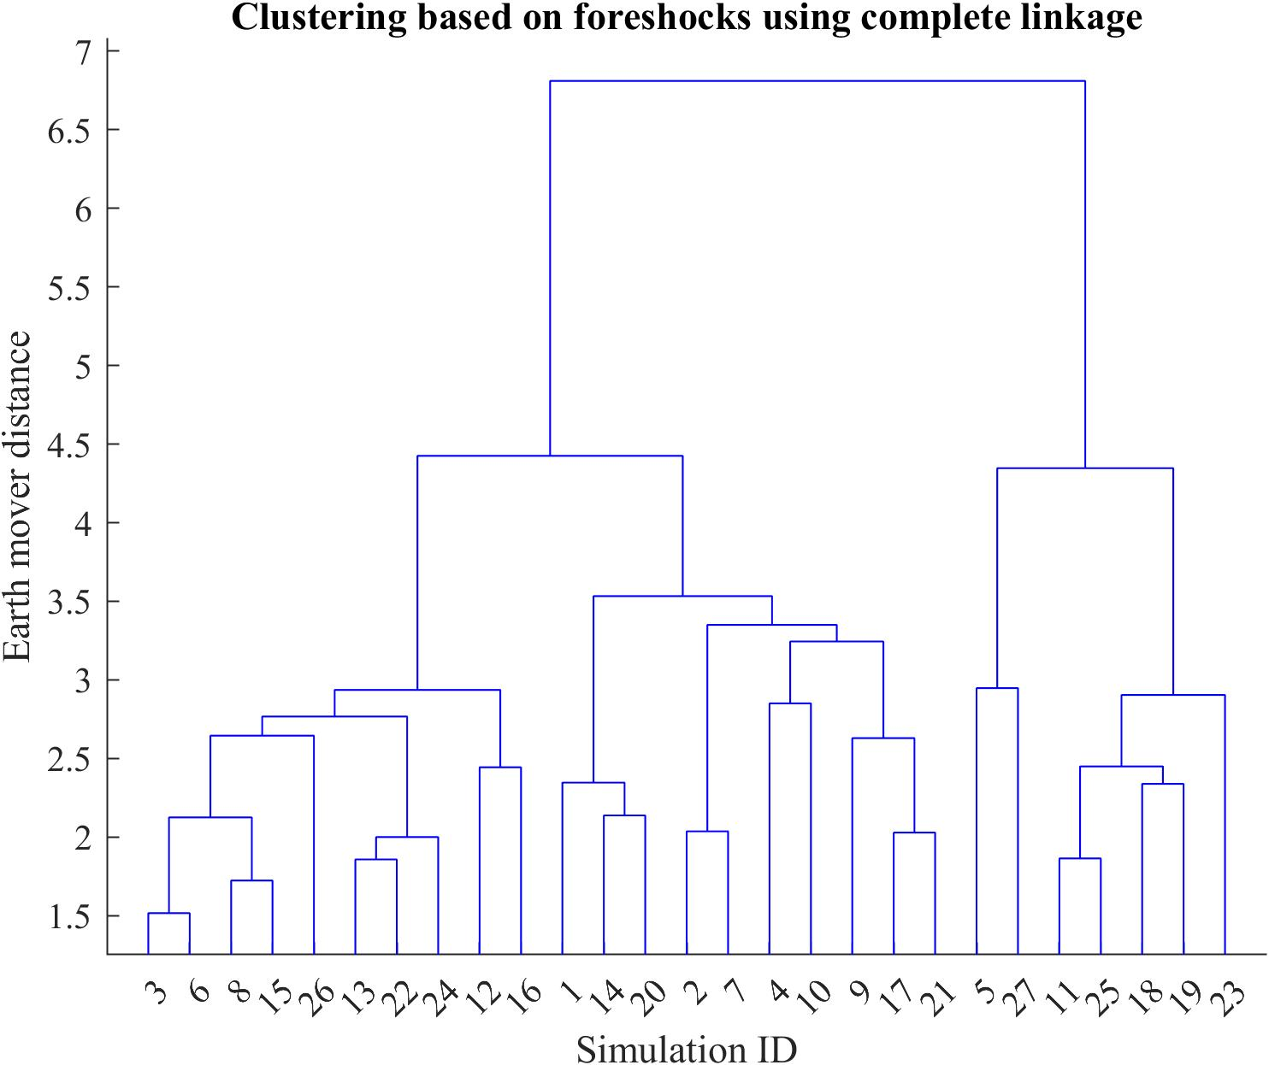
Figure S. 13 Hierarchy tree constructed using the Earth mover distance and complete linkage that describes the clustering of the 27 simulations based on foreshock variables.
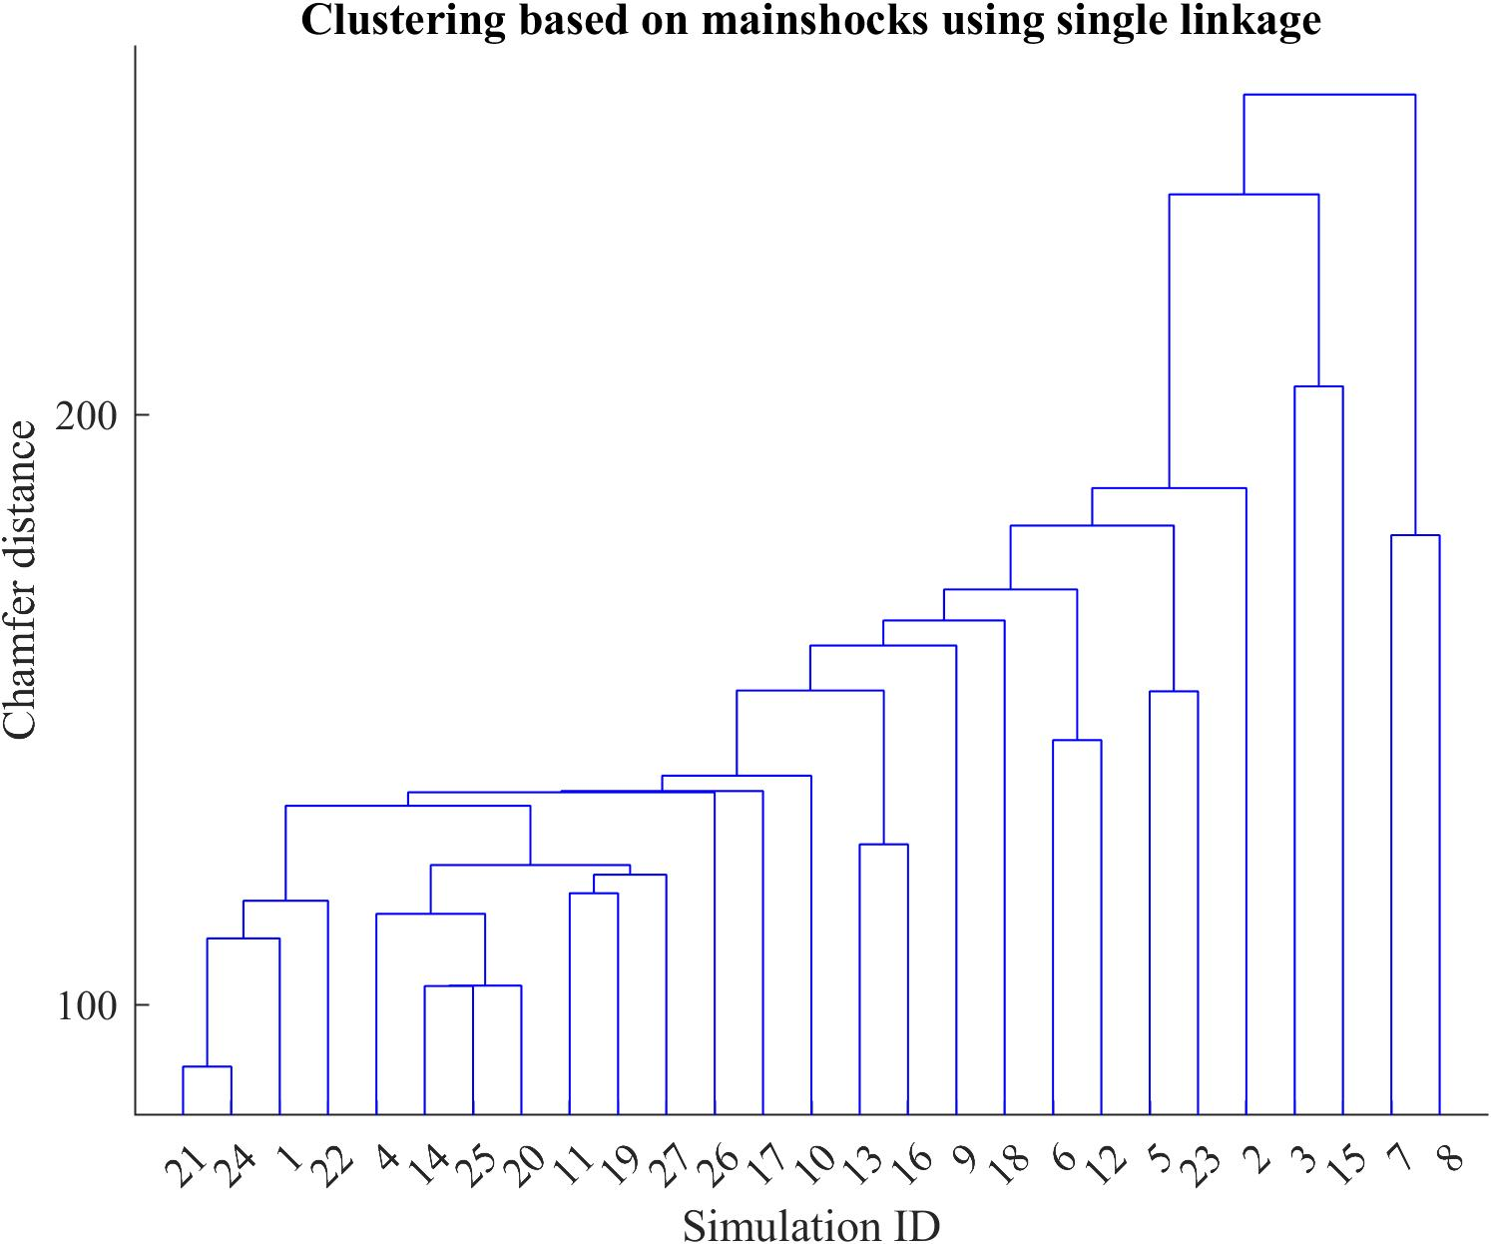
Figure S. 14 Hierarchy tree constructed using the Chamfer distance and single linkage that describes the clustering of the 27 simulations based on mainshock variables.

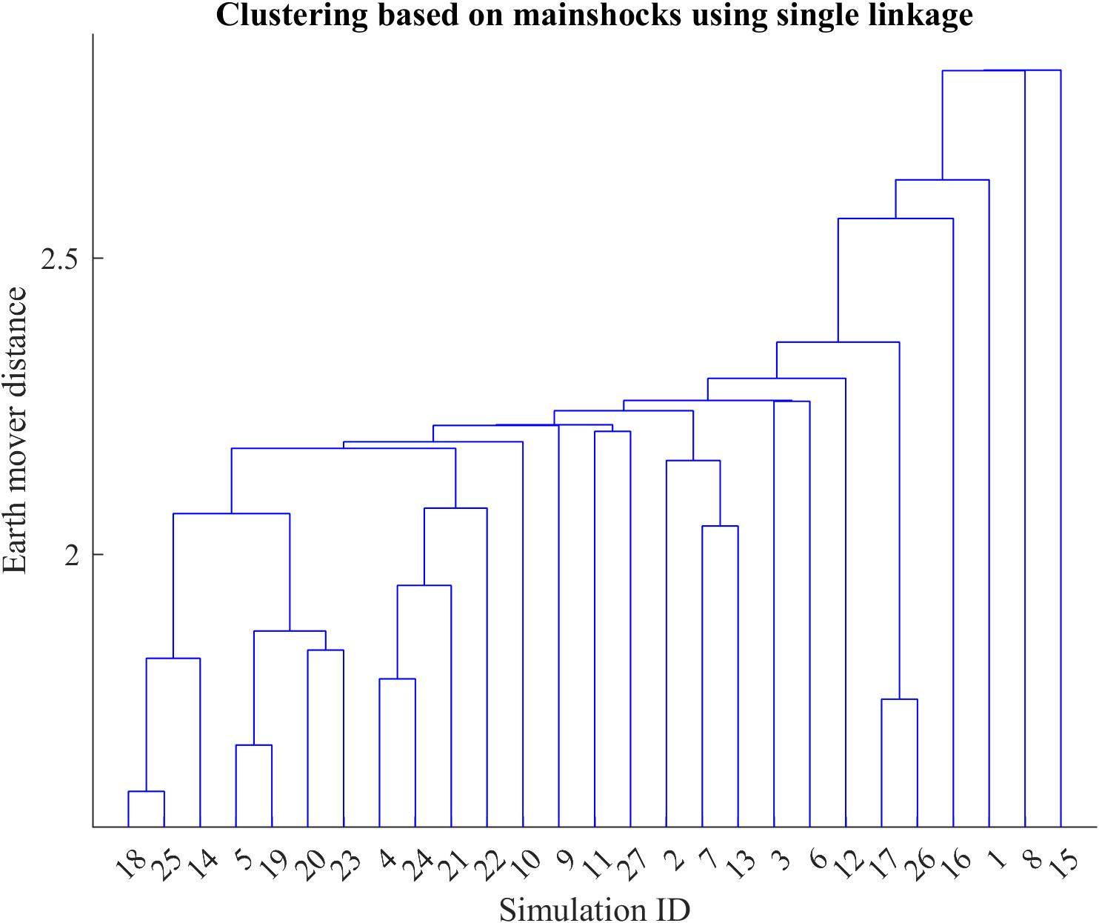
Figure S. 15 Hierarchy tree constructed using the Earth mover distance and single linkage that describes the clustering of the 27 simulations based on mainshock variables.
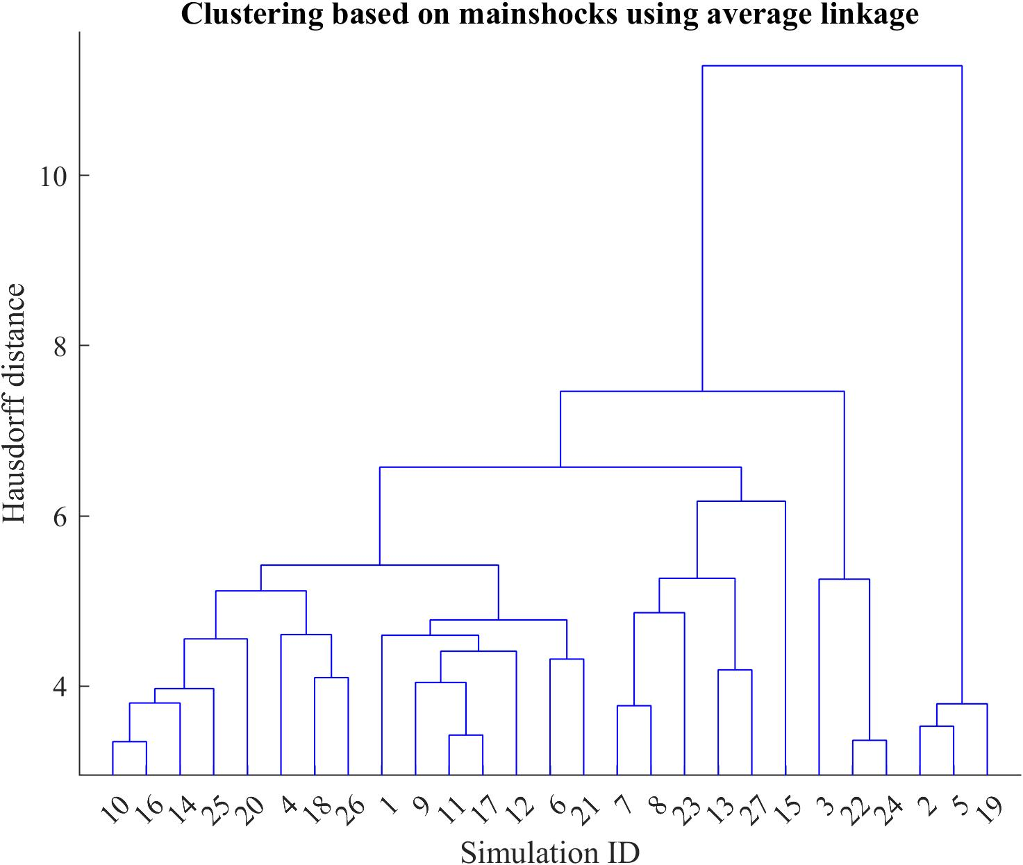
Figure S. 16 Hierarchy tree constructed using the Hausdorff distance and average linkage that describes the clustering of the 27 simulations based on mainshock variables.
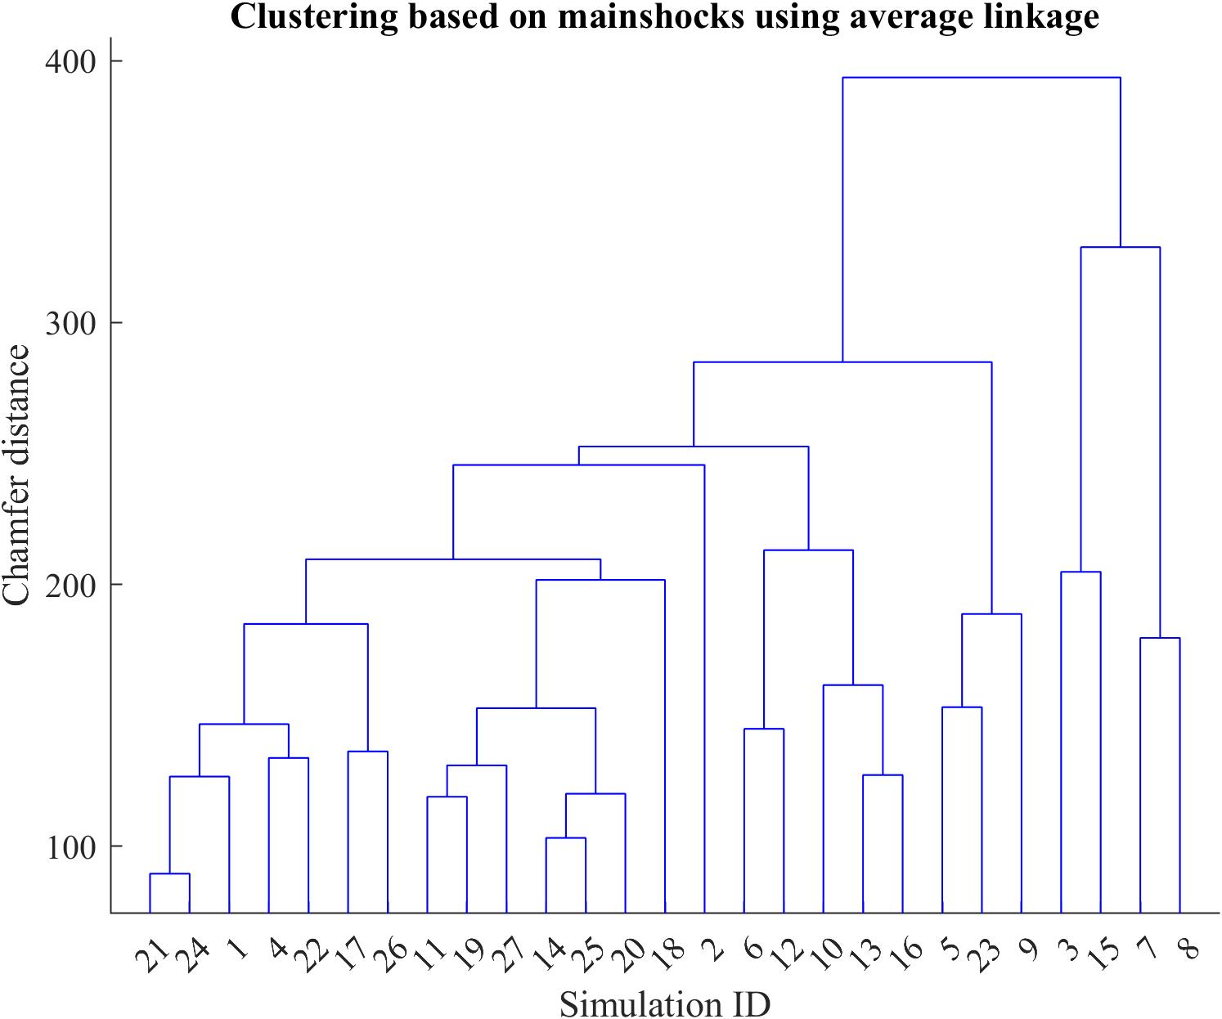
Figure S. 17 Hierarchy tree constructed using the Chamfer distance and average linkage that describes the clustering of the 27 simulations based on mainshock variables.

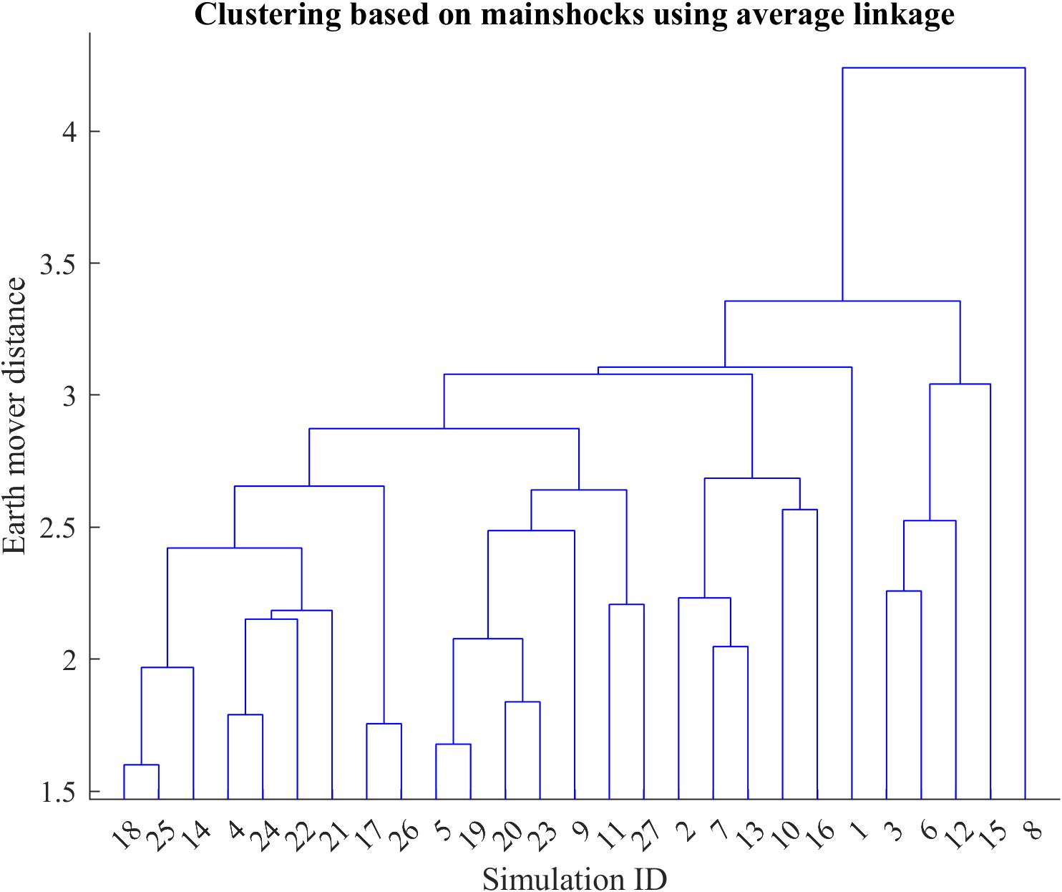
Figure S. 18 Hierarchy tree constructed using the Earth mover distance and average linkage that describes the clustering of the 27 simulations based on mainshock variables.
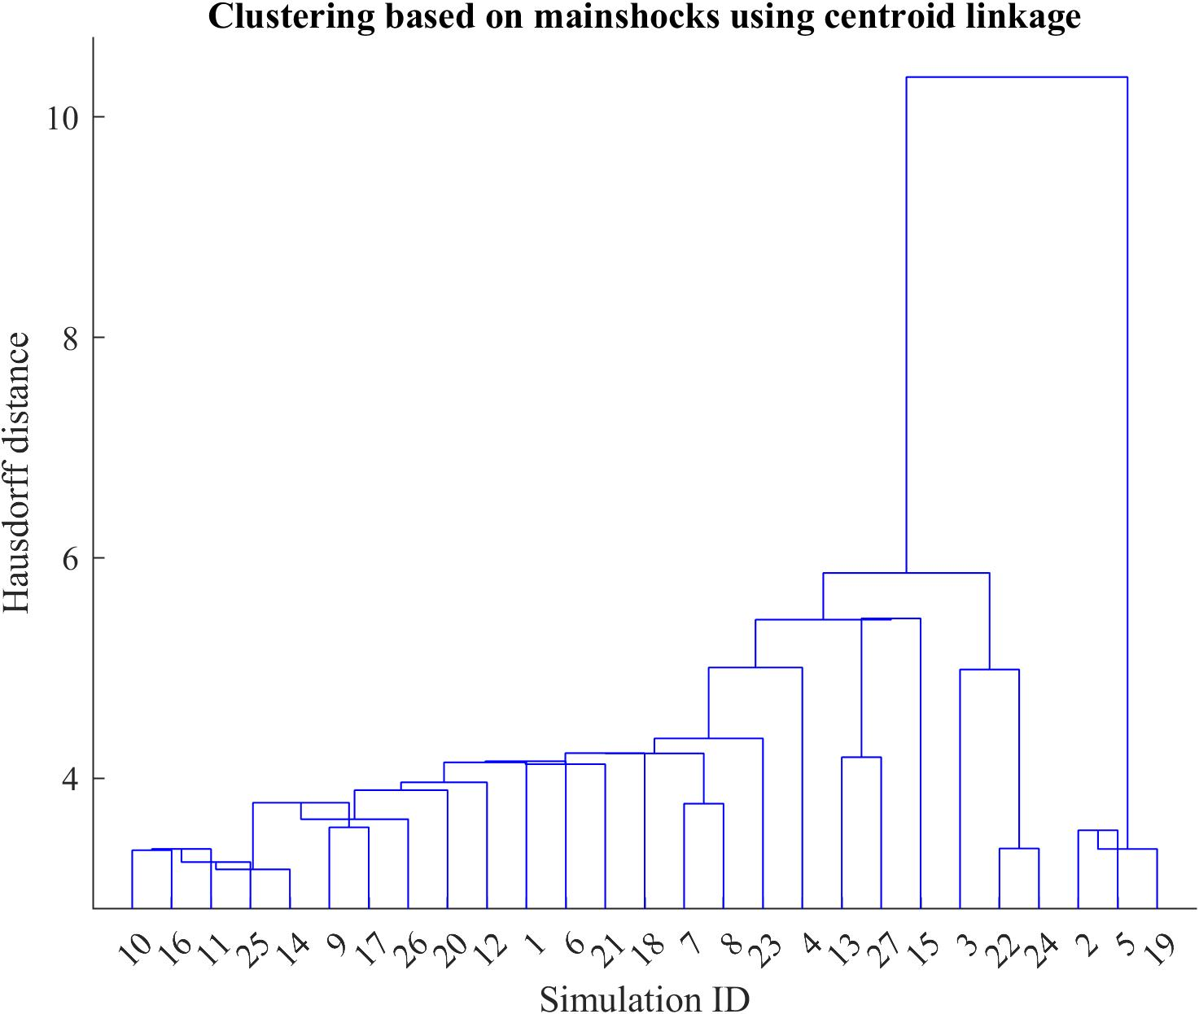
Figure S. 19 Hierarchy tree constructed using the Hausdorff distance and centroid linkage that describes the clustering of the 27 simulations based on mainshock variables.
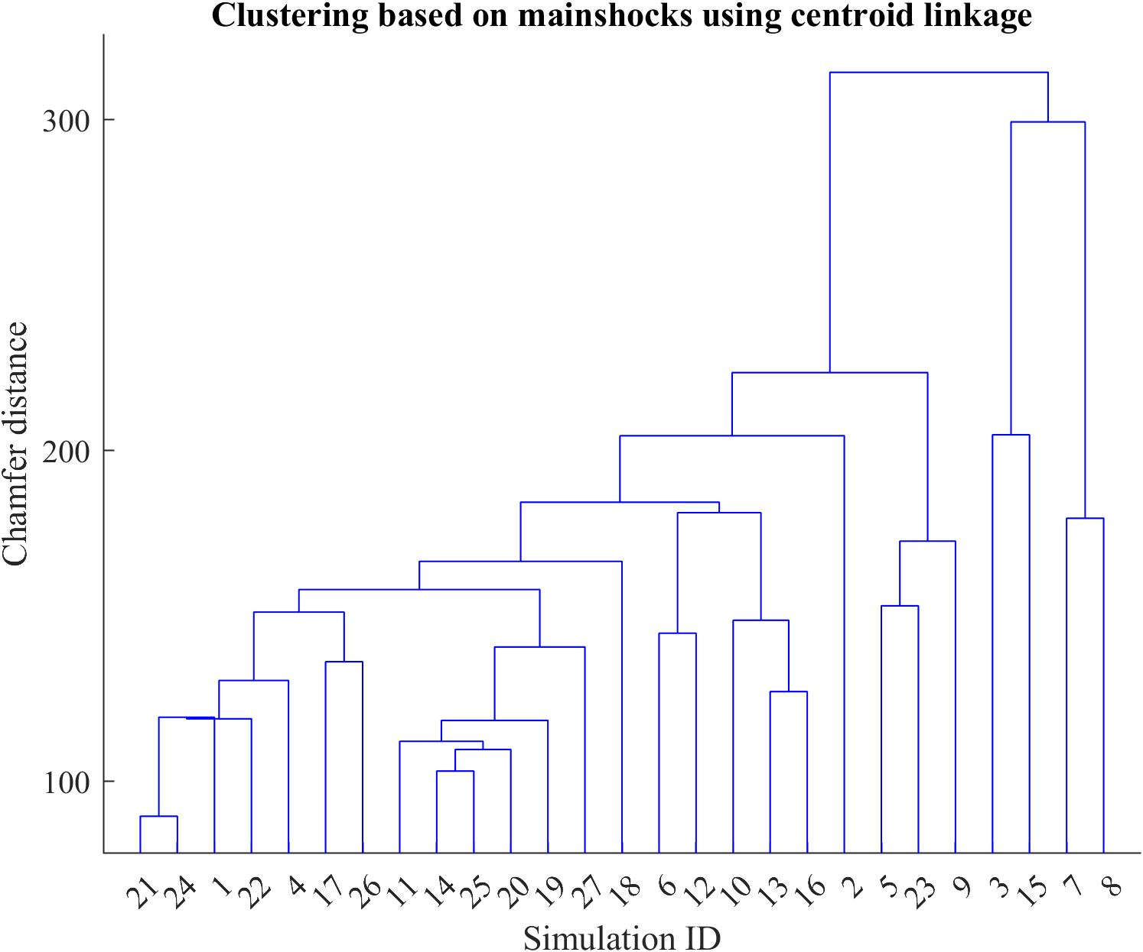
Figure S. 20 Hierarchy tree constructed using the Chamfer distance and centroid linkage that describes the clustering of the 27 simulations based on mainshock variables.

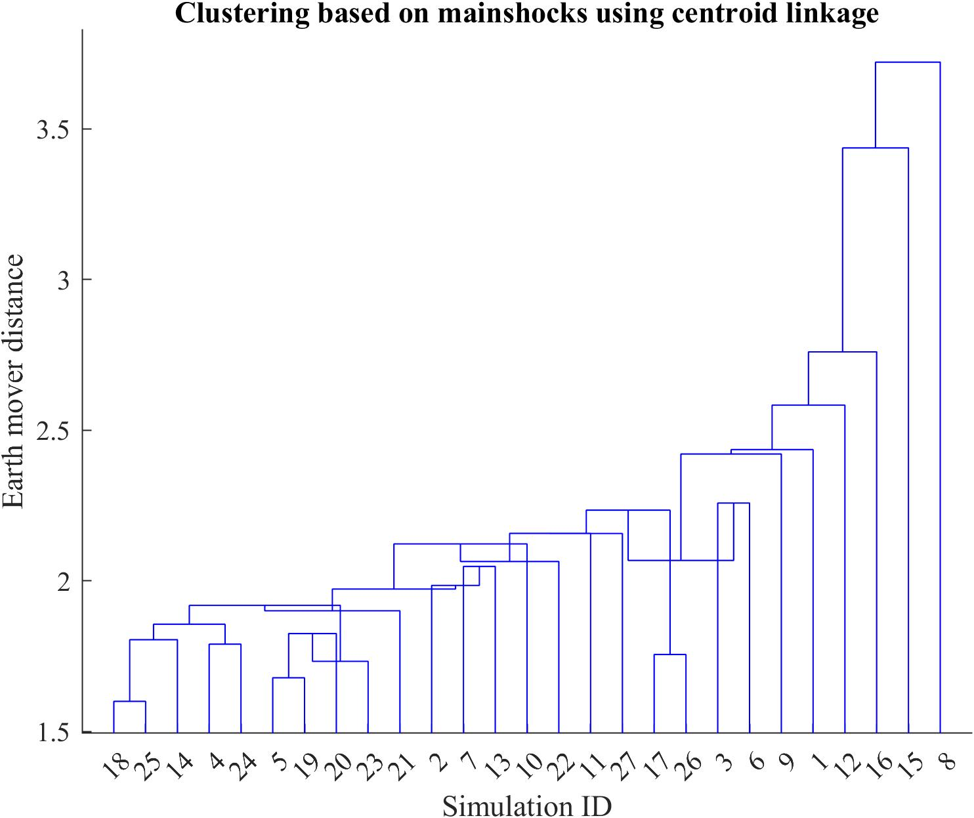
Figure S. 21 Hierarchy tree constructed using the Earth mover distance and centroid linkage that describes the clustering of the 27 simulations based on mainshock variables.
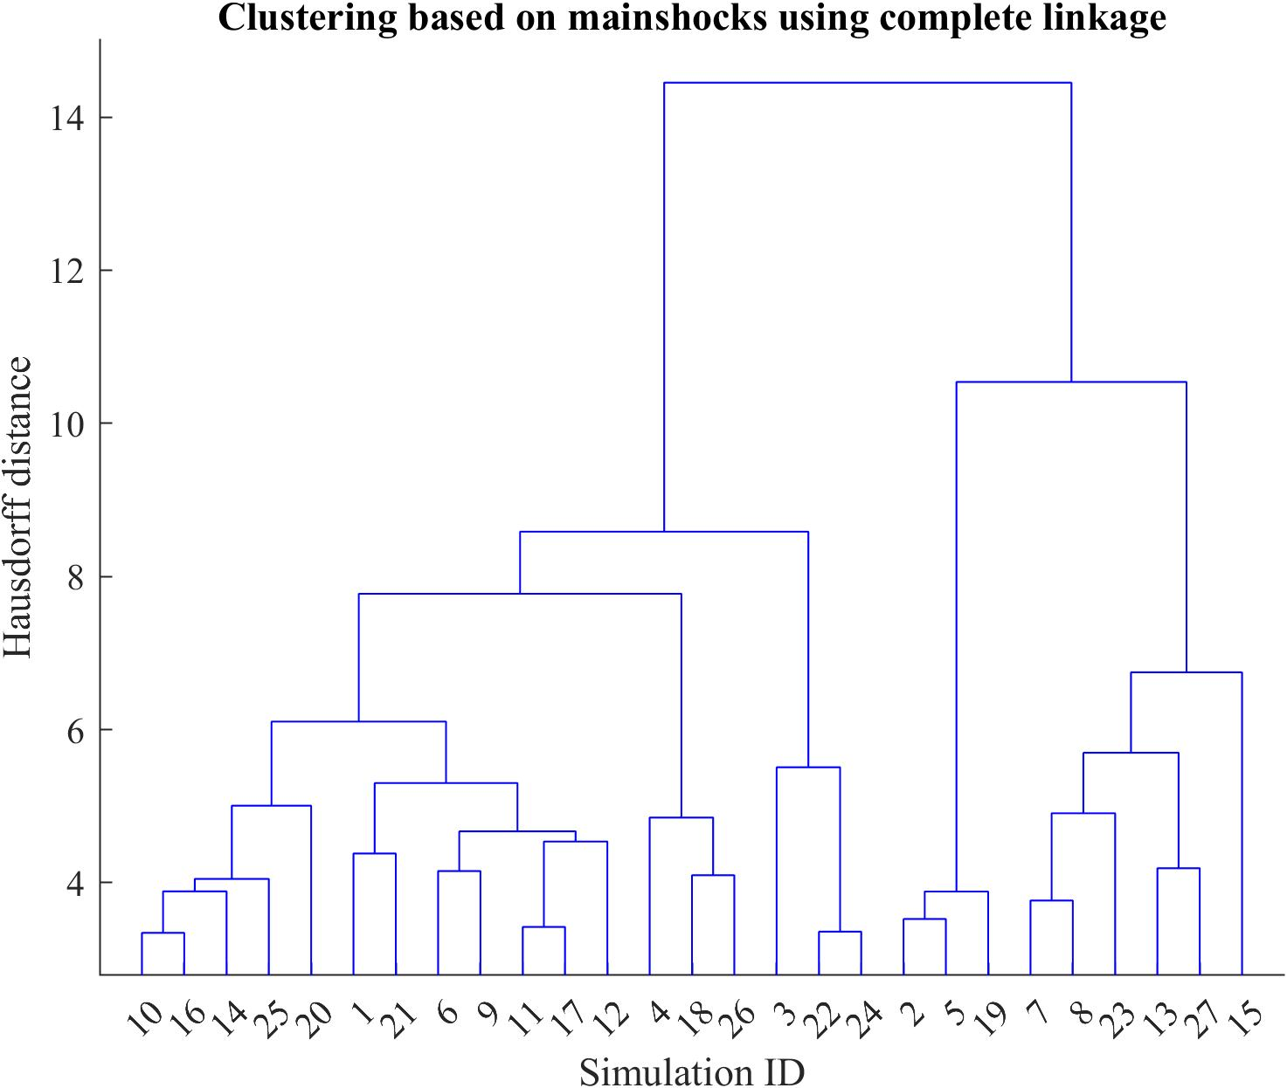
Figure S. 22 Hierarchy tree constructed using the Hausdorff distance and complete linkage that describes the clustering of the 27 simulations based on mainshock variables.
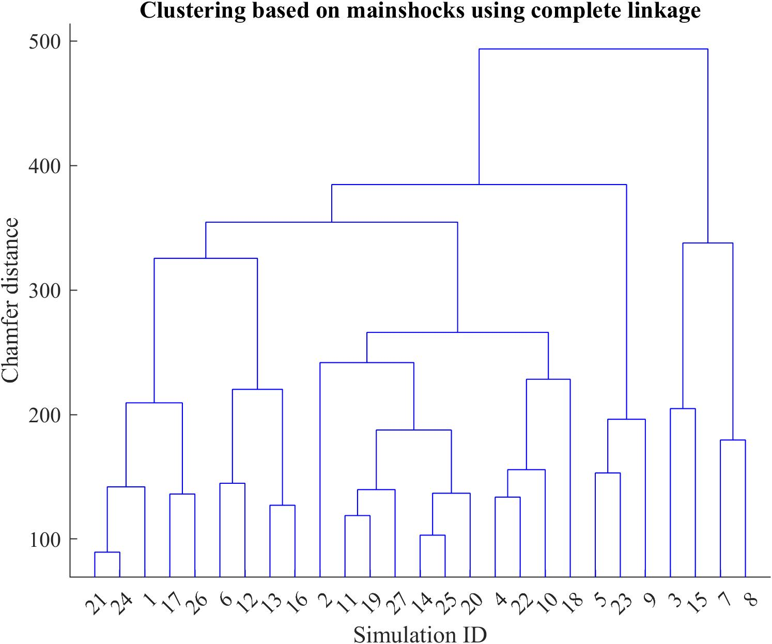
Figure S. 23 Hierarchy tree constructed using the Chamfer distance and complete linkage that describes the clustering of the 27 simulations based on mainshock variables.

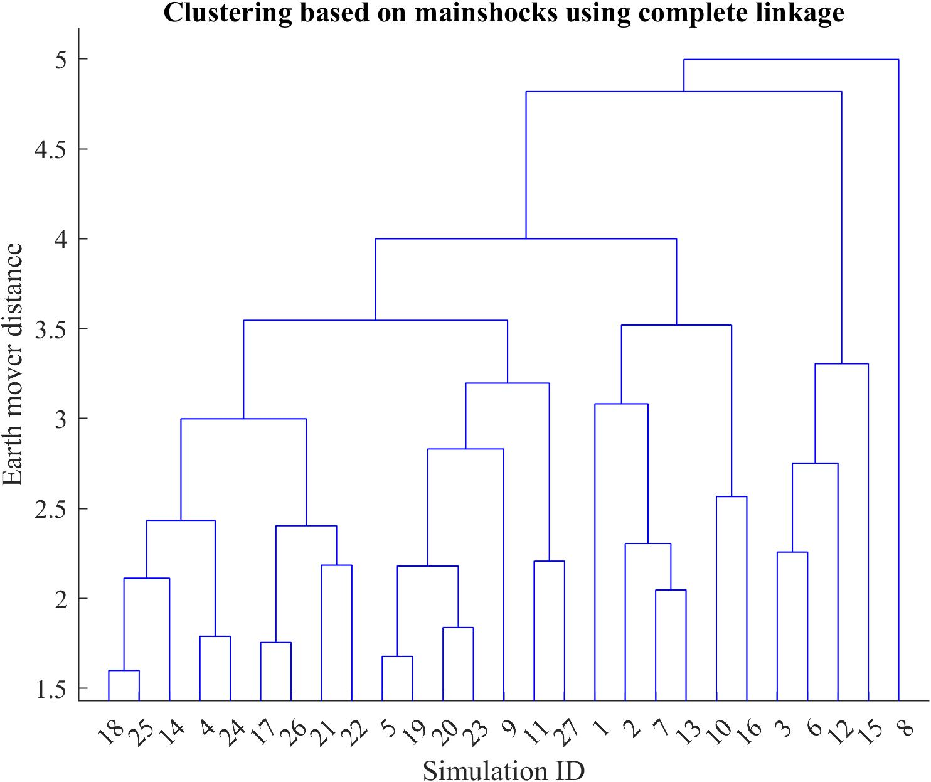
Figure S. 24 Hierarchy tree constructed using the Earth mover distance and complete linkage that describes the clustering of the 27 simulations based on mainshock variables.
Table S. 1 to Table S. 12 show the Fowlkes–Mallows index, p value, mean, and variance of the null distribution at each level of the hierarchy trees, constructed using various distances and linkages.
Table S. 1 The Fowlkes–Mallows index, p value, mean, and variance of the null distribution at each level of the hierarchy trees, constructed using Hausdorff distance and single linkage.
k | Bk(k,k) | P value | Μ (Bk(k,k), null) | Σ (Bk(k,k), null)
2 | 0.850151 | 0 | 0.766676 | 0.073903
3 | 0.694714 | 0.5 | 0.723515 | 0.043477
4 | 0.605712 | 0.1 | 0.576382 | 0.029453
3 | 0.554656 | 0.933333 | 0.591652 | 0.027719
6 | 0.589346 | 0.047619 | 0.548788 | 0.024579
7 | 0.536025 | 0.035714 | 0.496019 | 0.022643
8 | 0.429312 | 0 | 0.30151 | 0.028536
9 | 0.295298 | 0.022222 | 0.213916 | 0.027482
10 | 0.171499 | 0.818182 | 0.189816 | 0.025469
11 | 0.180538 | 0.212121 | 0.167934 | 0.022505
12 | 0.124515 | 0.089744 | 0.095984 | 0.018059
13 | 0.08969 | 0.054945 | 0.059396 | 0.016524
14 | 0.027277 | 0.933333 | 0.039603 | 0.016439
15 | 0.031009 | 0.966667 | 0.045799 | 0.018859
16 | 0.037743 | 0.154412 | 0.010852 | 0.017216
17 | 0 | 0.202614 | 0.009138 | 0.018226
18 | 0 | 0.140351 | 0.007632 | 0.018991
19 | 0 | 0.073684 | 0.005544 | 0.019751
20 | 0 | 0.047619 | 0.004483 | 0.020135
21 | 0 | 0.038961 | 0.004022 | 0.020061
22 | 0 | 0.031621 | 0.003662 | 0.02037
23 | 0 | 0.018116 | 0.003399 | 0.025151
24 | 0 | 0.01 | 0.00271 | 0.027127
25 | 0 | 0.006154 | 0.002795 | 0.035752
26 | 0 | 0.002849 | 0.002849 | 0.053376

Table S. 2 The Fowlkes–Mallows index, p value, mean, and variance of the null distribution at each level of the hierarchy trees, constructed using Chamfer distance and single linkage.
k | B_{k}(k,k) | p value | μ (B_{k}(k,k), null) | σ (B_{k}(k,k), null)
2 | 0.740289 | 0 | 0.872815 | 0.022204
3 | 0.613572 | 0 | 0.746336 | 0.022075
4 | 0.489526 | 0 | 0.697212 | 0.020797
5 | 0.400313 | 0 | 0.571594 | 0.025002
6 | 0.26049 | 0.047619 | 0.441422 | 0.022694
7 | 0.251351 | 0 | 0.356224 | 0.022444
8 | 0.244232 | 0.194444 | 0.242815 | 0.019208
9 | 0.211058 | 0.955556 | 0.266407 | 0.021904
10 | 0.18131 | 0.036364 | 0.180921 | 0.018464
11 | 0.162835 | 0.924242 | 0.191879 | 0.018858
12 | 0.139754 | 0 | 0.118715 | 0.017694
13 | 0.088581 | 0.054945 | 0.083327 | 0.017476
14 | 0.079181 | 0.352381 | 0.086994 | 0.018571
15 | 0.084515 | 0.175 | 0.072124 | 0.016858
16 | 0.052632 | 0.272059 | 0.0545 | 0.015068
17 | 0 | 0.908497 | 0.042755 | 0.016565
18 | 0 | 0.122807 | 0.043597 | 0.016147
19 | 0 | 0.078947 | 0.005123 | 0.017553
20 | 0 | 0.061905 | 0.004669 | 0.018221
21 | 0 | 0.051948 | 0.005485 | 0.023496
22 | 0 | 0.035573 | 0.005046 | 0.026355
23 | 0 | 0.021739 | 0.004125 | 0.027763
24 | 0 | 0.013333 | 0.00372 | 0.032113
25 | 0 | 0.006154 | 0.003077 | 0.039163
26 | 0 | 0.002849 | 0.002849 | 0.053376

Table S. 3 The Fowlkes–Mallows index, p value, mean, and variance of the null distribution at each level of the hierarchy trees, constructed using Earth mover distance and single linkage.
k | B_{k}(k,k) | p value | μ (B_{k}(k,k), null) | σ (B_{k}(k,k), null)
2 | 0.885635 | 0.666667 | 0.910596 | 0.021617
3 | 0.843333 | 0 | 0.824066 | 0.021106
4 | 0.76087 | 0 | 0.737174 | 0.020394
5 | 0.750988 | 0 | 0.717518 | 0.022529
6 | 0.620545 | 0 | 0.565507 | 0.023439
7 | 0.581453 | 0.035714 | 0.541306 | 0.023151
8 | 0.437301 | 0.027778 | 0.398231 | 0.02155
9 | 0.382754 | 0 | 0.275497 | 0.024523
10 | 0.175055 | 0.036364 | 0.142888 | 0.020195
11 | 0.10177 | 0.469697 | 0.101689 | 0.016795
12 | 0.096015 | 0.974359 | 0.131649 | 0.023151
13 | 0.122988 | 0.032967 | 0.096286 | 0.019456
14 | 0.09353 | 0.87619 | 0.11119 | 0.021332
15 | 0.143684 | 0.941667 | 0.171097 | 0.025031
16 | 0.135113 | 0.492647 | 0.142177 | 0.025853
17 | 0.101274 | 0.03268 | 0.056866 | 0.021835
18 | 0 | 0.081871 | 0.005846 | 0.019663
19 | 0 | 0.068421 | 0.005313 | 0.019679
20 | 0 | 0.052381 | 0.00469 | 0.020005
21 | 0 | 0.030303 | 0.003762 | 0.021333
22 | 0 | 0.023715 | 0.003423 | 0.022006
23 | 0 | 0.014493 | 0.002739 | 0.022626
24 | 0 | 0.01 | 0.002887 | 0.028771
25 | 0 | 0.006154 | 0.003077 | 0.039163
26 | 0 | 0.002849 | 0.002849 | 0.053376

Table S. 4 The Fowlkes–Mallows index, p value, mean, and variance of the null distribution at each level of the hierarchy trees, constructed using Hausdorff distance and average linkage.
k | B_{k}(k,k) | p value | μ (B_{k}(k,k), null) | σ (B_{k}(k,k), null)
2 | 0.850151 | 0 | 0.757697 | 0.081449
3 | 0.608284 | 0 | 0.503539 | 0.063272
4 | 0.324254 | 0.8 | 0.368957 | 0.051949
5 | 0.334694 | 0.133333 | 0.308212 | 0.039677
6 | 0.274817 | 0.333333 | 0.273872 | 0.02093
7 | 0.278838 | 0 | 0.207509 | 0.023002
8 | 0.200132 | 0.194444 | 0.181483 | 0.024689
9 | 0.150188 | 0.355556 | 0.158047 | 0.018909
10 | 0.129969 | 0.309091 | 0.120923 | 0.020629
11 | 0.065583 | 0.742424 | 0.078017 | 0.020929
12 | 0.072739 | 0.384615 | 0.081353 | 0.021283
13 | 0.08165 | 0.065934 | 0.049265 | 0.01957
14 | 0.046625 | 0.742857 | 0.055771 | 0.019768
15 | 0.055641 | 0.1 | 0.059929 | 0.019185
16 | 0.058926 | 0.014706 | 0.00621 | 0.018826
17 | 0 | 0.084967 | 0.00545 | 0.01836
18 | 0 | 0.076023 | 0.005062 | 0.017904
19 | 0 | 0.063158 | 0.005115 | 0.019824
20 | 0 | 0.042857 | 0.00423 | 0.02011
21 | 0 | 0.030303 | 0.003571 | 0.020289
22 | 0 | 0.019763 | 0.003458 | 0.024442
23 | 0 | 0.014493 | 0.003241 | 0.026772
24 | 0 | 0.01 | 0.003333 | 0.033222
25 | 0 | 0.006154 | 0.003077 | 0.039163
26 | 0 | 0.002849 | 0.002849 | 0.053376

Table S. 5 The Fowlkes–Mallows index, p value, mean, and variance of the null distribution at each level of the hierarchy trees, constructed using Chamfer distance and average linkage.
k | B_{k}(k,k) | p value | μ (B_{k}(k,k), null) | σ (B_{k}(k,k), null)
2 | 0.740289 | 0 | 0.710315 | 0.051916
3 | 0.613572 | 0.833333 | 0.653231 | 0.045472
4 | 0.489526 | 0.7 | 0.515435 | 0.036686
5 | 0.400313 | 0 | 0.307926 | 0.02954
6 | 0.26049 | 0.761905 | 0.282265 | 0.025397
7 | 0.251351 | 0.857143 | 0.270596 | 0.027252
8 | 0.244232 | 0.055556 | 0.215616 | 0.016935
9 | 0.211058 | 0.088889 | 0.177257 | 0.018533
10 | 0.18131 | 0.181818 | 0.164352 | 0.019427
11 | 0.162835 | 0.742424 | 0.174127 | 0.021148
12 | 0.139754 | 0.153846 | 0.120495 | 0.017579
13 | 0.088581 | 0.967033 | 0.11776 | 0.022522
14 | 0.079181 | 0.428571 | 0.087385 | 0.021874
15 | 0.084515 | 0.158333 | 0.090041 | 0.021321
16 | 0.052632 | 0.014706 | 0.007225 | 0.018007
17 | 0 | 0.084967 | 0.005492 | 0.018093
18 | 0 | 0.070175 | 0.00493 | 0.018005
19 | 0 | 0.057895 | 0.005275 | 0.021353
20 | 0 | 0.047619 | 0.004776 | 0.021434
21 | 0 | 0.034632 | 0.004441 | 0.023511
22 | 0 | 0.027668 | 0.004386 | 0.026074
23 | 0 | 0.018116 | 0.003709 | 0.027383
24 | 0 | 0.01 | 0.003184 | 0.031808
25 | 0 | 0.006154 | 0.003077 | 0.039163
26 | 0 | 0.002849 | 0.002849 | 0.053376

Table S. 6 The Fowlkes–Mallows index, p value, mean, and variance of the null distribution at each level of the hierarchy trees, constructed using Earth mover distance and average linkage.
k | B_{k}(k,k) | p value | μ (B_{k}(k,k), null) | σ (B_{k}(k,k), null)
2 | 0.733193 | 0.666667 | 0.80164 | 0.077401
3 | 0.558969 | 0.166667 | 0.541616 | 0.05727
4 | 0.426533 | 0.1 | 0.408782 | 0.030024
5 | 0.306786 | 0.8 | 0.330725 | 0.035993
6 | 0.273161 | 0.952381 | 0.30781 | 0.037839
7 | 0.223825 | 0.214286 | 0.208541 | 0.021521
8 | 0.1875 | 0.666667 | 0.200824 | 0.021089
9 | 0.161645 | 0.244444 | 0.154788 | 0.021035
10 | 0.116563 | 0.018182 | 0.085602 | 0.017126
11 | 0.075955 | 0.954545 | 0.103838 | 0.021909
12 | 0.098639 | 0.717949 | 0.112497 | 0.022245
13 | 0.113961 | 0.230769 | 0.119264 | 0.020527
14 | 0.146385 | 0.380952 | 0.150777 | 0.022502
15 | 0.105409 | 0.116667 | 0.108325 | 0.020917
16 | 0.057166 | 0.492647 | 0.063574 | 0.020507
17 | 0.062622 | 0.503268 | 0.068844 | 0.020959
18 | 0.074125 | 0.070175 | 0.077218 | 0.020882
19 | 0 | 0.063158 | 0.005146 | 0.019882
20 | 0 | 0.038095 | 0.003936 | 0.01984
21 | 0 | 0.030303 | 0.003762 | 0.021333
22 | 0 | 0.019763 | 0.003555 | 0.025096
23 | 0 | 0.014493 | 0.003241 | 0.026772
24 | 0 | 0.01 | 0.002887 | 0.028771
25 | 0 | 0.006154 | 0.003077 | 0.039163
26 | 0 | 0.002849 | 0.002849 | 0.053376

Table S. 7 The Fowlkes–Mallows index, p value, mean, and variance of the null distribution at each level of the hierarchy trees, constructed using Hausdorff distance and centroid linkage.
k | B_{k}(k,k) | p value | μ (B_{k}(k,k), null) | σ (B_{k}(k,k), null)
2 | 0.850151 | 0 | 0.757697 | 0.081449
3 | 0.608284 | 0 | 0.493974 | 0.06613
4 | 0.39132 | 0.8 | 0.433187 | 0.064304
5 | 0.403113 | 0.4 | 0.423574 | 0.056427
6 | 0.376309 | 0.666667 | 0.395644 | 0.045003
7 | 0.384784 | 0.107143 | 0.357825 | 0.036981
8 | 0.31828 | 0.833333 | 0.340757 | 0.032618
9 | 0.262741 | 0.066667 | 0.219098 | 0.024476
10 | 0.223298 | 0.218182 | 0.211196 | 0.022146
11 | 0.204219 | 0.666667 | 0.213995 | 0.022157
12 | 0.164472 | 0.205128 | 0.157574 | 0.01768
13 | 0.11477 | 0.153846 | 0.106051 | 0.013618
14 | 0.108643 | 0.228571 | 0.107446 | 0.019614
15 | 0.112199 | 0.075 | 0.071392 | 0.019257
16 | 0.072595 | 0.764706 | 0.083489 | 0.019853
17 | 0.089984 | 0.764706 | 0.099013 | 0.020682
18 | 0.0625 | 0.017544 | 0.005597 | 0.01751
19 | 0 | 0.078947 | 0.005146 | 0.017657
20 | 0 | 0.066667 | 0.005162 | 0.019385
21 | 0 | 0.051948 | 0.004943 | 0.021178
22 | 0 | 0.043478 | 0.004635 | 0.021782
23 | 0 | 0.036232 | 0.005124 | 0.026475
24 | 0 | 0.02 | 0.004082 | 0.028625
25 | 0 | 0.009231 | 0.003768 | 0.039102
26 | 0 | 0.002849 | 0.002849 | 0.053376

Table S. 8 The Fowlkes–Mallows index, p value, mean, and variance of the null distribution at each level of the hierarchy trees, constructed using Chamfer distance and centroid linkage.
k | B_{k}(k,k) | p value | μ (B_{k}(k,k), null) | σ (B_{k}(k,k), null)
2 | 0.777189 | 0.666667 | 0.803648 | 0.022914
3 | 0.766488 | 0 | 0.657071 | 0.056054
4 | 0.497 | 0.4 | 0.515435 | 0.036686
5 | 0.482098 | 0.333333 | 0.495461 | 0.024973
6 | 0.431934 | 0 | 0.314223 | 0.032095
7 | 0.254728 | 0.928571 | 0.284278 | 0.025833
8 | 0.257787 | 0.416667 | 0.267963 | 0.02643
9 | 0.24767 | 0.022222 | 0.212454 | 0.023352
10 | 0.202876 | 0.927273 | 0.229099 | 0.024891
11 | 0.236981 | 0.151515 | 0.216953 | 0.024923
12 | 0.161186 | 0.128205 | 0.133241 | 0.020651
13 | 0.129969 | 0.175824 | 0.11215 | 0.01843
14 | 0.092582 | 0.180952 | 0.097832 | 0.016592
15 | 0.06482 | 0.983333 | 0.090041 | 0.021321
16 | 0.088302 | 0.132353 | 0.09328 | 0.021584
17 | 0.100504 | 0.091503 | 0.104084 | 0.021579
18 | 0.105851 | 0.070175 | 0.059392 | 0.019859
19 | 0.062622 | 0.068421 | 0.066396 | 0.019998
20 | 0.066815 | 0.97619 | 0.086541 | 0.024133
21 | 0.098058 | 0.683983 | 0.106948 | 0.027573
22 | 0.123091 | 0.6917 | 0.135646 | 0.031268
23 | 0.188982 | 0.014493 | 0.187674 | 0.032481
24 | 0 | 0.013333 | 0.00372 | 0.032113
25 | 0 | 0.006154 | 0.003077 | 0.039163
26 | 0 | 0.002849 | 0.002849 | 0.053376

Table S. 9 The Fowlkes–Mallows index, p value, mean, and variance of the null distribution at each level of the hierarchy trees, constructed using Earth mover distance and centroid linkage.
k | B_{k}(k,k) | p value | μ (B_{k}(k,k), null) | σ (B_{k}(k,k), null)
2 | 0.885635 | 0.666667 | 0.910596 | 0.021617
3 | 0.843333 | 0 | 0.642475 | 0.098979
4 | 0.547976 | 0.1 | 0.559962 | 0.071766
5 | 0.485191 | 0.333333 | 0.491916 | 0.052866
6 | 0.427144 | 0.285714 | 0.426131 | 0.039906
7 | 0.373339 | 0.964286 | 0.411658 | 0.036016
8 | 0.358372 | 0.888889 | 0.389694 | 0.028209
9 | 0.370799 | 0 | 0.263607 | 0.02958
10 | 0.201343 | 0.054545 | 0.180075 | 0.022419
11 | 0.174596 | 0.136364 | 0.156516 | 0.020786
12 | 0.127536 | 0.948718 | 0.149515 | 0.019259
13 | 0.104257 | 0.241758 | 0.090821 | 0.015795
14 | 0.085787 | 0.771429 | 0.096492 | 0.017163
15 | 0.066932 | 0.083333 | 0.052261 | 0.013073
16 | 0.046127 | 0.941176 | 0.05797 | 0.013756
17 | 0.026064 | 0.137255 | 0.007734 | 0.011853
18 | 0 | 0.216374 | 0.00632 | 0.01208
19 | 0 | 0.089474 | 0.004367 | 0.013996
20 | 0 | 0.052381 | 0.00469 | 0.020005
21 | 0 | 0.034632 | 0.00383 | 0.020273
22 | 0 | 0.023715 | 0.003423 | 0.022006
23 | 0 | 0.014493 | 0.002739 | 0.022626
24 | 0 | 0.01 | 0.002887 | 0.028771
25 | 0 | 0.006154 | 0.003077 | 0.039163
26 | 0 | 0.002849 | 0.002849 | 0.053376

Table S. 10 The Fowlkes–Mallows index, p value, mean, and variance of the null distribution at each level of the hierarchy trees, constructed using Hausdorff distance and complete linkage.
k | B_{k}(k,k) | p value | μ (B_{k}(k,k), null) | σ (B_{k}(k,k), null)
2 | 0.693994 | 0 | 0.626959 | 0.060655
3 | 0.544785 | 0 | 0.460091 | 0.053555
4 | 0.360119 | 0.3 | 0.370131 | 0.038566
5 | 0.295531 | 0.866667 | 0.324115 | 0.037245
6 | 0.307032 | 0.095238 | 0.250669 | 0.034716
7 | 0.183712 | 0.035714 | 0.150759 | 0.024075
8 | 0.144841 | 0.305556 | 0.136739 | 0.021283
9 | 0.128586 | 0.288889 | 0.119197 | 0.021794
10 | 0.0625 | 0.363636 | 0.073626 | 0.020204
11 | 0.067884 | 0.742424 | 0.079732 | 0.020346
12 | 0.075485 | 0.820513 | 0.089784 | 0.020938
13 | 0.089087 | 0.318681 | 0.095781 | 0.020542
14 | 0.054074 | 0.32381 | 0.060737 | 0.020734
15 | 0.060634 | 0.766667 | 0.070686 | 0.022413
16 | 0.071611 | 0.286765 | 0.077629 | 0.024109
17 | 0.080582 | 0.071895 | 0.082975 | 0.023501
18 | 0.087706 | 0 | 0.00628 | 0.021995
19 | 0 | 0.063158 | 0.005711 | 0.022105
20 | 0 | 0.042857 | 0.004813 | 0.022831
21 | 0 | 0.030303 | 0.004136 | 0.023472
22 | 0 | 0.019763 | 0.003458 | 0.024442
23 | 0 | 0.014493 | 0.003241 | 0.026772
24 | 0 | 0.01 | 0.003333 | 0.033222
25 | 0 | 0.006154 | 0.003077 | 0.039163
26 | 0 | 0.002849 | 0.002849 | 0.053376

Table S. 11 The Fowlkes–Mallows index, p value, mean, and variance of the null distribution at each level of the hierarchy trees, constructed using Chamfer distance and complete linkage.
k | B_{k}(k,k) | p value | μ (B_{k}(k,k), null) | σ (B_{k}(k,k), null)
2 | 0.777189 | 0 | 0.661751 | 0.100311
3 | 0.458047 | 0.666667 | 0.492577 | 0.066371
4 | 0.318223 | 0.9 | 0.355573 | 0.031451
5 | 0.297394 | 0.266667 | 0.294394 | 0.027604
6 | 0.17561 | 0.904762 | 0.205763 | 0.024104
7 | 0.177667 | 0.571429 | 0.188755 | 0.021696
8 | 0.19139 | 0.777778 | 0.205473 | 0.020434
9 | 0.208469 | 0.466667 | 0.215294 | 0.024205
10 | 0.2 | 0.072727 | 0.175463 | 0.020289
11 | 0.127386 | 0.712121 | 0.138107 | 0.019485
12 | 0.10351 | 0.115385 | 0.079136 | 0.019591
13 | 0.075485 | 0.912088 | 0.095689 | 0.023216
14 | 0.057166 | 0.342857 | 0.063935 | 0.019654
15 | 0 | 0.133333 | 0.007963 | 0.020411
16 | 0 | 0.102941 | 0.00709 | 0.021028
17 | 0 | 0.084967 | 0.006355 | 0.020948
18 | 0 | 0.070175 | 0.0058 | 0.021192
19 | 0 | 0.052632 | 0.005031 | 0.021419
20 | 0 | 0.038095 | 0.0043 | 0.021683
21 | 0 | 0.025974 | 0.003807 | 0.023401
22 | 0 | 0.019763 | 0.003746 | 0.026461
23 | 0 | 0.014493 | 0.003336 | 0.027596
24 | 0 | 0.01 | 0.003184 | 0.031808
25 | 0 | 0.006154 | 0.003077 | 0.039163
26 | 0 | 0.002849 | 0.002849 | 0.053376

Table S. 12 The Fowlkes–Mallows index, p value, mean, and variance of the null distribution at each level of the hierarchy trees, constructed using Earth mover distance and complete linkage.
k | B_{k}(k,k) | p value | μ (B_{k}(k,k), null) | σ (B_{k}(k,k), null)
2 | 0.733193 | 0 | 0.707554 | 0.026481
3 | 0.505566 | 0.666667 | 0.541616 | 0.05727
4 | 0.351948 | 0.3 | 0.342871 | 0.026933
5 | 0.265844 | 0.6 | 0.276038 | 0.027829
6 | 0.257143 | 0.285714 | 0.252359 | 0.025293
7 | 0.198525 | 0.428571 | 0.199275 | 0.021582
8 | 0.166875 | 0.388889 | 0.165939 | 0.023255
9 | 0.158798 | 0.355556 | 0.154528 | 0.021548
10 | 0.130766 | 0.345455 | 0.137345 | 0.016332
11 | 0.140859 | 0.257576 | 0.142278 | 0.020659
12 | 0.145479 | 0.692308 | 0.156541 | 0.022127
13 | 0.160514 | 0.395604 | 0.165332 | 0.021523
14 | 0.190476 | 0.114286 | 0.154564 | 0.022728
15 | 0.117647 | 0.108333 | 0.1192 | 0.020275
16 | 0.06455 | 0.419118 | 0.070301 | 0.020333
17 | 0 | 0.091503 | 0.00622 | 0.019686
18 | 0 | 0.076023 | 0.005633 | 0.019727
19 | 0 | 0.063158 | 0.005851 | 0.022636
20 | 0 | 0.038095 | 0.004534 | 0.022861
21 | 0 | 0.025974 | 0.003807 | 0.023401
22 | 0 | 0.019763 | 0.003884 | 0.027424
23 | 0 | 0.014493 | 0.003623 | 0.029932
24 | 0 | 0.01 | 0.003333 | 0.033222
25 | 0 | 0.006154 | 0.003077 | 0.039163
26 | 0 | 0.002849 | 0.002849 | 0.053376

Supplemental Discussion
The selection of an optimal KDF bandwidth in isolating foreshock and mainshock episodes requires fitting linear functions to the contact forces. The optimal bandwidth is selected when the r² between linear functions and the contact forces is maximized. The maximum average r² was found to be approximately 0.76, occurring between a bandwidth of 1,800 to 3,600 steps (Figure S. 23). The reason the average r² is not closer to 1 is likely due to the vibrations associated with the contact forces, which decreases the goodness-of-fit to a linear function. Thus, in the following analyses, we selected 2,000 steps as the bandwidth.
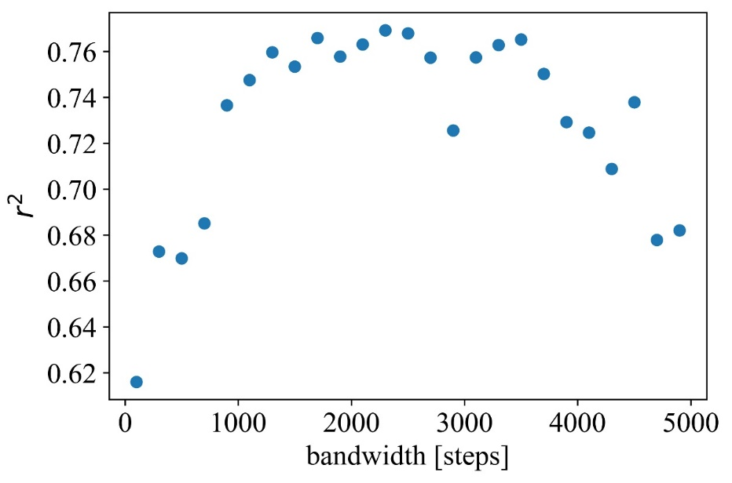
Figure S. 25 Average goodness-of-fit by fitting contact force segments to linear fits, calculated with various KDF bandwidths.
In this study, a total of 27 simulations were conducted to investigate the resemblance between two simulations, focusing on the distance between each pair of simulations. The justification of the number of simulations is evident in the analysis of the mean pair-wise distance as we increment the number of simulations from 2 to 27. The observed trend indicates that 27 simulations suffice to stabilize the evolution of the mean pair distance (Figure S. 26-28). This finding implies that the collection of 27 point clouds, representing the simulations, adequately captures all possible shapes, providing justification for the chosen number of simulations.
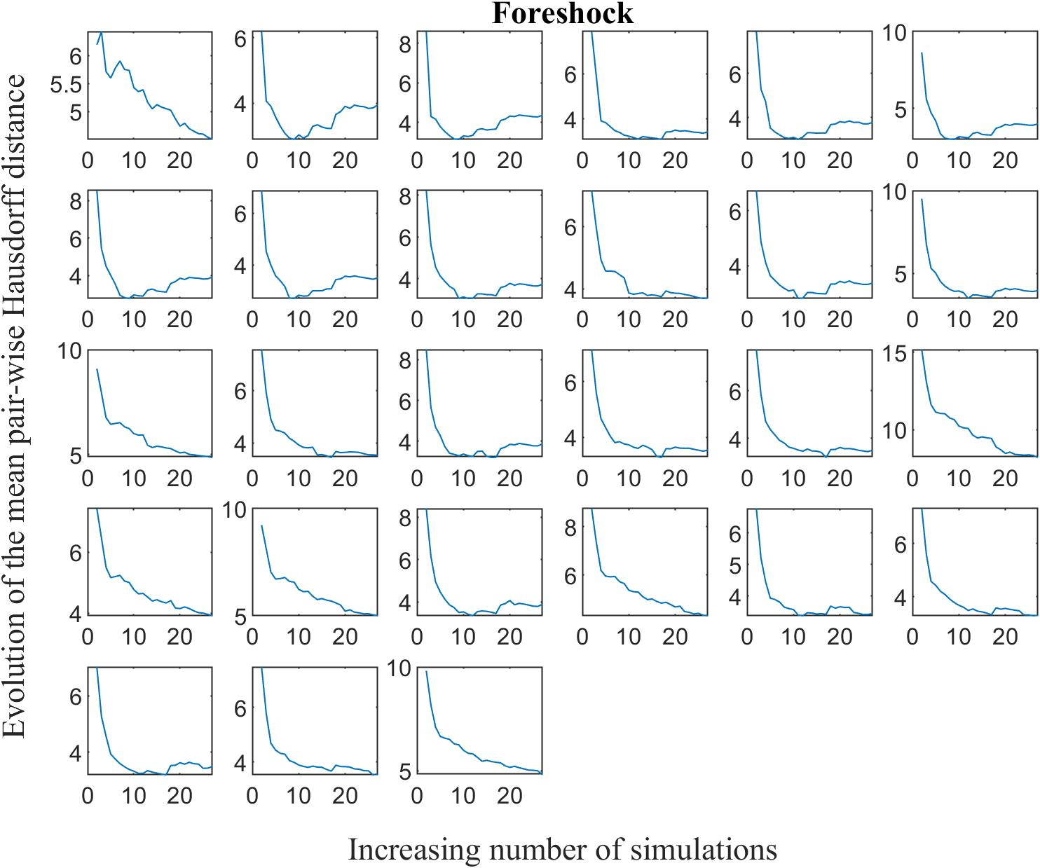
Figure S. 26 The figure illustrates the progression of the mean Hausdorff distance between each pair of foreshock simulations as the number of simulations increases. To clarify, consider the first data point in the initial sub-figure, which represents the mean Hausdorff distance between Simulation 1 and Simulation 2. Subsequently, the second data point reflects the mean distance between Simulation 1 and Simulation 2, as well as between Simulation 1 and Simulation 3.
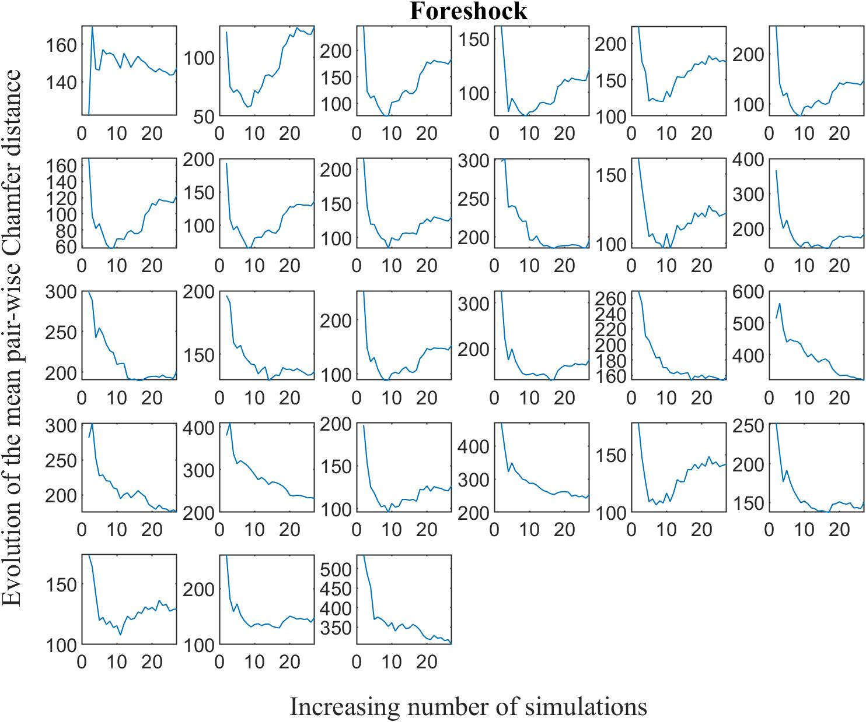
Figure S. 27 The figure illustrates the progression of the mean Chamfer distance between each pair of foreshock simulations as the number of simulations increases.
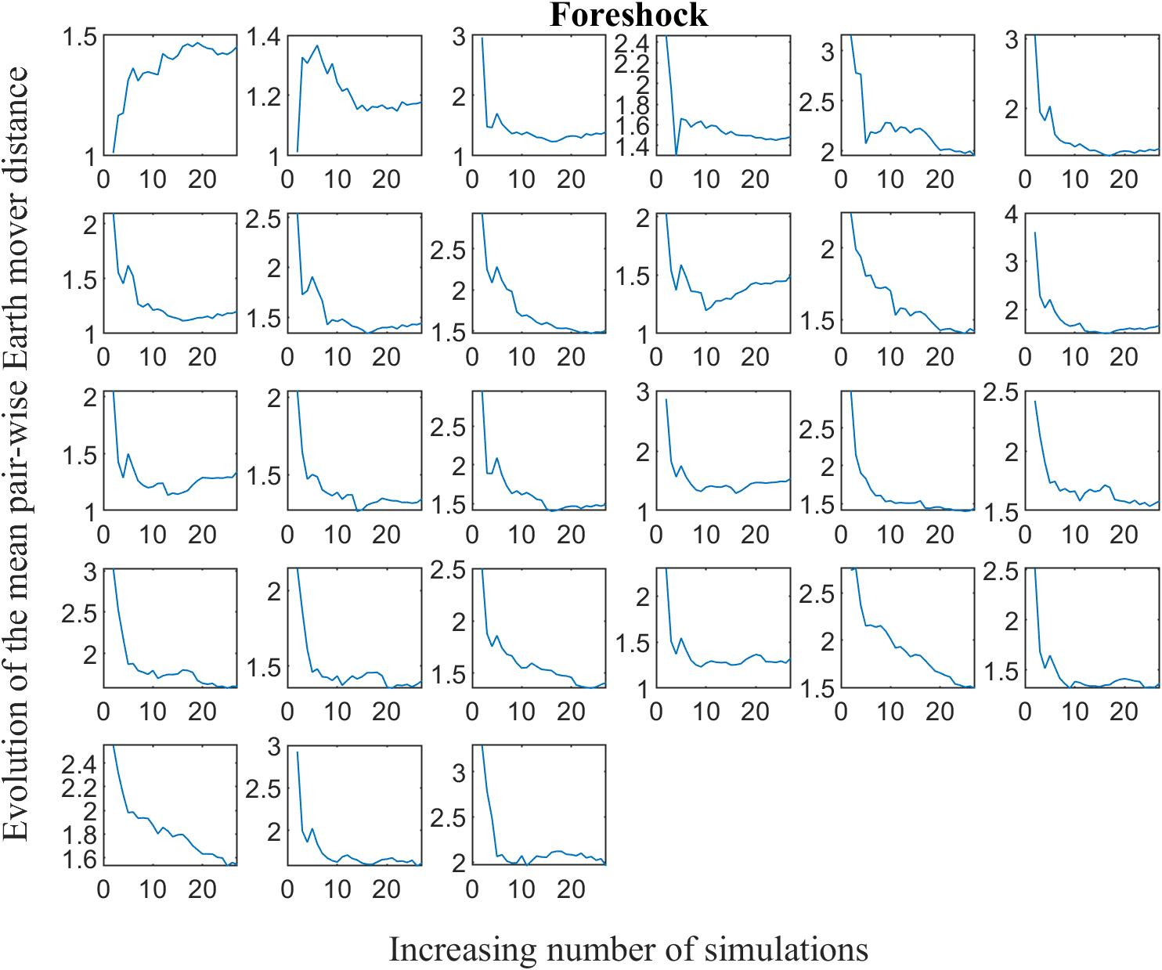 Figure S. 28 The figure illustrates the progression of the mean Earth mover distance between each pair of foreshock simulations as the number of simulations increases.
References
1. Bobet, A. et al. Numerical Models in Discontinuous Media: Review of Advances for Rock Mechanics Applications. Journal of Geotechnical and Geoenvironmental Engineering 135, (2009).
2. Potyondy, D. A flat-jointed bonded-particle material for hard rock. 46th U.S. Rock Mechanics / Geomechanics Symposium vol. 3 Preprint at (2012).
3. Itasca. PFC 5.0 Documentation. PFC 5.0 Documentation. (Itasca Consulting Group Inc, 2016).
4. Xu, X., Wu, S., Gao, Y. & Xu, M. Effects of Micro-structure and Micro-parameters on Brazilian Tensile Strength Using Flat-Joint Model. Rock Mech Rock Eng 49, 3575–3595 (2016).
5. Wu, S. & Xu, X. A Study of Three Intrinsic Problems of the Classic Discrete Element Method Using Flat-Joint Model. Rock Mech Rock Eng 49, 1813–1830 (2016).
6. Mas Ivars, D. et al. The synthetic rock mass approach for jointed rock mass modelling. International Journal of Rock Mechanics and Mining Sciences 48, (2011).
7. Park, E. S., Martin, C. D. & Christiansson, R. Simulation of the mechanical behavior of discontinuous rock masses using a bonded-particle model. in Gulf Rocks 2004 - 6th North America Rock Mechanics Symposium, NARMS 2004 (2004).
8. Mehranpour, M. H. & Kulatilake, P. H. S. W. Improvements for the smooth joint contact model of the particle flow code and its applications. Comput Geotech 87, 163–177 (2017).
9. Mas Ivars, D., Potyondy, D. O., Pierce, M. & Cundall, P. A. The Smooth-Joint Contact Model. in 8th World Congress on Computational Mechanics and 5th European Congress on Computational Methods in Applied Sciences and Engineering (Venice, Italy, 2008).
10. Khazaei, C., Hazzard, J. & Chalaturnyk, R. Discrete Element Modeling of Stick-Slip Instability and Induced Microseismicity. Pure Appl Geophys 173, 775–794 (2016).
11. Lambert, C. & Coll, C. Discrete modeling of rock joints with a smooth-joint contact model. Journal of Rock Mechanics and Geotechnical Engineering 6, 1–12 (2014).
12. Lisjak, A. & Grasselli, G. A review of discrete modeling techniques for fracturing processes in discontinuous rock masses. Journal of Rock Mechanics and Geotechnical Engineering 6, 301–314 (2014).
13. Rubner, Y., Tomasi, C. & Guibas, L. J. Metric for distributions with applications to image databases. in Proceedings of the IEEE International Conference on Computer Vision (1998). doi:10.1109/iccv.1998.710701.
14. Wu, T. et al. Density-aware Chamfer Distance as a Comprehensive Metric for Point Cloud Completion. in (2021).
15. Nemec, A. F. L. & Brinkhurst, R. O. The Fowlkes–Mallows Statistic and the Comparison of Two Independently Determined Dendrograms. Canadian Journal of Fisheries and Aquatic Sciences 45, (1988).

