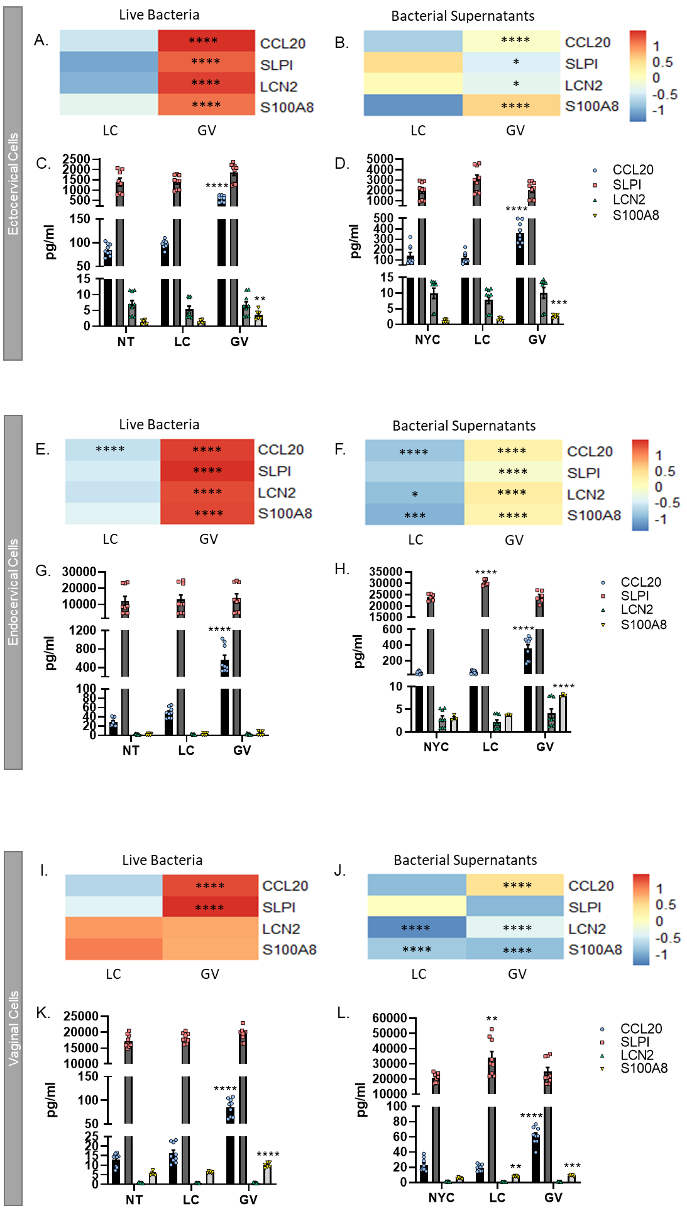

Supplemental Figure 1: Anti-microbial peptide gene expression and proteins are significantly increased after cervicovaginal cell exposure to live bacteria or culture supernatants from G. vaginalis. RNA-seq identified CCL20, SLPI, LCN2 and S100A8 as being significantly upregulated by live G. vaginalis and its supernatants in ectocervical (A, B), endocervical (E, F) and vaginal (I, J) epithelial cells. ELISAs further identified that these anti-microbial peptides were increased after live G. vaginalis (C, G, K) or G. vaginalis culture supernatant exposure (D, H, J). Values are mean ± SEM. Asterisks over the individual bars represent comparisons to control; asterisks over solid lines represent comparisons between treatment groups. *p<0.05, **p<0.01, ***p<0.001, ****p<0.0001.

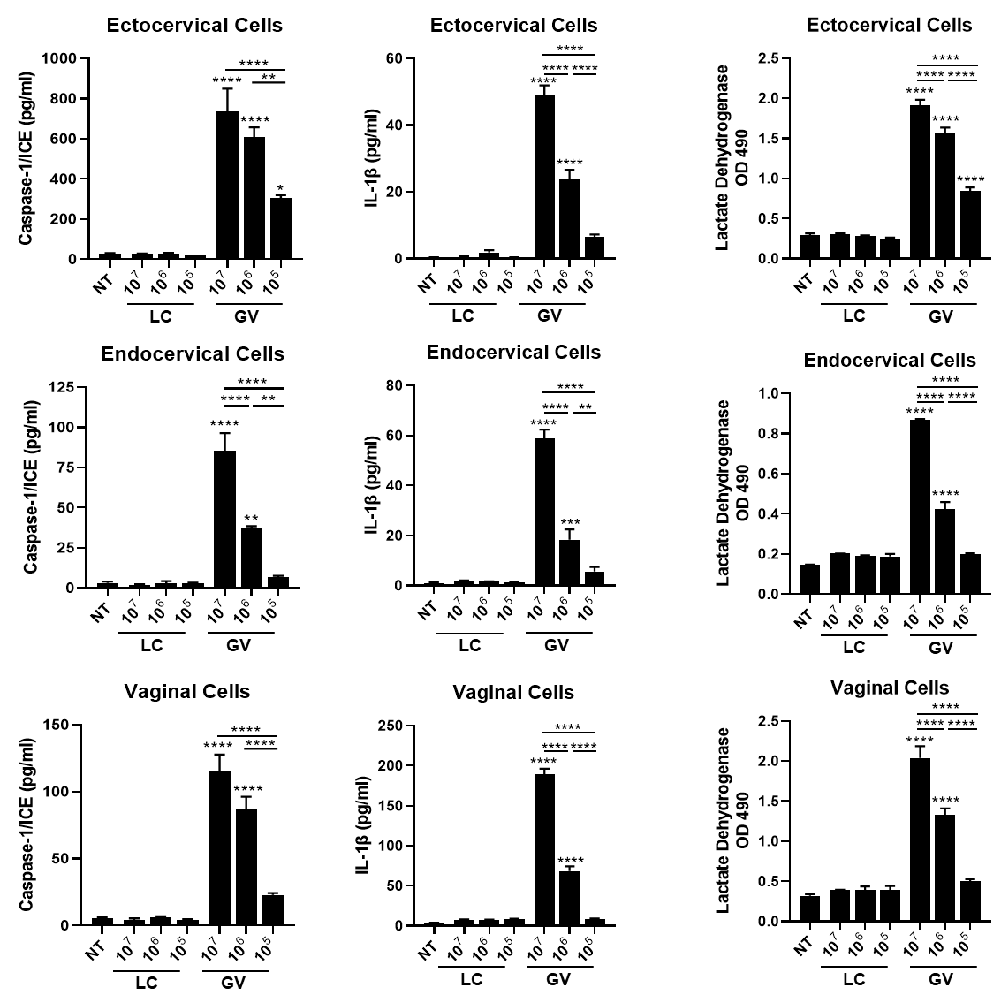
Supplementary Figure 2: Dose response of L. crispatus (LC) and G. vaginalis (GV) shows a dose-dependent increase in cell death, caspase-1 and IL-1b suggesting that GV activates an immune response through inflammasome-mediated mechanisms. Values are mean ± SEM. Asterisks over the individual bars represent comparisons to non-treated control; asterisks over solid lines represent comparisons between treatment groups. *p<0.05, **p<0.01, ***p<0.001, ****p<0.0001.

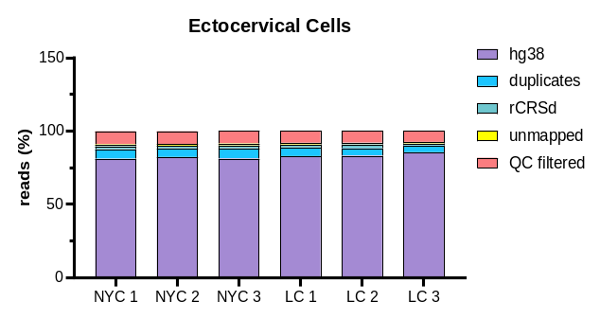
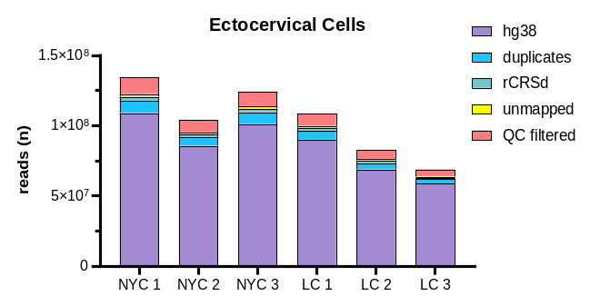
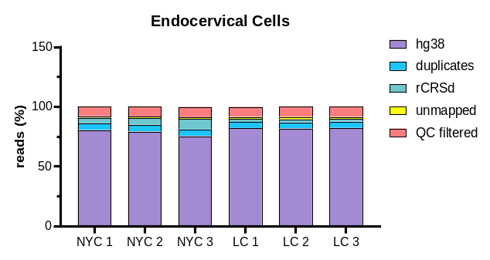
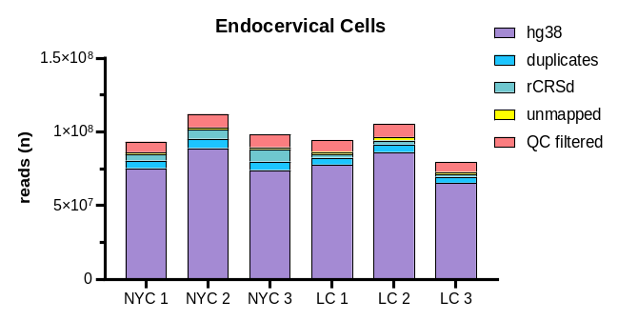
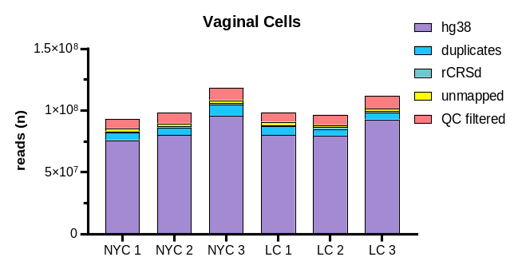
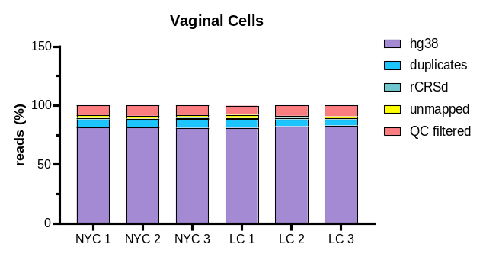
Supplementary Figure 3: Mapping (number and percentage) of reads for each cell type. hg38 = mapped to the human reference genome and used for downstream analysis. Duplicates = removed for the same exact DNA fragment. rCRSd = mitochondrial genome per revised Cambridge Reference Sequence doubled genome. QC filtered = poor quality reads that were removed (MAPQ score <10).

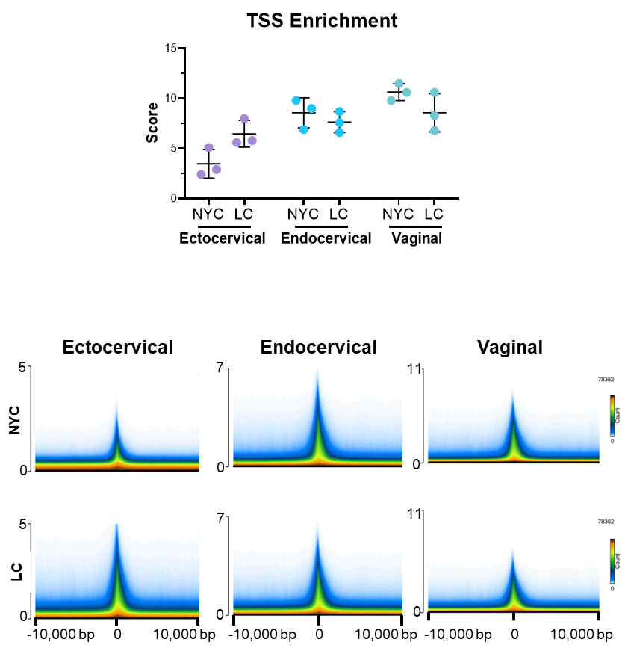
Supplementary Figure 4: Enrichment of reads around the TSS. Top: Graph of TSS enrichment score for each biological replicate. Bottom: Density of counts around the TSS for each condition by cell types.

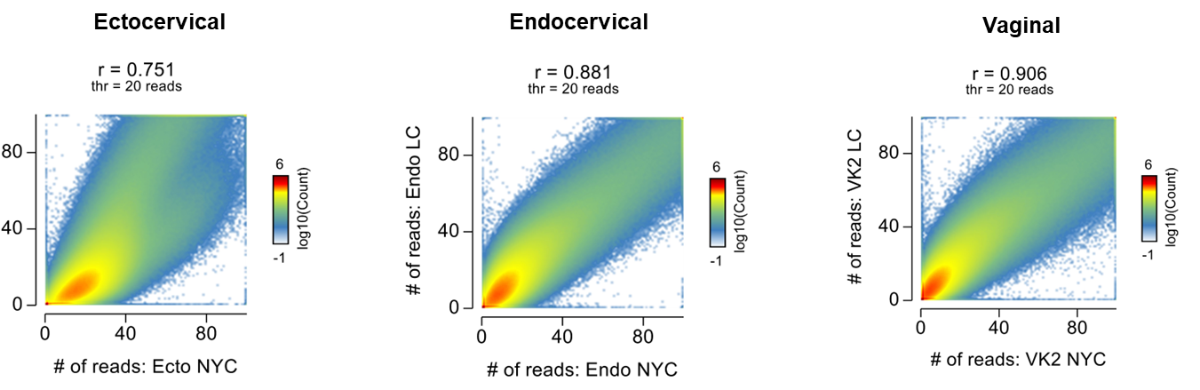
Supplementary Figure 5: Correlation between treatment conditions of read counts (not normalized)

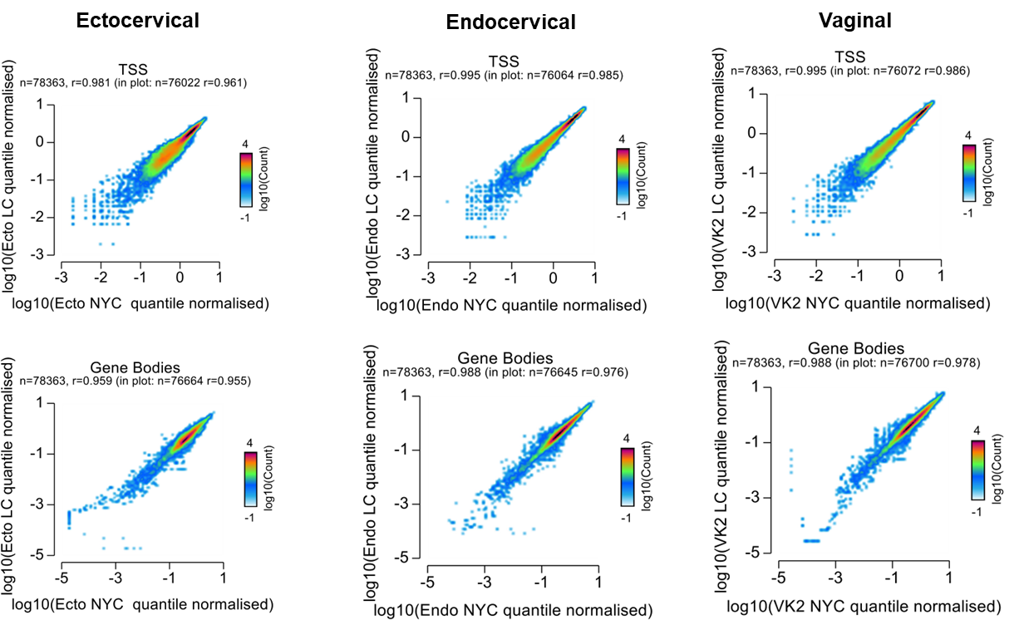

Supplementary Figure 6: Correlation of normalized read counts between conditions at TSS or within the gene bodies

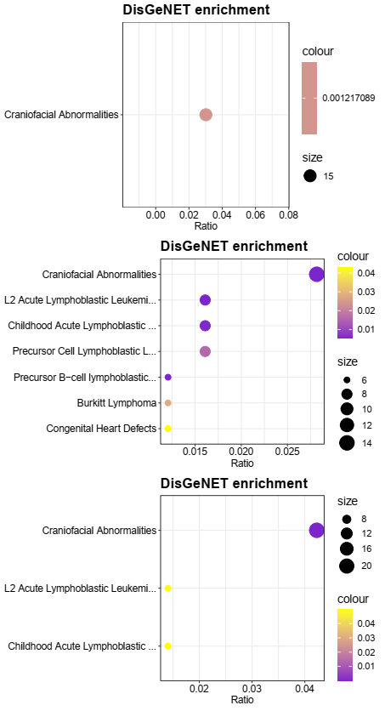
FDR
FDR
FDR

Supplementary Figure 7: Random DisGeNET enrichment bubble charts for random motif lists that were generated.

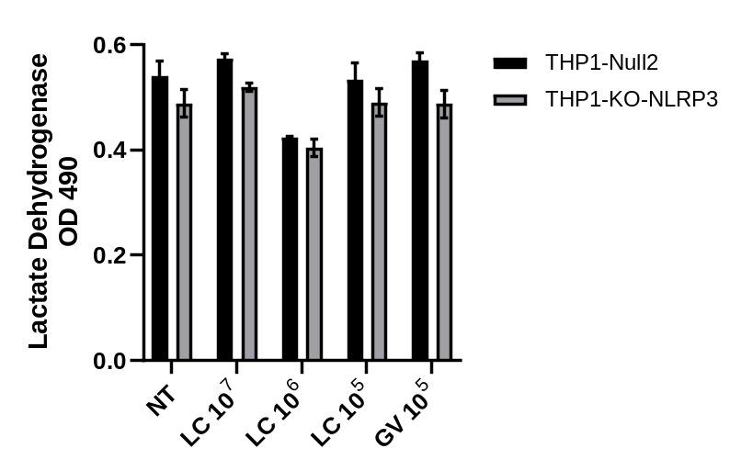

Supplementary Figure 8: Lactate Dehydrogenase (LDH) levels were measured in THP1 cells after 24 hour exposure to L. crispatus (LC) or G. vaginalis (GV) across different CFUs. No significant differences in cell death were observed at any dose.

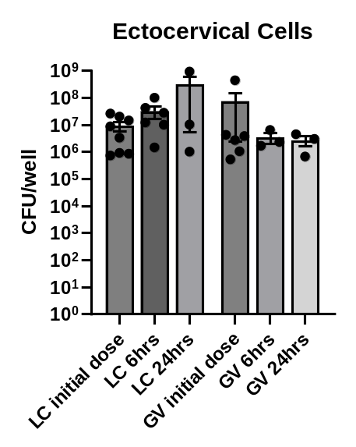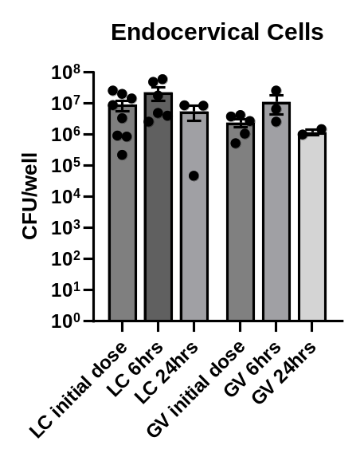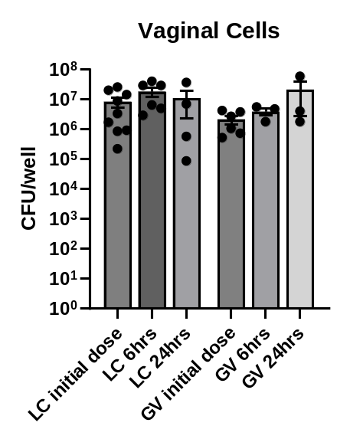

Supplementary Figure 9: L. crispatus (LC) and G. vaginalis (GV) survival after 6 and 24 hours of culture in Keratinocyte Serum Free Media (KSFM) with ectocervical, endocervical and vaginal epithelial cells. CFUs were performed at the conclusion of the experiment to determine bacterial survival under experimental conditions (37ºC at 5% CO₂). No significant changes in the number of bacteria were observed.

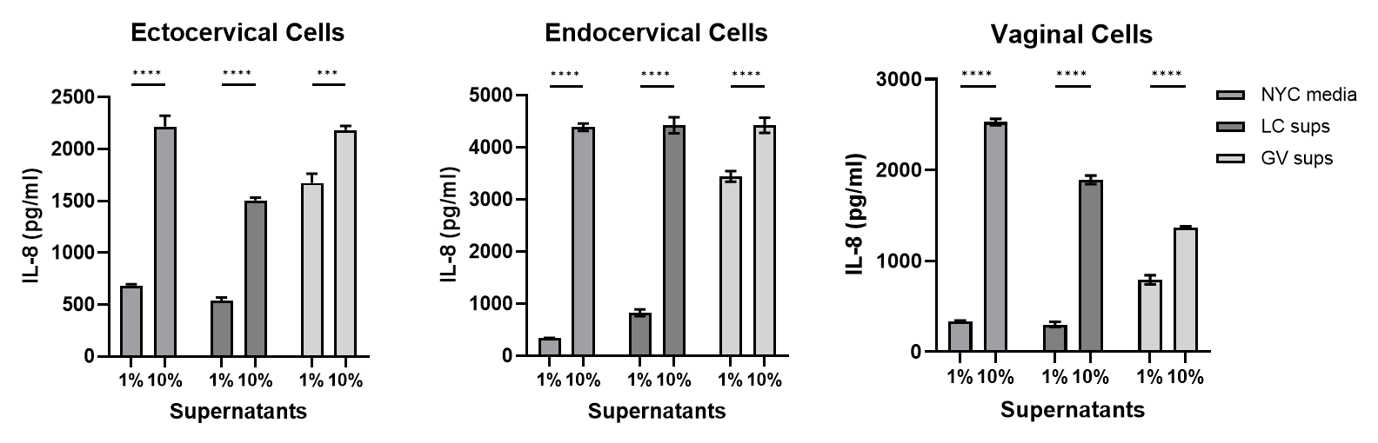

Supplementary Figure 10: Dose response of bacteria-free supernatants from L. crispatus (LC) or G. vaginalis (GV) cultures in ectocervical, endocervical or vaginal epithelial cells. Bacteria-free supernatants were diluted to either 1% (v/v) or 10% (v/v) in keratinocyte serum free media (KSFM). NYCIII media without bacteria diluted in KSMF was used as the control. IL-8 was utilized as a general marker of detectable inflammation and was measured by ELISA. Values are mean ± SEM. Asterisks over solid lines represent comparisons between treatment groups. ***p<0.001, ****p<0.0001

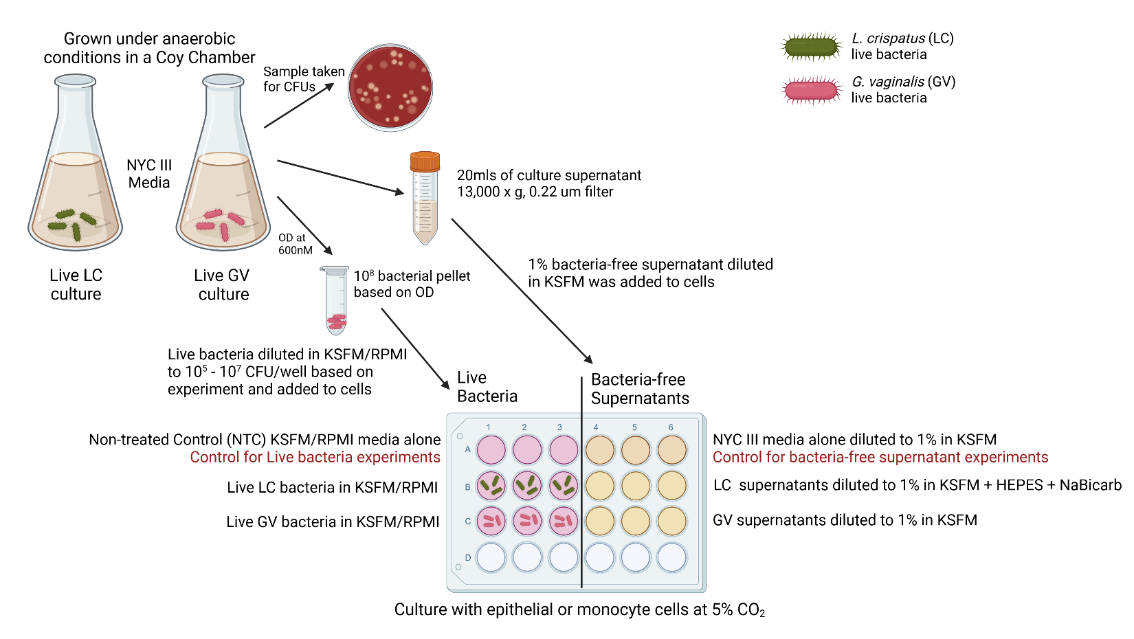

Supplementary Figure 11: Diagram showing the study design of in vitro epithelial and immune cell bacterial interactions. Keratinocyte serum free media (KSFM) is the growth media for all cervicovaginal epithelial cells. RPMI 1640 (RPMI) is the growth media for THP1 monocytes.

Supplemental Table 1: Number of differentially expressed genes in cervicovaginal epithelial cells after bacterial exposure
 | Ectocervical | Endocervical | Vaginal
Comparison | Log2FC  ≥ 1 and ≤ -1  p≤0.05 | Log2FC  ≥ 1 and ≤ -1  p≤0.05 | Log2FC  ≥ 1 and ≤ -1  p≤0.05
Live LC vs NTC | 6 ↑  4 ↓ | 15 ↑  5 ↓ | 3 ↑  8 ↓
Live GV vs NTC | 237 ↑  111 ↓ | 457 ↑  123 ↓ | 237 ↑  214 ↓
LC sups vs NYC | 562 ↑  224 ↓ | 776 ↑  370 ↓ | 289 ↑  135 ↓
GV sups vs NYC | 38 ↑  7 ↓ | 204 ↑  45 ↓ | 105 ↑  128 ↓
Differentially expressed genes were chosen based on a cut-off of Log2 Fold Change (FC) of ≥ 1 or ≤ -1
with an adjusted p value ≤ 0.05.

Supplemental Table 2: List of overlapping genes altered by bacteria exposure between epithelial cell types.
Live GV |  |  | LC sups |  |  | GV sups
ecto/endo  n=46 | endo/vag  n=66 | ecto/vag  n=37 | ecto/endo  n=133 | endo/vag  n=61 | ecto/vag  n=67 | ecto/endo  n=3 | endo/vag  n=39 | ecto/vag  n=3
NTSR1 | TRIM22 | NLRP3 | RCN3 | MMP2 | CCNA1 | PDZK1IP1 | CXCL10 | STC1
LCE3E | PTPN22 | VGLL3 | KPNA7 | PSTPIP1 | PTPRR | IL36G | CTSS | RUNDC3A
SOD2 | TGM2 | C17orf99 | OR2B6 | SLC16A14 | TMEM151A | IFITM1 | IL23A | novel protein
NR4A2 | ZMYND15 | NCF2 | CILP | TGM2 | GDF15 |  | INHBA
PAPSS2 | GFPT2 | H2AC8 | DNAI1 | DPP4 | KBTBD13 |  | CCL20
HRK | TNFRSF9 | PPBP | MMRN2 | RASAL1 | AKR1B10 |  | PTGS2
SPRR2D | GASK1B | IL1RL1 | CCL22 | KCNQ5 | PTPRZ1 |  | IL1R2
PLA2G4E | CSF1 | PSG4 | CRYM | AKR1C2 | NOS1 |  | SAA2
LIF | NFKB2 | IFIT2 | ARHGAP30 | AHR | LCE1B |  | TRHDE
DLL1 | NANOS3 | SPINK5 | WFDC5 | LGALS7B | SEMA3A |  | KRT34
ANXA9 | TENT5C | FPGT-TNNI3K | UAP1L1 | JPH2 | IQCH |  | MRGPRX3
PCDHGC5 | HDAC9 | NRG2 | SCX | TBC1D3B | DNASE1L3 |  | CXCL8
MUC2 | LAMB3 | PTX3 | NEFH | ABCC2 | FAM110C |  | CD70
SGK1 | FMN1 | PSG1 | ZNF556 | HR | H3C14 |  | BIRC3
CCDC158 | ZDHHC11B | H2AC19 | GSTA4 | RHCE | NEFM |  | SERPINB2
KYNU | MAP3K8 | CHST2 | LAMP3 | ETV7 | TLCD3B |  | ZC3H12A
ENKUR | FA2H | PLOD2 | KLHL30 | S1PR4 | CDH2 |  | IL32
SLPI | LTB | OASL | LRRC75A | CYP7B1 | EGR1 |  | TGM2
BMP2 | PCDHGC4 | DLL4 | PIBF1 | PTGS2 | MGAT5B |  | XAF1
RHCG | NT5DC4 | KLHDC1 | NCF2 | CPM | ZCCHC12 |  | KRT4
PGLYRP4 | CA9 | BLNK | KRTAP3-2 | NPIPB7 | CLDN9 |  | VNN1
S100A8 | ENO2 | TMEM158 | PRR22 | FAM166B | MYPN |  | NFKB2
PI3 | CALB2 | IL20 | KLHDC7B | ITGB8 | H1-5 |  | G0S2
SLC6A14 | DSG1 | ADAMTS1 | SHOC1 | C8orf88 | H2BC9 |  | TNFRSF1B
SLITRK6 | G0S2 | NR4A1 | PTPRB | CAVIN2 | ESPNL |  | TNFAIP3
ALOX12 | TMEM132A | AQP3 | STX19 | MAPK8IP2 | APOBEC3A |  | TNIP1
RORA | MMP1 | IFIT1 | MFAP5 | ARRDC4 | NEFL |  | C1orf68
DMBT1 | CXCL17 | PALMD | IL6R | BHLHA15 | H3C8 |  | SCHIP1
RASGEF1B | SGPP2 | CEMIP | VASH1 | PPP1R3F | LCE1E |  | CXCL3
SERPINB4 | DUSP19 | RSAD2 | CORO2B | SMIM1 | SLC6A14  BCL2A1 |  | TNF
SEMA6C | SULT1E1 | ETFBKMT | NEU1 | AMTN | LYPD1 |  | LTB
RPL3L | SESN3 | PPP2R2B | C15orf62 | CAPN8 | CNNM1 |  | NFKBIZ
SPRR2A | INHBA | PSG6 | STON1 | ZDHHC11 | MYH15 |  | TRPV3
PATL2 | IRAK2 | CXCL5 | PCDHGC5 | IFNE | TUBB2B |  | CXCL2
TRAF1 | NDRG1 | ADM | H1-3 | CDRT1 | S100A4 |  | NFKBIA
ZNF396 | TCAF2 | RNF157 | H2BC18 | COL11A2 | BLACAT1 |  | IL24
IL33 | AMH | LCE1F | AOC3 | LGALS7 | AK8 |  | ICAM1
KLF15 | KCTD11 |  | FOXL1 | TG | H2BC6 |  | IL6
TET1 | ICAM1 |  | P2RX6 | SPATA25 | SPTB |  | CSF2
TMEFF1 | TNFRSF1B |  | PDGFD | ANXA10 | BEX1
RNF224 | NEXN |  | KIT | TREM2 | ABHD12B
ITGB3 | MRGPRX3 |  | MYCT1 | CLEC7A | H2AC11
LCN2 | TNIP1 |  | SLC29A3 | CAMK2A | EIF4E3
SERPINB3 | IL7R |  | OLR1 | APOD | COX6B2
SERPINA3 | ADAM8 |  | TRIM63 | PATL2 | KIAA1614
SPRR2E | BTBD19 |  | FPGT-TNNI3K | USH1G | SLC7A7
 | NFKBIE |  | CLCN7 | MYL5 | PLPP3
 | IL32 |  | TNFAIP8L1 | WFDC2 | SPANXB1
 | CFB |  | PODXL | SLC47A2 | PSG6
 | TRPV3 |  | PER2 | RSAD2 | NDRG4
 | BORCS7-ASMT |  | POM121L2 | CLDN1 | PLEKHF1
 | TMEM135 |  | IL36G | TNFRSF6B | ELAPOR1
 | IL1B |  | PER3 | ATP8B3 | BORCS7-ASMT
 | NFKBIA |  | PSG1 | TMEM107 | PFKFB4
 | LAMA4 |  | GREM1 | CLTRN | SCNN1G
 | PPFIA4 |  | H2AC19 | PARD3B | KPRP
 | FAM47E |  | NATD1 | TTLL10 | TIMP4
 | MMP10 |  | NR4A3 | ZBTB32 | RELN
 | B4GALNT2 |  | SLC23A3 | AMIGO2 | TCN2
 | RND1 |  | SPAG4 | PDCD6-AHRR | GJA5
 | APOL3 |  | GBP4 | TNS2 | NPTXR
 | FOLR3 |  | TMEM265 |  | CYP1B1
 | C1QTNF1 |  | TEF |  | ROS1
 | ASB2 |  | NWD2 |  | H2BC17
 | ANKRD37 |  | THSD7B |  | ESM1
 |  |  | PROC |  | novel protein
 |  |  | CCR4
 |  |  | DNAJC6
 |  |  | CEP57L1
 |  |  | STX3
 |  |  | AP5Z1
 |  |  | RLN2
 |  |  | ACRV1
 |  |  | PPP1R15A
 |  |  | CITED2
 |  |  | KRT9
 |  |  | SEMA5B
 |  |  | ECM2
 |  |  | CENPE
 |  |  | FLCN
 |  |  | TLN2
 |  |  | CTNS
 |  |  | ACP5
 |  |  | CDH16
 |  |  | CYGB
 |  |  | IL1R2
 |  |  | RNASE7
 |  |  | DDIT3
 |  |  | OSR1
 |  |  | ZNF878
 |  |  | SORCS3
 |  |  | PRODH
 |  |  | CTSE
 |  |  | RDH12
 |  |  | SP140
 |  |  | H3C2
 |  |  | RAB3IL1
 |  |  | HYAL4
 |  |  | WNT2B
 |  |  | PAX8
 |  |  | SERHL2
 |  |  | SEMA4G
 |  |  | SLAMF7
 |  |  | SEC14L2
 |  |  | NKX1-2
 |  |  | ADAP2
 |  |  | ANGPTL2
 |  |  | KLF15
 |  |  | HMMR
ADM
PDLIM3
 |  |  | FOSB
 |  |  | NEURL1B
 |  |  | DEFB103B
 |  |  | GOLGA8R
 |  |  | CRYBB2
 |  |  | ODF3B
 |  |  | DNER
 |  |  | IFITM1
 |  |  | TMTC1
 |  |  | CALHM2
 |  |  | DEPDC4
 |  |  | SCG5
 |  |  | SH2D5
 |  |  | FAM222A
 |  |  | LRTM2
 |  |  | FOLR3
 |  |  | AS3MT
 |  |  | ABCA13
 |  |  | RDM1
 |  |  | KLHL24
 |  |  | CSF2
 |  |  | CRCT1

Supplemental Table 3: List of overlapping genes between bacterial exposures in each cervicovaginal cell line.
Ectocervical Cells |  |  | Endocervical Cells |  |  | Vaginal Cells
LC sups/ Live GV  n=91 | Live GV/  GV sups  n=9 | LC sups/ GV sups  n=9 | LC sups/ Live GV  n=95 | Live GV/  GV sups  n=80 | LC sups/ GV sups  n=23 | LC sups/ Live GV  n=37 | Live GV/  GV sups  n=90 | LC sups/ GV sups  n=23
HSD17B | PGBD5 | SYS1-DBNDD2 | EDN1 | RFLNA | PSTPIP1 | DACT2 | EDN1 | CAPN8
NTSR1 | RCSD1 | CDH16 | PADI3 | TNIP3 | SQSTM1 | KCNH3 | IGHMBP2 | SRCIN1
NR4A2 | STC1 | EVA1B | UBE2F-SCLY | CNTNAP1 | QPRT | SGPP2 | CXCL3 | ZDHHC11
PAPSS2 | CSF3 | SPNS2 | GPR143 | CXCL3 | ADAM23 | SLC16A14 | KLK6 | AKR1B10
SQSTM1 | PDZK1IP1 | NDRG4 | VEPH1 | C1R | FRA10AC1 | CALB1 | SPAG17 | TAS2R4
NAT8L | CXCL1 | ELAPOR1 | RBM24 | C15orf48 | NACAD | H3C10 | TMEM158 | MACROD1
NPW | ZP4 | IFITM1 | HBEGF | SOD2 | STX19 | H4C8 | EPDR1 | DNAJC15
IL24 | SAA1 | RUNDC3A | LAMP3 | NFKB2 | SHFL | LIFR | NLRP3 | GRIK5
SLC6A6 | MMP9 | novel protein | TNFSF10 | SAMSN1 | SCHIP1 | H2BC21 | CLCA4 | RASAL1
NCF2 |  |  | PLA2G4E | IL24 | HOXA5 | TNFSF15 | INHBA | RYR2
H2AC8 |  |  | LCN12 | ELF3 | TPGS1 | H2AC8 | ADAMTS1 | LIPH
H3C14 |  |  | FAM133B | ZBTB20 | PPP2R2C | H3C14 | CXCL2 | ALPP
PPBP |  |  | DNAH11 | SERPINA1 | WNK4 | NEXN | NDRG1 | RASSF4
PSG4 |  |  | PLAAT2 | HEPHL1 | TRANK1 | MS4A4E | IL1R2 | ANKRD22
EGR1 |  |  | CD40 | STAT5A | H2AC19 | HDAC11 | AQP3 | CYP7B1
PCDHGC5 |  |  | CIITA | CARD14 | POU2F2 | METTL7A | VNN1 | ITPR1
FAM229A |  |  | TENT5C | STEAP4 | INSYN1 | MAFB | IFI44L | PLEKHA7
RRAD |  |  | DLL1 | SERPINB2 | CDRT1 | IL7R | RNASE7 | CTAGE4
SLC19A3 |  |  | RET | CTSS | TMC5 | RRAD | NFKB2 | ANKRD1
RTL5 |  |  | ALPP | ZC3H12A | RSAD2 | FMN1 | CAVIN4 | ASIC3
LEF1 |  |  | VILL | RP1 | TNS2 | ZDHHC11B | SLC2A3 | PRRT2
ZFPM2 |  |  | PCDHGC5 | IL23A | CHKB-CPT1B | H1-5 | IL24 | FBXO32
MYPN |  |  | IFI27 | PDGFB | PLXNA3 | RSAD2 | AMH | DEPP1
P2RX6 |  |  | ACCS | LTB |  | TTN | DNAH11
SGK1 |  |  | NIPAL4 | CCDC158 |  | DNAH3 | ICAM1
MYCT1 |  |  | RRAD | CSF3 |  | CD177 | TNFRSF1B
OLR1 |  |  | AOC3 | ENKUR |  | FGD3 | GBP6
FPGT-TNNI3K |  |  | OAS3 | STX11 |  | SYT14 | ZNF467
NRG2  RDH16 |  |  | EDAR | APOBEC3A |  | H2AC13 | SLC5A10
PSG1 |  |  | UNC13D | GBP2 |  | BORCS7-ASMT | PIWIL2
GREM1 |  |  | METTL7B | CD83 |  | SLC9A2 | MRGPRX3
H2AC19 |  |  | LMO2 | SH2D3C |  | IGFBP3 | CXCL1
CHST2 |  |  | CPT1B | ICOSLG |  | TNFSF9 | ZP4
NR4A3 |  |  | OLR1 | E2F5 |  | NRK | IL1RL1
LCE1E |  |  | BMP2 | G0S2 |  | PDXP | CSPG5
SLC6A14 |  |  | CALB2 | RHCG |  | BCL2A1 | CXCL8
SLITRK6 |  |  | IQCD | SOCS3 |  | ESM1 | TNIP1
KIF5C |  |  | DSG1 | SLITRK6 |  |  | SAA1
IL6 |  |  | ACSL5 | FOXO1 |  |  | IFIT2
TMEM265 |  |  | VEGFA | DISP3 |  |  | SCHIP1
ATP6V0A4 |  |  | CAVIN2 | BCL2A1 |  |  | CXCL10
STX3 |  |  | LCE1C | PDZK1IP1 |  |  | SERPINB2
BLNK |  |  | ADRA1D | DTX2 |  |  | CTSS
PPP1R15A |  |  | MAPK8IP2 | BMF |  |  | TNF
BCL2A1 |  |  | ZBP1 | ALOXE3 |  |  | ZC3H12A
CITED2 |  |  | COL8A1 | EBI3 |  |  | STC1
FLT1 |  |  | RNF213 | INHBA |  |  | IL23A
IL20 |  |  | PCDHB6 | DSCAM |  |  | ETFBKMT
MYH15 |  |  | CAPN8 | SERPINB4 |  |  | BTBD19
PLCB4 |  |  | PPP1R15A | IFNK |  |  | IL32
RASGEF1B |  |  | ZDHHC11 | VNN1 |  |  | LTB
IL1R2 |  |  | NPFF | CD74 |  |  | CXCL5
SERPINB4 |  |  | PML | ICAM1 |  |  | SERPINB13
RNASE7 |  |  | MMP3 | TNFRSF1B |  |  | CSF3
RPL3L |  |  | BATF2 | MRGPRX3 |  |  | NFKBIZ
GDPD3 |  |  | GPR179 | ZP4 |  |  | DPYSL4
TMEM221 |  |  | PARP12 | TRAF1 |  |  | CCL20
WNT2B |  |  | FLCN | TNIP1 |  |  | TRPV3
RASD1 |  |  | SP100 | RHBDL2 |  |  | ENO2
BEX1 |  |  | IFI6 | IL7R |  |  | TMEM135
NFATC2 |  |  | SLC2A12 | CCL5 |  |  | NFKBIA
CD70 |  |  | PLXDC2 | ADAM8 |  |  | CALB2
NKPD1 |  |  | RNASE7 | RELB |  |  | SAA2
KLF15 |  |  | PLCD1 | TNFAIP2 |  |  | PPFIA4
PPP2R2B |  |  | SLC2A6 | NFKBIE |  |  | PTX3
PSG6 |  |  | CAVIN4 | ANKRD33B |  |  | DSC1
ADM |  |  | GBP1 | TRPV3 |  |  | TRHDE
ANK3 |  |  | OAS2 | BORCS7-ASMT |  |  | DSG1
FOSB |  |  | COL14A1 | LCN2 |  |  | TAF4
DEFB103B |  |  | LGALS9 | NFKBIA |  |  | CCIN
ANKRD1 |  |  | CCDC9B | NOD2 |  |  | G0S2
RNF157 |  |  | PATL2 | SYNPO |  |  | HPGD
ACTBL2 |  |  | PCDH17 | SERPINB3 |  |  | PSG1
KPRP |  |  | BTBD19 | SERPINA3 |  |  | KRT34
TIMP4 |  |  | TMEM229B | N4BP3 |  |  | TMEM132A
ZNF804A |  |  | KLF15 | S100A9 |  |  | NELL2
SERPINB3 |  |  | TRIML2 | BIRC3 |  |  | RUNDC3A
ETV1 |  |  | SLC6A12 | MMP9 |  |  | CPPED1
SLCO4C1 |  |  | RARRES1 | PIK3IP1 |  |  | TNFAIP3
FAM155B |  |  | TET1 | ESM1 |  |  | ALDH3B2
GJA5 |  |  | TCP11L2 |  |  |  | DLL4
ROS1 |  |  | CLDN1 |  |  |  | C1QTNF1
SLC16A10 |  |  | CCN3 |  |  |  | KRT23
C1orf68 |  |  | ITGB3 |  |  |  | IFIT3
KLHL24 |  |  | KRT6B |  |  |  | CSF2
CSF2 |  |  | FAM47E |  |  |  | MEF2C
MCTP1 |  |  | TEPP |  |  |  | PLXNA4
CRCT1 |  |  | CDA |  |  |  | BIRC3
LCE1F |  |  | B4GALNT2 |  |  |  | MMP9
ESM1 |  |  | SCG5 |  |  |  | CD14
novel protein |  |  | APOL3
 |  |  | YPEL2
 |  |  | KRT75
 |  |  | ASB2
 |  |  | APBA1

Supplemental Table 4: List of overlapping genes with divergent regulation in ectocervical cells exposed to live G. vaginalis or L. crispatus supernatant
Ectocervical Cells
Gene | log2FoldChange |  |  | Function
 | Live GV | LC Sups
PPBP | 2.57 |  | -1.27 | antimicrobial protein with bactericidal and antifungal activity
BCL2A1 | 2.06 |  | -1.50 | direct transcription target of NF-kappa B in response to inflammatory mediators
ESM1 | 1.86 |  | -1.32 | regulated by cytokines
TMEM265 | 1.86 |  | -8.16 | Integral cell membrane component
PAPSS2 | 1.44 |  | -1.39 | Bifunctional enzyme with both ATP sulfurylase and APS kinase activity, which mediates two steps in the sulfate activation pathway
EGR1 | 1.11 |  | -1.19 | regulation of cell survival, proliferation, and cell death
MYH15 | -1.15 |  | 1.18 | Enables ATP binding activity; actin filament binding activity; and calmodulin binding activity
TIMP4 | -1.22 |  | 1.37 | irreversibly inactivates matrix metalloproteinases
BLNK | -1.26 |  | 1.09 | downstream of the B-cell receptor, important for NFkB activation
P2RX6 | -1.39 |  | 1.69 | P2X receptor of ATP-gated ion channels that mediate rapid and selective permeability to cations
RDH16 | -1.42 |  | 1.31 | regulates steroid metabolic process
TMEM221 | -1.51 |  | 1.24 | Integral cell membrane component
SLCO4C1 | -1.93 |  | 1.54 | organic anion transporter involved in the membrane transport of bile acids, conjugated steroids, thyroid hormone, eicosanoids, peptides, and numerous drugs
RTL5 | -2.11 |  | 2.77 | long terminal repeat retrotransposon with unknown function
RNF157 | -3.31 |  | 3.66 | ubiquitinates APBB1 for its degradation by the proteasome prevents apoptosis and promotes survival

Supplemental Table 5: List of overlapping genes with divergent regulation in endocervical cells exposed to live G. vaginalis or L. crispatus supernatant
Endocervical Cells
Gene | log2FoldChange |  | Function
 | Live GV | LC Sups
TEPP | 1.56 | -1.08 | unknown function
CD40 | 1.30 | -1.15 | receptor on antigen-presenting cells of the immune system and is essential for mediating a broad variety of immune and inflammatory responses
AOC3 | 1.24 | -1.04 | cell surface protein with adhesive properties
PCDHB6 | 1.11 | -1.02 | calcium-dependent cell-adhesion protein
PCDHGC5 | 1.05 | -1.50 | calcium-dependent cell-adhesion protein
PLAAT2 | -1.07 | 1.80 | has both phospholipase and acyltransferase activities and acts as a tumor suppressor
ALPP | -1.08 | 2.12 | alkaline phosphatase, a metalloenzyme that catalyzes the hydrolysis of phosphoric acid monoesters
CAPN8 | -1.18 | 1.59 | membrane trafficking of mucus cells
CAVIN2 | -1.18 | 1.04 | calcium-independent phospholipid-binding protein, plays an important role in caveolar biogenesis and morphology
VEPH1 | -1.18 | 1.47 | negative regulation of transforming growth factor beta receptor signaling pathway
EDAR | -1.21 | 1.23 | activates the NFkB, JNK, and caspase-independent cell death pathways
COL14A1 | -1.23 | 1.74 | plays an adhesive role by integrating collagen bundles
FAM133B | -1.28 | 1.12 | Enables RNA binding activity
UNC13D | -1.35 | 1.14 | vesicle maturation during exocytosis
VILL | -1.37 | 1.62 | plays a role in actin-bundling, possible tumor suppressor
TCP11L2 | -1.38 | 2.54 | predicted to be involved in signal transduction
CCN3 | -1.43 | 2.19 | negative regulator of pro-inflammatory activation reducing monocyte adhesion
PLXDC2 | -1.44 | 1.88 | integral component of membrane, may play a role in tumor angiogenesis
RBM24 | -1.55 | 1.30 | regulation of pre-mRNA splicing, mRNA stability and mRNA translation
COL8A1 | -1.75 | 1.24 | one of the two alpha chains of type VIII collagen
FAM47E | -2.37 | 1.41 | positive regulation of histone methylation and protein localization to chromatin
ADRA1D | -3.28 | 1.42 | activates mitogenic responses and regulates growth and proliferation
DSG1 | -3.96 | 1.54 | interaction of plaque proteins and intermediate filaments mediating cell-cell adhesion
KLF15 | -4.01 | 2.67 | DNA-binding transcription activator activity, RNA polymerase II-specific and RNA polymerase II cis-regulatory region sequence-specific DNA binding activity

Supplemental Table 6: List of overlapping genes with divergent regulation in vaginal cells exposed to live G. vaginalis or L. crispatus supernatant
Vaginal Cells
Gene | log2FoldChange |  | Function
 | Live GV | LC Sups
BORCS7-ASMT | 26.79 | -25.10 | read-through transcript is a candidate for nonsense-mediated mRNA decay (NMD), and is therefore unlikely to produce a protein product
BCL2A1 | 2.60 | -1.46 | direct transcription target of NF-kappa B in response to inflammatory mediators
IGFBP3 | 1.74 | -2.51 | IGF-binding protein prolongs the half-life of IGFs and have been shown to either inhibit or stimulate the growth promoting effects of IGFs
ESM1 | 1.33 | -1.42 | gene is regulated by cytokines
SYT14 | -1.05 | 2.11 | involved in the trafficking and exocytosis of secretory vesicles
DNAH3 | -1.08 | 1.87 | large proteins that are constituents of the microtubule-associated motor protein complex
H4C8 | -1.22 | 2.39 | Core component of a nucleosome, encodes a replication-dependent histone that is a member of the histone H4 family
RSAD2 | -1.25 | 1.31 | cellular antiviral response and innate immune signaling, inhibit both DNA and RNA viruses, including HIV
NEXN | -1.34 | 1.52 | filamentous actin-binding protein that may function in cell adhesion and migration
KCNH3 | -2.16 | 2.09 | capable of binding glycoprotein 120 of the HIV-1 envelope
FMN1 | -2.34 | 1.45 | formation of adherens junction and the polymerization of linear actin cables
METTL7A | -2.63 | 2.41 | enables methyltransferase activity
TTN | -5.21 | 5.62 | key component in the assembly and functioning of vertebrate striated muscles

 | Ectocervical |  |  |  | Endocervical |  |  |  | Vaginal
 | Live Bacteria |  | Supernatants |  | Live Bacteria |  | Supernatants |  | Live Bacteria |  | Supernatants
Gene | LC | GV | LC | GV | LC | GV | LC | GV | LC | GV | LC | GV
Inflammasome Associated Pathway Genes
NOD1 | 0.06 | 0.02 | -0.19 | -0.04 | 0.32 | 0.30 | 0.49 | 0.33 | -0.05 | -0.01 | -0.11 | -0.04
NOD2 | -0.11 | 0.41 | 0.11 | 0.64 | 1.13 | 2.29 | 0.81 | 1.24 | -0.42 | 0.17 | 0.01 | 0.20
NEK7 | -0.09 | 0.26 | 0.25 | 0.05 | -0.38 | -0.39 | 0.37 | -0.25 | 0.02 | 0.07 | 0.32 | -0.01
PYCARD | 0.34 | -0.27 | -0.60 | 0.31 | 0.04 | -0.01 | -0.43 | 0.04 | -0.13 | -0.07 | -0.09 | 0.00
CASP1 | 0.15 | 0.29 | -0.52 | -0.08 | -0.17 | 0.79 | -0.07 | 0.47 | -0.31 | -0.59 | 0.43 | -0.16
IL18 | -0.01 | 0.41 | 0.25 | -0.05 | -0.22 | -0.46 | 0.29 | -0.38 | 0.16 | 0.10 | 0.86 | 0.03
IL1B | 0.16 | 0.96 | -0.87 | 0.11 | 0.31 | 2.06 | 0.08 | 0.76 | 0.15 | 1.37 | -0.77 | 0.43
IL1A | 0.12 | 1.28 | -0.55 | 0.25 | 0.30 | 2.07 | 0.53 | 0.91 | 0.23 | 1.12 | -0.23 | 0.37
HMGB1 | -0.07 | -0.13 | -0.18 | -0.07 | -0.04 | -0.18 | -0.62 | -0.29 | 0.00 | -0.06 | -0.09 | -0.16
GSDMD | -0.08 | 0.00 | -0.11 | -0.03 | 0.15 | 0.45 | 0.28 | 0.59 | -0.11 | 0.00 | -0.15 | 0.09
NOD-like Receptor – CARD (NLRC)
NLRC3 | 1.29 | -1.38 | -0.25 | -1.83 | 0.67 | 0.00 | 3.00 | 0.00 | 1.24 | -0.08 | 2.89 | 4.99
NLRC4 | 0.88 | -1.16 | 2.39 | 1.66 | 0.72 | 2.94 | 0.00 | 2.00 | 2.32 | -0.51 | 1.31 | 0.14
NLRC5 | -0.13 | -0.50 | 1.44 | -0.10 | 0.39 | 0.76 | 1.75 | -0.23 | -0.90 | -0.80 | 1.47 | -0.01
NOD-like Receptor – PYD (NLRP)
NLRP1 | 0.01 | 0.36 | -0.15 | 0.23 | 0.29 | 1.21 | 0.58 | 0.51 | 0.13 | 0.72 | -0.01 | 0.61
NLRP2 | 0.00 | 0.00 | 0.00 | 1.28 | 0.06 | 0.10 | -0.41 | -0.20 | -0.04 | 0.12 | 0.06 | 0.07
NLRP2B | 0.00 | 0.00 | 0.00 | 1.57 | 0.00 | 0.00 | 0.00 | 0.00 | 0.00 | 0.00 | -0.94 | -2.28
NLRP3 | 0.01 | 1.44 | -0.15 | 0.16 | 0.16 | 1.27 | 2.21 | 1.78 | 0.08 | 1.82 | -0.12 | 1.07
NLRP4 | 0.00 | 0.00 | 0.00 | 0.00 | 0.00 | 1.14 | 0.00 | 0.68 | 0.00 | 0.00 | 0.00 | 0.00
NLRP5 | 0.00 | 0.00 | 0.00 | 0.00 | 0.79 | 0.00 | 0.00 | 0.68 | -0.76 | -1.98 | 0.00 | 0.00
NLRP6 | 2.57 | 0.00 | 2.93 | 2.80 | 0.76 | 0.00 | -0.39 | -1.26 | 0.00 | 0.00 | 0.00 | 0.00
NLRP7 | 0.00 | 0.00 | 0.00 | 1.95 | -1.64 | 0.19 | -1.49 | -1.03 | -0.10 | 0.06 | 0.50 | -0.13
NLRP8 | 0.00 | 0.00 | 0.00 | 0.00 | 0.00 | 0.00 | -2.08 | -2.01 | 0.00 | 0.00 | 0.00 | 0.00
NLRP9 | 0.00 | 0.00 | 0.00 | 0.00 | 0.00 | 1.12 | 0.00 | 0.00 | 0.00 | 0.00 | -0.91 | -2.25
NLRP10 | 0.87 | 2.09 | 0.25 | -1.16 | 0.22 | 1.54 | 1.89 | 1.26 | -0.19 | -0.33 | 0.66 | 0.50
NLRP11 | 0.54 | 2.86 | 2.12 | 1.22 | 1.57 | 0.18 | -2.56 | 0.21 | 0.53 | -0.14 | 0.72 | 0.12
NLRP12 | 0.00 | 0.00 | -0.90 | -0.55 | 0.00 | 0.00 | 1.72 | 0.00 | 1.09 | 1.08 | 1.09 | 0.00
NLRP13 | 0.00 | 0.00 | 0.00 | 0.00 | 0.79 | 1.14 | 0.00 | 0.00 | 0.00 | -0.06 | 0.00 | 0.00
NLRP14 | 0.89 | -0.31 | -1.40 | -0.12 | -0.72 | -0.48 | -1.77 | 0.26 | -0.43 | 0.13 | -0.47 | 0.12
Caspase recruitment domains (CARDs)
CARD6 | -0.02 | 0.05 | 0.67 | 0.17 | -0.09 | 0.78 | 0.51 | 0.40 | 0.17 | 0.28 | 0.14 | 0.15
CARD8 | 0.43 | 0.11 | -0.11 | 0.36 | 0.27 | 0.32 | -0.19 | -0.06 | -0.13 | -0.04 | 0.07 | -0.14
CARD9 | 0.19 | 1.17 | 1.30 | -0.03 | 1.01 | 1.01 | 0.32 | 0.25 | -0.28 | 0.24 | 0.48 | 0.37
CARD10 | -0.13 | -0.17 | -0.11 | -0.04 | 0.22 | 0.03 | 0.40 | -0.06 | -0.03 | 0.07 | 0.23 | -0.02
CARD11 | 0.01 | -0.20 | -0.46 | 0.15 | 0.23 | 0.76 | 0.20 | 0.64 | 0.08 | 0.14 | -0.32 | 0.12
CARD14 | 0.76 | 0.28 | 0.29 | 1.11 | 0.92 | 3.33 | 1.24 | 1.85 | 0.37 | 0.43 | 0.65 | -0.59
CARD18 | -0.15 | 0.20 | 0.48 | -0.48 | 1.14 | 0.21 | 0.56 | -0.78 | 0.85 | 0.11 | 0.44 | -0.54
CARD19 | 0.03 | -0.17 | -0.08 | 0.11 | 0.00 | 0.04 | -0.68 | -0.08 | -0.14 | -0.06 | -0.38 | -0.08
Supplemental Table 8: List of inflammasome-related genes detected by RNA-sequencing
Altered genes after bacteria exposure are shown as Log2FoldChange from either non-treated control (NTC) for live bacteria or NYC media for bacterial supernatants, yellow shading denotes adjusted p<0.05.

