Supplementary Table 1 Genetic contamination identified using nine microsatellite markers among a historic data set of cranberry samples collected across Wisconsin and other growing regions (Minnesota, New Jersey, Oregon, Washington, and Europe). N=number of samples submitted. Samples were genetically analyzed and divided into cultivars, cultivars selfs/crosses, Barren Berry 1 (BB1), Perry Red (PR), and unknown (UNK) genotypes. *First PR and UNK encounter and **First BB1 encounter.
Date | Grower | Location | N | Cultivar | Self/cross | BB1 | PR | UNK
2011* | 1 | Monroe, WI | 20 | 15 | 0 | 0 | 2 | 3
2013 | 2 | Juneau, WI | 62 | 20 | 0 | 0 | 38 | 4
2013 | 3 | Minnesota | 70 | 38 | 1 | 0 | 0 | 31
2015 | 4 | Europe | 99 | 90 | 1 | 0 | 0 | 8
2016** | 5 | Wood, WI | 48 | 8 | 0 | 36 | 1 | 3
2016 | 6 | Monroe, WI | 96 | 74 | 1 | 0 | 0 | 21
2016 | 7 | Monroe, WI | 68 | 67 | 0 | 0 | 0 | 1
2016 | 8 | Juneau, WI | 48 | 1 | 0 | 47 | 0 | 0
2017 | 9 | Juneau, WI | 208 | 88 | 7 | 0 | 0 | 113
2018 | 10 | Oregon State | 24 | 5 | 0 | 0 | 0 | 19
2019 | 11 | Wood, WI | 96 | 74 | 0 | 0 | 0 | 22
2019 | 12 | La Crosse, WI | 96 | 45 | 0 | 0 | 42 | 9
2019 | 13 | Wood, WI | 48 | 24 | 0 | 0 | 24 | 0
2019 | 14 | La Crosse, WI | 54 | 8 | 0 | 0 | 43 | 3
2019 | 15 | Monroe, WI | 24 | 21 | 0 | 1 | 0 | 2
2019 | 16 | Wood, WI | 36 | 11 | 0 | 0 | 0 | 25
2019 | 17 | Wood, WI | 48 | 48 | 0 | 0 | 0 | 0
2019 | 18 | Juneau, WI | 24 | 24 | 0 | 0 | 0 | 0
2020 | 19 | La Crosse, WI | 60 | 56 | 1 | 0 | 0 | 3
2020 | 20 | Juneau, WI | 40 | 12 | 0 | 0 | 5 | 23
2020 | 21 | Wood, WI | 24 | 0 | 1 | 0 | 21 | 2
2020 | 22 | Wood, WI | 36 | 25 | 0 | 0 | 11 | 0
2020 | 23 | Wood, WI | 24 | 5 | 0 | 0 | 15 | 4
2020 | 24 | La Crosse, WI | 32 | 31 | 0 | 0 | 0 | 1
2020 | 25 | Monroe, WI | 48 | 33 | 0 | 0 | 1 | 14
2020 | 26 | Crawford, WI | 12 | 0 | 0 | 12 | 0 | 0
2020 | 27 | La Crosse, WI | 48 | 30 | 0 | 9 | 9 | 0
2020 | 28 | Washington State | 16 | 10 | 0 | 0 | 0 | 6
2020 | 29 | Washington State | 12 | 12 | 0 | 0 | 0 | 0
2020 | 30 | Washington State | 24 | 19 | 0 | 0 | 0 | 5
2020 | 31 | Washington State | 32 | 9 | 0 | 0 | 7 | 16
2020 | 32 | Washington State | 32 | 16 | 1 | 0 | 7 | 8
2020 | 33 | Washington State | 28 | 27 | 1 | 0 | 0 | 0
2020 | 34 | Washington State | 32 | 17 | 1 | 0 | 7 | 7
2020 | 35 | Monroe, WI | 96 | 69 | 0 | 0 | 10 | 17
2020 | 36 | Monroe, WI | 98 | 81 | 0 | 0 | 10 | 7
2020 | 37 | Juneau, WI | 44 | 36 | 1 | 0 | 0 | 7
2021 | 38 | Juneau, WI | 12 | 0 | 0 | 0 | 4 | 8
2021 | 39 | Juneau, WI | 72 | 53 | 3 | 0 | 15 | 1
2021 | 40 | Wood, WI | 48 | 11 | 0 | 0 | 35 | 2
2021 | 41 | Juneau, WI | 48 | 43 | 0 | 0 | 0 | 5
2021 | 42 | Vilas, WI | 32 | 6 | 0 | 21 | 0 | 5
2021 | 43 | Wood, WI | 16 | 14 | 0 | 0 | 0 | 2
2021 | 44 | Wood, WI | 8 | 8 | 0 | 0 | 0 | 0
2021 | 45 | Wood, WI | 16 | 0 | 0 | 0 | 1 | 15
2021 | 46 | Juneau, WI | 8 | 5 | 0 | 0 | 2 | 1
2021 | 47 | Wood, WI | 16 | 12 | 0 | 0 | 0 | 4
2021 | 48 | Wood, WI | 80 | 72 | 0 | 0 | 2 | 6
2022 | 49 | Rock, WI | 40 | 16 | 0 | 0 | 23 | 1
2022 | 50 | Juneau, WI | 48 | 47 | 1 | 0 | 0 | 0
2022 | 51 | Juneau, WI | 108 | 79 | 0 | 0 | 0 | 29
2022 | 52 | Juneau, WI | 168 | 116 | 0 | 3 | 28 | 21
2022 | 53 | Monroe, WI | 22 | 21 | 1 | 0 | 0 | 0
2022 | 54 | Jackson, WI | 45 | 45 | 0 | 0 | 0 | 0
2022 | 55 | Juneau, WI | 184 | 56 | 0 | 1 | 101 | 26
NR | 56 | Wood, WI | 12 | 3 | 0 | 0 | 5 | 4
NR | 57 | New Jersey State | 6 | 5 | 1 | 0 | 0 | 0
NR | 58 | Juneau, WI | 36 | 32 | 3 | 0 | 0 | 1
Totals |  |  | 2912 | 1778 | 25 | 130 | 467 | 512

Supplementary Table 2 Cranberry genotypes of Stevens, Ben Lear, Searles, HyRed and Barren Berry 1 (BB1) and Perry Red based on nine cranberry microsatellite markers.
Cultivar | Origin | Year | ct04084 | ct26877 | ct28527 | ct31701 | ct38401 | ct39030 | ct51985 | ct52682 | ct78806
Stevens | McFarlin x Potter's Fav. | 1950 | 151/151 | 246/268 | 216/218 | 257/268 | 185/201 | 196/202 | 122/182 | 269/279 | 223/223
Searles | Wild, WI | 1893 | 155/155 | 259/268 | 232/242 | 268/303 | 185/185 | 196/196 | 174/178 | 269/271 | 227/231
Ben Lear | Wild, WI | 1901 | 155/155 | 265/265 | 216/216 | 288/305 | 185/185 | 206/206 | 122/174 | 271/271 | 225/241
HyRed | Stevens x Ben Lear | 2003 | 151/155 | 246/265 | 216/216 | 268/305 | 185/185 | 202/204 | 174/182 | 271/279 | 223/225
BB1 | Unknown | 2016 | 151/153 | 265/268 | 216/232 | 257/301 | 185/191 | 206/206 | 174/178 | 271/308 | 227/237
PR | Unknown | 2011 | 173/179 | 271/271 | 216/252 | 257/257 | 187/195 | 214/214 | 171/178 | 291/304 | 227/227

Supplementary Fig. 1 Principal coordinate analysis (PCoA) of 65 unique genotypes of cranberry samples submitted as productive or unproductive/barren (Table 1; Fig. 2) based on nine microsatellite markers. Known genotypes of the submitted beds are shown in blue. The genotypes of Barren Berry 1 and Perry Red are shown in Red.
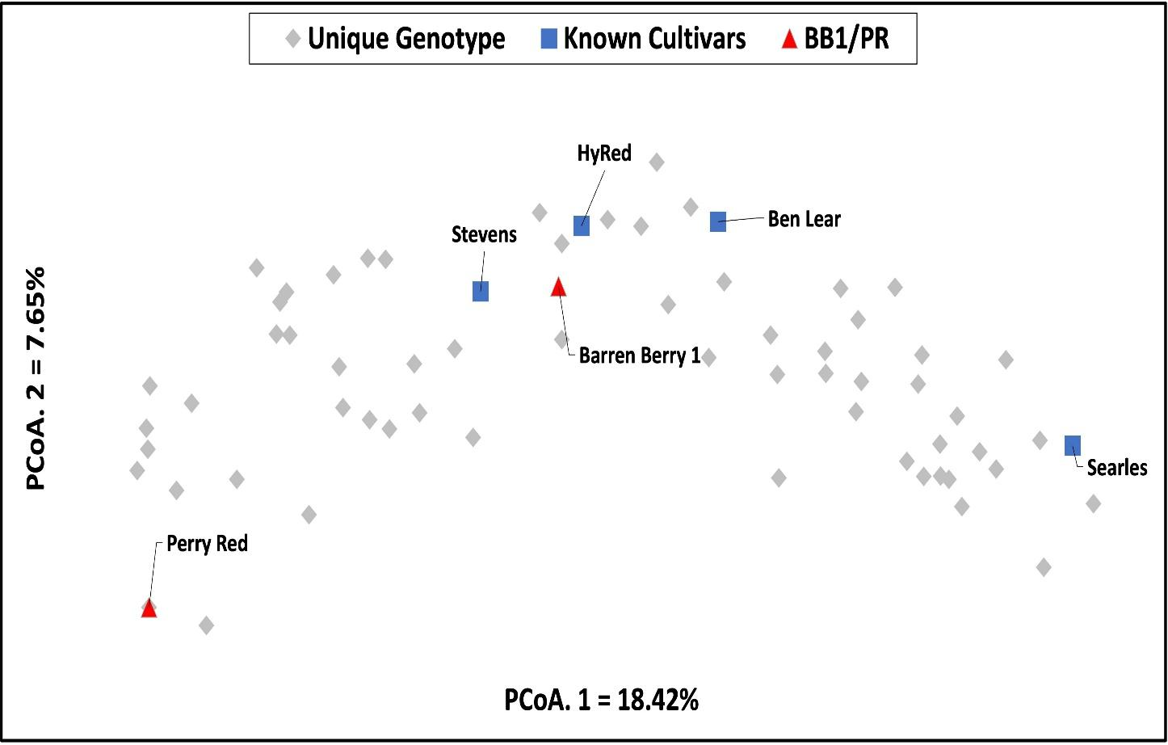

Supplementary Fig. 2 Principal coordinate analysis (PCoA) of 65 unique genotypes of cranberry samples submitted as productive or unproductive/barren (Table 1; Fig. 2) based on nine microsatellite markers. The genotypes of Barren Berry 1 and Perry Red are shown in Red. Diverse cultivar genotypes are shown in blue.
