Supplemental figures

Figure | Image
A, Ring stage | 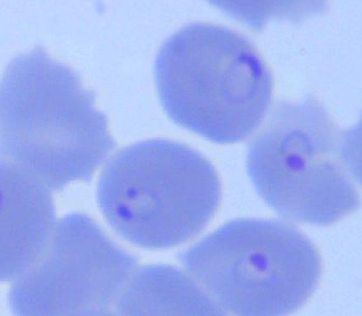
B, Gam stage I/II | 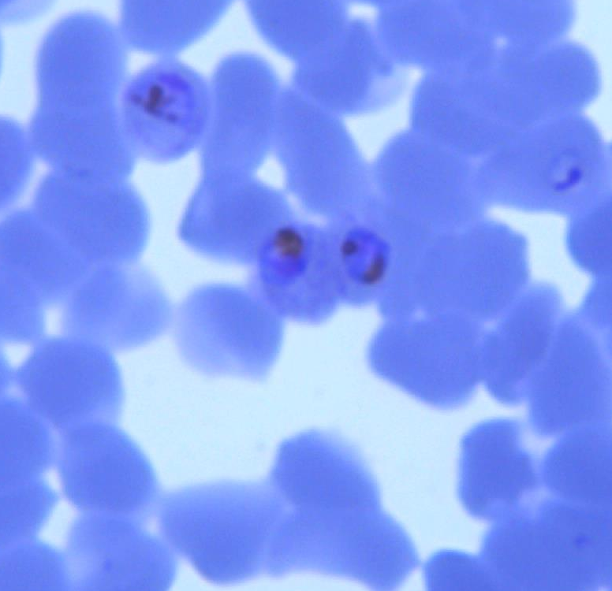
C, Gam stage III/IV | 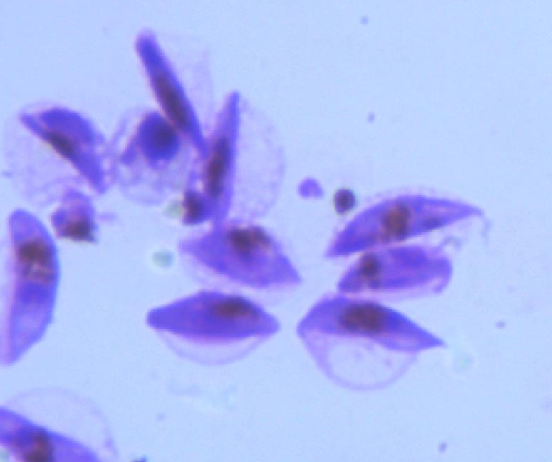
D, Gam stage V | 