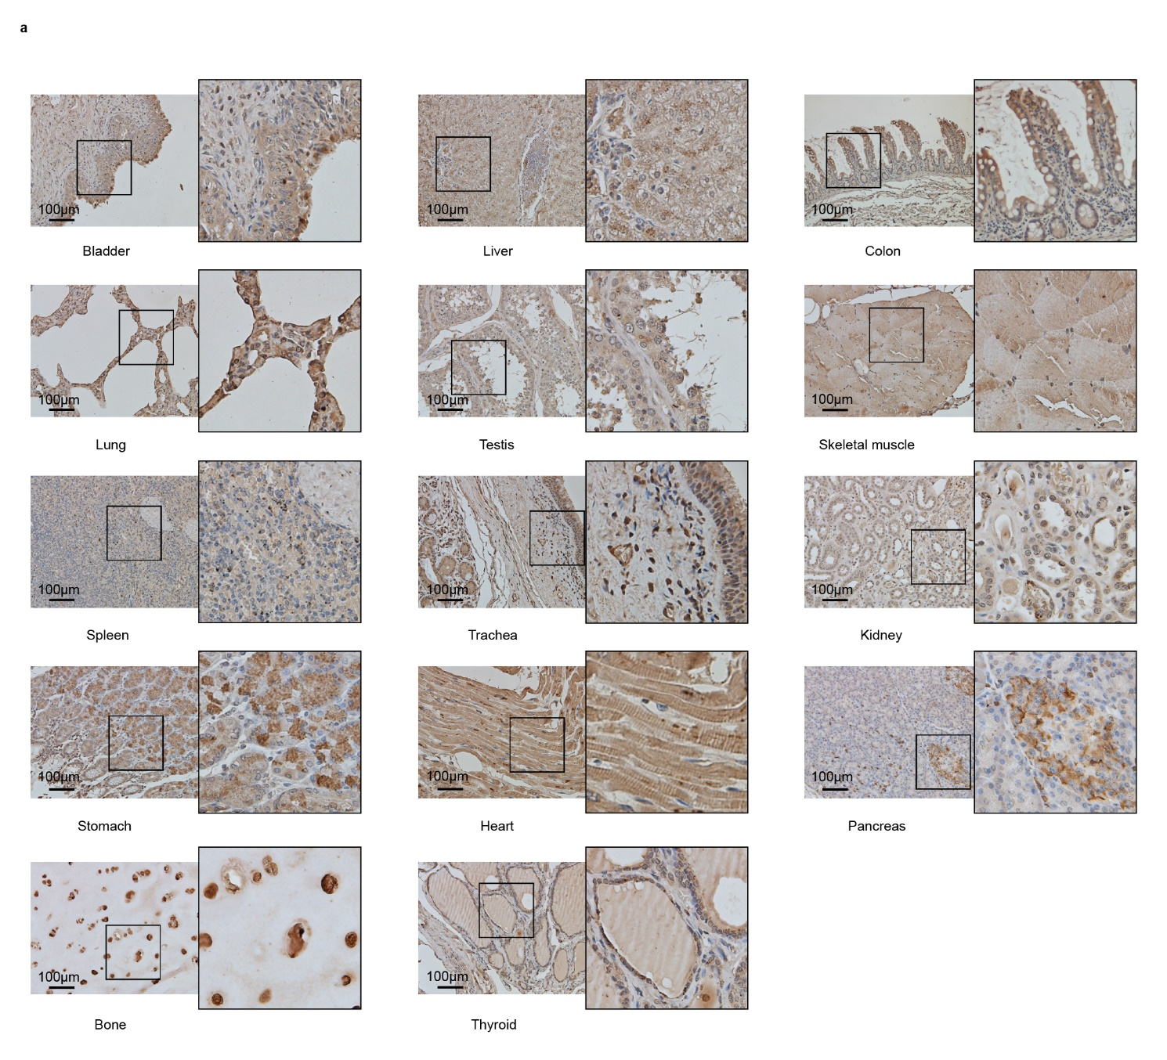Extended Data Fig. 1｜Expression and distribution of Knic in human tissues. a, Detection of Knic marks in human tissues. A variety of human tissues were performed by IHC staining with pan-Knic antibody respectively, followed by visualization with light microscopy. Scale bar, 100 μm.
Extended Data Fig. 2｜Nicotinic acid stimulates histone Knic. a, Chemical structures of NA. b, Core histones acid-extracted from HepG2 and MEF cells were treated with increasing concentration of NA for 24 h and tested using pan-Knic, pan-Kac, and H3 antibodies by Western blot analysis. Total histones were visualized with Coomassie blue staining. c, Core histones acid-extracted from HeLa, SW1116 and HEK293T cells were treated with 20 mM NA for 0,6,12,24,48 h respectively, and tested using pan-Knic, pan-Kac, and H3 antibodies by Western blot analysis. Total histones were visualized with Coomassie blue staining. d, The 1H-NMR spectrum of the H3K24-QLATKnicAAR peptide. e, The 1H-NMR spectrum of the H2BK6-MPEPAKnicSAPAPK peptide. f, Liver, kidney, colon, lung and heart tissue samples from C57BL/6J mice gavage-treated with NS, 600 mg/kg/day of NA or 600 mg/kg/day NAM for ten days were collected. And core histones were extracted and tested using pan-Knic and H3 antibodies by Western blot. Total histones were visualized with Coomassie blue staining. g, Liver and kidney tissue samples from C57BL/6J mice gavage-treated with NS, NA or NAM (n = 8). And core histones were extracted and tested using pan-Knic and H3 antibodies by Western blot. Total histones were visualized with Coomassie blue staining. h, Detection of Knic marks in gavage-treated C57BL/6J mice. Kidney and liver tissues from C57BL/6J mice gavage-treated with NS, NA or NAM were performed by IHC staining with pan-Knic antibody respectively, followed by visualization with light microscopy. Scale bar, 100 μm. i, Illustration of core histone Knic sites identified in HeLa cells. Histone Kinic sites that were reported previously are shown for comparison. ‘Inic’ indicates histone Kinic sites, ‘Nic’ indicates histone Knic sites. j, Extracted ion chromatograms from HPLC–MS/MS analysis of histone Knic peptides from NA-treated HeLa cells.

Extended Data Fig. 3｜Histone Knic is NAD⁺ independent and regulated by ACSS2. a, Schematic diagram of NA metabolism in vivo. b-c, Core histones acid-extracted from cells that treated with increasing concentration of NAM (b) or QA (c) and tested using pan-Knic, pan-Kac, and H3 antibodies by Western blot analysis. Total histones were visualized with Coomassie blue staining. d, e, Core histones acid-extracted from HEK293T cells were incubated with NA in vitro and detected. f, The HNMR spectrum of the nicotinyl-CoA（MeOD）. The detection result is consistent with the target structure. g, The MS test of the nicotinyl-CoA. At a wavelength of 254nm, the liquid phase test of the sample is 98.6%. The molecular weight of 872.5 corresponds to M+H (positive); The molecular weight of 436.8 corresponds to M/2+H. The detection result is consistent with the target structure. h, MS/MS spectra of standard sample nicotinyl-CoA, D4-Nicotinyl-CoA derived from HepG2 cells treated with or without D4-NA. i, Total CoAs were extracted from kidney and liver tissues of mice oral gavaged with NS, NA or NAM for 10 days, then tested acetyl-CoA level by HPLC-MS/MS, quantifications of the chromatographic peak area. Data presented are as mean ± SEM (n = 3), as determined by one-way ANOVA followed by Bonferroni’s test. j, The percentage of D4-NAD⁺ or D4-NAM in cells after D4-NA or D4-NAM treatment was detected by HPLC-MS/MS. k, Core histones acid-extracted from HeLa cells knocked down ACSS2 were tested using pan-Knic, pan-Kac, H3, ACSS2 and β-actin antibodies by Western blot. Total histones were visualized with Coomassie blue staining. l, Core histones acid-extracted from HeLa cells treated with ACSS2 inhibitor ACSS2i were tested using pan-Knic and H3 antibodies by Western blot. Total histones were visualized with Coomassie blue staining. m, Core histones acid-extracted from HeLa cells treated with ACSS2 inhibitor ACSS2i with or without treatment of NA were tested using pan-Knic and H3 antibodies by Western blot. Total histones were visualized with Coomassie blue staining.
Extended Data Fig. 4｜CUT&Tag-seq experiments of histone Knic. a, Distribution of hyper- (red) and hypo-accessible (blue) peaks over chromosomes in indicated cells. b, Pie chart showing the proportion of hyper-accessible peaks within the indicated genomic regions: 3’ UTR, 5’ UTR, distal intergenic, downstream, exon, intron and promoter. c, Volcano plot showing the CUT&Tag-seq results from HeLa cells treated with or without 10 mM NA for 24 h (n = 3) and enriched via pan anti-Knic antibody. 488 hyper histone Knic peaks are shown as red dots, whereas 15 peaks hypo histone Knic peaks are shown as blue dots. Filtered by p value < 0.05, absolute log2(FC) > 0.5.
Extended Data Fig. 5｜Histone Knic suppress PPFIA1 expression by blocking its binding to HOXB9. a, HEK293A cells were transfected with FLAG-PPFIA1. After treatment of NA, the cell lysates were co-immunoprecipitated with M2 beads and immunoblotted with the Knic antibody. b, Correlation of protein levels of ACSS2 and PPFIA1 from 165 pairs of HCC (red) and adjacent non-tumor tissues (blue) proteomic data in CPTAC dataset. c, DNA-pull down assay was conducted and HOXB9 protein pulled down by specific DNA sequences in PPFIA1 promoter was analyzed via LC-MS. d, The mRNA levels of HOXB9 from 374 HCC and 40 adjacent non-tumor tissues RNA-seq data in TCGA dataset.

Extended Data Fig. 6｜PPFIA1 regulates tumor oncogenes expression and participates in metastasis related signaling pathways. a, PPFIA1 survival curves in patients with multiple cancers in TCGA database were calculated using Kaplan-Meier plot analysis. b, Volcano plot of RNA-seq results comparing stably overexpressed Flag-PPFIA1 HepG2 cells with Flag-Vector. c, Heatmap of differential genes expression of indicated cells. d, KEGG pathways analysis of upregulated and downregulated genes in stably overexpressed Flag-PPFIA1 HepG2 cells. e, GSEA analysis of RNA-seq results. f, Heatmap of several oncogenes in stably overexpressed Flag-PPFIA1 HepG2 cells.

Extended Data Fig. 7｜PPFIA1 affects multiple tumor-related signaling pathways, also promotes HCC proliferation and metastasis. a, Heatmap showing the GSVA of KEGG terms between patients with high (n=72) and low (n=72) mRNA expression levels of PPFIA1 in TCGA-LIHC dataset, in which red and blue represent activated and inhibited pathways, respectively. b, Volcano plot showing the transcript levels of differentially expressed genes (DEGs) in patients with high and low mRNA expression levels of PPFIA1. Filtered by p value < 0.001, absolute log2(FC) > 1.5. c, Dot plot showing the significant enrichment GO ontology and KEGG terms of hyper expression genes in patients with high mRNA expression of PPFIA1. d, The PPFIA1 protein expression levels in normal tissues and primary tumor tissues of Breast cancer, CCRCC, Colon cancer, HNSCC, Liver cancer, LSCC, LUAD, Ovarian cancer and PDA cancer were examined using the CPTAC dataset. The red and blue boxes represent tumor tissues and normal tissues, respectively. e, Detection of PPFIA1 in HepG2 cells stably overexpressed Flag-PPFIA1 by Western blot. f, Colony formation assay for stably overexpressed Flag-Vector and Flag-PPFIA1 cells. g, Migrating and invasive ability of the indicated cells was determined by transwell assay.
Extended Data Fig. 8｜Knockdown of PPFIA1 inhibits HCC proliferation and metastasis. a, Detection of PPFIA1 in HepG2 cells after downregulating PPFIA1 by transfection with shRNA by Western blot assays. b, Proliferation ability of the indicated cells was detected by the CCK-8 assay. Data presented are as mean ± SEM (n = 4), as determined by two-way ANOVA test. c, Colony formation assay for PPFIA1 knockdown HepG2 cells. Data presented are as mean ± SEM (n = 3), as determined by one-way ANOVA followed by Bonferroni’s test. d, Migrating and invasive ability of the indicated cells was determined by transwell assay. Data presented are as mean ± SEM (n = 3), as determined by one-way ANOVA followed by Bonferroni’s test. e, The expression of Ki-67 and E-cadherin in liver and lung indicated by IHC staining. Scale bar, 50μm.

Extended Data Fig. 9｜Overexpression of PPFIA1 rescued the suppression of HepG2 cells proliferation, migration and invasion caused by NA. a, Proliferation ability of the indicated cells was detected by the CCK-8 assay. Data presented are as mean ± SEM (n = 4), as determined by two-way ANOVA test. b, Colony formation assay for indicated cells. Data presented are as mean ± SEM (n = 3), as determined by one-way ANOVA followed by Bonferroni’s test. c, Migrating and invasive ability of the indicated cells was determined by transwell assay. Data presented are as mean ± SEM (n = 3), as determined by one-way ANOVA followed by Bonferroni’s test. d, Representative multi-color immunofluorescence images of Knic (grey), PPFIA1(purple) and DAPI (blue) staining in paired HCC (right) and adjacent non-tumor (left) tissues. e, Detection of Knic in HCC patient samples paired with tumor tissue (shown as Tumor) and adjacent non-tumor tissue (shown as Adjacent) by IHC staining with Knic antibody, followed by visualization with light microscopy, scale bar, 250 μm, and the positive percentage were quantified. Data presented are as mean ± SEM (n = 76 pairs), as determined by paired two-tailed Student’s t-test. f, Kaplan–Meier survival analysis of the relationship between survival time and expression of Knic in HCC patients. Data presented are as mean ± SEM (n = 80 pairs), as determined by Breslow’s test. g, A model for the histone Knic in transcription regulation and its molecular mechanism of inhibiting HCC.

Extended Data Fig. 10｜NA suppresses hepatocarcinoma cell progression. a, Proliferation ability of the HepG2 cells treated with NA was detected by the CCK-8 assay. Data presented are as mean ± SEM (n = 3), as determined by two-way ANOVA test. b, Colony formation assay for the HepG2 cells treated with NA. Data presented are as mean ± SEM (n = 3), as determined by unpaired two-tailed Student’s t-test. c, Migrating and invasive ability of the indicated cells was determined by transwell assay. Data presented are as mean ± SEM (n = 3), as determined by unpaired two-tailed Student’s t-test. d, Liver tissue samples from C57BL/6J mice gavage-treated with NS, 600 mg/kg/day of NA or 600 mg/kg/day NAM for ten days were collected.

