Availability of Data and Software
In this study, some free open access software were used to obtain information about the data which is given below-
1. Protein Data Bank (PDB) – It is the free access software, to collect the information about the three dimensional (3D) structure of large biomolecules such as proteins and nucleic acids.
Software available from:https://www.rcsb.org/
In current study, 3 crystal structures of PCOS proteins were downloaded from the Protein Data Bank and their accession numbers (PDB IDs) are given below-
S.No. | Protein | PDB IDs
1 | CYP 17 | 3RUK
2 | 5α-reductase | 7BW1
3 | Human androgen receptor | 2AM9
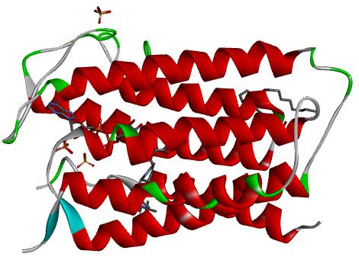
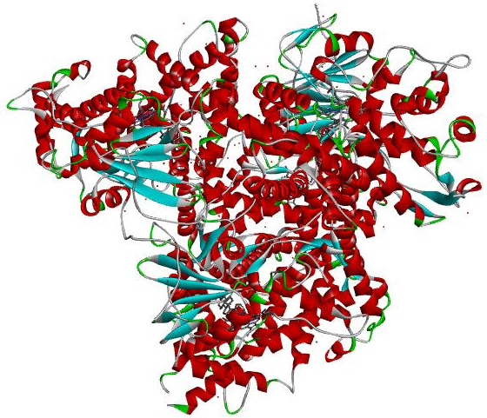
B

A

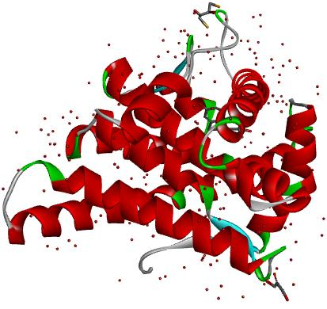
C

Fig.1 3D crystallographic structure of target protein A. CYP-17 B. 5α-reductase C. Human androgen receptor

2. PubChem – It is an open access database, to collect the 2D and 3D structure of chemical substances and their biological activities.
Software available from: https://pubchem.ncbi.nlm.nih.gov/
In current study, 3 reference drugs namely (metformin, spironolactone and cyproterone acetate) and18 phytochemical compounds of Zanthoxylum armatum, were downloaded from the Pubchem database and their Pubchem CID number and chemical structure are given below-
2D interaction of reference drugs (metformin, spironolactone and cyproterone acetate) and phytochemical compounds of Zanthoxylum armatum with CYP-17, 5α-reductase and Human Androgen Receptor by Discovery Studio Visualizer

S.No. | Phytochemical compounds of Zanthoxylum armatum | PubChem CID | Chemical structure | CYP-17 | 5α-reductase | Human Androgen Receptor
1 | Hesperidin | 10621 | 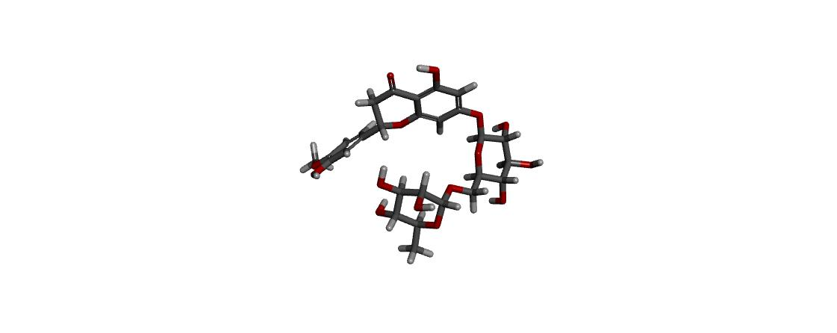 | 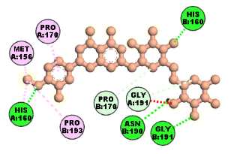 | 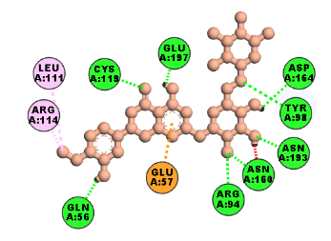 | 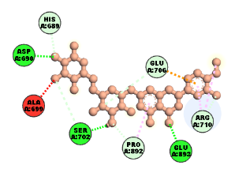
2 | Asarinin | 11869417 | 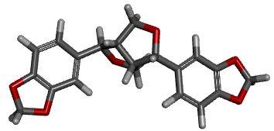 | 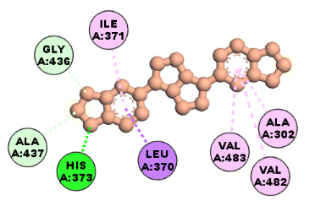 | 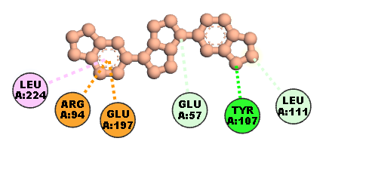 | 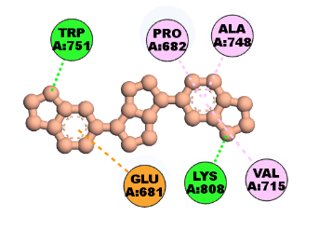
3 | Isovitexin | 162350 | 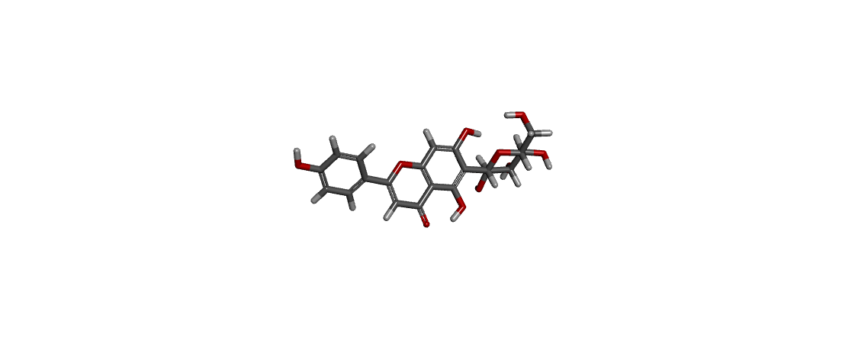 | 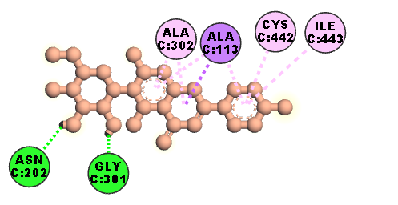 | 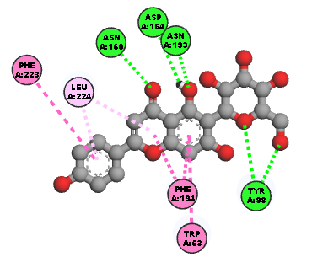 | 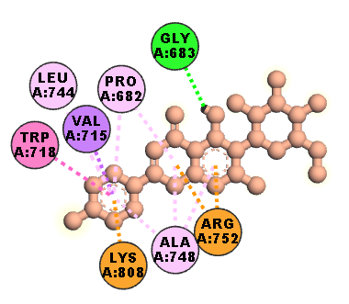
4 | Tambuletin | 9936050 | 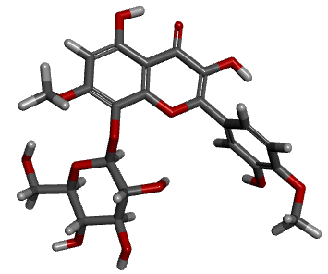 | 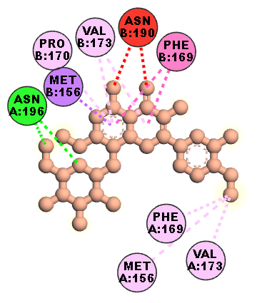 | 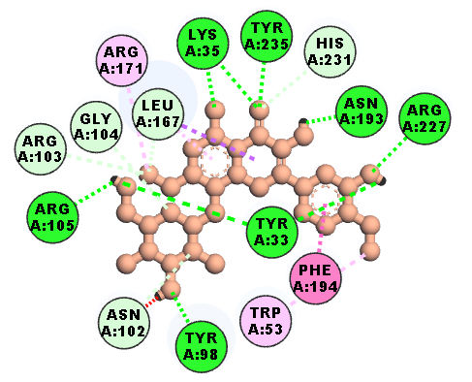 | 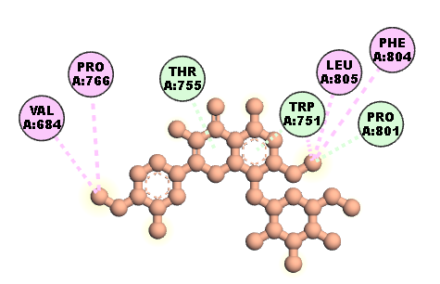
5 | Chelerythrine | 2703 | 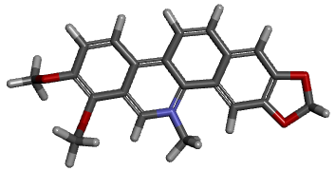 | 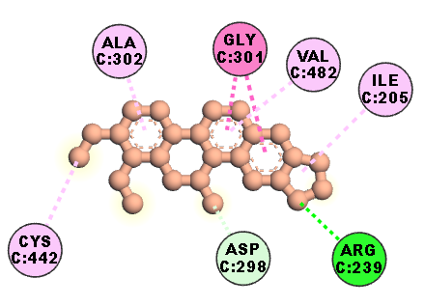 | 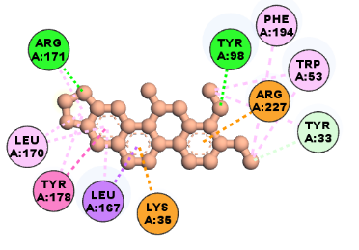 | 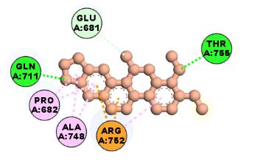
6 | Lupeol | 259846 | 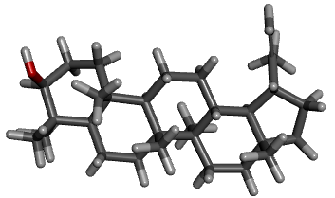 | 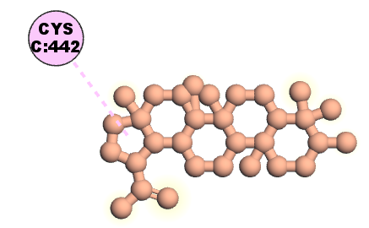 | 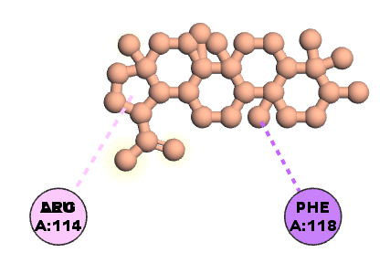 | 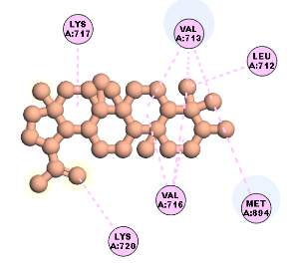
7 | Vitexin | 5280441 | 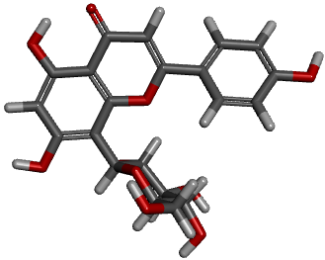 | 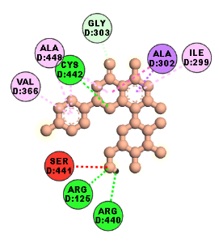 | 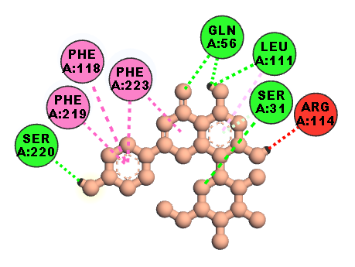 | 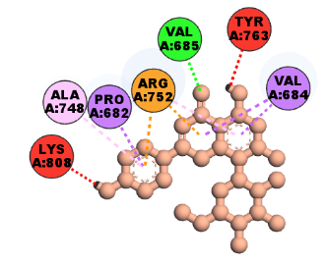
8 | Xanthyletin | 65188 | 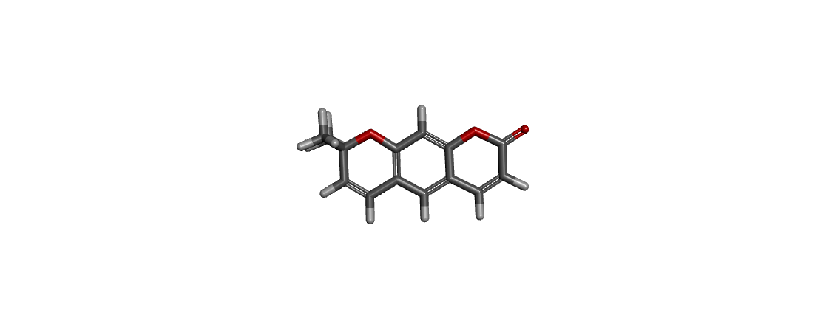 | 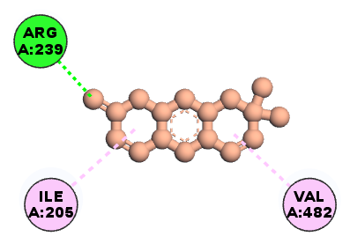 | 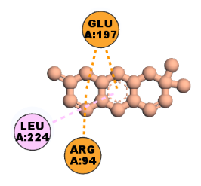 | 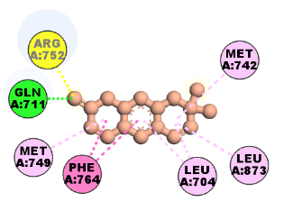
9 | Kaempferol | 5280863 | 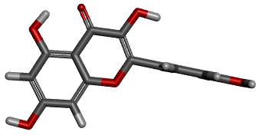 | 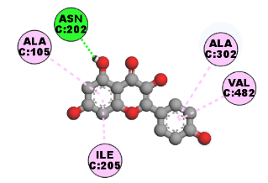 | 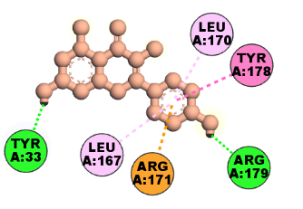 | 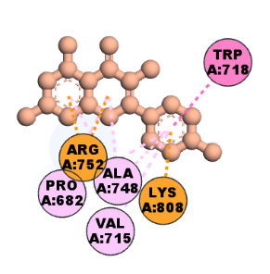
10 | Kobusin | 182278 | 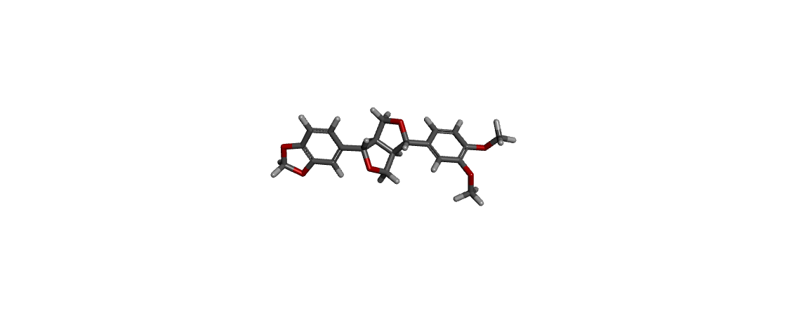 | 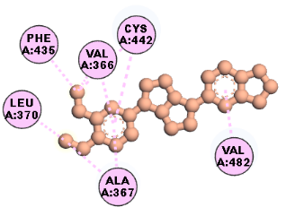 | 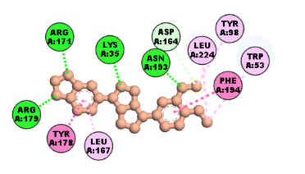 | 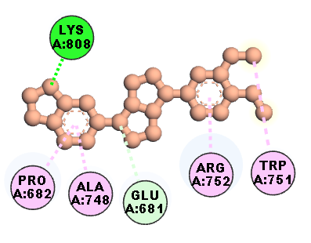
11 | β-sitosterol | 222284 | 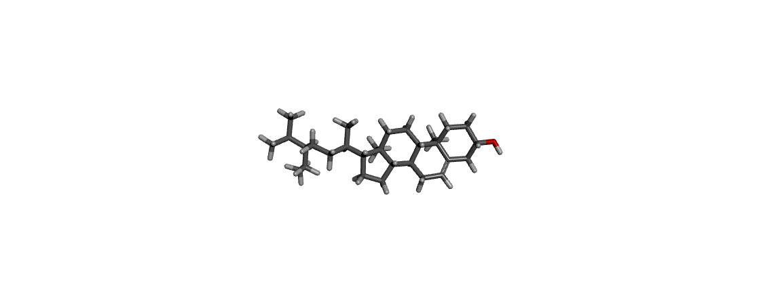 | 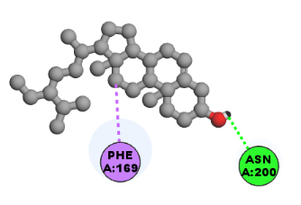 | 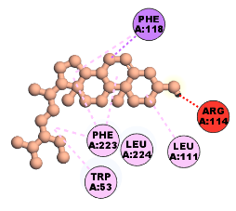 | 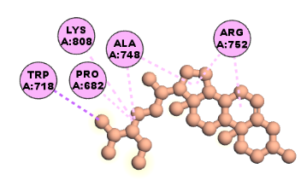
12 | Fargesin | 10926754 | 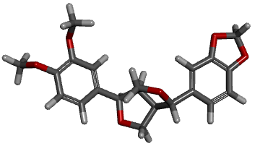 | 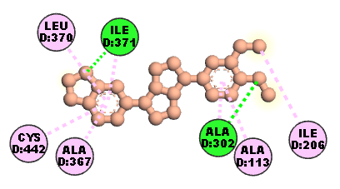 | 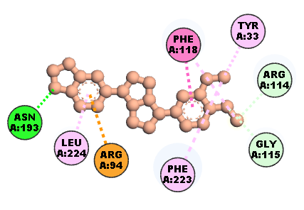 | 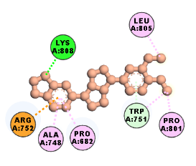
13 | Eudesmin | 234823 | 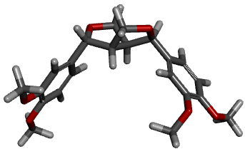 | 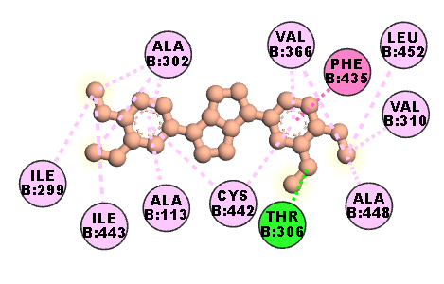 | 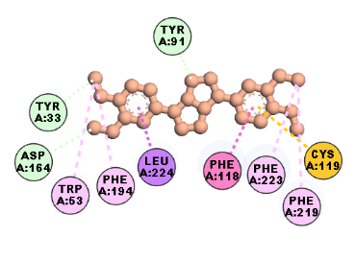 | 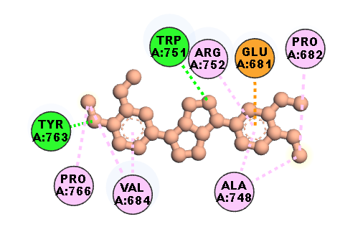
14 | Epieudesmin | 7000209 | 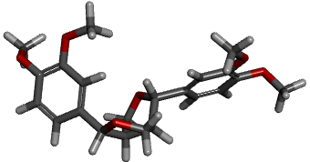 | 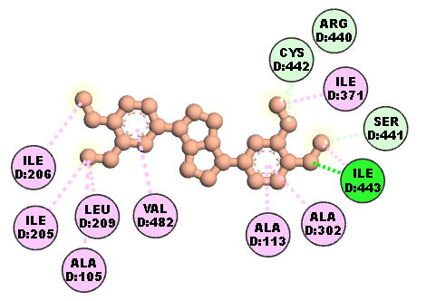 | 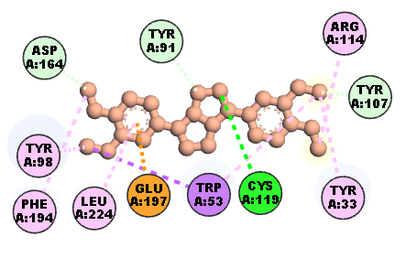 | 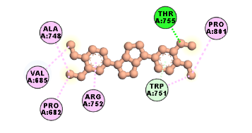
15 | Catechin | 9064 | 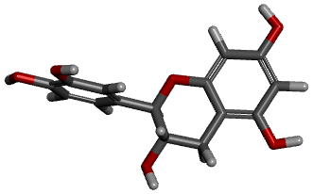 | 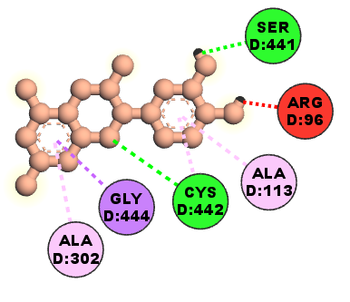 | 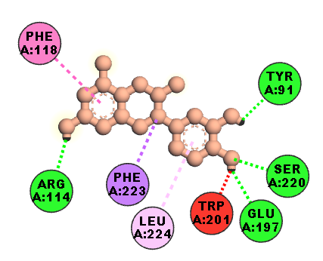 | 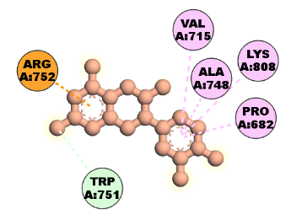
16 | Planinin | 129290 | 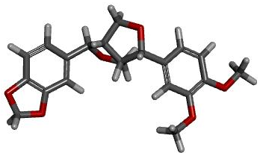 | 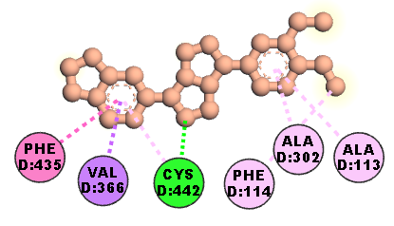 | 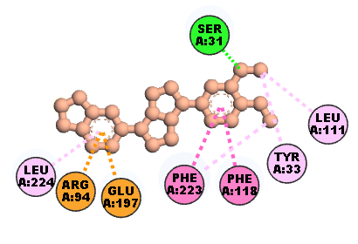 | 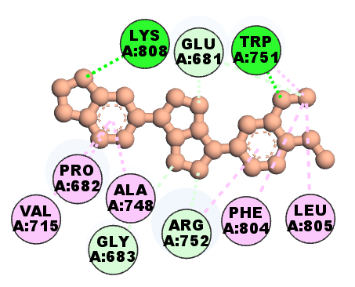
17 | Metformin | 4901 |  | 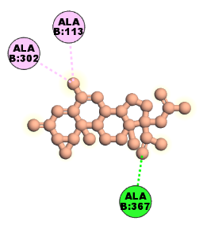 | 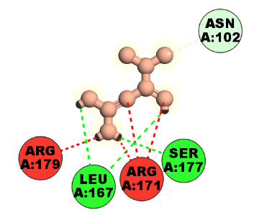 | 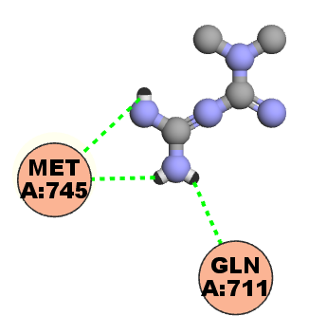
18 | Spironolactone | 5833 |  | 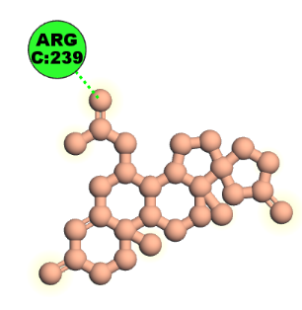 | 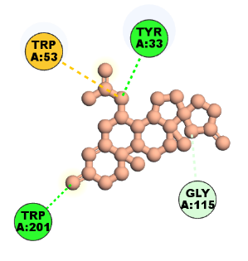 | 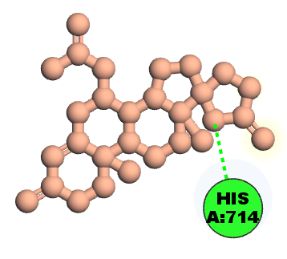
19 | Cyproterone acetate | 9880 | 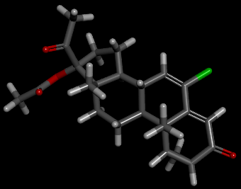 | 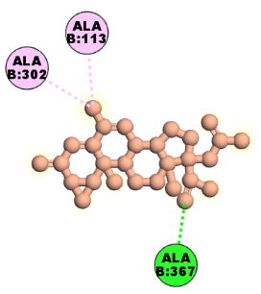 | 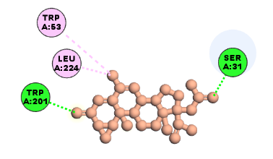 | 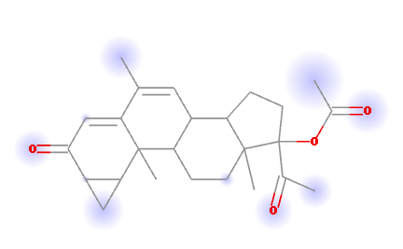

Table.1Showing the phytochemical structure of Zanthoxylum armatum and their PubChem CID number and 2D interaction of reference drugs (metformin, spironolactone and cyproterone acetate) and phytochemical compounds of Zanthoxylum armatum with CYP-17, 5α-reductase and Human Androgen Receptor by Discovery Studio Visualizer

3. PyMOL- It is freely available software, has been widely used for 3D visualization of protein and nucleic acid and also removing the water molecule and existing ligand from protein molecule.
Software available from:https://pymol.org/2/
B
A
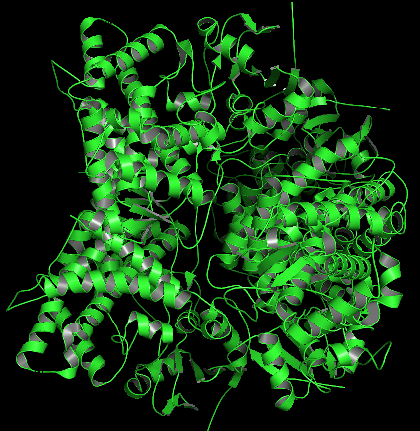
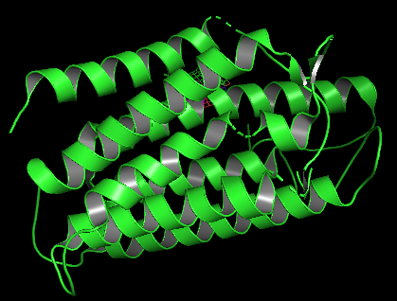

C
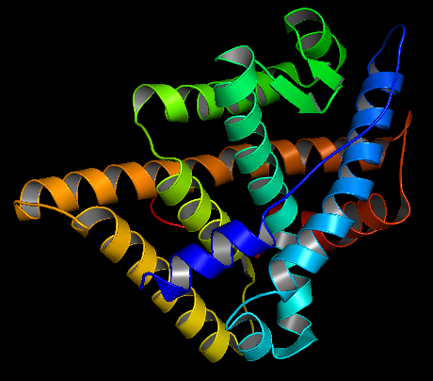

Fig. 2 A. Showing the CYP-17 receptor after removal of the water molecule B.Showing the 5α-reductase receptor after removal of the water molecule C. Showing the Human androgen receptor after removal of the water molecule

4. Open Babel Software- It is an open-source software, used to convert the structure data format (SDF) to PDB format.
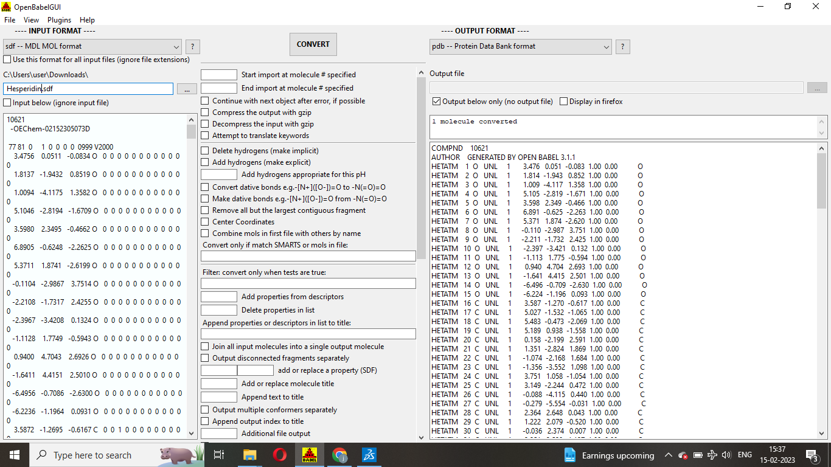
Software available from:https://openbabel.org/wiki/Main_Page

Fig.3 Showing the conversion of SDF file of hesperidin to PDB format

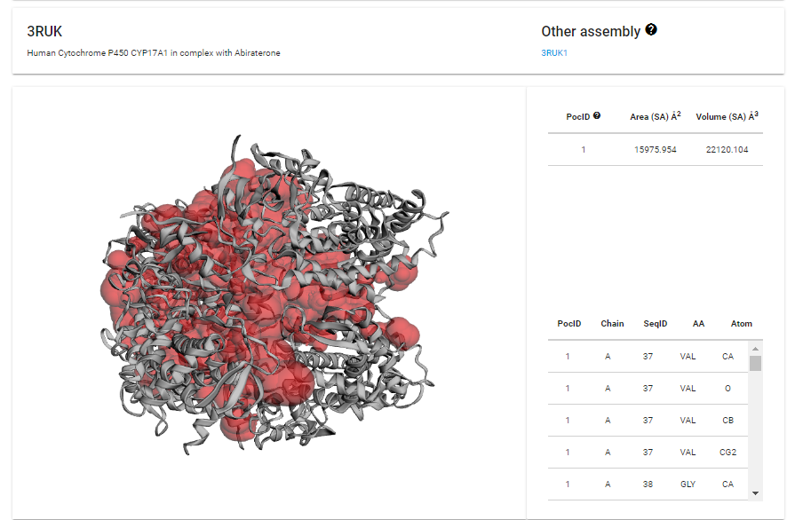
5. Active site prediction –This was executed using CAST_{P} 3.0 and PLIP web server to find the active sites/binding pockets in the selected target proteins where the drugs are most likely to bind with stable free energy.
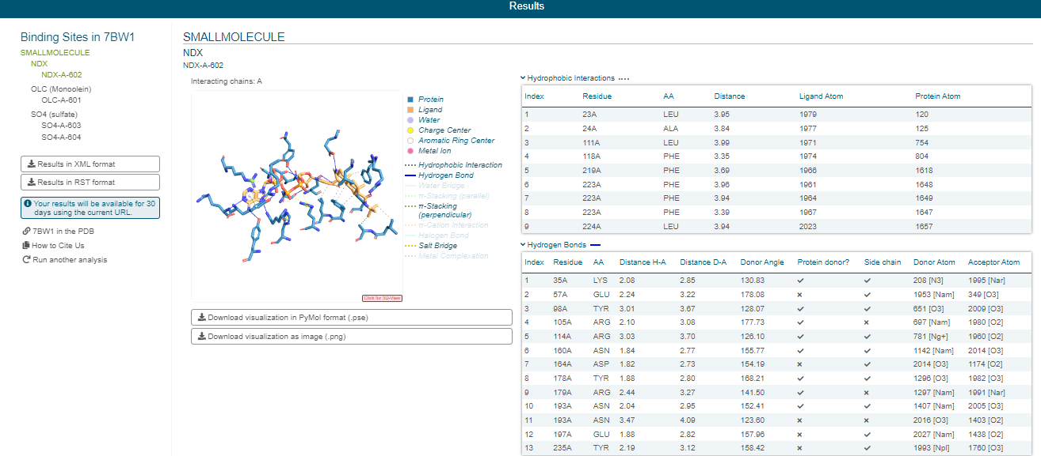
Fig.4 Showing the active sites/binding pockets of CYP-17 receptor

Fig.5 Showing the active sites/binding pockets of 5α-reductase receptor

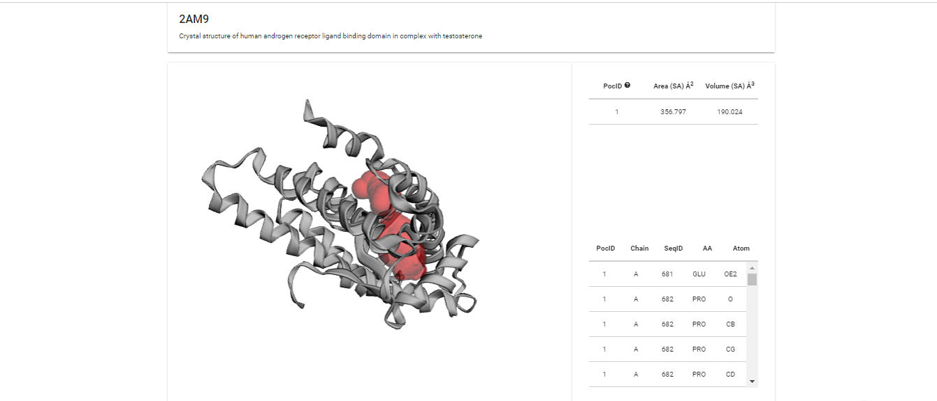
Fig.6 Showing the active sites/binding pockets of Human androgen receptor

6. PyRx (Auto vina and Autodock 4.2)- It is free and open-source software, used to screen libraries of compounds against potential drug targets.
Software available from:https://pyrx.sourceforge.io/
Target candidate | X coordination | Y coordination | Z coordination
CYP-17 | 2.012 | 18.474 | 45.844
5α- reductase | -32.310 | 14.101 | 31.023
Human Androgen Receptor | 25.118 | 9.514 | 8.216

Table.2 Showing the x, y and z coordinates of the grid docking box of each protein molecule

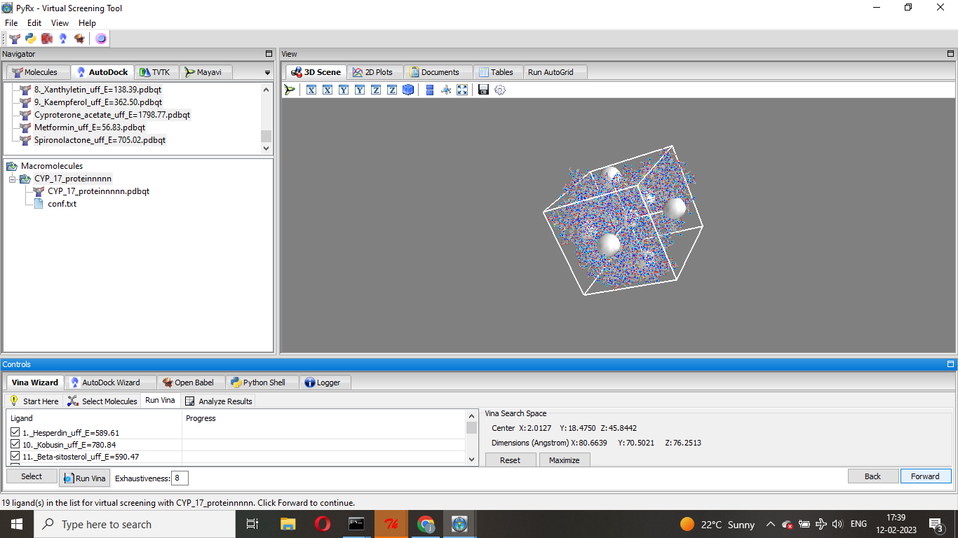
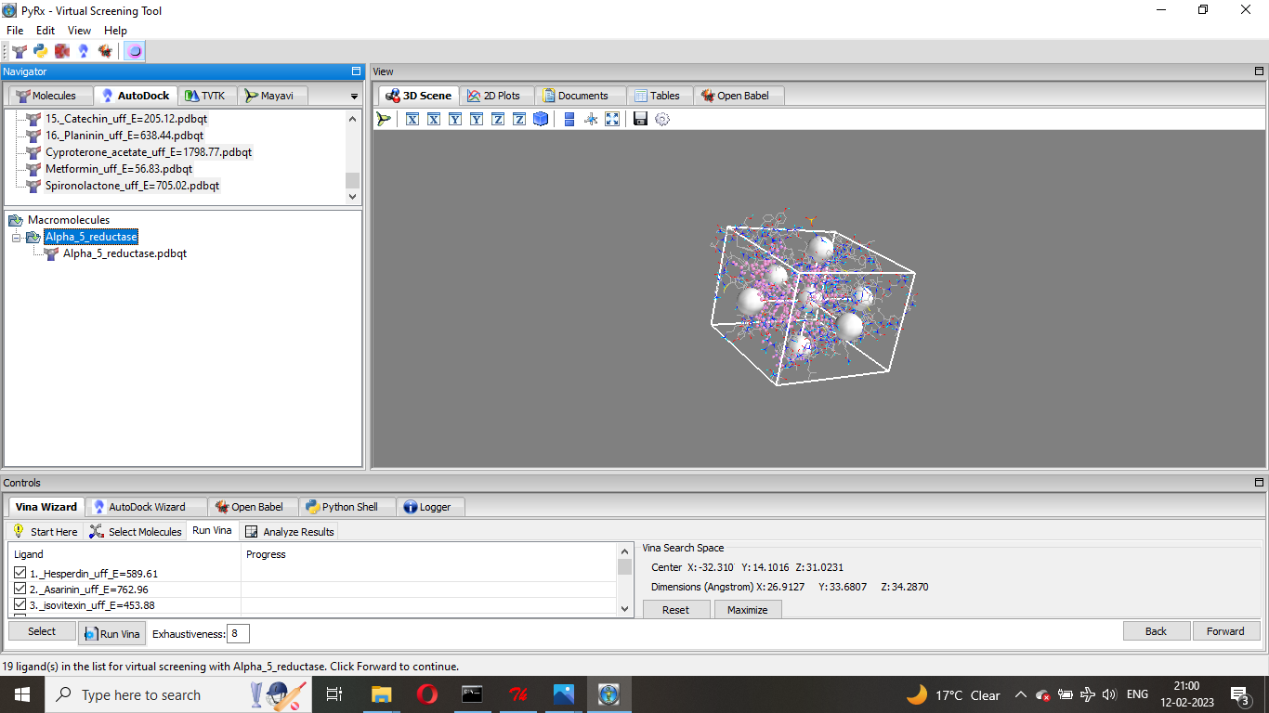
Fig.7 Showing the x, y and z dimension of the grid box of CYP-17 receptor

Fig.8 Showing the x, y and z dimension of the grid box of 5α-reductase receptor

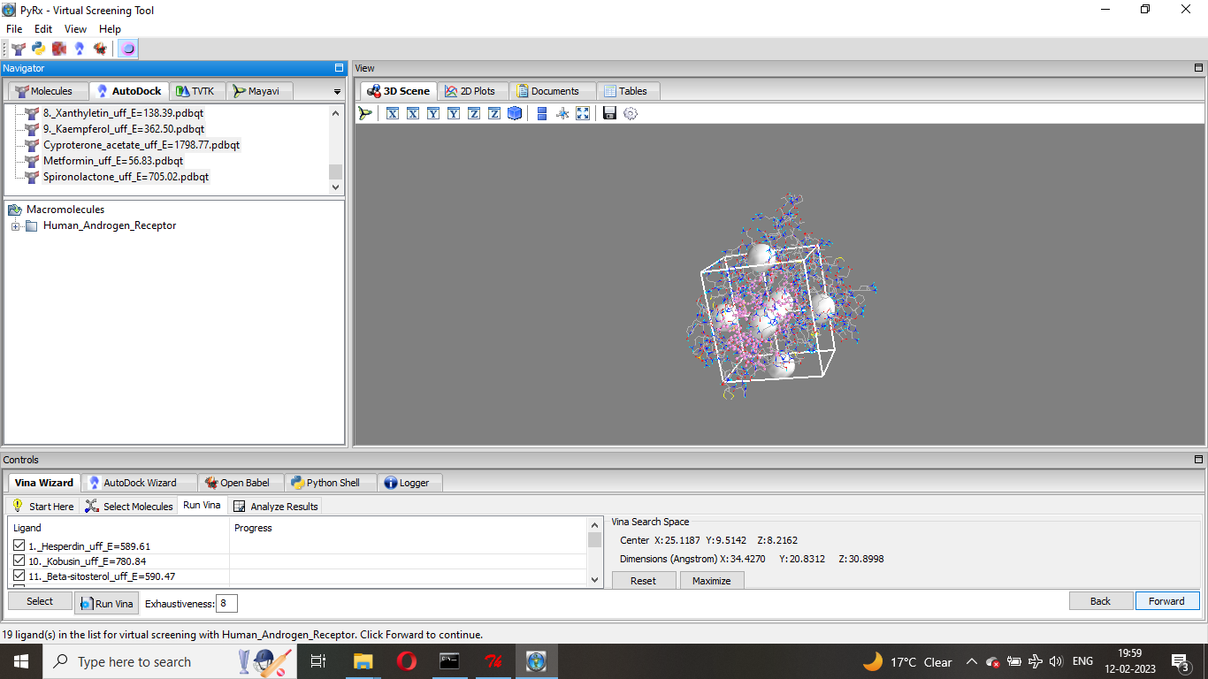
Fig.9 Showing the x, y and z dimension of the grid box of Human androgen receptor
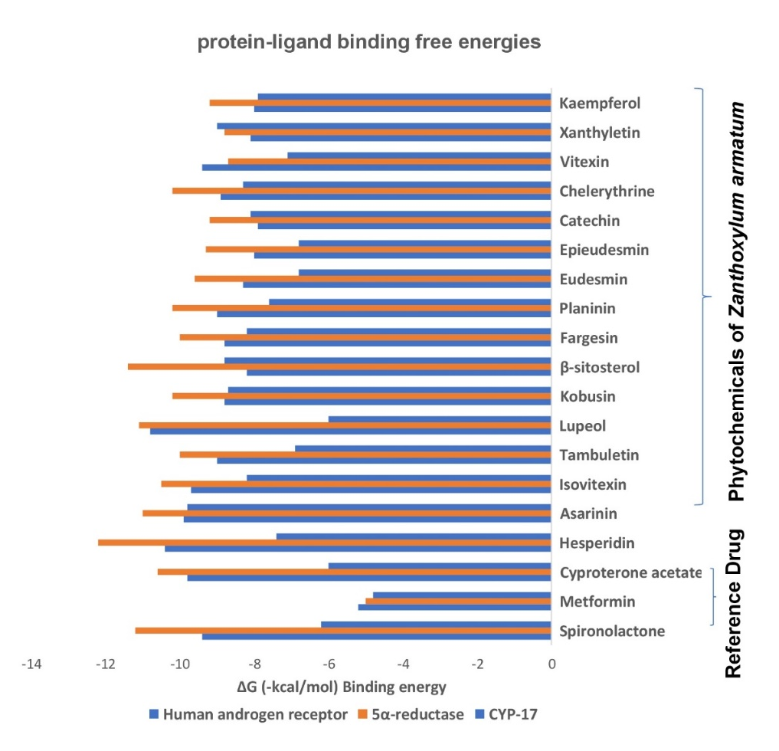

Fig.10 Graph showing the binding energy value ΔG (-kcal/ mol) of CYP-17, 5α-reductase and human androgen receptor with several inhibitor compound candidate

7. Swiss ADME- It is freely available software, used to predict the potential toxicity of any drug molecule.
Software available from:http://www.swissadme.ch/
In current study, we have taken 16 phytochemicals of Zanthoxylum armatum, to predict the potential toxicity and their canonical smiles are given below-
S.No. | Phytochemical of Zanthoxylum armatum | Canonical smiles
1 | Hesperidin | CC1C(C(C(C(O1)OCC2C(C(C(C(O2)OC3=CC(=C4C(=O)CC(OC4=C3)C5=CC(=C(C=C5)OC)O)O)O)O)O)O)O)O
2 | Asarinin | C1C2C(COC2C3=CC4=C(C=C3)OCO4)C(O1)C5=CC6=C(C=C5)OCO6
3 | Isovitexin | C1=CC(=CC=C1C2=CC(=O)C3=C(O2)C=C(C(=C3O)C4C(C(C(C(O4)CO)O)O)O)O)O
4 | Tambuletin | COC1=C(C=C(C=C1)C2=C(C(=O)C3=C(O2)C(=C(C=C3O)OC)OC4C(C(C(C(O4)CO)O)O)O)O)O
5 | Chelerythrine | C[N+]1=C2C(=C3C=CC(=C(C3=C1)OC)OC)C=CC4=CC5=C(C=C42)OCO5
6 | Lupeol | CC(=C)C1CCC2(C1C3CCC4C5(CCC(C(C5CCC4(C3(CC2)C)C)(C)C)O)C)C
7 | Vitexin | C1=CC(=CC=C1C2=CC(=O)C3=C(O2)C(=C(C=C3O)O)C4C(C(C(C(O4)CO)O)O)O)O
8 | Xanthyletin | CC1(C=CC2=C(O1)C=C3C(=C2)C=CC(=O)O3)C
9 | Kaempferol | C1=CC(=CC=C1C2=C(C(=O)C3=C(C=C(C=C3O2)O)O)O)O
10 | Kobusin | COC1=C(C=C(C=C1)C2C3COC(C3CO2)C4=CC5=C(C=C4)OCO5)OC
11 | β-sitosterol | CCC(CCC(C)C1CCC2C1(CCC3C2CC=C4C3(CCC(C4)O)C)C)C(C)C
12 | Fargesin | COC1=C(C=C(C=C1)C2C3COC(C3CO2)C4=CC5=C(C=C4)OCO5)OC
13 | Eudesmin | COC1=C(C=C(C=C1)C2C3COC(C3CO2)C4=CC(=C(C=C4)OC)OC)OC
14 | Epieudesmin | COC1=C(C=C(C=C1)C2C3COC(C3CO2)C4=CC(=C(C=C4)OC)OC)OC
15 | Catechin | C1C(C(OC2=CC(=CC(=C21)O)O)C3=CC(=C(C=C3)O)O)O
16 | Planinin | COC1=C(C=C(C=C1)C2C3COC(C3CO2)C4=CC5=C(C=C4)OCO5)OC
17 | Metformin | CN(C)C(=N)N=C(N)N
18 | Spironolactone | CC(=O)SC1CC2=CC(=O)CCC2(C3C1C4CCC5(C4(CC3)C)CCC(=O)O5)C
19 | Cyproterone acetate | CC(=O)C1(CCC2C1(CCC3C2C=C(C4=CC(=O)C5CC5C34C)Cl)C)OC(=O)C

Table.3 Showing the canonical SMILES format of phytochemical compounds of Zanthoxylum armatum
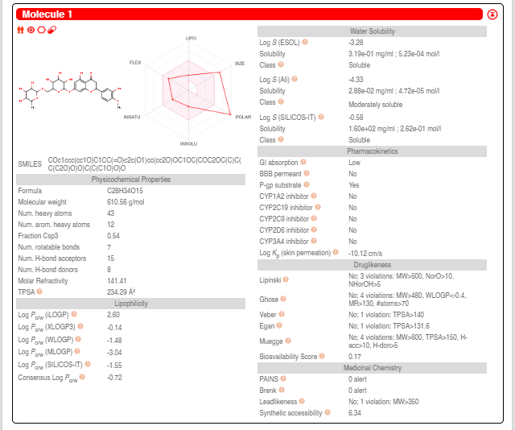

Fig.11 Schematic representation of Hesperidin for drug likeness
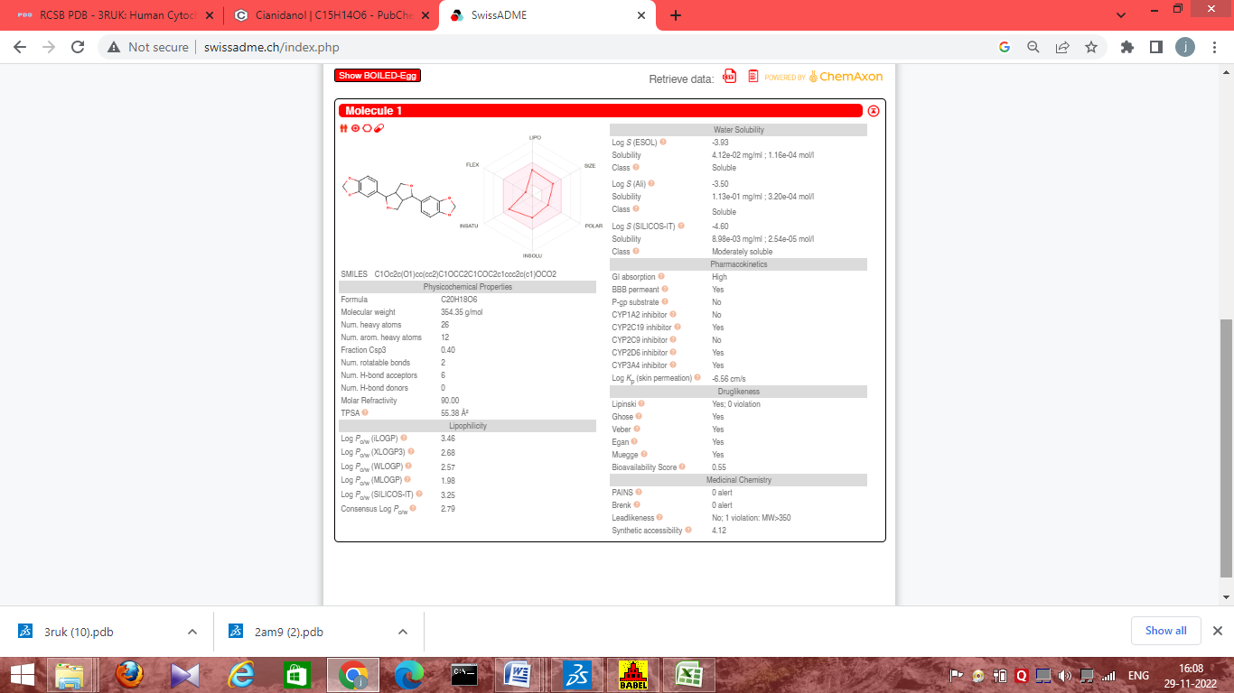

Fig.12 Schematic representation of Asarinin for drug likeness
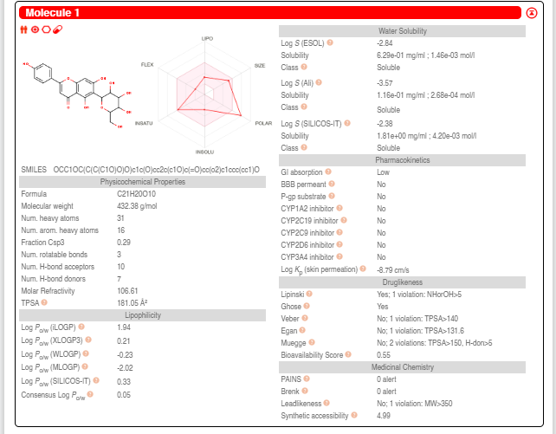

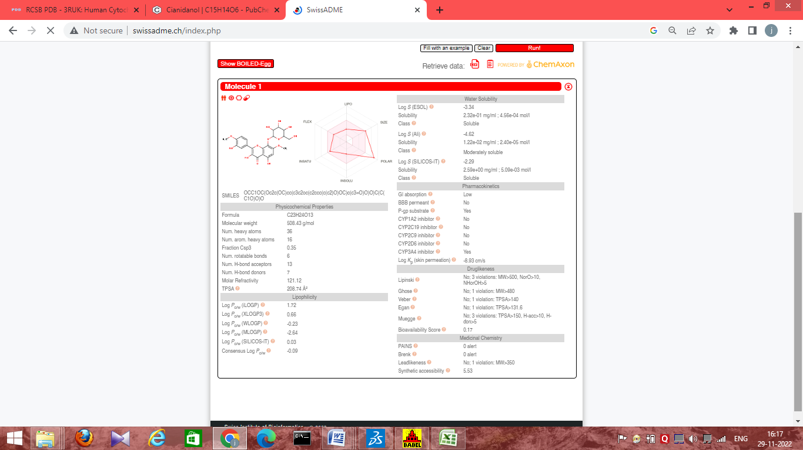
Fig.13 Schematic representation of Isovitexin for drug likeness

Fig.14 Schematic representation of Tambuletin for drug likeness
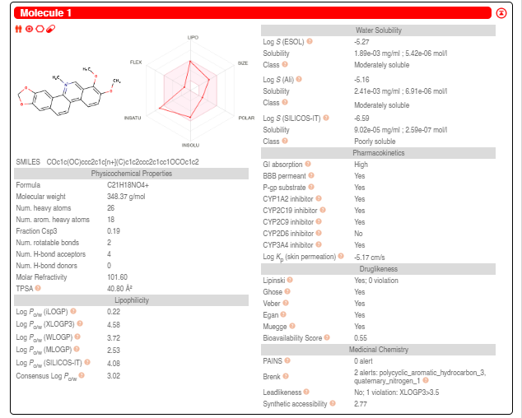

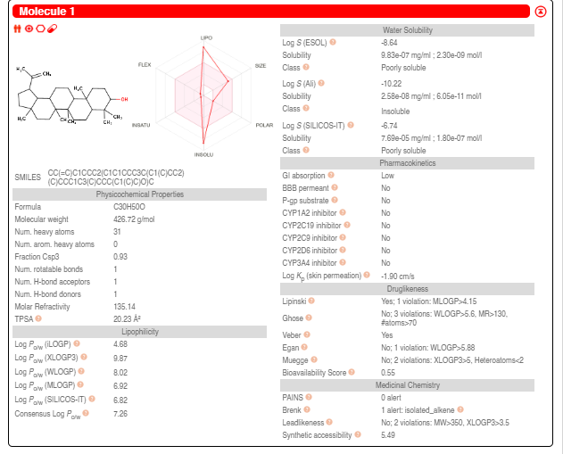
Fig.15 Schematic representation of Chelerythrine for drug likeness

Fig.16 Schematic representation of Lupeol for drug likeness
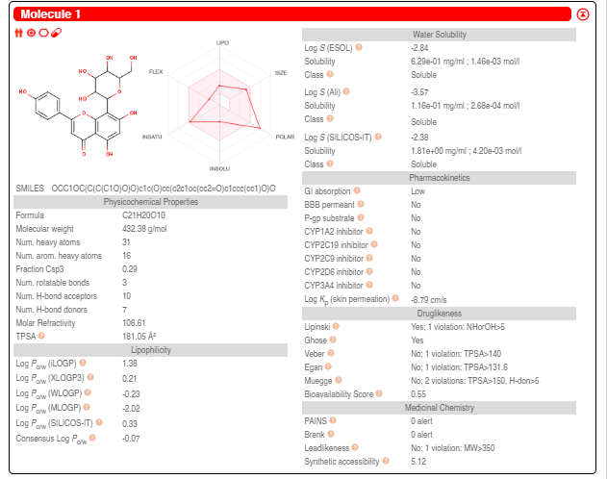

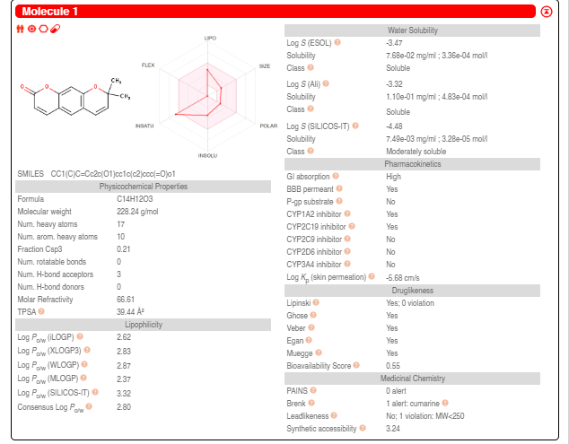
Fig.17 Schematic representation of Vitexin for drug likeness

Fig.18 Schematic representation of Xanthyletin for drug likeness
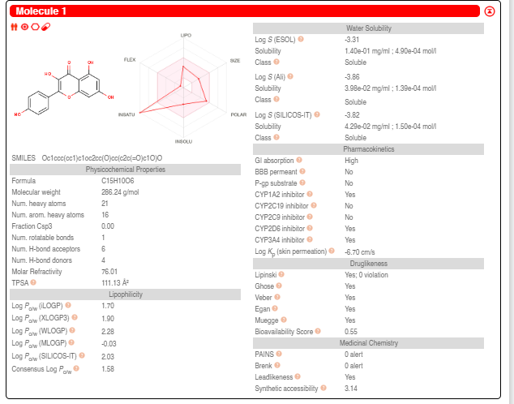
Fig.19 Schematic representation of Kaempferol for drug likeness
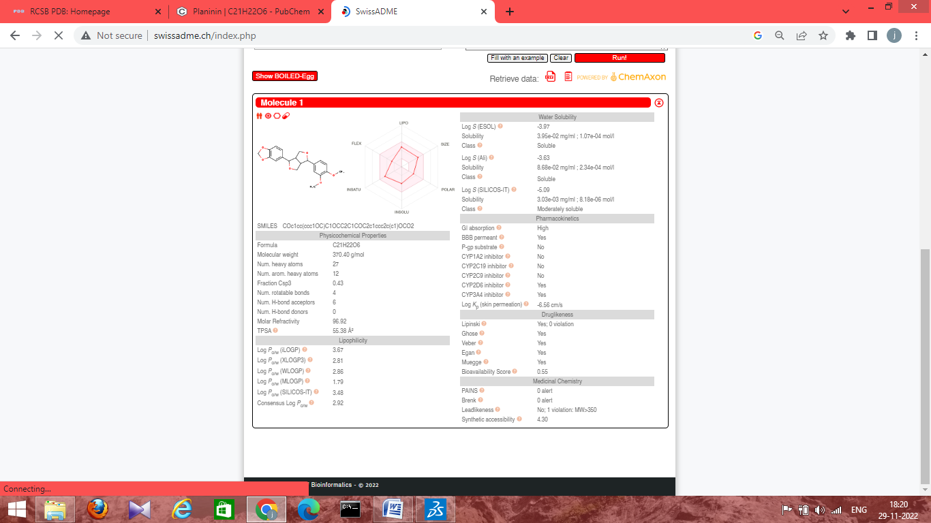

Fig.20 Schematic representation of Kobusin for drug likeness
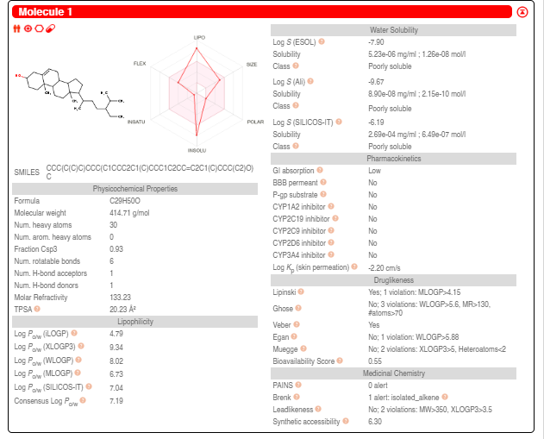

Fig.21 Schematic representation of β-sitosterol for drug likeness
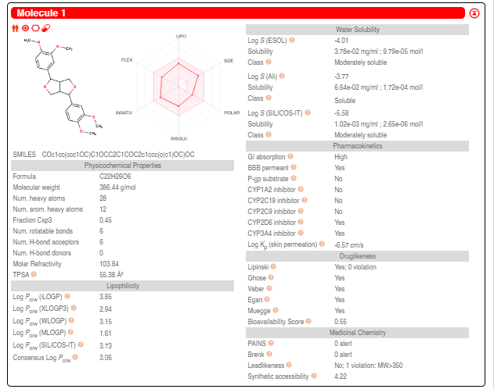

Fig.22 Schematic representation of Eudesmin for drug likeness
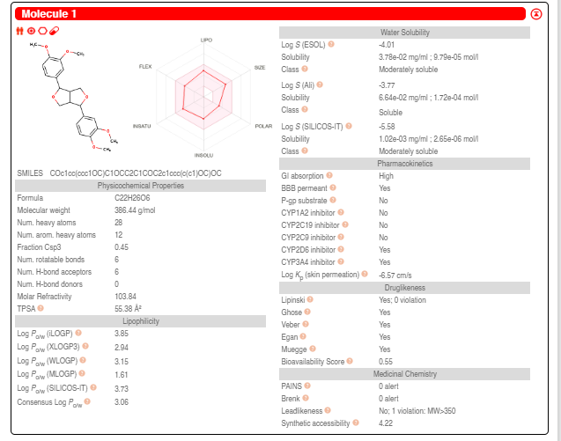

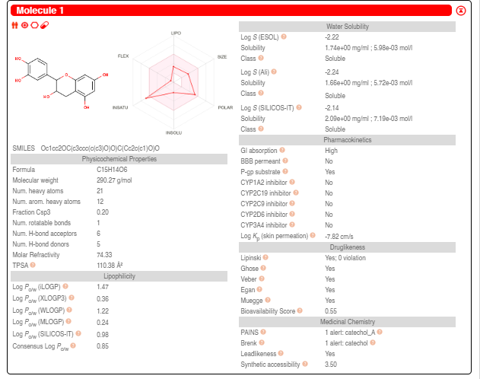
Fig.23 Schematic representation of Epieudesmin for drug likeness

Fig.24 Schematic representation of Catechin for drug likeness

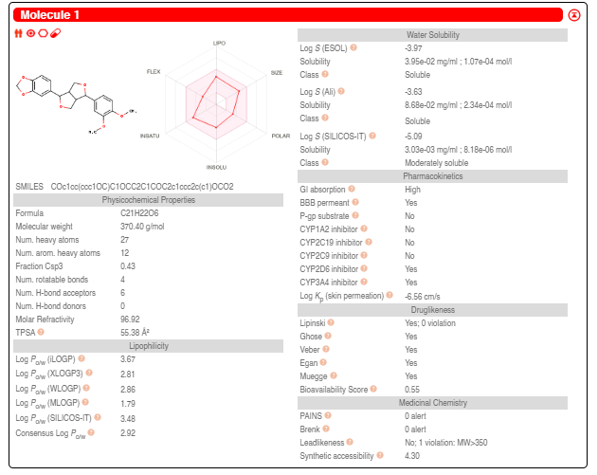

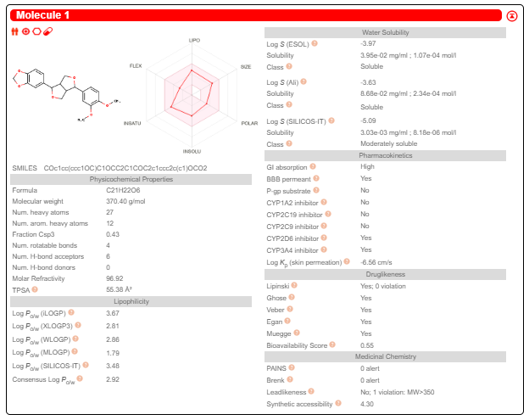
Fig.25 Schematic representation of Planinin for drug likeness

Fig.26 Schematic representation of fargesin for drug likeness
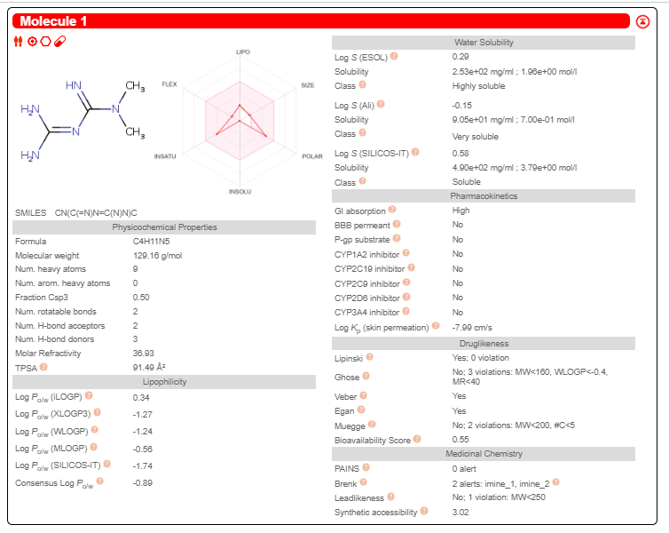

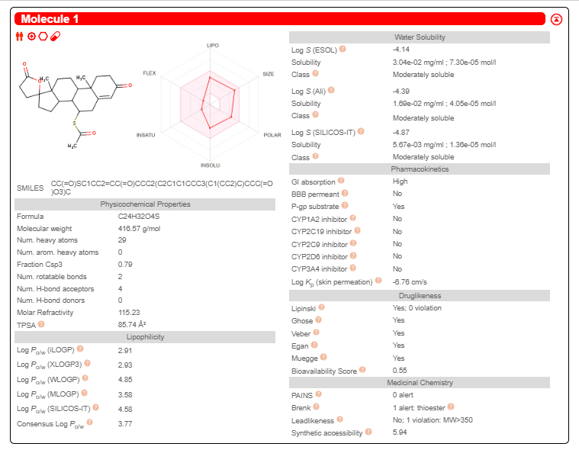
Fig.27 Schematic representation of metformin for drug likeness

Fig.28 Schematic representation of spironolactone for drug likeness
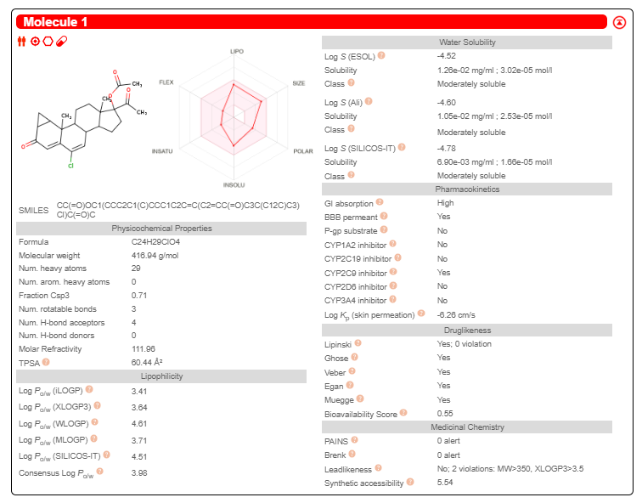
Fig.29 Schematic representation of cyproterone acetate for drug likeness

Summary of Swiss ADME for toxicity of phytochemical of Zanthoxylum armatum
Lipinski’s Rule of five (Ro5)
S.No. | Name | Molecular weight (g/mol) | Lipophilicity  (MLogP) | H-bond donors | H-bond acceptors | No. Of rule violations | Drug-Likeness  Lipinski’s
S.No. | Name | Less than 500 dalton | Less than  4.5 | Less than  5 | Less than 10 | Less than 2 violations | Rule Follows
1. | Hesperidin | 610.56 | -3.04 | 8 | 15 | 3 | No
2. | Asarinin | 354.35 | 1.98 | 0 | 6 | 0 | Yes
3. | Isovitexin | 432.38 | -2.02 | 7 | 10 | 2 | No
4. | Tambuletin | 508.43 | -2.64 | 7 | 13 | 3 | No
5. | Chelerythrine | 348.37 | 2.53 | 0 | 4 | 0 | Yes
6. | Lupeol | 426.72 | 6.92 | 1 | 1 | 1 | Yes
7. | Vitexin | 432.38 | -2.02 | 7 | 10 | 2 | No
8. | Xanthyletin | 228.24 | 2.37 | 0 | 3 | 0 | Yes
9. | Kaempferol | 286.24 | -0.03 | 4 | 6 | 0 | Yes
10. | Kobusin | 370.40 | 1.79 | 0 | 6 | 0 | Yes
11. | β-sitosterol | 414.71 | 6.73 | 1 | 1 | 1 | Yes
12. | Fargesin | 370.40 | 1.79 | 0 | 6 | 0 | Yes
13. | Eudesmin | 386.44 | 1.61 | 0 | 6 | 0 | Yes
14. | Epieudesmin | 386.44 | 1.61 | 0 | 6 | 0 | Yes
15. | Catechin | 290.27 | 0.24 | 5 | 6 | 0 | Yes
16. | Planinin | 370.40 | 1.79 | 0 | 6 | 0 | Yes
17. | Metformin | 129.16 | -0.56 | 3 | 2 | 0 | Yes
18. | Spironolactone | 416.57 | 3.58 | 0 | 4 | 0 | Yes
19. | Cyproterone acetate | 416.94 | 3.71 | 0 | 4 | 0 | Yes

Table. 4 Showing the Lipinski’s rule of five for ADME analysis of inhibitors (ligands) using Swiss ADME online server

