Table S1 Primers used in this study for qPCR analysis.
Gene Name | Primer forward sequence (5'–3') | Primer reverse sequence (5'–3')
AsSWEET1a | CACCTTCTGGCGGATCATCA | AGGATGTTGTTCGGGGACAC
AsSWEET1b | ATGCAGCTCATCCTCTACGC | GGCGACCTTGTTGTTGTTCC
AsSWEET2a | TTTGTGCTCTTCGTCTCCCC | TTGACGGTGGCGATTAGGAC
AsSWEET2b | CCTGGAGTTCATGCCGTTCT | ACAACTCCAAGCCCGTTAGG
AsSWEET3a | CGGTAGCATTGGTCTGGTGA | GATCCCTTCCTAGGATCCCGT
AsSWEET4 | GTGATCAGGACGAAGAGCGT | GAACATCACACCGAGGCCAT
AsSWEET5 | CTCCCACACCAAAAGGTCCA | ACGCTCTTGGTCTCGATCAC
AsSWEET11 | TCCTGGTGTTCCTAGCTCCA | TGGAGTTGGTCTTGACGTGG
AsSWEET12 | GGCATCGTAGGCAACATCCT | GAACGACTCCGTCGACTTCC
AsSWEET13 | CATCTCCTTCGCGAGCTACC | CACCAGCGCGTAGTAGATCC
AsSWEET15 | ACCATGTTGGTGTCCAAGGG | AGAAGGACAGCGAGAATGGC
AsSWEET16 | GTCGGAATCGTCGGGAACAT | TTGAGCTTCACGATCCTCCG
AsSWEET17 | GCTGCTCACCACACTGCTAT | GAGCACGACGTAGATGGTCG
Actin | GAGCGGGAAATTGTAAGGGAC | ATGGATGGCTGGAAGAGGAC

AsSWEET1a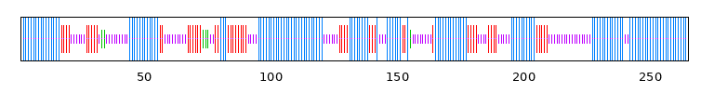 AsSWEET1b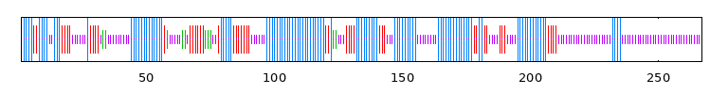
AsSWEET2a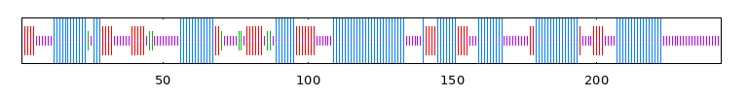 AsSWEET2b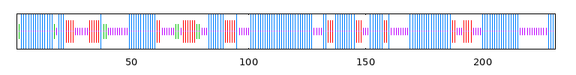
AsSWEET3a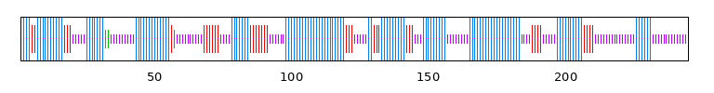 AsSWEET4 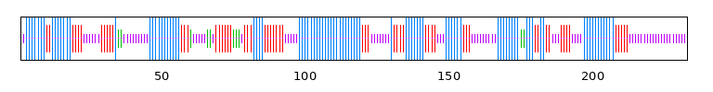
AsSWEET5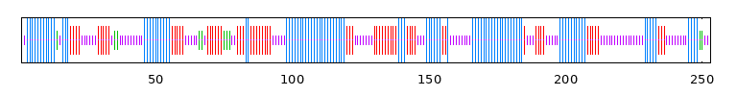 AsSWEET11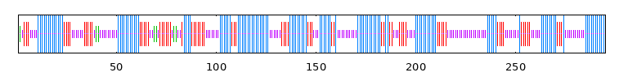
AsSWEET12 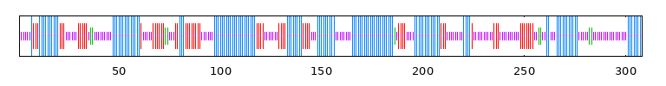AsSWEET13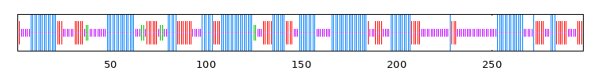
AsSWEET15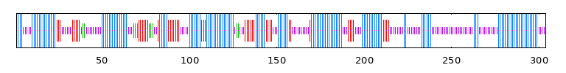 AsSWEET16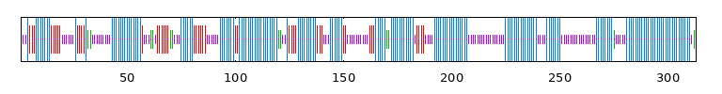
AsSWEET17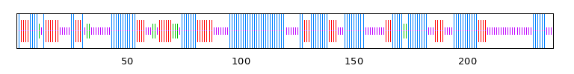
Fig.S1Protein secondary structure encoded by AsSWEETs in Avena sativa
Note: Blue represents α- Spiral. Red indicates irregular curls.

Motif1 Motif2
Motif3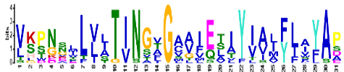 Motif4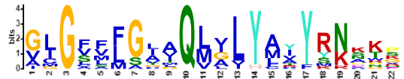
Motif5 Motif6
Motif7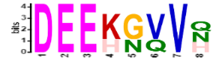 Motif8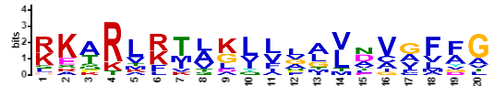
Motif9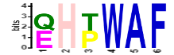 Motif10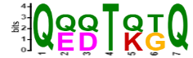
Motif11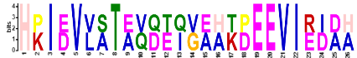 Motif12
Fig.S2 Sequence marker soften motifs of AsSWEETs protein identified by MEME program
Note:Each site is displayed in alphabetical (amino acid residue) order. The total height of the amino acid stacking represents the information content of the site in the motif. The height of each letter in the stack represents the degree of conservation of the amino acid in that position. The X axis is the length of the motif, and the Y axis is the site of the letter.

