Continuous-Transition-Mediated Deformation Twinning in Cubic Boron Nitride

Yeqiang Bu^{1,2†}, Zhengping Su^{2†}, Junquan Huang^{1†}, Ke Tong^{1†}, Penghui Li¹, Chong Wang¹, Tianye Jin¹, Song Zhao¹, Zhisheng Zhao¹, Alexander Soldatov¹, Yanbin Wang³, Bo Xu¹, Zhongyuan Liu¹, Anmin Nie^{1*}, Hongtao Wang^{2,4*}, Wei Yang², Yongjun Tian¹

¹Center for High Pressure Science, State Key Laboratory of Metastable Materials Science and Technology, Yanshan University, Qinhuangdao 066004, China
²Center for X-mechanics, School of Aeronautics and Astronautics, Zhejiang University, Hangzhou 310027, China
³Center for Advanced Radiation Sources, The University of Chicago, Chicago, IL 60439, USA
⁴ZJU-Hangzhou Global Scientific and Technological Innovation Center, Zhejiang University, Hangzhou 311215, China

†These authors contributed equally to this work
*Corresponding author. Email: anmin@ysu.edu.cn (A.M.N.), and htw@zju.edu.cn (H.T.W.)

The PDF file includes:

Figs. 1 to 14

Other Supplementary Materials for this manuscript include the following:

Videos 1 to 9

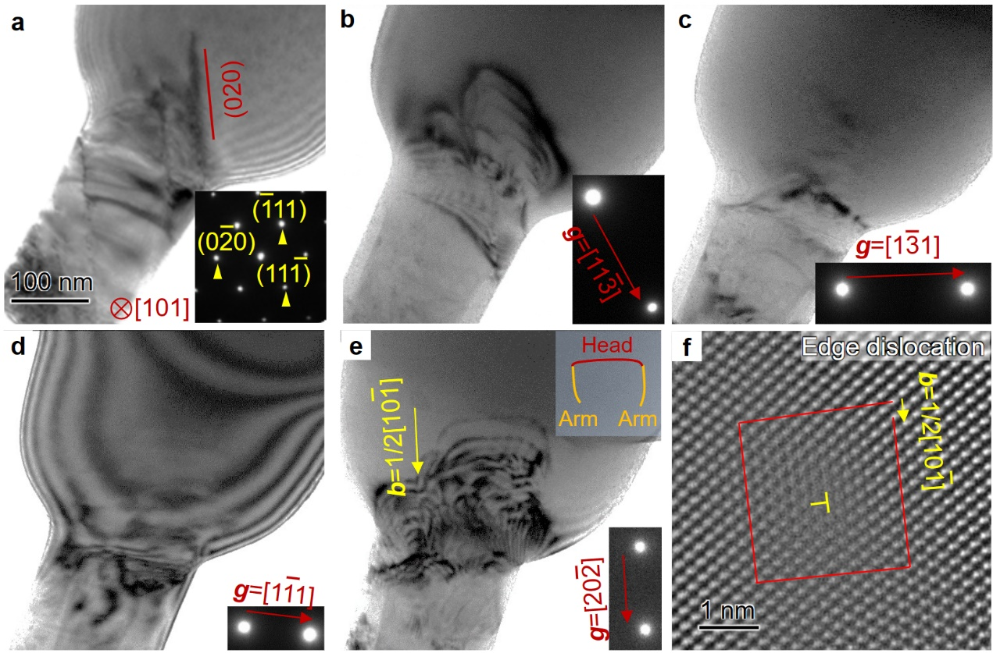
Extended Data Fig.1. Dislocations in a <111>-oriented cBN pillar. a, According to the inset SAED pattern, slip plane was determined to be (010) plane. Four images were captured under various two-beam conditions: b, g = $\text{[}\text{11}\overline{\text{3}}\text{]}$, c, g = $\text{[}\text{1}\overline{\text{3}}\text{1]}$, around the [211] zone axis, d, g = $\text{[}\text{1}\overline{\text{1}}\text{1]}$ along the [110] zone axis and e, g = $\text{[}\text{2}\text{0}\overline{\text{2}}\text{]}$ around the [010] zone axis. The dislocations exhibit clear contrast in (b) and (e), but are extinct in (c) and (d). According the g·b = 0 extinction criteria, the Burgers vector of the dislocations is 1/2 $\text{[}\text{10}\overline{\text{1}}\text{]}$, and the corresponding slip system is 1/2 $\text{[}\text{10}\overline{\text{1}}\text{]}$(010). When the incident beam is parallel to the [010] direction [as shown in (e)], the viewing direction is nearly perpendicular to the (010) slip plane. We can approximately determine the geometric relationship between the dislocation line direction and the Burgers vector according to the TEM image. As shown in the inset of (e), the dislocation half loops can be divided into two arm segments and one head segment (inset). The line direction of the arm segments is nearly parallel to the Burgers vector (yellow arrow), while the line direction of the head segment is nearly perpendicular to the Burgers vectors. Thus, these dislocation half loops are mixed type, including edge head segments and screw arm segments. f, The core structure of the edge head segment recorded by HAADF-STEM. Insets at the lower right corner of (a-e) are the corresponding SAED patterns.

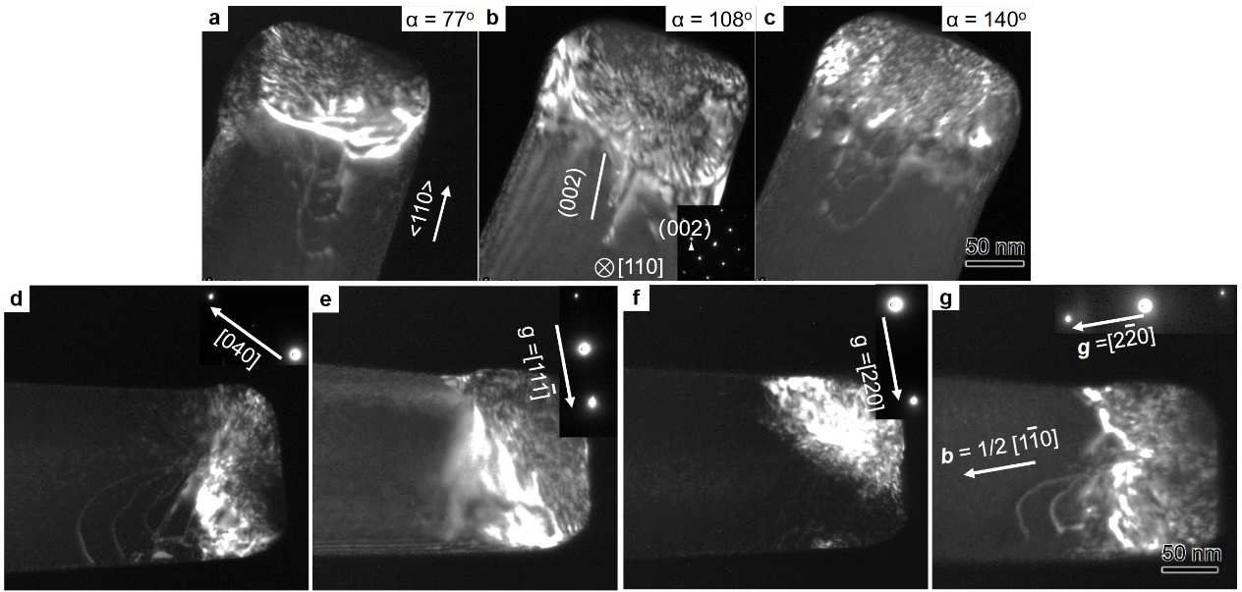
Extended Data Fig.2. Dislocations in a <110>-oriented cBN pillars. a-c, A <110>-oriented nanopillar rotated around the <110> axis, showing dislocation morphologies at various viewed angles. According to the edge-on view of the dislocation slip plane and the inset SAED in (b), the slip plane in this pillar is (001). To determining the type and Burgers vector of the dislocations, images were captured under various two-beam conditions. d, g = [040] around the [101] zone axis. e, g = $\text{[}\text{1}\text{1}\overline{\text{1}}\text{]}$ around the [011] zone axis. f, g = [220] and g, g = $\text{[2}\overline{\text{2}}\text{0]}$ around the [001] zone axis. The dislocations are extinct in (e) and (f), the Burgers vector is therefore b = 1/2 $\text{[}\text{1}\overline{\text{1}}\text{0]}$ based on the g·b = 0. According to the geometric relationship between Burgers vectors and the dislocation line direction in (d), the head segments of the dislocations are edge type, and the arm segments are screw type. Insets are the corresponding SAED patterns.

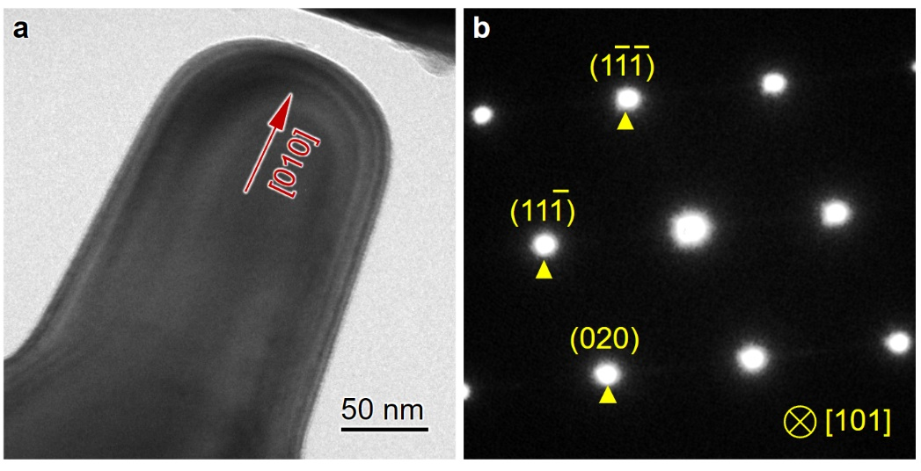
Extended Data Fig.3. The original pillar before compression test of the twinned pillar in Fig. 1C. a, TEM image. b, SAED pattern

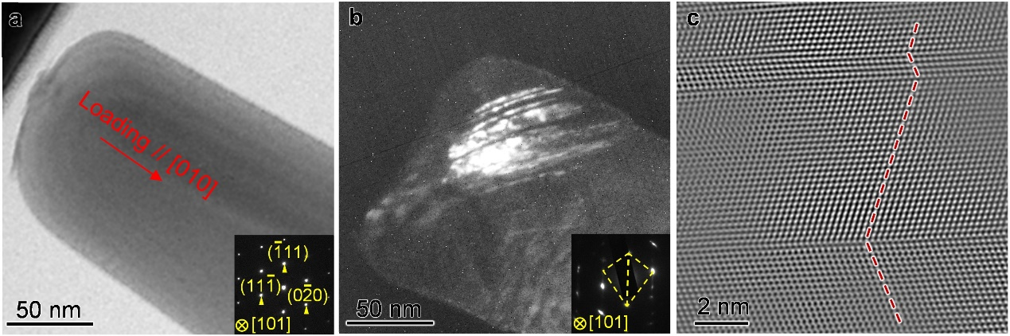
Extended Data Fig.4. Deformation mechanism of <100>-oriented cBN pillars during uniaxial compression. a, Bright field (BF) TEM image of a pillar before deformation. b, Dark field (DF) TEM images of the pillar compressed along [010]. c, Atomic scale HAADF image captured from the deformed pillar, evidencing the generation of deformation twins in the <100> oriented pillar. Insets in (a) and (b) are corresponding selective area electron diffraction (SAED) patterns.

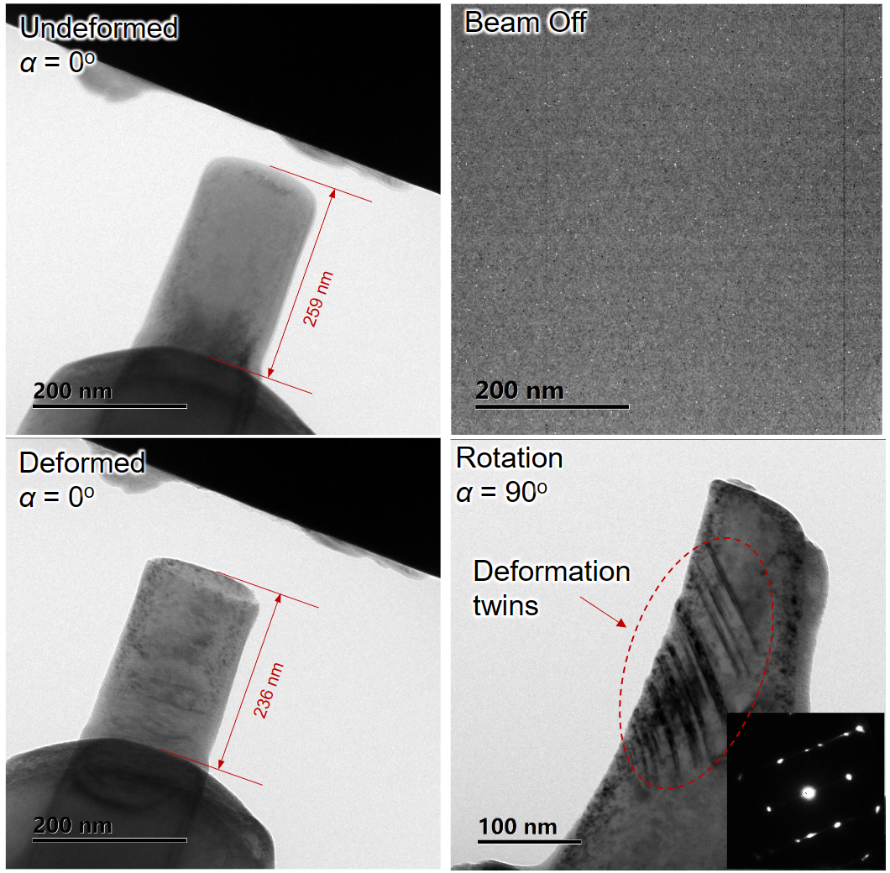
Extended Data Fig.5. Compression of a <100>-oriented cBN pillar with electron beam switched off. The cBN submicron pillars are plastically deformed without the electron beam inside TEM. Deformation twins were observed when the deformed pillar rotated 90 degrees, confirming that the electron beam we used had no effect on the mechanical behavior of the tested samples.

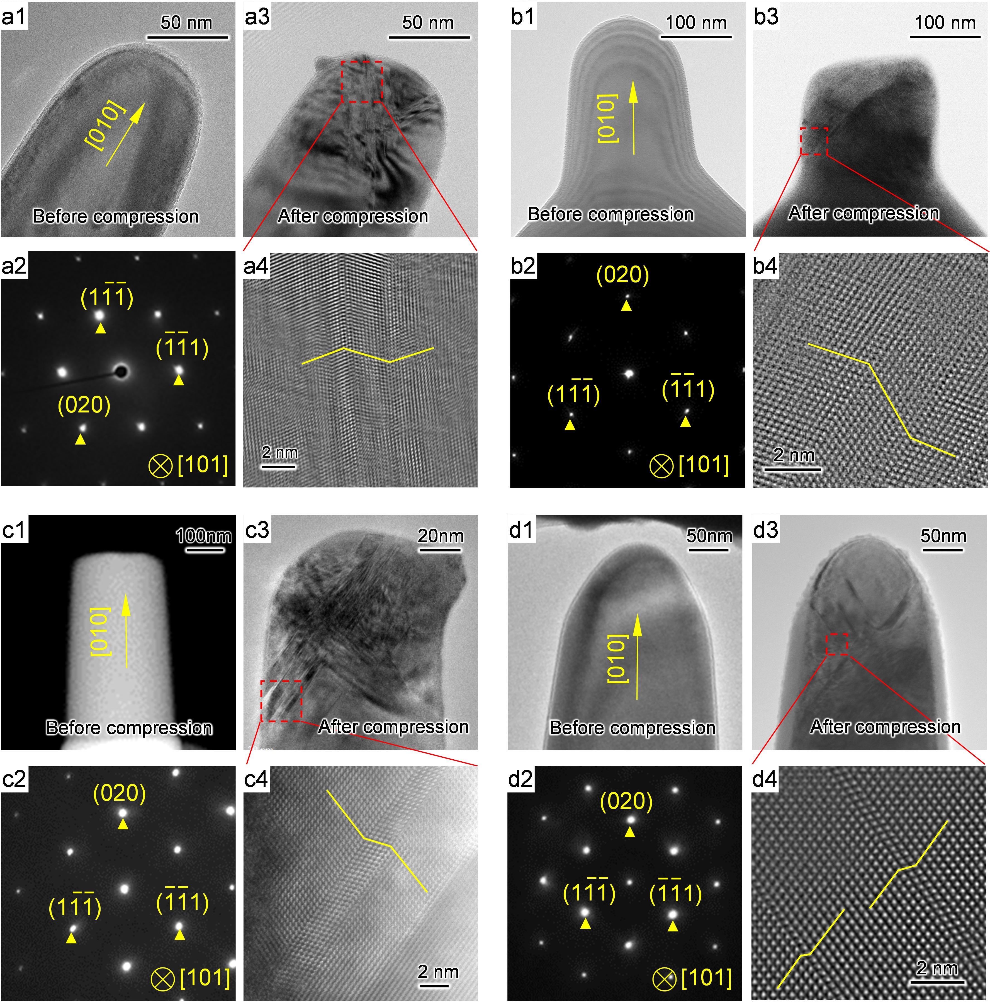
Extended Data Fig.6. Along the strategy based on the loading-specific criterion, deformation twinning was activated in other brittle and hard covalent crystals with face-centered cubic structures. (a1-d1) The [010]-oriented single-crystalline diamond, silicon carbide (SiC), gallium arsenide (GaAs) and boron arsenide (BAs) pillars. (a2-d2) The corresponding SAED patterns. (a3-d3) Diamond, SiC, GaAs and BAs pillars after uniaxial compression. (a4-d4) High-resolution TEM images revealing the generation of deformation twins.

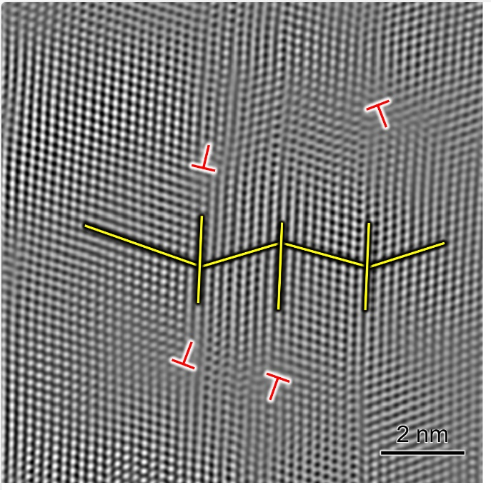
Extended Data Fig.7. Several dislocations are blocked by the twin boundaries.

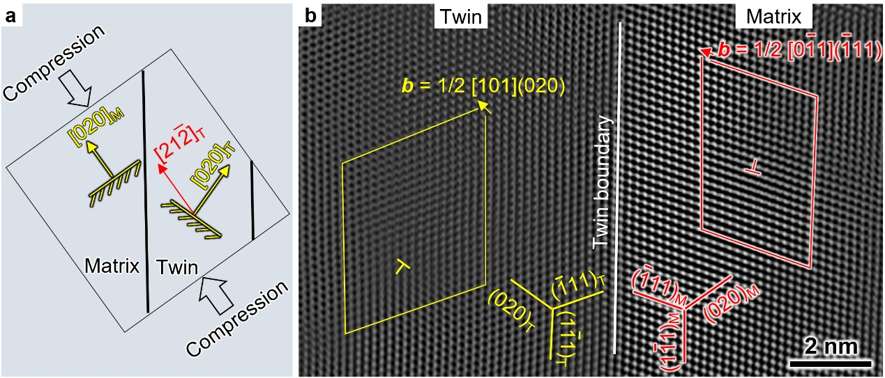
Extended Data Fig.8. Multiple slip systems activated by twinning induced reorientation. a, Schematic illustration showing the orientation change inside the twins, where the loading direction changes to the $\text{[21}\overline{\text{2}}\text{]}$crystallographic orientation. b, An edge dislocation gliding on (010) plane activated in the reoriented twin domain (left) and a 60° dislocation gliding on (111) plane activated in the matrix (right).

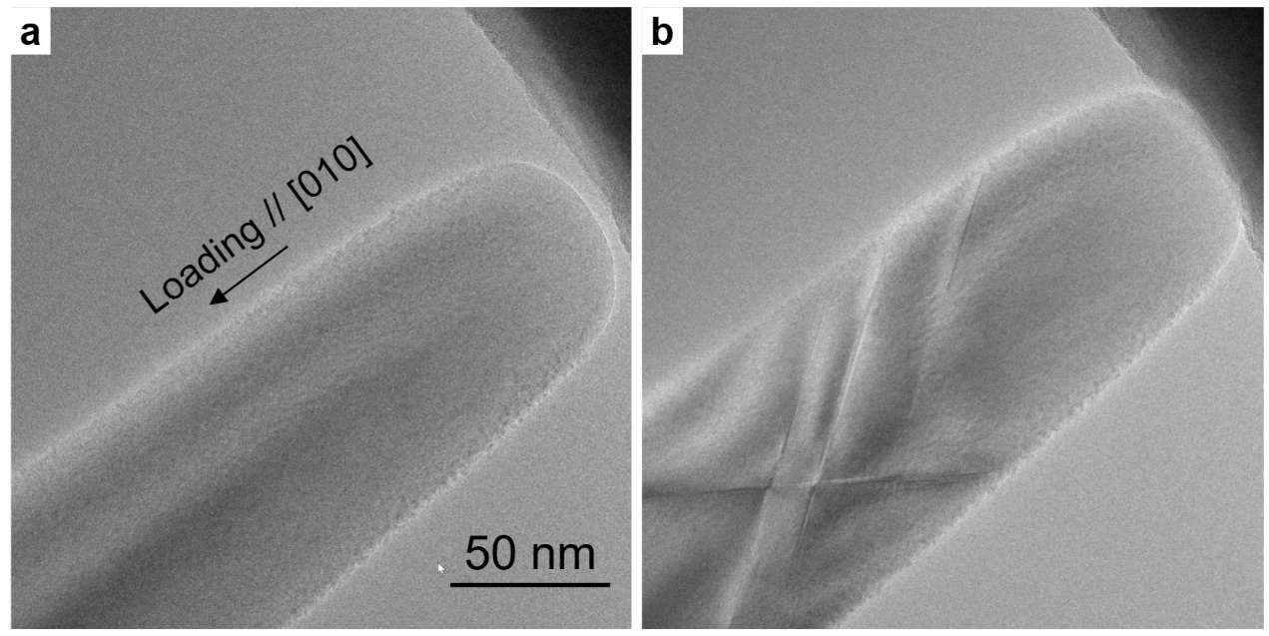
Extended Data Fig.9. Multiple twinning system are activated in cBN. a, An undeformed <100>-oriented cBN nanopillar. b, Twinning systems on two {111} planes are generated.

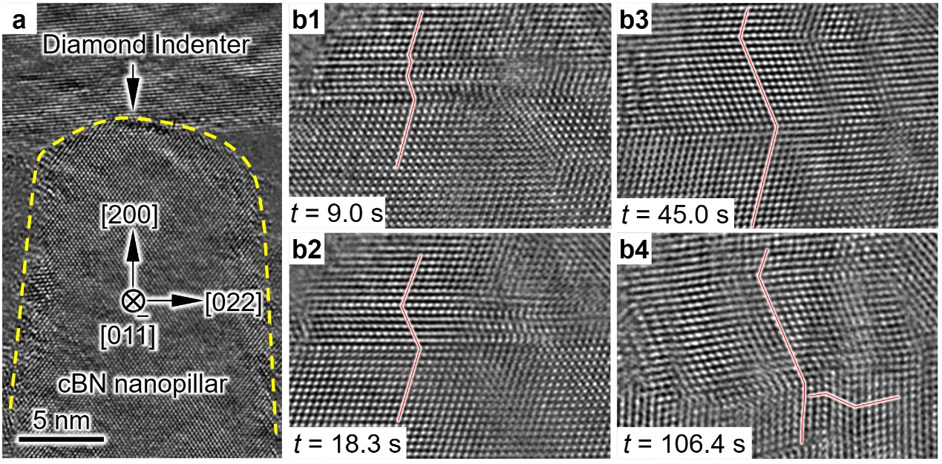
Extended Data Fig.10. Viewing the deformation twinning at atomic scale using in-situ high-resolution TEM. a, A <100>-oriented cBN nanopillar micromachined from the bulk counterpart using focused ion beam (FIB) and sequentially thinned to ~15 nm thick by low-energy argon plasma milling. b1 - b3, The generation process of a 14-atom-layer twin during compression. b4, A secondary twin generated on the further compression.

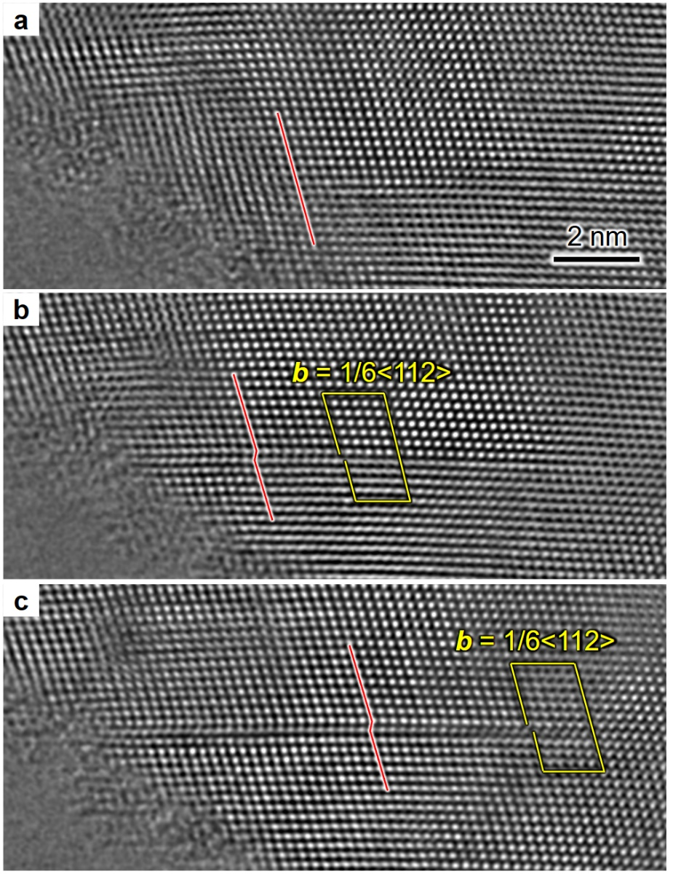
Extended Data Fig.11. A partial dislocation gliding left a trail of stacking fault. a, The cBN lattice before generating partial dislocation and stacking fault. b, A partial dislocation with Burgers vector of 1/6<112> and the trailing stacking fault were produced by nano-compression. c, The stacking fault propagated with the partial dislocation gliding.

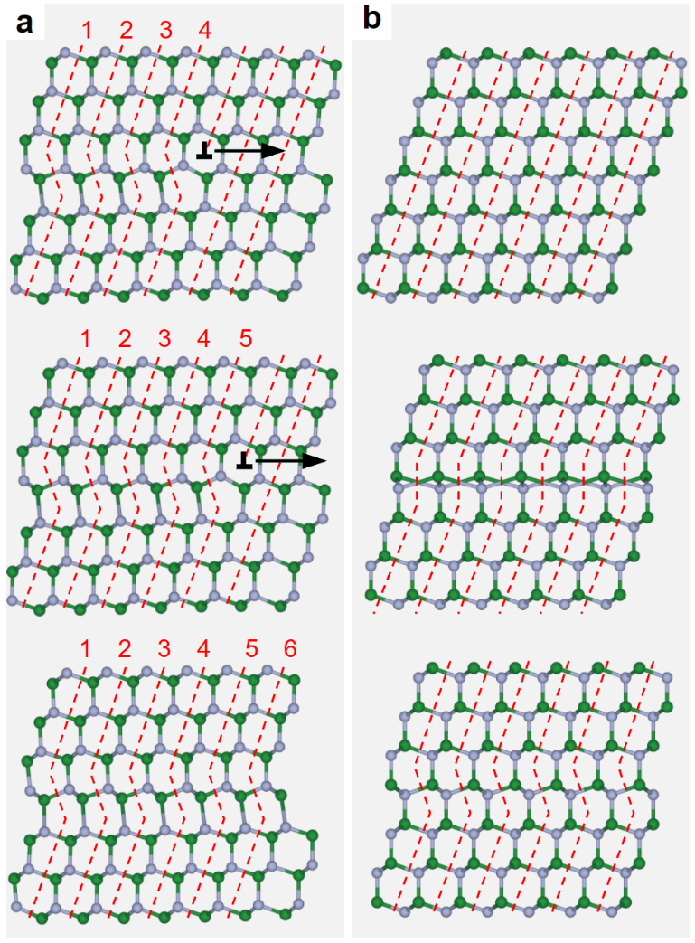
Extended Data Fig.12. Partial dislocation mediated twinning versus continuous-transition-mediated twinning. a, Schematics showing the discrete twinning mechanism mediated by step-by-step partial dislocation (labelled by “⊥”) gliding. b, Schematics showing the continuous-transition-mediated mechanism via continuous displacement of entire atoms below the (111) slip plane of FCC lattice.

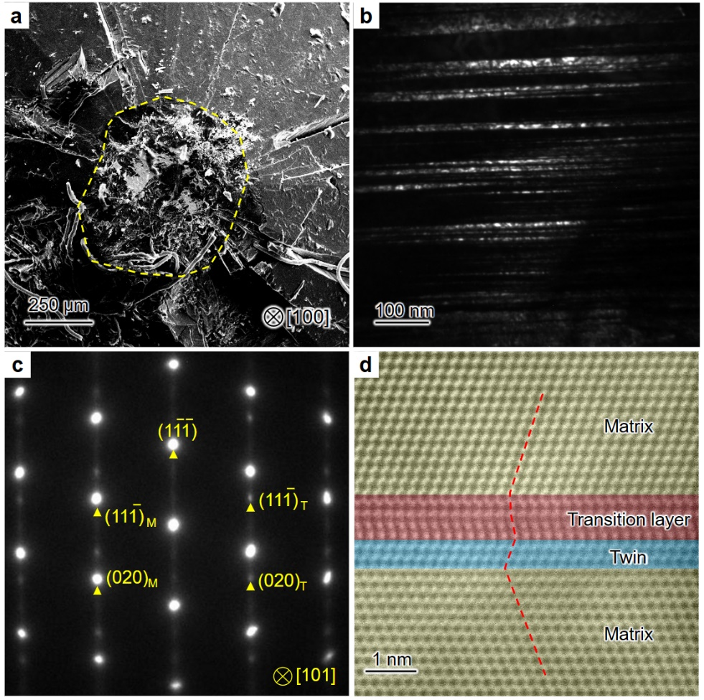
Extended Data Fig.13. Continuous-transition-mediated deformation twinning in diamond. a, A top view image of a deformed <100>-oriented diamond anvil tip after diamond anvil cell test under pressure of ~360 GPa. b, The dark field TEM image shows that there generated high density of twins in the deformed diamond anvil tip. c, The corresponding SAED patterns. d, HAADF-STEM image captures the transition layer in front of the twin boundary, indicating that continuous-transition-mediated deformation twinning occurs in this bulk diamond.

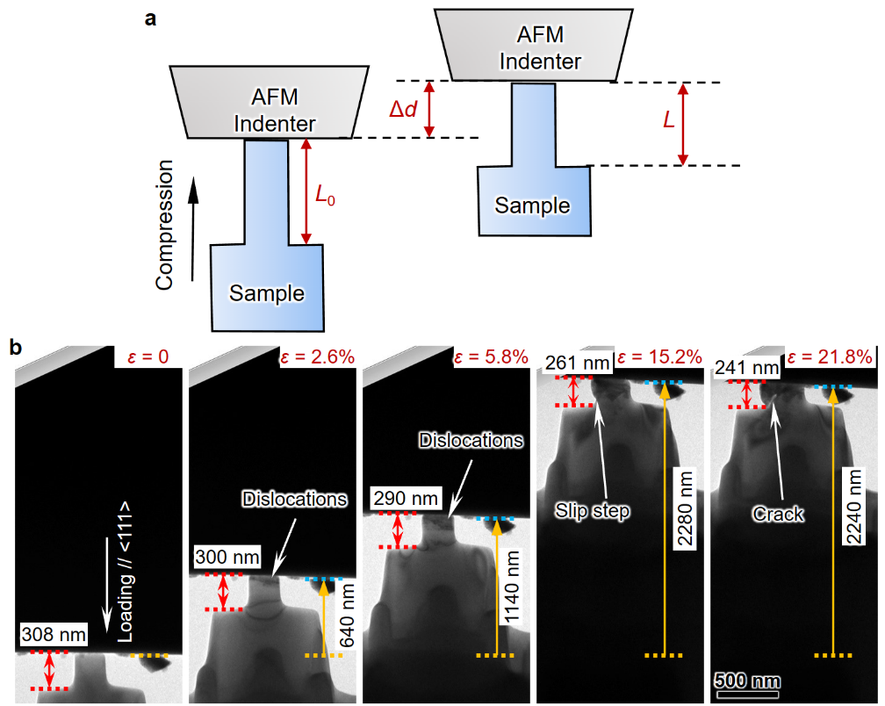
Extended Data Fig.14. In situ mechanical testing of cBN pillar inside TEM. a, Schematics showing the displacements of the AFM indenter and the size change in the samples. The axial compression stress σ is determined by σ = k Δd/A, where Δd is the displacement of the AFM indenter, A is the cross-sectional area of the pillar. Strain ε is determined by ε = (L-L₀)/L₀, where L and L₀ are the lengths of deformed and undeformed pillars, respectively. b, Stress-strain measuring process for a <111>-oriented cBN nanopillar. The displacement and size change are determined by optical flow method. The spring constant of the used AFM cantilever is 1600 N/m. The cross-section of the used nanopillars possesses a square shape.

Video1.
Typical video records deformation process of a cBN pillar with <100> orientation. The video speeds at 2 times the speed of experiment.

Video 2.
An additional example showing the deformation twinning in a <100>-oriented cBN pillar during uniaxial compression.

Video 3.
In situ TEM compression on a <111> oriented cBN pillar. The video speeds at 2 times the speed of experiment.

Video 4.
In situ TEM compression on a <100> oriented cBN pillar. The video speeds at 2 times the speed of experiment.

Video 5.
In situ atomic resolution characterization of deformation twinning process in cBN. The video speeds at 2 times the speed of experiment.

Video 6.
Abundant partial dislocation behaviors in <100>-oriented cBN nanopillar during compression.

Video 7.
Continuous-transition-mediated twining mechanism in cBN.

Video 8.
Continuous-transition-mediated twin thickening in cBN.

Video 9.
The five-degree-of-freedom nanomanipulation of X-Nano double-tilt TEM holder.

