Supplemental material

Table 1S. BOD experiment setup, sludge volume, mineral medium volume, soap volume

Bottle number | Volume of washed activated sludge [mL] | The volume of the mineral medium according to OECD [mL] | Volume of soap solution [mL] | The degree of burning with the concentration of the soap solution (%)
1; 2 | 15 | 23.5 | 5 | 0P 2.5
3, 4 | 15 | 23.5 | 5 | 0P 1.7
5, 6 | 15 | 23.5 | 5 | 0P 1.25
7, 8 | 15 | 23.5 | 5 | 1P 2.5
9, 13 | 15 | 23.5 | 5 | 1P 1.7
11, 12 | 15 | 23.5 | 5 | 1P 1.25
13, 14 | 15 | 23.5 | 5 | 2P 2.5
15, 16 | 15 | 23.5 | 5 | 2P 1.7
17, 18 | 15 | 23.5 | 5 | 2P 1.25
14, 15 | 15 | 28.5 | 0 | Control
10 | 15 | 28.5 | 0 | Control

Table 2S. Parameters of activated sludge

Sample number | Date collection | Place collection | Sample description | Group | pH | NL [g/L] | Redox potential [mV] | Conductivity [μS/cm] | Dry Matter [%] | Organic Dry Matter [%_{DM}]
220001MH | 28.02.2022 | WWTP Modřice | sludge, activation tank | liquid | 7.00 | 3.70 | 150 | 1440 | 0.66±0.01 | 66.14±0.41
220002MH | 14.03.2022 | WWTP Modřice | sludge, activation tank | liquid | 7.20 | 3.70 | 170 | 1220 | 0.57±0.01 | 88.08±0.12
220003MH | 28.03.2022 | WWTP Modřice | sludge, activation tank | liquid | 7.05 | 3.60 | 132 | 1213 | 0.65±0.12 | 75.48±1.39
220004MH | 14.04.2022 | WWTP Modřice | sludge, activation tank | liquid | 7.10 | 3.70 | 168 | 1219 | 0.48±0.01 | 68.66±0.73
220005MH | 25.04.2022 | WWTP Modřice | sludge, activation tank | liquid | 8.14 | 3.70 | 160 | 1172 | 0.51±0.01 | 69.20±0.22
220006MH | 10.05.2022 | WWTP Modřice | sludge, activation tank | liquid | 7.14 | 3.70 | 170 | 1150 | 0.64±0.46 | 72.73±28.74
220007MH | 26.05.2022 | WWTP Modřice | sludge, activation tank | liquid | 7.39 | 3.70 | 150 | 1250 | 0.38±0.00 | 72.06±1.62
220008MH | 14.06.2022 | WWTP Modřice | sludge, activation tank | liquid | 7.14 | 3.70 | 170 | 1083 | 0.68±0.08 | 70.39±1.68
WWTP – wastewater treatment plant; ± standard deviation

Table 3S. Determination of kinetics parameters

Sample | Growth Rate [h⁻¹] | Maximum Growth  Rate [h⁻¹] | Doubling time  [h] | Lag phase  [h]
0P 2.5 % | 6.52∙10⁻¹±1.18∙10⁻³ | 7.89∙10⁻¹±2.44∙10⁻¹ | 1.06±1,92∙10⁻² | 4.42±1.65∙10⁻¹
0P 1.7 % | 2.78∙10⁻¹ ± 6,19∙10⁻³ | 6.66∙10⁻¹±2.22∙10⁻¹⁶ | 2.49±5.57∙10⁻² | 6.66∙10⁻¹±2.22∙10⁻¹⁶
0P 1.25 % | 5.64∙10⁻¹ ± 9.51∙10⁻³ | 6.66∙10⁻¹±2.22∙10⁻¹⁶ | 1.22±2.07∙10⁻² | 6.66∙10⁻¹±2.22∙10⁻¹⁶
5P 2.5 % | 5.67∙10⁻¹ ± 1.42∙10⁻² | 6.66∙10⁻¹±2.22∙10⁻¹⁶ | 1.22±3.07∙10⁻² | 6.66∙10⁻¹±2.22∙10⁻¹⁶
5P 1.7 % | 4.09∙10⁻¹ ± 4.75∙10⁻³ | 6.66∙10⁻¹±2.22∙10⁻¹⁶ | 1.69±1.96∙10⁻² | 6.66∙10⁻¹±2.22∙10⁻¹⁶
5P 1.25 % | 4.09∙10⁻¹ ± 6.78∙10⁻³ | 6.66∙10⁻¹±2.22∙10⁻¹⁶ | 1.69±2.81∙10⁻² | 6.66∙10⁻¹±2.22∙10⁻¹⁶
0R 2.5 % | 3.22∙10⁻¹ ± 8.56∙10⁻³ | 6.66∙10⁻¹±2.22∙10⁻¹⁶ | 2.15±5.73∙10⁻² | 6.66∙10⁻¹±2.22∙10⁻¹⁶
0R 1.7 % | 2.04∙10⁻¹ ± 4.93∙10⁻³ | 2.19∙10⁻¹±1.22∙10⁻¹⁶ | 3.40±8.11∙10⁻² | 6.73∙10⁻¹±1.11∙10⁻²
0R 1.25 % | 5.14∙10⁻¹ ± 4.69∙10⁻³ | 6.66∙10⁻¹±2.22∙10⁻¹⁶ | 1.35±1.22∙10⁻² | 6.66∙10⁻¹±2.22∙10⁻¹⁶
5R 2.5 % | 2.19∙10⁻¹ ± 2.31∙10⁻³ | 8.34∙10⁻¹±4.37∙10⁻¹ | 3.15±3.32∙10⁻² | 1.30±1.47∙10⁻¹
5R 1.7 % | 2.03∙10⁻¹ ± 4.93∙10⁻³ | 2.19∙10⁻¹±1.23 | 3.40±8.11∙10⁻² | 6.73∙10⁻¹±1.11∙10⁻²
5R 1.25 % | 5.01∙10⁻¹ ± 1.09∙10⁻² | 6.66∙10⁻¹±2.22∙10⁻¹⁶ | 1.38±3.03∙10⁻² | 6.66∙10⁻¹±2.22∙10⁻¹⁶
0S 2.5 % | 4.48∙10⁻¹ ± 1.95∙10⁻² | 6.66∙10⁻¹±2.22∙10⁻¹⁶ | 1.55±6.71∙10⁻² | 6.66∙10⁻¹±2.22∙10⁻¹⁶
0S 1.7 % | 4.83 ± 8.85∙10⁻² | 6.66∙10⁻¹±2.22∙10⁻¹⁶ | 1.43∙10⁻¹±2.52∙10⁻³ | 6.66∙10⁻¹±2.22∙10⁻¹⁶
0S 1.25 % | 4.37∙10⁻¹ ± 4.77∙10⁻³ | 6.66∙10⁻¹±2.22∙10⁻¹⁶ | 1.58±1.73∙10⁻² | 6.66∙10⁻¹±2.22∙10⁻¹⁶
5S 2.5 % | 9.17∙10⁻¹ ± 3.17∙10⁻² | 6.66∙10⁻¹±2.22∙10⁻¹⁶ | 7.56±2.22∙10⁻² | 6.66∙10⁻¹±2.22∙10⁻¹⁶
5S 1.7 % | 5.96∙10⁻¹ ± 1.78∙10⁻³ | 6.66∙10⁻¹±2.22∙10⁻¹⁶ | 1.16±3.48∙10⁻² | 6.66∙10⁻¹±2.22∙10⁻¹⁶
5S 1.25 % | 1.46 ± 3.06∙10⁻² | 6.66∙10⁻¹±2.22∙10⁻¹⁶ | 4.73±9.82∙10⁻² | 6.66∙10⁻¹±2.22∙10⁻¹⁶
± standard deviation

Table 4S. Determination of parameters of anaerobic sludge and soap samples
Sample number | Collection date | Place of collection | Sample description | Group | pH | Redox potential [mV] | Conductivity [mS/cm] | Dry Matter [%] | Organic Dry Matter [%_{DM}]
2204MH | 03.11.2022 | WWTPModřice | sludge, anaerobic stabilization | liquid | 7.40 | -248±10 | 8.34 | 3.50±0.14 | 59.34±1.60
2205MH | 03.11.2022 | – | soap 0P | solid | – | – | – | 97.39±0,01 | 84.76±0.01
2206MH | 03.11.2022 | – | soap 3P | solid | – | – | – | 98.00±0.14 | 85.33±0.03
2207MH | 03.11.2022 | – | soap 4P | solid | – | – | – | 98.11±0.03 | 85.32±0.03
2301MH | 04.01.2023 | WWTP Modřice | sludge, anaerobic stabilization | liquid | 7.36 | -250±10 | 7.60 | 3.31±0.01 | 60.81±0.09
2302MH | 04.01.2023 | – | soap 0S | solid | – | – | – | 97.26±0.05 | 85.36±0.14
2303MH | 04.01.2023 | – | soap 2S | solid | – | – | – | 97.30±0.22 | 85.55±0.02
2304MH | 04.01.2023 | – | soap 5S | solid | – | – | – | 96.85±0.12 | 85.41±0.13
2305MH | 09.02.2023 | WWTP  Modřice | sludge, anaerobic stabilization | liquid | 7.38 | -350±10 | 7.09 | 3.27±0.01 | 61.43±0.05
2306MH | 09.02.2023 | – | soap 0R | solid | – | – | – | 95.96±0.22 | 86.60±0.13
2307MH | 09.02.2023 | – | soap 2R | solid | – | – | – | 95.77±0.66 | 86.59±0.17
2308MH | 09.02.2023 | – | soap 5R | solid | – | – | – | 96.93±0.02 | 86.30±0.05
± standard deviation

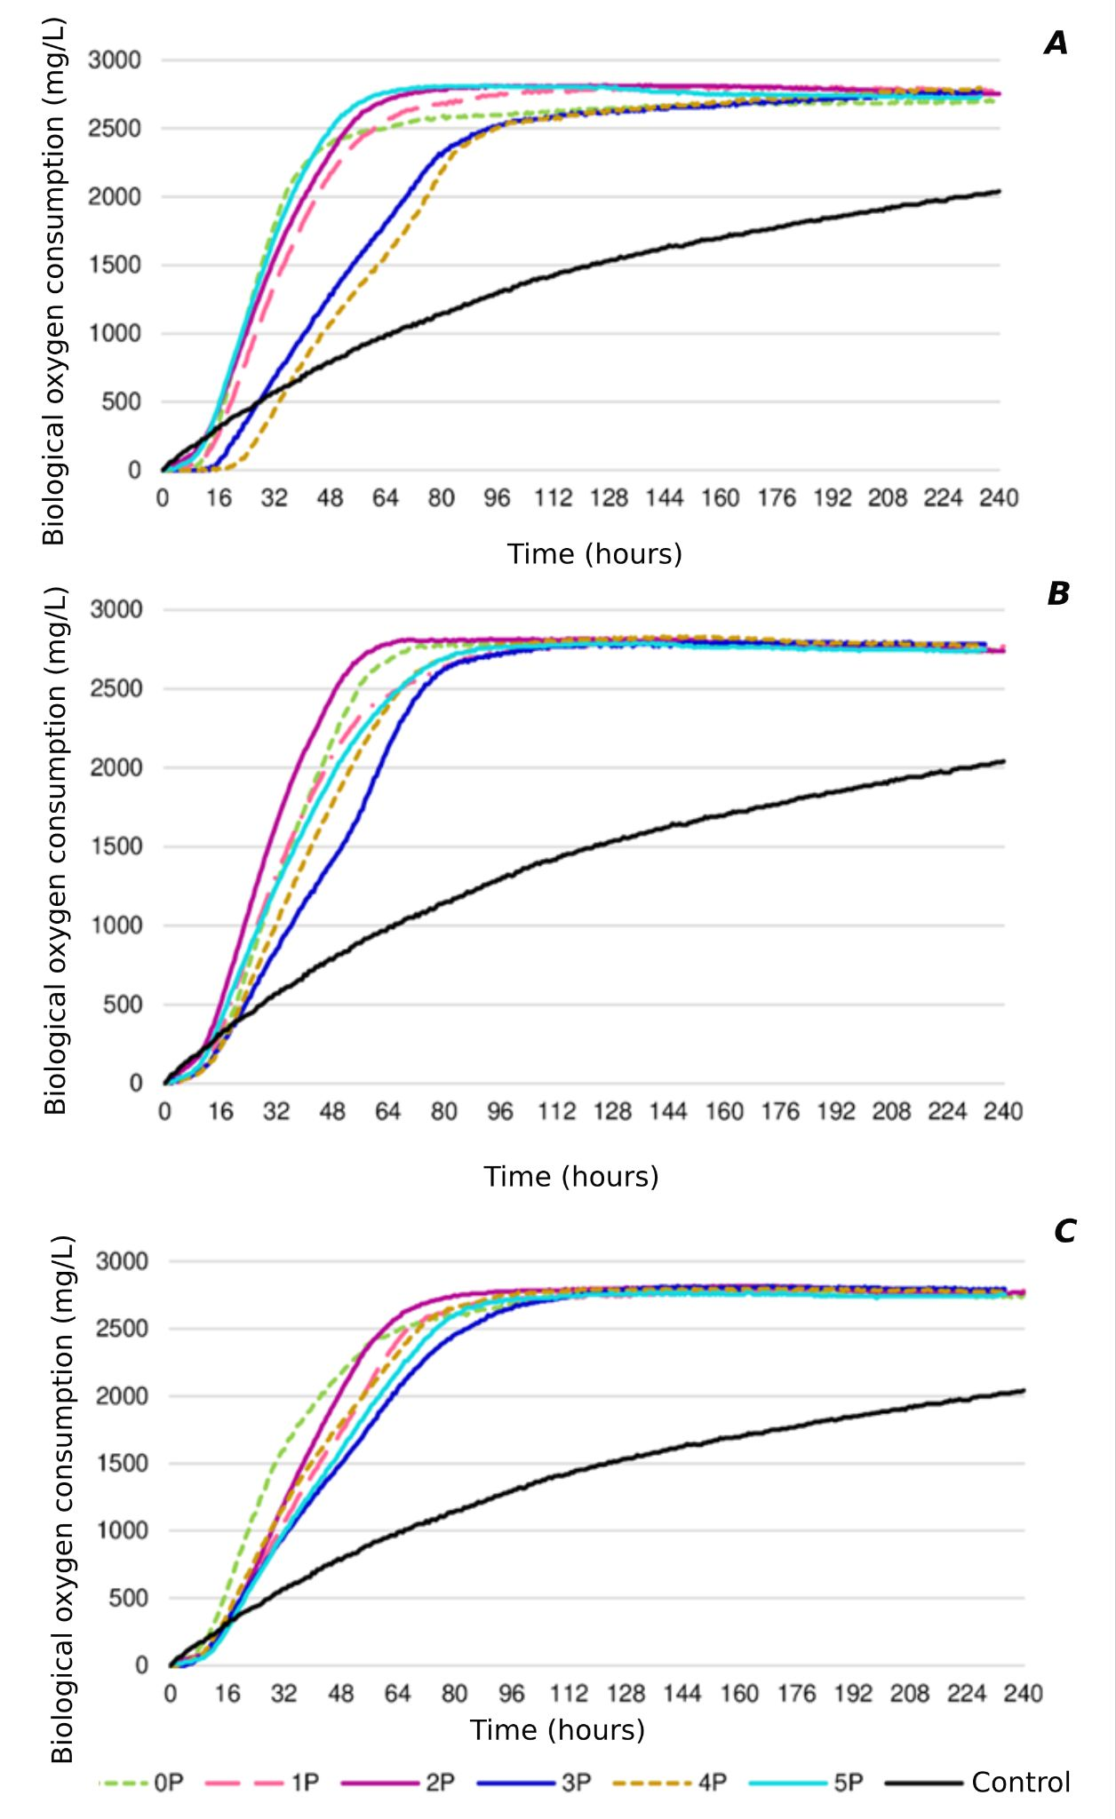
Figure 1S. Biological oxygen demand of activated sludge with addition of palm oil soap samples. A concentration 2.5%; B concentration 1.7%; C concentration 1.25%
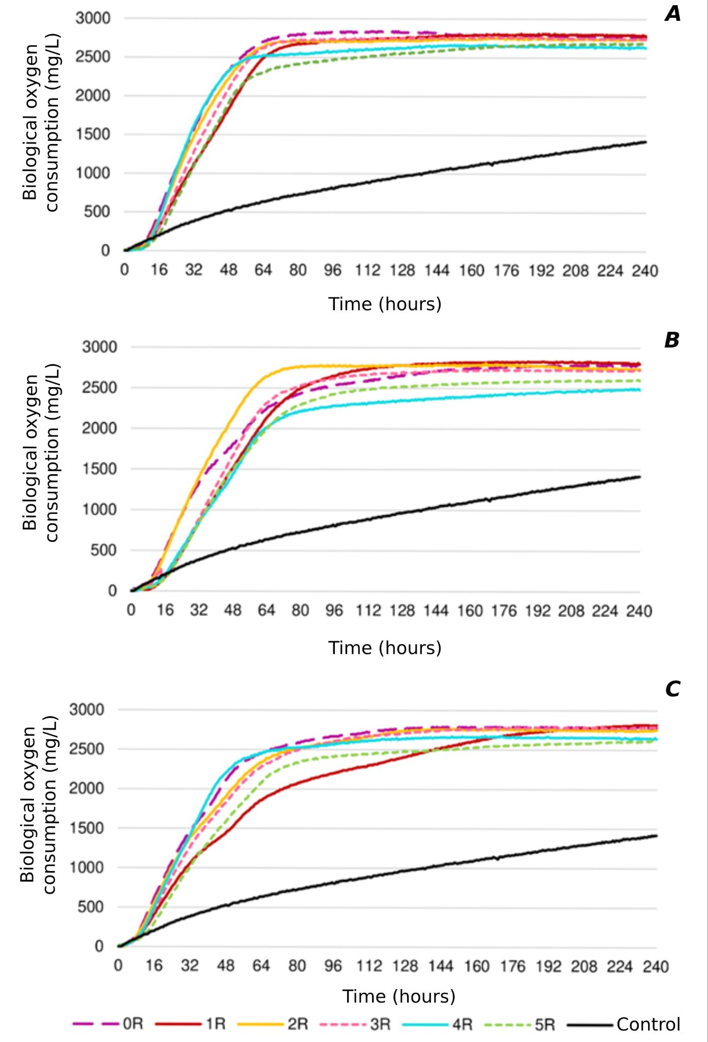
Figure 2S. Biological oxygen demand of activated sludge with the addition of rapeseed oil soap samples: A concentration 2.5%; B concentration 1.7%; C concentration 1.25%

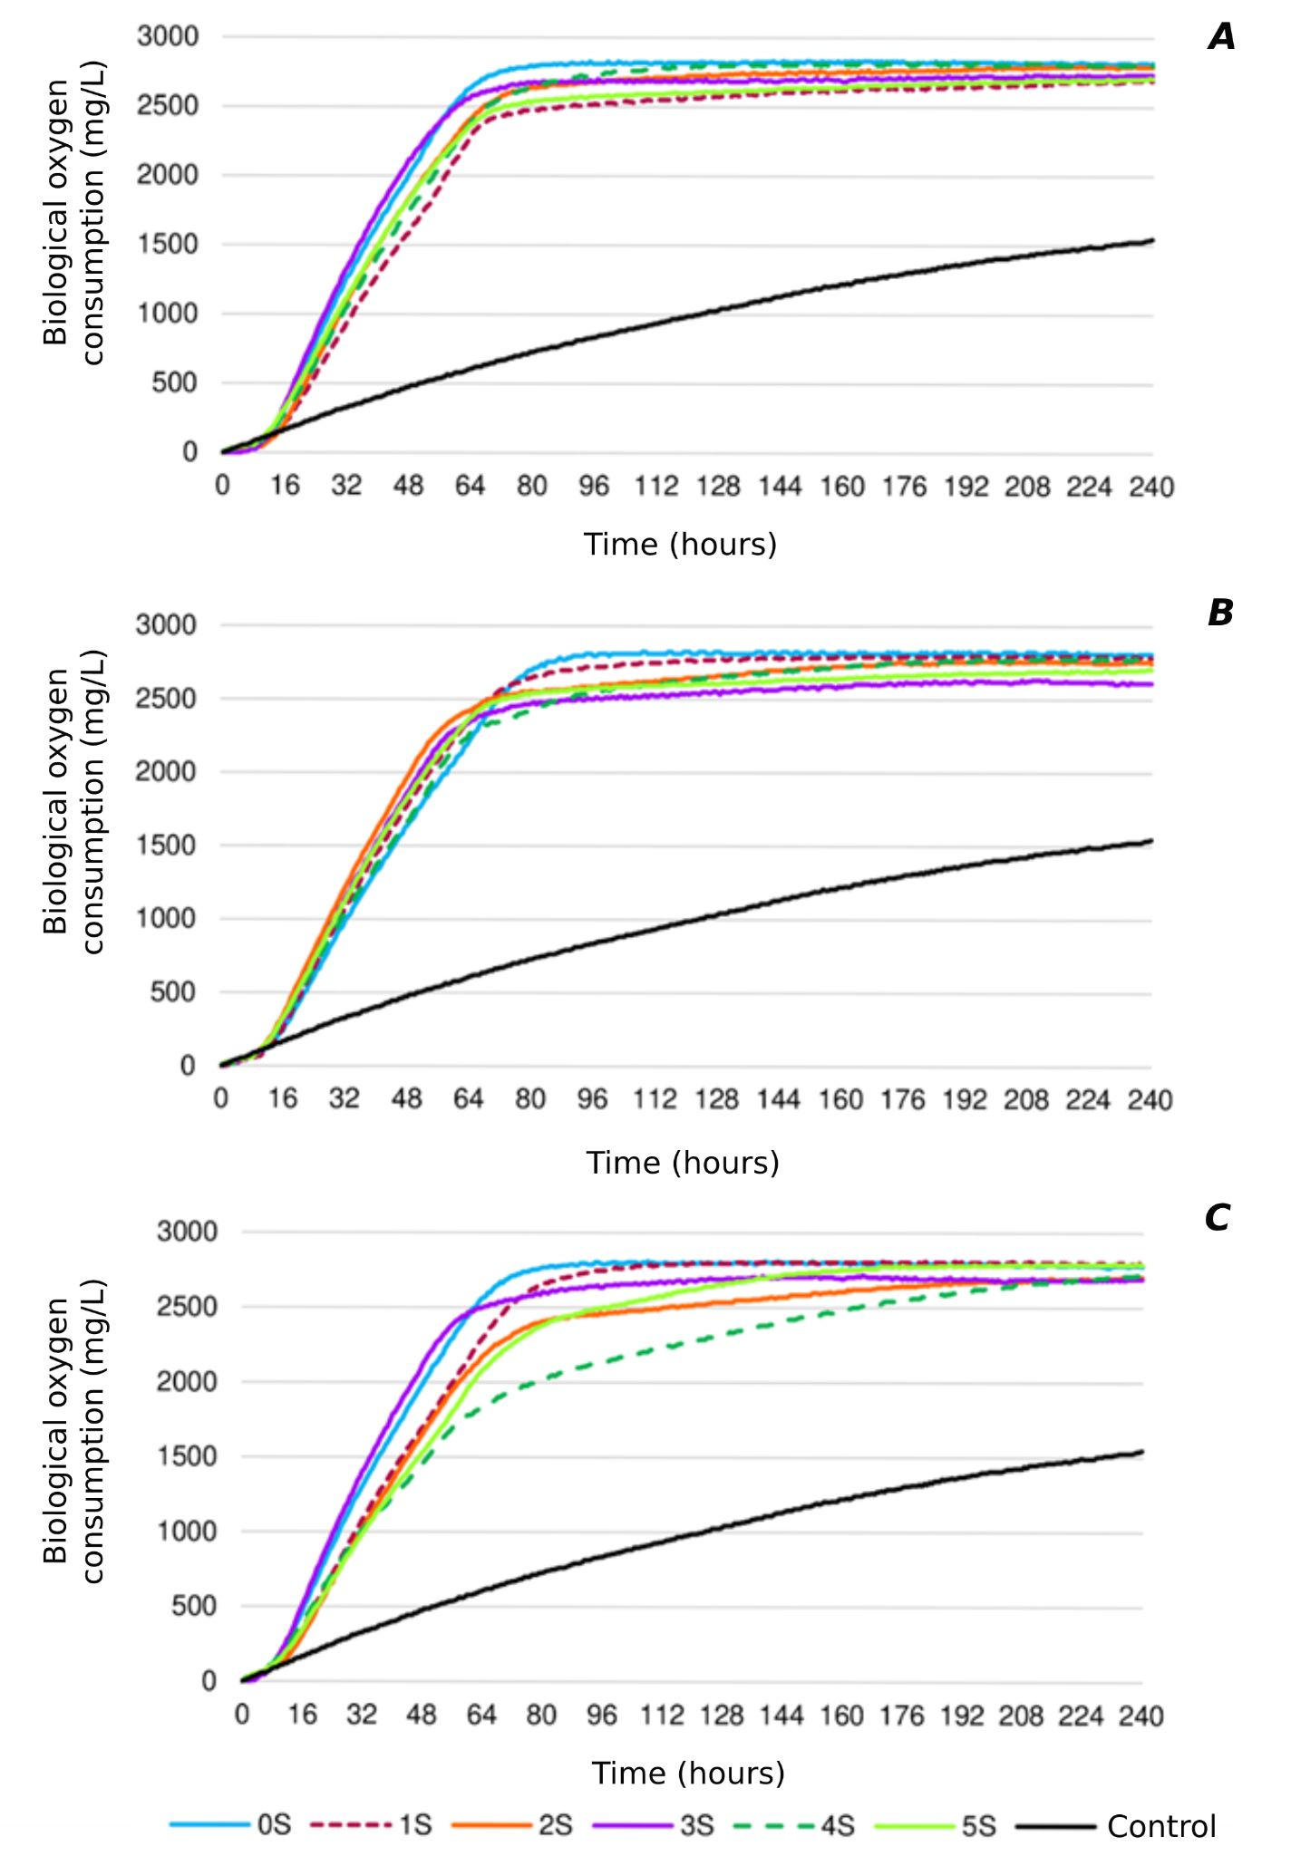
Figure 3S. Biological oxygen demand of activated sludge with the addition of sunflower oil soap samples: A concentration of 2.5%; B concentration 1.7%; C concentration 1.25%

