Supplemental Table S1. Clinical characteristics of AUD and AH patients
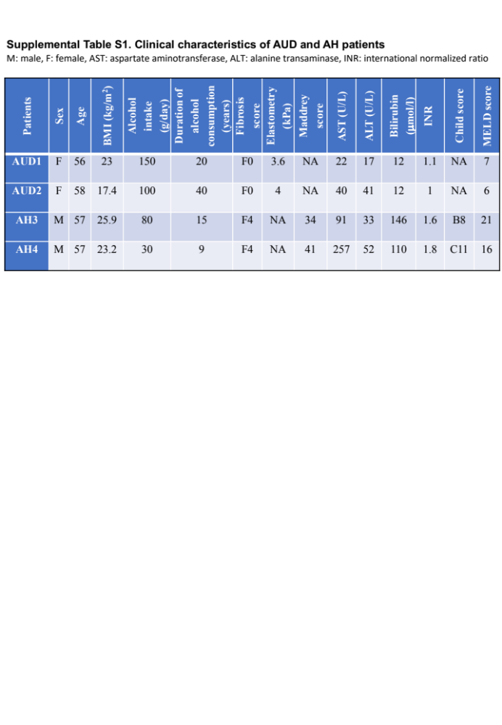
M: male, F: female, AST: aspartate aminotransferase, ALT: alanine transaminase, INR: international normalized ratio

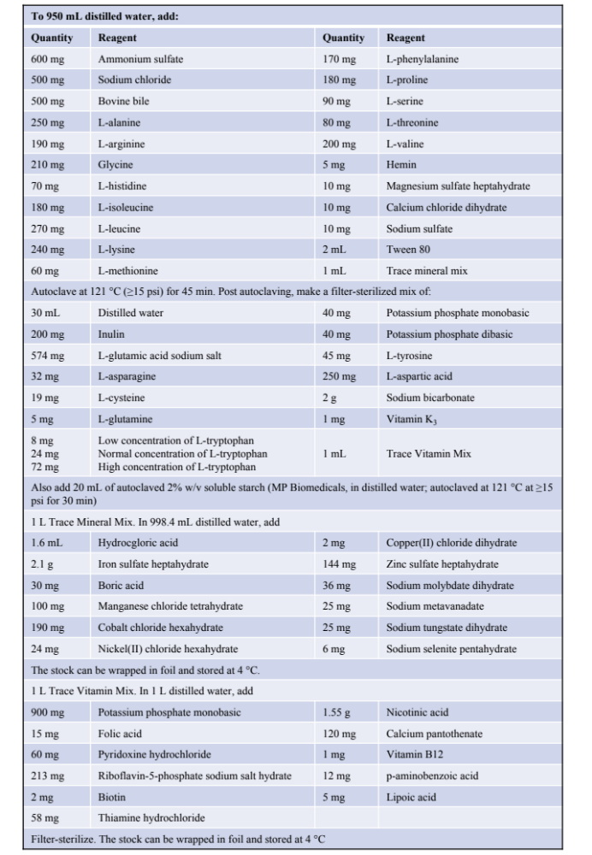
Supplemental Table S2. Recipe for IL of culture media

Supplemental Figure S1. MBRA system
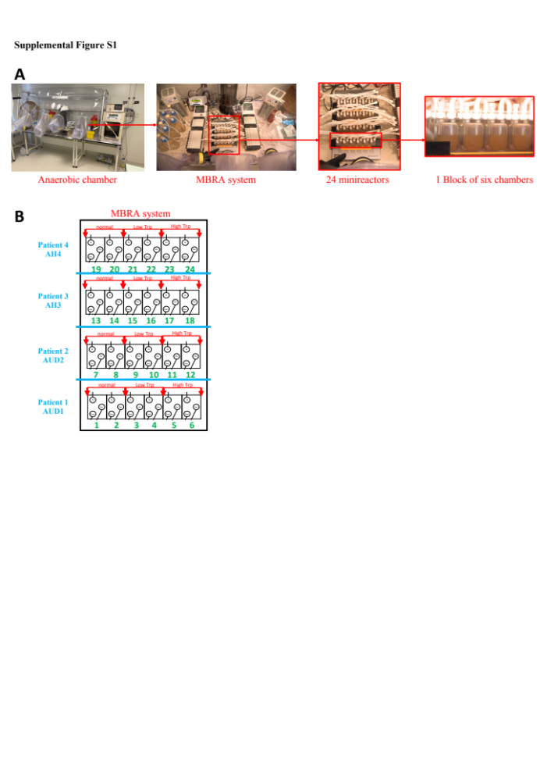
Figure S1. MBRA system. (A) A whole MBRA system is in an anaerobic chamber, consisting of 24 minireactors. (B) The plan for patients’ fecal samples in the MBRA system.

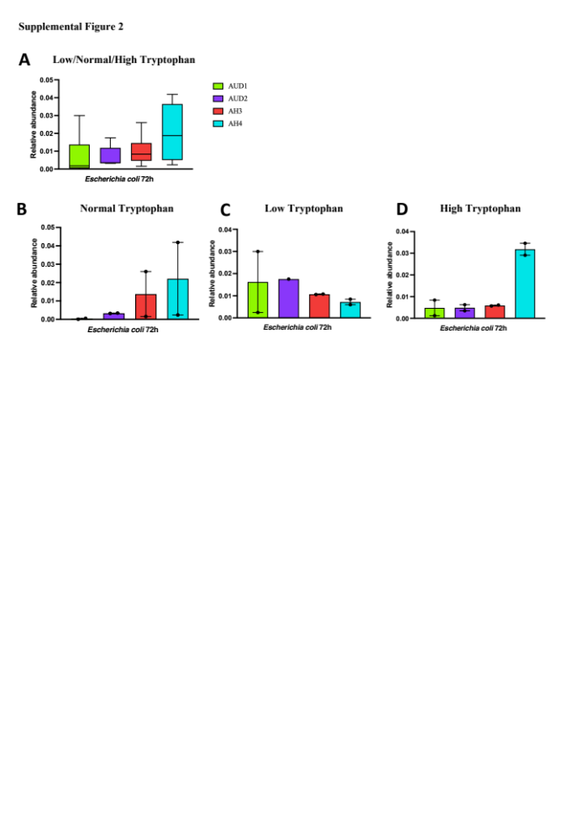
Supplemental Figure S2.
Supplemental Figure S2. Relative abundances of Escherichia coli in 72h. (A) Relative abundances of Escherichia coli based on individual patients. (B, C, D). Relative abundances of Escherichia coli based on individual patients and different concentrations of tryptophan.

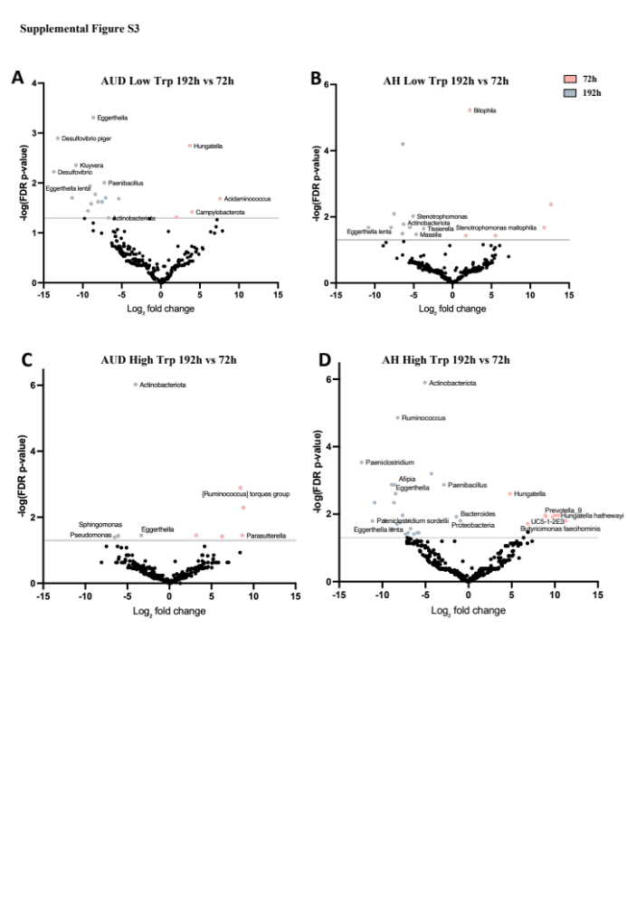
Supplemental Figure S3.

Supplemental Figure S3. The effect of alcohol on the AH gut microbiota under low and high tryptophan concentration. Microbiota members with differential relative abundance between conditions with (192h) and without (72h) alcohol in low (A, B) and high (C, D) tryptophan concentration (FDR p < 0.05 and fold change > 1.5, statistic significances by a one-way ANOVA followed by a Bonferroni post hoc test).

