Electronic Supplement of
Site-characterization using 1D/2D/3D Site Response Modelling vis-à-vis Surface-consistent Probabilistic Seismic Hazard, Microzonation and Damage Potential Studies in the Six-Tectonic Ensemble consisting of Kashmir Himalaya to Northeast India
Journal of Seismology
Sankar Kumar Nath*, Arpita Biswas, Anand Srivastava, Jyothula Madan, Chitralekha Ghatak, Amrendra Pratap Bind, Arnab Sengupta and Pritam Singh
Department of Geology & Geophysics, Indian Institute of Technology Kharagpur, Kharagpur, 721302, India
*Correspondence to: Sankar Kumar Nath (nath@gg.iitkgp.ac.in)
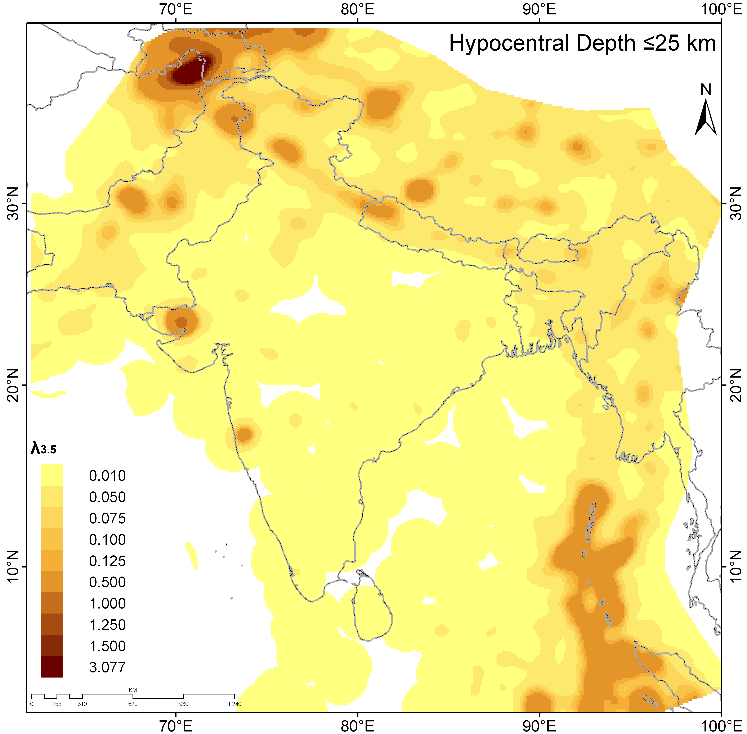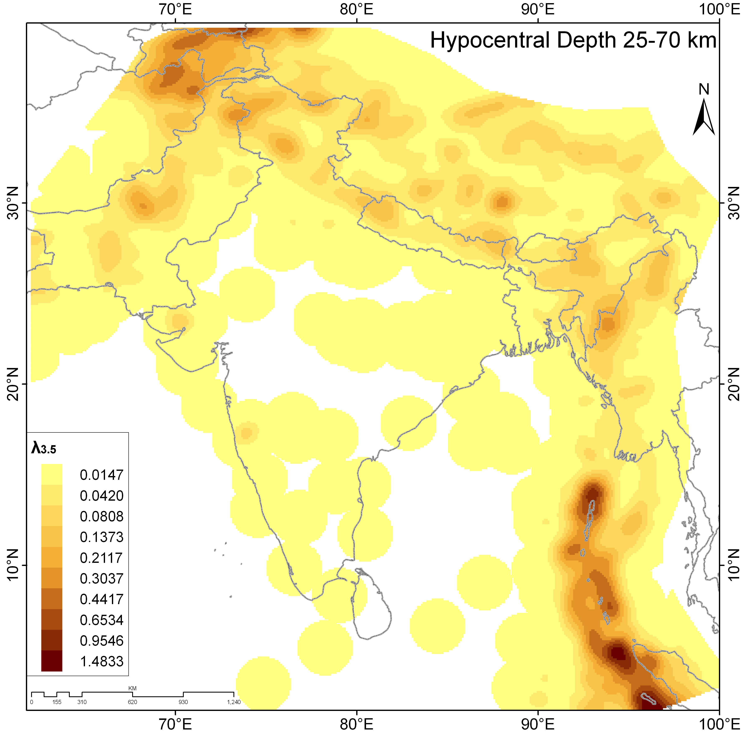
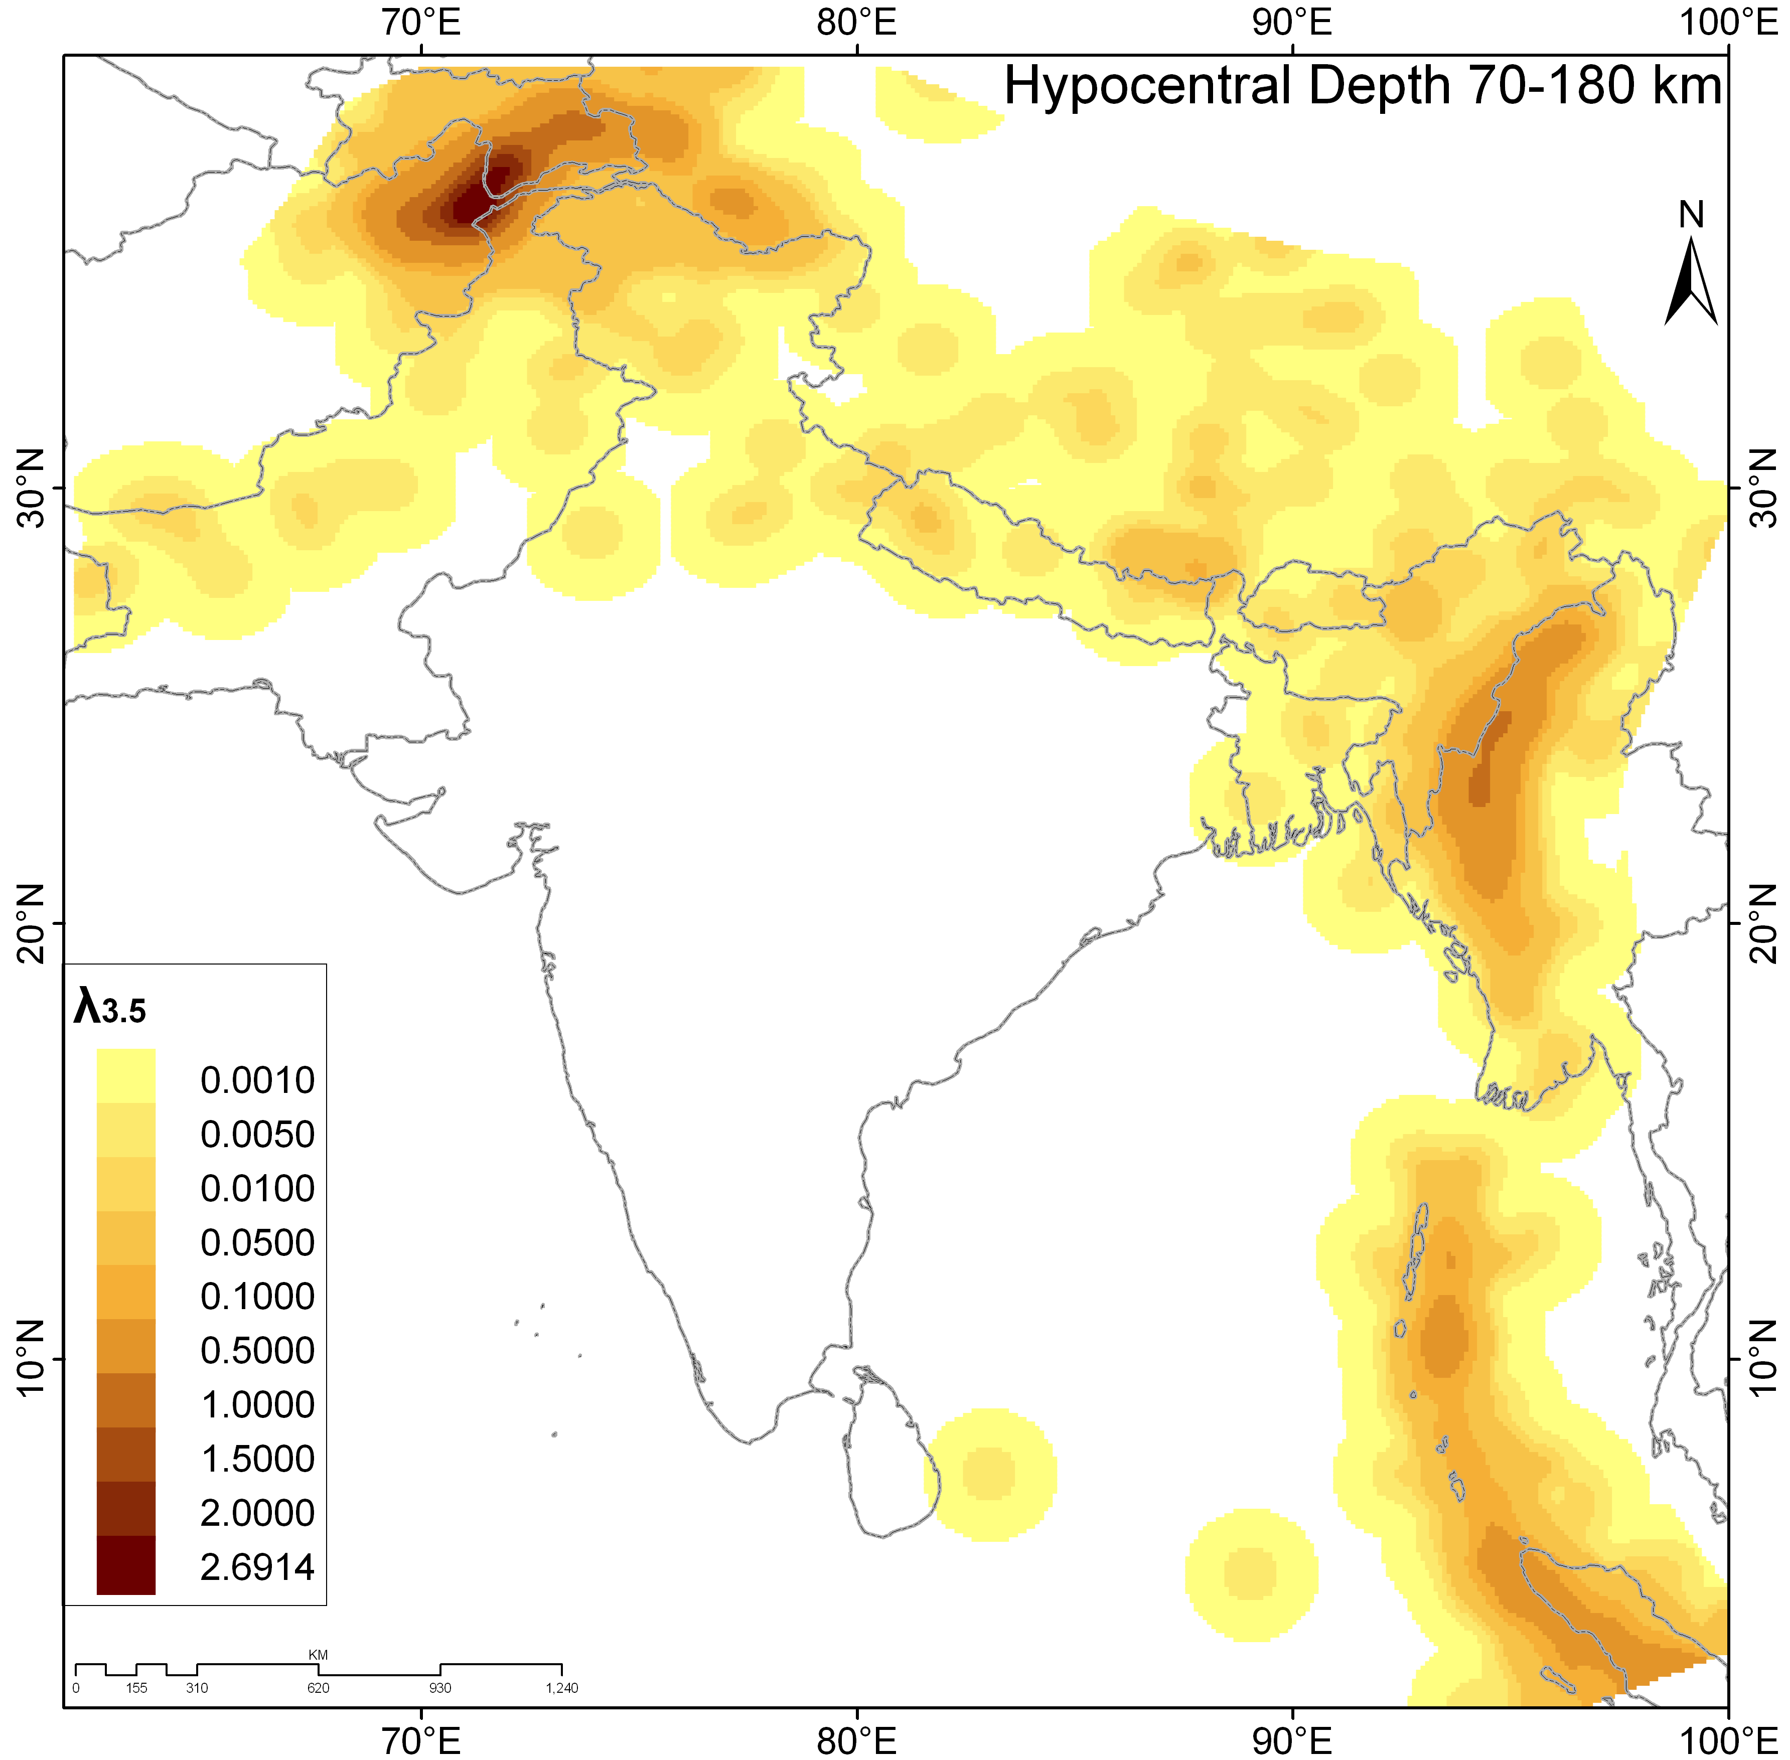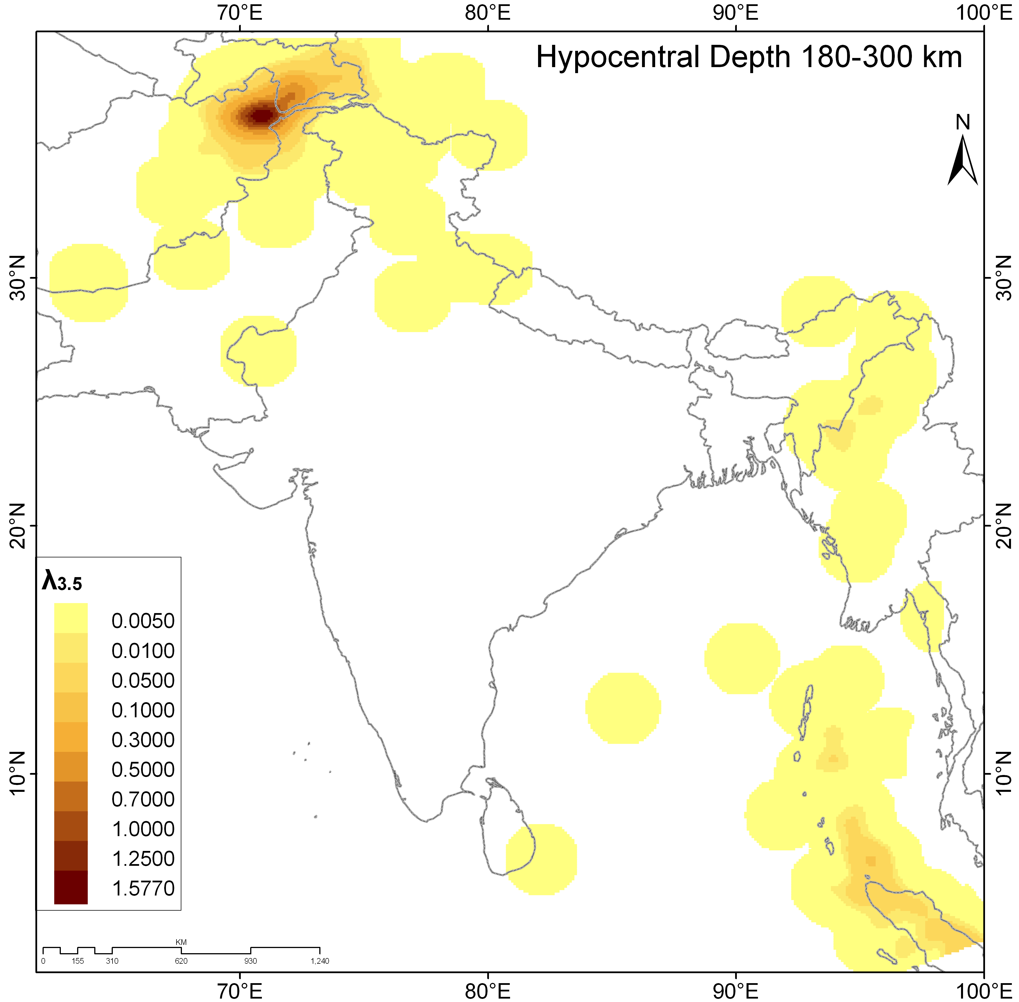
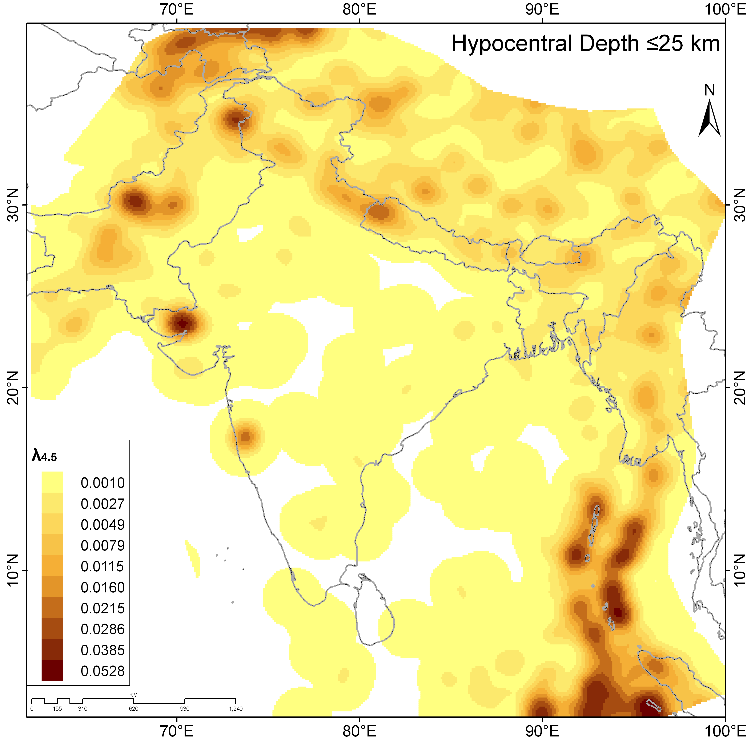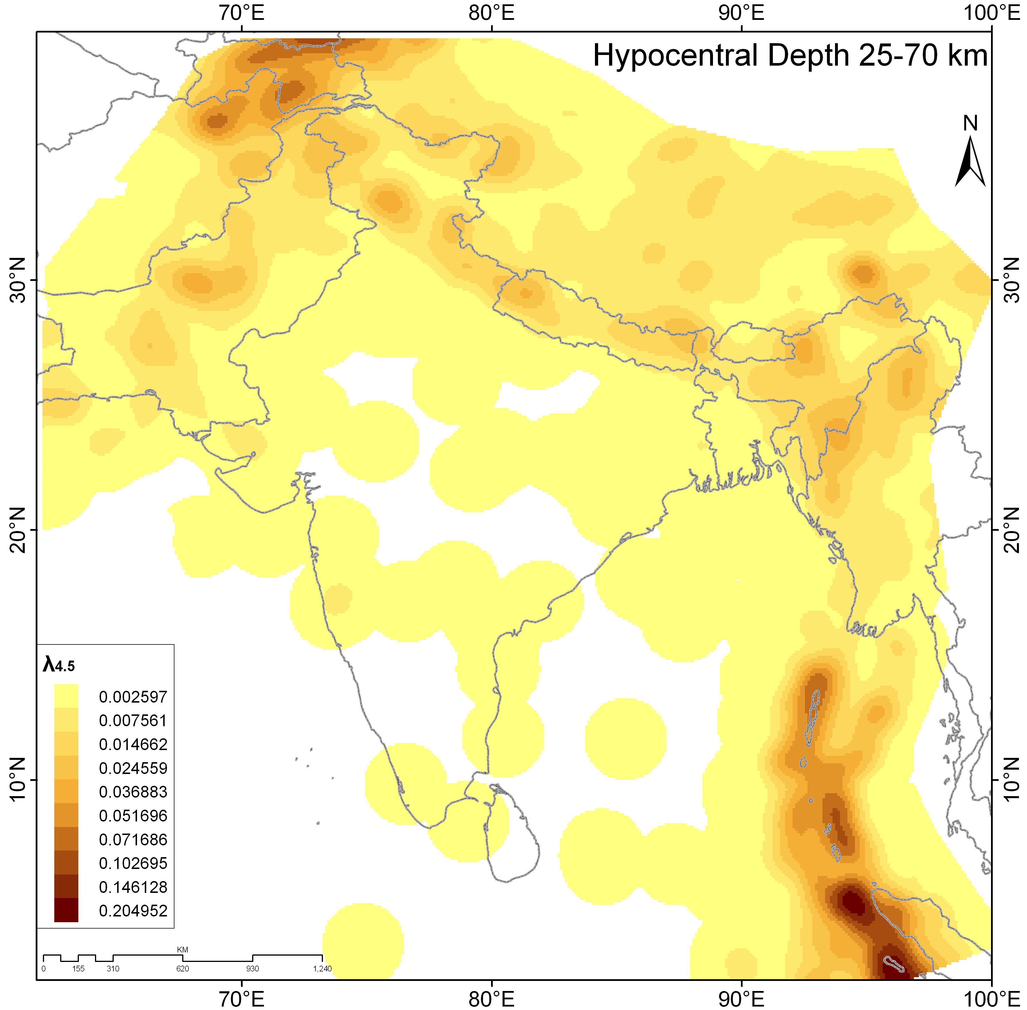
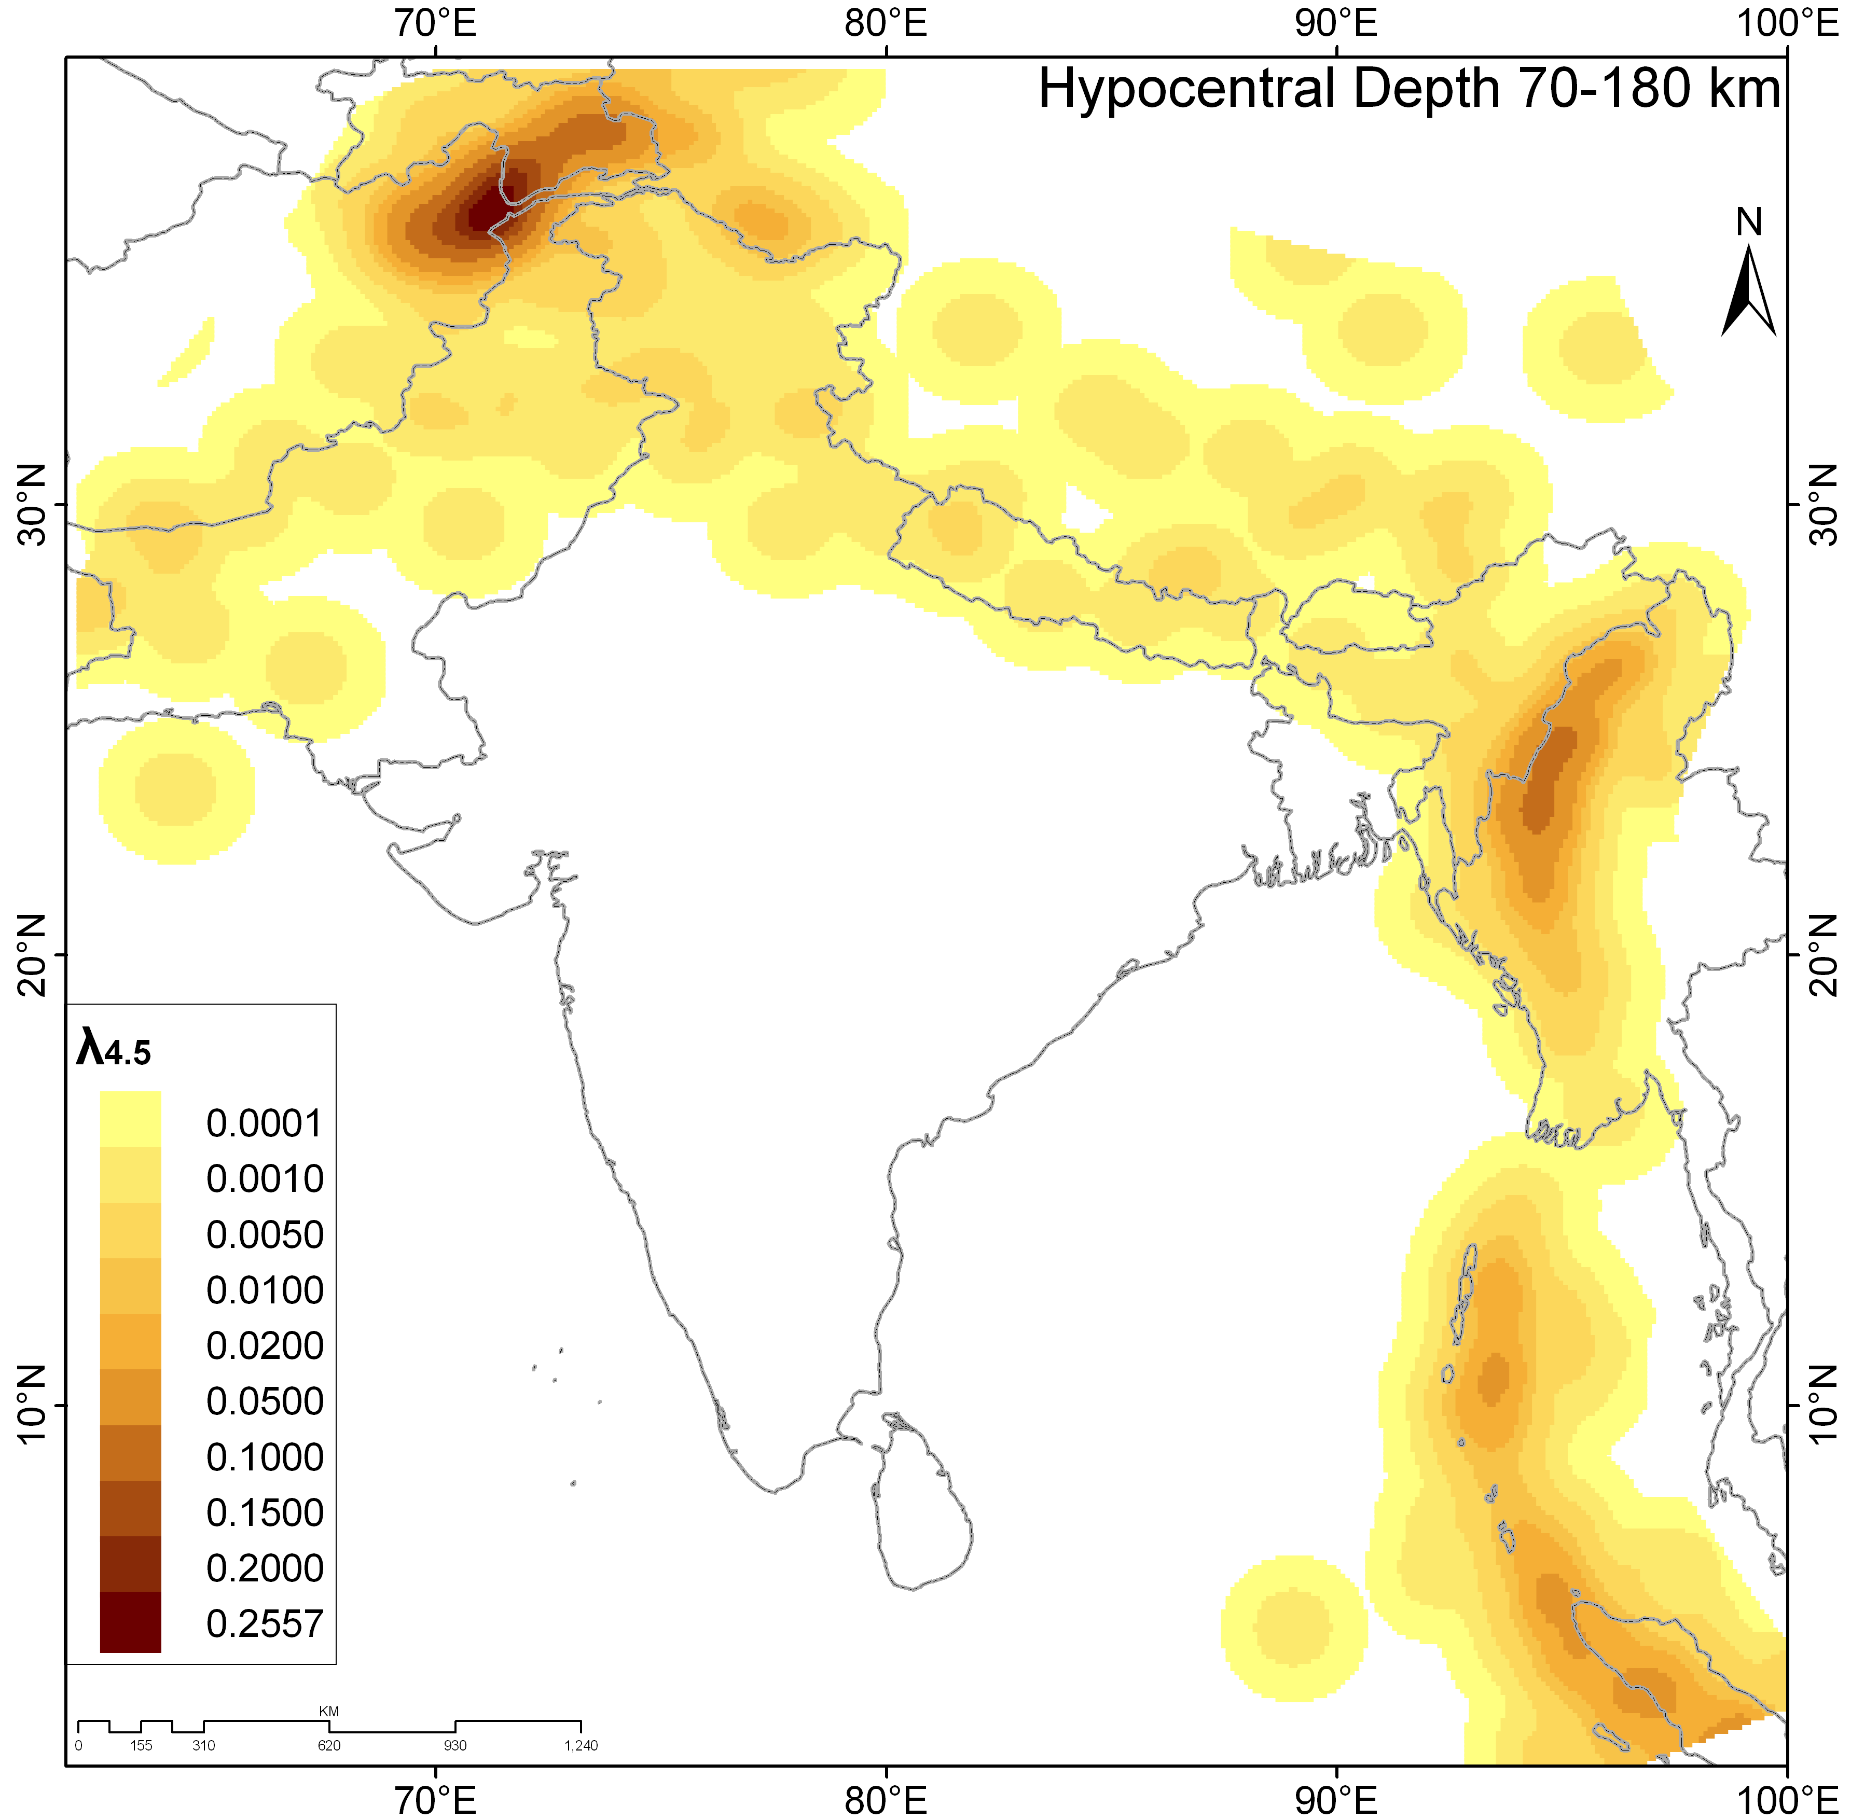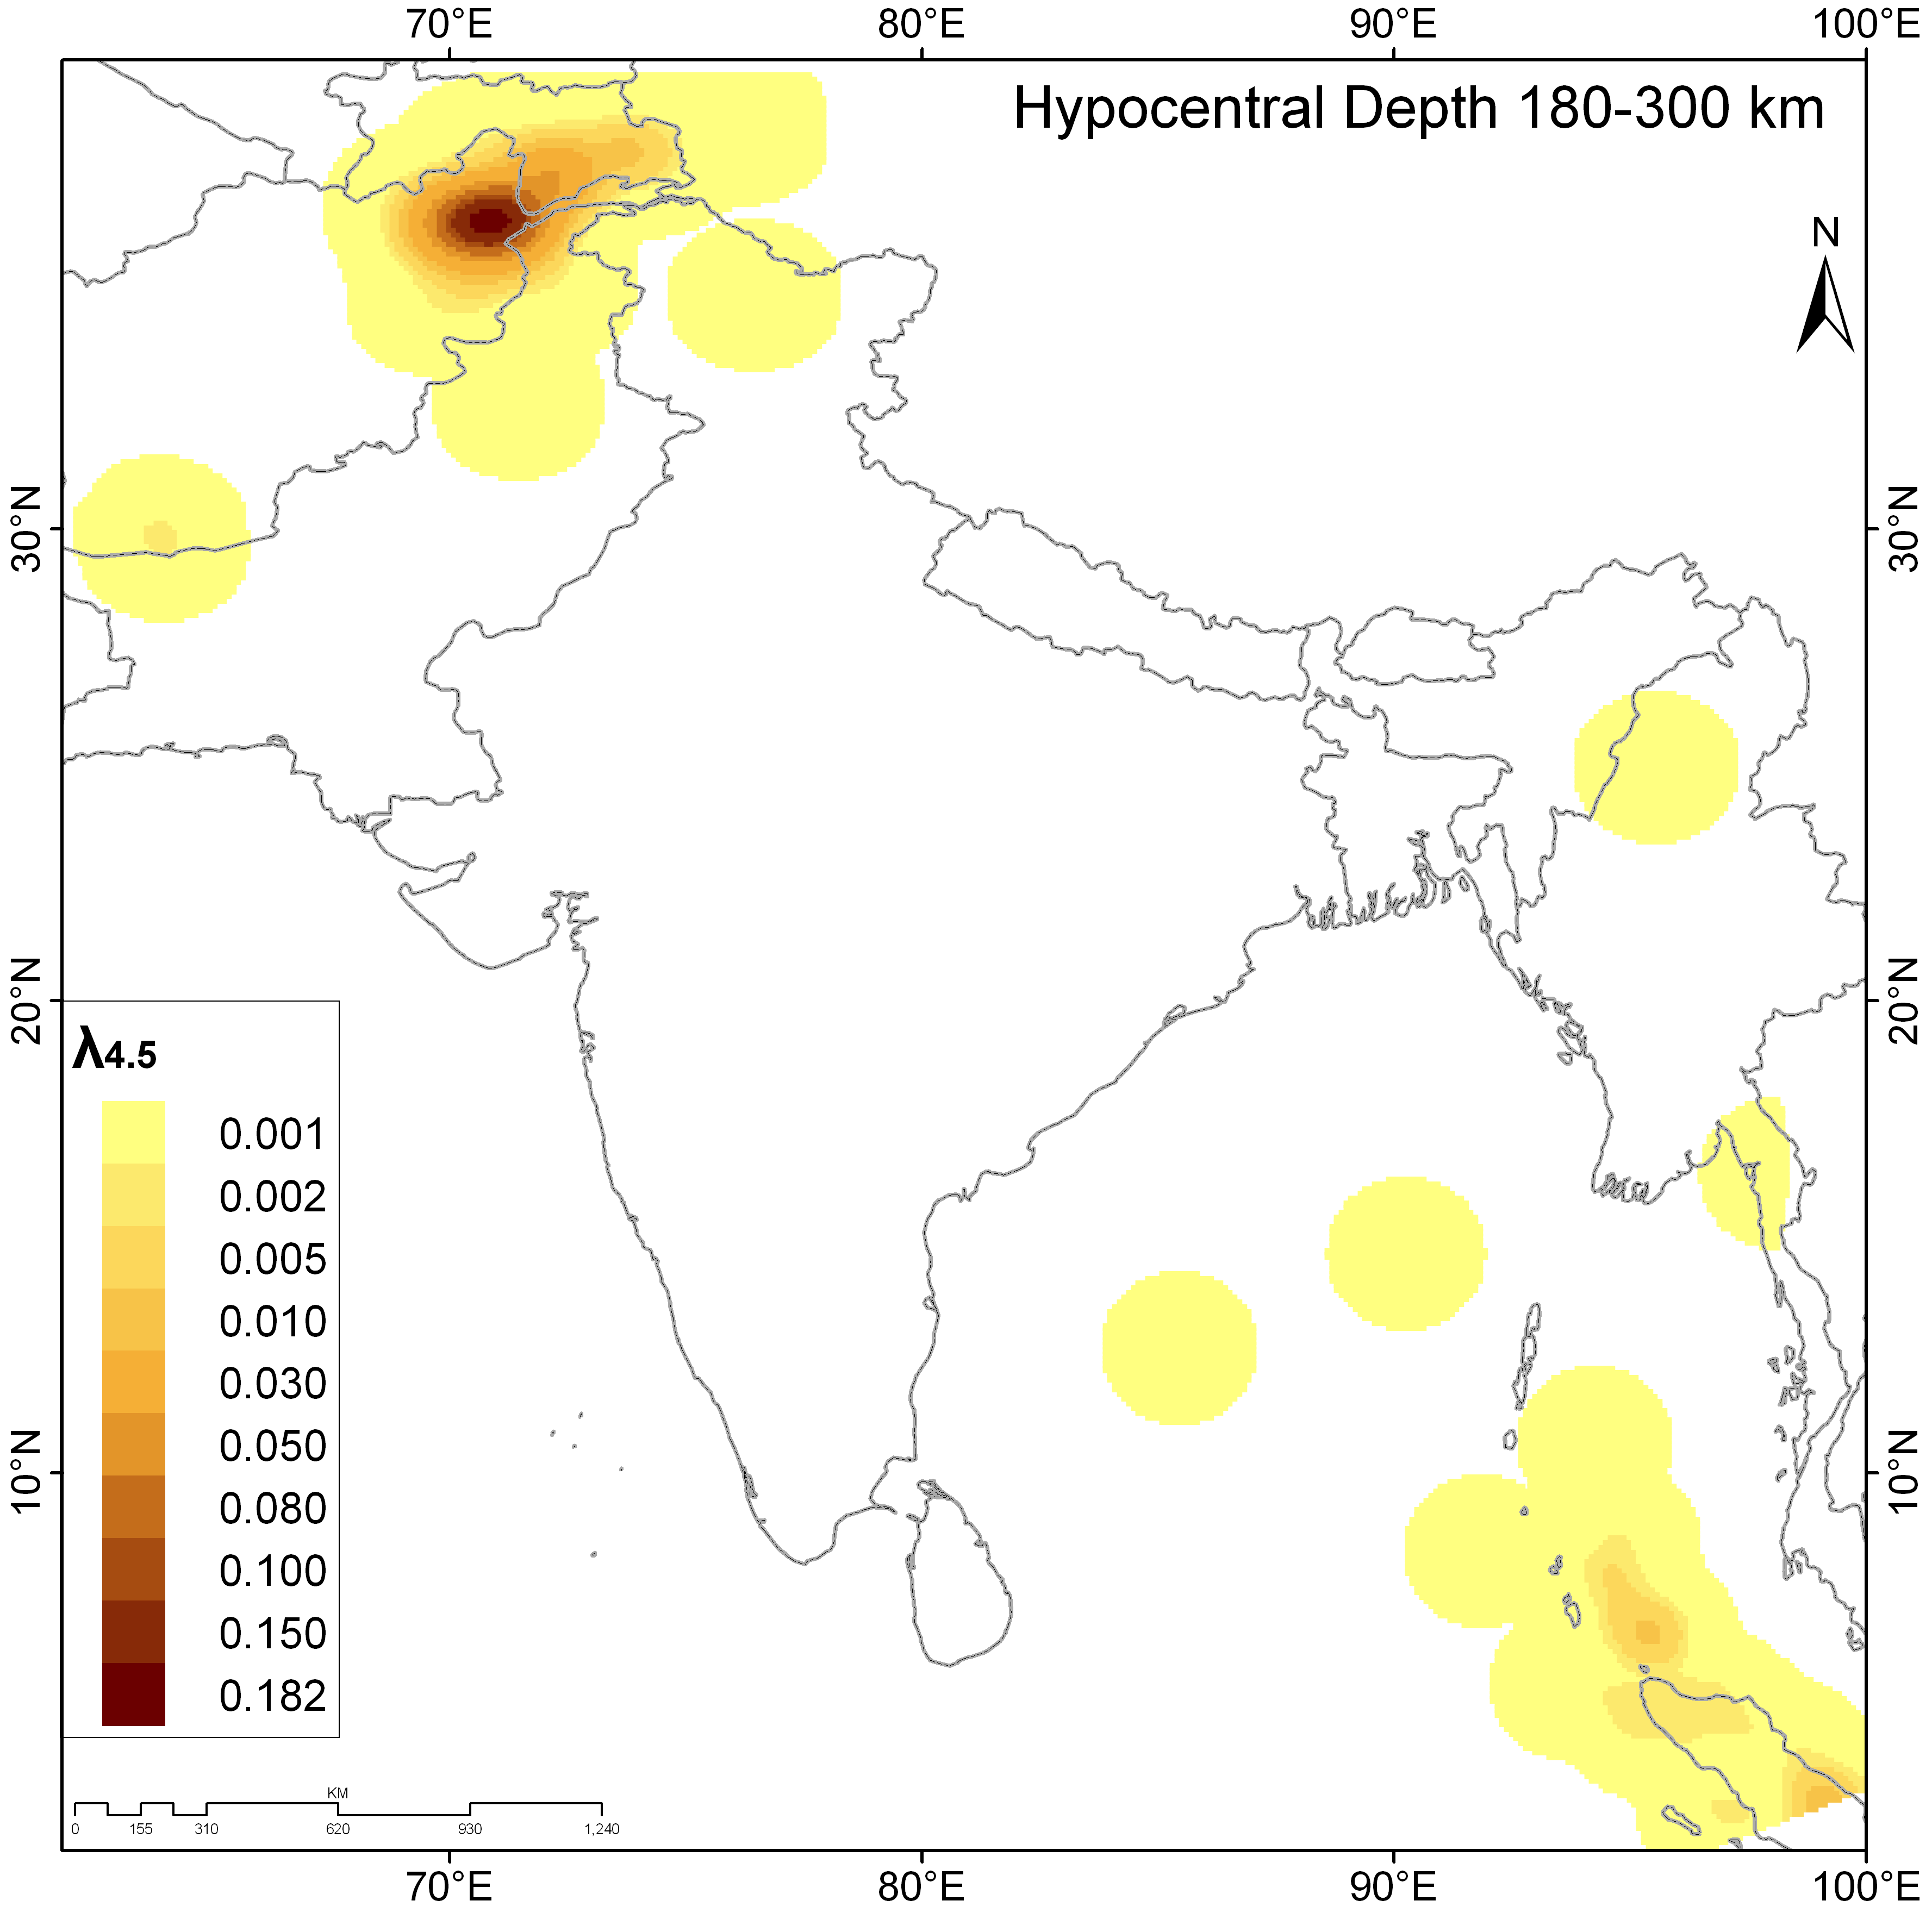
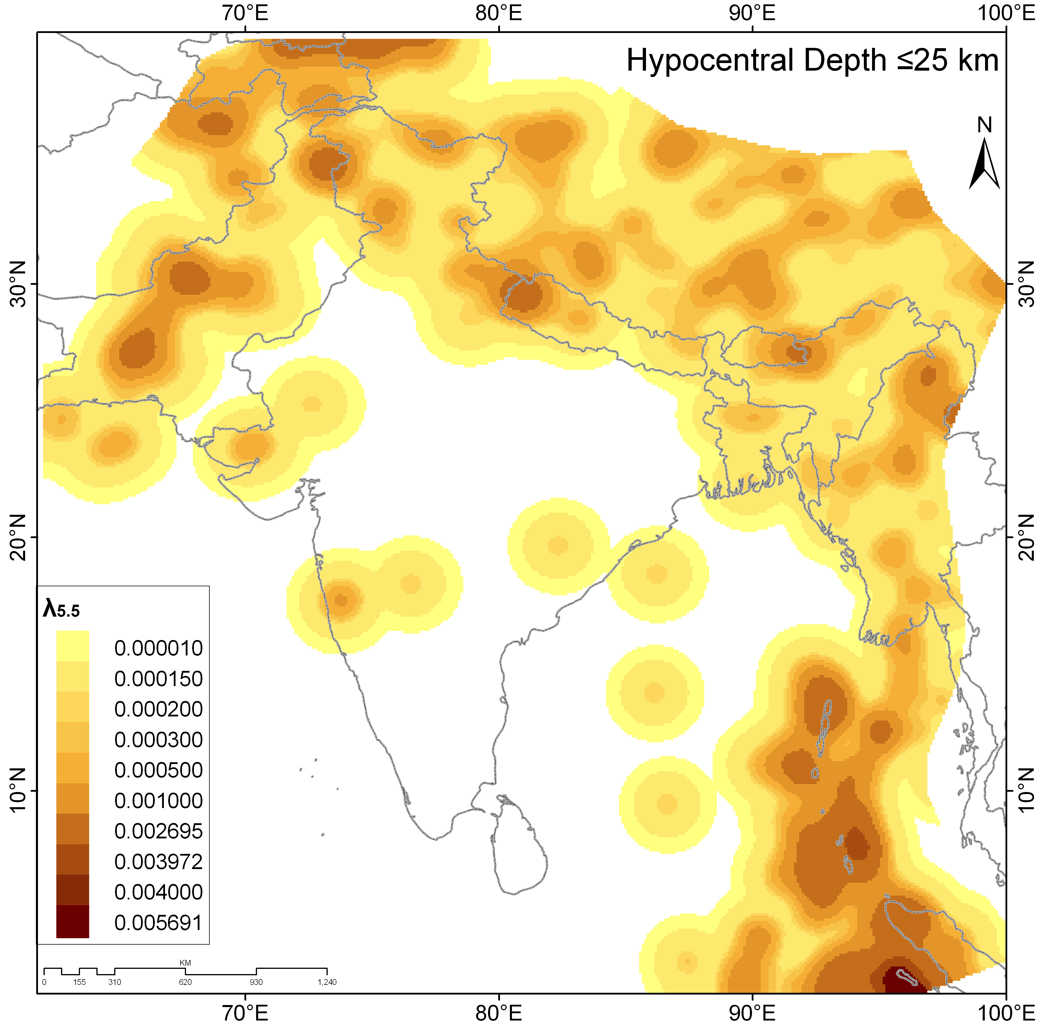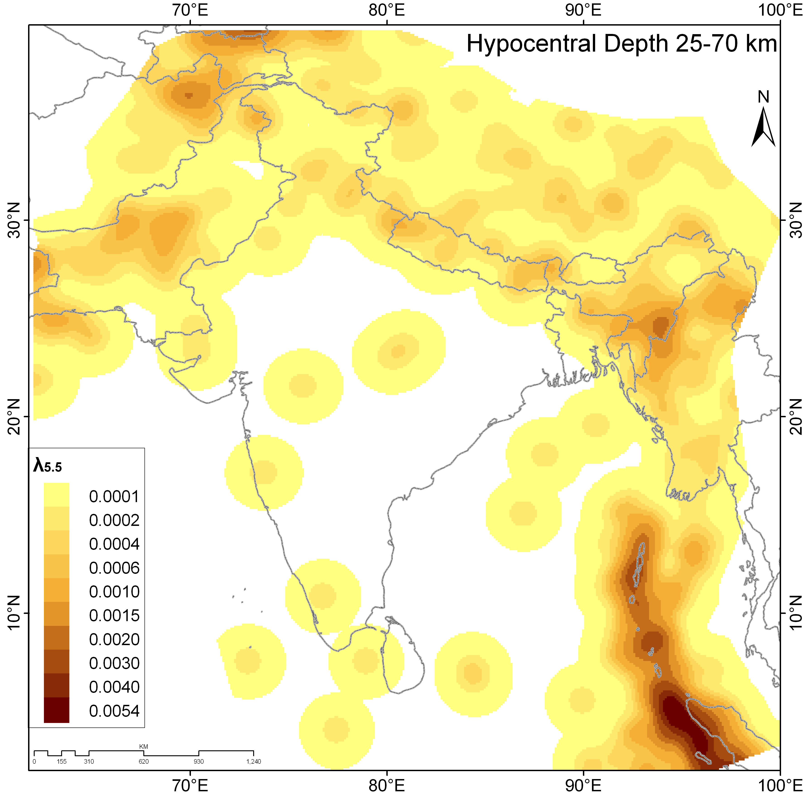
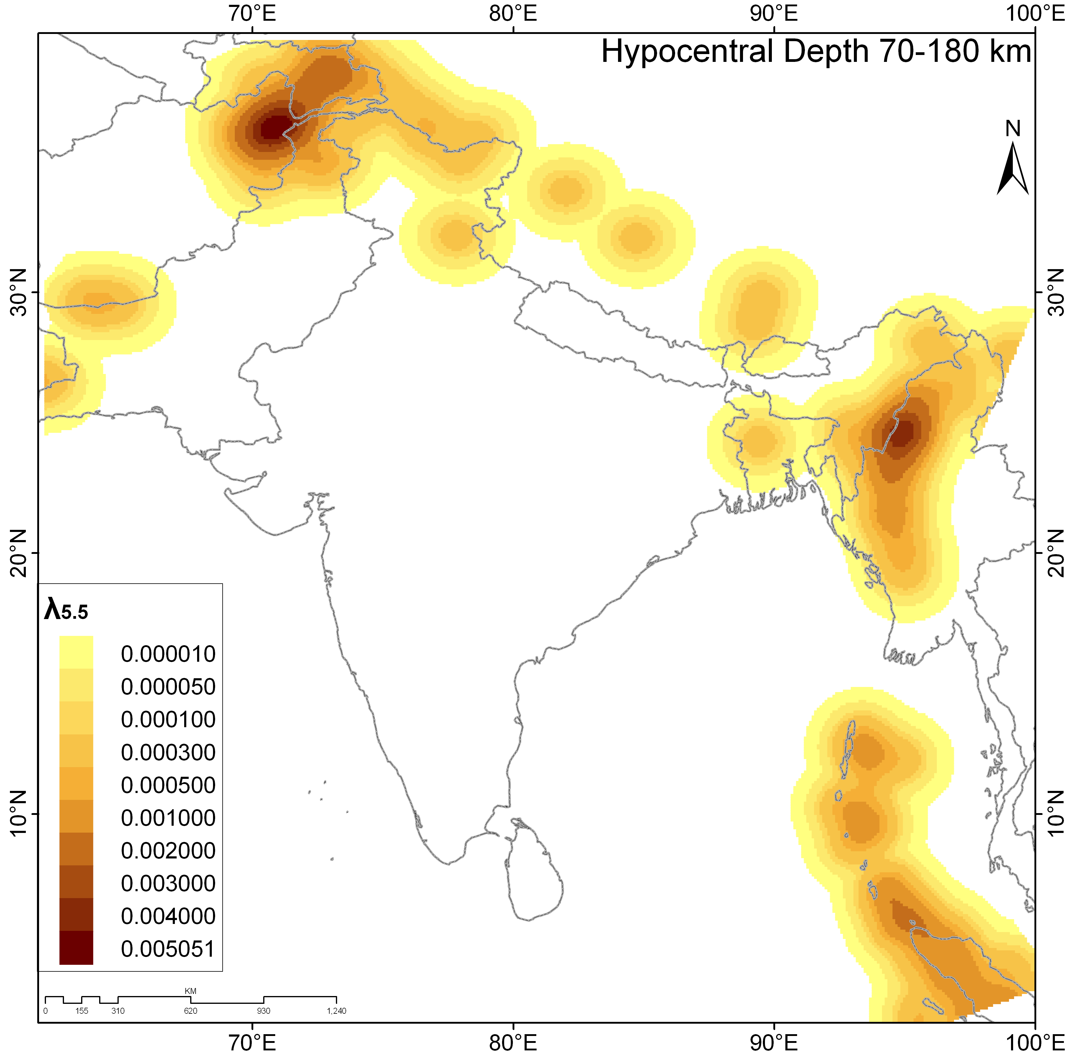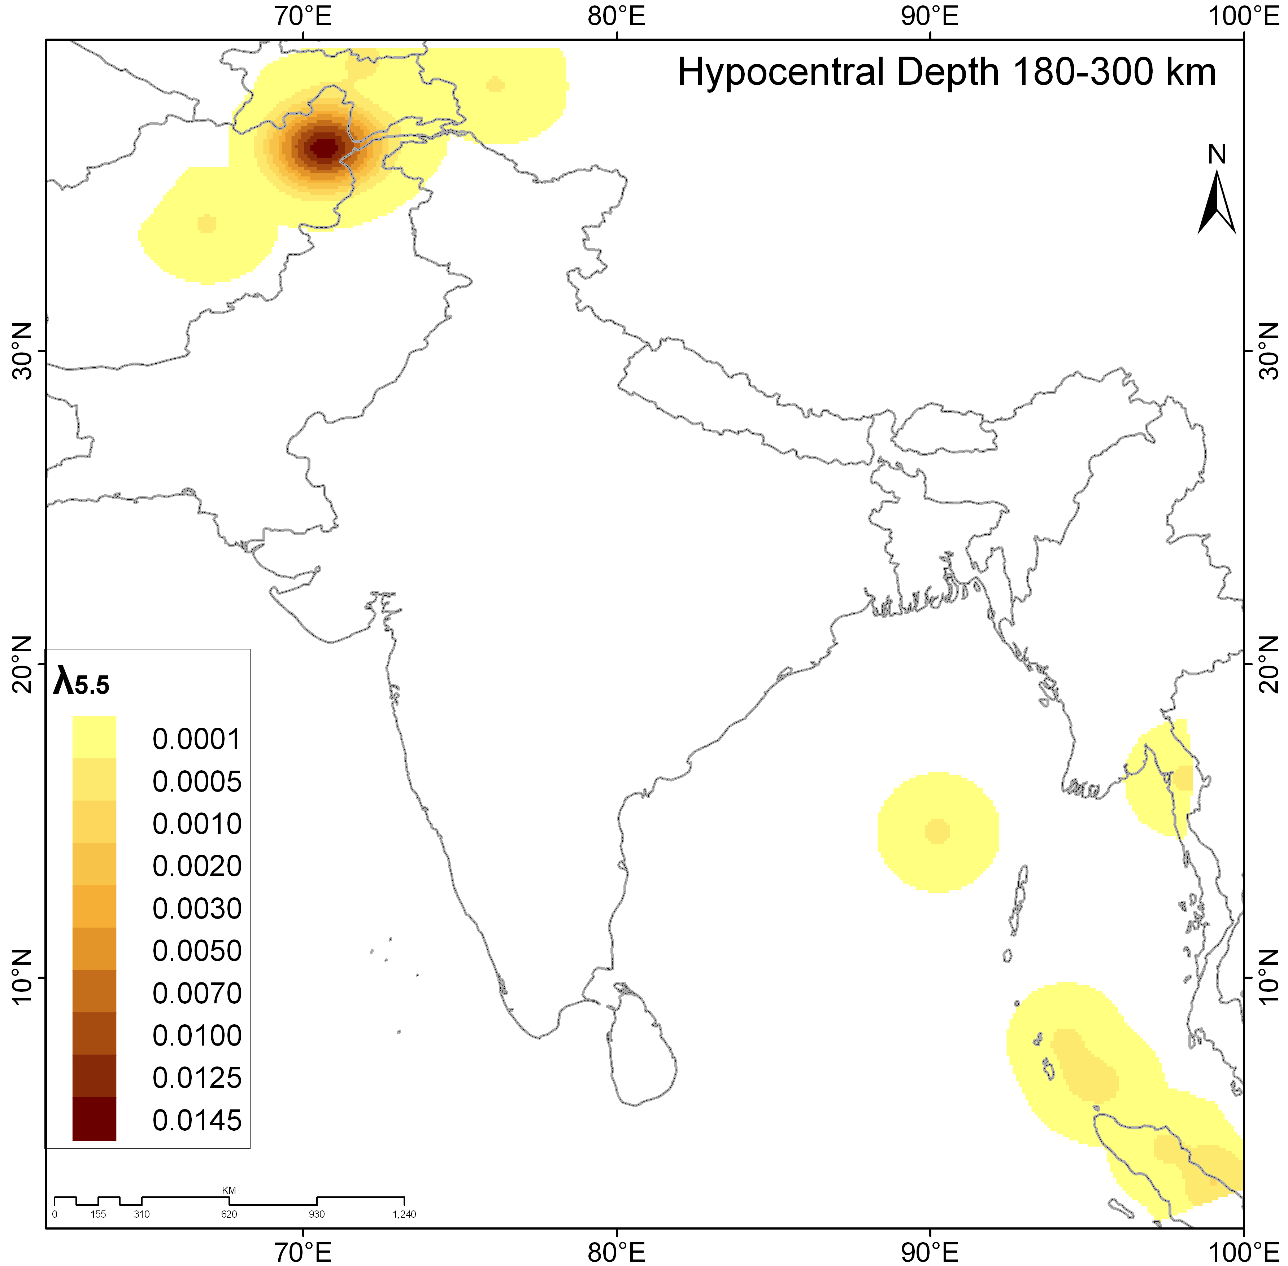
Fig. S1 Smoothened gridded seismicity for the polygonal seismogenic sources of India and its surrounding region for the threshold magnitude of M_{W} 3.5, 4.5 and 5.5 at the hypocentral depth range of (a) 0-25km, (b) 25-70km, (c) 70-180km and (d) 180-300km (after Nath and Thingbaijam 2012 and Nath 2017)

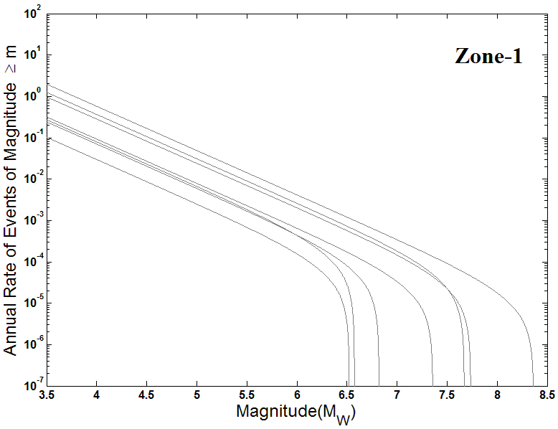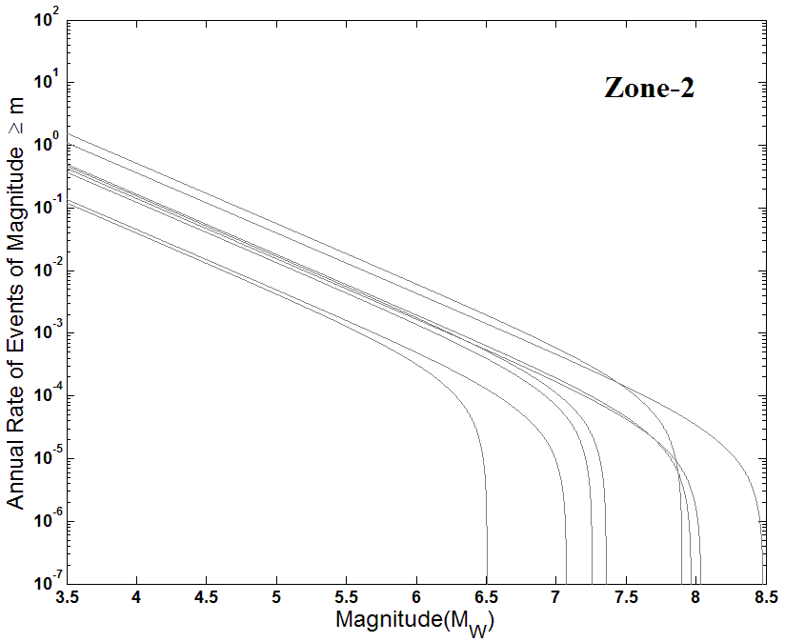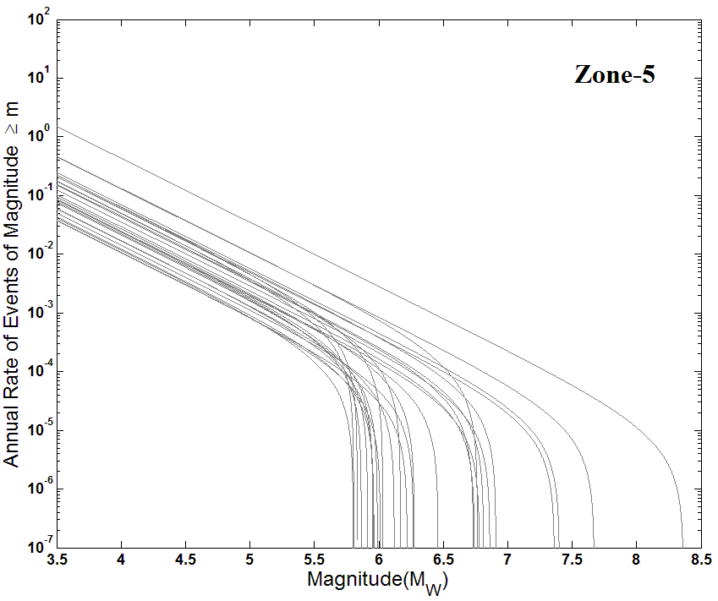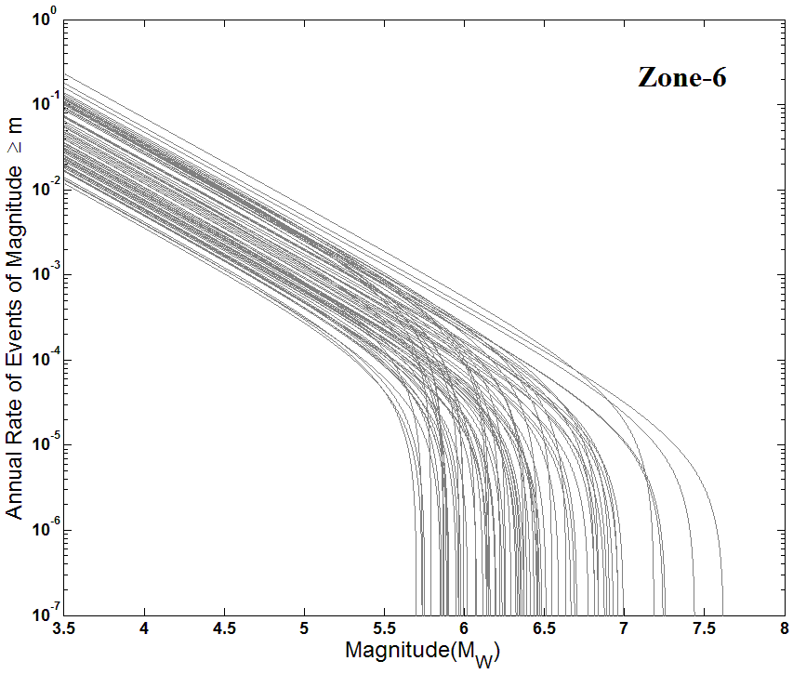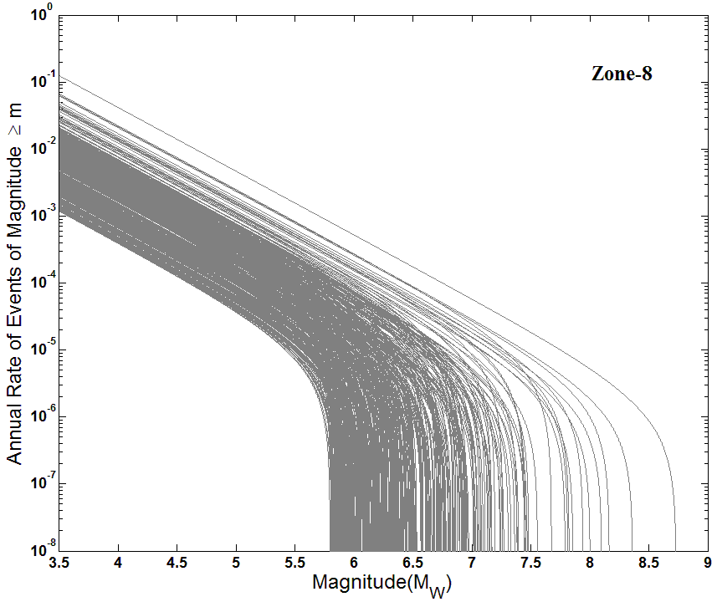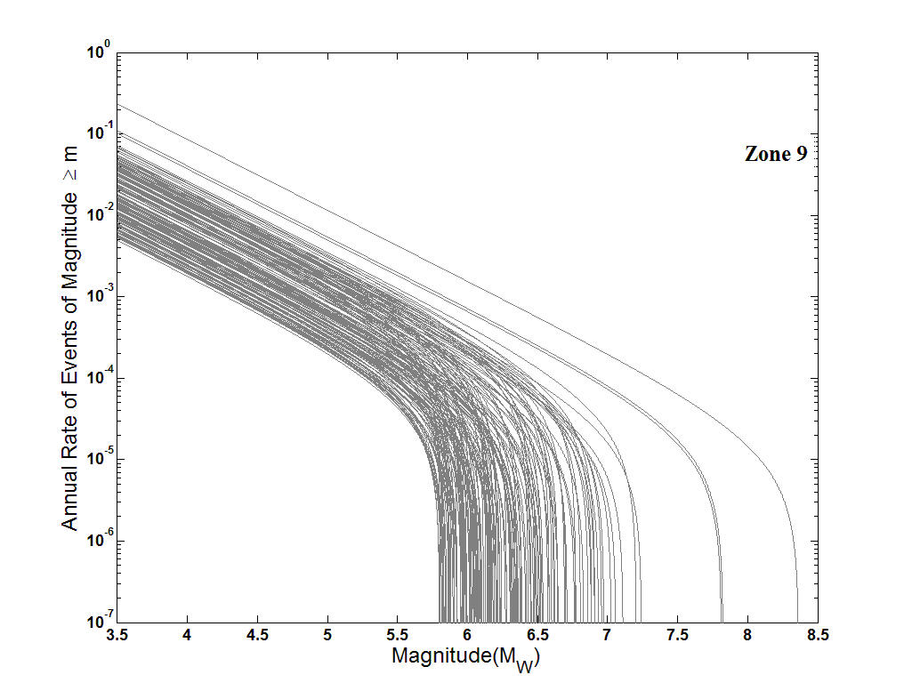
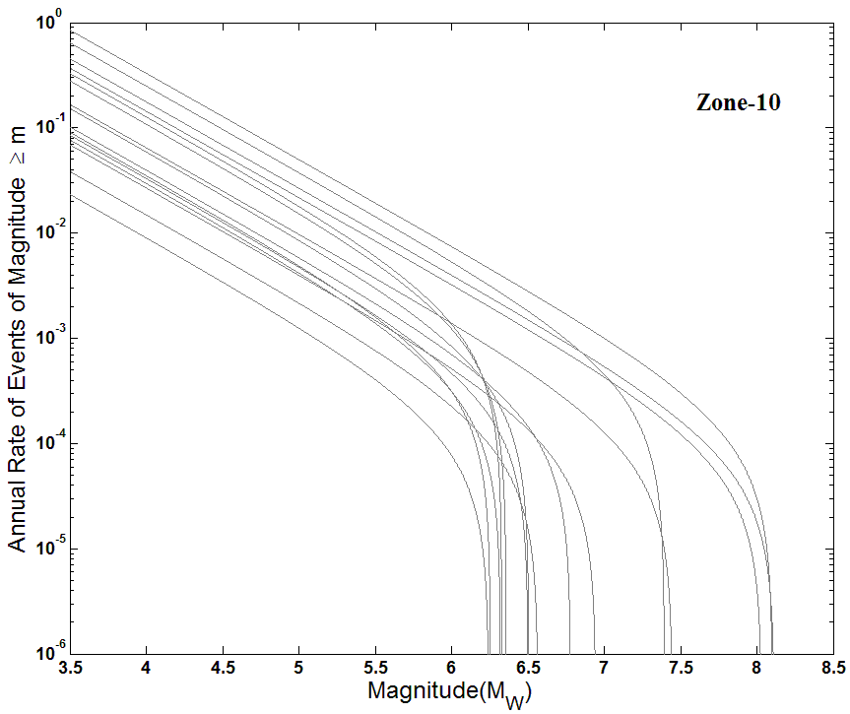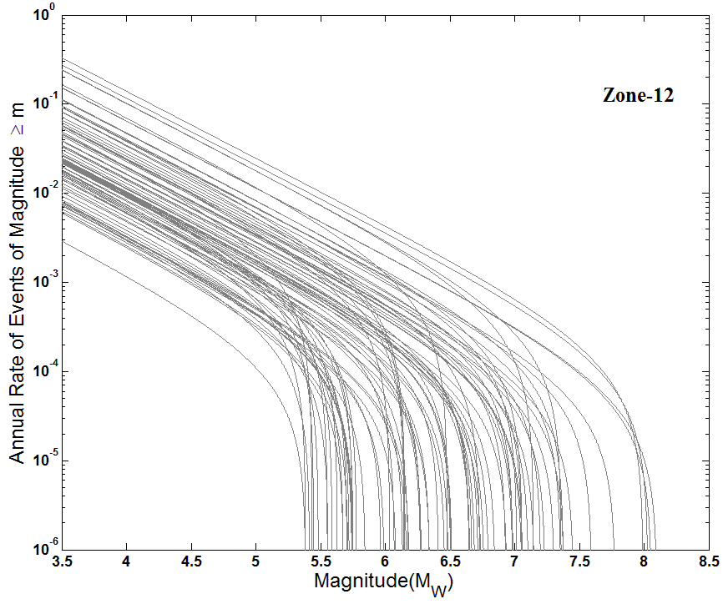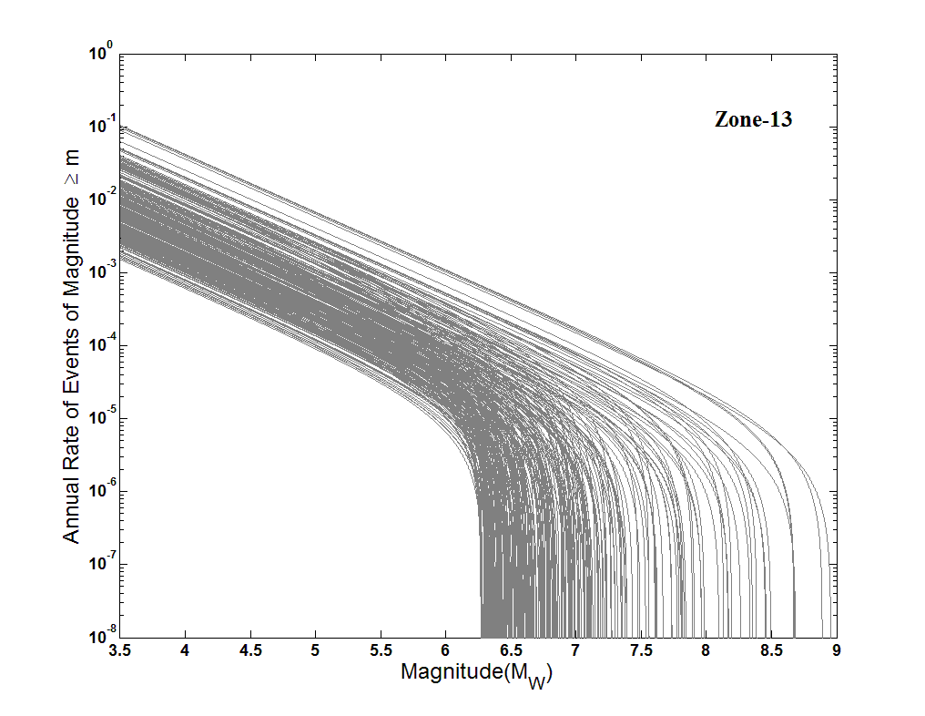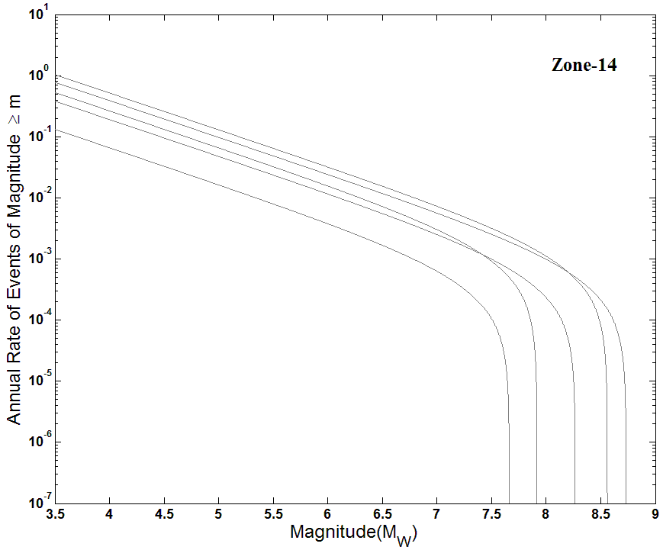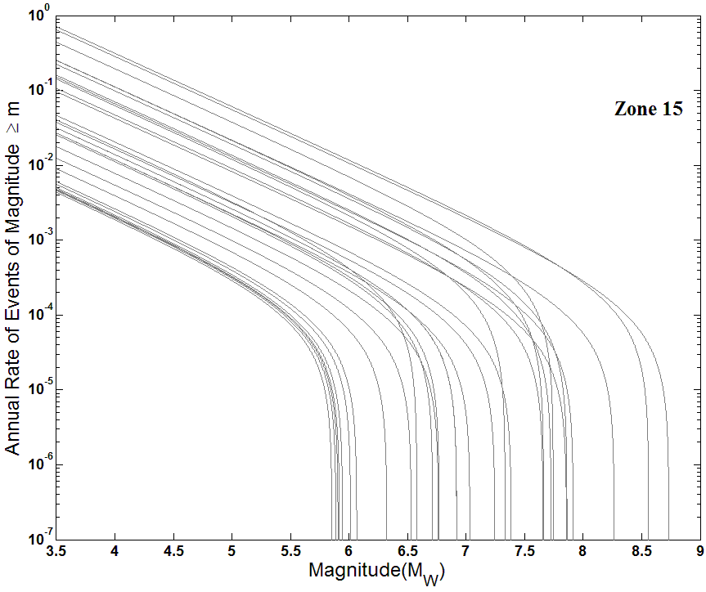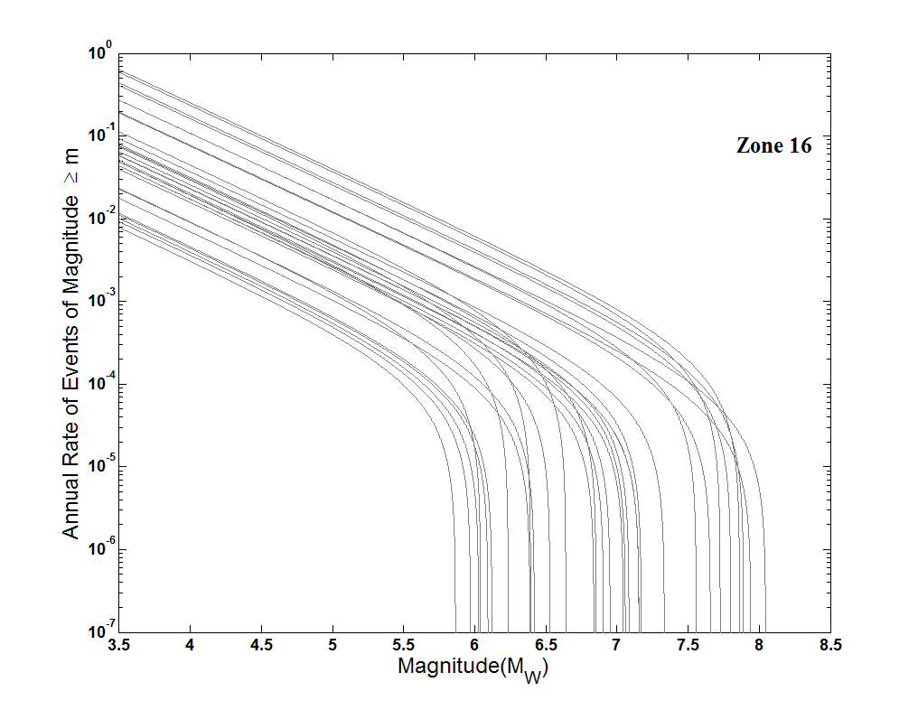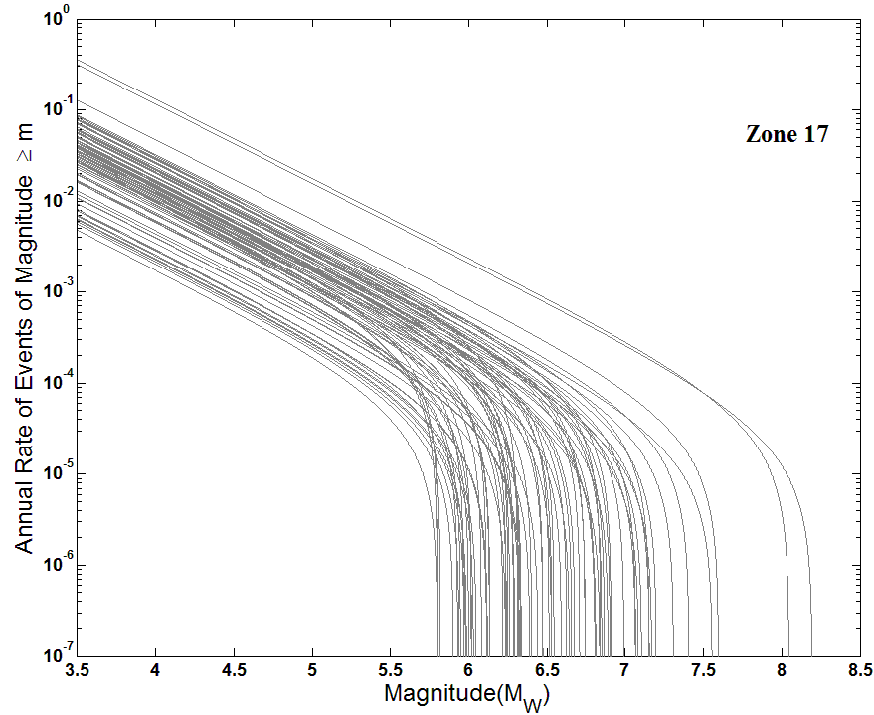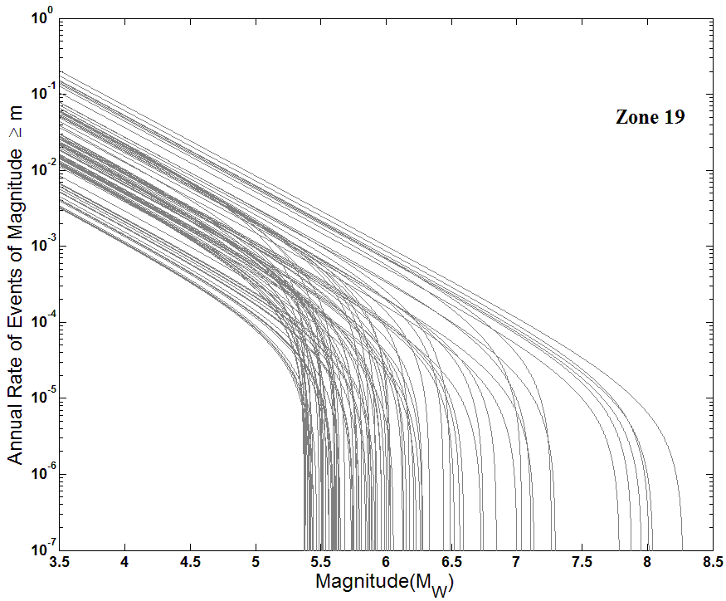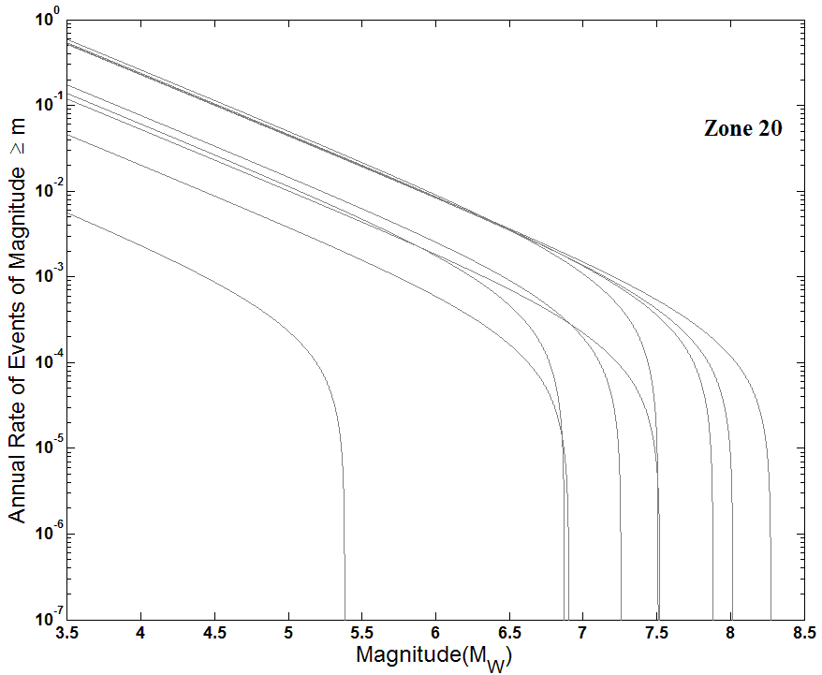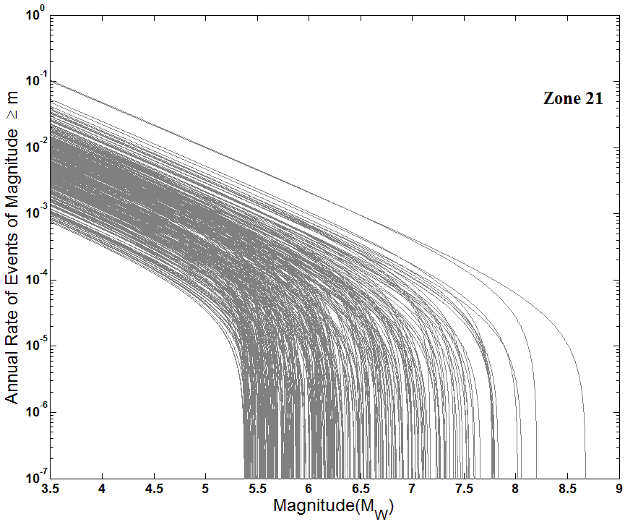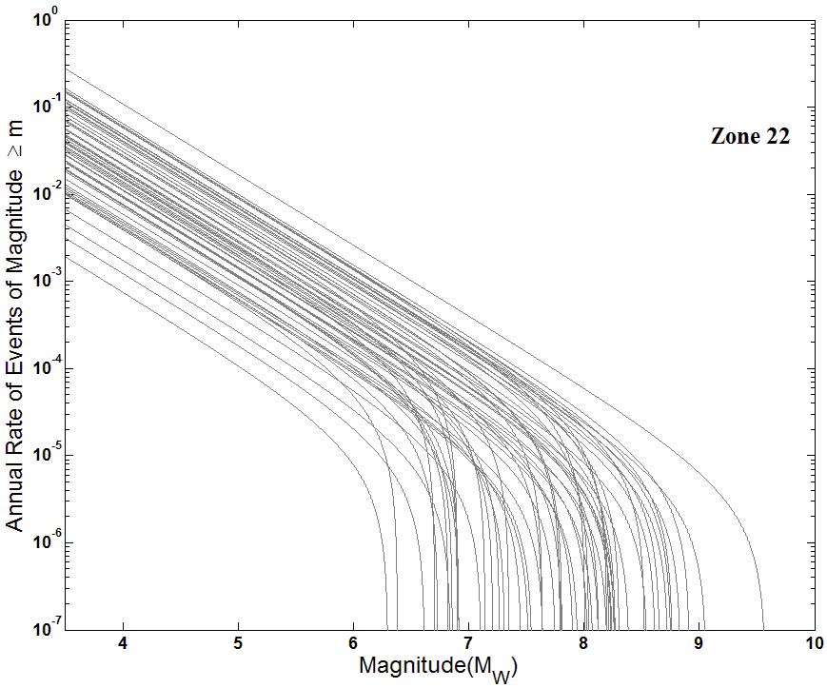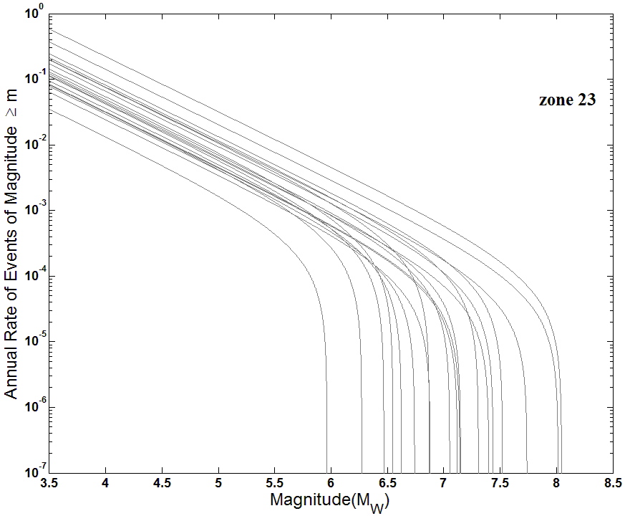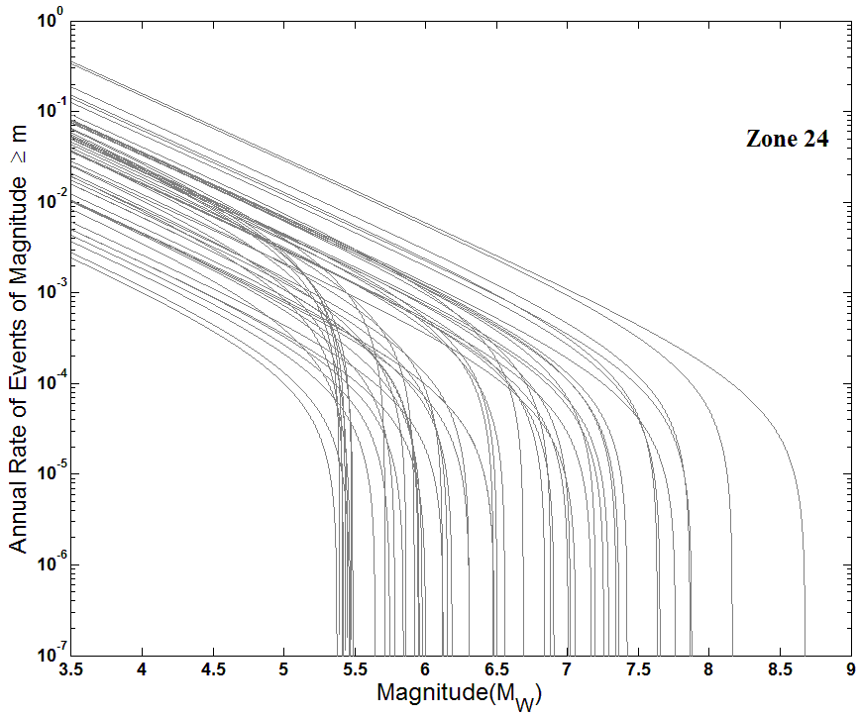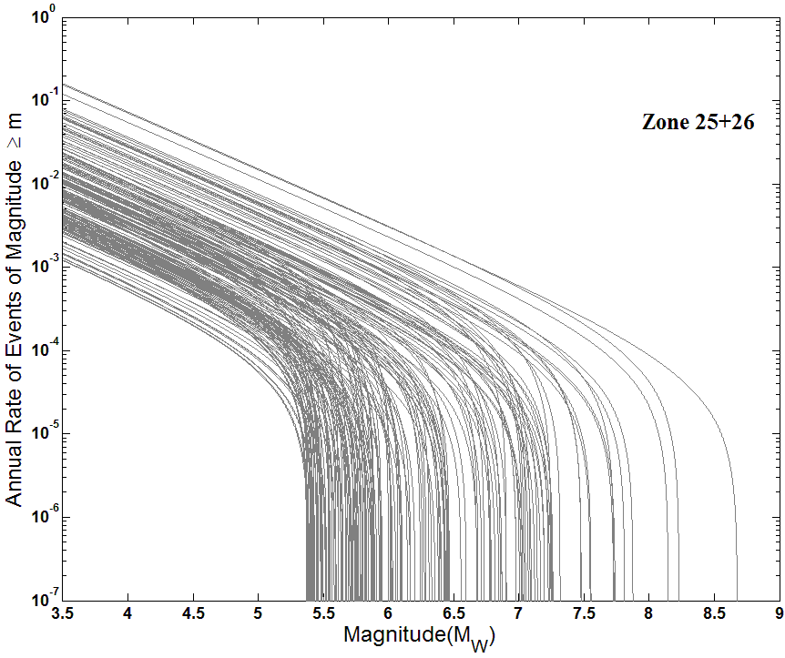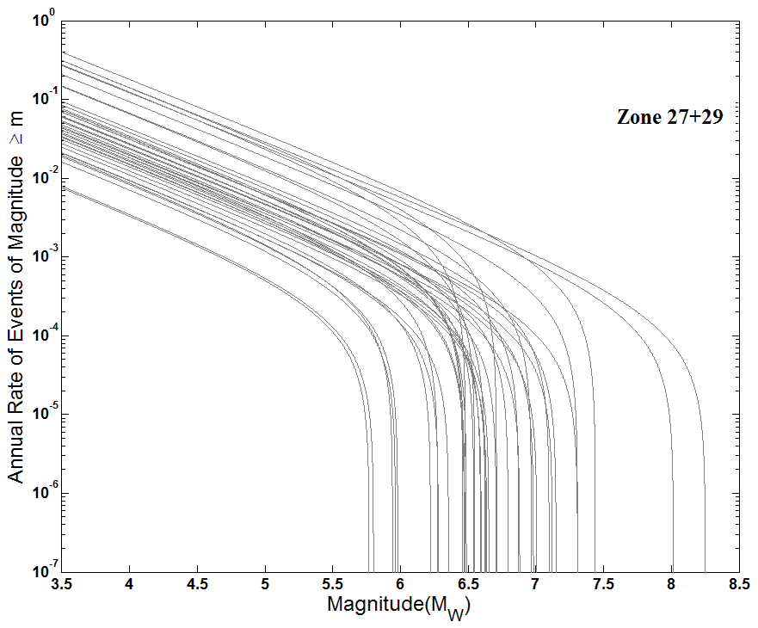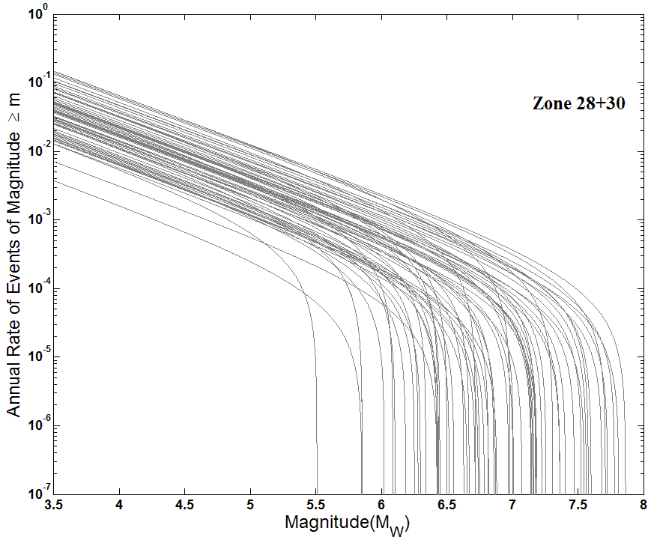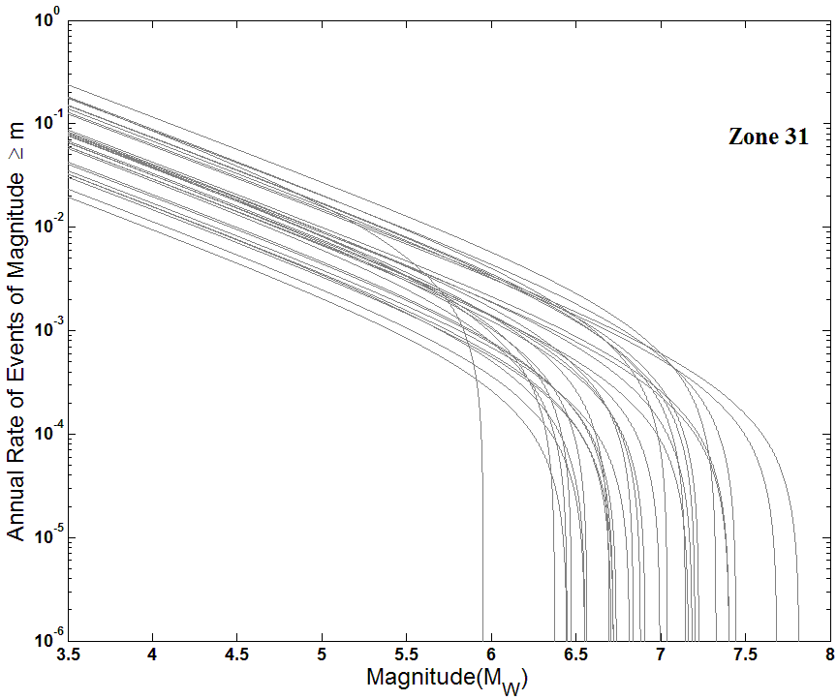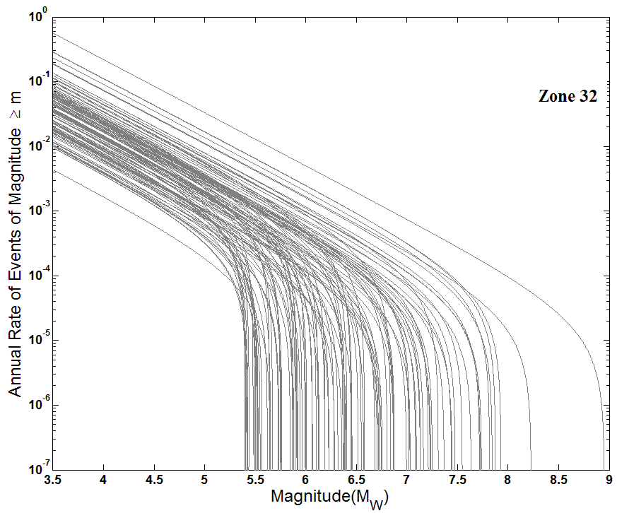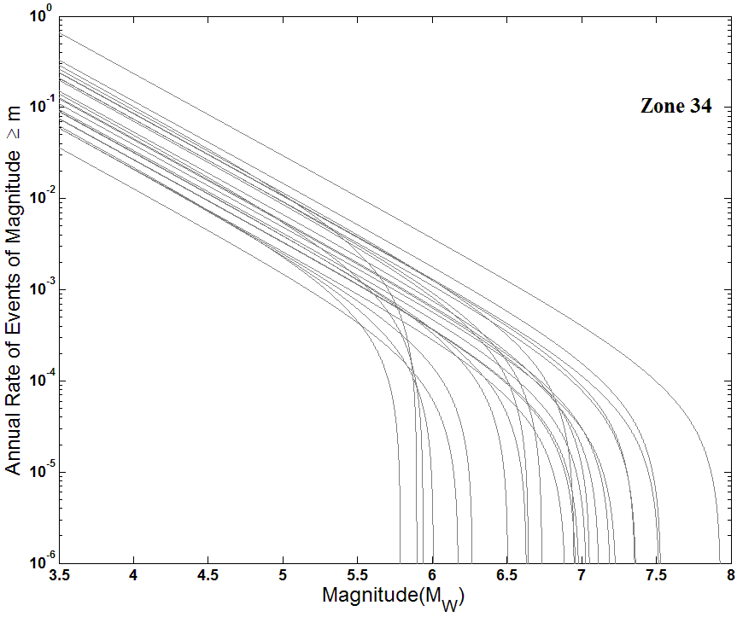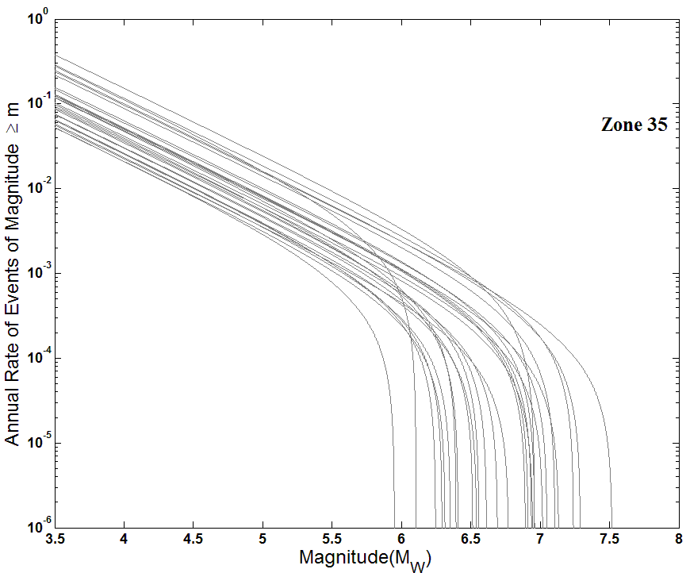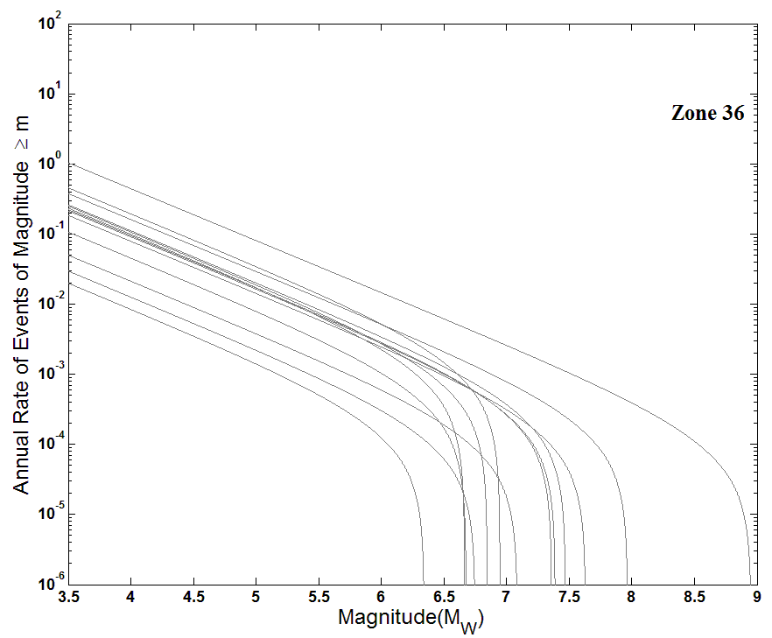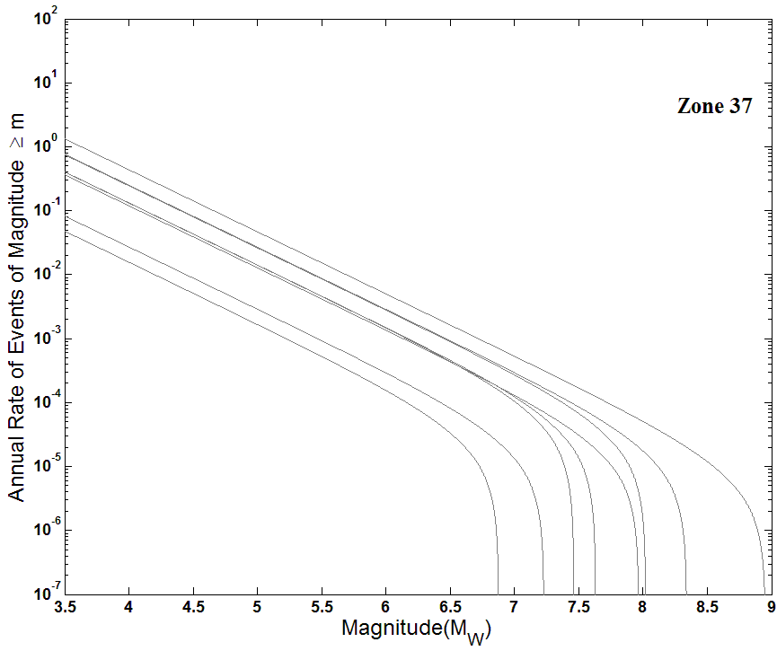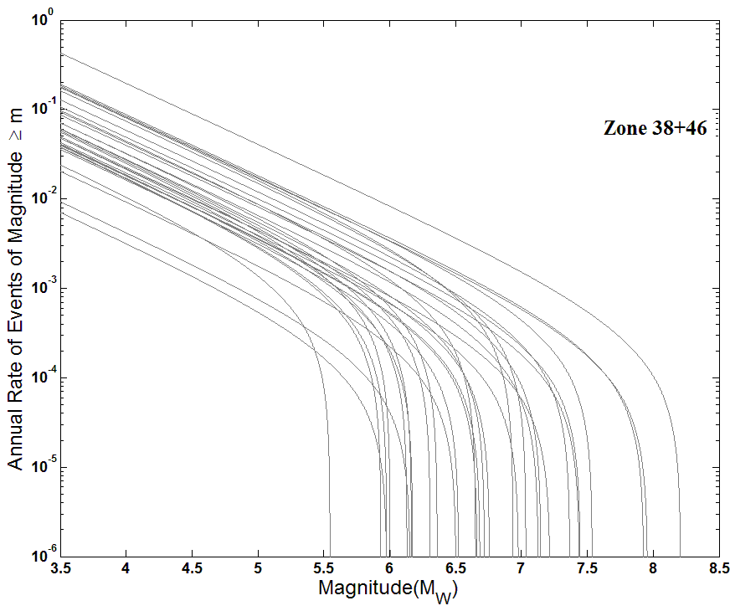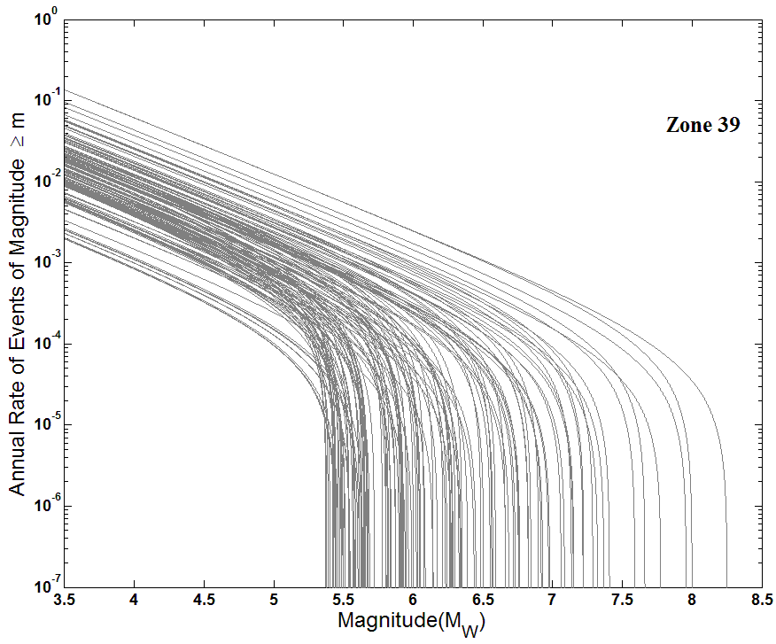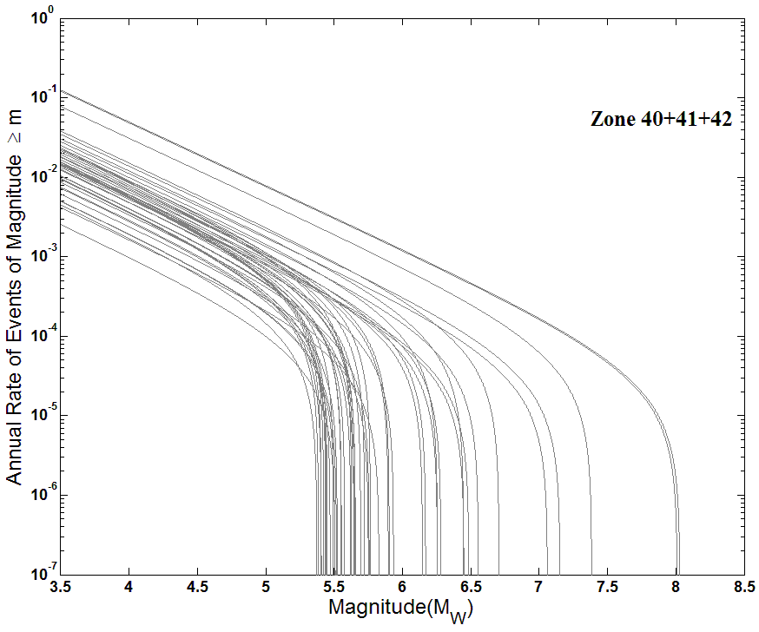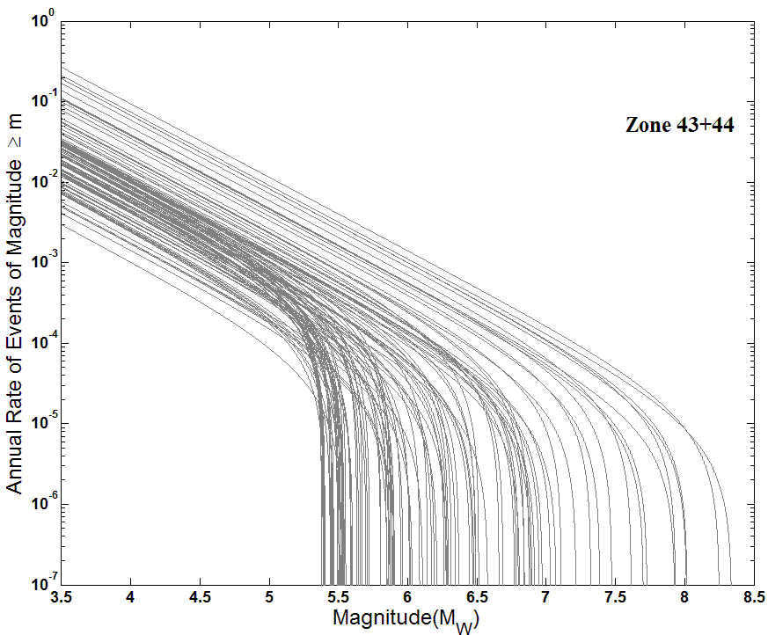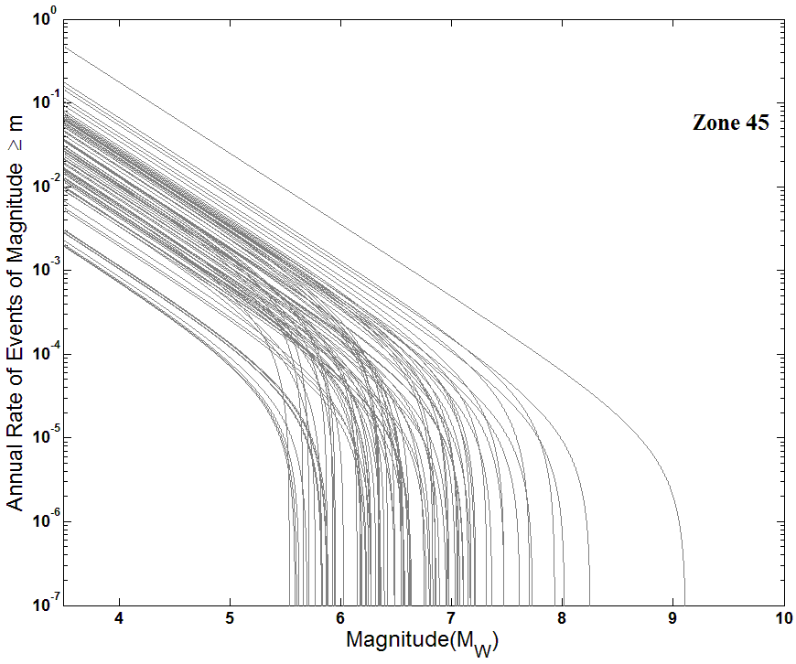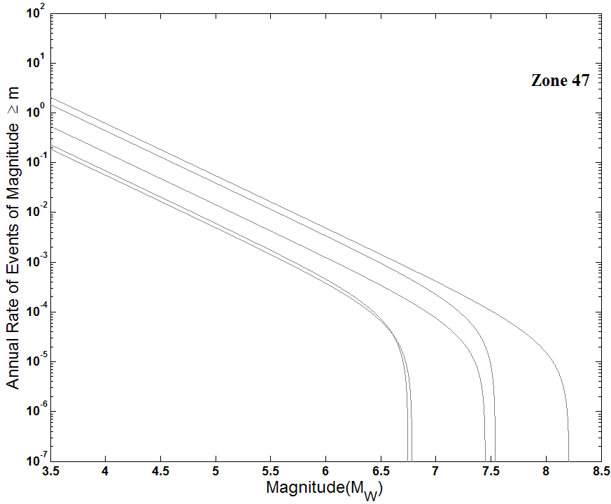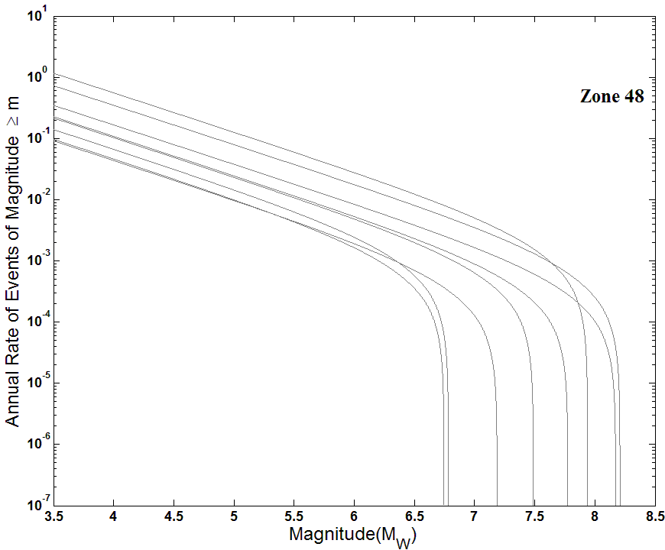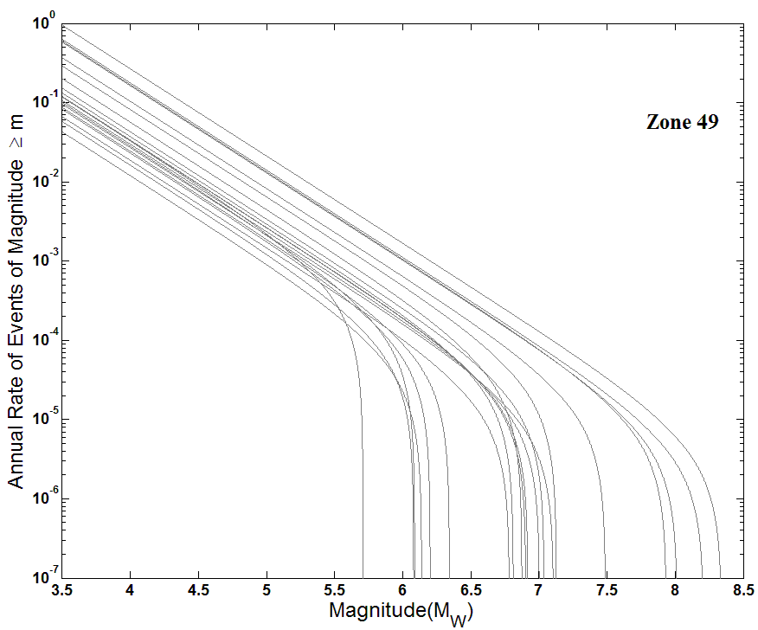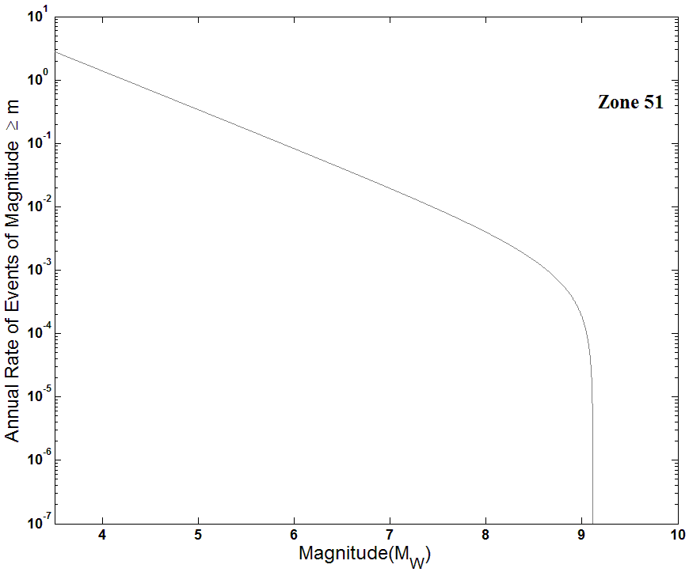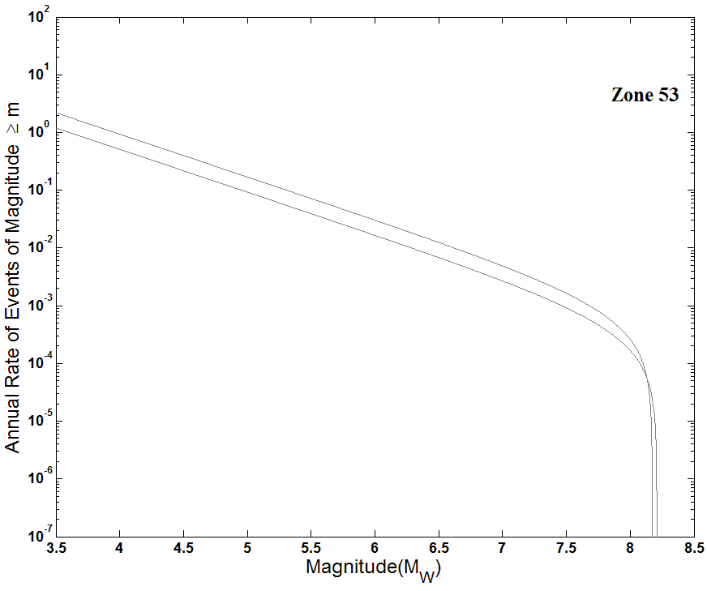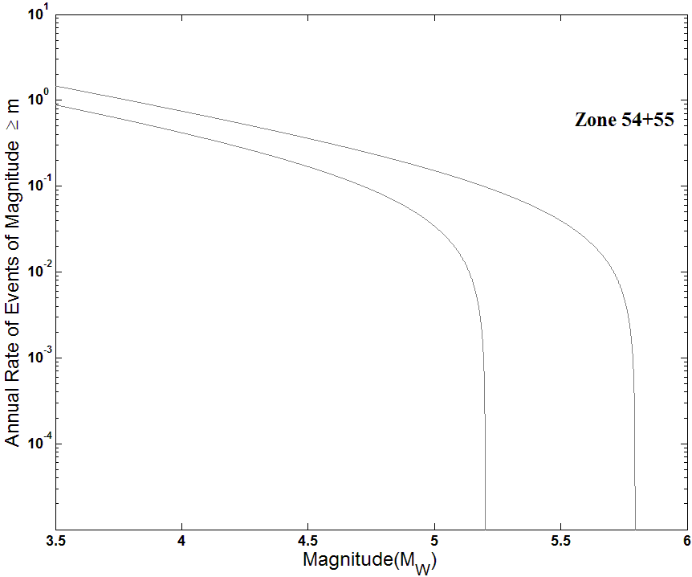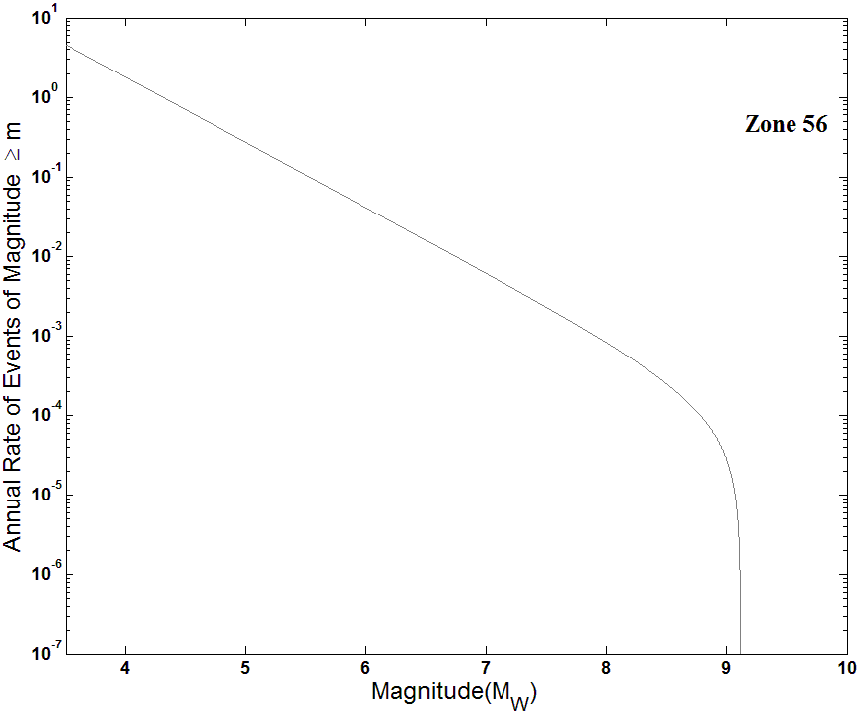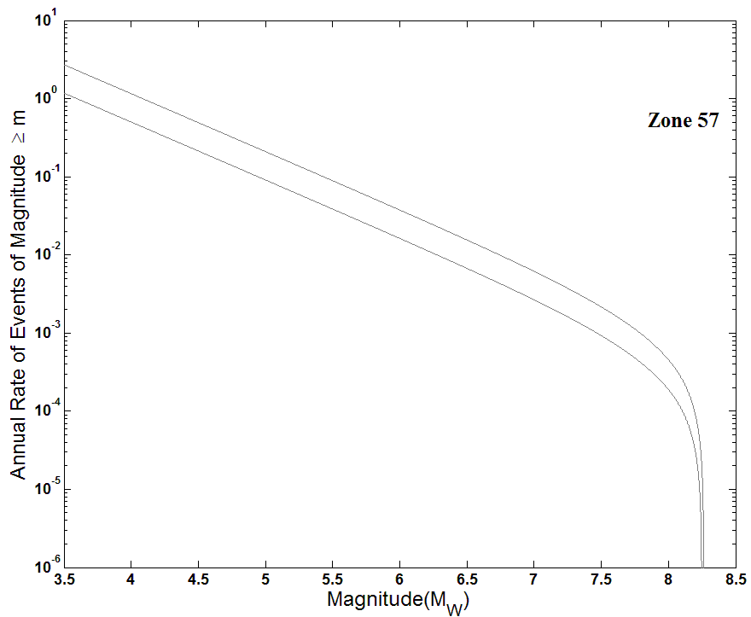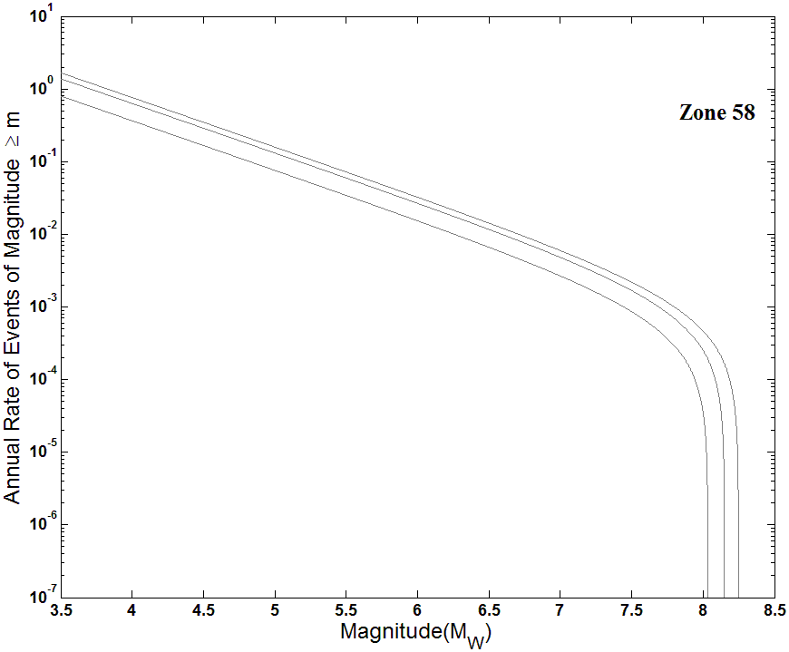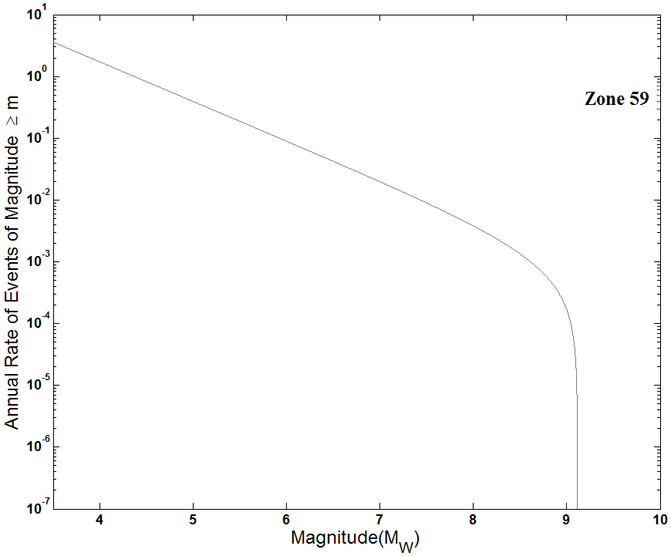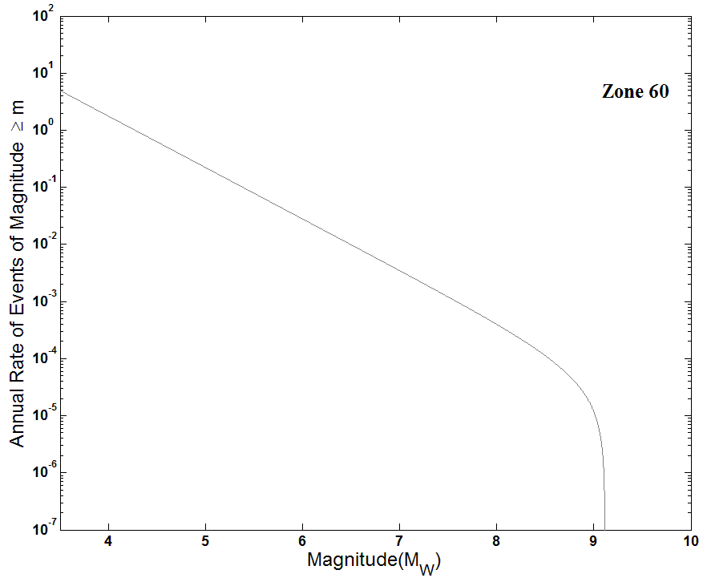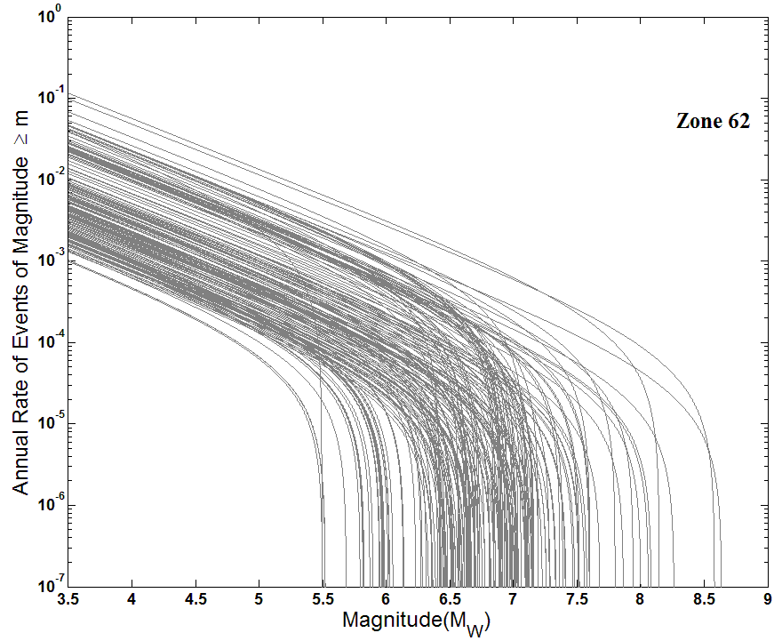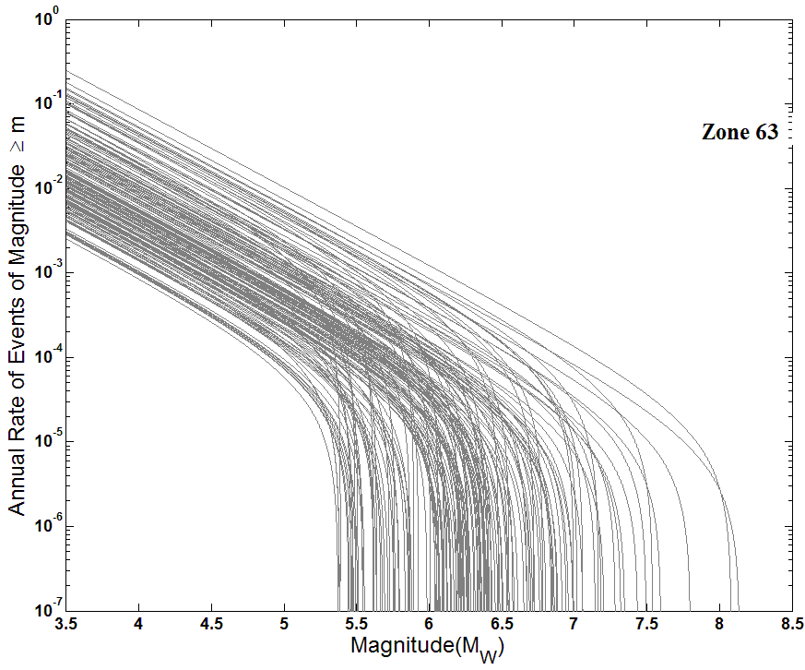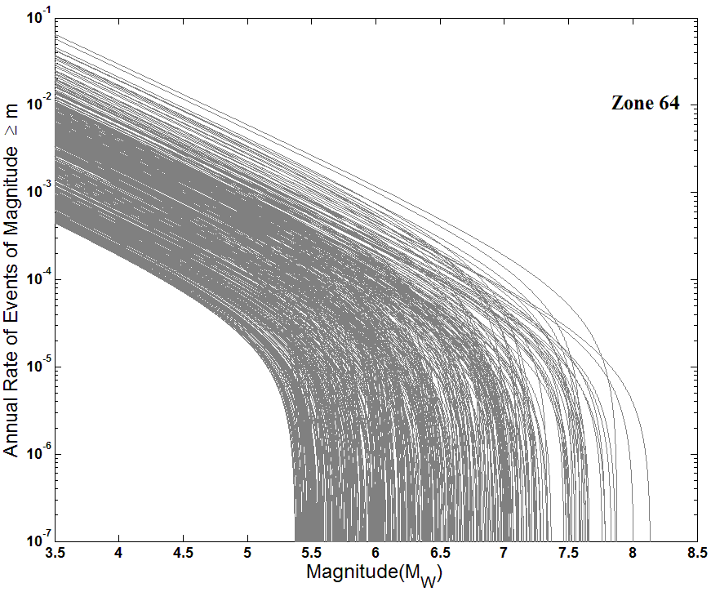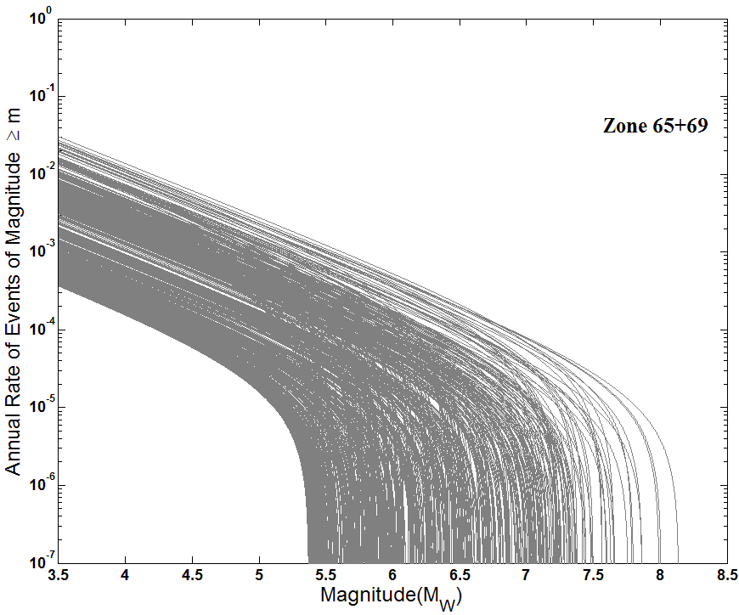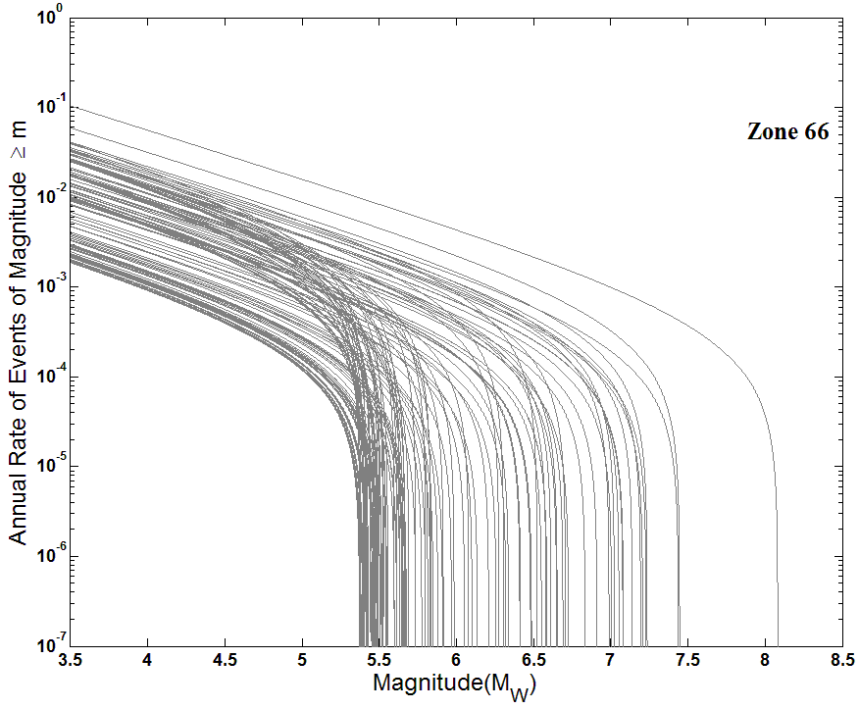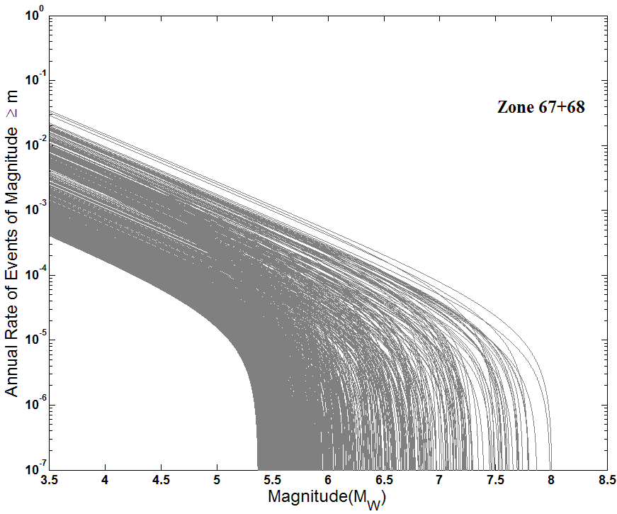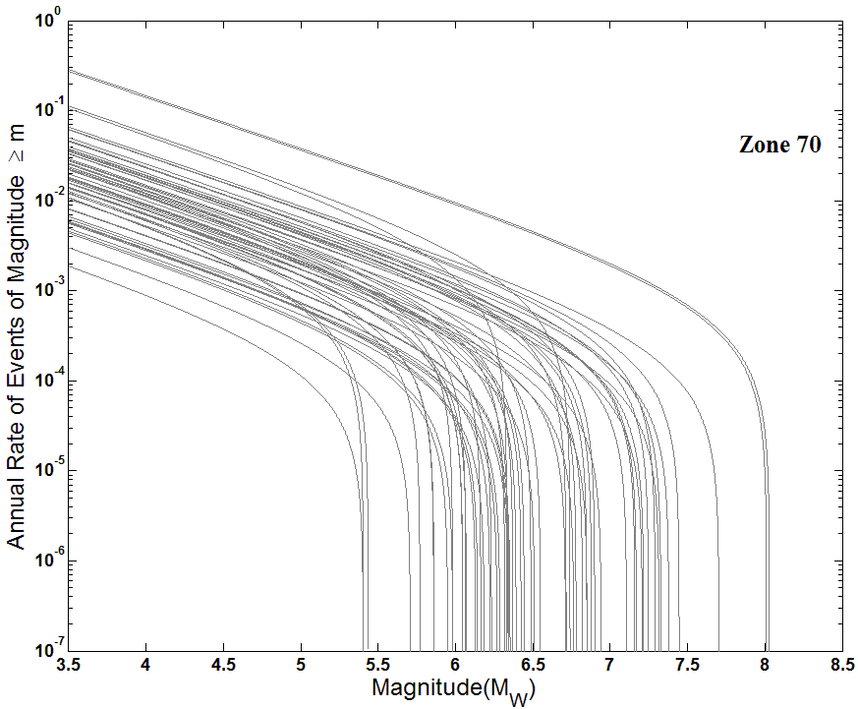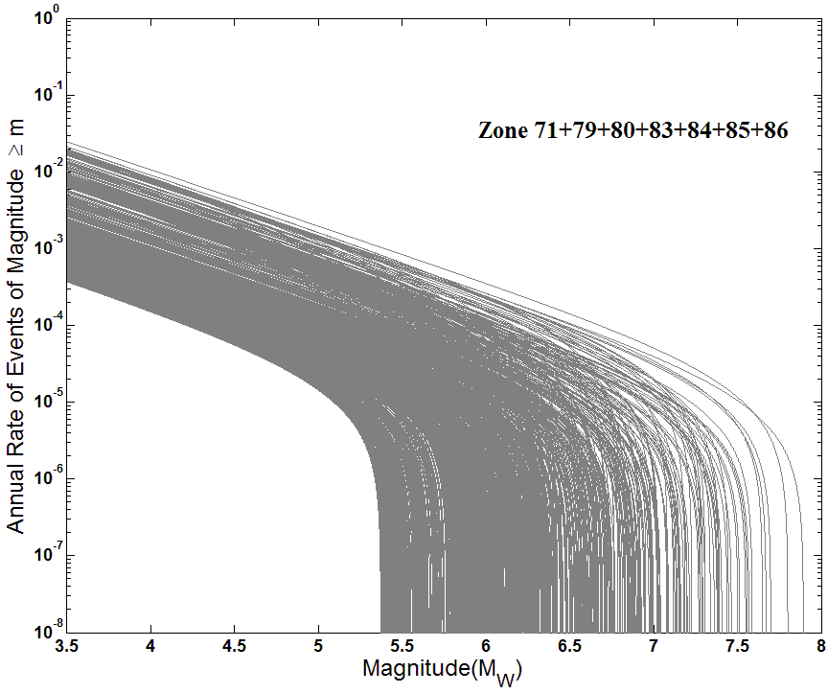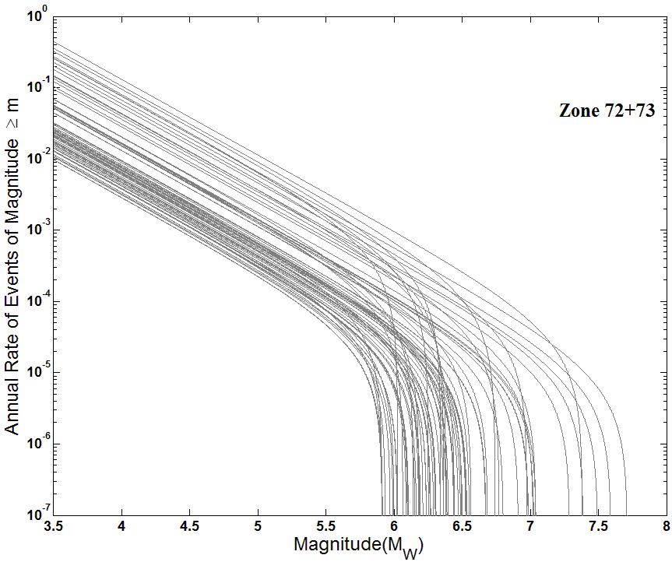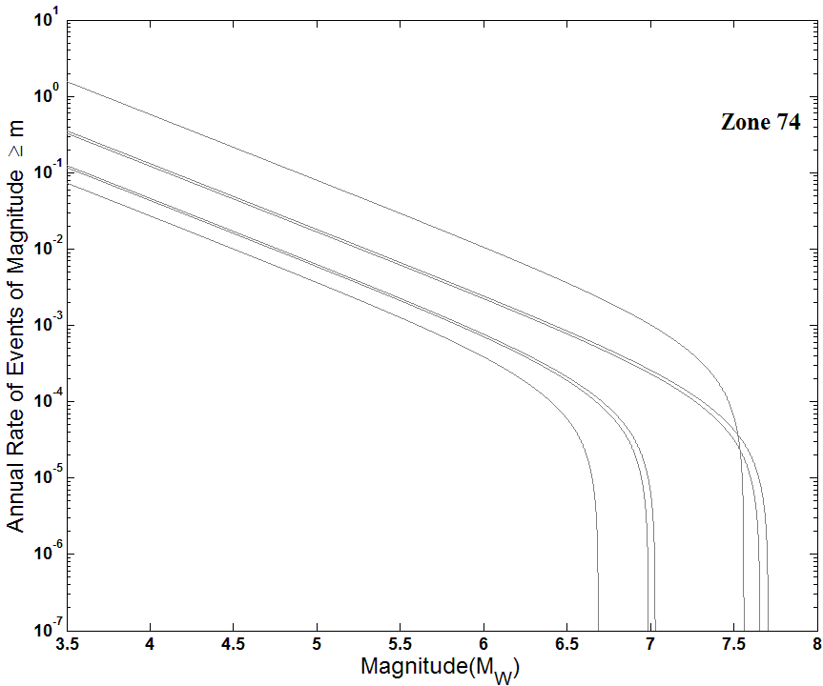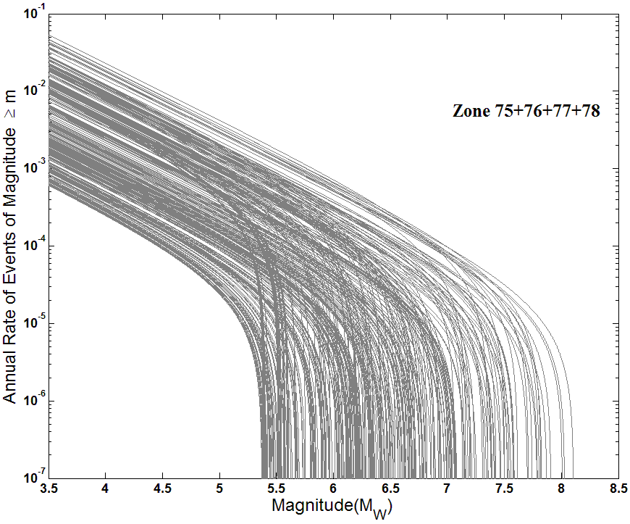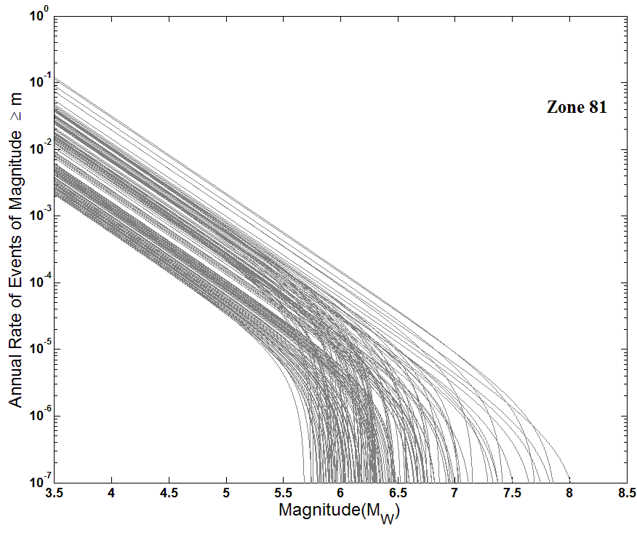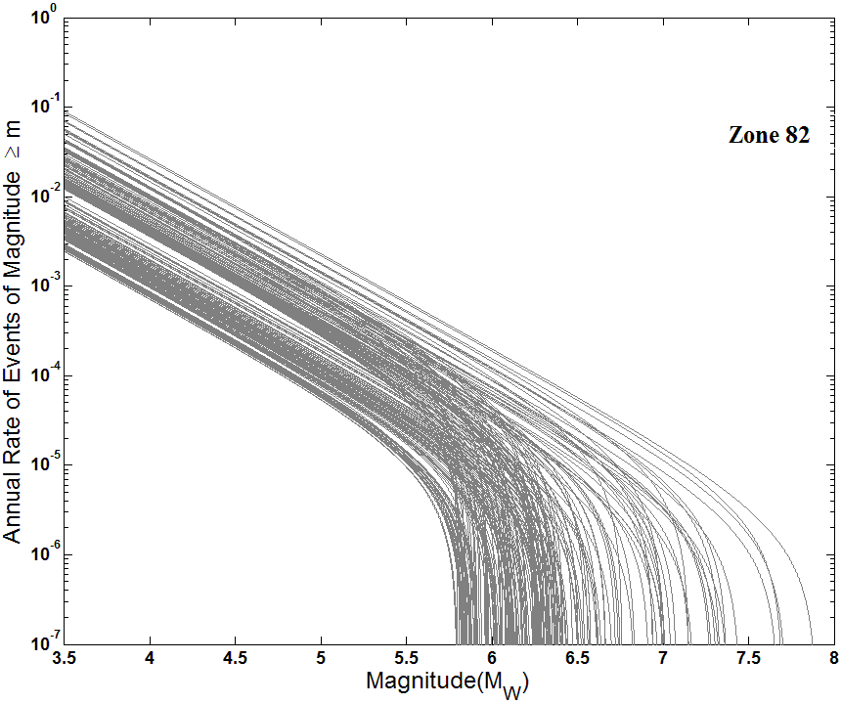
Fig. S2 The annual activity rate versus magnitude for a group of active tectonic features inscribed in each polygonal areal seismogenic source at 0-25km focal depth range for threshold magnitude of M_{W} 3.5 (after Nath 2017)

Table S1 Selected Ground Motion Prediction Equations for PSHA of the Indian Peninsula comprising of eleven Seismogenic Tectonic Provinces shown in Fig. 1 in the manuscript
Seismogenic Tectonic Province | Seismogenic Sources | Global/Regional Ground Motion Prediction Equations (GMPEs) | Next Generation Attenuation (NGA) Models
Bengal Basin including Bangladesh | East-Central Himalaya | Sharma et al. (2009); Toro (2002); Campbell and Bozorgnia (2008) | Nath (2017); Campbell and Bozorgnia (2003); Atkinson and Boore (2006)
Bengal Basin including Bangladesh | Bengal Basin | Raghukanth and Iyengar (2007); Toro (2002) | Nath (2017); Nath et al. (2014); Maiti et al. (2017); Campbell and Bozorgnia (2003); Atkinson and Boore (2006)
Bengal Basin including Bangladesh | Northeast India | Youngs et al. (1997); Campbell and Bozorgnia (2008); Nath et al. (2012) (Shallow and Deep crust) | Nath (2017); Nath et al. (2009); Nath et al. (2012); Campbell and Bozorgnia (2003); Atkinson and Boore (2006)
Indo-Gangetic Foredeep | Indo-Gangetic Foredeep | NDMA (2010); Abrahamson and Silva (2008); Raghukanth and Kavitha (2014) | Nath (2017); Nath et al. (2019); Campbell and Bozorgnia (2003); Atkinson and Boore (2006)
Indo-Gangetic Foredeep | Central Himalaya | Anbazhagan et al. (2013a); Sharma et al. (2009); Chiou and Youngs (2008) | Nath (2017); Campbell and Bozorgnia (2003); Atkinson and Boore (2006)
Indo-Gangetic Foredeep | Central India | Raghukanth and Iyengar (2007); Toro (2002); NDMA (2010) | Nath (2017); Campbell and Bozorgnia (2003); Atkinson and Boore (2006)
Koyna-Warna Region | Central India | Raghukanth and Iyengar (2007); Toro (2002); NDMA (2010) | Nath (2017); Campbell and Bozorgnia (2003); Atkinson and Boore (2006)
Koyna-Warna Region | Kutch Region | Boore and Atkinson (2008); Sadigh et al. (1997); NDMA (2010) | Nath (2017); Campbell and Bozorgnia (2003); Atkinson and Boore (2006)
Koyna-Warna Region | Koyna-Warna Region | Raghukanth and Iyengar (2007); Sharma et al. (2009); Youngs et al. (1997) | Nath (2017); Campbell and Bozorgnia (2003); Atkinson and Boore (2006)
Western Ghat Region | Western Ghat Region | Raghukanth and Iyengar (2007); NDMA (2010); Hwang and Huo (1997) | Nath (2017); Campbell and Bozorgnia (2003); Atkinson and Boore (2006)
Western Ghat Region | Eastern Ghat Region | Raghukanth and Iyengar (2007); NDMA (2010); Hwang and Huo (1997) | Nath (2017); Campbell and Bozorgnia (2003); Atkinson and Boore (2006)
Western Ghat Region | Koyna-Warna Region | Raghukanth and Iyengar (2007); Sharma et al. (2009); Youngs et al. (1997) | Nath (2017); Campbell and Bozorgnia (2003); Atkinson and Boore (2006)
Eastern Ghat Region | Western Ghat Region | Raghukanth and Iyengar (2007); NDMA (2010); Hwang and Huo (1997) | Nath (2017); Campbell and Bozorgnia (2003); Atkinson and Boore (2006)
Eastern Ghat Region | Eastern Ghat Region | Raghukanth and Iyengar (2007); NDMA (2010); Hwang and Huo (1997) | Nath (2017); Campbell and Bozorgnia (2003); Atkinson and Boore (2006)
Eastern Ghat Region | Koyna-Warna Region | Raghukanth and Iyengar (2007); Sharma et al. (2009); Youngs et al. (1997) | Nath (2017); Campbell and Bozorgnia (2003); Atkinson and Boore (2006)
Northwest India including Nepal Himalaya | Kashmir Himalaya | Anbazhagan et al. (2013a); Raghukanth and Kavitha (2014); Sharma et al. (2012) | Nath (2017); Campbell and Bozorgnia (2003); Atkinson and Boore (2006)
Northwest India including Nepal Himalaya | Northwest India | Anbazhagan et al. (2013a); Raghukanth and Kavitha (2014); Harbindu et al. (2014) | Nath (2017); Campbell and Bozorgnia (2003); Atkinson and Boore (2006)
Northwest India including Nepal Himalaya | Hindu Kush Region | Anbazhagan et al. (2013a); Raghukanth and Kavitha (2014); Youngs et al. (1997) | Nath (2017); Campbell and Bozorgnia (2003); Atkinson and Boore (2006)
Darjeeling-Sikkim Himalaya | Normal Fault | Anbazhagan et al. (2013a); Raghukanth and Kavitha (2014); NDMA (2010); Toro (2002); Akkar and Bommer (2010); Lin and Lee (2008); Chiou and Youngs (2008); Zhao et al. (2006); Atkinson and Boore (2006); Abrahamson and Silva (2008); Campbell and Bozorgnia (2008) | Nath (2017); Adhikari and Nath (2016); Campbell and Bozorgnia (2003); Atkinson and Boore (2006)
Darjeeling-Sikkim Himalaya | Reverse Fault | Anbazhagan et al. (2013a); Raghukanth and Kavitha (2014); NDMA (2010); Toro (2002); Akkar and Bommer (2010); Lin and Lee (2008); Chiou and Youngs (2008); Zhao et al. (2006); Atkinson and Boore (2006); Abrahamson and Silva (2008); Campbell and Bozorgnia (2008); Sharma et al. (2009); Nath et al. (2012) | Nath (2017); Adhikari and Nath (2016); Campbell and Bozorgnia (2003); Atkinson and Boore (2006)
Darjeeling-Sikkim Himalaya | Strike-slip Fault | Anbazhagan et al. (2013a); Raghukanth and Kavitha (2014); NDMA (2010); Toro (2002); Akkar and Bommer (2010); Lin and Lee (2008); Chiou and Youngs (2008); Zhao et al. (2006); Atkinson and Boore (2006); Abrahamson and Silva (2008); Campbell and Bozorgnia (2008); Sharma et al. (2009); Nath et al. (2012) | Nath (2017); Adhikari and Nath (2016); Campbell and Bozorgnia (2003); Atkinson and Boore (2006)
Northeast India including Bhutan Himalaya | Eastern Himalayan Zone (EHZ) | Anbazhagan et al. (2013a); Nath et al. (2012); Toro (2002) | Nath (2017); Campbell and Bozorgnia (2003); Atkinson and Boore (2006)
Northeast India including Bhutan Himalaya | Mishmi Block Zone (MBZ) | Nath et al. (2012); Youngs et al. (1997); Gupta (2010) | Nath (2017); Campbell and Bozorgnia (2003); Atkinson and Boore (2006)
Northeast India including Bhutan Himalaya | Eastern Boundary Zone (EBZ) | Singh et al. (2016); Gupta (2010); Youngs et al. (1997) | Nath (2017); Campbell and Bozorgnia (2003); Atkinson and Boore (2006)
Northeast India including Bhutan Himalaya | Shillong Zone (SHZ) | Nath et al. (2012); Youngs et al. (1997); Singh et al. (2016) | Nath (2017); Nath et al. (2009); Nath et al. (2012); Campbell and Bozorgnia (2003); Atkinson and Boore (2006)
Central India | Central India | Raghukanth and Iyengar (2007); Toro (2002); NDMA (2010) | Nath (2017); Campbell and Bozorgnia (2003); Atkinson and Boore (2006)
Central India | Kutch Region | Boore and Atkinson (2008); Sadigh et al. (1997); NDMA (2010) | Nath (2017); Campbell and Bozorgnia (2003); Atkinson and Boore (2006)
Central India | Koyna-Warna Region | Raghukanth and Iyengar (2007); Sharma et al. (2009); Youngs et al. (1997) | Nath (2017); Campbell and Bozorgnia (2003); Atkinson and Boore (2006)
Kutch Region | Central India | Raghukanth and Iyengar (2007); Toro (2002); NDMA (2010) | Nath (2017); Campbell and Bozorgnia (2003); Atkinson and Boore (2006)
Kutch Region | Kutch Region | Boore and Atkinson (2008); Sadigh et al. (1997); NDMA (2010) | Nath (2017); Campbell and Bozorgnia (2003); Atkinson and Boore (2006)
Kutch Region | Koyna-Warna Region | Raghukanth and Iyengar (2007); Sharma et al. (2009); Youngs et al. (1997) | Nath (2017); Campbell and Bozorgnia (2003); Atkinson and Boore (2006)
Kashmir Himalaya | Kashmir Himalaya | Anbazhagan et al. (2013a); Raghukanth and Kavitha (2014); Sharma et al. (2012) | Nath (2017); Campbell and Bozorgnia (2003); Atkinson and Boore (2006)
Kashmir Himalaya | Northwest India | Anbazhagan et al. (2013a); Raghukanth and Kavitha (2014); Harbindu et al. (2014) | Nath (2017); Campbell and Bozorgnia (2003); Atkinson and Boore (2006)
Kashmir Himalaya | Hindu Kush Region | Anbazhagan et al. (2013a); Raghukanth and Kavitha (2014); Youngs et al. (1997) | Nath (2017); Campbell and Bozorgnia (2003); Atkinson and Boore (2006)

Table S2 Comparison of Peak Ground Acceleration (PGA) for 10% probability of exceedance in 50 years from various literatures and the present study
Sl. No. |  | City Name |  | PGA(g) for 10% probability of exceedance in 50 years |  |  |  |  |  |  |  | Reference
 |  |  |  | BIS (2002) [zone] | GSHAP  (Bhatia et al. 1999) |  | Nath and Thingbaijam (2012) |  | Present Study | Other Studies
1 |  | Amritsar |  | 0.12  [IV] | 0.00-0.05 |  | 0.20-0.25 |  | 0.17-0.18 | 0.18  0.20-0.35  0.12 |  | Bajaj and Anbazhagan (2019)  Rao et al. (2020)  Mir and Parvez (2020)
2 |  | Bhubaneswar |  | 0.08  [III] | 0.00-0.05 |  | 0.04-0.08 |  | 0.07-0.08 | 0.05-0.08  0.04-0.06 |  | Rao et al. (2020)  Scaria et al. (2021)
3 |  | Chandigarh |  | 0.12  [IV] | 0.15-0.20 |  | 0.30-0.35 |  | 0.30-0.31 | 0.14-0.21  0.24  0.35-0.55 |  | Puri and Jain (2018)  Bajaj and Anbazhagan (2019)  Rao et al. (2020)
4 |  | New Delhi |  | 0.12  [IV] | 0.10-0.15 |  | 0.20-0.25 |  | 0.19-0.20 | 0.27  0.00-0.37  0.2-0.35  0.18  0.07-0.33  0.10 |  | Sitharam et al. (2015)  Sarkar and Shanker (2017)  Rao et al. (2020)  Gupta et al. (2021a)  Gupta et al. (2021b)  Ramkrishnan et al. (2021)
5 |  | Guwahati |  | 0.18  [V] | 0.25-0.30 |  | 0.60-0.70 |  | 0.70-0.71 | 0.46  0.35-0.55  0.20-0.25  0.54-0.62 |  | Bahuguna and Sil (2020)  Rao et al. (2020)  Ghione et al. (2021)  Agrawal et al. (2021)
6 |  | Kolkata |  | 0.08  [III] | 0.05-0.10 |  | 0.12-0.16 |  | 0.13-0.14 | 0.13  0.08-0.20 |  | Sitharam et al. (2015)  Rao et al. (2020)
7 |  | Lucknow |  | 0.08  [III] | 0.05-0.10 |  | 0.16-0.20 |  | 0.16-0.17 | 0.08-0.13  0.06 |  | Rao et al. (2020)  Ramkrishnan et al. (2021)
8 |  | Ranchi |  | 0.05  [II] | 0.075 |  | 0.12-0.16 |  | 0.05-0.15 | 0.04-0.06  0.13-0.20 |  | Scaria et al. (2021)  Rao et al. (2020)
9 |  | Patna |  | 0.12  [IV] | 0.00-0.05 |  | 0.20-0.25 |  | 0.14-0.15 | 0.11-0.15  0.08-0.13  0.04 |  | Anbazhagan et al. (2019a)  Rao et al. (2020)  Ramkrishnan et al. (2021)
10 |  | Srinagar |  | 0.18  [V] | 0.20-0.25 |  | 0.08-0.12 |  | 0.36-0.37 | 0.22-0.27  0.39  0.06  0.35-0.55 |  | Jaisal et al. (2020)  Mir and Parvez (2020)  Ramkrishnan et al. (2021)  Rao et al. (2020)
11 |  | Varanasi |  | 0.08  [III] | 0.05-0.10 |  | 0.08-0.12 |  | 0.10-0.11 | 0.09-0.11  0.05-0.08 |  | Nath et al. (2019)  Rao et al. (2020)
12 |  | Dhaka |  |  | 0.20-0.25 |  | 0.20-0.25 |  | 0.23-0.24 | 0.14  0.29  0.13  0.15-0.20  0.27  0.13-0.20 |  | Al-Hussaini and Al-Noman (2010)  Trianni et al. (2014)  BNBC (2017)  Rahman et al. (2020)  Haque et al. (2020)  Rao et al. (2020)
13 |  | Chittagong |  |  | 0.35-0.40 |  | 0.30-0.35 |  | 0.35-0.36 | 0.18  0.13  0.19  0.40-0.50  0.41 |  | Al-Hussaini and Al-Noman (2010)  Trianni et al. (2014)  BNBC (2017)  Rahman et al. (2020)  Haque et al. (2020)
14 |  | Jammu |  | 0.12  [IV] | 0.10-0.15 |  | 0.30-0.35 |  | 0.33-0.34 | 0.17-0.22  0.35-0.55 |  | Jaisal et al. (2020)  Rao et al. (2020)
15 |  | Thimphu |  |  | 0.25-0.30 |  | 0.25-0.30 |  | 0.35-0.37 | 0.55-0.60  0.20-0.35 |  | Ghione et al. (2021)  Rao et al. (2020)
16 |  | Kathmandu |  |  | 0.20-0.25 |  | 0.45-0.5 |  | 0.50-0.51 | 0.51-0.55  0.75  0.35  0.52-0.57  0.08 |  | Ram and Wang (2013)  Chaulagain et al. (2015)  Rahman et al. (2018a)  Stevens et al. (2018)  Ramkrishnan et al. (2021)
17 |  | Aizawl |  | 0.18  [V] | 0.40-0.45 |  | 0.50-0.55 |  | 0.54-0.56 | 0.35-0.55  0.15-0.20 |  | Rao et al. (2020)  Ghione et al. (2021)
18 |  | Imphal |  | 0.18  [V] | 0.40-0.45 |  | 0.60-0.70 |  | 0.68-0.69 | 0.20-0.25  0.55-0.90  0.90-1.50 |  | Pallav et al. (2012)  Rao et al. (2020)  Ghione et al. (2021)
19 |  | Shillong |  | 0.18  [V] | 0.25-0.30 |  | 0.60-0.70 |  | 0.73-0.74 | 0.35-0.55  0.16  0.40-0.45 |  | Rao et al. (2020)  Baro et al. (2020)  Ghione et al. (2021)
20 |  | Gangtok |  | 0.12  [IV] | 0.25-0.30 |  | 0.30-0.35 |  | 0.36-0.38 | 0.43  0.35-0.55  0.55-0.60  0.08 |  | Rahman et al. (2018a)  Rao et al. (2020)  Ghione et al. (2021)  Ramkrishnan et al. (2021)
21 |  | Agartala |  | 0.18  [V] | 0.35-0.40 |  | 0.25-0.30 |  | 0.28-0.29 | 0.20-0.35 |  | Rao et al. (2020)
Table S3 Comparison of Peak Ground Acceleration (PGA) for 2% probability of exceedance in 50 years from various literatures and the present study
Sl. No. | City Name |  | PGA(g) for 2% probability of exceedance in 50 years
Sl. No. |  |  | Nath and Thingbaijam (2012) |  |  | Present Study |  | Other Studies |  |  | Reference
1 | Amritsar |  | 0.25-0.40 |  |  | 0.40-0.42 |  | 0.25-0.3 |  |  | Sitharam et al. (2015)
2 | Bhubaneswar |  | 0.08-0.20 |  |  | 0.17-0.19 |  | 0.09-0.14  0.01 |  |  | Scaria et al. (2021)  Huded and Dash (2022)
3 | Chandigarh |  | 0.35-0.70 |  |  | 0.60-0.61 |  | 0.24-0.4 |  |  | Puri and Jain (2018)
4 | New Delhi |  | 0.25-0.50 |  |  | 0.42-0.43 |  | 0.22  0.51  0.00-0.64  0.32  0.12-0.37  0.18 |  |  | Iyengar and Ghosh (2004)  Sitharam et al. (2015)  Sarkar and Shanker (2017)  Gupta et al. (2021a)  Gupta et al. (2021b)  Ramkrishnan et al. (2021)
5 | Guwahati |  | 0.70-1.30 |  |  | 0.85-0.87 |  | 0.78  0.83-0.93 |  |  | Bahuguna and Sil (2020)  Agrawal et al. (2021)
6 | Kolkata |  | 0.16-0.30 |  |  | 0.30-0.31 |  | 0.23 |  |  | Sitharam et al. (2015)
7 | Lucknow |  | 0.20-0.40 |  |  | 0.42-0.43 |  | 0.07-0.13  0.08 |  |  | Sitharam et al. (2013)  Ramkrishnan et al. (2021)
8 | Ranchi |  | 0.30-0.40 |  |  | 0.28-0.30 |  | 0.09-0.14 |  |  | Scaria et al. (2021)
9 | Patna |  | 0.25-0.40 |  |  | 0.31-0.33 |  | 0.05-0.44  0.3-0.38  0.08 |  |  | Anbazhagan et al. (2015)  Anbazhagan et al. (2019a)  Ramkrishnan et al. (2021)
10 | Srinagar |  | 0.30-0.40 |  |  | 0.58-0.60 |  | 0.69-0.70  0.37-0.47  0.08 |  |  | Sana (2019)  Jaisal et al. (2020)  Ramkrishnan et al. (2021)
11 | Varanasi |  | 0.30-0.40 |  |  | 0.25-0.27 |  | 0.03 |  |  | Raghucharan and Somala (2022)
12 | Dhaka |  | 0.50-0.60 |  |  | 0.39-0.40 |  | 0.30-0.40  0.55 |  |  | Rahman et al. (2020)  Haque et al. (2020)
13 | Chittagong |  | 0.70-0.80 |  |  | 0.49-0.51 |  | 0.9-1.0  0.84 |  |  | Rahman et al. (2020)  Haque et al. (2020)
14 | Jammu |  | 0.60-0.70 |  |  | 0.52-0.54 |  | 0.27-0.37 |  |  | Jaisal et al. (2020)
15 | Kathmandu |  | 0.90-1.00 |  |  | 0.76-0.78 |  | 1.00-1.07  0.66  0.81-0.90  1.00  0.18 |  |  | Ram and Wang (2013)  Chaulagain et al. (2015)  Rahman et al. (2018a)  Stevens et al. (2018)  Ramkrishnan et al. (2021)
16 | Aizawl |  | 1.00-1.10 |  |  | 0.72-0.73 |  | 0.13-0.20  0.22-0.32 |  |  | Sil et al. (2013)  Agrawal et al. (2021)
17 | Imphal |  | 1.30-1.40 |  |  | 0.97-0.99 |  | 0.3-1.1  0.14  0.32-0.42 |  |  | Pallav et al. (2012)  Das et al. (2016)  Agrawal et al. (2021)
18 | Shillong |  | 1.40-1.50 |  |  | 0.87-0.88 |  | 0.24  0.73-0.83 |  |  | Baro et al. (2020)  Agrawal et al. (2021)
19 | Gangtok |  | 0.60-0.70 |  |  | 0.69-0.70 |  | 0.62  0.18 |  |  | Rahman et al. (2018a)  Ramkrishnan et al. (2021)
20 | Agartala |  | 0.50-0.60 |  |  | 0.45-0.46 |  | 0.20-0.27  0.42-0.52 |  |  | Sil et al. (2013)  Agrawal et al. (2021)

Table S4 Comparison of effective shear wave velocity (V_{S}³⁰) variation from various literatures and the present study
Sl. No. | Location | V_{S}³⁰ (m/s)  Present study | V_{S}³⁰ (m/s)  Other studies | Reference
1 | Amritsar | 257-370 | 180-360 | Anbazhagan et al. (2019b)
2 | New Delhi | 220-360 | 230-350  270-565 | Satyam and Rao (2010)  Pandey et al. (2016)
3 | Lucknow | 204-391 | 230-470 | Anbazhagan et al. (2013b)
4 | Patna | 198-356 | 180-270 | Anbazhagan et al. (2019b)
5 | Varanasi | 191-356 | 180-360  221-692 | Anbazhagan et al. (2019b)  Singh et al. (2021)
6 | Kolkata | 160-310 | 119-359 | Nath et al. (2014)
7 | Dhaka | 114-291 | 127-320 | Rahman et al. (2018b)
8 | Chittagong | 108-304 | 123-420 | Rahman et al. (2016)
9 | Jammu | 250-470 | 340-390 | Mahajan et al. (2012)
10 | Chandigarh | 180-360 | 210-290 | Kandpal et al. (2009)
11 | Kathmandu | 112-368 | 366-490  148-298 | Chen et al. (2017)  Gautam and Chamlagain (2016)
12 | Guwahati | 102-300 | 180-760 | Kumar et al. (2018)
13 | Aizawl | 320-620 | 360-760  200-950 | Sil and Sitharam (2017)  Rao and Ramhmachhuani (2017)
14 | Shillong | 248-760 | 275-375 | Biswas et al. (2018)
15 | Agartala | 120-240 | 180-360 | Sil and Sitharam (2017)
16 | Srinagar | 140-380 | <180-360  139-451 | Sana (2018)  Zahoor et al. (2021)

Fig. S3 Quartile plot for comparison of Absolute Site Amplification obtained from PLAXIS 2D and DEEPSOIL Analysis

Table S5 Comparison of Surface-consistent Probabilistic Peak Ground Acceleration (PGA) for 10% probability of exceedance in 50 years from various literatures and the present study

Sl. No. | City Name | Surface-consistent PGA(g) for 10% probability of exceedance in 50 years |  | References
Sl. No. | City Name | Present Study | Other Studies
1 | Aizawl | 0.6-0.8 | 0.60-0.70 | Sitharam et al. (2015)
2 | Ambala | 0.20-0.40 | 0.299  0.30-0.40 | Puri and Jain (2021)  Sitharam et al. (2015)
3 | Chandigarh | 0.20-0.40 | 0.20-0.30  0.30-0.40 | Puri and Jain (2018)  Sitharam et al. (2015)
4 | Gangtok | 0.4-0.6 | 0.70 | Sitharam et al. (2015)
5 | Imphal | 0.8-1.0 | 0.30-0.80  0.63 | Pallav et al. (2015)  Sitharam et al. (2015)
6 | Itanagar | 0.4-0.6 | 0.60-0.70 | Sitharam et al. (2015)
7 | Kohima | 0.8-1.0 | 0.60-0.70 | Sitharam et al. (2015)
8 | Kolkata | 0.20-0.40 | 0.17-0.25  0.30-0.40  0.39 | Nath et al. (2014)  Sitharam et al. (2015)  Maiti et al. (2017)
9 | Lucknow | 0.20-0.40 | 0.10-0.40  0.26-0.29  0.20-0.30 | Sitharam et al. (2013)  Nath et al. (2019)  Sitharam et al. (2015)
10 | New Delhi | 0.2-0.4 | 0.42  0.20 | Sitharam et al. (2015)  Iyenger and Ghosh (2004)
11 | Panipat | 0.20-0.40 | 0.145  0.20-0.30 | Puri and Jain (2021)  Sitharam et al. (2015)
12 | Patna | 0.20-0.40 | 0.22-0.24  0.20-0.30 | Nath et al. (2019)  Sitharam et al. (2015)
13 | Srinagar | 0.8-1.0 | 0.6-0.7 | Sitharam et al. (2015)
14 | Varanasi | 0.05-0.20 | 0.14-0.17  0.20-0.30 | Nath et al. (2019)  Sitharam et al. (2015)

Fig. S4 Computational framework for liquefaction potential analysis of the region
Fig. S5 Building typology classification based on hybrid Remote Sensing and Rapid Visual Screening (RVS) Processing
Fig. S6 Building sub-classification protocol based on building height
Fig. S7 Rapid Visual Screening (RVS) survey for field and satellite imagery comparisons of existing building type and the height in selected urban centers
Table S6 Error matrix derived for the building typology
 | RVS based building typology  (Reference data) |  |  |  |  |  |  |  |  |  |  |  |  |  | User’s
 |  |  |  |  |  |  |  |  |  |  |  |  |  |  | Accuracy (%)
Classified building typology |  | W1 | A1 | RS2 | URMM | URML | C1L | C1M | C1H | C3L | C3M | C3H | HER | Total
Classified building typology | W1 | 3 | 1 | 1 | 0 | 0 | 0 | 0 | 0 | 0 | 0 | 0 | 0 | 5 | 60
Classified building typology | A1 | 2 | 15 | 4 | 0 | 1 | 0 | 0 | 0 | 0 | 0 | 0 | 0 | 22 | 68.18
Classified building typology | RS2 | 1 | 10 | 70 | 6 | 0 | 0 | 0 | 0 | 0 | 0 | 0 | 0 | 87 | 80.45
Classified building typology | URMM | 0 | 5 | 17 | 100 | 20 | 0 | 0 | 0 | 0 | 0 | 0 | 0 | 142 | 70.42
Classified building typology | URML | 0 | 0 | 3 | 43 | 189 | 8 | 0 | 0 | 0 | 0 | 0 | 0 | 243 | 77.77
Classified building typology | C1L | 0 | 0 | 0 | 8 | 21 | 156 | 4 | 0 | 0 | 0 | 0 | 0 | 189 | 82.53
Classified building typology | C1M | 0 | 0 | 0 | 0 | 2 | 31 | 120 | 9 | 0 | 0 | 0 | 0 | 162 | 74.07
Classified building typology | C1H | 0 | 0 | 0 | 0 | 0 | 4 | 15 | 90 | 0 | 0 | 0 | 0 | 109 | 82.56
Classified building typology | C3L | 0 | 0 | 0 | 0 | 0 | 0 | 0 | 10 | 107 | 2 | 0 | 0 | 119 | 89.91
Classified building typology | C3M | 0 | 0 | 0 | 0 | 0 | 0 | 0 | 0 | 7 | 80 | 22 | 0 | 109 | 73.39
Classified building typology | C3H | 0 | 0 | 0 | 0 | 0 | 0 | 0 | 0 | 0 | 7 | 63 | 0 | 70 | 90
Classified building typology | HER | 0 | 0 | 0 | 0 | 0 | 0 | 0 | 0 | 0 | 0 | 0 | 5 | 5 | 100
Classified building typology | Total | 6 | 31 | 95 | 157 | 233 | 199 | 139 | 109 | 114 | 89 | 85 | 5 | 1262
Producer’s Accuracy (%) |  | 50 | 50 | 74.47 | 63.29 | 81.47 | 78.39 | 86.33 | 82.57 | 93.86 | 83.33 | 76.83 | 100
Overall Accuracy (%) |  | 79.08

Table S7 Error matrix derived for the building height
Classified  Building Height | RVS based Building Height  (Reference data) |  |  |  |  |  |  | User’s  Accuracy (%)
Classified  Building Height |  | Houses | Buildings | Tall Buildings | Multistoried Buildings | Skyscrapers | Total | User’s  Accuracy (%)
Classified  Building Height | Houses  (1 Floor) | 205 | 47 | 0 | 0 | 0 | 252 | 81.34
Classified  Building Height | Buildings  (2-4 Floors) | 25 | 149 | 15 | 0 | 0 | 189 | 78.84
Classified  Building Height | Tall Buildings  (5-8 Floors) | 0 | 5 | 105 | 23 | 0 | 133 | 78.94
Classified  Building Height | Multistoried  Buildings  (9-10 Floors) | 0 | 0 | 15 | 63 | 0 | 78 | 80.76
Classified  Building Height | Skyscrapers  (>10 Floors) | 0 | 0 | 0 | 0 | 10 | 10 | 100
Classified  Building Height | Total | 230 | 201 | 135 | 86 | 10
Producer’s Accuracy (%) |  | 89.13 | 74.13 | 77.78 | 73.26 | 100
Overall Accuracy (%) |  |  | 80.36

Table S8 Different model building types used in the present study (adopted from FEMA 2000; WHE-PAGER 2008)
Model Building Type | Description | Height | Stories
HER | Heritage building
C1L | Ductile reinforced concrete frame with or without infill | Low-Rise | 1 – 3
C1M | Ductile reinforced concrete frame with or without infill | Mid-Rise | 4 - 6
C1H | Ductile reinforced concrete frame with or without infill | High-Rise | 7+
C3L | Non-ductile reinforced concrete frame with masonry infill walls | Low-Rise | 1 - 3
C3M |  | Mid-Rise | 4 - 6
C3H |  | High-Rise | 7+
A1 | Adobe Block, Mud Mortar, Wood Roof and Floors | Low-Rise | 1-2
W1 |  | Low-Rise | 1-2
  Adobe block, wood roof and floors
RS2 | Rubble stone masonry walls with timber frame and roof | Low-Rise | 1-2
URML | Unreinforced masonry bearing wall | Low-Rise | 1-3
URMM | Unreinforced masonry bearing wall | Mid-Rise | 3+

Fig. S8 Peak Ground Acceleration (PGA) with respect to fault distance for corresponding seismogenic sources for the Tectonic Provinces of (a) Kashmir Himalaya, (b) Northwest India including Nepal, (c) Indo-Gangetic Foredeep (Nath et al. 2019), (d) Bengal Basin including Bangladesh (Nath et al. 2014), (e) Darjeeling-Sikkim Himalaya and (f) Northeast India including Bhutan. The blue dots represent the simulated PGA; the red dots represent the estimated PGA from predicted NGA models of Atkinson and Boore (2006)
Fig. S9 Representative Pseudo Spectral Acceleration (PSA) at 0.2sec (left), 0.3sec (middle) and 1.0sec (right) with respect to fault distance for seismogenic source zones of (a) Kashmir Himalaya, (b) Northwest India, (c) Indo-Gangetic Foredeep and (d) Northeast India (Shillong Zone). The green dots represent the simulated PSA and the red dots represent the estimated PSA from predicted NGA models of Atkinson and Boore (2006) for each seismogenic sources
Fig. S10 Residuals of PGA with respect to fault distance for corresponding seismogenic sources for the Tectonic Provinces of (a) Kashmir Himalaya, (b) Northwest India, (c) Indo-Gangetic Foredeep (Nath et al. 2019), (d) Bengal Basin (Nath et al. 2014), (e) Darjeeling-Sikkim Himalaya and (f) Northeast India (Nath et al. 2009) considering NGA model of Atkinson and Boore (2006)

Fig. S11 The intensity as a function of fault distance for the indicated earthquakes derived from the Ground Motion Prediction Equations for suitability testing of GMPEs for the Tectonic Provinces of (a) Kashmir Himalaya, (b) Northwest India, (c) Indo-Gangetic Foredeep (Nath et al. 2019), (d) Bengal Basin (Nath et al. 2014; Maiti et al. 2017), (e) Darjeeling-Sikkim Himalaya and (f) Northeast India
Table S9 The weights and ranks assigned to respective GMPEs based on the average LLH ranking in the three seismogenic source zones for Kashmir Himalaya Tectonic Province
Kashmir Himalaya Seismogenic Source regime
Model | LLH | Rank | Weight
Campbell and Bozorgnia (2003); Present Study | 2.1279 | 5 | 0.33
Atkinson and Boore (2006); Present Study | 2.1408 | 4 | 0.27
Sharma et al. (2012) | 2.1505 | 3 | 0.20
Anbazhagan et al. (2013a) | 2.2669 | 2 | 0.13
Raghukanth and Kavitha (2014) | 2.4501 | 1 | 0.07
Northwest India Seismogenic Source regime
Model | LLH | Rank | Weight
Campbell and Bozorgnia (2003); Present Study | 2.1020 | 5 | 0.33
Atkinson and Boore (2006); Present Study | 2.1599 | 4 | 0.27
Harbindu et al. (2014) | 2.2276 | 3 | 0.20
Anbazhagan et al. (2013a) | 2.2561 | 2 | 0.13
Raghukanth and Kavitha (2014) | 2.2733 | 1 | 0.07
Hindu Kush Seismogenic Source regime
Model | LLH | Rank | Weight
Campbell and Bozorgnia (2003); Present Study | 2.2503 | 5 | 0.33
Atkinson and Boore (2006); Present Study | 2.2648 | 4 | 0.27
Anbazhagan et al. (2013a) | 2.2791 | 3 | 0.20
Raghukanth and Kavitha (2014) | 2.4293 | 2 | 0.13
Youngs et al. (1997) | 2.6283 | 1 | 0.07

Table S10 The weights and ranks assigned to respective GMPEs based on the average LLH ranking in the three seismogenic source zones for Northwest India Tectonic Province
Kashmir Himalaya Seismogenic Source regime
Model | LLH | Rank | Weight
Campbell and Bozorgnia (2003); Present Study | 2.1279 | 5 | 0.33
Atkinson and Boore (2006); Present Study | 2.1408 | 4 | 0.27
Sharma et al. (2012) | 2.1505 | 3 | 0.20
Anbazhagan et al. (2013a) | 2.2669 | 2 | 0.13
Raghukanth and Kavitha (2014) | 2.4501 | 1 | 0.07
Northwest India Seismogenic Source regime
Model | LLH | Rank | Weight
Campbell and Bozorgnia (2003); Present Study | 2.1020 | 5 | 0.33
Atkinson and Boore (2006); Present Study | 2.1599 | 4 | 0.27
Harbindu et al. (2014) | 2.2276 | 3 | 0.20
Anbazhagan et al. (2013a) | 2.2561 | 2 | 0.13
Raghukanth and Kavitha (2014) | 2.2733 | 1 | 0.07
Hindu Kush Seismogenic Source regime
Model | LLH | Rank | Weight
Campbell and Bozorgnia (2003); Present Study | 2.2503 | 5 | 0.33
Atkinson and Boore (2006); Present Study | 2.2648 | 4 | 0.27
Anbazhagan et al. (2013a) | 2.2791 | 3 | 0.20
Raghukanth and Kavitha (2014) | 2.4293 | 2 | 0.13
Youngs et al. (1997) | 2.6283 | 1 | 0.07

Table S11 The weights and ranks assigned to respective GMPEs based on the average LLH ranking in the three seismogenic source zones for Indo-Gangetic Foredeep Tectonic Province
Indo-Gangetic Foredeep Seismogenic Source
Model | LLH | Rank | Weight
Campbell and Bozorgnia (2003); Present Study | 2.144 | 5 | 0.33
Atkinson and Boore (2006); Present Study | 2.346 | 4 | 0.27
NDMA (2010) | 2.386 | 3 | 0.20
Abrahamson and Silva (2008) | 2.510 | 2 | 0.13
Raghukanth and Kavitha (2014) | 2.511 | 1 | 0.07
Central Himalaya Seismogenic Source
Model | LLH | Rank | Weight
Campbell and Bozorgnia (2003); Present Study | 2.482 | 5 | 0.33
Atkinson and Boore (2006); Present Study | 2.546 | 4 | 0.27
Sharma et al. (2009) | 2.552 | 3 | 0.20
Anbazhagan et al. (2013a) | 2.577 | 2 | 0.13
Chiou and Youngs (2008) | 2.892 | 1 | 0.07
Central India Seismogenic Source
Model | LLH | Rank | Weight
Campbell and Bozorgnia (2003); Present Study | 2.201 | 5 | 0.33
Atkinson and Boore (2006); Present Study | 2.219 | 4 | 0.27
Toro (2002) | 2.225 | 3 | 0.20
NDMA (2010) | 2.303 | 2 | 0.13
Raghukanth and Iyengar (2007) | 2.389 | 1 | 0.07

Table S12 The weights and ranks assigned to respective GMPEs based on the average LLH ranking in the three seismogenic source zones for Bengal Basin Tectonic Province
Bengal Basin Seismogenic Source regime
Model | LLH | Rank | Weight
Campbell and Bozorgnia (2003); Present Study | 2.169 | 4 | 0.4
Atkinson and Boore (2006); Present Study | 2.189 | 3 | 0.3
Raghukanth and Iyengar (2007) | 2.368 | 2 | 0.2
Toro (2002) | 2.397 | 1 | 0.1
Northeast India Seismogenic Source regime
Model | LLH | Rank | Weight
Campbell and Bozorgnia (2003); Present Study | 2.306 | 5 | 0.33
Atkinson and Boore (2006); Present Study | 2.331 | 4 | 0.27
Nath et al. (2012) | 2.370 | 3 | 0.20
Campbell and Bozorgnia (2008) | 2.545 | 2 | 0.13
Youngs et al. (1997) | 2.670 | 1 | 0.07
East-Central Himalaya Seismogenic Source regime
Model | LLH | Rank | Weight
Campbell and Bozorgnia (2003); Present Study | 2.264 | 5 | 0.33
Atkinson and Boore (2006); Present Study | 2.296 | 4 | 0.27
Toro (2002) | 2.371 | 3 | 0.20
Sharma et al. (2009) | 2.412 | 2 | 0.13
Campbell and Bozorgnia (2008) | 2.712 | 1 | 0.07

Table S13 The weights and ranks assigned to respective GMPEs based on the average LLH ranking in the three seismogenic source zones for Darjeeling-Sikkim Himalaya Tectonic Province
Strike-Slip Fault
Model | LLH | Rank | Weight
Campbell and Bozorgnia (2003); Present Study | 2.325 | 15 | 0.125
Atkinson and Boore (2006); Present Study | 2.357 | 14 | 0.117
Anbazhagan et al. (2013a) | 2.363 | 13 | 0.108
Atkinson and Boore (2006) | 2.401 | 12 | 0.100
Sharma et al. (2009) | 2.421 | 11 | 0.092
Nath et al. (2012) | 2.436 | 10 | 0.083
Akkar and Bommer (2010) | 2.434 | 9 | 0.075
NDMA (2010) | 2.441 | 8 | 0.067
Raghukanth and Kavitha (2014) | 2.476 | 7 | 0.058
Lin and Lee (2008) | 2.483 | 6 | 0.050
Toro (2002) | 2.552 | 5 | 0.042
Campbell and Bozorgnia (2008) | 2.592 | 4 | 0.033
Abrahamson and Silva (2008) | 2.652 | 3 | 0.025
Chiou and Youngs (2008) | 2.742 | 2 | 0.017
Zhao et al. (2006) | 2.987 | 1 | 0.008
Reverse Fault
Model | LLH | Rank | Weight
Campbell and Bozorgnia (2003); Present Study | 2.222 | 15 | 0.125
Atkinson and Boore (2006); Present Study | 2.285 | 14 | 0.117
Anbazhagan et al. (2013a) | 2.345 | 13 | 0.108
Raghukanth and Kavitha (2014) | 2.389 | 12 | 0.100
NDMA (2010) | 2.405 | 11 | 0.092
Nath et al. (2012) | 2.495 | 10 | 0.083
Toro (2002) | 2.496 | 9 | 0.075
Lin and Lee (2008) | 2.497 | 8 | 0.067
Atkinson and Boore (2006) | 2.504 | 7 | 0.058
Sharma et al. (2009) | 2.536 | 6 | 0.050
Akkar and Bommer (2010) | 2.636 | 5 | 0.042
Chiou and Youngs (2008) | 2.657 | 4 | 0.033
Abrahamson and Silva (2008) | 2.822 | 3 | 0.025
Campbell and Bozorgnia (2008) | 2.977 | 2 | 0.017
Zhao et al. (2006) | 3.078 | 1 | 0.008
Normal Fault
Model | LLH | Rank | Weight
Campbell and Bozorgnia (2003); Present Study | 2.037 | 13 | 0.143
Atkinson and Boore (2006); Present Study | 2.206 | 12 | 0.132
Anbazhagan et al. (2013a) | 2.218 | 11 | 0.121
Raghukanth and Kavitha (2014) | 2.243 | 10 | 0.110
NDMA (2010) | 2.315 | 9 | 0.099
Toro (2002) | 2.322 | 8 | 0.088
Akkar and Bommer (2010) | 2.357 | 7 | 0.077
Lin and Lee (2008) | 2.412 | 6 | 0.066
Chiou and Youngs (2008) | 2.433 | 5 | 0.055
Zhao et al. (2006) | 2.539 | 4 | 0.044
Atkinson and Boore (2006) | 2.547 | 3 | 0.033
Abrahamson and Silva (2008) | 2.595 | 2 | 0.022
Campbell and Bozorgnia (2008) | 2.652 | 1 | 0.011

Table S14 The weights and ranks assigned to respective GMPEs based on the average LLH ranking in the four seismogenic zones for Northeast India Tectonic Province

Eastern Himalayan Seismogenic Zone (EHZ)
Model | LLH | Rank | Weight
Campbell and Bozorgnia (2003); Present Study | 2.168 | 5 | 0.33
Atkinson and Boore (2006); Present Study | 2.236 | 4 | 0.27
Anbazhagan et al. (2013a) | 2.268 | 3 | 0.20
Nath et al. (2012) | 2.438 | 2 | 0.13
Toro (2002) | 2.656 | 1 | 0.07
Mishmi Block Seismogenic Zone (MBZ)
Model | LLH | Rank | Weight
Campbell and Bozorgnia (2003); Present Study | 2.243 | 5 | 0.33
Atkinson and Boore (2006); Present Study | 2.333 | 4 | 0.27
Nath et al. (2012) | 2.570 | 3 | 0.20
Youngs et al. (1997) | 2.573 | 2 | 0.13
Gupta (2010) | 2.760 | 1 | 0.07
Eastern Boundary Seismogenic Zone (EBZ)
Model | LLH | Rank | Weight
Campbell and Bozorgnia (2003); Present Study | 2.369 | 5 | 0.33
Atkinson and Boore (2006); Present Study | 2.370 | 4 | 0.27
Singh et al. (2016) | 2.635 | 3 | 0.20
Gupta (2010) | 2.712 | 2 | 0.13
Youngs et al. (1997) | 2.786 | 1 | 0.07
Shillong Seismogenic Zone (SHZ)
Model | LLH | Rank | Weight
Campbell and Bozorgnia (2003); Present Study | 2.316 | 5 | 0.33
Atkinson and Boore (2006); Present Study | 2.323 | 4 | 0.27
Nath et al. (2012) | 2.425 | 3 | 0.20
Youngs et al. (1997) | 2.705 | 2 | 0.13
Singh et al. (2016) | 2.748 | 1 | 0.07

Table S15 Pairwise comparison matrix and normalized weights assigned to the GMPEs used for Northwest India seismogenic source zone

Model | Campbell and Bozorgnia (2003) | Atkinson and Boore (2006) | Harbindu et al. (2014) | Anbazhagan et al. (2013a) | Raghukanth and Kavitha (2014) | Weight
Campbell and Bozorgnia (2003) | 1 | 5/4 | 5/3 | 5/2 | 5/1 | 0.33
Atkinson and Boore (2006) | 4/5 | 1 | 4/3 | 4/2 | 4/1 | 0.27
Harbindu et al. (2014) | 3/5 | 3/4 | 1 | 3/2 | 3/1 | 0.20
Anbazhagan et al. (2013a) | 2/5 | 2/4 | 2/3 | 1 | 2/1 | 0.13
Raghukanth and Kavitha (2014) | 1/5 | 1/4 | 1/3 | 1/2 | 1 | 0.07

Reference:
Abrahamson N, Silva W (2008) Summary of the Abrahamson & Silva NGA ground-motion relations. Earthquake Spectra 24(1):67-97. https://doi.org/10.1193%2F1.2924360
Adhikari MD, Nath SK (2016) Site-specific next generation ground motion prediction models for Darjeeling-Sikkim Himalaya using strong motion seismometry. Journal of Indian Geophysical Union 20(2):151-170.
Agrawal N, Gupta L, Dixit J, Dash SK (2021) An integrated assessment of seismic hazard exposure and its societal impact in Seven Sister States of North Eastern Region of India for sustainable disaster mitigation planning. https://doi.org/10.21203/rs.3.rs-1003515/v1
Akkar DS, Bommer JJ (2010) Empirical equations for the prediction of PGA, PGV, and spectral accelerations in Europe, the Mediterranean region, and the Middle East. Seismological Research Letters 81 (2):195-206. https://doi.org/10.1785/gssrl.81.2.195
Al-Hussaini TM, Al-Noman MN (2010) Probabilistic estimates of PGA and Spectral Acceleration in Bangladesh. In: Proc. 3rd international earthquake symposium, Bangladesh, Dhaka, pp 5-6
Anbazhagan P, Bajaj K, Patel S (2015) Seismic hazard maps and spectrum for Patna considering region-specific seismotectonic parameters. Natural Hazards 78:1163–1195. https://doi.org/10.1007/s11069-015-1764-0
Anbazhagan P, Bajaj K, Matharu K, Moustafa SSR, Al-Arifi NSN (2019a) Probabilistic seismic hazard analysis using the logic tree approach – Patna district (India). Natural Hazards and Earth System Sciences 19:2097–2115. https://doi.org/10.5194/nhess-19-2097-2019
Anbazhagan P, Srilakshmi KN, Bajaj K, Moustafa SS, Al-Arifi NS (2019b) Determination of seismic site classification of seismic recording stations in the Himalayan region using HVSR method. Soil Dynamics and Earthquake Engineering 116:304-316. https://doi.org/10.1016/j.soildyn.2018.10.023
Anbazhagan P, Kumar A, Sitharam TG (2013a) Ground motion prediction equation considering combined dataset of recorded and simulated ground motions. Soil Dynamics and Earthquake Engineering 53:92-108. https://doi.org/10.1016/j.soildyn.2013.06.003
Anbazhagan P, Kumar A, Sitharam TG (2013b) Seismic Site Classification and Correlation between Standard Penetration Test N Value and Shear Wave Velocity for Lucknow City in Indo-Gangetic Basin. Pure and Applied Geophysics 170:299-318. https://doi.org/10.1007/s00024-012-0525-1
Atkinson GM, Boore DM (2006) Earthquake ground-motion prediction equations for eastern North America. Bulletin of the Seismological Society of America 96(6):2181-2205. https://doi.org/10.1785/0120050245
Bahuguna A, Sil A (2020) Comprehensive seismicity, seismic sources and seismic hazard assessment of Assam, North East India. Journal of Earthquake Engineering 24(2):254-297. https://doi.org/10.1080/13632469.2018.1453405
Bajaj K, Anbazhagan P (2019) Comprehensive amplification estimation of the Indo Gangetic Basin deep soil sites in the seismically active area. Soil Dynamics and Earthquake Engineering 127:105855. https://doi.org/10.1016/j.soildyn.2019.105855
Baro O, Kumar A, Ismail-Zadeh A (2020) Seismic hazard assessment of the Shillong Plateau using a probabilistic approach. Geomatics, Natural Hazards and Risk 11(1):2210-2238. https://doi.org/10.1080/19475705.2020.1833989
Bhatia SC, Kumar MR, Gupta HK (1999) A probabilistic seismic hazard map of India and adjoining regions. Annali di Geofisica 42(6):1153-1164.
BIS (2002) IS 1893–2002 (Part 1): Indian Standard Criteria for Earthquake Resistant Design of Structures, Part 1 – General Provisions and Buildings. Bureau of Indian Standards, New Delhi.
Biswas R, Baruah S, Bora N (2018) Assessing shear wave velocity profiles using multiple passive techniques of Shillong region of northeast India. Natural Hazards 94(3):1023-1041. https://doi.org/10.1007/s11069-018-3453-2
BNBC (2017) Bangladesh National Building Code. Bangladesh House Building Research Institute.
Boore DM, Atkinson GM (2008) Ground-motion prediction equations for the average horizontal component of PGA, PGV, and 5%-damped PSA at spectral periods between 0.01s and 10.0s. Earthquake Spectra 24(1):99-138. https://doi.org/10.1193%2F1.2830434
Campbell KW, Bozorgnia Y (2008) NGA ground motion model for the geometric mean horizontal component of PGA, PGV, PGD and 5% damped linear elastic response spectra for periods ranging from 0.01 to 10s. Earthquake Spectra 24(1):139-171. https://doi.org/10.1193%2F1.2857546
Campbell KW, Bozorgnia Y (2003) Updated near-source ground-motion (attenuation) relations for the horizontal and vertical components of peak ground acceleration and acceleration response spectra. Bulletin of the Seismological Society of America 93(1):314-331. https://doi.org/10.1785/0120020029
Chaulagain H, Rodrigues H, Silva V, Spacone E, Varum H (2015) Seismic risk assessment and hazard mapping in Nepal. Natural Hazards 78:583-602. https://doi.org/10.1007/s11069-015-1734-6
Chen H, Xie Q, Li Z, Xue W, Liu K (2017) Seismic damage to structures in the 2015 Nepal earthquake sequences. Journal of Earthquake Engineering 21(4):551-578. https://doi.org/10.1080/13632469.2016.1185055
Chiou BJ, Youngs RR (2008) An NGA model for the average horizontal component of peak ground motion and response spectra. Earthquake Spectra, 24(1):173-215. https://doi.org/10.1193%2F1.2894832
Das R, Sharma ML, Wason HR (2016) Probabilistic Seismic Hazard Assessment for Northeast India Region. Pure and Applied Geophysics 173:2653–2670. https://doi.org/10.1007/s00024-016-1333-9
FEMA (2000) Prestandard and commentary for the Seismic Rehabilitation of Buildings. Federal Emergency Management Agency, FEMA 356, Washington D.C.
Gautam D, Chamlagain D (2016) Preliminary assessment of seismic site effects in the fluvio-lacustrine sediments of Kathmandu valley, Nepal. Natural Hazards 81(3):1745-1769. https://doi.org/10.1007/s11069-016-2154-y
Ghione F, Poggi V, Lindholm C (2021) A hybrid probabilistic seismic hazard model for Northeast India and Bhutan combining distributed seismicity and finite faults. Physics and Chemistry of the Earth, Parts A/B/C, 123:103029. https://doi.org/10.1016/j.pce.2021.103029
Gupta A, Gupta ID, Gupta VK (2021a) Probabilistic seismic hazard mapping of National Capital Region of India using a modified gridded seismicity model. Soil Dynamics and Earthquake Engineering 144:106632. https://doi.org/10.1016/j.soildyn.2021.106632
Gupta L, Agrawal N, Dixit J (2021b) Spatial distribution of bedrock level peak ground acceleration in the National Capital Region of India using geographic information system. Geomatics, Natural Hazards and Risk 12(1):3287-3316. https://doi.org/10.1080/19475705.2021.2008022
Gupta ID (2010) Response spectral attenuation relations for in-slab earthquakes in Indo-Burmese subduction zone. Soil Dynamics and Earthquake Engineering 30(5):368-377. https://doi.org/10.1016/j.soildyn.2009.12.009
Haque DME, Khan NW, Selim M, Kamal ASM, Chowdhury SH (2020) Towards improved probabilistic seismic hazard assessment for Bangladesh. Pure and Applied Geophysics 177(7):3089-3118 https://doi.org/10.1007/s00024-019-02393-z
Harbindu A, Gupta S, Sharma ML (2014) Earthquake ground motion predictive equations for Garhwal Himalaya, India. Soil Dynamics and Earthquake Engineering 66:135-148. https://doi.org/10.1016/j.soildyn.2014.06.018
Huded PM, Dash SR (2022) Probabilistic Seismic Hazard Assessment at Bedrock Level Using a Logic Tree Approach: A Case Study for Odisha, an Eastern State of India. Pure and Applied Geophysics 179:527-549. https://doi.org/10.1007/s00024-021-02929-2
Hwang H, Huo JR (1997) Attenuation relations of ground motion for rock and soil sites in eastern United States. Soil Dynamics and Earthquake Engineering 16(6):363-372. https://doi.org/10.1016/S0267-7261(97)00016-X
Iyengar RN, Ghosh S (2004) Seismic hazard mapping of Delhi city. In: Proc. 13th world conference on earthquake engineering, Vancouver, BC, Canada, pp 180
Jaisal AK, Gupta ID, Gupta VK (2020) Probabilistic seismic hazard mapping of northwest India using area sources with non-uniform spatial distribution of seismicity. ISET Journal of Earthquake Technology, Paper No. 556 57(3):103-150.
Kandpal GC, John B, Joshi KC (2009) Geotechnical studies in relation to seismic microzonation of union territory of Chandigarh. Journal of Indian Geophysical Union 13(2):75-83.
Kumar P, Joshi A, Kumar S, Lal S (2018) Determination of site effect and anelastic attenuation at Kathmandu, Nepal Himalaya region and its use in estimation of source parameters of 25 April 2015 Nepal earthquake M_{w}= 7.8 and its aftershocks including the 12 May 2015 M_{w}= 7.3 event. Natural Hazards 91(3):1003-1023 https://doi.org/10.1007/s11069-018-3178-2
Lin PS, Lee CT (2008) Ground-motion attenuation relationships for subduction-zone earthquakes in northeastern Taiwan. Bulletin of the Seismological Society of America 98(1):220-240. https://doi.org/10.1785/0120060002
Mahajan AK, Mundepi AK, Chauhan N, Jasrotia AS, Rai N, Gachhayat TK (2012) Active seismic and passive microtremor HVSR for assessing site effects in Jammu city, NW Himalaya, India—A case study. Journal of Applied Geophysics 77:51-62. https://doi.org/10.1016/j.jappgeo.2011.11.005
Maiti SK, Nath SK, Adhikari MD, Srivastava N, Sengupta P, Gupta AK (2017) Probabilistic seismic hazard model of West Bengal, India. Journal of Earthquake Engineering 21(7):1113-1157. https://doi.org/10.1080/13632469.2016.1210054
Mir RR, Parvez IA (2020) Ground motion modelling in northwestern Himalaya using stochastic finite-fault method. Natural Hazards 103:1989–2007. https://doi.org/10.1007/s11069-020-04068-8
Nath SK, Thingbaijam KKS (2012) Probabilistic seismic hazard assessment of India. Seismological Research Letters 83(1):135-149. https://doi.org/10.1785/gssrl.83.1.135
Nath SK, Adhikari MD, Maiti SK, Ghatak C (2019) Earthquake hazard potential of Indo-Gangetic Foredeep: its seismotectonism, hazard, and damage modeling for the cities of Patna, Lucknow, and Varanasi. Journal of Seismology 23(4):725-769. https://doi.org/10.1007/s10950-019-09832-3
Nath SK, Adhikari MD, Maiti SK, Devaraj N, Srivastava N, Mohapatra LD (2014) Earthquake scenario in West Bengal with emphasis on seismic hazard microzonation of the city of Kolkata, India. Natural Hazards and Earth System Sciences 14:2549-2575. https://doi.org/10.5194/nhess-14-2549-2014
Nath SK, Raj A, Thingbaijam KKS, Kumar A (2009) Ground Motion Synthesis and Seismic Scenario in Guwahati City—A Stochastic Approach. Seismological Research Letters 80(2):233-242. https://doi.org/10.1785/gssrl.80.2.233
Nath SK, Thingbaijam KKS, Maiti SK, Nayak A (2012) Ground-motion predictions in Shillong region, northeast India. Journal of Seismology 16(3):475-488. https://doi.org/10.1007/s10950-012-9285-8
Nath SK (2017) Probabilistic Seismic Hazard Atlas of 40 Cities in India. Ministry of Earth Sciences, Government of India, New Delhi, pp 457
NDMA (2010) Development of probabilistic seismic hazard map of India. Working committee of experts (WCE), NDMA, Technical Report Published by Govt. of India, New Delhi.
Pallav K, Raghukanth STG, Singh KD (2015) Estimation of seismic site coefficient and seismic microzonation of Imphal City, India, using the probabilistic approach. Acta Geophysica 63(5):1339-1367. https://doi.org/10.1515/acgeo-2015-0045
Pallav K, Raghukanth STG, Singh KD (2012) Probabilistic seismic hazard estimation of Manipur, India. Journal of geophysics and engineering 9(5):516-533. https://doi.org/10.1088/1742-2132/9/5/516
Pandey B, Jakka RS, Kumar A, Mittal H (2016) Site characterization of strong‐motion recording stations of Delhi using joint inversion of phase velocity dispersion and H/V curve. Bulletin of the Seismological Society of America 106(3):1254-1266. https://doi.org/10.1785/0120150135
Puri N, Jain A (2021) Development of Surface Level Seismic Hazard Maps Considering Local Soil Conditions for the State of Haryana, India. Journal of the Geological Society of India 97(11):1365-1378. https://doi.org/10.1007/s12594-021-1875-z
Puri N, Jain A (2018) Possible seismic hazards in Chandigarh city of north-western India due to its proximity to Himalayan frontal thrust. Journal of Indian Geophysical Union 22(5):485-506.
Raghucharan MC, Somala SN (2022) Seismic risk for vernacular building classes in the fertile Indus Ganga alluvial plains at the foothills of the Himalayas, India. In: Risk, Reliability and Sustainable Remediation in the Field of Civil and Environmental Engineering, pp 53-72. https://doi.org/10.1016/B978-0-323-85698-0.00025-3
Raghukanth STG, Iyengar RN (2007) Estimation of seismic spectral acceleration in peninsular India. Journal of Earth System Science 116(3):199-214. https://doi.org/10.1007/s12040-007-0020-8
Raghukanth STG, Kavitha B (2014) Ground motion relations for active regions in India. Pure and Applied Geophysics 171(9):2241-2275. https://doi.org/10.1007/s00024-014-0807-x
Rahman MM, Bai L, Khan NG, Li G (2018a) Probabilistic seismic hazard assessment for Himalayan–Tibetan region from historical and instrumental earthquake catalogs. Pure and Applied Geophysics 175(2):685-705. https://doi.org/10.1007/s00024-017-1659-y
Rahman MZ, Kamal AM, Siddiqua, S (2018b) Near-surface shear wave velocity estimation and Vs30 mapping for Dhaka City, Bangladesh. Natural Hazards 92(3):1687-1715. https://doi.org/10.1007/s11069-018-3266-3
Rahman MZ, Siddiqua S, Kamal AM (2016) Shear wave velocity estimation of the near-surface materials of Chittagong City, Bangladesh for seismic site characterization. Journal of Applied Geophysics 134, 210-225. https://doi.org/10.1016/j.jappgeo.2016.09.006
Rahman M, Siddiqua S, Kamal ASM (2020) Seismic source modeling and probabilistic seismic hazard analysis for Bangladesh. Natural Hazards 103(2):2489-2532. https://doi.org/10.1007/s11069-020-04094-6
Ram TD, Wang G (2013) Probabilistic seismic hazard analysis in Nepal. Earthquake Engineering and Engineering Vibration 12(4):577-586. https://doi.org/10.1007/s11803-013-0191-z
Ramkrishnan R, Kolathayar S, Sitharam TG (2021) Probabilistic seismic hazard analysis of North and Central Himalayas using regional ground motion prediction equations. Bulletin of Engineering Geology and the Environment 80(10):8137-8157, https://doi.org/10.1007/s10064-021-02434-9
Rao A, Dutta D, Kalita P, Ackerley N, Silva V, Raghunandan M, Ghosh J, Ghosh S, Brzev S, Dasgupta K (2020) Probabilistic seismic risk assessment of India. Earthquake Spectra 36(1_suppl):345–371. https://doi.org/10.1177/8755293020957374
Rao KS, Ramhmachhuani R (2017) Site specific seismic input for structures on hill slopes. Procedia engineering 173:1747-1754. https://doi.org/10.1016/j.proeng.2016.12.212
Sadigh K, Chang CY, Egan JA, Makdisi F, Youngs RR (1997) Attenuation relationships for shallow crustal earthquakes based on California strong motion data. Seismological Research Letters 68(1):180-189. https://doi.org/10.1785/gssrl.68.1.180
Sana H (2019) A probabilistic approach to the seismic hazard in Kashmir basin, NW Himalaya. Geoscience Letters 6(5). https://doi.org/10.1186/s40562-019-0136-0
Sana H (2018) Seismic microzonation of Srinagar city, Jammu and Kashmir. Soil Dynamics and Earthquake Engineering 115:578-588, https://doi.org/10.1016/j.soildyn.2018.09.028
Sarkar S, Shanker D (2017) Estimation of seismic hazard using PSHA in and around National Capital Region (NCR) of India. Geosciences 7(4):109-116. https://doi.org/109-116, 10.5923/j.geo
Satyam DN, Rao KS (2010) Multi-channel analysis of surface wave (MASW) testing for dynamic site characterization of Delhi region. In: Fifth International Recent Advances in Geotechnical Earthquake Engineering and Soil Dynamics and Symposium in Honor of Professor IM Idriss, San Diego, California.
Scaria A, Gupta ID, Gupta VK (2021) An improved probabilistic seismic hazard mapping of peninsular shield region of India. Soil Dynamics and Earthquake Engineering 141:106417. https://doi.org/10.1016/j.soildyn.2020.106417
Sharma ML, Douglas J, Bungum H, Kotadia J (2009) Ground-Motion Prediction Equations Based on Data from the Himalayan and Zagros Regions. Journal of Earthquake Engineering 13(8):1191-1210. https://doi.org/10.1080/13632460902859151
Sharma ML, Harbindu A, Kamal (2012) Strong ground motion prediction equation for Northwest Himalayan region based on stochastic approach. In: Proceedings of 15th World Conference of Earthquake Engineering, Lisbon.
Sil A, Sitharam TG (2017) Detection of local site conditions in Tripura and Mizoram using the Topographic Gradient Extracted from Remote Sensing Data and GIS Techniques. Natural Hazards Review 18(2):04016009. https://doi.org/10.1061/(ASCE)NH.1527-6996.0000228
Sil A, Sitharam TG, Kolathayar S (2013) Probabilistic seismic hazard analysis of Tripura and Mizoram states. Natural Hazards 68:1089–1108. https://doi.org/10.1007/s11069-013-0678-y
Singh M, Duggal SK, Singh VP (2021) A Study to Establish Regression Correlation Between Shear Wave Velocity and “N”-Value for Varanasi City, India. Proceedings of the National Academy of Sciences, India Section A: Physical Sciences 91:405-417. https://doi.org/10.1007/s40010-020-00686-w
Singh NM, Rahman T, Wong IG (2016) A New Ground Motion Prediction Model for Northeastern India (NEI) Crustal Earthquakes. Bulletin of the Seismological Society of America 106(3):1282-1297. https://doi.org/10.1785/0120150180
Sitharam TG, Kolathayar S, James N (2015) Probabilistic assessment of surface level seismic hazard in India using topographic gradient as a proxy for site condition. Geoscience Frontiers 6(6):847-859. https://doi.org/10.1016/j.gsf.2014.06.002
Sitharam TG, Kumar A, Anbazhagan P (2013) Comprehensive seismic microzonation of Lucknow city with detailed geotechnical and deep site response studies. Proceedings of Indian geotechnical conference, Roorkee, India.
Stevens VL, Shrestha SN, aMaharjan DK (2018) Probabilistic seismic hazard assessment of Nepal. Bulletin of the Seismological Society of America 108(6):3488-3510. https://doi.org/10.1785/0120180022
Toro GR (2002) Modification of the Toro et al. (1997) attenuation equations for large magnitudes and short distances. Risk Engineering Technical Report 10.
Trianni SCT, Lai CG, Pasqualini E (2014) Probabilistic seismic hazard analysis at a strategic site in the Bay of Bengal. Natural Hazards 74(3):1683-1705 https://doi.org/10.1007/s11069-014-1268-3.
WHE-PAGER (2008) WHE-PAGER Phase 2, Development of Analytical Seismic Vulnerability Functions. EERI-WHE-US Geological Survey.
Youngs RR, Chiou SJ, Silva WJ, Humphrey JR (1997) Strong ground motion attenuation relationships for subduction zone earthquakes. Seismological Research Letters 68(1):58-73. https://doi.org/10.1785/gssrl.68.1.58
Zahoor F, Rao KS, Malla SA, Tariq B, Bhat WA (2021) Seismic Site Characterization using MASW of Sites along Srinagar Metro Rail Alignment, Jammu and Kashmir. In: Patel S, Solanki CH, Reddy KR, Shukla SK (eds) Proceedings of the Indian Geotechnical Conference 2019, Lecture Notes in Civil Engineering, Springer, Singapore, Vol. 138. https://doi.org/10.1007/978-981-33-6564-3_49
Zhao JX, Zhang J, Asano A, Ohno Y, Oouchi T, Takahashi T, Ogawa H, Irikura K, Thio HK, Somerville PG, Fukushima Y, Fukushima Y (2006) Attenuation relations of strong ground motion in Japan using site classification based on predominant period. Bulletin of the Seismological Society of America 96(3):898-913. https://doi.org/10.1785/0120050122

