Supplementary files:

The basic building block of EIT is Maxwell’s equations.
In an inhomogeneous medium
$$∇×E= -\frac{∂B}{∂t}$$ | (1)
$$∇×H=J+\frac{∂D}{∂t}$$ | (2)
Here E is the electric field inside the body or ROI, B is magnetic induction, H is the magnetic field, J is current density, and D is the displacement vector. If injected current is harmonic in nature frequency ω, then fields are
$$E=\overset{̊}{E}e^{iωt} and B=\overset{̊}{B}e^{iωt}$$ |  | (3)

In a linear isotropic medium, the following relation is followed by the fields
D = $εE$ | (4)

$$B = μH$$ | (5)

$$J = σE$$ | (6)
and voltage and current obey the following Ohm's law
Where $σ$ is the conductivity, $ε$ is the permittivity, and $μ$ is the permeability of the medium or ROI. To solve the EIT problem, we assume that the subject under test or ROI has an isotropic distribution. From equation (1), (2), and (3)
$$∇×E= -iωμH$$ | (7)

$$∇×H=J+iωεE$$ | (8)

$$E= -∇ɸ-\frac{∂A}{∂t}$$ | (9)

From electrodynamics

Here $φ$ is the potential field inside ROI, and A is vector potential. We assume that in EIT, change in the electric field due to change in a magnetic field is neglected, so the second term in eq(9) can be neglected i.e.
$$E= -∇ɸ$$ | (10)

There is one more assumption that we hold in the case of EIT is that capacitive effects are neglected. This can be true only if $\frac{ωε}{σ}≪1$. Which is true in the EIT case (approximate values: f = 10KHz, ε= 8.85 x 10⁻¹² C²/N.m², σ = 0.25 (Ჲ.m)⁻¹). This assumption can be modified where we can use capacitive effects for more realistic cases. Combining Eq(6) and Eq(10)
$$J= -σ∇ɸ$$ | (11)

$$∇.J=0$$
In the absence of any internal current source
$$∇.\left( -σ∇ɸ\right)=0$$
So
$$∇.\left( σ∇ɸ\right)=0$$ | (12)
Or
Boundary current is given by $j=-J.n= σ∇φ$, where n is the normal unit vector to the ROI. Eq (12) is an elliptic differential equation whose solution is obtained numerically using appropriate boundary conditions (Dirichlet and Neumann). This equation is not linear in nature, and after solving, it provides information about the conductivity/resistivity of ROI.

Forward and inverse problem:

Forward problem:
In equation(12) let’s suppose conductivity σ is known at all the points of ROI; then, it is possible to measure the potential of boundary electrodes by using numerical methods with appropriate boundary conditions. This is known as a forward problem. For known conductivity distribution, the analytic solution of the forward problem is not possible, so we use the Finite element method, boundary element method, finite difference method, etc., to solve the forward problem.
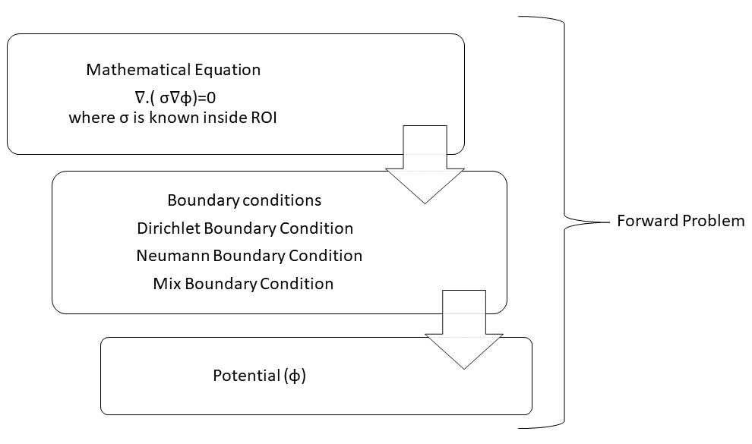

Boundary conditions: the solution of Eq(12) is governed by obeying the following boundary conditions
i). Dirichlet Boundary Condition: When the potentials are specified (from measurements) on boundary
ɸ = ɸ_{i}; where i = 1…..N(number of electrodes) and ɸ_{i} is the measured potential on the i^{th} electrode.
ii). Neumann Boundary Condition: these boundary conditions are as follows
$\int{\frac{σ∂ϕ}{∂n}= }$ +1 on the source electrode, -1 on the sink electrode, and zero otherwise. Where $∂$Ω is the outer boundary surface, and n is the unit vector normal to the boundary surface. It has been found that the relation between the measured potentials and the conductivity of ROI is represented by
$∂$Ω
δɸ = S$δσ$ | (13)

Where T is the transformation matrix associated with potential and conductivity, t and $σ$ are known, then potential can be obtained numerically. This sort of mathematical problem is known as the forward problem.
$δσ$ = S⁻¹ δɸ | (14)

But if we have Eq. like (14), where we have information about the transformation matrix and the boundary potentials, this sort of problem is known as an inverse problem. Finding the inverse of T is not straightforward.

Inverse Problem:
Inverse problems are ill-conditioned in nature means if we make a slight change in the experimental environment, it may lead to a significant change in output. These kinds of problems are highly unstable in nature and prone to error. An inverse problem is a way to get information about the resistivity or the conductivity distribution of the subject under test. It uses the boundary condition to extract the information from ROI. In some and simplest cases, like circular geometry having a homogeneous distribution of conductivity or resistivity, it’s easy to find out an analytical solution, but in a practical scenario, this is not the case. So we use numerical methods, specially regularization methods are used to solve the inverse problem.
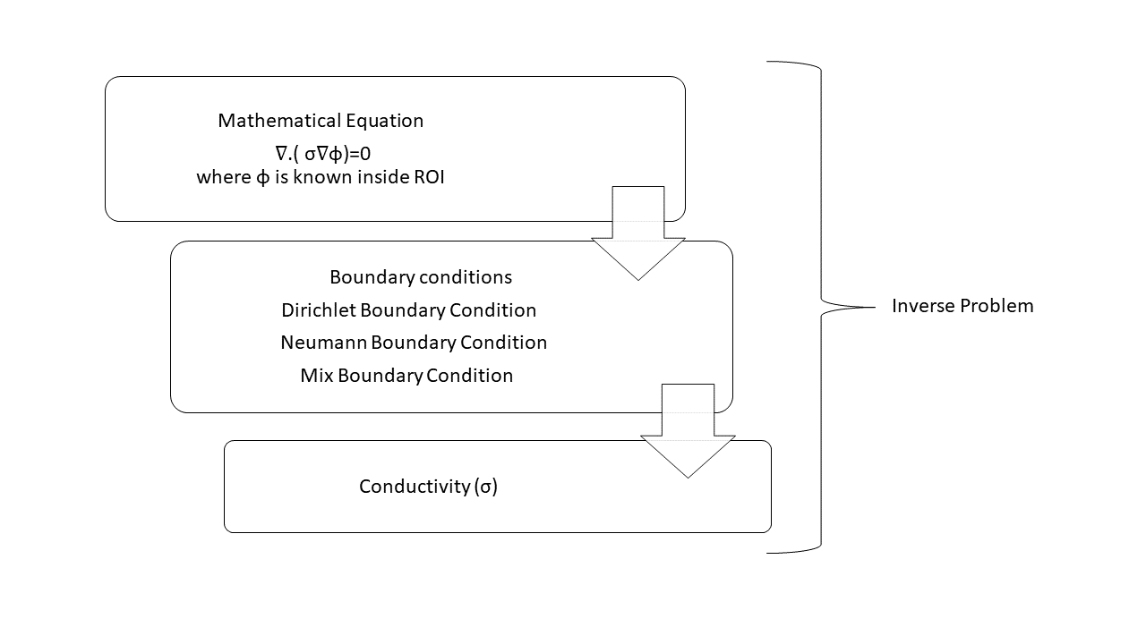

Following are the steps to solve these problem:
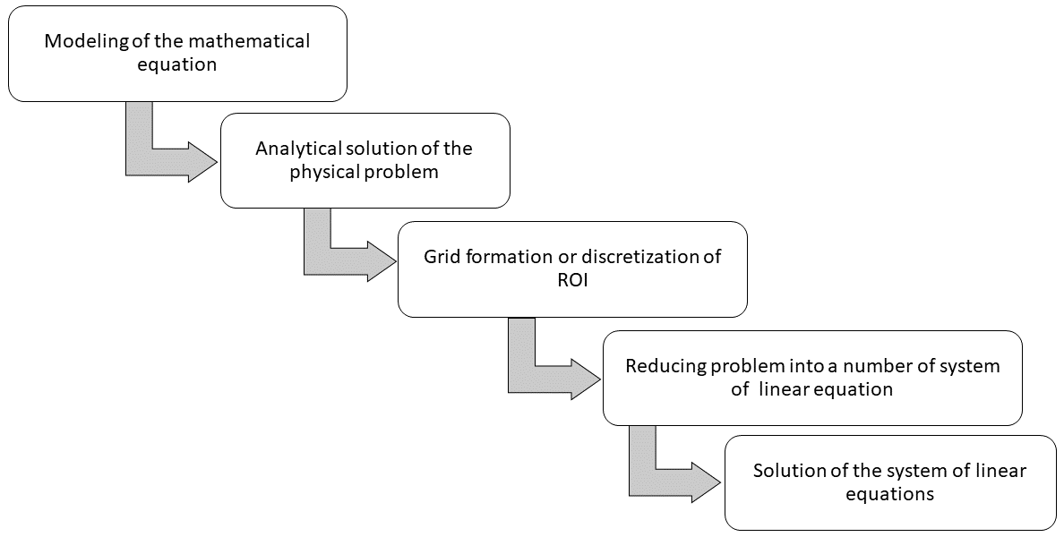

Electronics involved:

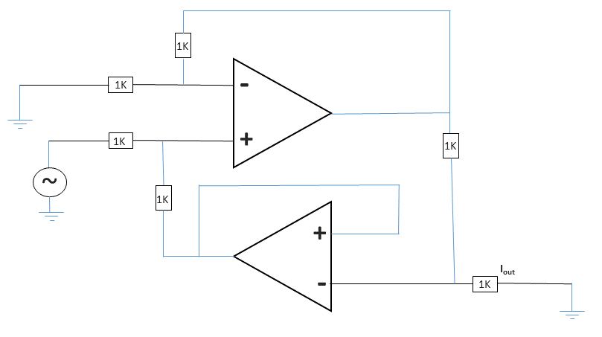 | 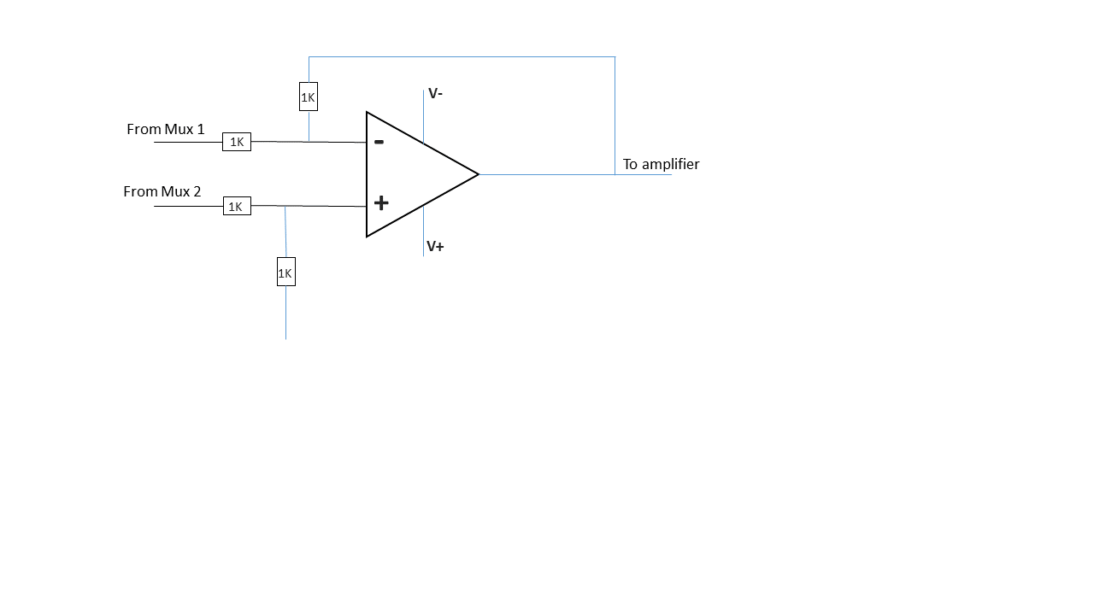
Figure 1(a). Modified voltage controlled current source VCCS | Figure 1(b). Differential Voltmeter

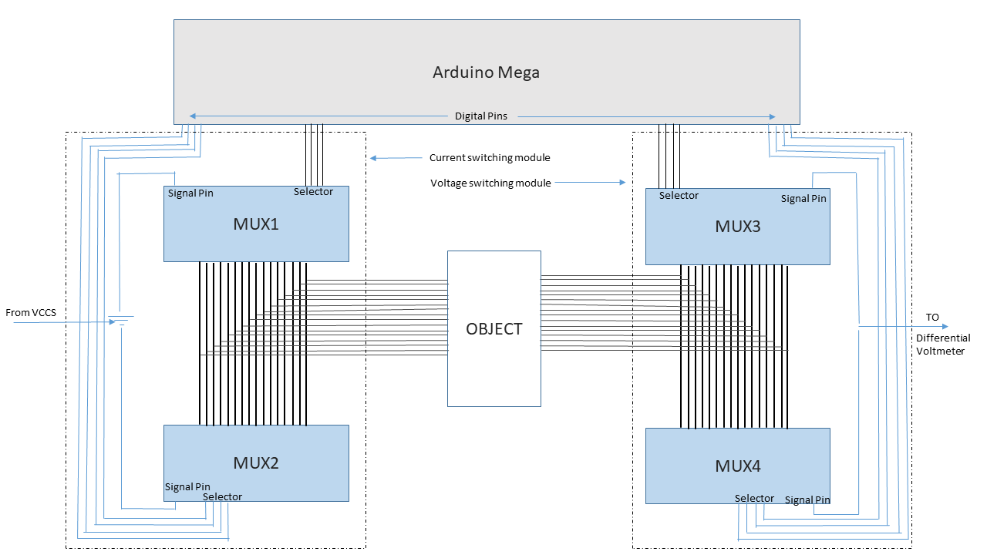
Figure 2. Circuit Diagram of EIT Switching Module

Non-linear fitting:
Numerous experiments (nearly 500) have been conducted for non-linear fitting. Only one variable was changed in one experiment. Experiments corresponding to 4 and 5 number of electrodes have been skipped. The table that is attached below contains information about the experimental variables. RMSE corresponding to every experiment is used for fitting. This fitting is done using MATLAB inbuilt function ‘lsqcurvefit()’. Fitting RMSE is used to find out the best fit.
Molarity | Time (Min) | No. of electrodes | Size of object (cm) | Diameter of container (cm) | Periphery covered by electrodes (%)
0.434 | 20 | 4 (skipped) | 0.2 | 5.4 | 38.66
0.513 | 40 | 5 (skipped) | 0.4 | 6.5 | 39.19
0.684 | 60 | 8 | 0.5 | 8.3 | 50.88
1.024 | 80 | 12 | 0.7 | 19 | 35
2.053 | 100 | 16 | 0.9 | 21.7 | 35

