Supplementary Information for
Radiocatalytic synthesis of ammonia under ambient conditions with efficiency exceeding that of Haber–Bosch process
Changjiang Hu¹, Junyi Zhao¹, Zhiwen Jiang¹, Degao Wang², Xiaoping Ouyang³,
Shuao Wang⁴*, Jun Ma ¹*
¹ School of Nuclear Science and Technology, University of Science and Technology of China, Hefei, Anhui 230026, China.
²Engineering Laboratory of Advanced Energy Materials, Ningbo Institute of Materials Technology and Engineering, Chinese Academy of Sciences, Ningbo, Zhejiang 315201, China
³Northwest Institute of Nuclear Technology, Xi'an 710024, China
⁴State Key Laboratory of Radiation Medicine and Protection, School for Radiological and Interdisciplinary Sciences (RAD-X), Soochow University, Suzhou 215123, P. R. China
These authors contributed equally: Changjiang Hu, Junyi Zhao
E-mails: majun0502@ustc.edu.cn; shuaowang@ suda.edu.cn

Part 1 Comparison with other reported methods.
Supplementary Table 1. The comparison of catalytic activity in production NH₃ production using different.
Method | Conditions | Efficiency of catalyst  (NH₃, μmol/g/s) | Energy conversion  (MJ/mol)
Radiocatalysis | R.T.，1bar | 48 | 17
Haber-Bosch ^{1,2} | 300-500 °C, 1-90 bar | 1.54-12.5 | 662 ¹
Electrochemical ³⁻⁶ | R.T., 1~20 bar | 0.0002~0.15 μmol/cm/s | 35.7~3876
Photochemical ⁷ | Light, 1000 °C | 0.00046 | 64
Mechanochemical ⁸ | 45℃，1bar | 0.013 | 76.5
Plasma ⁹ | R.T.，1bar | 0.0072 | 138
Laser ¹⁰ | R.T.，1~7.5 bar | 32.8 | 19.7
The method for calculating energy consumption: the energy consumption equals the sum of energy needed to fix equivalent N* and hydrogenation to produce 1 mol ammonia. The calculation of the energy efficiency of radiocatalysis was based on the conversion of the G (NH₃) value of radiation yield.
The effects on the energetic cost of the electrochemical NRRs illustrated in Figure 3b are calculated according to this equation:
$$\text{E(MJ/}{\text{kg}}_{{\text{NH}}_{\text{3}}}\text{)=}\frac{\text{3∙U(V)∙F(C/mol)∙1000}}{\text{17(g/mol)∙}\frac{\text{FE(100\%)}}{\text{100}}}$$

Part 2 Supplementary methods
Chemicals and materials
Hafnium(IV) chloride (HfCl₄, 98%, Sigma), 2-hydroxyterephthalic acid (BDC-OH, 98%, Macklin), 2-aminotereph thalic acid (BDC-NH₂, 99%, Sigma), sodium sulfiye (98.0%, Aladdin), methanol (99.5%, Aladdin), sulfur dioxide solution (SO₂ ≥ 6%, Alfa), acetic acid ( ≥ 99%, Sigma), hydrochloric acid (AR, 37%), KOH (99.9%, Aladdin), NaOH (99.9%, Aladdin), salicylic acid (99.5%, Aladdin), sodium citrate dihydrete (99%, Aladdin), NaClO (6%-14%, Aladdin), and Sodium nitroferricyanide(III) dihydrate Na₂[Fe(CN)₅NO]•2H₂O (99.98%, Aladdin) were used. All chemicals were used without further purification.
Radiation dose calibration
The Fricke dosimeter system obtained by the national standard method (GB T 139-2008) was accepted to calibrate the X-ray dose. The dosimeter configuration was shown in the following listing. A mixture containing 392 mg of (NH₄)₂Fe(SO₄)₂∙6H₂O, NaCl (58 mg), 0.4 mol/L H₂SO₄ (22.5 ml), was dissolved in a 1L volumetric flask and diluted with air-saturated sulfuric 0.4 mol/L H₂SO₄ solution to volume. The absorbed dose range should be from 20 to 400 Gy. Net absorbance (Δ$\text{A}$) was derived from the ultraviolet absorbance of a solution before (${\overline{\text{A}}}_{\text{0}}$) and after ($\text{A}$) irradiation. Fricke solution absorbed dose values are calculated using the following formula:
$$\text{ΔA =}\left|\text{A- }{\overline{\text{A}}}_{\text{0}}\right|$$
$${\text{D}}_{\text{F}}\text{ = }\frac{\text{ΔA}}{\text{ϵ ×G × ρ ×l}}$$
$G$ – chemical yield for the irradiation energy
$ϵ$ – molar extinction coefficient
$l$ – optical pathway
$ρ$ – solution density

G (NH₃) calculation
$${\text{G}}_{\text{tot}}\left({\text{NH}}_{\text{3}}\right)\text{= }\frac{\text{n(}{\text{NH}}_{\text{3}}\text{)}}{{\text{w}}_{\text{aq}}{\text{γ}}_{\text{aq}}\text{+}{\text{w}}_{\text{M}}{\text{γ}}_{\text{M}}}$$
$${\text{G}}_{\text{aq}}\left({\text{NH}}_{\text{3}}\right)\text{= }\frac{\text{n(}{\text{NH}}_{\text{3}}\text{)}}{{\text{w}}_{\text{aq}}{\text{γ}}_{\text{aq}}}$$
Where n(NH₃) is the amount of NH₃ produced by radiolysis, w_{aq}, and w_{M} are the mass fraction of water and catalyst in the mixture, and γ_{aq} and γ_{M} are the respective absorbed doses of the water and catalyst. However, in our experiment, the weight of the catalyst ranged from 0.06 %, much less than that of H₂O content, so the contribution to the total absorbed dose was ignored. The value of γ_{aq} was measured by the Fricke dosimeter and finally used as the total absorbed dose.

X-ray/electron beam-driven catalytic conversion of N₂ to NH₃
The X-ray-driven NRR experiment was finished in a 300 mL continuous aeration reactor using a panoramic X-ray source (160 keV, 20 mA) with a dose rate of 0.81 kGy h⁻¹ at room temperature (Figure S1). In a typical experimental process, 600 mg of UiO-66(Hf)-NH₂ was dispersed into 150 mL H₂SO₃ solution (1.25 mL sulfur dioxide solution in 150 mL deionized water) with different pH-concentrated HCl as a regulator. Then, the mixture was bubbled with high-purity N₂. 3 mL of the filtered reaction liquid was detected by ion chromatography (IC), ¹H nuclear magnetic resonance (NMR) method, and indophenol blue method.
During the experiment on NH₃ synthesis using an electron beam, 400 mg catalyst was dispersed in a 100 mL solution of H₂SO₃ (1.25 mL sulfur dioxide solution in 150 mL deionized water) saturated with N₂. The mixture was then transferred to a 1200 mm petri dish and irradiated using a 1 MeV electron beam with a different current. This experimental setup proved more effective than an open system. Liquid products are detected by the same method as above.

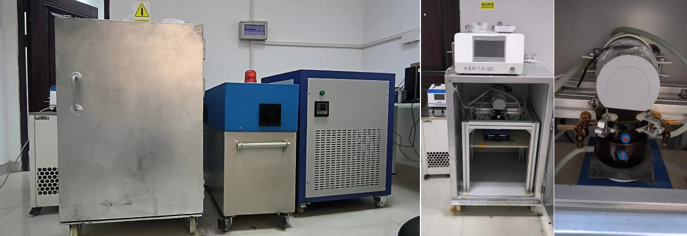
Supplementary Fig. 1. 300 mL continuous aeration reactor using a panoramic X-ray source (160 keV, 20 mA).

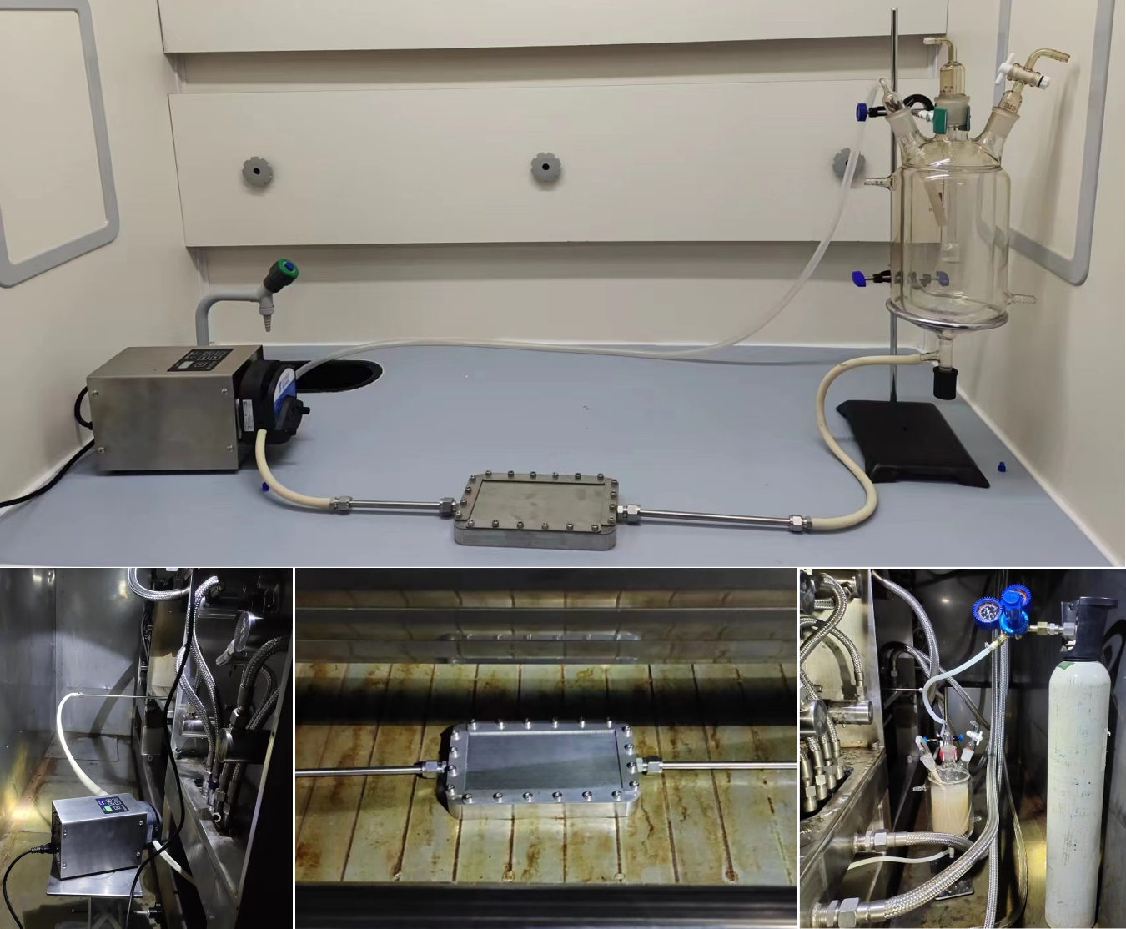
Supplementary Fig. 2. The assembled continuous-flow reactor for NRR. The dimension of the flow cell was 15 cm×8 cm×2 cm with a 1mm titanium plate as a sealing layer. The effective area of the reactor with the gasket was 90 cm². Additionally, a gas-liquid separator with a volume of 1.5L was incorporated.

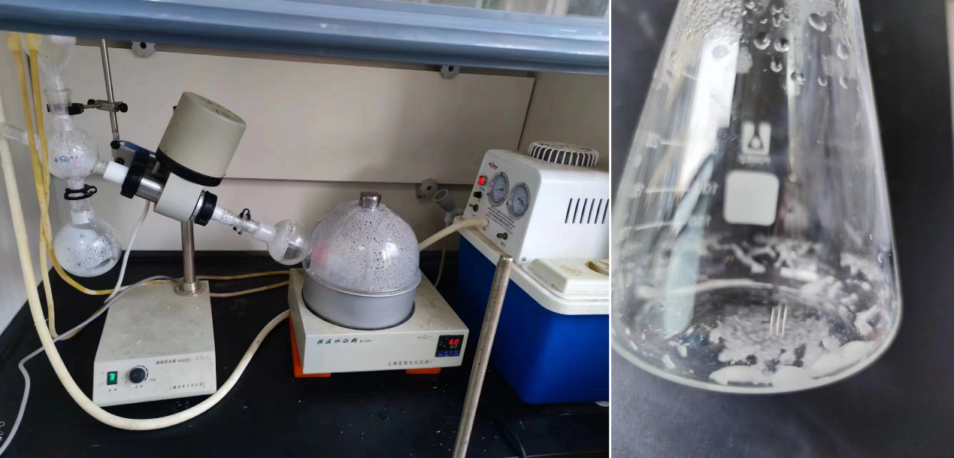
Supplementary Fig. 3. A rotary evaporator is used to evaporate 180 mL of the reaction liquid within a continuous reactor after 30 minutes of irradiation, resulting in the formation of a solid product.

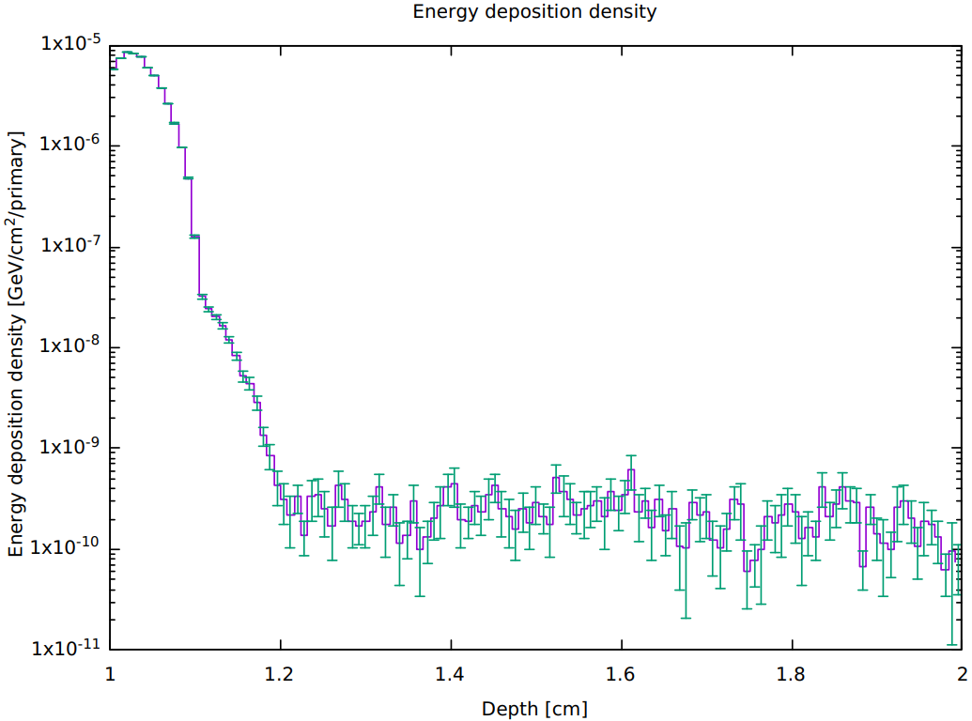
Supplementary Fig. 4. Energy deposition of aqueous solution in a continuous reactor after electron beam energy penetrating 1mm titanium plate.

Part 3 Ammonia quantification
Detection of produced ammonia and performance evaluation
The generated ammonia was detected and quantified after the hydrolysis of UiO-66(Hf)-NH₂ in 150 mL solution with different pH (2, 3, and 6) containing a certain amount of H₂SO₃.
The NH₄⁺ concentration in acid traps was quantitatively determined by the ion chromatograph (IC) system, indophenol blue spectrophotometric method, and ¹H nuclear magnetic resonance.
Determination of NH₃ by ion chromatography method.
The NH₄⁺ concentration was quantified by the IC system (YYIC-1600). 100 ppm NH₄⁺ was added to a solution with different pH (2, 3, and 6) containing a certain amount of H₂SO₃, diluted to an appropriate concentration, and then injected into the IC system to obtain a series of peak heights. The standard curve was prepared by correlating the NH₄⁺ concentration and the peak height. Then, through the standard curves, we can get the concentration of the samples.
Determination of NH₃ by indophenol blue spectrophotometric method.
The concentration of NH₄⁺ was detected by the indophenol blue spectrophotometric method. Ammonia standard solutions were prepared by diluting 100 ppm NH₄⁺ stock solution under different pH conditions (1, 2 and water) in designated concentrations. 2 mL color solution (1 M NaOH, 5 wt% salicylic acid and 5 wt% sodium citrate), 1 mL oxidizing solution (0.38 M NaClO) and 0.2 mL catalysts solution (1 wt% sodium nitroferricyanide dihydrate) were mixed with 2 mL above the diluted solution. After 2 h at room temperature, the absorption spectrum was measured using a UV-Vis spectrophotometer (UV-3300). NH₄⁺ standard curve was constructed by correlating standard solution concentrations with absorbances at the wavelength of 655 nm. The same procedure was used to quantify the amount of NH₄⁺ in stability test samples.
Determination of NH₃ by ¹H nuclear magnetic resonance (¹H NMR).
50 μL of 1 mM Maleic acid was used as the internal standard; 50 μL of DMSO-d6 was used for a spin-lock field. The above solutions were added to 900 μL of ammonia in aqueous media. After shaking up, 600 μL of the above-mixed solution was added into an NMR tube. ¹H NMR measurements were done on a Bruker 400MHz AVANCE III HD with a cryoprobe. Standard Bruker pulse sequence (pulse program: zgesgp) was used to suppress the solution water ¹H signal and acquire NMR data. The NS were set to be 256, respectively. All the ¹H NMR spectra were processed by Mnova.

Supplementary Fig. 5. The standard working curve for the amount of NH₄⁺ in the pH=2 solution using IC.

Supplementary Fig. 6. The standard working curve for the amount of NH₄⁺ in the pH=3 solution using IC.

Supplementary Fig.7. The standard working curve for the amount of NH₄⁺ in the pH=6 solution using IC.

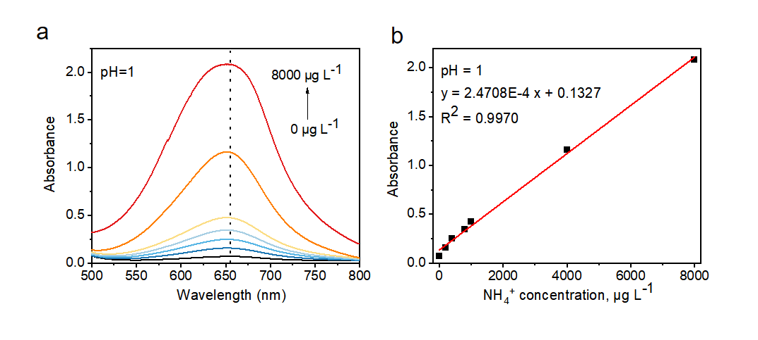
Supplementary Fig. 8. (a) UV-Vis spectra of various NH₄⁺ concentrations at pH=1. (b) Calibration curve of the absorbance at 655 nm versus the concentration of NH₄⁺ at pH=1.

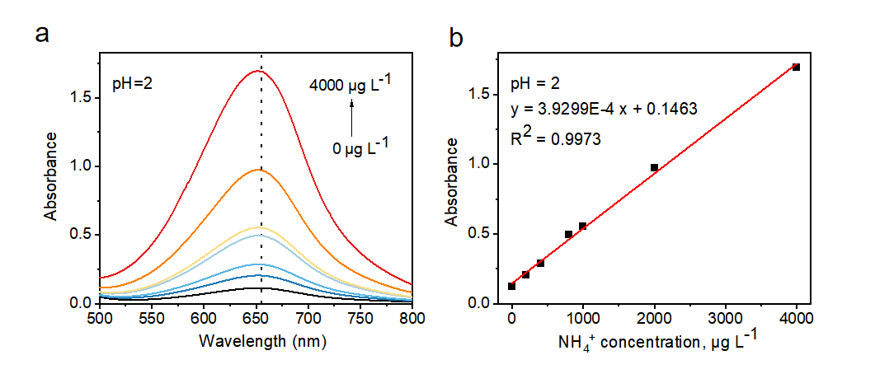
Supplementary Fig. 9. (a) UV-Vis spectra of various NH₄⁺ concentrations at pH=2. (b) Calibration curve of the absorbance at 655 nm versus the concentration of NH₄⁺ at pH=2.

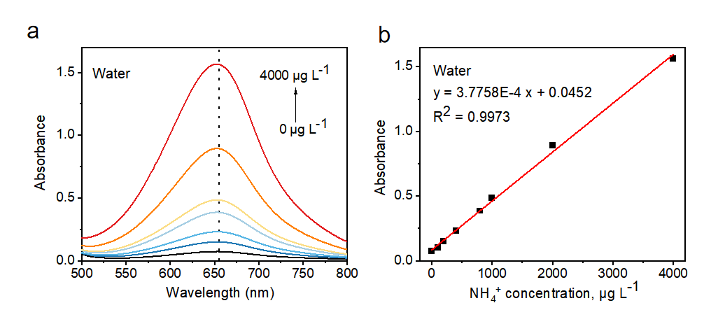
Supplementary Fig. 10. (a) UV-Vis spectra of various NH₄⁺ concentrations in water. (b) Calibration curve of the absorbance at 655 nm versus the concentration of NH₄⁺ in water.

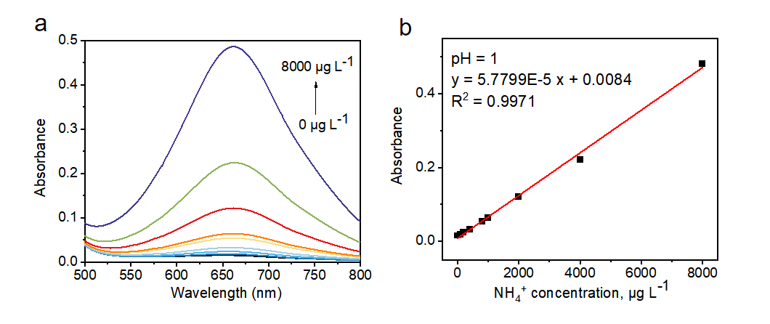
Supplementary Fig. 11. (a) UV-Vis spectra of various NH₄⁺ concentrations in 0.1 M Na₂SO₃. (b) Calibration curve of the absorbance at 655 nm versus the concentration of NH₄⁺. Calibration for the Berthelot spectrophotometric analysis of ammonia: UV-vis absorption spectra of a solution prepared by mixing 2 mL of a defined amount of NH₄⁺ in 0.1 M Na₂SO₃ with 2 ml of a 1 M NaOH solution that contained salicylic acid and sodium citrate, 1 ml of 3 M NaClO, and 0.2 ml of 1 wt% Na₂[Fe(CN)₅NO]•2H₂O.

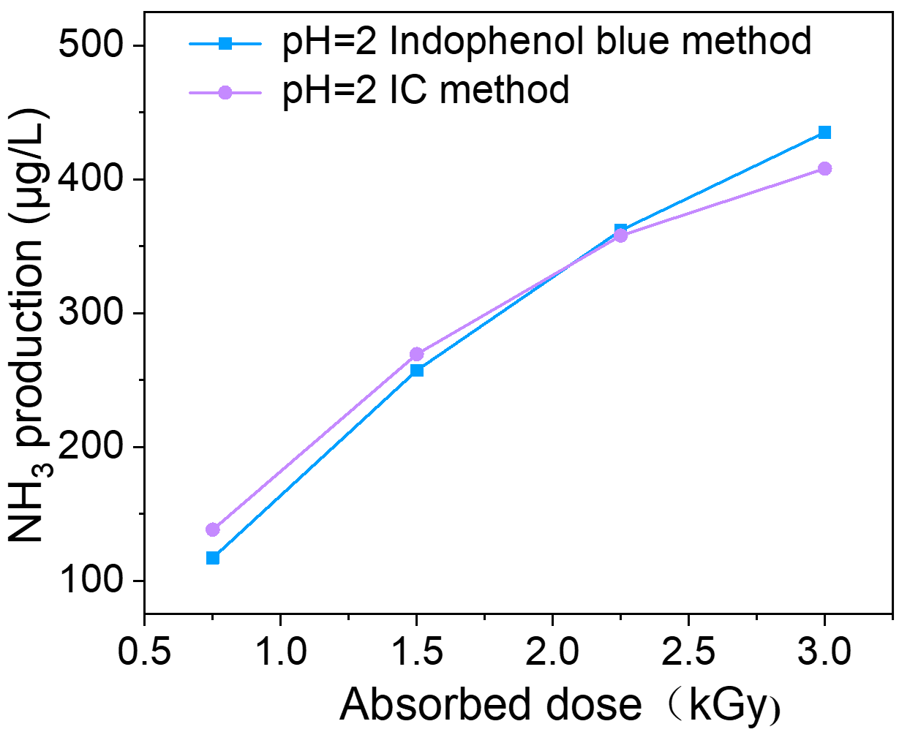
Supplementary Fig. 12. Performance comparison of different ammonia quantification methods for 100 mg UiO-66-NH₂ at pH=2.

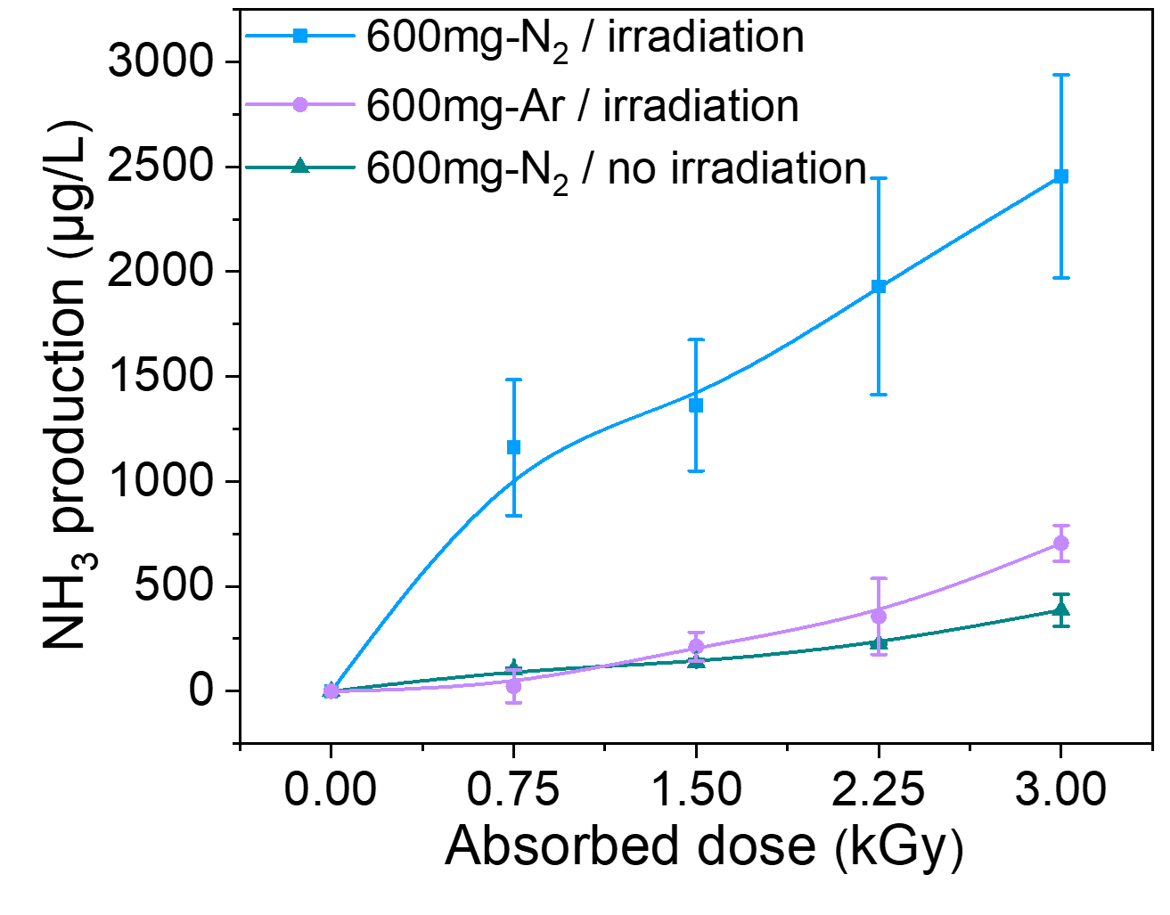
Supplementary Fig. 13. Effect of N₂ without X-ray irradiation and Ar with irradiation on ammonia production at pH=1 H₂SO₃ solution (HCl as a regulator).

Part 4 Pulse radiolysis
Pulse radiolysis experiments
In the pulse radiolysis experiments, we utilized the picosecond laser-triggered electron accelerator, ELYSE, in conjunction with a time-resolved absorption spectrophotometric detection system. The laser (260 nm) driven Cs₂Te photocathode allowed for the production of short electron pulses with a typical half-width of 7 ps, a charge of approximately 6 nC, and an energy of approximately 7.8 MeV at a repetition rate of 10 Hz.
During the irradiation process, the sample solutions were contained in a fused cell with a path length of 5 mm, which was connected to a closed circulation system from a 100 mL stock solution. The sample in the irradiation cell was renewed after each pulse using a peristaltic pump with a flow rate of 100 mL/min. The diameter of the electron beam was 3 mm, and the irradiated volume was less than 0.1 mL.
Absorption spectral measurements were conducted using the white light from a homemade Xenon flash lamp. The light was focused on the sample parallel to the electron beam with a smaller diameter and then directed onto a flat field spectrograph (Chromex 250IS). This setup dispersed the light on the entrance optics of a high dynamic range streak camera (model C-7700-01 from Hamamatsu) to obtain an image resolved in wavelength and time. The kinetic data and absorption spectra were extracted from three series of 200 resulting images. In this study, the transient spectra were measured from 290 to 720 nm.

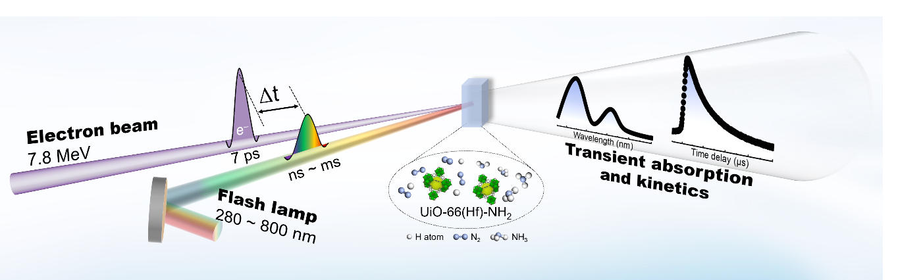
Supplementary Fig. 14. Schematic diagram of transient absorption spectral pulse radiolysis device for studying solvated electrons in MOF solutions.

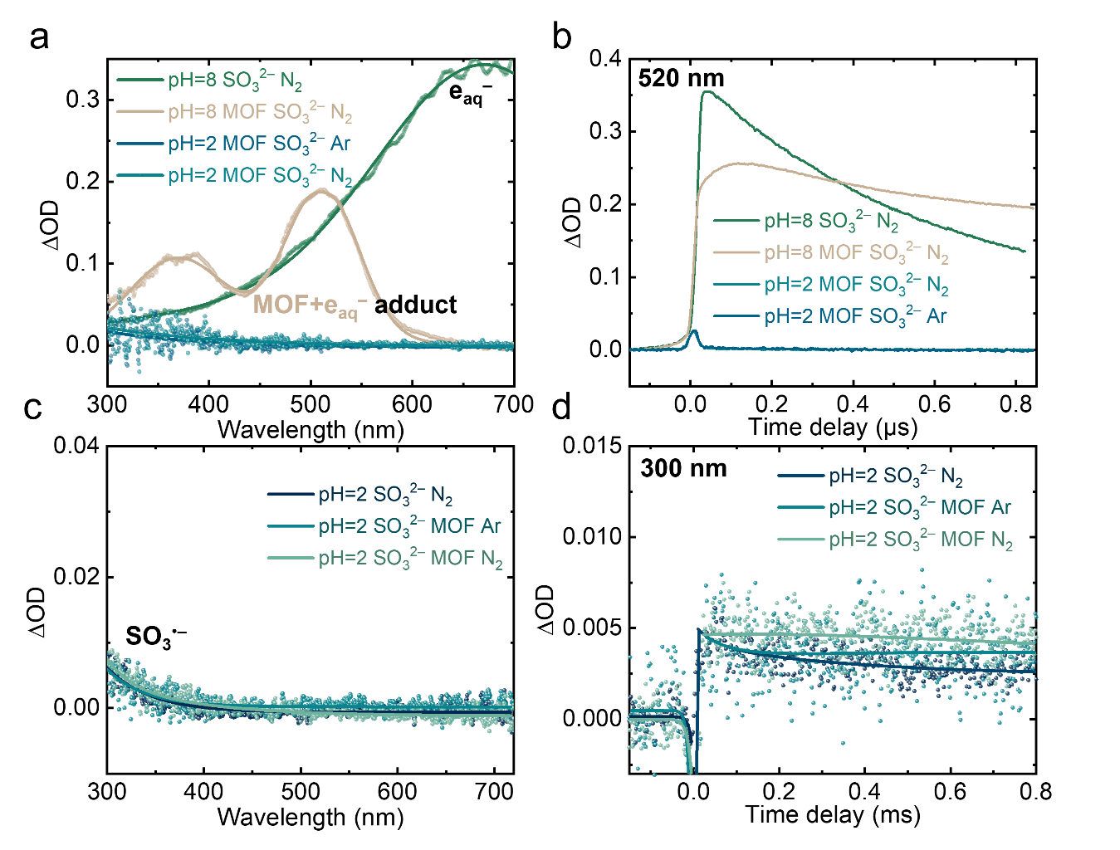
Supplementary Fig. 15. Transient absorption matrix within 820 µs recorded by pulse radiolysis of N₂ or Ar-saturated solution containing H₂SO₃ solution (pH=2 or 8). a. Transient absorption spectra at 0.8 µs and 800 µs for UiO-66-NH₂ or pure solution. b Transient kinetics within 800 µs for UiO-66-NH₂ or pure solution at 520 nm. c Transient absorption spectra at 0.8 µs and 800 µs for UiO-66-NH₂ or pure solution. d Transient kinetics within 800 µs for UiO-66-NH₂ or pure solution at 300 nm.

Part 4 Fast and scalable synthesis of catalyst (UiO-66(Hf)-NH₂)
In pursuit of synthesizing a substantial quantity of catalysts for the large-scale radiation synthesis of ammonia, we devised a hydrothermal scheme. This scheme facilitates the rapid synthesis of G-class UiO-66 within a 2-hour timeframe, showcasing exceptional crystallinity ideal for small modular radiation catalysis applications
Synthesis of UiO-66(Hf)-Type MOF
In a typical synthesis, a mixture of HfCl₄ (3.36 g, 10.5 mmol), 2-hydroxyterephthalic acid or 2-aminoterephthalic acid (10 mmol), acetic acid (40 mL) in water (60 mL) was heated at 100°C for 48 h. The resulting particles were isolated by centrifugation (8000 rpm for 5 min) and completely washed with methyl alcohol. Then, the resulting solids were dried in air at 80°C to generate nanoscale UiO-66-NH₂(Hf) or UiO-66-OH(Hf) as crystalline solids.

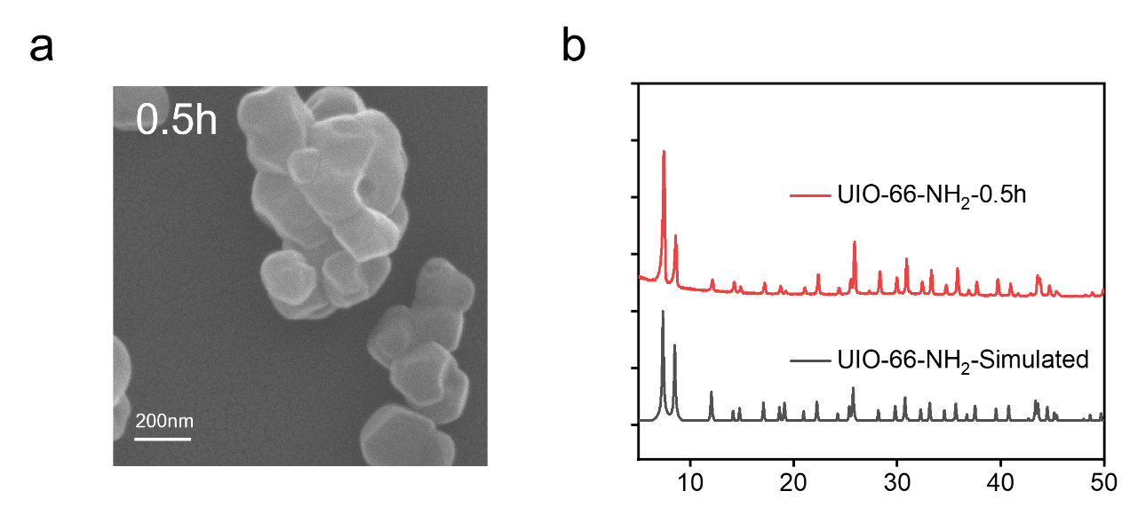
Supplementary Fig. 16. SEM (a) and XRD (b) patterns of UiO-66-NH₂ synthesized by heating oil bath for 0.5 h.

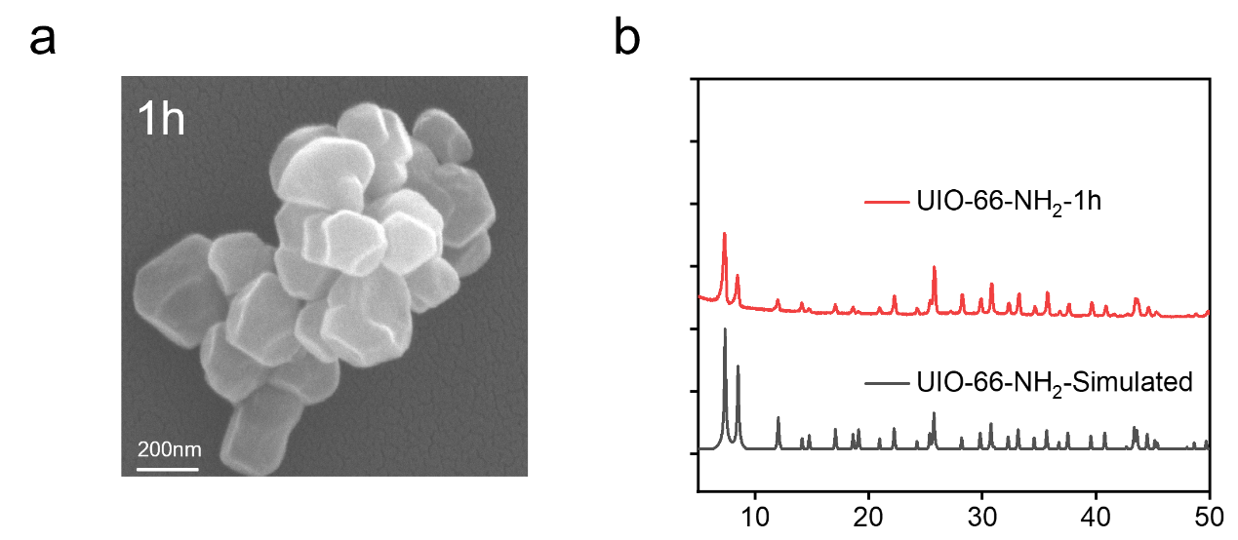
Supplementary Fig. 17. SEM (a) and XRD (b) patterns of UiO-66-NH₂ synthesized by heating oil bath for 1 h.

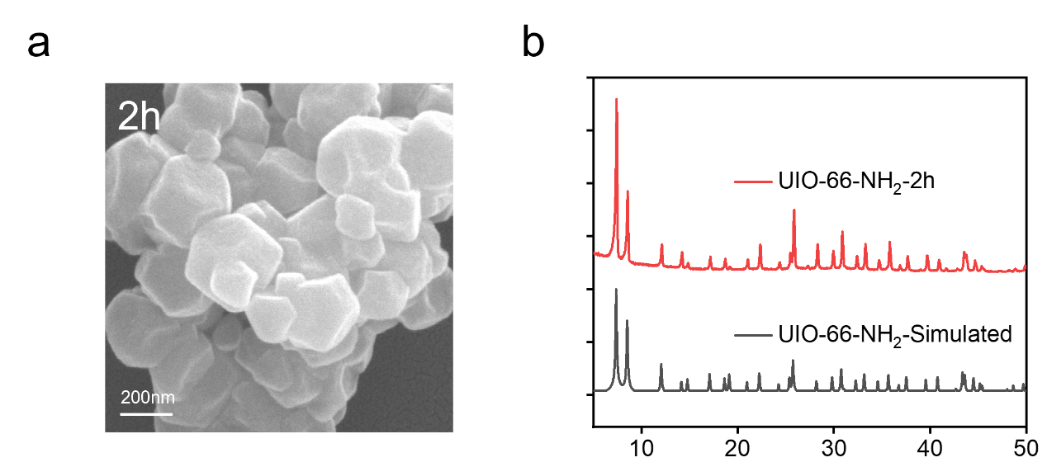
Supplementary Fig. 18. SEM (a) and XRD (b) patterns of UiO-66-NH₂ synthesized by heating oil bath for 2 h.

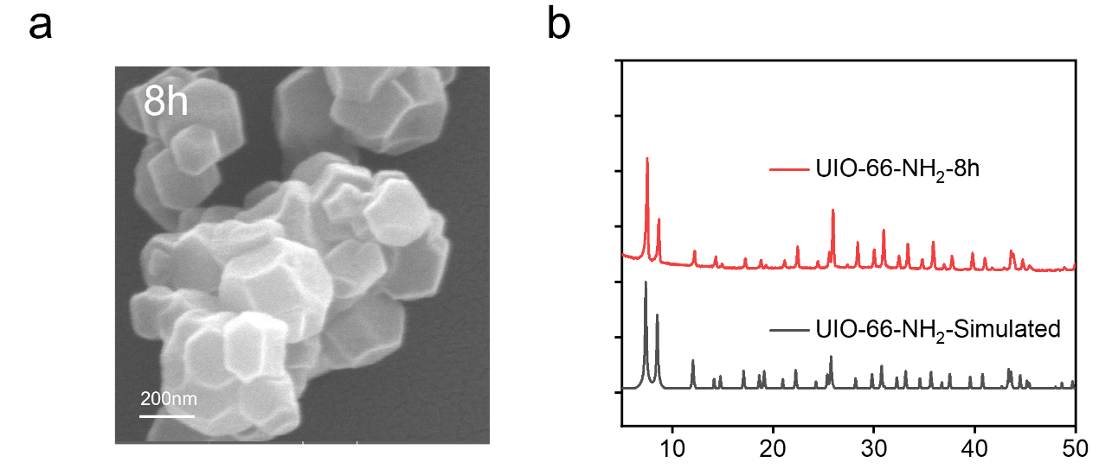
Supplementary Fig. 19. SEM (a) and XRD (b) patterns of UiO-66-NH₂ synthesized by heating oil bath for 8 h.

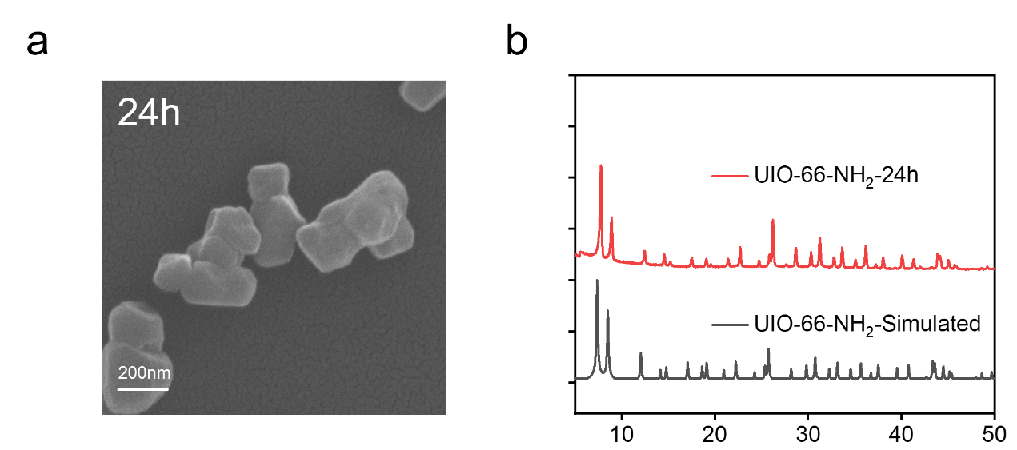
Supplementary Fig. 20. SEM (a) and XRD (b) patterns of UiO-66-NH₂ synthesized by heating oil bath for 24 h.

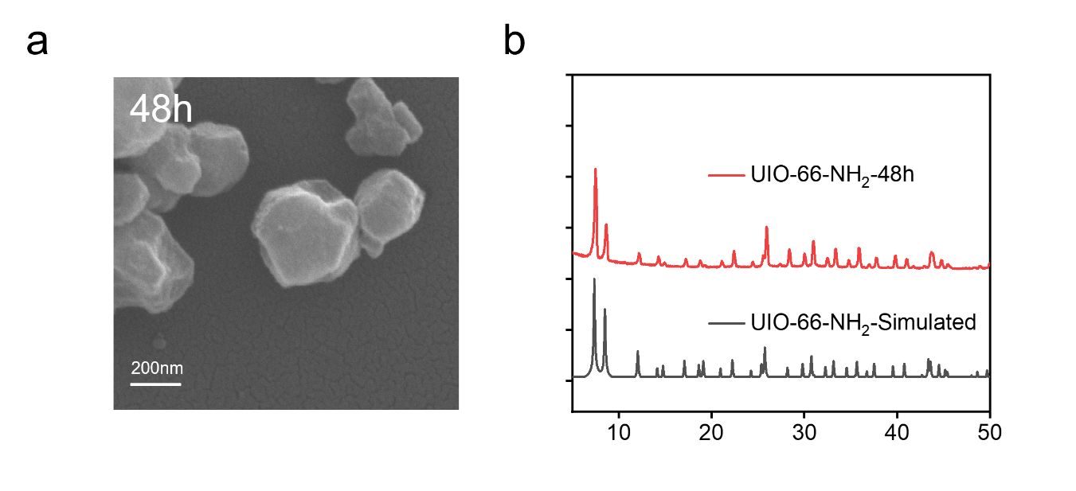
Supplementary Fig. 21. SEM (a) and XRD (b) patterns of UiO-66-NH₂ synthesized by heating oil bath for 48 h.

Supplementary Fig. 22. SEM (a) and XRD (b) patterns of UiO-66-NH₂ synthesized by heating oven for 48 h.

Part 4 Supplementary experiment for NRR
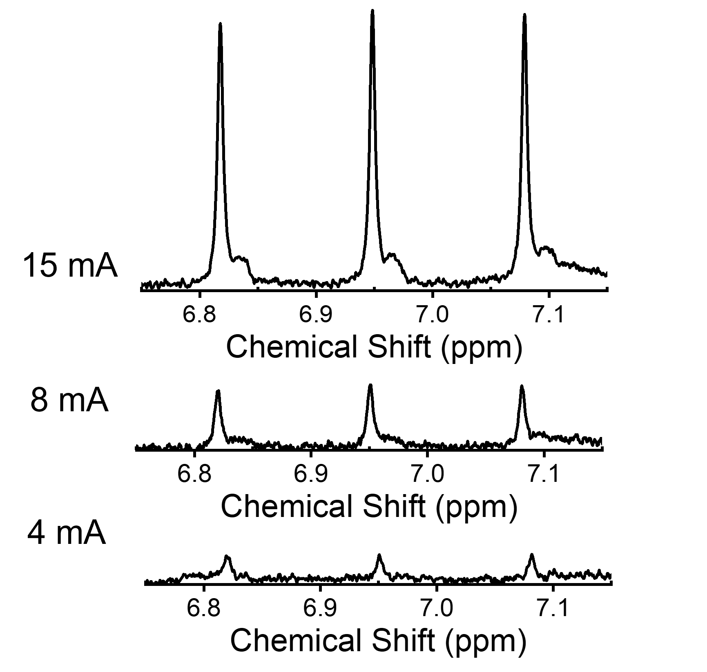
Supplementary Fig. 23. ¹H NMR spectra of NH₄⁺ (4mA, 8 mA, and 15mA) in aqueous media included a stand reference (maleic acid) and repetitive experiments using D₂O.

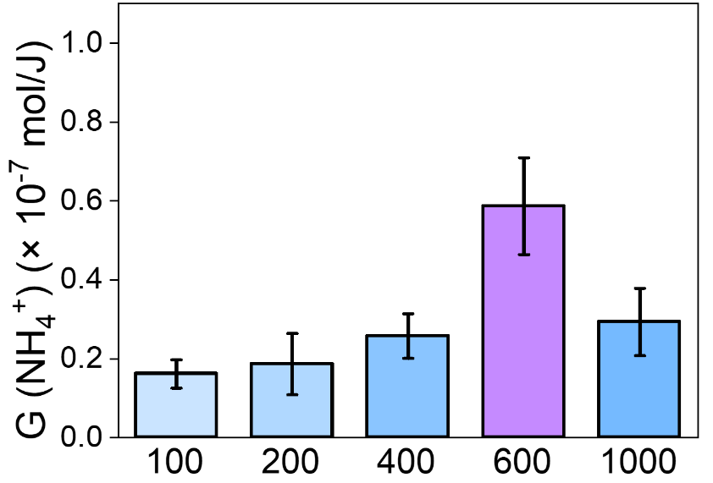
Supplementary Fig. 24. The amplified C-product in G-value by the increase of UiO-66-NH₂ mass fraction.

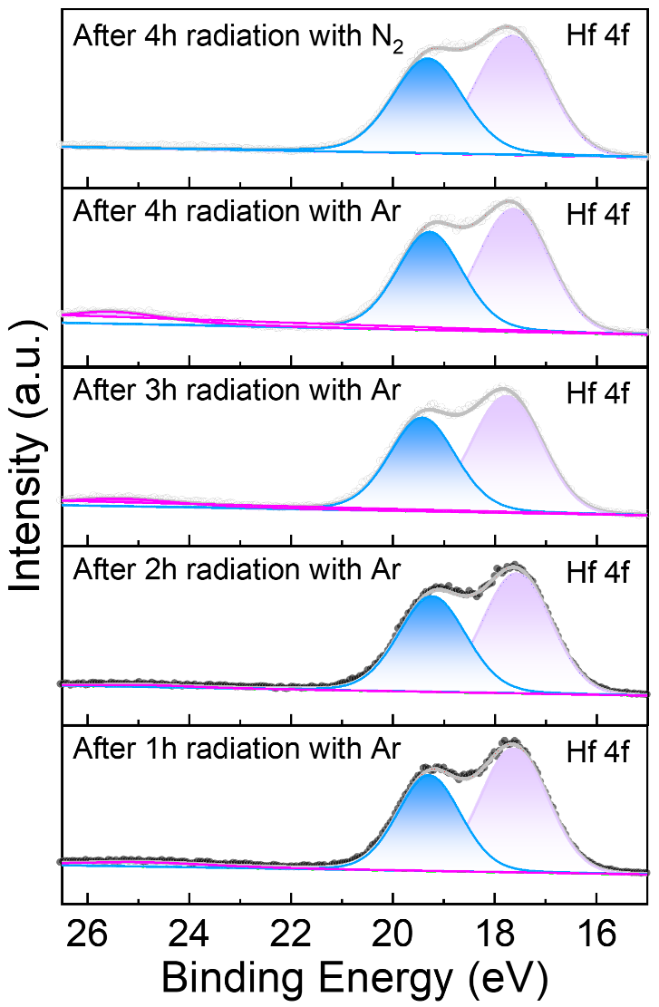
Supplementary Fig. 25. XPS of UiO-66-NH₂ irradiated by Ar or N₂ at different time.

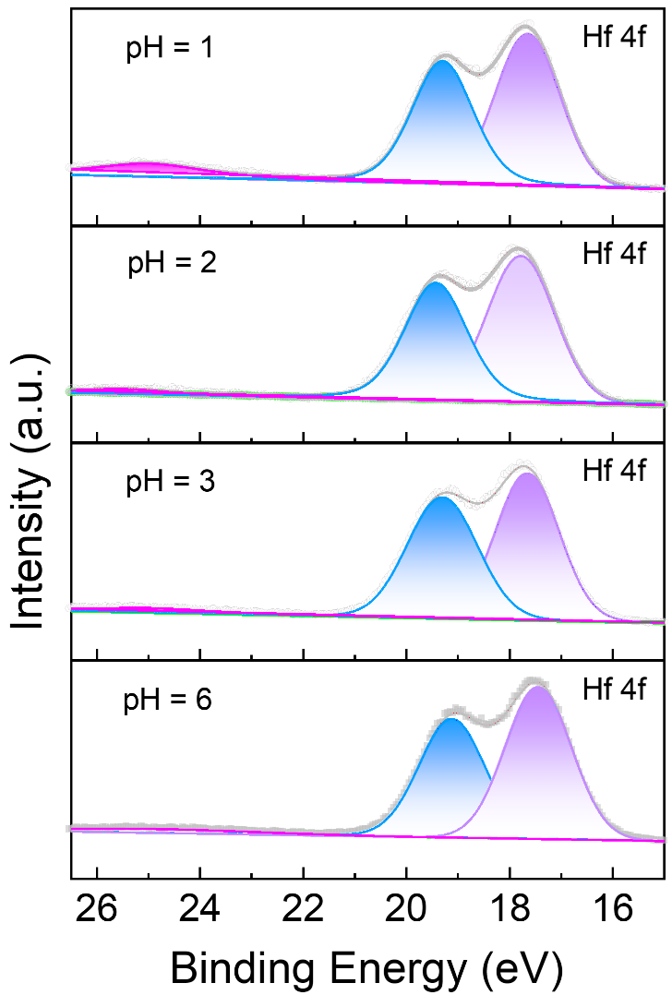
Supplementary Fig.26. XPS of UiO-66-NH₂ irradiated by Ar at different pH.

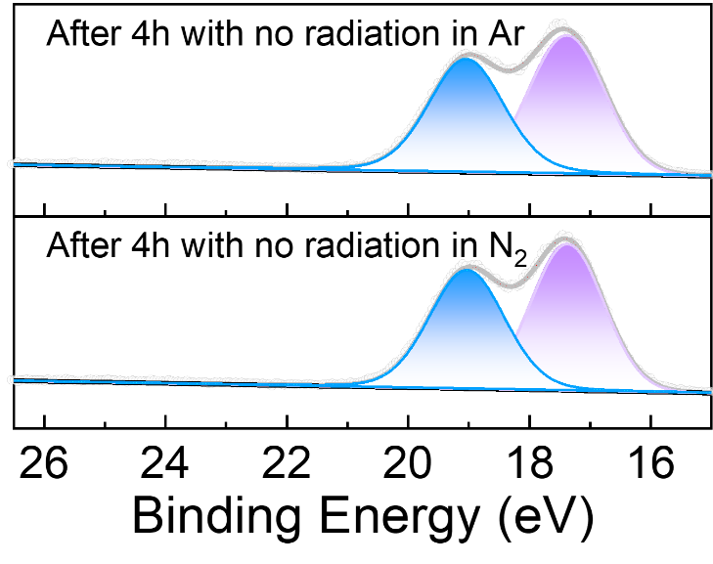
Supplementary Fig. 27. XPS of UiO-66-NH₂ is not irradiated after 4 hours in Ar or N₂.

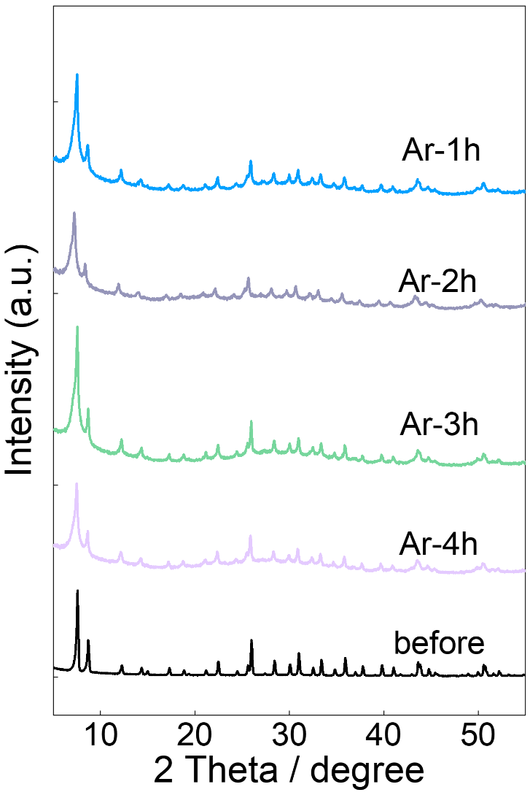
Supplementary Fig. 28. XRD of UiO-66-NH₂ irradiated under argon at different time.

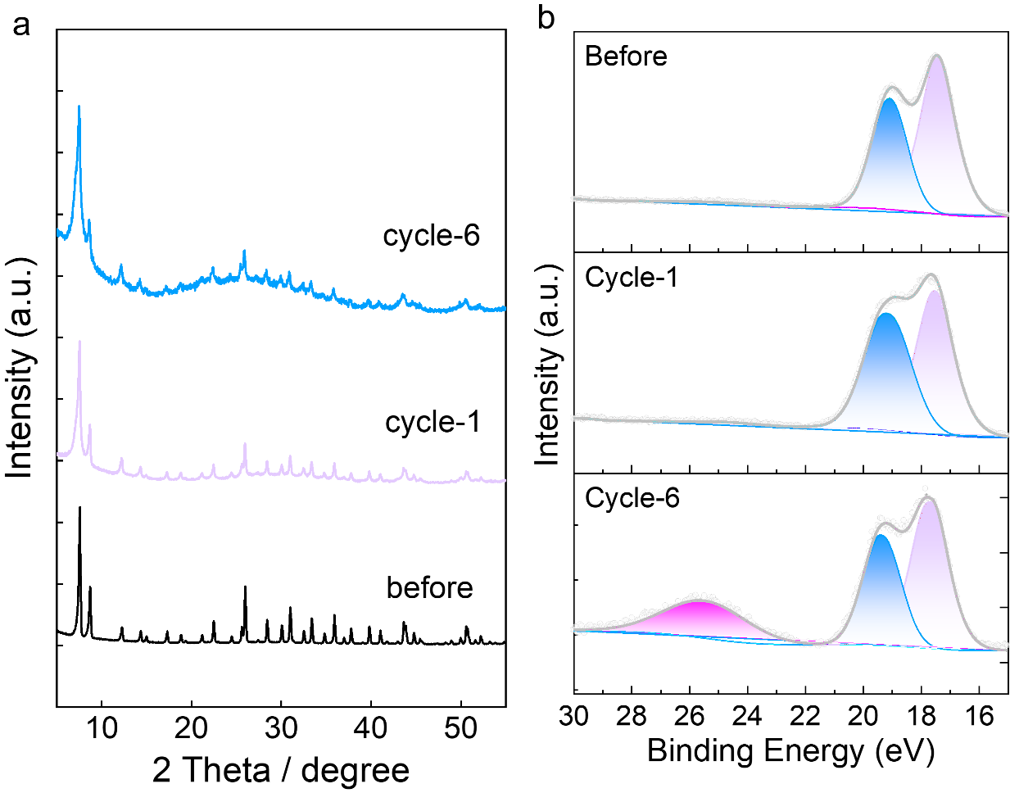
Supplementary Fig. 29. XRD (a) and XPS (b) spectra of 100 mg UiO-66-Hf-NH₂ before and after 6 cycles with 18 kGy irradiation for NH₄⁺ production.

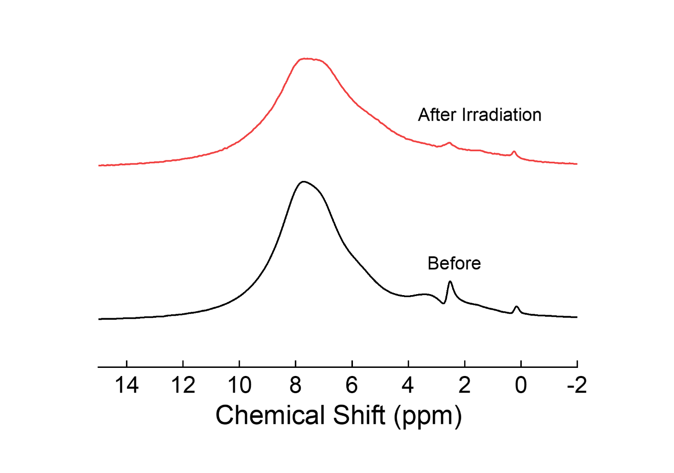
Supplementary Fig. 30. ¹H MAS NMR spectra of 100 mg UiO-66-Hf-NH₂ before and after 6 cycles.

Reference
- T.-N. Ye, S.-W. Park, Y. Lu, J. Li, M. Sasase, M. Kitano, T. Tada, H. Hosono, Vacancy-enabled N₂ activation for ammonia synthesis on an Ni-loaded catalyst. Nature. 583, 391-395 (2020).
- J. Humphreys, R. Lan, S. Tao, Development and recent progress on ammonia synthesis catalysts for Haber–Bosch process. ADV ENERG SUST RES. 2, 2000043 (2021).
- S. Z. Andersen, V. Čolić, S. Yang, J. A. Schwalbe, A. C. Nielander, J. M. McEnaney, K. Enemark-Rasmussen, J. G. Baker, A. R. Singh, B. A. Rohr, M. J. Statt, S. J. Blair, S. Mezzavilla, J. Kibsgaard, P. C. K. Vesborg, M. Cargnello, S. F. Bent, T. F. Jaramillo, I. E. L. Stephens, J. K. Nørskov, I. Chorkendorff, A rigorous electrochemical ammonia synthesis protocol with quantitative isotope measurements. Nature. 570, 504-508 (2019).
- K. Li, S. Z. Andersen, M. J. Statt, M. Saccoccio, V. J. Bukas, K. Krempl, R. Sažinas, J. B. Pedersen, V. Shadravan, Y. Zhou, D. Chakraborty, J. Kibsgaard, P. C. K. Vesborg, J. K. Nørskov, I. Chorkendorff, Enhancement of lithium-mediated ammonia synthesis by addition of oxygen. Science. 374, 1593-1597 (2021).
- B. H. R. Suryanto, K. Matuszek, J. Choi, R. Y. Hodgetts, H.-L. Du, J. M. Bakker, C. S. M. Kang, P. V. Cherepanov, A. N. Simonov, D. R. MacFarlane, Nitrogen reduction to ammonia at high efficiency and rates based on a phosphonium proton shuttle. Science. 372, 1187-1191 (2021).
- H.-L. Du, M. Chatti, R. Y. Hodgetts, P. V. Cherepanov, C. K. Nguyen, K. Matuszek, D. R. MacFarlane, A. N. Simonov, Electroreduction of nitrogen with almost 100% current-to-ammonia efficiency. Nature. 609, 722-72 (2022).
- D. F. Swearer, N. R. Knowles, H. O. Everitt, N. J. Halas, Light-driven chemical looping for ammonia synthesis. ACS Energy Lett. 4, 1505-1512 (2019).
- G.-F. Han, F. Li, Z.-W. Chen, C. Coppex, S.-J. Kim, H.-J. Noh, Z. Fu, Y. Lu, C. V. Singh, S. Siahrostami, Q. Jiang, J.-B. Baek, Mechanochemistry for ammonia synthesis under mild conditions. Nat. Nanotechnol. 16, 325-330 (2021).
- R. Hawtof, S. Ghosh, E. Guarr, C. Xu, R. Mohan Sankaran, J. N. Renner, Catalyst-free, highly selective synthesis of ammonia from nitrogen and water by a plasma electrolytic system. Sci. Adv. 5, eaat5778 (2019).
- H. Wang, R. R. Seemakurthi, G.-F. Chen, V. Strauss, O. Savateev, G. Hai, L. Ding, N. López, H. Wang, M. Antonietti, Laser-induced nitrogen fixation. Nat. Commun. 14, 5668 (2023).

