Images:
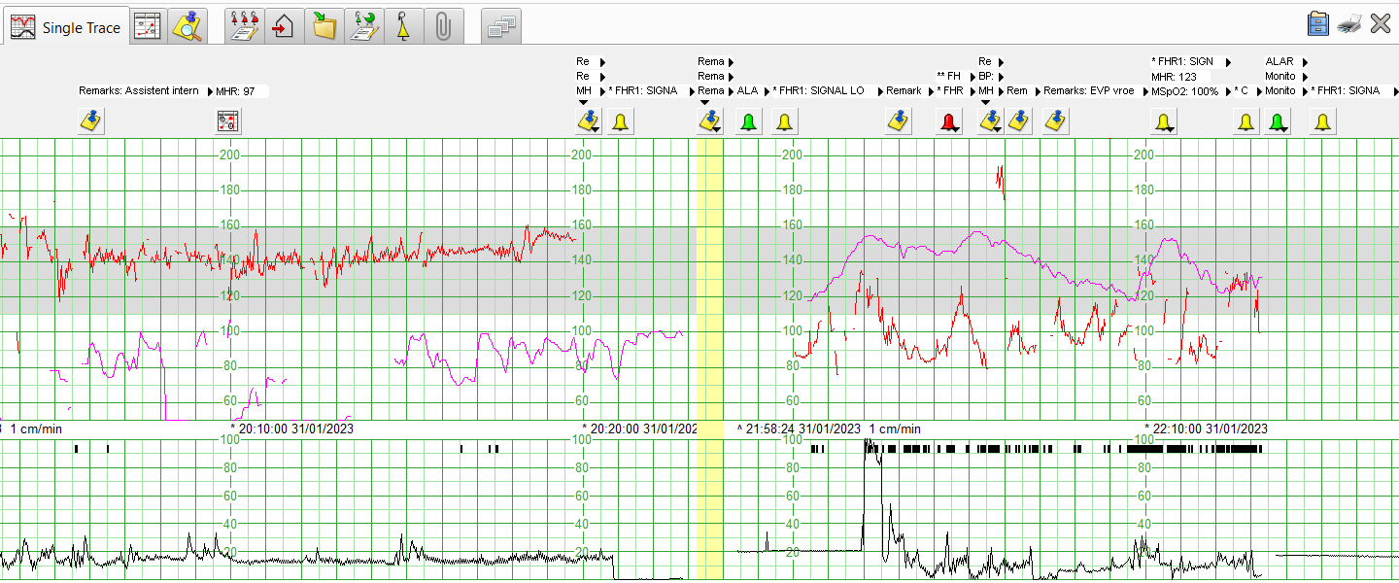
Image 1: Fetal monitoring showing sudden onset of maternal tachycardia
and fetal bradycardia prior to the emergency cesarian section.

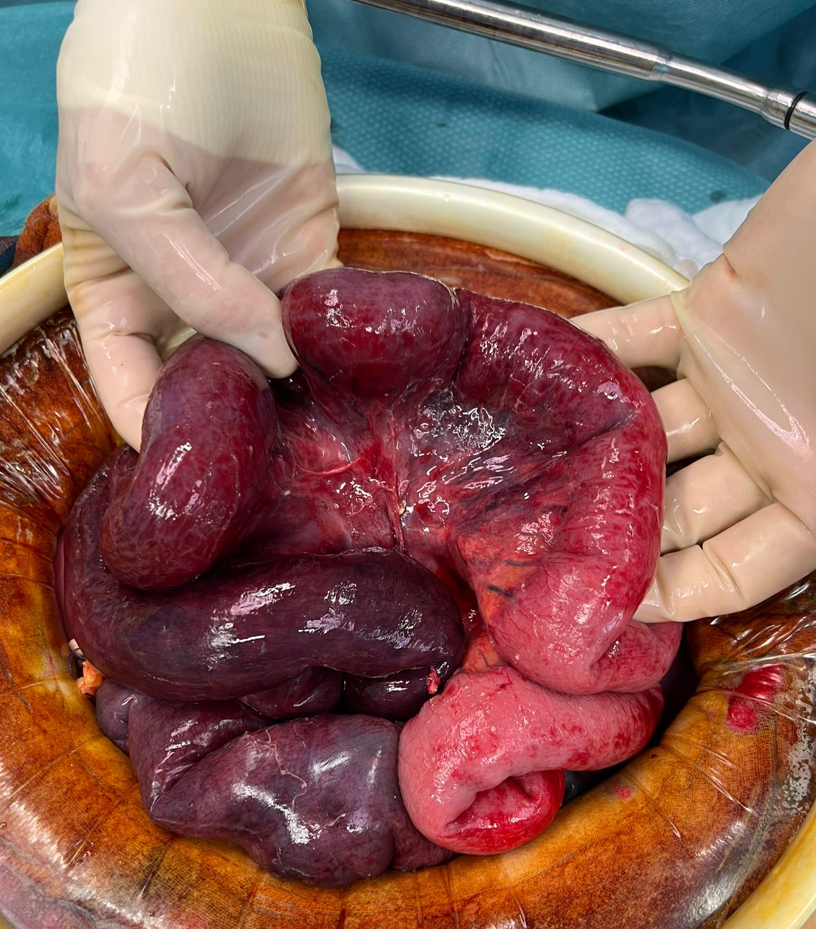
Image 2 Second-look laparotomy: additional intestine resections and a triple anastomosis of the remaining living tissue.

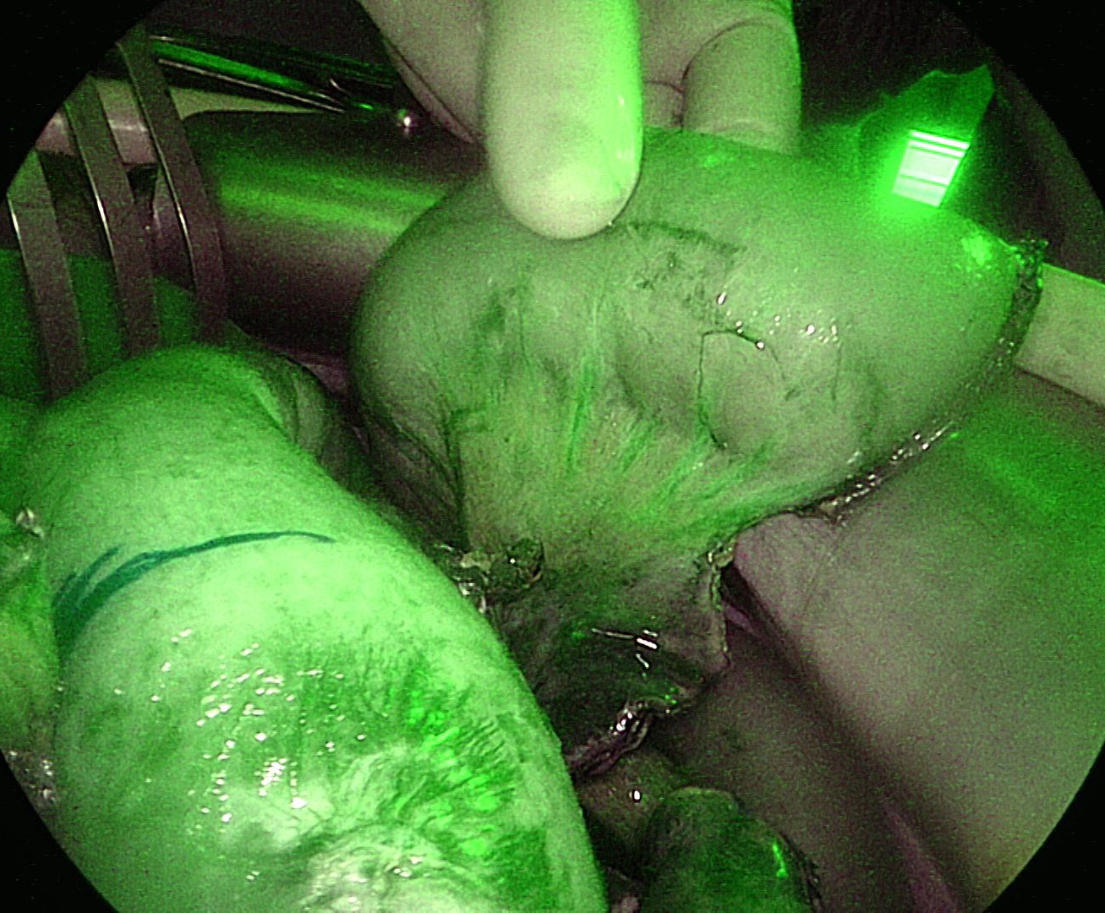
Image 3. Assessment of the intestine viability with indocyanine green angiography technology.

