Supporting Information
Figure S1. C57BL/6 mice in the AB4 pretreatment group were intraperitoneally injected with AB4 (5 mg/kg) for 7 days, and then given 3.0% DSS in drinking water for 7 days, during which AB4 (5 mg/kg) was continuously injected intraperitoneally; mice in the AB4 treatment group were given 3.0% DSS in drinking water for 7 days, during which AB4 (5 mg/kg) was intraperitoneally injected; 5-ASA (200 mg/kg) was orally administrated daily for 7 days as a positive control (n = 6 per group) (A). At the end of the experiment, the mice were sacrificed, and the colons were collected. (B) The body weight change, (C) DAI score, and (D) the colon length were measured. (E) Production of IL-1β, IL-18, IL-6, iNOS, and TNF-α in the serum of DSS-induced colitis mice was determined by ELISA. Data are presented as mean ± SD. **P < 0.01 and ns, not significantly different vs. Normal group; #P < 0.05, ##P < 0.01 vs. DSS group; $P < 0.05, $$P < 0.01 AB4 pretreatment group vs. 5-ASA group or AB4 treatment group.

Figure S2. C57BL/6 mice in the AB4 group were intraperitoneally injected with AB4 (5 mg/kg) for 7 days, and then given 3.0% DSS in drinking water for 7 days, during which AB4 (5 mg/kg) was continuously injected intraperitoneally; mice in the BTWT group were orally administrated BTWT (5 g/kg) for 7 days, and then given 3.0% DSS in drinking water for 7 days, during which BTWT (5 g/kg) was orally administrated (n= 6 per group) (A). At the end of the experiment, the mice were sacrificed, and the colons were collected. (B) The body weight change, (C) DAI score, and (D) the colon length were measured. (E) Production of IL-1β, IL-18, IL-6, iNOS, and TNF-α in the serum of DSS-induced colitis mice was determined by ELISA. Data are presented as mean ± SD. **P < 0.01 vs. Normal group; #P < 0.05, ##P < 0.01 vs. DSS group; ns, not significantly different AB4 treatment group vs. BTWT treatment group; $P < 0.05 AB4 treatment group vs. BTWT treatment group.

Figure S3. Interaction of NLRP3 with AB4. (A) BLI to determine the binding affinity (K_{D} value) of the NLRP3 protein with AB4. The concentrations of AB4 were set to 31.25, 62.5, 125, 250, and 500 μM. (B) CETSA of the NLRP3 protein with AB4. Data are presented as mean ± SD.

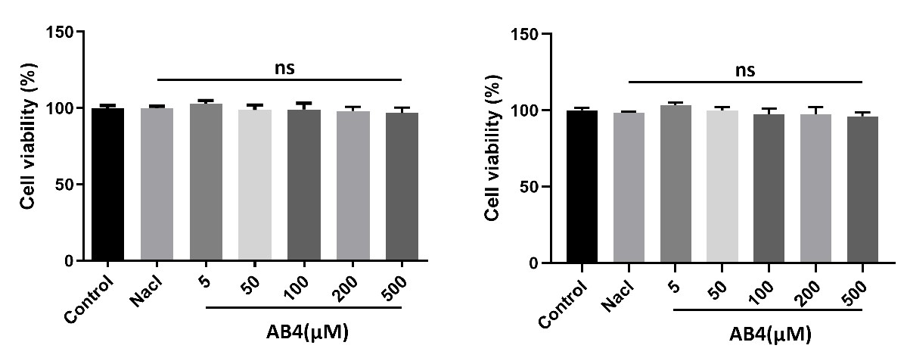
Figure S4. BMDMs (A)and THP-1 (B) cells were treated with different concentrations of AB4 for 24 h, and cell viability was assessed by CCK-8 assay . Data are presented as mean ± SD. ns, not significantly different vs. Control group.

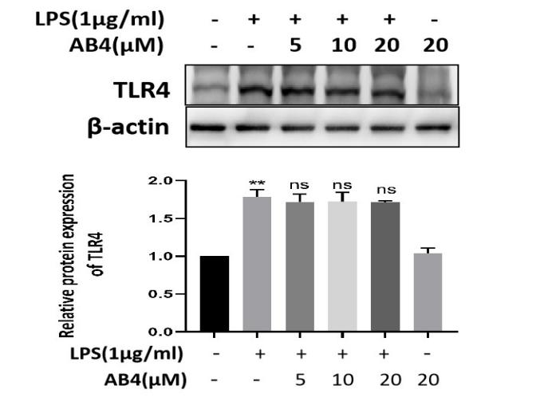
Figure S5. BMDMs were pretreated with AB4 (5, 10, and 20 μM) for 4 h, and then cultured with LPS (1μg/ml) for 6 h. The protein of TLR4 was detected by Western Blot. Data are presented as mean ± SD. **P < 0.01 vs. Control group; ns, not significantly different vs. LPS group.

Figure S6. WT mice were subjected to DSS-induced colitis. The protein expression of CD1d in colonic homogenates was detected by Western Blot. Data are presented as mean ± SD. **P < 0.01 vs. Normal group; #P < 0.05, ##P < 0.01 vs. DSS group.

