Latent Classes of Adolescent Health Behaviour, Social Covariates and Mental Wellbeing: A Longitudinal Birth Cohort Study (Supplementary Material)

Table S1: Demographic characteristics of the analytical sample, Greater Manchester (GM) and national population of adolescents

 | Sex (%) | FSM (%) | EAL (%) | SEN (%) | Ethnicity (%)
Analytical Sample | F = 50.5  M = 49.4  NA = 0.1 | No = 72.2  Yes = 25.6  NA = 2.2 | No = 78.0  Yes = 20.7  NA = 1.3 | No = 83.7  Yes = 14.9  NA = 1.5 | AOEG = 2.2  Asian = 16.9  Black = 4.8  Chinese = 0.9  Mixed = 5.8  Unclassified = 2.0  White = 64.0  NA = 3.4
GM Population of Year 8 Pupilsª | F = 48.7  M = 51.3 | No = 64.4  Yes = 35.6 | *No = 76.9  *Yes = 22.7  *Unclassified = 0.4 | No = 81.1  Yes = 18.9 | *AOEG = 3.0  *Asian = 17.6  *Black = 7.1  *Chinese = 1.1  *Mixed = 6.5  *Unclassified = 1.7  *White = 63.1
National Statistics for Year 8 Pupilsª | F = 48.7  M = 51.3 | No = 71.0  Yes = 29.0 | *No = 81.2  *Yes = 18.1  *Unclassified = 0.7 | No = 81.5  Yes = 18.5 | *AOEG = 2.3  *Asian = 12.2  *Black = 6.3  *Chinese = 0.7  *Mixed = 6.5  *Unclassified = 2.0  *White = 70.0
EAL English as an additional language; FSM Free School Meal Eligibility over the last six years; SEN Special Educational Needs
ªNational statistics data gathered in the academic year 2022/23: here
*Proportions for Year 8 were unavailable so statistics represent proportions across years in state-funded secondary schools
Table S2: Model fit statistics for latent classes of health behaviour (half one)
Classes | LL | AIC | BIC | ssaBIC | LMRa | Entropy | Model Estimated Class Proportions
1 | -44973.693 | 89959.386 | 90002.173 | 89983.106 | - | - | 1
2 | -44162.679 | 88347.359 | 88425.802 | 88390.846 | .000 | .739 | .42, .58
3 | -43353.928 | 86739.855 | 86853.954 | 86803.109 | .000 | .916 | .40, .14, .46
4 | -43240.145 | 86522.290 | 86672.045 | 86605.311 | .000 | .836 | .46, .16, .27, .11
5 | -40013.428 | 80078.856 | 80264.267 | 80181.643 | .000 | .995 | .14, .16, .25, .24, .21

Note: only two random starts converged for the 5-class solution so could indicate non-convergence.

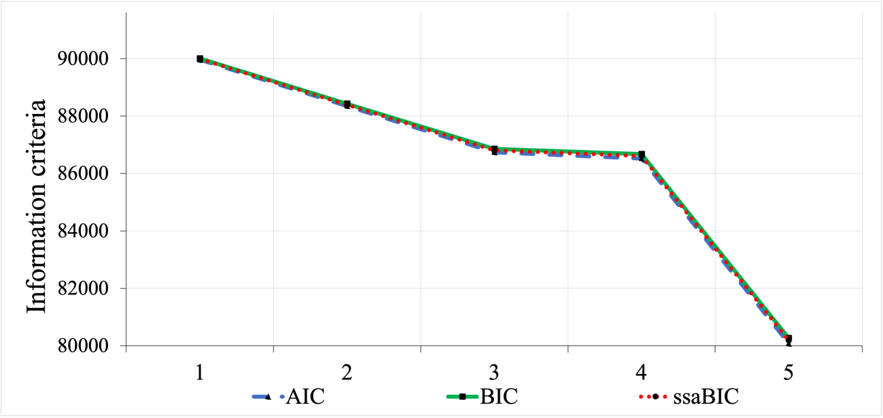
Figure S1: Elbow plot illustrating model fit (half one)

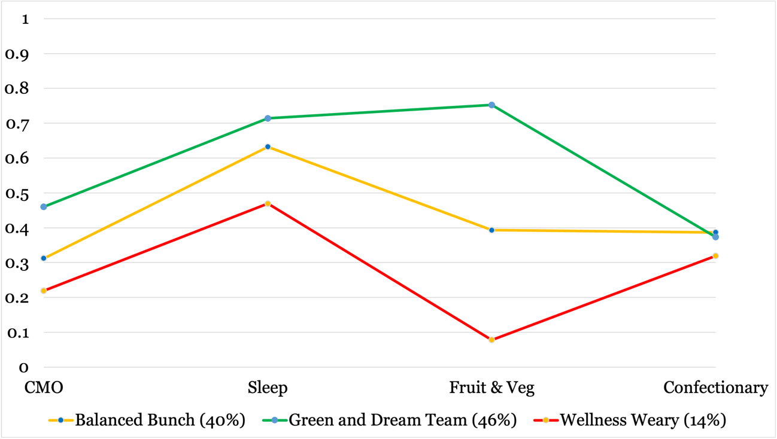
Figure S2: Three latent classes of adolescent health behaviour (half one)

Table S3: Model fit statistics for latent classes of health behaviour (half two)

Classes | LL | AIC | BIC | ssaBIC | LMRa | Entropy | Model Estimated Class Proportions
1 | -45231.249 | 90474.499 | 90517.286 | 90498.219 | - | - | 1
2 | -44464.455 | 88950.910 | 89029.353 | 88994.397 | .000 | .720 | .43, .57
3 | -43652.041 | 87336.083 | 87450.182 | 87399.336 | .000 | .916 | .40, .15, .45
4 | -43523.660 | 87089.320 | 87239.075 | 87172.340 | .000 | .836 | .12, .16, .45, .27
5 | -43437.672 | 86927.343 | 87112.754 | 87030.130 | .000 | .834 | .04, .16, .07, .45, .28

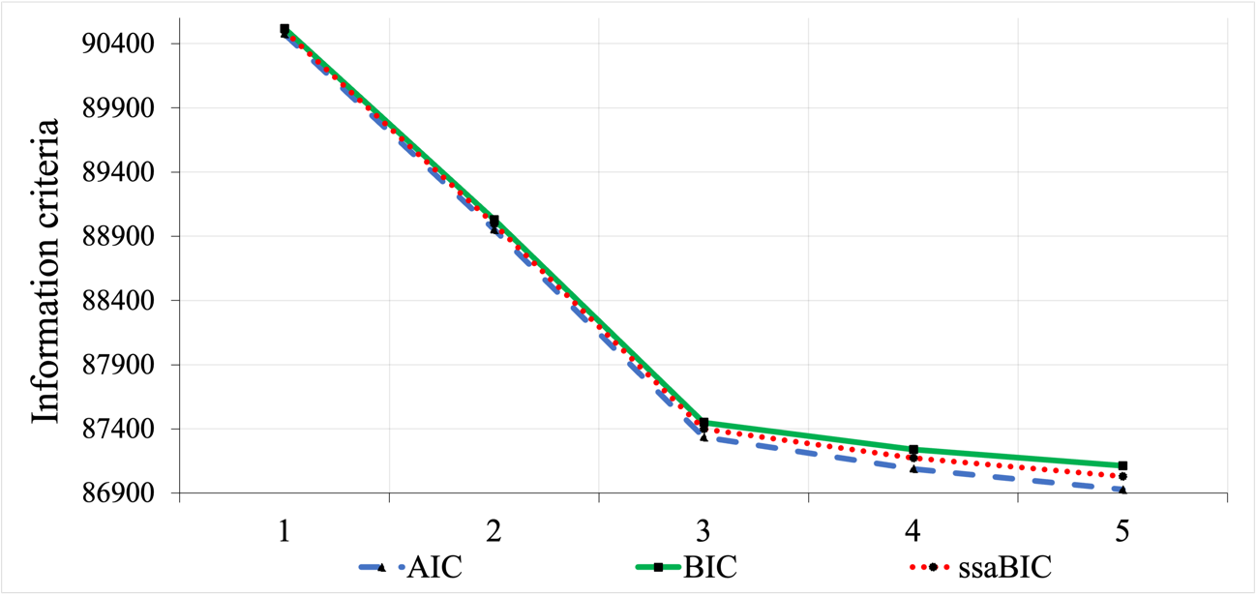
Figure S3: Elbow plot illustrating model fit (half two)

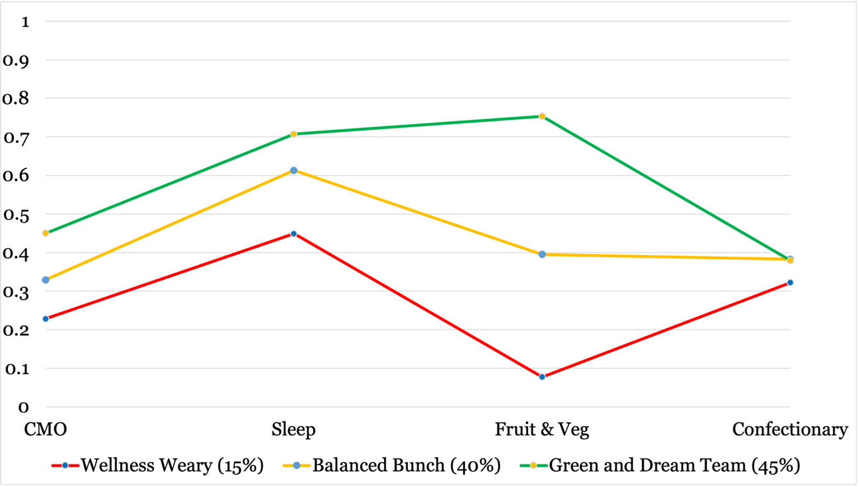
Figure S4: three latent classes of adolescent health behaviour (half two)
Table S4: Item response probabilities and model estimated mean scores for class indicators (split halves analysis)

 | Full Sample |  |  | Half One |  |  | Half Two
Item | GDT | BB | WW | GDT | BB | WW | GDT | BB | WW
CMO | .455 | .320 | .224 | .460 | .312 | .219 | .450 | .329 | .228
Sleep | .710 | .623 | .459 | .714 | .632 | .469 | .707 | .613 | .449
Fruit and Veg | 5.517 | 3.364 | 1.466 | 5.513 | 3.358 | 1.469 | 5.520 | 3.370 | 1.464
Confectionary | 3.258 | 3.308 | 2.924 | 3.238 | 3.320 | 2.916 | 3.278 | 3.295 | 2.932

Table S5: Associations between latent classes of health behaviour and covariates (complete case sensitivity analysis)

 |  |  | 95% CI |  |  |  |  | 95% CI
Variable | Class | OR (S.E.) | Lower | Upper | Variable | Class | OR (S.E.) | Lower | Upper
Physical | WW | 1 | 1 | 1 | Mixed | WW | 1 | 1 | 1
Health | BB | 1.232 (.045)* | 1.148 | 1.322 |  | BB | 1.240 (.150)ª | .978 | 1.571
 | GDT | 1.590 (.058)* | 1.480 | 1.708 |  | GDT | 1.164 (.137) | .924 | 1.465
IMD | WW | 1 | 1 | 1 | AOEG | WW | 1 | 1 | 1
 | BB | .590 (.075)* | .460 | .757 |  | BB | 1.223 (.340) | .709 | 2.110
 | GDT | .298 (.043)* | .225 | .395 |  | GDT | 1.945 (.582)*ª | 1.083 | 3.496
Social | WW | 1 | 1 | 1 | Cisgender | WW | 1 | 1 | 1
Media | BB | .931 (.012)* | .907 | .955 | Heterosexual | BB | 1.223 (.101)* | 1.041 | 1.438
 | GDT | .845 (.012)* | .822 | .869 | Girl | GDT | 1.493 (.128)* | 1.262 | 1.767
Bullied | WW | 1 | 1 | 1 | LGBTQ+ | WW | 1 | 1 | 1
 | BB | .887 (.069) | .761 | 1.033 |  | BB | .827 (.065)* | .709 | .964
 | GDT | .993 (.080) | .848 | 1.163 |  | GDT | .969 (.079) | .827 | 1.136
Asian | WW | 1 | 1 | 1 | SWEMWBS | WW | 1 | 1 | 1
 | BB | .830 (.071)* | .702 | .981 |  | BB | 1.043 (.008)* | 1.028 | 1.059
 | GDT | .789 (.070)* | .664 | .937 |  | GDT | 1.063 (.007)* | 1.049 | 1.078
Black | WW | 1 | 1 | 1
 | BB | .565 (.094)* | .407 | .784
 | GDT | .498 (.072)* | .374 | .662
* indicates significant ORs (95% CIs do not cross 1)
ª Cases where discrepancies in statistical significance were observed between FIML and complete case analysis

