Sequential interpenetrating polymer network confines shear-aligned graphene oxide liquid crystals enabling precise molecular sieving
Ria Sen Gupta^{#a}, Sk Safikul Islam#*ª, Dhondi Pradeep^{#b}, Ananth Govind Rajan*^{b} and Suryasarathi Bose*ª
ªDepartment of Materials Engineering, Indian Institute of Science, Bengaluru, Karnataka 560012, India
^{b}Department of Chemical Engineering, Indian Institute of Science, Bengaluru, Karnataka 560012, India
* sbose@iisc.ac.in, ananthgr@iisc.ac.in, skislam@iisc.ac.in,
Fax: +91-80-2360 0472

Supporting Information:

Characterization of the fabricated particles and membranes:
The synthesized rGO-I particles and the rGO-I@IPN_LC membranes were thoroughly characterized using FTIR (Fourier Transform IR spectroscopy) provided by PerkinElmer Frontier in the mid-IR range. XPS as performed on Axis Ultra (equipped with Al monochromatic source (1.486 keV)). XPS further corroborated the FTIR findings. PANalytical X'pert PRO (Cu Kα source, operating at 40 kV, 30 mA in the 2θ range of 10-50°, scan rate 0.04° s⁻¹) was used to study the X-ray diffraction caused by the crystalline domains of the particles as well as the membranes. SAXS measurements were performed with a XEUSS SAXS SYSTEM. Thermogravimetric analysis was performed using TA Q500. Water contact angle measurements were carried out in a FAMAS water contact angle goniometer using the sessile drop method. UV-Vis spectra were generated using Perkin Elmer’s UV/Vis/NIR Spectrometer, Lambda 1050+. The zeta potential of the particles was measured using the Zetasizer Nano Series (Malvern Instruments), and the surface charge of the membranes was inferred from its zeta potential using the Surpass 3 instrument, Anton Paar having an adjustable cell set at a gap height of 100 µm and pH 7. A scanning electron microscope (Ultra55 FE-SEM) from Karl Zeiss was used to gauge the morphological architectures and elemental compositions. Optical and POM (polarised optical microscope) images of the IPN dope solutions with varying rGO-I concentrations were gathered using a ZEISS Axio Scope. The membrane pore size was evaluated using nitrogen adsorption-desorption isotherms. Molecular weight cut-off (MWCO) measurements taking into account the rejection of a range of neutral molecules (Giemsa stain (GS 291.8 Da), Sudan IV (SD 380.44 Da), Tetracycline (TC 444.43 Da), Oxytetracycline (OTC 460.46 Da), Azithromycin (Azithro, 785 Da), and Vitamin B₁₂ (VB 1355.37 Da)) were performed to back up the isotherm experiments. For surface roughness measurements a Park NX10 AFM (non-contact mode, 5N/m cantilever force constant, tip radius curvature 8nm) was used. Rheological evaluations were carried out using a Discovery Hybrid Rheometer 3 (TA instruments) under amplitude sweep conditions (at 80 °C, 40 mm, 1.011° cone plate geometry, Peltier steel plate, constant angular frequency of 1 rad/s at a strain rate of 0.0001 to 100 s⁻¹).
Membrane uptake and pore size evaluation:
The membrane uptake studies were performed by drying ten membrane coupons of equal size (45 mm diameter) under vacuum for a whole night, which were then weighed. Immediately after this, the membranes were dipped in DI water for 24 hrs and weighed again. The water uptake capacity of the membranes was calculated using the equation:
%Uptake = $\left(\frac{Weight after 24 h immersion - Weight before immersion }{Weight before immersion}\right) × 100$ (1)
Nitrogen adsorption-desorption isotherms were studied for calculating the pore size. To further quantify the obtained data, molecular weight cut-off analysis was performed. A range of neutral molecules, in the molecular weight range of 300-1400 Da were selected. Giemsa stain, Sudan IV, tetracycline, oxytetracycline, azithromycin, and vitamin B₁₂ were taken for the study. The rejection of these molecules was determined using the fabricated membrane, and the removal efficiency was evaluated by adopting the rejection percentage equation, similar to the dye rejection experiments.
Performance of the fabricated membranes:
Quantification of Pure water flux (PWF) and antifouling abilities:
The pure water flux was evaluated using a laboratory-fabricated in-house crossflow setup. For the calculation of water flux (J_{W}) at steady state, equation (2) was employed. Membrane coupons of 45 mm diameter were taken, fixed onto the test cell, and compacted (10 psi, ca. 0.7 bar) for half an hour before commencing the experimental analysis. The pressure across the membrane was carefully varied from 10 to 100 psi (0.7 to 7 bar). The stability of the membranes were adjudged by carrying out the flux experiments for 3 weeks. For authenticating the repeatability of the test results, all experiments were carried out in triplicates. The water flux was obtained as
$J_{w} =\frac{V}{At} ($Lm⁻²h⁻¹) (2)
where $V$ represents the permeate volume in litres, $A$ is the effective membrane area in m², and $t$ represents the operating time in hours.
Fouling remains, by and large, the most pressing problem of commercial membranes. It impedes membrane performance and drastically reduces the longevity of the membranes. For appraising the antifouling characteristics of the membrane, 1000 ppm of negatively charged BSA (Bovine Serum Albumin) solution was taken as a representative foulant. Prior to the usage of BSA, the pure water flux of the membranes was evaluated using equation (2). Subsequently, the BSA flux values (J_{B}) were recorded at 100 psi transmembrane pressure for a duration of 1 h. 0.9 wt% of NaCl solution was used to thoroughly backflush and clean the membrane. Then, the pure water flux was measured (J_{w1}) again. The flux recovery ratio (FRR) was calculated by employing equation (3), which quantifies the antifouling performance of the membrane:²⁴
FRR = J_{W1}/J_{W} $×$ 100 (3)
Rejection studies (dye, antibiotics, and salt removal and chlorine tolerance levels):
A range of cationic dyes and anionic dyes, such as methylene blue (MB), Congo red (CR), amido black 10B (AB), safranin O (SO), as well as a mixture of MB and CR, were taken for evaluating the separation performance of the membrane. Membrane coupons of 45 mm diameter were set up in a dead-end set up, and 100 mL of 20 ppm solutions of each model dye were taken for each cycle. After each cycle of operation, the used membranes were thoroughly washed with distilled water before using it for the next cycle. The membranes were compacted and samples were collected for UV-Vis analysis. The permeate concentration was evaluated from UV-Vis spectroscopy, and the rejection efficiency was quantified using the formula:
$\%Rejection = \left[1-\left(\frac{Concentration of permeate}{Concentration of feed}\right)\right]×100$ (4)
The studies were continued for a stretch of 3 weeks to gauge the stability of the membranes over long periods of usage. Similarly, antibiotic rejections were carried out using azithromycin and amoxicillin as the model antibiotic foulants. These two antibiotics were specifically chosen owing to their over usage during the Covid pandemic. Note that the remnants of antibiotics in aquatic bodies even in extremely low concentrations can lead to serious hazards affecting the entire ecosystem.
Removal efficiency of salts were analysed with 2000 ppm each of NaCl and Na₂SO₄ and MgSO₄, while 0.5 (M) sucrose solution served as the draw solution.¹ 45 mm diameter token membranes were placed in the membrane holder of an in-house forward osmosis (FO) setup. A total dissolved solids (TDS) meter was adopted to measure the concentration of salts on the permeate side in a round-robin fashion. Long-term stability studies were performed by continuing the studies for a 3-week duration. The rejection percentage was calculated using equation (5)
$\%Rejection =\left(1-\frac{(( Cd+ΔCd)*( Vd+ΔV) -CdVd))}{Cf ΔV}\right)×100 (5)$
Where, ΔCd = increase in the concentration of salt in the draw side when its volume goes from Vd to (Vd + ΔV);Vd = initial volume in the draw side; ΔV = increase in volume in the draw side;Cf = concentration of salt in the feed side; (Cd+ΔCd)×(Vd+ΔV) is the final amount of salt on the draw side; CdVd is the initial amount of salt on the draw side.
After salt rejection studies, the membranes were dipped in 2000 ppm of sodium hypochlorite solution for a duration of 6 hours. Following this, the membranes were washed and rinsed thoroughly with DI water and were again deployed for salt rejection experiments involving 2000 ppm of NaCl solutions. The deviation in the values of salt rejection before and after chlorine exposure was used as the metric for evaluating the chlorine tolerance levels of the fabricated membranes.

Biological studies:
- Evaluation of in-vitro cytotoxicity:
Standard MTT [(3-4, 5 dimethylthiazol-2-yl)-2,5 diphenyl tetrazolium bromide] assay was carried out to evaluate the cytotoxic potential of the membranes. In this assay, yellow water-soluble MTT changes into non-soluble purple formazan via reduction in the presence of live cells that are active metabolically. Polyurethane (PU) (electrospun) and low-density polyethylene (LDPE) membranes served as the positive and negative controls respectively. Mammalian cell lines (L929) were used for assessment. MEM (minimum essential medium) and 10% FBS (fetal bovine serum) was used for growing and maintaining the cells. In brief, 10,000 L929 (NCCS/1469) cells were seeded in a 96 well plate using 100 μL of the MEM culture medium. Upon maintaining the plates in the culture media for 24 h, the formation of a semi-confluent layer occurred, which in turn was exposed to the test extract material. For sample extract preparation, 1 g of the sample was heated for 15 min at an elevated temperature of 121 °C. To the extract, 10 mL of MEM medium was added, and the entire setup was incubated in a 5% CO₂ atmosphere at 37 °C for 24 hrs. 10-100% concentration range was taken for completing the assay, and 100% referred to the virgin extract. Subsequently, on exposing the semi-confluent layer formed to the sample extracts for 24 h the formation of formazan was monitored by optical density measurements. The count of viable cells varies linearly with the intensity of colour in the optical density (OD) tests. The cell viability percent was directly calculated using the equation:
$\%Viability= \left(\frac{OD at 570 nm for extract}{OD at 570 nm for blank}\right) × 100$ (6)
- Antibacterial Performance:
The bacterial strains Staphylococcus aureus (gram-positive) ATCC 25923 and Escherichia coli (gram-negative) ATCC 25922 were considered for gauging the antibacterial performance of the membranes. The membranes (4.5 mm diameter) were incubated at 37 °C for 2 h and the bacterial strains were sub-cultured for 24 h at the same temperature in a trypticase soy broth (TSB) media using a shaker incubator. The cultures were effectively harvested in log phase. Subsequently, these cultures were centrifuged (3000 rpm) and the pellets of bacteria obtained were washed thoroughly with PBS buffer and resuspended in PBS to obtain 10⁸ CFU/mL which was further used in the experiments. In brief, discs of 4.5 mm diameter membrane coupons were placed in 96 well plates. An inoculum volume (test suspension) of 0.1 mL was subsequently added to the well plates containing membrane discs and also to the control without any treatment. The well plates were then incubated at 37 °C for 24 h. One by one the membranes were taken out and treated with 1 mL of PBS. The suspensions were then collected and subjected to serial dilutions. The standard plate count technique was then carried out using TSA (trypticase soy agar), and the plates were incubated at 37 °C for 24 h. After the completion of the incubation period, the growth of the colonies was calculated to gauge the log reduction.

- XPS Deconvoluted Spectra:
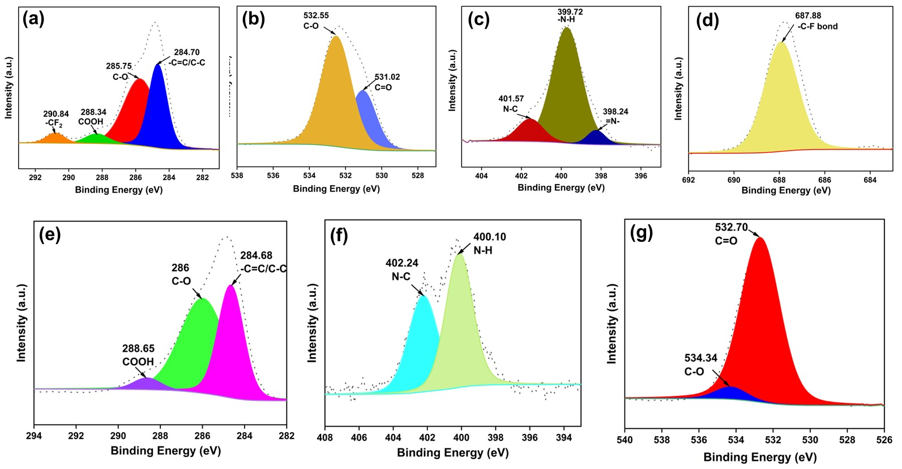

Fig. S1. Deconvoluted XPS spectra for the rGO-I@IPN-LC membrane: (a) C 1s, (b) O 1s, (c) N 1s, (d) F 1s, and the synthesized rGO-I LC sheets: (a) C 1s, (b) N 1s, and (c) O 1s respectively.

- X-ray Diffraction Pattern:

Fig. S2. XRD spectra for the dry and wet rGO-I@IPN-LC membrane after an immersion duration of 90 days.

- AFM Profile of GO and rGO-I Sheets:

Fig. S3. AFM micrograph and line profiles for (a,b) GO sheets and (c,d) rGO-I sheets, respectively.

- Line Profile of the Synthesized Membranes:

Figure S4. AFM line profile for neat IPN and rGO-I@IPN-LC membranes.

- Pore-Size Analysis of Fabricated LC Membrane:

Figure S5. The N₂ adsorption/desorption isotherm of rGO-I@IPN-LC membrane. The plot of pore size distributions employing the NLDFT method is shown in the inset.

- Polarized Optical Microscope Images:

Figure S6. POM images of rGO-I@IPN-LC dope solution containing 10 mg/mL and 20 mg/mL concentration of the sheets.

- Nanography:

Fig. S7. Representatives of the 2D X-ray scattering patterns of the rGO-I@IPN-LC membrane.

- Pure water flux:
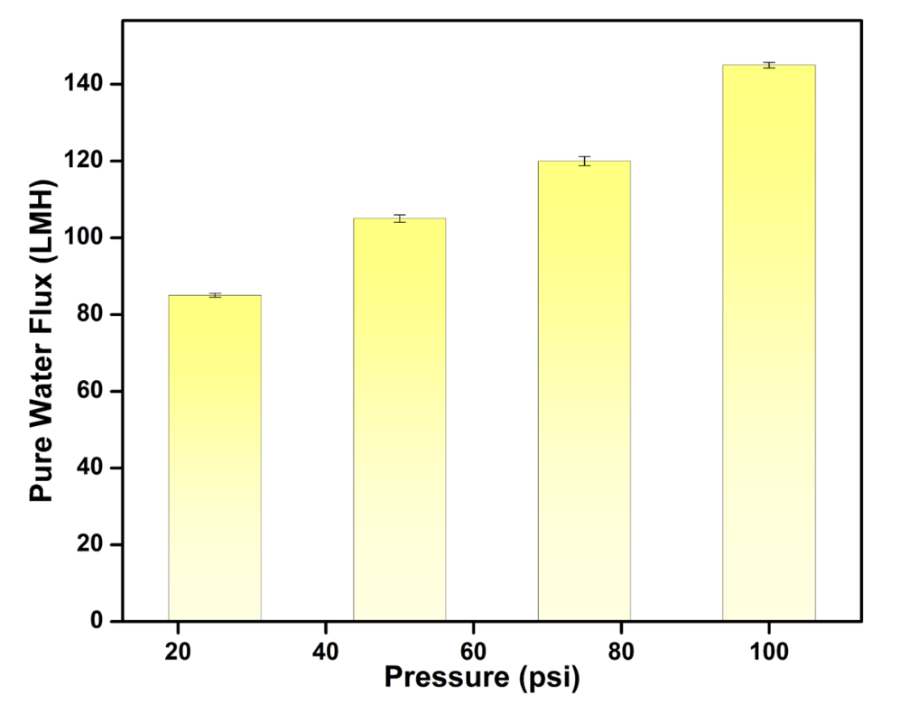
Fig. S8 Pure water flux experiments at different pressure

- FTIR Spectra after Continuous Flux Experiments:

Fig. S9. FTIR spectra of the neat membrane and that after performing pure water flux studies for a period of 3 weeks.

- Integrated XPS Spectra:

Figure S10. XPS spectra before and after 3 weeks of pure water flux experiments.

From both the FTIR and the XPS spectra of the membranes before and after long periods of pure water flux operations, it was further ascertained the chemical robustness of the fabricated rGO-I@IPN-LC membranes.
- EDAX Spectra:
Figure S11. EDAX spectra of the rGO-I@IPN-LC membranes after (a) methylene blue rejection, (b) congo red removal, and (c) continuous salt rejection after 21 days.

- Rejection and Leaching Studies:

Figure S12. UV-Vis spectra for rejection studies of (a) azithromycin, (b) amoxicillin, (c) methylene blue, (d) congo red, and (e) mixed (MB+CR) dye. Percentage removal of (f) antibiotics and (g) safranin O and amido black dyes. (h) UV-Vis plot demonstrating the non-leaching behaviour of the rGO-I@IPN-LC membranes.

- Temporal Water Permeation Behaviour from MD Simulations:
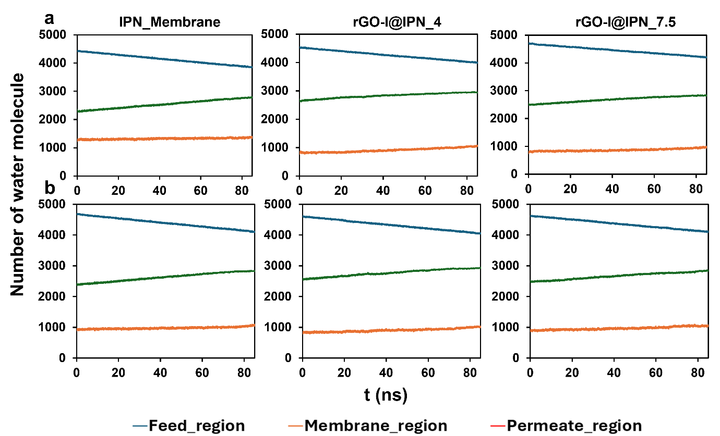
Fig. S13. The number of water molecules in the feed, membrane, and permeate regions, over time in MD simulations under a 100 MPa pressure condition for (a) NaCl salt solution and (b) Na₂SO₄ salt solution.
In Fig. S13, we depict the water molecule counts in various regions of the simulation setup for different membranes (IPN, rGO-I@IPN[4], and rGO-I@IPN[7.5]). Over time, the number of water molecules declines steadily in the feed region, contrasting with a gradual increase in the permeate region. Notably, the count of water molecules within the membrane region remains stable throughout the simulation, evidently illustrating the steady-state behavior of water transport within the system.

REFERENCES:
- Sapkota, B., Liang, W., VahidMohammadi, A., Karnik, R., Noy, A., Wanunu, M. High permeability sub-nanometre sieve composite MoS2 membranes. Nature communications, 2020, 11(1), 2747

