SUPPLEMENTAL MATERIALS
Definition of dose-limiting toxicity
A DLT is defined as any of the following events attributable, with reasonable certainty, to IMC001 and occurring within the first 28 days after the first infusion of IMC001:
Hematologic toxicity:
- EpCAM CAR-T cell therapy-related Grade ≥4 hematologic toxicity that does not recover to Grade ≤2 within 14 days after treatment (excluding lymphocyte and white blood cell reductions).
- Hemophagocytic lymphohistiocytosis (HLH) / hemophagocytic syndrome (HPS) related to EpCAM CAR-T cell therapy.
Non-hematologic toxicity:
- Any EpCAM CAR-T cell therapy-related Grade ≥4 non-hematologic toxicity.
- EpCAM CAR-T cell therapy-related Grade ≥3 cytokine release syndrome that is not controlled to Grade ≤2 within 7 days after treatment.
- EpCAM CAR-T cell therapy-related Grade 3 or higher CAR-T cell therapy-related encephalopathy syndrome (CRES) / immune effector cell-associated neurotoxicity syndrome (ICANS).
- EpCAM CAR-T cell therapy-related Grade 3 non-hematologic toxicity lasting more than 7 days, excluding:
  - Grade ≤3 fever or fever of Grade >3, recovering to Grade ≤3 within 48 hours after adequate intervention.
  - Grade 3 nausea/vomiting recovering to Grade ≤2 within 48 hours after adequate intervention.
  - Grade 3 diarrhea/abdominal pain recovering to Grade ≤2 within 48 hours after adequate intervention.
  - Asymptomatic Grade 3 bilirubin elevation or alanine aminotranferase/aspartate aminotransferase elevation.
  - Grade 3 fatigue.
  - Other laboratory abnormalities without significant clinical significance.

Pharmacokinetic and pharmacodynamic methods
- EpCAM expression detection
EpCAM expression was detected by immunohistochemistry (IHC), and the method development and validation as well as the subsequent testing were performed by Shanghai AKM Pathology and Diagnostics Co., Ltd.
The validation items of the IHC method for EpCAM expression detection in this study were: analytical sensitivity, analytical specificity, precision (including inter-assay precision and intra-assay precision), and consistency of interpretation. The validation conclusions were as follows: 1) the sensitivity and specificity of the assay met the expected requirements, and it was expressed in normal tissues, and the staining observed was consistent with the antibody specification and the literature reports, with no non-specific staining; 2) the results of comparison by the internal laboratory reproducibility experiments showed that the consistency of the EpCAM staining was 100%, and the consistency of the judgment between the pathologists was 100%, and the consistency of the interpretation was 100%; 3) The results of precision experiments showed that the quality of section staining was within the acceptable range for inter-operator comparisons as well as for intra-operator comparisons.
The proportion and intensity of EpCAM expression was reported using two values, the overall percentage of positivity and the H-score value. The formulas for both are as follows:
Overall positivity percentage % = (number of EpCAM stained tumor cells / number of all active tumor cells) * 100%
H-score = ∑ (1+ %) + (2+ %) + (3+ %)
1+: weak intensity staining; 2+: moderate intensity staining; 3+: strong staining

- CAR copy number detection in peripheral blood
In this study, the method used for CAR copy number detection in peripheral blood after IMC001 EpCAM CAR-T cells were infused into the peripheral blood was based on the Taqman probe-based qPCR, and the method development and validation, as well as the subsequent detection, were completed by Shanghai Triapex Biotechnology Co., Ltd and Shanghai Immunofoco Pharmaceutical Research Co., Ltd. The general protocol of this method is to extract genomic DNA from peripheral blood, then use a Taqman probe specific for the CAR sequence, and quantitative analysis by the cumulative intensity of the fluorescence signal of the probe. In this study, a linearized standard plasmid containing the CAR sequence was used for the establishment of the standard curve and subsequent quantitative calculation of the CAR copy number.
The validation items of this method are: specificity, accuracy, precision (including repeatability and intermediate precision), lower limit of quantification (LLOQ)/ lower limit of detection (LLOD), linear range and sample stability. The validation conclusions were as follows: 1) the healthy human genome as a control amplification results were negative, the standard curve amplification was normal, the specificity of the method meets the requirements; 2) the recovery rate was between 75-125%, the accuracy, which met requirements; 3) repeatability and intermediate precision validation of the experimental results of the coefficient of variance (CV%) was ≤30%, which met the requirements; 4) the LLOQ was 50 copies/μg gDNA; 5) the linear range was 20 copies/test - 2×10⁶ copies/test, which met requirements; 6) sample stability: the stability of the extracted genome stored at 2-8℃ for 48h and -80℃ for 7 days met requirements.
The quantitative calculation of CAR copy number was obtained automatically by establishing a standard curve and since the sample genome added in each test was 400 ng, the final calculation formula was:
Sample CAR copy number copies/μg gDNA = CAR copy number value copies/μg gDNA *(1000ng/ 400ng) automatically calculated from the standard curve in the qPCR experiment.

- Detection of cytokine levels in peripheral blood
One of the two methods used in this study to detect the level of cytokines in peripheral blood was Cytometric Bead Array (CBA) analysis, which is based on the principle of double-antibody sandwich ELISA, using microspheres labeled with antibodies as the reaction carrier, and applying flow cytometry for the simultaneous quantification of multiple soluble proteins in the same sample. The gating strategy used was the LEGENDplex Human Essential Immune Response Panel Assay Gating Strategy (see figure below) The other method was MSD's electrochemiluminescence (ECL) analysis (generally known as the MSD method), which is characterized by high sensitivity and high specificity through the specific binding of electrochemically labeled probe molecules to the analytes to be analyzed, and these markers can emit light signals under a specific voltage.

LEGENDplex Human Essential Immune Response Panel Assay Gating Strategy
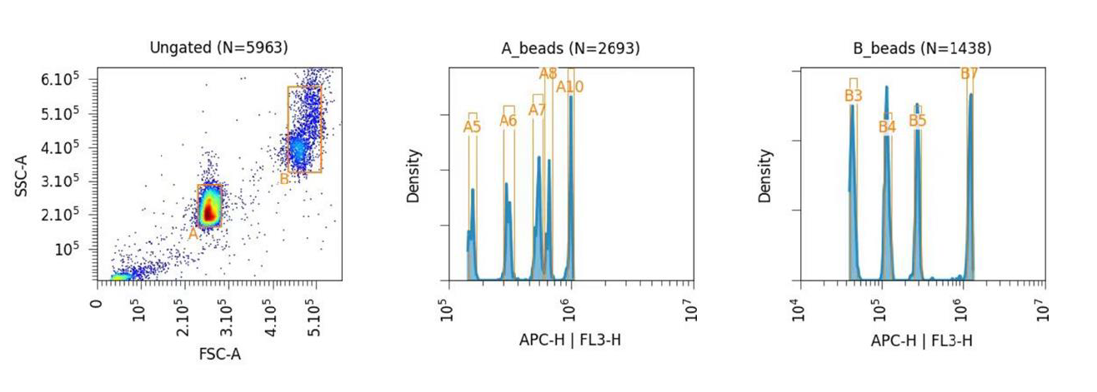
- Multiplex Immunohistochemistry OF TME
The multiplex immunohistochemistry (mIHC) of TME was performed on tumor samples collected before CAR-T treatment. CD4 (Abcam, ab133616) and α-SMA (CST, 19245) was concurrent staining on the same slide, and DAPI was used to staining nucleus. The staining procedure was conducted using the Leica Bond III//bond MAX staining platform, which facilitated dewaxing, antigen retrieval, and staining processes. Antigen retrieval was achieved by incubating the slides at 100 degrees Celsius using antigen retrieval solution for 20 minutes, followed by thorough washing with TBST between each step. Subsequently, the slides were treated with hydrogen peroxide for 10 minutes, followed by incubation with sealing liquid for an additional 10 minutes to prevent nonspecific binding. Primary antibody incubation involved dilution of the antibody in antibody diluent/blocking solution, followed by incubation at room temperature for 60 minutes. Secondary antibody staining was carried out using Leica DS9800 staining system with an incubation period of 10 minutes at room temperature. Subsequent to secondary antibody staining, the slides were incubated with fluorescent dye for 10 minutes at room temperature. Afterward, an anti-fluorescence quencher sealant was applied. Two rounds of antibodies staining were conducted followed by DAPI incubation for 10 minutes to stain nuclei. Then images were captured, and data analysis was performed using HALO image analysis software. The software identified the stained positive regions for CD4 and α-SMA to facilitate statistical analysis.

PK/PD sampling times
Sample time-points  Test items | Before LD | After LD & before IMC001 infusion | Follow-up peroids
Sample time-points  Test items | Before LD | After LD & before IMC001 infusion | Treatment day(D0) | D1 | D3 | D5 | D7 | D9 | D11 | D14 | D28/W4 | W8 | W12 | W24 | W48 | W96
Time window (d) |  | ±0d | Day of infusion | ±0d | ±1d | ±2d | ±2d | ±2d | ±2d | ±2d | ±2d | ±7d | ±7d | ±7d | ±7d | ±14d
cytokines |  | × | × | × | × | × | × | × | × | × | × | × | × | × | × | ×
CTC | × | × |  | × | × |  | × |  |  |  | × |  | × |  | × | ×
CAR-T subsets/ phenotypes |  |  | × | × | × | × | × | × | × | × | × | × | × | × | × | ×
CAR-T copies |  |  | × | × | × | × | × | × | × | × | × | × | × | × | × | ×
D, day; LD, lymphodepletion; W, week.

