Supplementary File 1. Average number of total hospitals visited according to the travel distance to hospitals and the residential region’s population density

Average travel distance to the hospital | Population density of the residential region, mean (SD)
Average travel distance to the hospital | Low | Mid | High
< 15km | 1.5 (1.0) | 3.9 (3.6) | 17.7 (7.9)
15-49.9km | 6.2 (4.5) | 14.7 (13.2) | 22.9 (13.9)
50-99.9km | 8.7 (7.5) | 11.2 (10.0) | 5.4 (2.6)
≥100km | 11.3 (7.0) | 21.9 (10.8) | 20.1 (9.2)

SD, standard deviation

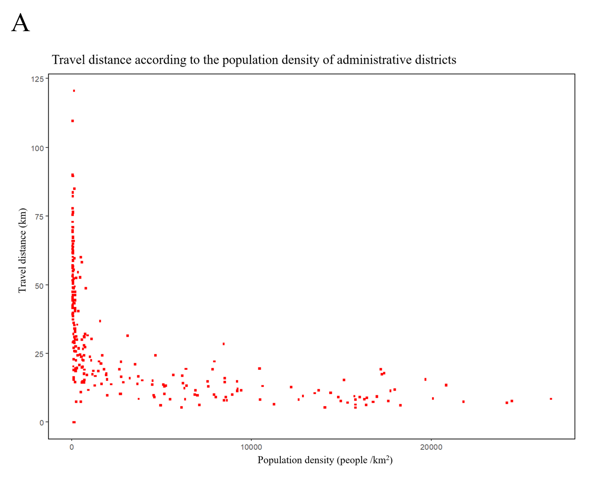
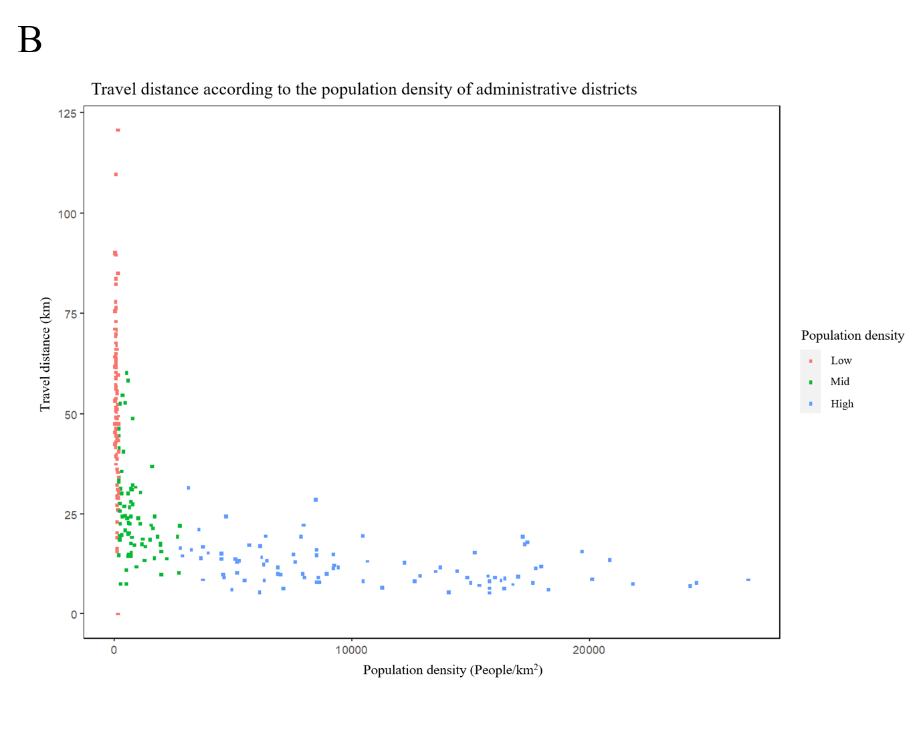
Supplementary File 2. A scatter plot of 252 administrative districts (‘Si’, ‘Gun’, ‘Gu’) according to their average travel distance to hospital and population density (A). B shows the same image with the classification of regions to three groups by population density (Low: <182.27, red; Mid: 182.27-2735.87, green; High: 2735.88≤ , blue. Unit: people/km²)

