Fabrication of visible light active Mn-doped Bi₂WO₆-GO/MoS₂ heterostructure for enhanced photocatalytic degradation of methylene blue

Supplementary Material
Noor Tahir ª, Muhammad Zahid ^{a,*}, Ijaz Ahmad Bhatti ª, Yasir Jamil ^{b}
ª Department of Chemistry, University of Agriculture, Faisalabad- 38040 Pakistan
^{b} Department of Physics, University of Agriculture, Faisalabad- 38040 Pakistan
*Corresponding Author Email: Zahid595@gmail.com; rmzahid@uaf.edu.pk

Synthesis:
Synthesis of Graphene Oxide

In a typical synthesis procedure, the graphitic oxide was prepared by adding graphite powder (5g) was added in a flask along with 300 ml of 98% sulfuric acid (H₂SO₄) dropwise and about 2.5g of sodium nitrate (NaNO₃) with continuous stirring. The reaction mixture is kept in an ice bath to maintain the temperature below 5ºC and then finely powdered potassium permanganate (KMnO₄) was added slowly with continuous mechanical stirring for several hours. The temperature of the reaction mixture was then increased up to 37ºC with continued vigorous stirring until brown color appeared. Afterward, 200 ml distilled water is added at 95ºC with continued stirring for half an hour. 30ml of 10% hydrogen peroxide was added. The obtained yellowish-brown paste of graphitic oxide was washed with distilled water by centrifugation until pH was neutralized. The obtained graphitic oxide was later sonicated employing an ultrasonicator. A suspension of graphene oxide was obtained which was oven-dried at 60 ºC to get the final product (Tabasum et al., 2018).

UV-visible spectral changes in MB :

The Fig S1 shows the spectral changes in the methylene blue degradation at 665nm at various time intervals. The fig S1(b) shows complete degradation of MB by Mn-BMG in just an hour and above 90% degradation by ternary BMG.
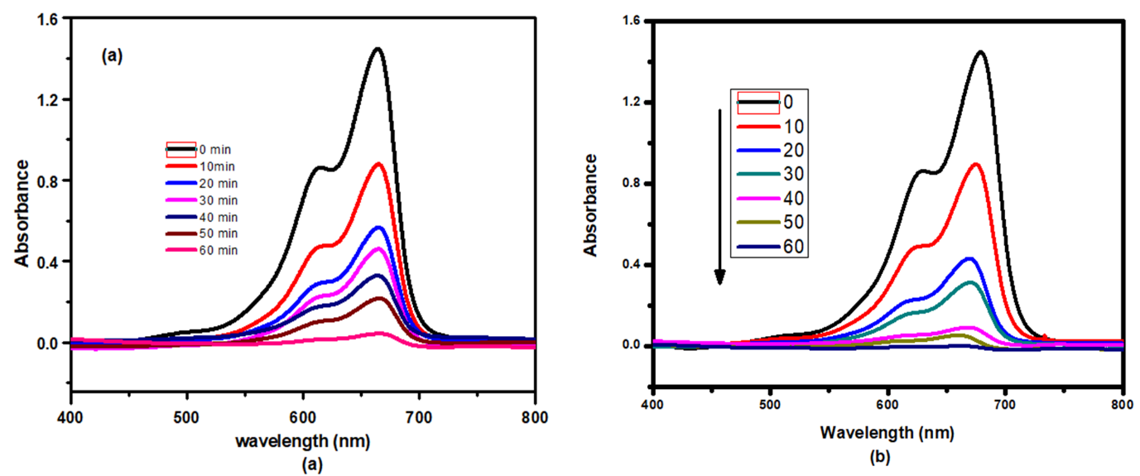
(b)

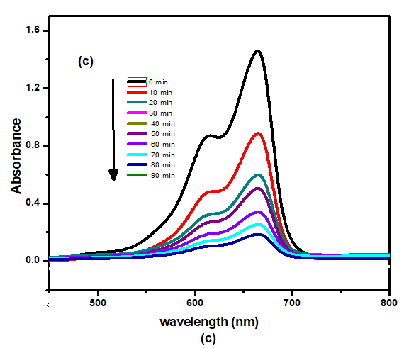
Fig. S1 UV-VIS spectral changes of MB during degradation using (a) BMG (b), Mn-BMG (c) and BG nanocomposite for different irradiation times under sunlight

Tabasum, A., Zahid, M., Bhatti, H. N., and Asghar, M. 2018. Fe3O4-GO composite as efficient heterogeneous photo-Fenton’s catalyst to degrade pesticides. Materials Research Express, 6(1), 015608.

