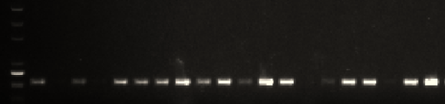
Fig S1. PCR amplification of Cas9 gene in the transgenic line T1-4.

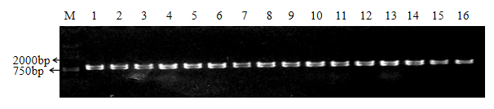

Fig S2. PCR amplification of BnS-1 specific molecular marker SPeS1-7/8 in F₁ plants.

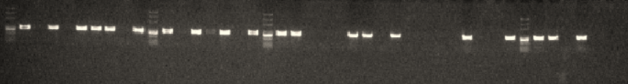
Fig S3. PCR amplification of BnS-1 specific molecular marker SPeS1-7/8 in BC₁ plants.

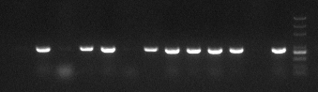
Fig S4. PCR amplification of BnS-1 specific molecular marker SPeS1-7/8 in BC₂ plants.

Table S1. The primers used in this study

Primers | Sequence（5’—3’） | Note
17KN22-1abT1-BsF | ATATATGGTCTCGATTGTTGAGGGTTCCAATGGAATGTT | CRISPR/Cas9
17KN22-1abT1-F0 | TGTTGAGGGTTCCAATGGAATGTTTTAGAGCTAGAAATAGC | CRISPR/Cas9
17KN22-1a-T2-BsF | ATATATGGTCTCGCGAGAAGCTCTGCCATCACGTT | CRISPR/Cas9
17KN22-1a-T2-R0 | CGAGAAGCTCTGCCATCACGTTTTAGAGCTAGAAATAGC | CRISPR/Cas9
NPTIIF68 | ACTGGGCACAACAGACAATCG | Transgenic test
NPTIIR356 | GCATCAGCCATGATGGATACTTT | Transgenic test
545PKSE-Cas9-F | GGGACCTACCACGATCTCCT | Transgenic test
545PKSE-Cas9-R | CCCTTCTGCGTGGTCTGATT | Transgenic test
SpeS1-7 | CTTCTGATCATGTTTTGCCTCTG | molecular marker
SpeS1-8 | CGAGATCTTTGGGACCATATTTC | molecular marker

Table S2. Self- compatibility index (SCI) of the plants in the BC₂ generation.

Plants | B2-1 | B2-2 | B2-3 | B2-4 | B2-5 | B2-6 | B2-7 | B2-8 | B2-9 | B2-10 | B2-11 | B2-12 | B2-13
BnS-1 | - | + | - | + | + | - | + | + | + | + | + | - | +
SCI index | 0.35 | 4.30 | 0.05 | 1.40 | 5.55 | 0.13 | 0.90 | 5.80 | 4.45 | 1.95 | 4.35 | 0.70 | 1.15

