Supporting Information
Polarization-Independent Dynamic Beam Steering based on Liquid Crystal-Integrated Metasurface
Dian Yu¹, Shaozhen Lou¹, Xiangnian Ou¹, Ping Yu³, Huigao Duan^{1,2,4} & Yueqiang Hu^{1,4}*
¹National Research Center for High-Efficiency Grinding, College of Mechanical and Vehicle Engineering, Hunan University, Changsha 410082, China.
²Greater Bay Area Institute for Innovation, Hunan University, Guangzhou 511300, China.
³Songshan Lake Materials Laboratory, Dongguan 523808, China
⁴Advanced Manufacturing Laboratory of Micro-Nano Optical Devices, Shenzhen Research Institute, Hunan University, Shenzhen 518000, China.

Design and simulation of polarization-independent beam streeing metasurface:
In order to meet the requirements for reflectance, polarization conversion efficiency, and phase variation, optimization design of the dimensional parameters of the unit structure in the metasurface is necessary. The substrate of the metasurface consists of a silicon dioxide layer (h₂ = 50nm), a gold reflective layer (h₃ = 100nm), and a silicon base, as shown in Fig. S1(a). Firstly, the selection of the supercell period needs to consider the period of the dielectric grating. Different periods of the dielectric grating will affect the diffraction of the incident light, which in turn affects the phase difference provided by the device. Therefore, we simulated the phase distribution of various periodic dielectric gratings (θ = 90°) at a wavelength of 950nm, as shown in Fig. S1(b). Among them, the dielectric grating with a period close to 1120nm is more conducive to achieving an additional phase difference of π. Considering the limitations of fabrication and the improvement of efficiency in the metasurface, we chose to fix the period of the metasurface to one-fourth of the dielectric grating period (P=280nm). Based on this, we performed scanning simulations in FDTD for the length (L), width (W), and height (H) of the gold nanocolumns, as shown in Fig. S1(c). Finally, considering the requirements for reflectance, polarization conversion efficiency, and phase variation, we selected two suitable gold nanocolumn size parameters (W₁ = 100nm, L₁ = 310nm; W₂ = 70nm, L₂ = 130nm).
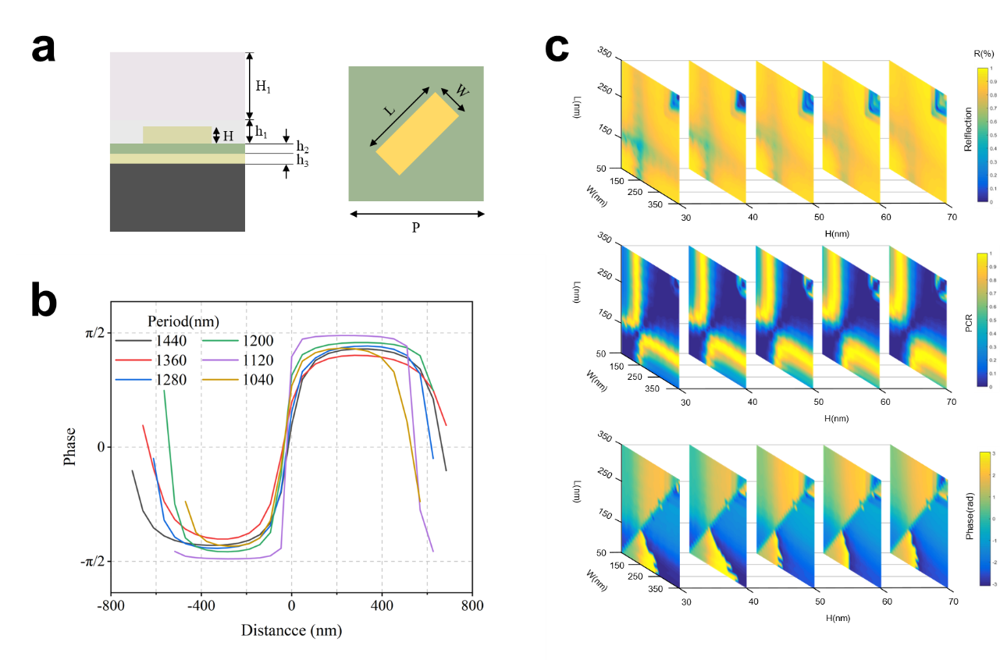
Fig. S1 (a) Dimensions of the unit cells in the metasurface. (b) Phase distribution of dielectric gratings with different periods in 950nm. (c) Simulation of reflectance, polarization conversion efficiency, and phase distribution for various dimensions of gold nanorods with period 280nm.

